|  |  |
| --- | --- |
| **GOH YEE MUN MASTER OF BUSINESS ADMINISTRATION 2019** | **RESEARCH ON USER LEVEL OF ACCEPTANCE**  **NFC MOBILE PAYMENT IN IPOH, MALAYSIA**  **GOH YEE MUN**  **MASTER OF BUSINESS ADMINISTRATION**  **FACULTY OF BUSINESS, COMMUNICATION & LAW INTI INTERNATIONAL UNIVERSITY**      **2019** |

**INTI INTERNATIONAL UNIVERSITY**

**MASTER OF BUSINESS ADMINISTRATION**

**RESEARCH ON USER LEVEL OF ACCEPTANCE NFC MOBILE PAYMENT IN IPOH, MALAYSIA**

**Author: GOH YEE MUN**

**Student No: I18014754**

**Supervisor: Dr. Alex Ng**

**2nd Panel: Dr. Sam Toong Hai**

**Submission Date: 23 AUGUST 2019**

**Final Word Court: 11092 WORDS**

**Declarations**

I hereby declare that this thesis is my own work and effort and it has not been submitted anywhere for any reward. Where other sources of information have been used, they have been duly acknowledged.

Name: GOH YEE MUN

Student ID: I18014754

Signature: GOH YEE MUN

Date: 26 August 2019

**Acknowledgements**

It has been a rough and memorable journey to make this research achievable. Foremost, I would like to express my sincere gratitude to Dr Alex my supervisor and Dr. Sam Toong Hai (2nd supervisor) for their time, patience guidance and feedback throughout the entire MBA project. The guidance given me a clear direction on research and writing of this thesis which made the research possible to be completed on time.

Not forgetting, I would like to thank and appreciate my husband and my parents who have been supportive towards my research, without their constant support and sacrifices during my study time, the entire course of study will never be achieved smoothly.

I would like to thank the colleagues and anonymous participants who were willing to spend their time helping and responding to my survey questionnaire. Last and not least, I would like to thank my beloved course mates for their continuous support and motivation throughout my study and completion of coursework and exams.

**Table of Contents**

Declarations ......................................................................................................... 2

Acknowledgements ............................................................................................. 3

Table of Contents ............................................................................................... 4

List of Tables ...................................................................................................... 7

List of Figures .................................................................................................... 8

List of Appendices ............................................................................................ 9

List of Abbreviations ........................................................................................... 10

Abstract ...............................................................................................................11

CHAPTER 1 INTRODUCTION 12

1.1 Research Background 12

1.2 Problem Statement 15

1.3 Research Objectives 18

1.3.1 General Research Objectives 18

1.3.2 Specific Research Objectives 18

1.4 Research Question 19

1.4.1 General Question 19

1.4.2 Specific Research Question 19

1.5 Significance of The Study 19

1.6 Scope of the Study 20

1.7 Ethical Consideration 20

CHAPTER 2 LITERATURE REVIEW 21

2.1 Overview Mobile Commerce – As New Payment Method 21

2.2 Types of Mobile Payment 23

2.2.1 Proximity Mobile Payment 23

2.2.2 Remote Mobile Payment 25

2.3 Advantages NFC Compare with QR Codes in Mobile Payment 26

2.4 An Overview Near Field Communication (NFC) Technology 26

2.4.1 NFC Enabled Mobile Payment- Work as “Mobile Wallet” 28

2.5 Theoretical Background 29

2.5.1 Unified Theory of Acceptance and Use of Technology (UTAUT) 31

2.6 Literature Gap 33

2.7 Conceptual Framework 33

2.8 Hypotheses Development 34

2.8.1 Performance Expectancy (PE) 34

2.8.2 Effort Expectancy (EE) 34

2.8.3 Social influence (SI) 35

2.8.4 Facilitating Condition (FC) 35

2.8.5 Perceived Security (PS) 35

CHAPTER 3 RESEARCH METHODOLOGY 36

3.1 Research Methodology Overview 36

3.2 Research Design 36

3.3 Unit Analysis 37

3.4 Sampling Design 37

3.4.1 Sampling Plan 38

3.4.2 Sampling Size 40

3.5 Questionnaire Design 41

3.6 Data Analysis 42

3.6.1 Descriptive Analysis 42

3.6.2 Reliability Tests 43

3.6.3 Factor Analysis 43

3.7 Pilot Test 44

3.8 Data Collection and Data Analysis Methods 44

CHAPTER 4 DATA ANALYSIS 45

4.1 Introduction 45

4.2 Preliminary Data Analysis 45

4.2.1 Reliability Test 45

4.3 Descriptive Analysis 46

4.3.1 Demographic Profile 46

4.3.2 NFC Mobile Payment Services Perception 48

4.4 Reliability Test 49

4.5 Factor Analysis 50

4.6 Multiple Regression Analysis 52

4.6.1 Regression Analysis 52

4.6.2 Multicollinearity 52

**CHAPTER 5 FINDINDS, CONCLUSION AND RECOMMENDATION** 54

5.1 Major Findings 54

5.2 Limitations of the Study 55

5.3 Recommendation 55

5.4 Conclusion 55

5.5 Personal Reflection 56

References………………………………………………………………………………… 58

Appendices 64

# **List of Tables**

**Table No. Page**

Table 1: Comparison Top 10 Popular “E-wallets” in Malaysia 15

Table 2: Type of Mobile Payment 23

Table 3: QR Codes Categories 24

Table 4: Comparison NFC Mobile Payment Vs QR Codes Mobile Payment 26

Table 5: Key Theories Commonly Used in Technology Acceptance Research Area 29

Table 6: Comparison Technology Acceptance Key Theories Commonly Used in

Research Area 30

Table 7: Explanation UTAUT 4 key constructs 31

Table 8: Comparison 4 Types of Quantitative Research Design 37

Table 9: Probability and Nonprobability Sampling Design 38

Table 10: Sample Size Calculation for This Study Base on Cohen’s Table 40

Table 11: Questionnaire Design 41

Table 12: Questionnaire adapt From Previous Studies 42

Table 13: Cronbach’s alpha at Pilot Test (20 respondents) 47

Table 14: Gender Distribution 47

Table 15: Crosstabulation Age and Gender Distribution 48

Table 16: Monthly Income Distribution 48

Table 17: Crosstabulation- Own A Smartphone Vs Use NFC Mobile Payment 49

Table 18: Crosstabulation- Understanding NFC Mobile Payment Vs Use NFC Mobile Payment 49

Table 19: Cronbach’s Alpha 50

Table 20: All Variable Cronbach’s Alpha 51

Table 21: Kaiser-Meyer-Olkin Test and Bartlett’s Test 51

Table 22: - Factor loadings - Rotated Component Matrix 52

Table 23: Regression coefficients and significance 53

Table 24: Collinearity Statistic 54

# **List of Figures**

**Figure No. Page**

Figure 1: Globally Non-Cash Transaction by Region 1

Figure 2: Smartphone penetration Rate in Malaysia Population from 2017 to 2023 15

Figure 3: Crime Index in Global Ranking 17

Figure 4: Crime Index in South East Asia 17

Figure 5: Comparison Mobile Users and Desktop User Consume Time in 2018 21

Figure 6: Worldwide Advertisement Expenditure by Medium in 2019 22

Figure 7: NFC Three Operate Modes 27

Figure 8: Utilization of NFC in Applications 28

Figure 9: Unified Theory of Acceptance and Use of Technology (UTAUT) Model 32

Figure 11: Proposed Research Framework 33

Figure 12: Checkpoint to Selected Sampling Method for This Study 39

# **List of Appendices**

**Appendix No. Page**

Appendix 1: Online Questionnaire 67

Appendix 2: Project Paper Log 73

Appendix 3: Turnitin Report 79

# **List of Abbreviations**

**CAGR -** Compound Annual Growth Rate

**DV –** Dependent Variable

**EE -** Effort Expectancy

**FC -** Facilitating Condition

**ICTF -** Operationalisation of the Interoperable Credit Transfer Framework

**IV** – Independent Variable

**M-commerce –** Mobile Commerce

**NFC** - Near Field Communication

**NMT**- NFC Money Transfer Candidate Specification

**PE -** Performance Expectancy

**QR Code -** Quick Response Code

**SI** - Social influence

**SMS** - Short Message Service

**UTAUT** - Unified Theory of Acceptance and Use of Technology

**WAP**- Wireless Application Protocol

**WARC** - World Advertising Research Centre

**Abstract**

This research is to identify the factor affected the level of acceptance on NFC mobile payment in Ipoh, Perak Context. This research allows us knowing which factors that directly influence user’s level of acceptance on NFC mobile payment in Ipoh, Perak. Research methodology and design was a self-administered questionnaire via online distribute (Google Form) and link was available online with total 23 questions design to measure entire variables. Sampling method used is convenience sampling, the final sample consisted of 81 respondents in Ipoh, Malaysia. Findings –The results show that performance expectancy and effort expectancy are factors affect the level of acceptance on NFC mobile payment services. Recommendation- Total 5 independent variable in this study, recommend future research focus more variables. Thus, can further research NFC technology beside used at mobile payment, suggest focus in IoT area.

Keywords – Mobile payments, NFC, UTAUT, Malaysia.

# **CHAPTER 1 INTRODUCTION**

## **Research Background**

These days, trend setting innovation development on smartphones empower it function as a shrewd gadget which can nearly do everything. One of the most intelligent capacities in smartphone is Near Field Communication (NFC) innovation which give contactless portable instalment the implicit new channel of instalment and had been acquainted with the world under the venture name "E-Wallet" (Ruangkanjanases & Sirikulprasert, 2018). The most grounded highlight of NFC portable instalment is rearranging clients' day by day exercises which can finished transaction in anyplace, any situation and any occasions (Liébana-Cabanillas, et al., 2018). NFC mobile payment application fascination is the additional incentive to clients as well as business organizations too. For instance, client’s advantage on portable wallet, versatile ticketing though business organizations advantage on keen commercial and customer steadfastness applications (Van & Trong, 2015).

According World Payments Report 2018, highlighted non-cash transactions are estimated to accelerate at CAGR of 12.7% globally which from 2016 reached 482.6 billion and estimated to continue increase until 876.4 billion transactions in 2021 and details can further refer to Figure 1. Emerging markets coverage one third of worldwide non-cash transaction volume are expected to contribute nearly half of worldwide volume in 2021. Meanwhile, global “E-Wallet” are estimated to be about 41.8 million in 2016 and estimate will continue growth (Capgemini & BNPParibas, 2018). Besides this, refer to Statista Corporation survey also highlighted worldwide Mobile Payment profit are predicted at year 2019 will reach 1 trillion USD and emphasize conducting mobile financial transactions become very important (Statista, 2019c).

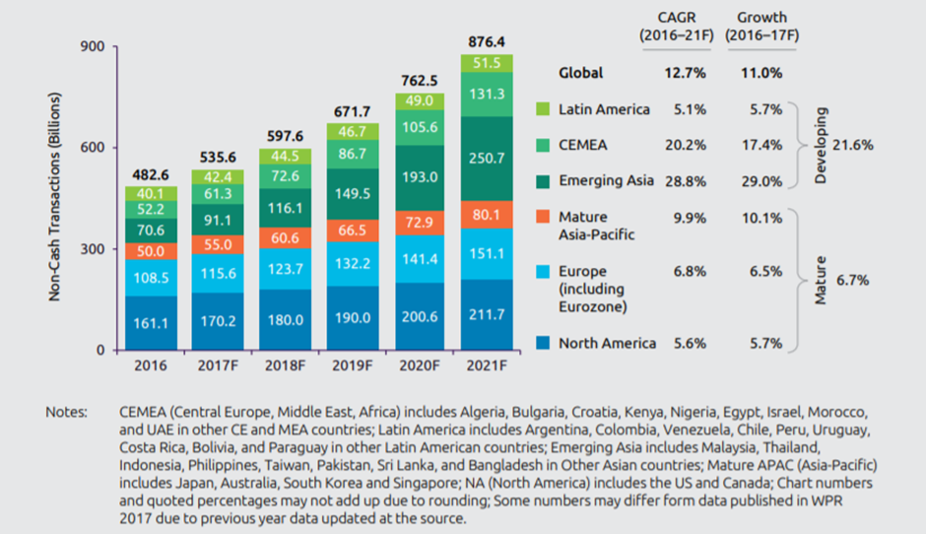Figure 1: Globally Non-Cash Transaction by Region (Capgemini & BNPParibas, 2018)

As results, greater part legitimate mobile organization, bank or non-bank was eager to get up to speed this brilliant possibility with propelled their very own portable installment stage. For instance, Alipay was the earliest mobile payment stage which dispatch at 2004 and become benchmark in industry (Forrester, 2016). Pursue by Apple, dispatch their own mobile stage – "Apple pay" at 2014 (Apple, 2014). Whereas, "Samsung Pay" dispatch at 2015 with higher security through Samsung KNOX versatile security stage (SAMSUNG, 2015). Recently, plenty of “mobile wallet” or “E-Wallet” are launched in Malaysia which can refer to Table 1. For example, bank like Maybank launch their e-wallet called “Maybank Pay” (Star, 2016).

This pattern lead m-commerce are encountering a blast and fame in around the world, presently it functions as real pattern reshaping the retail scene. Mobile payment developed as another payment style particularly in Emerging Asia like China which high selection portable payment and very believe on mobile payment platform (Shao & Zhang, 2018). As of now, mobile payment is beginning famous in numerous ASEAN nations like Malaysia, Singapore, Indonesia and Thailand. By and large, Asia locale is the quickest developing use of mobile payment because of high smartphone selection and business development in Asia district (Phneah, 2012). Surely, NFC mobile payment is play biggest part in mobile commerce due to it enable user to apply their smartphones as 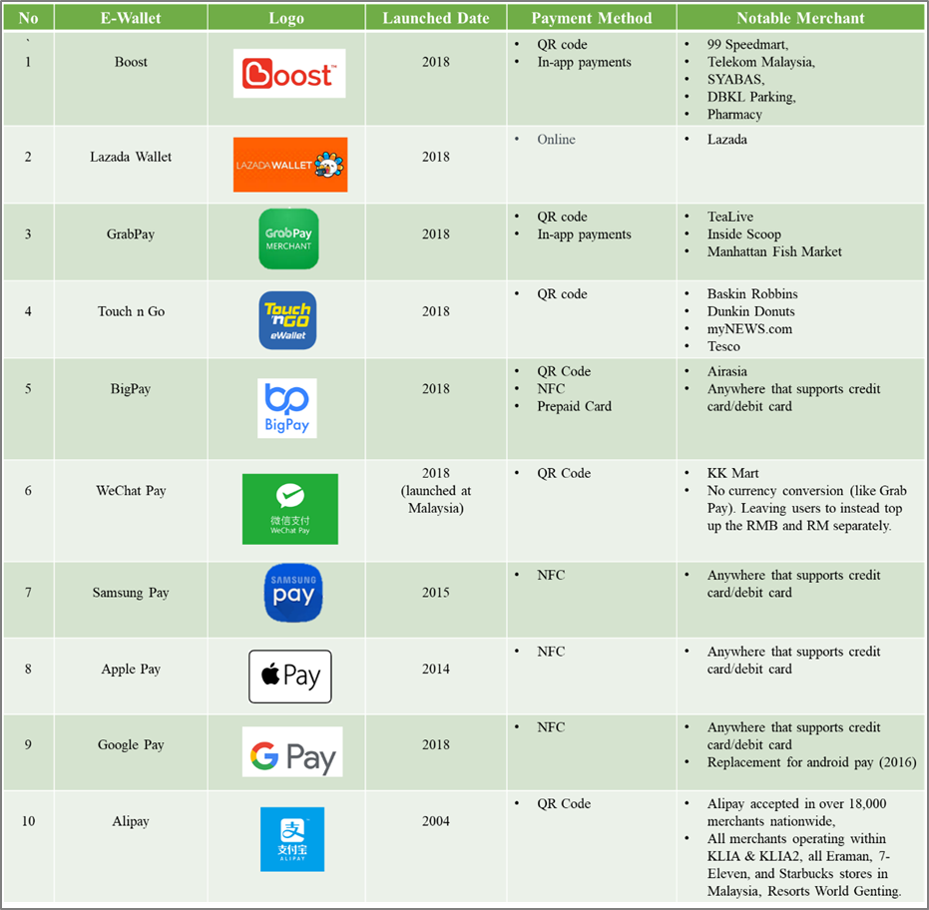e-wallets to do payment services without any complication steps (Pham & Ho, 2015).

Table 1: Comparison Top 10 Popular “E-wallets” in Malaysia (Gazi, 2018)

In this study, we will identify problem statement and develop research objective and question. In Chapter 2, there is two section was carried out. First, we will review the related literature and clarification of the technical concepts related to the mobile payment technology and narrow down to literature review NFC mobile payment. Follow by next section is review main theories of acceptance technological innovations and mobile payments, and a proposal of a model based on the theoretical review that attempts to explain by enunciating different hypotheses the process of acceptance of NFC technology. In chapter 3, research methodology will discuss which including the measurement instrument, the techniques to analyse the data and the sampling. Thus, Chapter 4 reported the results and discusses the ﬁndings, with theoretical implications to explain the relationships between the different factors that, from the user point of view, influence the acceptance of NFC payment. Lastly, Chapter 5 are discussing the conclusion and recommendation future lines of research.

## **Problem Statement**

In Malaysia, according to Bank Negara Malaysia highlighted non-money exchange are increment which the quantity of electronic payments exchanges made per capita to 56 exchanges in 2012 when contrasted with 14.3 in 2003, and that over 80% of retail payment exchanges are directed electronically (BNM, 2019a). Moreover, allude to Figure 2 demonstrated the smartphone infiltration in Malaysia as portion of the populace from 2017 to 2023 is pattern up and anticipated at year 2023, 61% of the populace in Malaysia utilized a smartphone compare at 2017 just have 49% populace utilizing smartphone (Statista, 2019a). This rate demonstrated smartphone entrance in Malaysia is high and well-situated to progress into a cashless society.

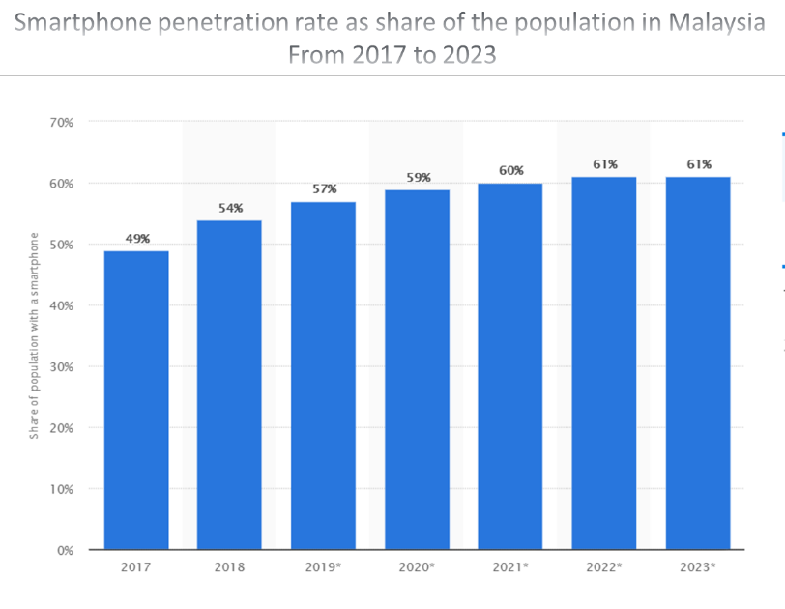

Figure 2: Smartphone penetration Rate in Malaysia Population from 2017 to 2023 (Statista, 2019a).

NFC enabled mobile payments to have been used in many ASEAN countries such as Singapore, Malaysia, Thailand, and Indonesia (Ruangkanjanases & Sirikulprasert, 2018). Unfortunately, still a significant number of Malaysian won't utilize this innovation. Despite the fact that, NFC mobile payment is generally accessible and advantageous to utilize, even measurement indicated noteworthy increment retail payment transactions by e-installment and increment populace on utilizing smartphones, yet the NFC NFC mobile payment systems still not broadly embraced by Malaysians (Balachandran & Tan, 2015). Alluding Star Online have featured 80% of exchanges in Malaysia are still in real money and just 20% cashless and it just 50% of that including e-wallets.(Yuen, 2019). Malaysia government even rules out policy to support mobile payment system especially NFC mobile payment. For example, government launched which looks to cultivate an effective, focused and creative payments scene in Malaysia (BNM, 2018). Therefore, there is an urgency helps industry faster to identify factor that affect Malaysian acceptance level on NFC mobile payment services. Because it helps Malaysian quickly adapt NFC mobile payment and bring up country economic.

Secondly, adoption of NFC mobile payment services will help country reduce crime case as the whole transaction system is cashless. For example, robbery case will reduce if Malaysia is cashless society as there is no cash on hand and security step needed in order to get the money. According to the Numbeo, Malaysia crime index is ranked 20th in global which can refer to Figure 3 (Numbeo, 2019a). When narrowed down to the SEA region, Malaysia is number 1 on the list which can refer to Figure 4 (Numbeo, 2019b). This number shown they is an urgency to increase Malaysian adoption in NFC mobile payment services to reduce the crime case like robbery, bribery and money laundering. In conclusion, with adoption of NFC mobile payment services can help increase Malaysia society Safety Index. End up, local citizen and traveller are felt more secure and more travelling activity occur indirectly in help Malaysia economy too. Again, there is an urgency to identify factor that affect Malaysian acceptance level on NFC mobile payment services. Because adoption of NFC mobile payment will help country reduce crime case as the whole transaction system is cashless and recording. Therefore, quickly identify factor can assists Malaysian faster accept NFC mobile payment and increase government awareness to bring back country safety & security.

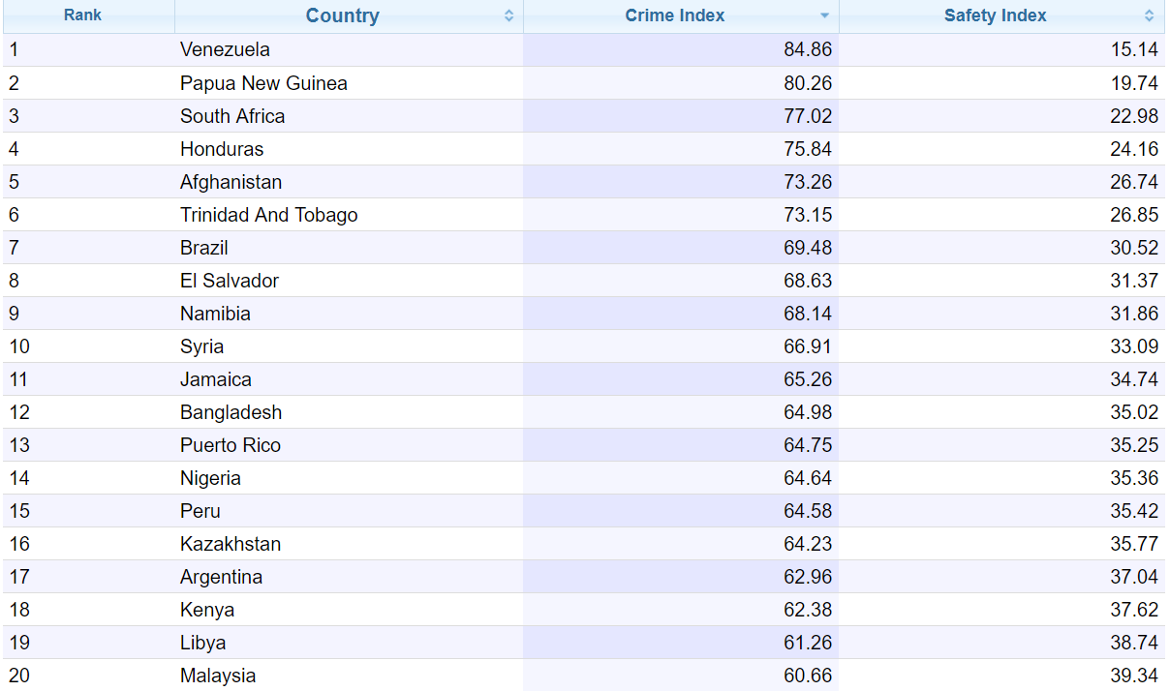Figure 3: Crime Index in Global Ranking (Numbeo, 2019a)

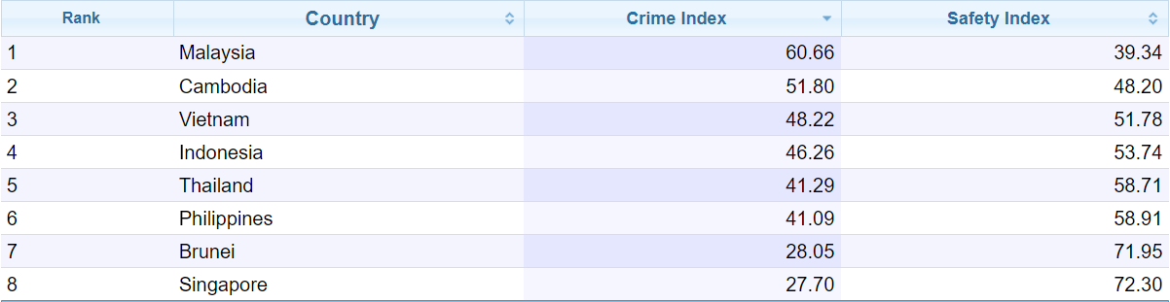Figure 4: Crime Index in South East Asia (Numbeo, 2019b)

Thirdly, larger part writing survey is done on China, Korea, Thailand, Europe, US nations and the majority of them is examine how to receive the mobile payment, however less examination paper bring Malaysia into research region and investigate the level of acceptance NFC mobile payment services. End up, there is a research gap at here. As results, the motivation behind this examination is to researches the degree of acknowledgment on NFC mobile payment in Ipoh, Malaysia, to identify and explore key factors that affect the decision.

## **Research Objectives**

### **General Research Objectives**

To identify factors that influence the consumers' acceptance on NFC mobile payment services in Ipoh, Malaysia which able help consumer faster adopt the NFC mobile payment services to improve country economic as it brings great impact to Malaysia economic.

* + 1. **Specific Research Objectives**

1. The determine the relationship between “**Performance Expectancy**” and consumers' acceptance on NFC mobile payment services in Ipoh, Malaysia.
2. The determine the relationship between “**Social Influence**” and consumers' acceptance on NFC mobile payment services in Ipoh, Malaysia
3. The determine the relationship between “**Effort Expectance**” and consumers' acceptance on NFC mobile payment services in Ipoh, Malaysia.
4. The determine the relationship between “**Facilitating Condition**” and consumers' acceptance on NFC mobile payment services in Ipoh, Malaysia
5. The determine the relationship between “**Perceived Security**” and consumers' acceptance on NFC mobile payment services in Ipoh, Malaysia.

## **Research Question**

### **1.4.1 General Question**

Research questions is to identify the factor influence level of acceptance on NFC mobile payment services in Malaysia.

### **1.4.2 Specific Research Question**

1. Is there a significant relationship between “**Performance Expectancy**” and consumers' acceptance on NFC mobile payment services in Malaysia?
2. Is there a significant relationship between “**Social Influence**” and consumers' acceptance on NFC mobile payment services in Malaysia?
3. Is there a significant relationship between **“Effort Expectance**” and consumers' acceptance on NFC mobile payment services in Malaysia?
4. Is there a significant relationship between “**Facilitating Condition**” and consumers' acceptance on NFC mobile payment services in Malaysia?
5. Is there a significant relationship between “**Perceived Security**” and consumers' acceptance on NFC mobile payment services in Malaysia?

## **Significance of The Study**

Significance of the study is to enables industry to discover factor influence acceptance level and to encourage more user to adopt NFC mobile payment as results, it enables industry to create more income and improve nation financial. In scholastic, this investigation is one of the main determinants level of acknowledgment on NFC mobile payment in Malaysia point of view. In this manner, it can help further look into by contrast changed district with comprehend sway on social contrasts in the acknowledgment of the NFC payment system. This investigation likewise can help government division more productivity to build up an imaginative arrangement fathom Malaysian low appropriation rate utilizing mobile payment.

## **1.6 Scope of the Study**

Scope of the study are focus level of acceptance on NFC mobile payment service and geographic focus was in Ipoh, Perak. The sample for this study is target Ipoh, Perak population who have smartphone and debit or credit card. The key theories apply in this study is UTAUT (Unified Theory of Acceptance and Use of Technology) and research methodology approach is quantitative. The independent variable is the factor that affected the level of acceptance NFC mobile payment. Meanwhile, sampling procedure and size are use Cohen Theory which used the statistical power and effect size to help calculate the sample size (Cohen, 1988). Refer to the Cohen’s table (1988) the significant level: 5% and R2: 0.25, and this study have 5 independent variables and total sample size needed is 70 respondents in Ipoh, Malaysia. Sampling method used is convenience sampling (also called referral sampling) which using researcher social networks, participants were asked to forward the invitation to others of their network. Data collection approach are self-administered questionnaire via online distribute (Google Form) and link was available online between 25/7/19 till 6/8/19. Total 23 questions design to measure all variables. Measurement is referring to a 5-point Likert Scale of responses with 1 corresponding to “strongly agree” and 5 to “strongly disagree” (Joshi, et al., 2015). Data analysis is applying SPSS 26 to analyse.

## **1.7 Ethical Consideration**

To anticipate information distorting in quantitative research, some moral thought taken to forestall this manufacture like information preparing which need run a few stages before the information being dissect. First, information checking to guarantee all question is answer totally, pursue by information altering which guarantee information precision, information coding is one of the procedures which to ensure surveys capable examined by SPSS to get the understandings. Ultimately, is information cleaning to guarantee information does not have outrageous worth or conflicting. Therefore, educate member nature regarding the examination and they are through and through freedom to take an interest on this exploration as no power been present.

# **CHAPTER 2 LITERATURE REVIEW**

## **2.1 Overview Mobile Commerce – As New Payment Method**

Mobile commerce also called M-commerce and may deﬁned as a complete transaction done through mobile device with network connection (Liébana-Cabanillas, et al., 2018). Strong availability of 3G, 4G and coming soon 5G mobile communication systems enable users utilize it to do their transaction faster, convenience and more flexibility via smartphone. According to the Smart Insight highlighted adults age 18 to 34-year-old have spent more time on their mobile phones than personal computers and can refer to Figure 5 which showing mobile monopolize and Malaysia population also spent 2x times more in mobile compare with desktop (Chaffey, 2018).

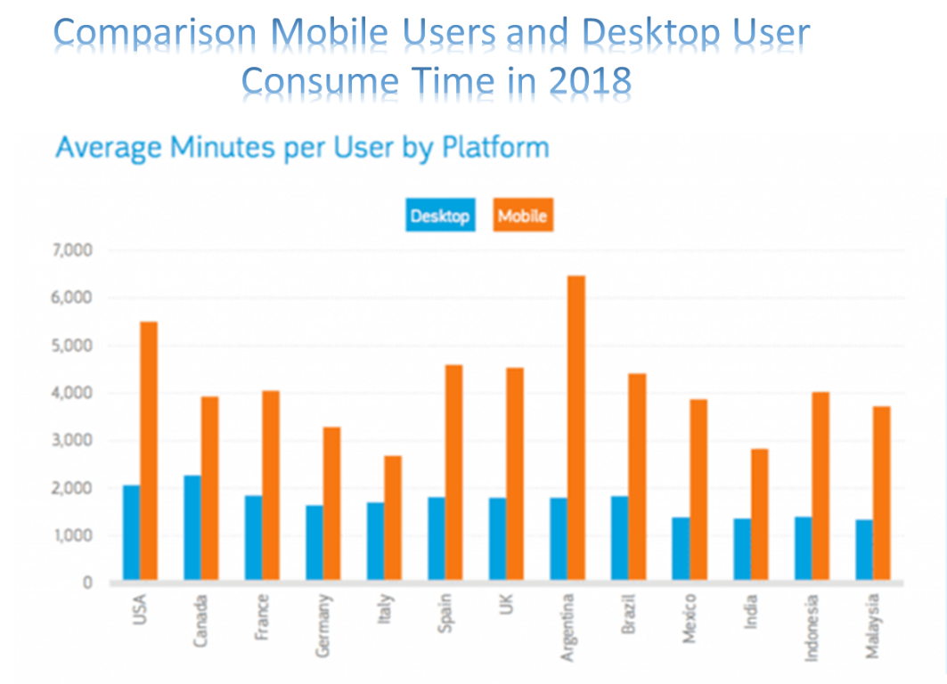

Figure 5: Comparison Mobile Users and Desktop User Consume Time in 2018 (Chaffey, 2018)

Furthermore, referring WARC latest Global Advertisement Trends report, worldwide mobile advertisement expenditure will overstep TV in 2019, if current growth rates are maintained and the 5G speedy networks launch which can refer to Figure 6. Under this report highlighted $138 billion advertisement spent to reach mobile users in 2018. and amount will increase to $153.2 billion in 2019 and surpass TV (WARC, 2019). Next, 5G launching soon in year 2019 the giants like China Mobile, verizon, and EE funnelling invest into 5G and expected 18% of the global population (1.5 billion population) will subscribe 5G by 2024 (Stewart, 2019). As results, all this data solid proven mobile commerce develops rapidly and in expansion phase, now it’s become major trend reshaping the retail landscape and certainly NFC mobile payment is play biggest part which enable user to apply their smartphones as e-wallets (Pham & Ho, 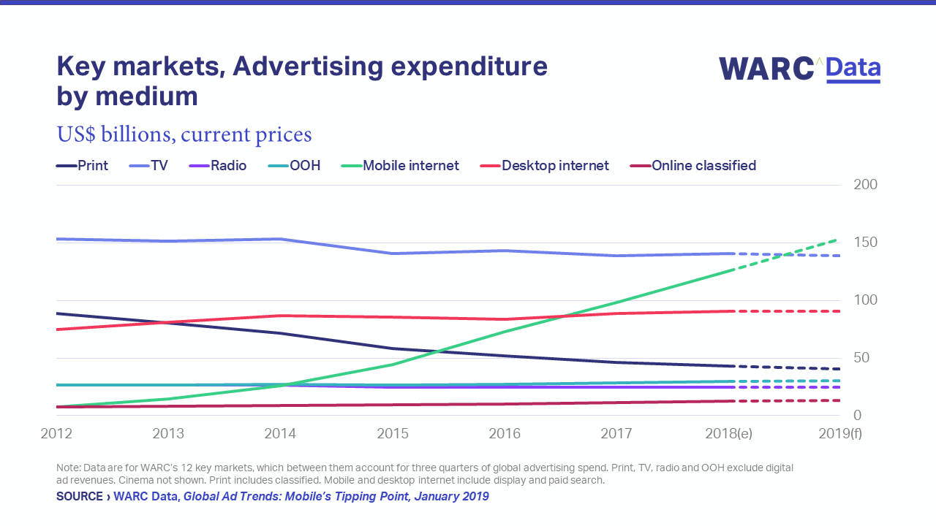2015). To sum up, a new payment method was begun.

Figure 6: Worldwide Advertisement Expenditure by Medium in 2019 (WARC, 2019)

Successful of mobile commerce are mainly due to frequently mobile advance technology developing and it is an extension of e-commerce which only difference at transactions are conducted over contactless technologies by using mobile devices (Bhullar & Gill, 2018). After review the literatures and come in conclusion mobile commerce not only monetary transactions but have its own features like more personalization, uniqueness, flexibility, convenience compare to e-commerce (Cao, et al., 2015).

## **2.2 Types of Mobile Payment**

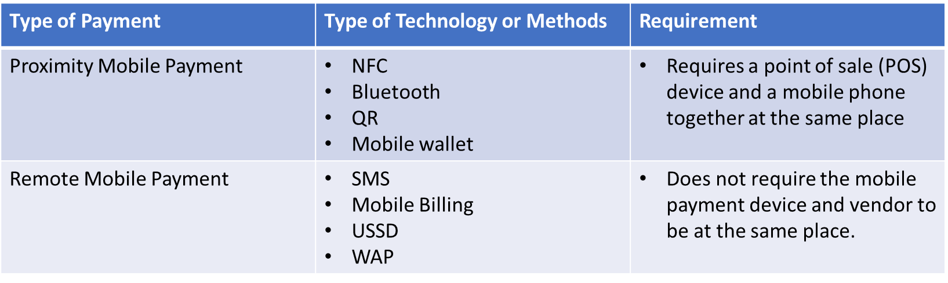Mobile payment types are categorized in 2 group which is proximity mobile payments and remote mobile payments and can refer to Table 2.

Table 2: Type of Mobile Payment (Sorensen, 2018).

Below will further details mobile payment method that commonly used in commercial.

### **2.2.1 Proximity Mobile Payment**

#### **2.2.1.1 Near-Field Communication (NFC) Payments**

NFC is one of the proximity mobile payments known as mobile contactless payment which require payment done together at the point of sale (POS). After installed the payment application and fill up personal payment account info like debit or credit card, mobile device is ready to do payment services (Muna, et al., 2017). Users just need put the smartphone within a few inches of the terminal and payment will make. The process is faster, convenience and interesting compare to chip and PIN technology which need longer time to process the transaction (Sorensen, 2018). This mobile payment method will be focus discussed at below section which can refer to Chapter 2.3: An Overview Near Field Communication (NFC) Technology.

#### **2.2.1.2 Mobile Wallets**

Mobile wallets are under proximity mobile payments group which is an application that store bank account, debit card or credit card information of user. User can pay via the application in smartphone without physical credit card. For certain cases it need authorization through either thumbprint or enter PIN number. Advantage of mobile wallet is convenience, modern, lower costs and competitive advantage (ICEMD, 2016). Mobile wallet transaction always via NFC. Lately, there is few mobile wallets like Samsung pay, Apple Pay and Google Pay are popular used by globally (Sorensen, 2018).

#### **2.2.1.3** **Quick Response (QR) Code Payments**

QR Codes also under proximity mobile payments group which is the square bar codes were designed to contain the useful info inside the bar code. Basically, QR codes divided into 2 categories which can refer to Table 3. The process will slower as take few steps to open the apps compare to NFC and mobile wallet, therefore some people feel there is a barrier.

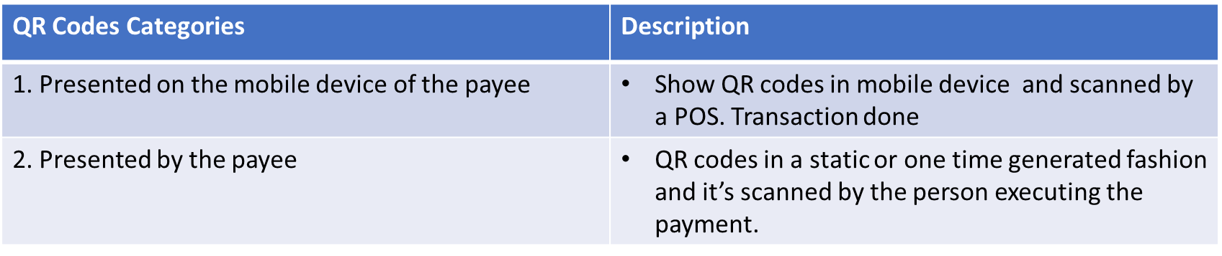

Table 3: QR Codes Categories (ICEMD, 2016)

### **2.2.2 Remote Mobile Payment**

#### **2.2.2.1 Short message service (SMS) payments**

SMS payment method is most traditional and commonly used remote mobile payment method. User’s will send a text message via mobile phone to make transaction. Payment charges will be reflected to user’s phone bill (Sorensen, 2018).

#### **2.2.2.2 Mobile Web Payments (WAP)**

Wireless Application Protocol (WAP) is mobile web payment and under remote payment groups. WAP enable user’s log on website in smartphone and follow the step to complete the transaction (Larkotey, et al., 2013).

#### **2.2.2.3 Direct Mobile Billing**

Direct mobile billing is under remote payment group which user will select this option when checkout to make a payment at an e-commerce website. There involve two authorization which is One-Time-Password and PIN. When finished all step user will charge the amount. Advantage is more security, convenience (ICEMD, 2016).

## **2.3 Advantages NFC Compare with QR Codes in Mobile Payment**

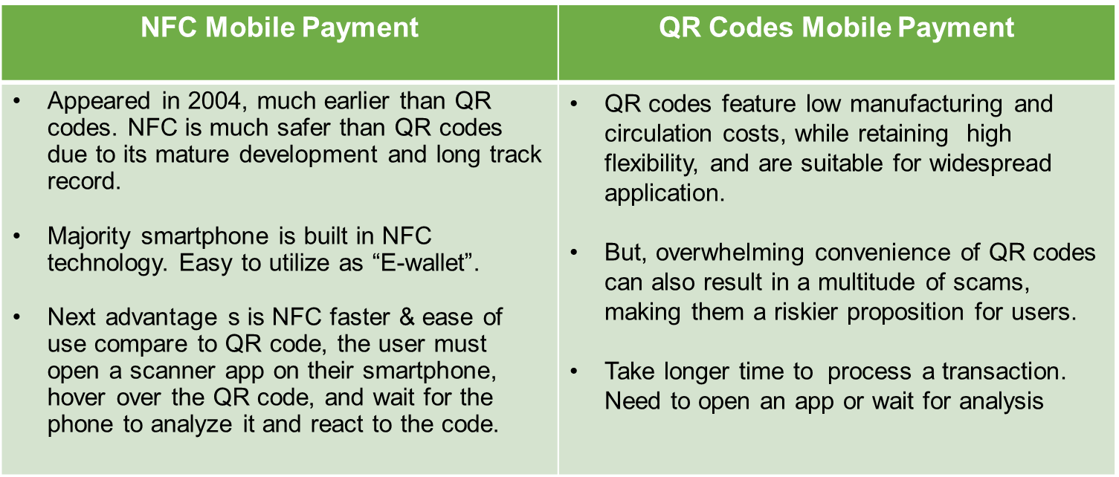Refer to the NFC Forum reported latest NFC Money Transfer Candidate Specification (NMT) enable NFC mobile payment become a more secure and simple way to use which now works as an alternative to QR code-based mobile payment. NMT uses the intrinsic benefits of NFC technology which is speed, convenience, usability and security (NFC, 2019). End up, user have great mobile payment experience than QR codes mobile payment. The comparison NFC mobile payment with QR codes mobile payment can further refer to the Table 4.

Table 4: Comparison NFC Mobile Payment Vs QR Codes Mobile Payment

## 

## **2.4 An Overview Near Field Communication (NFC) Technology**

Lately, Near Field Communication (NFC) is getting popular and have been introduced to the world under the project name “Mobile Wallet” (Ruangkanjanases & Sirikulprasert, 2018). NFC technology is a close distance (4-10 cm) wireless technologies which allow contactless data transmission with its magnetic field and require both devices must have NFC (Lerner, 2013). The core advantage of NFC is work faster than others current technologies which communication link is not needed prior establish (Tarang & Tamalika, 2017). The whole process for NFC transfer data is typically takes less than half a second (Intel, 2013). Basically, NFC-enabled devices operate in three modes which is reader or writer mode, peer to peer mode and card emulation modes (Coskun, et al., 2015). This can refer to Figure 7 for further understanding.

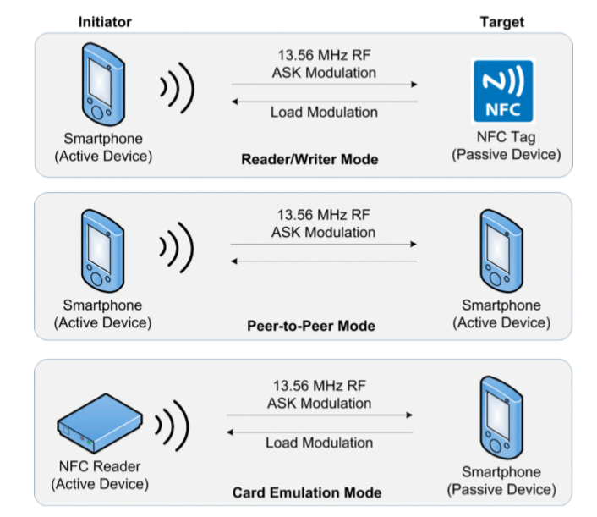

Figure 7: NFC Three Operate Modes (Coskun, et al., 2015)

NFC technology not only apply to mobile payment but also can use in numerous areas such as healthcare industry, home appliance, home security systems due to NFC allows both one way and two-way communication. Speedy advance NFC technology, allow smartphone do more than a wallet but it also can used to store membership cards, voucher, building secure access or instruction printing (Guillaume, 2014) which can refer to Figure 8.

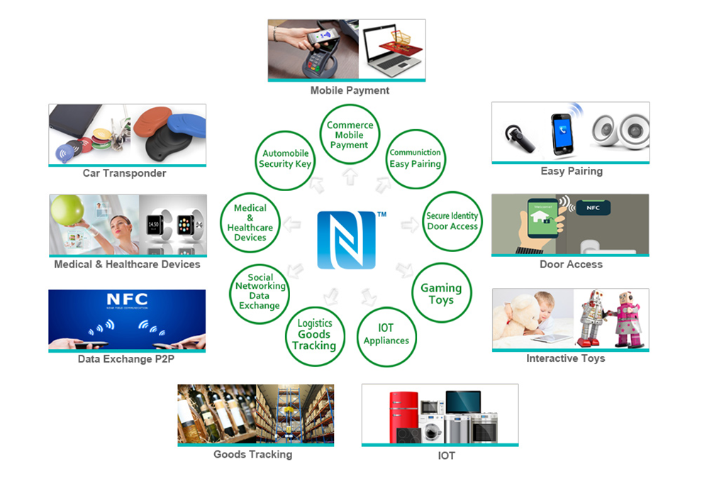Figure 8: Utilization of NFC in Applications

### **2.4.1 NFC Enabled Mobile Payment- Work as “Mobile Wallet”**

NFC is well recognized it will be leading in cashless payments at next frontier. Therefore, NFC is always link to "mobile wallet" or “E-wallet” terminology. NFC Enabled Mobile Payment process is very simple which just needed basic bank info like debit or credit card info and incorporate with mobile device. After that, users can utilize their smartphone as “mobile wallet” to pay restaurant bills, supermarket bills or transport's tickets (Wong & Anand, 2013). Recently, majority mobile operating systems have their own application for NFC enabled mobile payments. For example, Apple first launch their “Apple Pay” at IOS 6 at year 2014 (Apple, 2014), Samsung launched their “Samsung Pay” at 2015 which emphasis on higher security through Samsung KNOX mobile security platform (SAMSUNG, 2015). Lately, Google announced launch “Google Pay” to replace its Android Pay and Google Wallet services (Maring, 2018). In Malaysia, not only operating system has their own mobile payment platform, bank like Maybank lately launch their e-wallet and named as “Maybank Pay” (Star, 2016).

In order, to encourage more people usages of NFC enables mobile payment, all this giant company are incorporate with financial institutes. Furthermore, those countries highly usage with NFC enable mobile payment are integrated both public sector and government together like U.S. and China to increase NFC mobile payment adoption. Therefore, understanding consumer acceptance level of NFC mobile payment is urgency and important.

## **2.5 Theoretical Background**

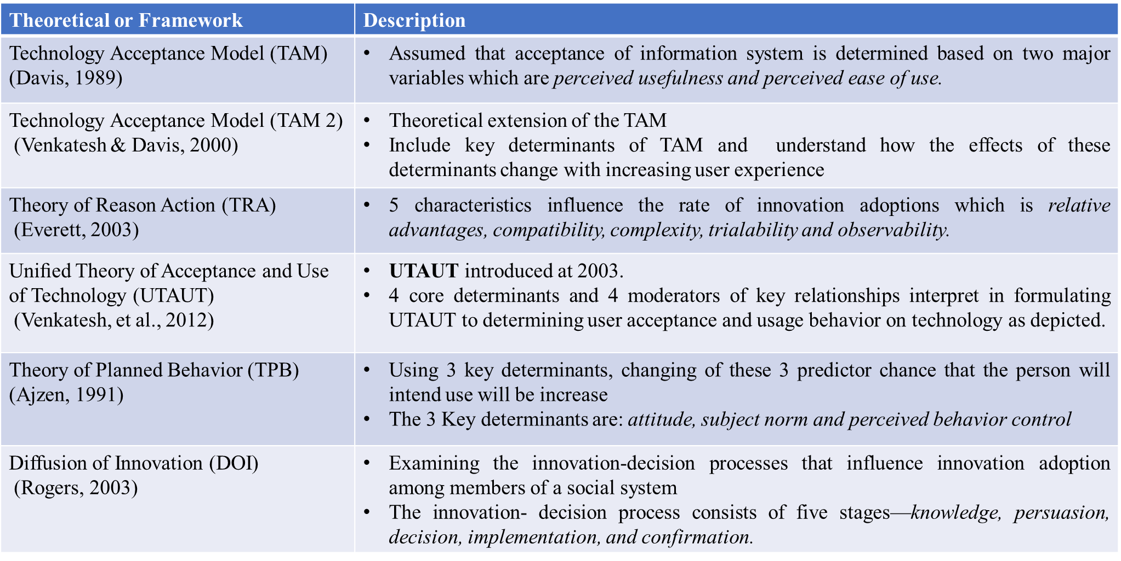There are numerous theorical can find the factors that affect the acceptance level on new technology. After literature review can be concluded that there is few theorical or framework are broadly undertaken in research area such as Technology Acceptance Model (TAM), Theory of Reason Action (TRA), Uniﬁed Theory of Acceptance and Use of Technology (UTAUT), Theory of Planned Behaviour (TPB) and Diffusion of Innovation (DOI) and details can refer to Table 5.

Table 5: Key Theories Commonly Used in Technology Acceptance Research Area (Davis, 1989; Ajzen, 1991; Venkatesh & Davis, 2000; Everett, 2003; Rogers, 2003; Venkatesh, et al., 2012).

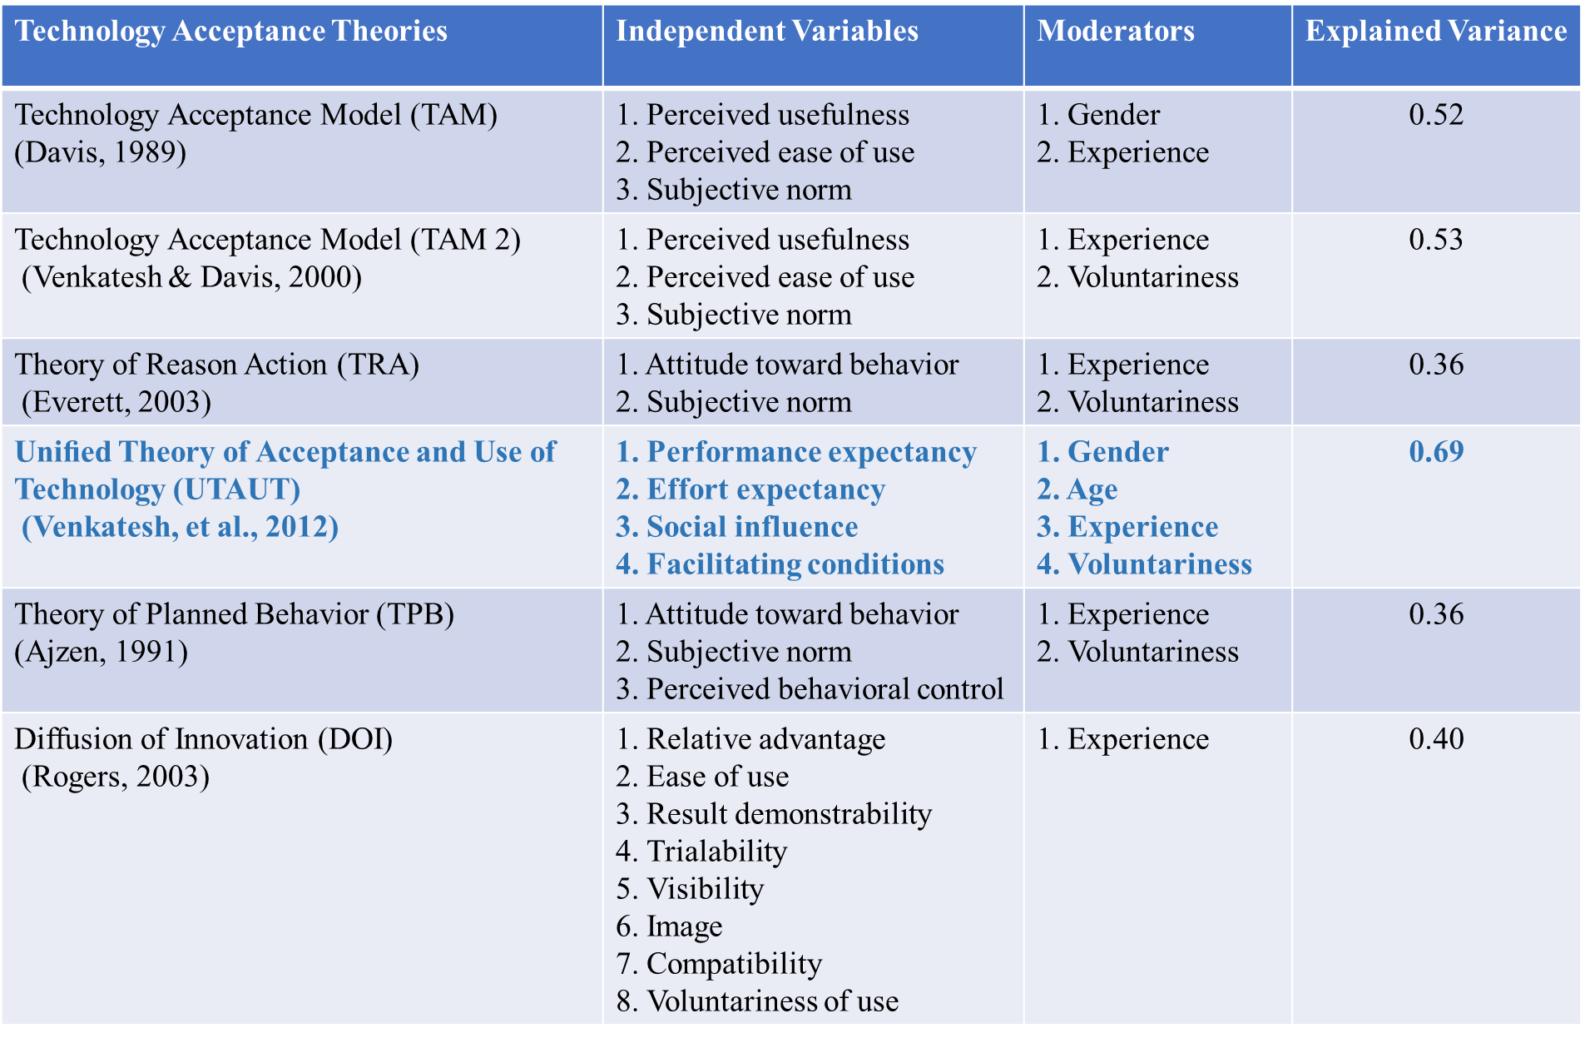A comparison was done for all these theories to have clearer mapping in order to find out which theories are best fit for this study to investigate the level of acceptance in NFC mobile payment. Details on the comparison technology acceptance theories can further refer to Table 6.

Table 6: Comparison Technology Acceptance Key Theories Commonly Used in Research Area (Davis, 1989; Ajzen, 1991; Venkatesh & Davis, 2000; Everett, 2003; Rogers, 2003; Venkatesh, et al., 2012; Samaradiwakara & Gunawardena, 2014)

According to Rosenthal & Rosenthal research highlighted the explained variance higher signifies a stronger strength of relation. In other words, it works as guideline for researcher to make better predictions (Rosenthal & Rosenthal, 2011). As results, Uniﬁed Theory of Acceptance and Use of Technology (UTAUT) are selected as key theoretical frameworks for this study. Below section will further review literature UTAUT model.

### **2.5.1 Unified Theory of Acceptance and Use of Technology (UTAUT)**

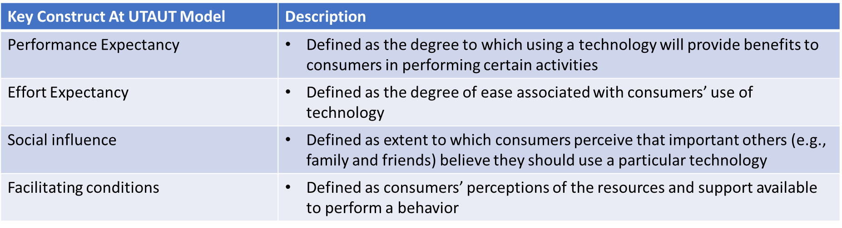UTAUT model introduce at year 2003 with objective to give better perspective on acceptance technology model compare to others traditional technology acceptance models (Venkatesh, 2003). Basically, UTAUT has 4 key constructs which is social influence (SI), effort expectancy (EE), performance expectancy (PE) and facilitating conditions (FC). These 4 key constructs influence user’s behavioural intention on adopt new technology. Details of each key constructs can refer to Table 7.

Table 7: Explanation UTAUT 4 key constructs (Venkatesh, 2003)

Referring to UTAUT key construct like PE, EE and SI are more to influence behavioural intention. Meanwhile, behavioural intention and facilitating conditions are direct decide use of technology which can refer Figure 9 for further understand. Beside this, the variables like gender, age and experience, voluntariness are more to individual differences variable also interpret in UTAUT to moderate the relationship. Therefore, this become advantage of UTAUT model which able create eight key variable and interpret in one model.

In 2012, a theoretical extension of the UTAUT is introduce and named as UTAUT 2 which this model is more appropriate to study the acceptance in technology. UTAUT 2 enhanced with 3 constructs which is price value, hedonic motivation and habit but have remove the voluntariness with aim tailor it to the customer technology use settings (Venkatesh, et al., 2012). Refer to Figure 10 for UTAUT 2 model.

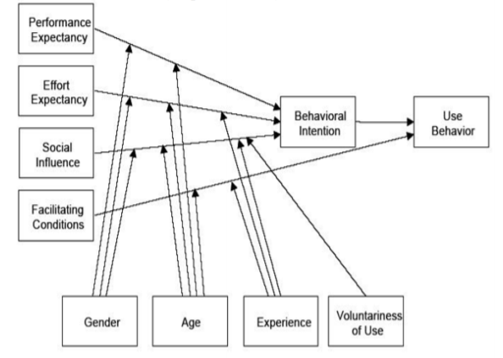

Figure 9: Unified Theory of Acceptance and Use of Technology (UTAUT) Model (Venkatesh, 2003)

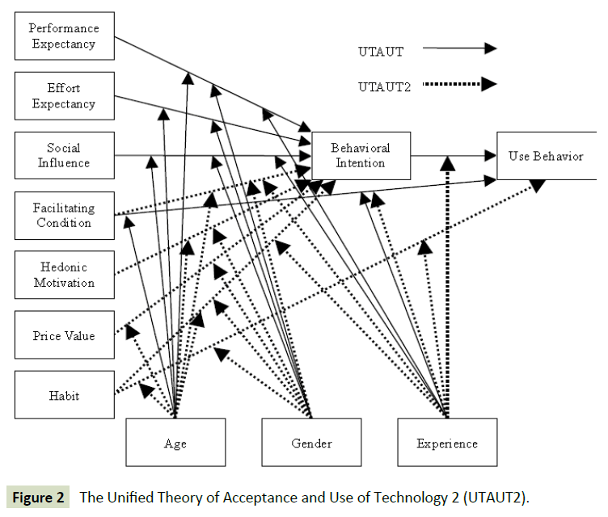

Figure 10: Unified Theory of Acceptance and Use of Technology (UTAUT 2) Model (Venkatesh, et al., 2012)

## **2.6 Literature Gap**

Base on the literature review, UTAUT model is more concentrate customer use setting and match with this study objective which is to investigate the factors that affect user’s level of acceptance on NFC mobile payment. However, this is still not enough to identify the factor affected level of acceptance NFC mobile payment cause perceived security or risk as a lot of literature review had stated this might be one of the factions that influence people to use mobile payment. Therefore, a research gap at here.

Next, majority literature review is done on China, Korea, Thailand, Europe, US countries and most of them is investigate how to adopt the mobile payment, but less study paper take Malaysia into research area and investigate the level of acceptance NFC mobile payment services. Especially Ipoh, Perak Malaysia. End up, there is a research gap at here too. As results, this study will try to fulfil to research gap which is to investigates the level of acceptance on NFC mobile payment services in Ipoh, Malaysia, to identify and explore key factors that affect the decision.

## **2.7 Conceptual Framework**

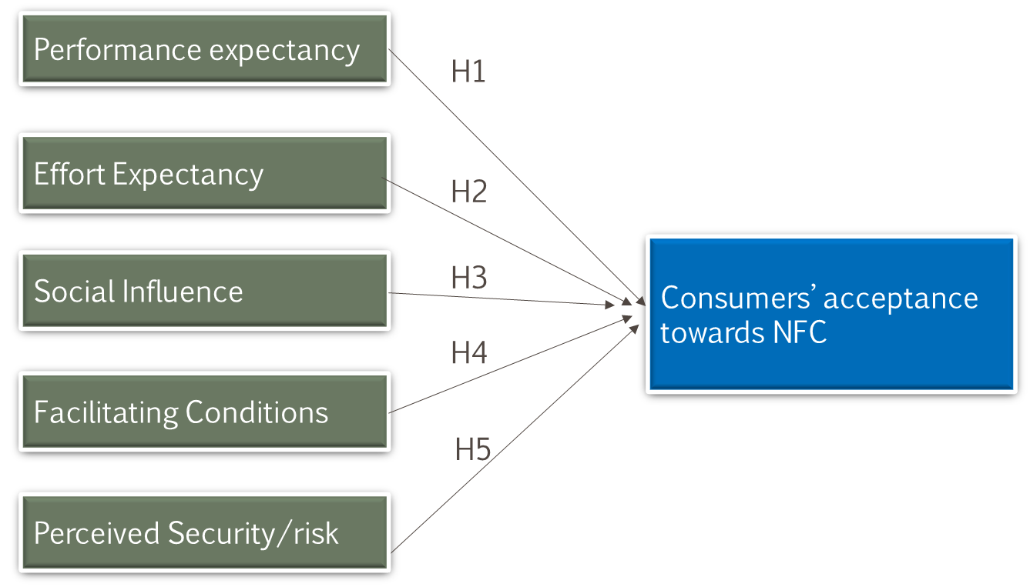

Figure 11: Proposed Research Framework

## **2.8 Hypotheses Development**

Hypotheses development is based on UTAUT model with modify by add on one more independent variable (IV). The null hypotheses in this study which is the opposite of the alternate hypothesis are showing below:

***H0: No factors influence user’s level of acceptance on NFC mobile Payment Services in Ipoh, Malaysia.***

Whereas, the alternative hypothesis will further discuss at part below: -

### **2.8.1** **Performance Expectancy (PE)**

The construct of EE in UTAUT was come from perceived usefulness, both are measure alike psychological concepts (Chang & Xue, 2017). The purpose of PE is to measure an individual trust that using the technology system will help them perform better in works (Venkatesh, et al., 2012). Therefore, we proposed that:

***H1: Performance expectancy positively influence user’s level of acceptance on NFC mobile payment in Ipoh, Malaysia.***

### **2.8.2** **Effort Expectancy** **(EE)**

The construct of EE in UTAUT is similar to users’ perceived ease-of-use at TAM which both mention that this constructs will influence user’s attitude to use or accept the technology (Chang & Xue, 2017). In literature review can find EE is one of the most significant predictors at user level of acceptance on technology. The purpose of EE is to measure the degree of ease relation with user’ level of acceptance on technology system (Venkatesh, et al., 2012). Therefore, we proposed that:

***H2: Effort expectancy positively influence user’s level of acceptance on NFC mobile payment in Ipoh, Malaysia.***

### **2.8.3** **Social influence (SI)**

UTAUT highlighted there is significant show SI have directly affected user’s level of acceptance in technology adoption (Chang & Xue, 2017). This mean, individual prefer to get advice from their social network and may influence by social pressure like perceive that important to others. Therefore, we believe SI like family members, close friends’ opinion has influence user’s level of acceptance and we proposed that:

***H3: Social influence positively influence user’s level of acceptance on NFC mobile payment in Ipoh, Malaysia.***

### **2.8.4** **Facilitating Condition (FC)**

The construct of FC in UTAUT is to measure users’ resources perceptions and the available support to perform a behaviour. In others word is to measure how users control their own behaviour. This is like the TPB constructs “perceived behavioural control” (Ajzen, 1991). But in UTAUT model, FC is direct associate to intention to use and this relationship is proven in a research (Lai, 2015). FC in UTAUT highlighted is vital for the acceptance of technology (Venkatesh, et al., 2012). Therefore, we proposed that:

***H4: Facilitating Condition positively influence user’s level of acceptance on NFC mobile payment in Ipoh, Malaysia.***

### **2.8.5 Perceived Security (PS)**

Perception of security are major concerns in the field of electronic payment systems. It always is a major inhibitor of the implementation of new payment systems. As results, there is important to consider PS in accepting new payment systems and Its direct affected consumer’s acceptance (Liébana-Cabanillas, et al., 2017). Therefore, we propose that:

***H5: Perceived Security positively influence user’s level of acceptance on NFC mobile payment in Ipoh, Malaysia.***

# **CHAPTER 3 RESEARCH METHODOLOGY**

## **3.1 Research Methodology Overview**

After hypotheses development and proposed research framework. This chapter will further discuss on research design, measuring instrument, data processing, sampling design and data collection in detail. Furthermore, study of target population, unit of analysis, data collection process, reliability and validity test will be included and discussed, to ensure the completeness of the whole research findings.

## **3.2 Research Design**

In research design approach it has many types such as qualitative, quantitative approach or multiple method. In this study, quantitative approach was use and the variables is the factor that affected the level of acceptance NFC mobile payment services in Malaysia. Select quantitative approach is due to quantitative research design is best way to finalize the results and able to test the significance of the hypotheses that being developed. Furthermore, this structure is standard across the fields (Shuttleworth, 2008).

Quantitative research design mainly is combining data and using statistical tools analyse, interpret and discussion the variables that being researched. Under quantitative approach that has 4 types research design which is correlational, descriptive, experimental and quasi-experimental (Almalki, 2016). The dissimilarities are associate with the degree of study designs to control the variables which can refer to Table 8. Descriptive are selected in this study as its only describe the lately variable status and data collection are regularly in observation (CIRT, 2019). Descriptive approach allows researchers to obtain target group behaviour towards use of questionnaires (Sekaran & Bougie, 2010). This study also used correlation design to establish the relationship between PE, EE, SI, FC and PS in level of acceptance on NFC mobile payment in Ipoh, Malaysia. Correlation design approach will be used to determine the association as well as its strength

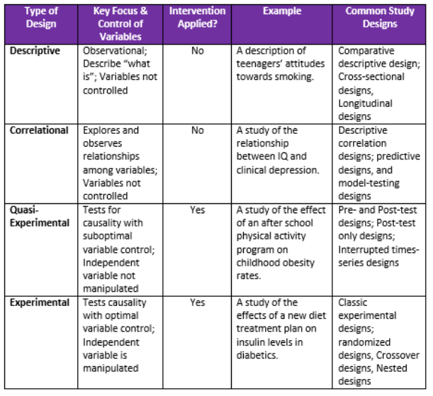

Table 8: Comparison 4 Types of Quantitative Research Design (CIRT, 2019)

## **3.3 Unit Analysis**

Unit of analysis indicate target population in study during data collection. Research design is suggested to include a focus unit of analysis as this determine the target population of the research (Sekaran & Bougie, 2010). The unit of analysis is at individual level to identify factors that affect acceptance on NFC mobile payment in Ipoh, Malaysia. Therefore, target population are Ipoh, Malaysian with a smart phone, possesses a debit or credit card, age above 18 years old. The data will be collected as individual base via online questionnaire distributed.

## **3.4 Sampling Design**

Sampling design is a mathematical function that helps researcher derive the probability functions and how to design a best-fit sampling method for actual case. Sampling is selected a small number of samples from the target population to represent the total population (Sekaran & Bougie, 2010). As results, it helps researchers’ accurate collect sample (Greener & Martelli, 2015). In this research study, the targeted population will be the Malaysian at Ipoh with aged above 18 years old who have smartphone and debit or credit card.

### **3.4.1 Sampling Plan**

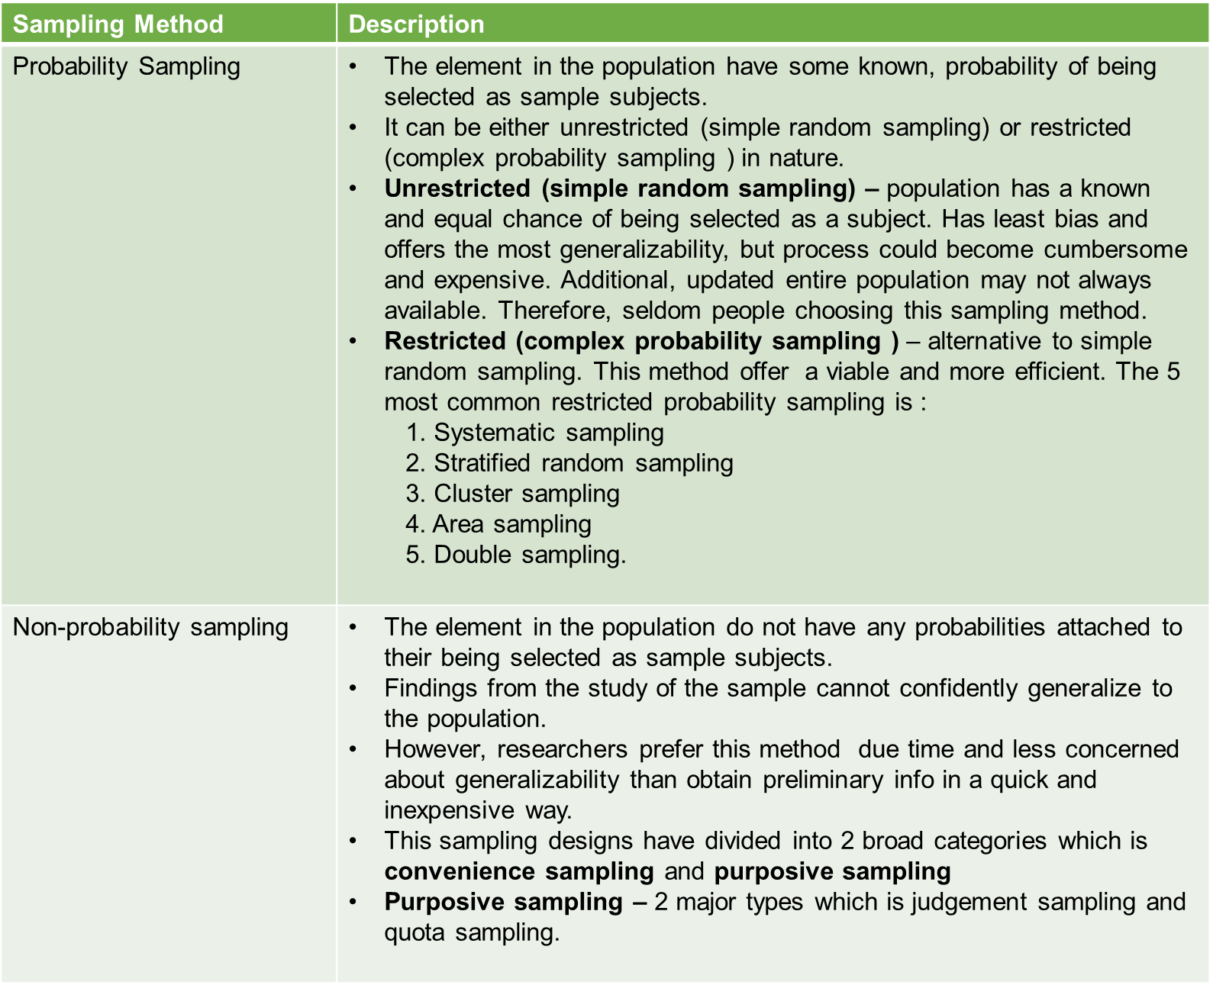There are two major types of sampling design which are probability sampling method and non-probability sampling method (Sekaran & Bougie, 2013). Details can refer to Table 9.

Table 9: Probability and Nonprobability Sampling Design (Sekaran & Bougie, 2013)

Referring to Sekaran and Bougie (2013), have suggest the checkpoint to choose suitable sampling method for the research which can refer to Figure 12 for details. Base on the checkpoint, this study was used a non-probability convenient sampling to do data collection. A self-administered questionnaire via online distribute to collect data where using researcher social networks, participants were asked to forward the invitation to others of their network

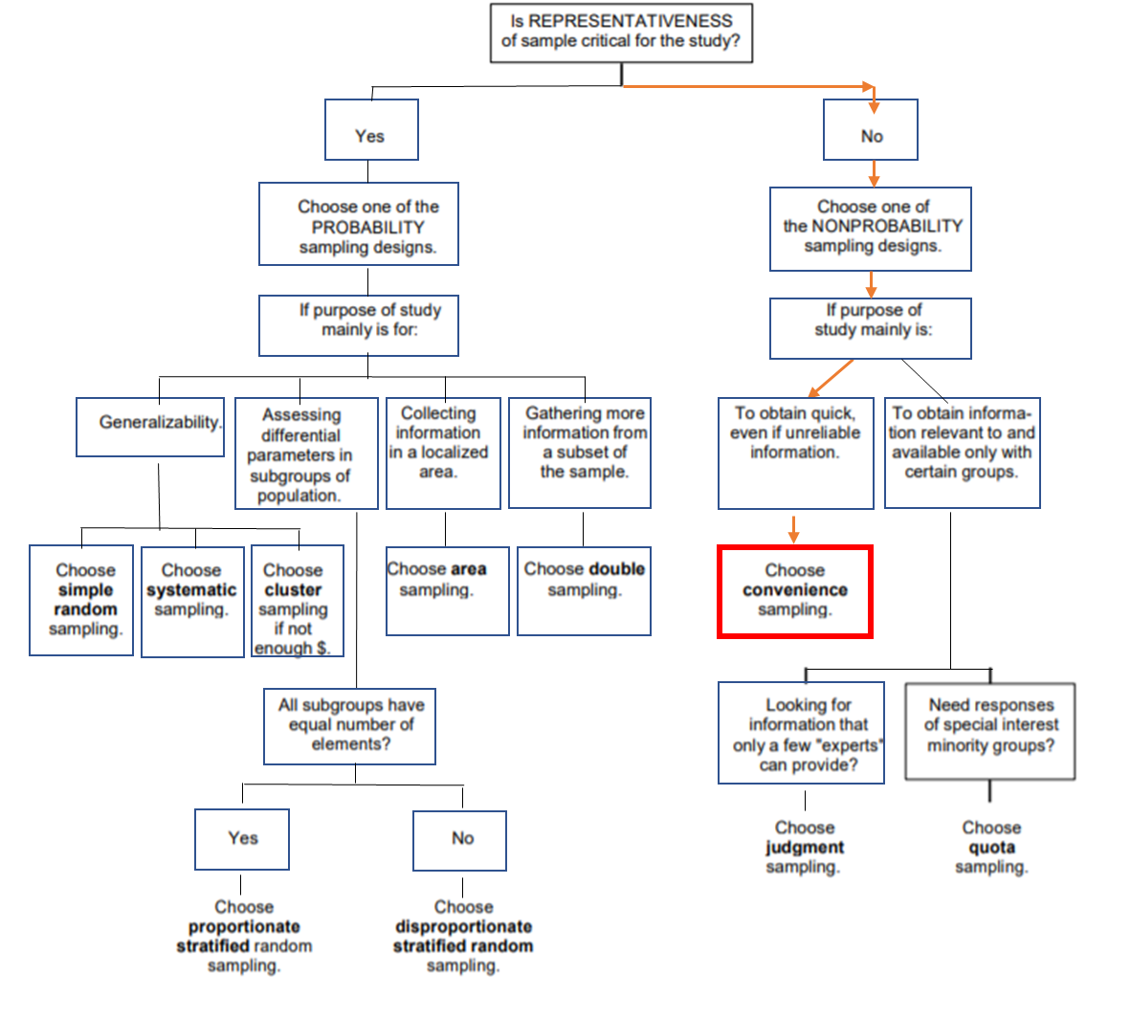

Figure 12: Checkpoint to Selected Sampling Method for This Study (Sekaran & Bougie, 2013)

### **3.4.2 Sampling Size**

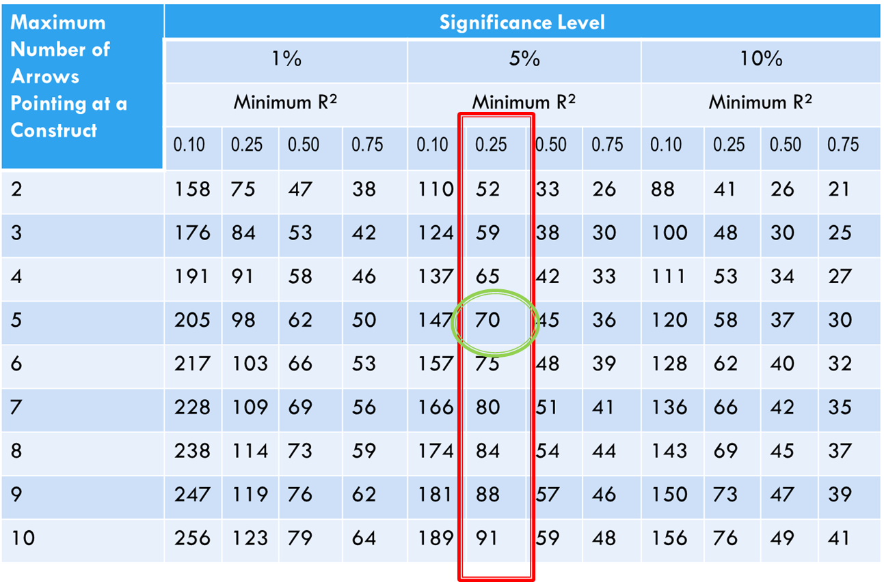In this study, sample size is determined by using Cohen Theory which its used the statistical power and effect size to help calculate the sample size (Cohen, 1988). Refer to the Cohen’s table (1988) at Table 10 mentioned the significant level: 5% and R2: 0.25, this study has 5 independent variables end up total sample size needed is 70 respondents at targeted population.

Table 10: Sample Size Calculation for This Study Base on Cohen’s Table (Cohen, 1988).

Furthermore, there are a simple formulation justify the sample size which sample size should be at least 10 times to the numbers of variables, and there are 5 variables to in this research. Therefore, the sample size in this study should be more than 50 to ensure the reliability of data (Roscoe, 1975). In conclusion, total 81 respondents collected in this study is justify representing the target population.

## **3.5** **Questionnaire Design**

The questionnaire is a gathering of related inquiries use to incorporate objective gathering (test) reaction towards the point of research (Sekaran & Bougie, 2010) 2010). Questionnaires is the most reasonable estimation instrument for this investigation because of it fill in as a clever and productive instrument to gather information from enormous example bunch for quantitative analysis. This research is a self-managed questionnaire by means of online convey (Google Form) and connection was accessible online between 25/7/19 till 6/8/19. All out 23 questions design to measure all variables. The questionnaire consists of four sections and refer to Table 11 for details.

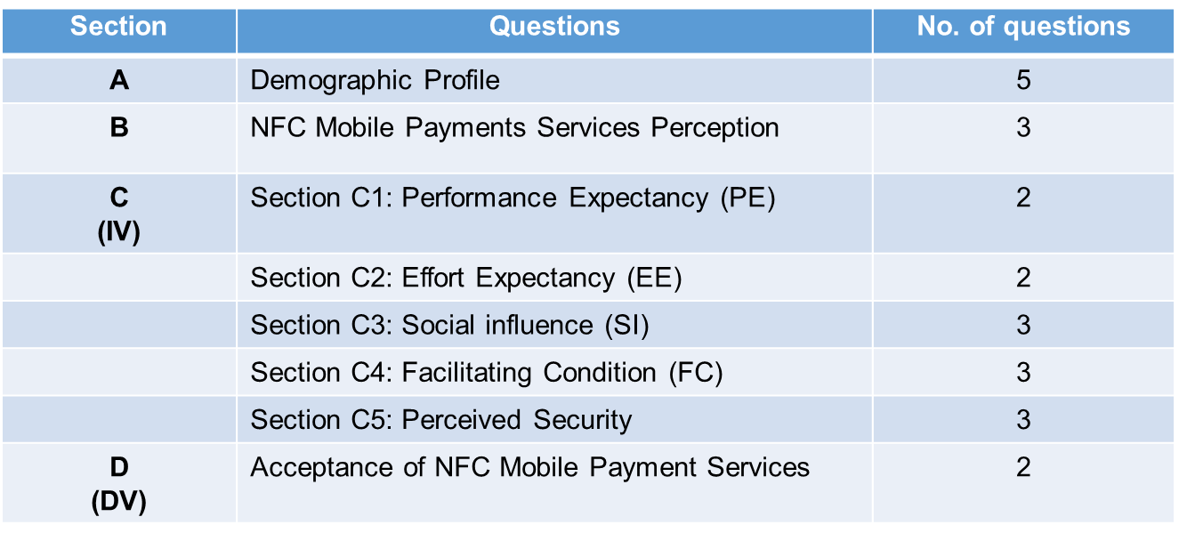

Table 11: Questionnaire Design

Questionnaire are conduct in English language version and all the questions used to collect data are adapted from previous studies to ensure this research validity and reliability and details can refer to Table 12. Sample questionnaire can refer to the Appendix 3. Measurement each of the variable in this questionnaire were used 5-point Likert Scale with 1 corresponding to “strongly agree” and 5 to “strongly disagree” (Joshi, et al., 2015).

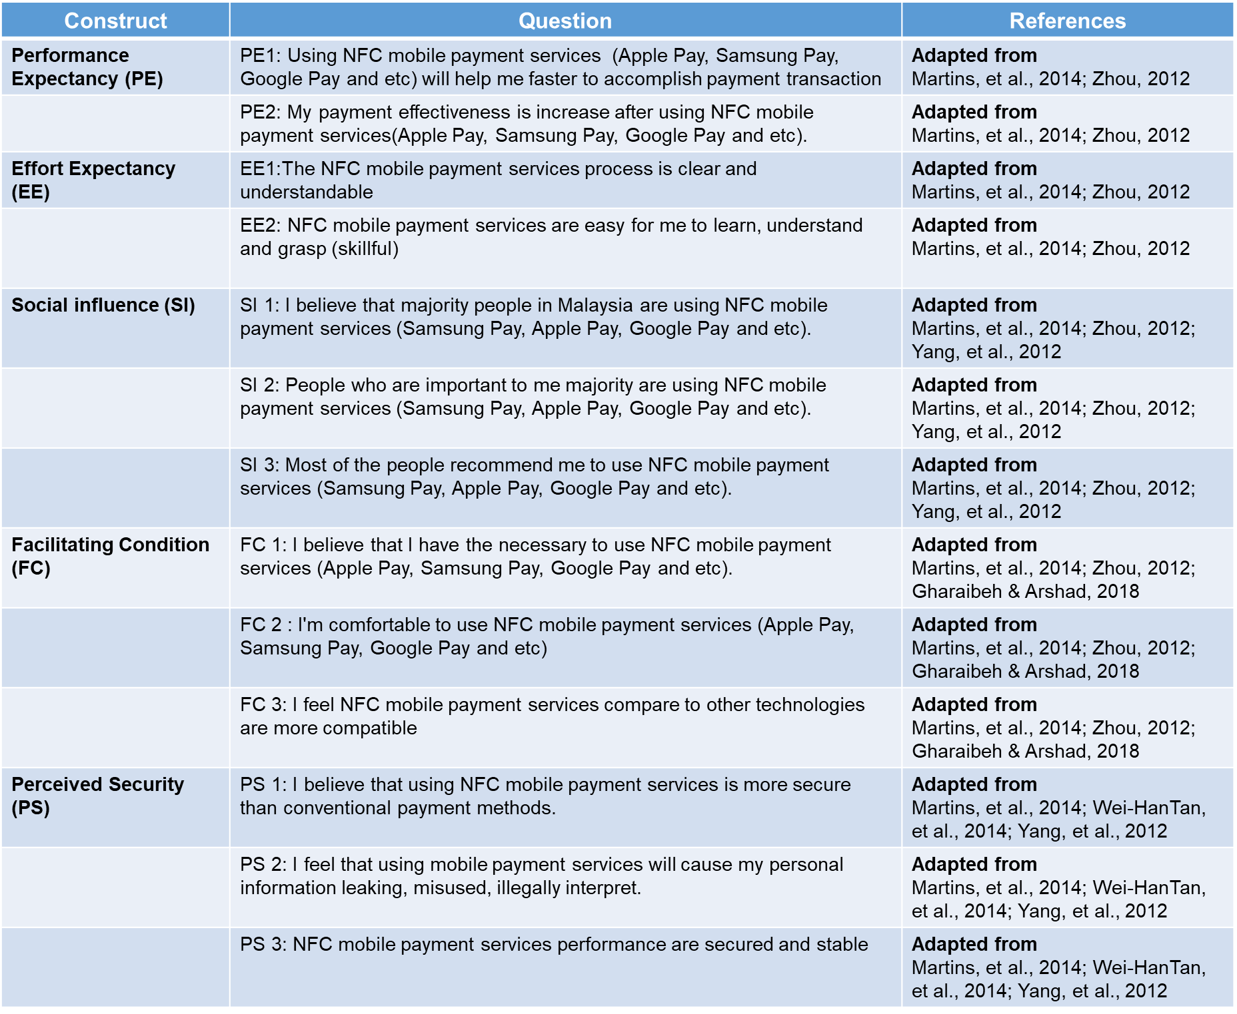

Table 12: Questionnaire adapt From Previous Studies

## **3.6 Data Analysis**

### **3.6.1 Descriptive Analysis**

Descriptive analysis is the basic analysis in the research process. It assists the us understand and identifying research questions and lastly generating hypotheses based on what has been observed. In this study, descriptive information will be including gender, age, monthly income. We will used cross tabulation and frequency distribution to analysis the data.

### **3.6.2 Reliability Tests**

Reliability test are conducted in this study to ensure reliability of the survey instrument. It is the measurement of consistency within questions in questionnaire and the responses of the survey (Sekaran & Bougie, 2013). The recommended range for Cronbach’s alpha is 0.70 to 0.95, which means good reliability.

### **3.6.3 Factor Analysis**

Factor analysis is a multivariate analytical technique which purpose to reduce many variables to a manageable number of factors (Karami, 2014). There are two techniques in factor analysis which is KMO (Kaiser-Meyer-Olkin Test) and Bartlett's Test of Sphericity and will conducted this research. The objective KMO is used to measure the adequacy of the sampling, KMO test is more than 0.5 consider adequate sampling. Whereas, Bartlett's Test of Sphericity is the test for the presence of correlations among variables which enable the researchers to know whether the correlation matrix is identical or vice versa to the identity matrix. The data significant value less than 0.05 is acceptable for further analysis. It’s shown does not produce identity matrix and approximately multivariate normal (Pallant, 2013)

**3.6.4 Correlation Analysis**

Correlation is used to analysis the relation more than two quantitative variables (Gogtay & Thatte, 2017). It is scaled at the range of -1 to +1, where 0 indicates the absence of linear association (Schober & Schwarte, 2018). The closer the correlation coefficient to ± 1, the higher the strength of association. The association between factors and their influence on user level of acceptance on NFC mobile payment will be tested using Pearson’s Correlation analysis.

**3.6.5 Multiple Regression Analysis**

Multiple regression analysis used in this study to examine the relationship between both IV and DV. It’s is an extension of bivariate regression by taking more than one independent variable in the analysis, the dependent variable is taking multiple factors into the account. Benefits using multiple regression besides analysis relationship all IV on the DV, it also able to control the effects of another independent variable (Sekaran & Bougie, 2013).

Correlation coefficient is presented in the form of “r”, measuring the strength and direction of the relationship between two variables. The r square explained the percentage of variance in dependent variable and the value close to 1 means regression model is significant (Cohen & Cohen, 2009). Meanwhile, p-value is also known as statistical significance value and p-value < 0.05 indicate the relationship is significant at 5% significant level.

## **3.7 Pilot Test**

Pilot test is a questionnaire trial procedure which to collect data in a research to detect the drawback in the measure instrument (Goeke & Pousttchi, 2010). Furthermore, it’s helps to questions refine before rolling out at the large scale. Commonly, pilot test ideal sample size is 20 (Monette, et al., 2002). Therefore, in this study, 20 samples will select randomly to gain the feedback of the questionnaire.

## **3.8 Data Collection and Data Analysis Methods**

The questionnaire will be distributed to the public via online. All samples select with carefully to ensure equal ratio gender, age and other factors. Total 90 questionnaire distributed and used for data analysis. Data analysis was carried out following a two-stage procedure. Validity of scales will analysis priority and next multi-group analysis will perform. The SPSS 26 will used to check theoretical establishment association.

**CHAPTER 4 DATA ANALYSIS**

## **4.1 Introduction**

After data collection, next chapter will discuss data analysis. Total 81 sets of data were collected from online questionnaire. The SPSS 26 will used to check theoretical establishment association. Analysis conducted are descriptive analysis, factor analysis, Pearson correlation analysis and multiple regression analysis.

## **4.2 Preliminary Data Analysis**

All the tests including factor analysis and reliability tests were run again under this preliminary analysis to ensure the data collected is ready to be used and testing hypothesis. The pilot test on 20 respondents was conducted to check on the reliability and validity of the constructs.

### **4.2.1 Reliability Test**

The Cronbach’s alpha used to test the construct’s reliability. Higher Cronbach’s alpha value that approximates 1 indicates a more reliable construct and the standard acceptable reliability is 0.7 and above (Pallant, 2013). Refer to Table 13 Cronbach’s alpha at pilot test are greater than 0.8. No item needs to be removed as all the Cronbach’s alpha has achieved more than 0.7 which is considered reliable to proceed further.

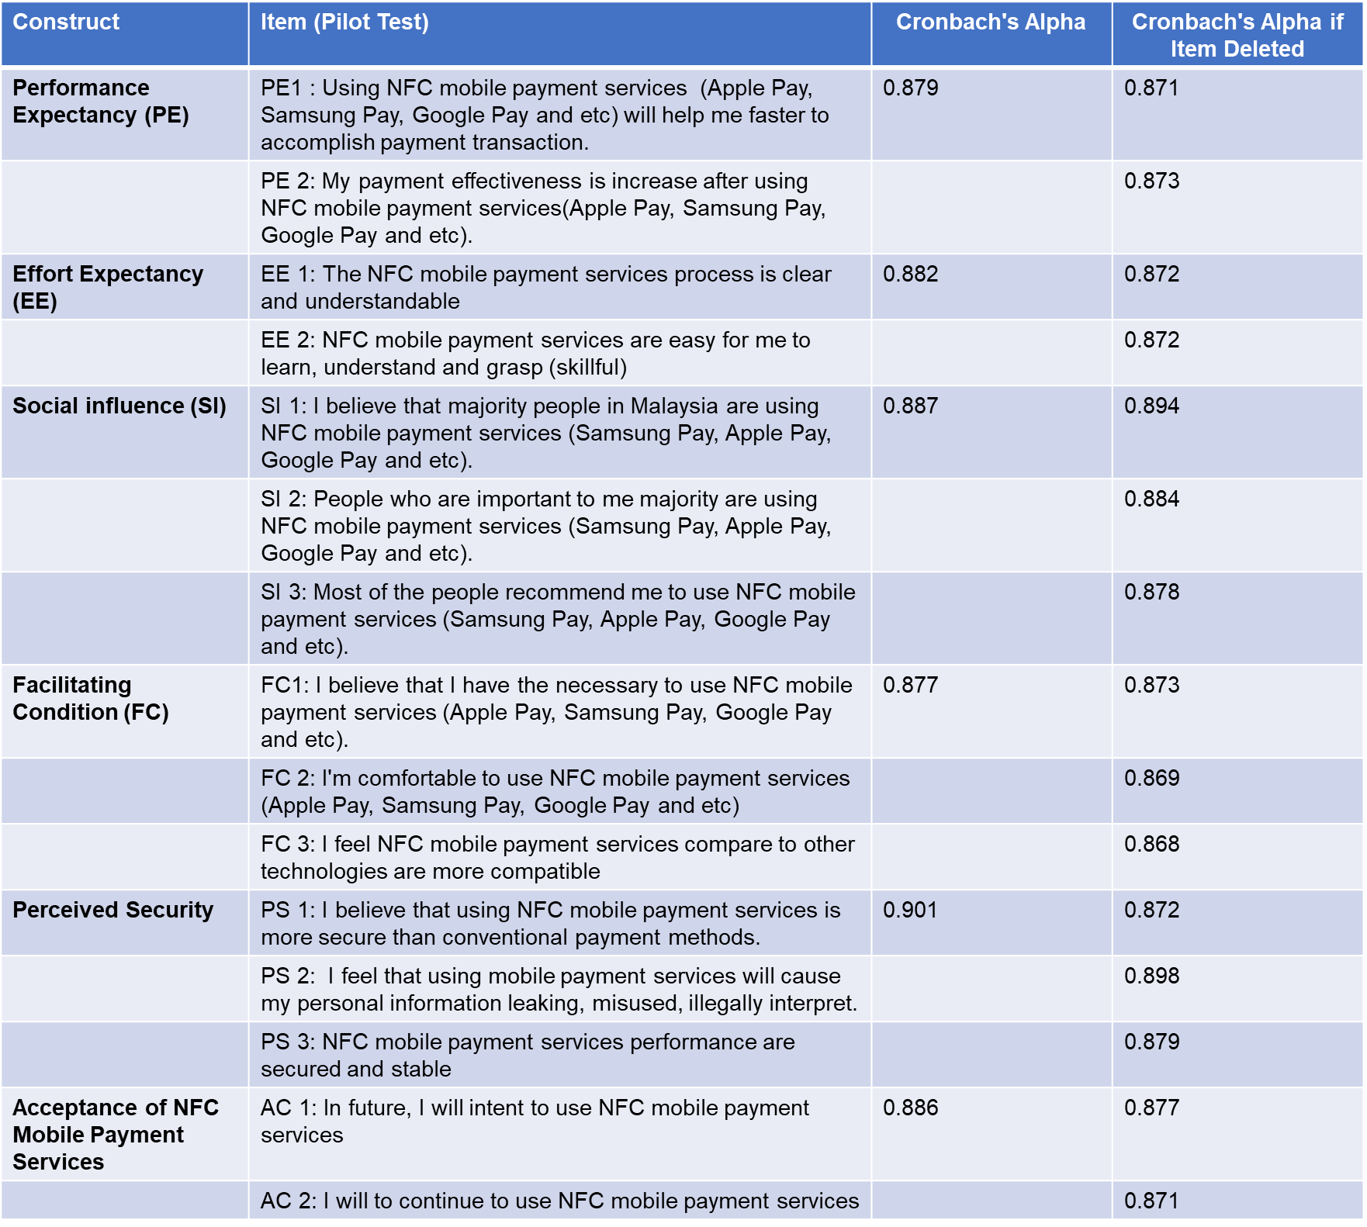Table 13: Cronbach’s alpha at Pilot Test (20 respondents)

## **4.3 Descriptive Analysis**

### **4.3.1 Demographic Profile**

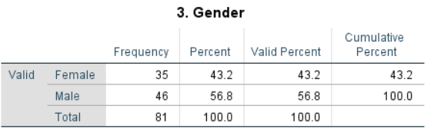

Table 14: Gender Distribution

Total 81 respondent collected and consisted of 56.8% Male and 43.2% Female. Gender is equally distributed.

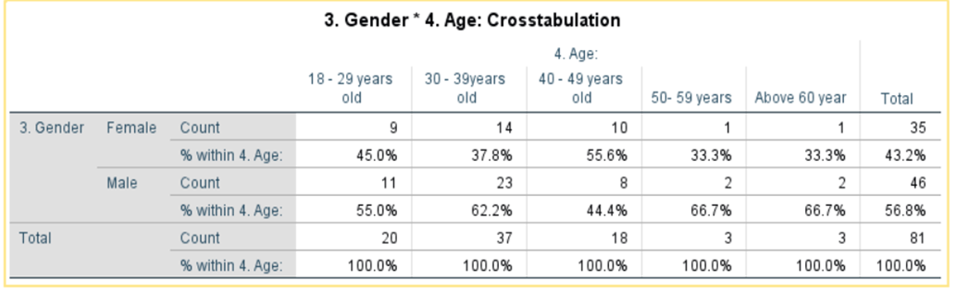Table 15: Crosstabulation Age and Gender Distribution

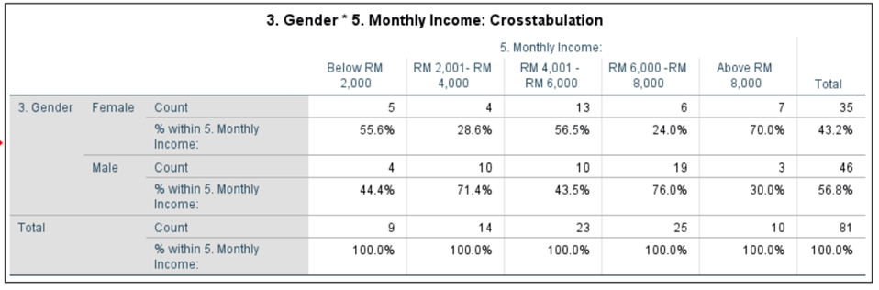Refer to Table 15 shown majority respondents are between the aged of 30 and 39 years old which is 45.7% total 37 respondents. This is can interpret is convenience sampling used which using researcher social networks. Majority male respondents fall at aged group 30-39 years old too. Follow by second large group is at aged 18-29years old.

Table 16: Monthly Income Distribution

Refer to Table 16 shown majority respondents fall on monthly income RM 6,001– RM 8,000 which is 30.9% total 25 respondents. Follow by second large group is at monthly income RM 4,001 – RM 6,000 which have total 23 respondents with 28.4%. This can conclude 59.3% on the respondent’s monthly income is more than RM 4,000. Majority Male fall in monthly income RM 6,001 – RM 8,000 whereas Female majority fall in monthly income category RM 4,001 – RM6,000.

### **4.3.2 NFC Mobile Payment Services Perception**

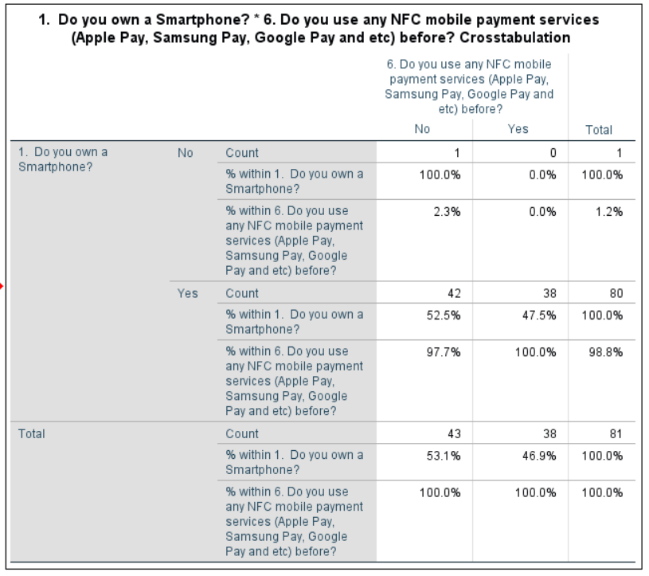

Table 17: Crosstabulation- Own A Smartphone Vs Use NFC Mobile Payment

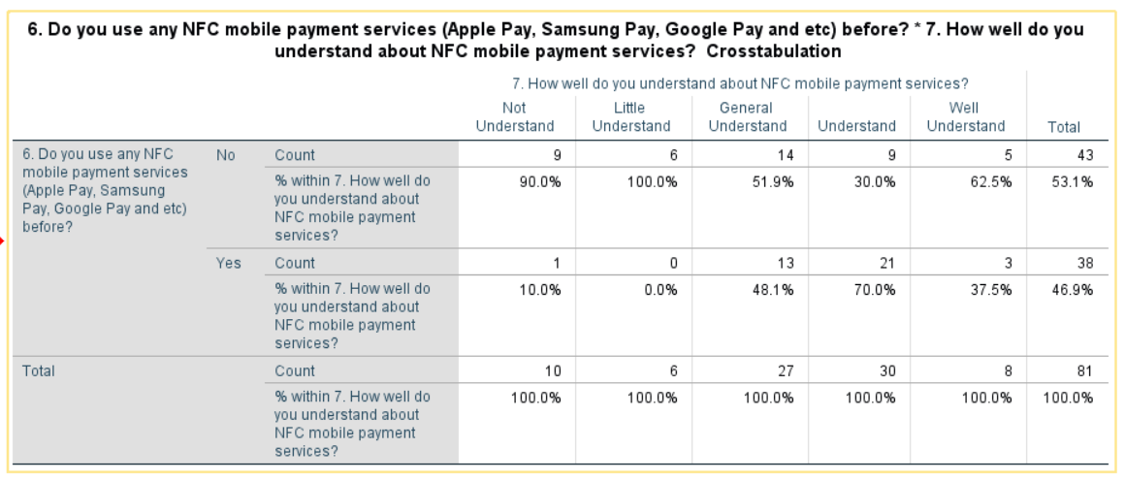Refer to Table 17 shown out of the 98.8% of the respondents who have a smartphone, only 47.5% have experience using NFC mobile payment services (Apple Pay, Samsung Pay, Google Pay). This interpret more exposure needed to educate the public regards NFC mobile payment cause less than half target population is familiar with NFC mobile payment.

Table 18: Crosstabulation- Understanding NFC Mobile Payment Vs Use NFC Mobile Payment

Refer Table 18 shown majority respondents is general understanding NFC mobile payment services which 33% and 27respondents. Those do not understand what NFC mobile payment are 90% select not use NFC mobile payment. This may interpret education on what is mobile payment services will help consumer faster adopt NFC mobile payment services

## **4.4 Reliability Test**

The reliability test was performed before carrying out the multiple regression analysis. From Table 19, Cronbach’s alpha above 0.8. Refer to Table 20 shown all variables was above 0.8 which mean no item needs to be removed as all the Cronbach’s alpha has achieved more than 0.7 which is considered reliable to proceed further.

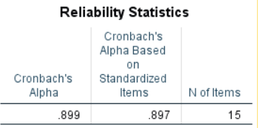

Table 19: Cronbach’s Alpha

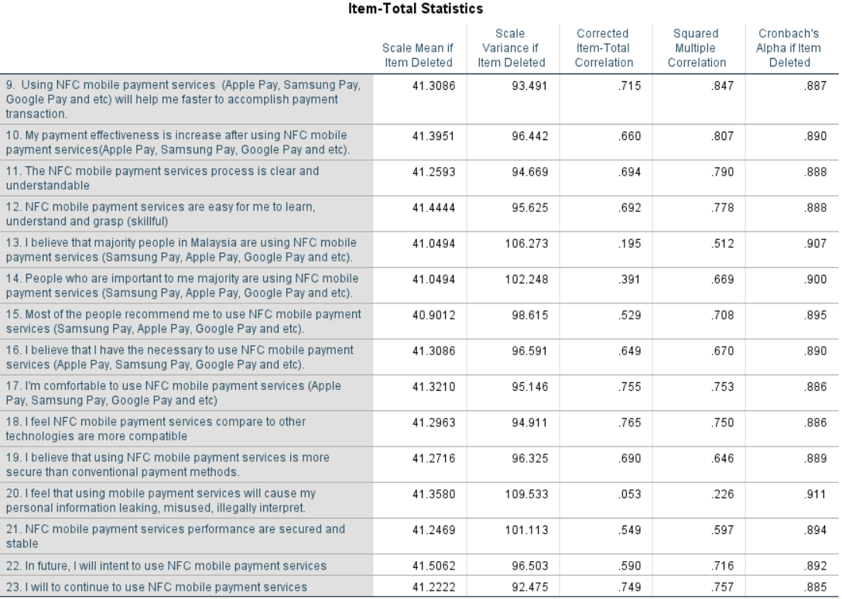

Table 20: All Variable Cronbach’s Alpha

## **4.5 Factor Analysis**

According to the literature on mobile payments acceptance and UTAUT, before a regression analysis conducted a factor analysis is mandatory with purpose to determine whether two or more variables measures the same (Bruin, 2019). To justify factor analysis is appropriate a Kaiser-Meyer-Olkin test (KMO) is necessary to indicate the suitability of the data.

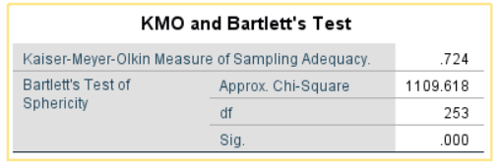

Table 21: Kaiser-Meyer-Olkin Test and Bartlett’s Test

Results shown KMO are 0.724 is greater than 0.5, indicate that a factor analysis useful with data and sampling is adequate. For Bartlett’s Testis used to test that variances are equal for all samples. Results shown significance value of 0.000 which is smaller than 0.05. This suggests a factor analysis should be appropriate.

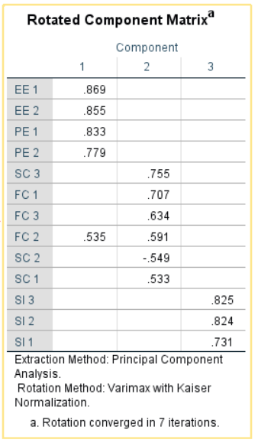



Table 22: - Factor loadings - Rotated Component Matrix

Next, run with principal component analysis and Varimax method, this is the most common used method in the literature on UTAUT and mobile payments. According to Hair et al (2006) the factor loading should be greater than 0.5 to confirm the existence of convergent and discriminant validity. Refer to Table 22 shown, all results shown in 3 components are loaded onto their corresponding items with factors loading greater than 0.5 except SC2 (perceived security). These are not considered in the analysis.

## **4.6 Multiple Regression Analysis**

### **4.6.1 Regression Analysis**

Multiple regression analysis used in this study to examine the relationship between both IV and DV. It’s used to test the research hypotheses. Regression analysis examine is there a relationship based on the correlation of the IV and DV.

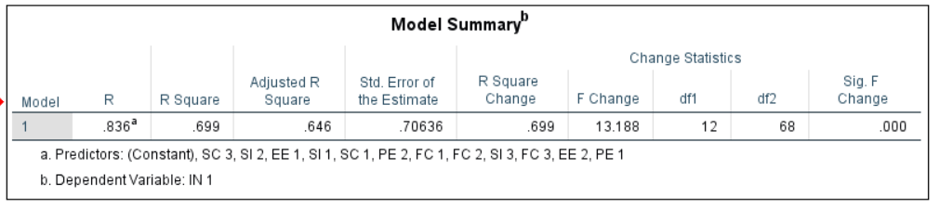

Table 23: Regression coefficients and significance

Correlation coefficient is presented in the form of “r”, measuring the strength and direction of the relationship between two variables. The r square explained the percentage of variance in dependent variable and the value close to 1 means regression model is significant (Cohen & Cohen, 2009). Meanwhile, p-value is also known as statistical significance value and p-value < 0.05 indicate the relationship is significant at 5% significant level. Refer to Table 23 shown r square value was 0.699 this can interpret more than 60% of the variance in acceptance to use NFC mobile payments was explained by the all independent constructs.

### **4.6.2 Multicollinearity**

Multicollinearity is when there is a high correlation identified between two or more variables. Variation influence factor (VIF) is used to assess multicollinearity. Tolerance value should be above 0.1 and VIF value should be below 10 to ensure there is no multicollinearity in the data (Pallant, 2013). Refer to Table 24 shown all VIF less than 10 and above tolerance value 0.1. In conclusion, this study is free from collinearity problem.

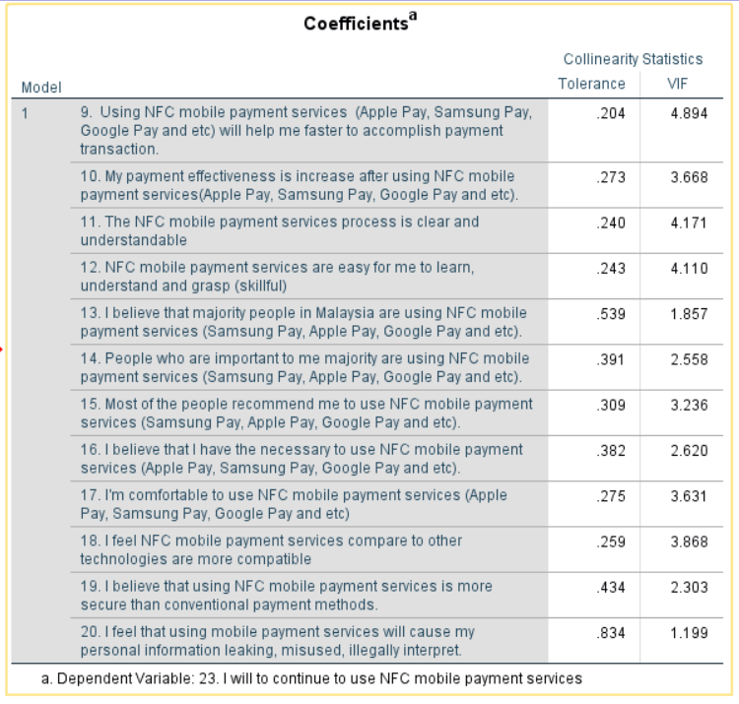Table 24: Collinearity Statistic

The results show Performance Expectancy, Effort Expectancy factors that influence the intention to use NFC mobile payments. The strongest factor to influence the intention to use NFC mobile payments is Performance Expectancy, this factor showed that the correlation was higher (0.795) than the others.

# **CHAPTER 5 FINDINDS, CONCLUSION AND RECOMMENDATION**

## **5.1 Major Findings**

* The construct, performance expectancy (PE), positively affects the acceptance NFC mobile payments services. This result supports the H1. The standardized coefficient of performance expectancy is 0.311, correlation is 0.645 and the Sig. = 0.000 (p ≤ 0.05).
* Effort Expectancy (EE), positively affects the acceptance NFC mobile payments services. This result supports the H2. The standardized coefficient of Effort Expectancy is 0.329, correlation is 0.607 and the Sig. = 0.000 (p ≤ 0.05).
* Social Influence (SI), reject hypothesis H3 as not positively affect the acceptance NFC mobile Payment. The standardized coefficient of social influence is -0.184, correlation is 0.116 and the Sig. = 0.151 (p ≤ 0.05).
* Facilitating Conditions (FC), positively affects the acceptance NFC mobile payments services. This result supports the H4. The standardized coefficient of facilitating conditions expectancy is 0.131, correlation is 0.490 and the Sig. = 0.000 (p ≤ 0.05).
* Perceived Security (SC), positively affects the acceptance NFC mobile payments services. This result supports the H5. The standardized coefficient of perceived security is 0.256, correlation is 0.525 and the Sig. = 0.000 (p ≤ 0.05).

In conclusion, all factor is positively affected level of acceptance on NFC mobile payment except the social influence factor. However, this is not representing that social influence are not important this may due to respondent the way interpreted question and the way questionnaire is present. Suggest may need further investigate just for social influence factor.

## **5.2 Limitations of the Study**

Limitation of the study is samples focused on users in Ipoh, Perak state due to time constraints, which may not be able to represent entire population of Malaysia. Secondly, this study total cover 5 independent variable, there may have other important variables are unable to be included in this research.

## **Recommendation**

As mention in the limitation of the study, recommend future research can go different state in Malaysia as Ipoh, Malaysia could not represent Malaysia whole population. Secondly suggest enhancing more variable to have complete coverage factor affected level of acceptance NFC mobile payment in Malaysia. There might be other factor affect Malaysian intension to use NFC mobile payment. Beside this, recommended further research NFC technology focus in IoT area as NFC technology not only for mobile payment it can be a Smart Home Appliance.

On the results, can identify Ipoh, Malaysia still have more than half population not been used the NFC mobile payment due to their lack of knowledge on this area. In order to help Ipoh, Malaysian faster adopt the NFC mobile Payment a series of education by digital, newspaper or billboard is needed. As results, user will feel familiar and easy to operate and utilize the NFC mobile payment services.

## **Conclusion**

This study is investigating factors that affected level of acceptance NFC mobile payment by consumers in the Malaysia. Several models of technology acceptance were described but one was the best suited to investigate the acceptance of NFC mobile payments is UTAUT because it more focuses on the consumers context.

Overall, all factor shown positively influence user’s level of acceptance on NFC mobile payment in Malaysia except social influence factor but after read through literature review majority highlighted social influence is most important. Therefore, we assume customer the way interprets the question and way of presenting question may the reason cause the hypothesis rejected. Recommendation a further investigate on this factor.

Results shown Performance Expectancy, Effort Expectancy factors that influence the intention to use NFC mobile payments. The strongest factor to influence the intention to use NFC mobile payments is Performance Expectancy, this factor showed that the correlation was higher (0.795) than the others. This research result is very useful to industry like giant mobile phone manufacturer, banks and government. It important cause can help them design and development of devices and mobile payment systems fit to consumer needs.

The factors performance expectancy needed to promote due to it was the strongest factors to influence the acceptance level on NFC mobile payments. Industry should not focus to much on NFC mobile payments how easy can be function cause this is not a problem for the consumers. They concern effort expectancy, joyful of NFC mobile payments. More security feature should add in the NFC mobile payment to get user confidence to full force use it.

## **5.5 Personal Reflection**

In this project the most challenging part is from unknown, unclear the research process till read through 78 articles to come out a literature review and well understand each step at research process till summary all the informative result and citation. It is a full satisfied and challenging MBA project journey because it also needs completed at short of time frame.

This is a valuable process as I can systematically know how to identify problem statement and research question. Besides this, the way to collect data an analysis really makes me have a brand-new impression compare my last degree. Continuous attending different workshop to enhance my research paper writing skill also is a joyful journey. To sum up, enjoy all the precious moment.

**References**

Ajzen, I., 1991. The Theory of Planned Behaviour. *Organisational Behaviour and Human Decision Processes,* 50(2), pp. 179-211.

Almalki, S., 2016. Integrating Quantitative and Qualitative Data in Mixed Methods Research--Challenges and Benefits. *Sage,* 5(3), pp. 288-296 .

Apple, 2014. *Apple Announces Apple Pay.* [Online]Available at:https://www.apple.com/newsroom/2014/09/09Apple-Announces-Apple-Pay/[Accessed 10 April 2019].

Balachandran, D. & Tan, G.-W.-H., 2015. Regression modelling of predicting NFC mobile payment adoption in Malaysia. *Int. J. Modelling in Operations Management,* 5(2), pp. 100-116.

Bhullar, A. & Gill, a. P. S., 2018. Adoption of Mobile Commerce: An Empirical Study among Mobile Users. *International Journal of Engineering Technology Science and Research,* May, 5(5), pp. 438-449.

BNM, 2018. *Interoperable Credit Transfer Framework (ICTF).* [Online]   
Available at: http://www.bnm.gov.my/index.php?ch=en_announcement&pg=en_announcement&ac=619[Accessed 11 April 2019].

BNM, 2019a. *Electronic payments on the rise.* [Online]Available at: http://www.bnm.gov.my/index.php?ch=ps&pg=ps_mep_rise&ac=195&lang=en[Accessed 10 April 2019].

Bruin, J., 2019. *Newtest: command to compute new test. UCLA: Statistical.* [Online]   
Available at: http://www.ats.ucla.edu/stat/stata/ado/analysis/.[Accessed 2 August 2019].

Cao, Y., Lu, Y., Gupta, S. & Yang, S., 2015. The effects of differences between e-commerce and m-commerce on the consumers’ usage transfer from online to mobile channel. *International Journal of Mobile Communications ,* 13(1), pp. 51-70.

Capgemini & BNPParibas, 2018. *World Payments Report 2018,* s.l.: World Payments Report.

Chaffey, D., 2018. *Mobile marketing statistics compilation.* [Online]Available at: https://www.smartinsights.com/mobile-marketing/mobile-marketing-analytics/mobile-marketing-statistics/[Accessed 21 April 2019].

Chang, C.-W. & Xue, F., 2017. Why Do People Continue Using Facebook: An Empirical Study from the Perspectives of Technology Adoption and Social Contract. *Global Media Journal,* pp. 15-28.

CIRT, 2019. *Quantitative Approaches.* [Online]Available at: https://cirt.gcu.edu/research/developmentresources/research_ready/quantresearch/approaches[Accessed 26 April 2019].

Cohen, J., 1988. *Statistical power analysis for the behavioral.* 2nd ed. Hillsdale, NJ: Erlbaum.

Cohen, J. & Cohen, P., 2009. *Applied Multiple Regression/Correlation Analysis For The Behavioral Sciences.* s.l.:Lawrence Erlbaum Associates.

Coskun, V., Ozdenizci, B. & Ok, a. K., 2015. The Survey on Near Field Communication. *Sensors,* 15(6), pp. 13348-13405.

Davis, F., 1989. Perceived usefulness, perceived ease of use, and user acceptance of information technology. *MIS Quarterly,* Volume 13, pp. 319-340.

Escobar-Rodrígueza, T. & Carvajal-Trujillob, E., 2014. Online purchasing tickets for low cost carriers: An application of the unified theory of acceptance and use of technology (UTAUT) model. *Tourism Management,* Volume 43, pp. 70-88.

Everett, M. R., 2003. *Diffusion of Innovations.* New York: The Free Press.

Forrester, 2016. *2016 China Mobile Banking Functionality Benchmark.* [Online]   
Available at: https://www.forrester.com/report/2016+China+Mobile+Banking+Functionality+Benchmark/-/E-RES133001#[Accessed 10 April 2019].

Gazi, F., 2018. *What Is An E-Wallet And How Is It Different From A Credit Card?.* [Online]Available at: https://www.imoney.my/articles/choosing-e-wallet[Accessed 6 July 2019].

Gerbing, D. W. & and Anderson, J. C., 1992. Monte Carlo evaluations of goodness of fit indices for structural equation models. *Sociological Methods and Research,* 21(2), pp. 132-160.

Gharaibeh, M. K. & Arshad, M. R. M., 2018. Using the UTAUT2 Model to Determine Factors Affecting Adoption of Mobile Banking Services: A Qualitative Approach. *iJIM,* 12(4), pp. 123-134.

Goeke, L. & Pousttchi, K., 2010. A scenario-based analysis of mobile. *In Mobile Business and 2010 Ninth Global Mobility Roundtable (ICMBGMR), 2010 Ninth International Conference ,* pp. 371-378.

Gogtay, N. & Thatte, U., 2017. Principles of Correlation Analysis. *Journal of The Association of Physicians of India,* Volume 65, pp. 78-81.

Greener, S. & Martelli, J., 2015. *An introduction to business research methods..* s.l.:s.n.

Guillaume, 2014. *Tag Archives: secure element.* [Online] Available at: https://nfcforall.wordpress.com/tag/secure-element/[Accessed 24 April 2019].

ICEMD, 2016. *Types of Mobile Payments.* [Online]Available at: http://blogs.icemd.com/blog-moma-trends-mobile-payments/types-of-mobile-payments/[Accessed 22 April 2019].

Intel, 2013. *AN OVERVIEW OF NEAR FIELD COMMUNICATIONS (NFC).* [Online]   
Available at: https://01.org/blogs/sortiz/2013/overview-near-field-communications-nfc  
[Accessed 23 April 2019].

Joshi, A., Kale, S. & Pal, S. C. a. D. K., 2015. Likert Scale: Explored and Explained. *British Journal of Applied Science & Technology,* 7(4), pp. 396-403.

Karami, H., 2014. Exploratory FactorAnalysis as a Construct Validation Tool: (Mis) applications in Applied Linguistics Research. *TESOL Journal.,* 6(3), pp. 476-498.

Lai, I. K. W., 2015. Traveler Acceptance of an App-Based Mobile Tour Guide. *Journal of Hospitality & Tourism Research,* 39(3), pp. 401-432.

Larkotey, W. O., Amoako, P. Y. & Dey, E. A. L. a. E., 2013. Adoption of Mobile Payment Systems in Ghana. *International Journal of Societal Applications of Computer Science,* 2(4), pp. 367-372.

Lerner, T., 2013. *Mobile Payment.* Mainz: Springer Fachmedien Wiesbaden.

Liébana-Cabanillas, F., Luna, I. R. d. & Montoro-Ríos, F., 2017. Intention to use new mobile payment systems: a comparative analysis of SMS and NFC payments. *Economic Research-Ekonomska Istraživanja,* 30(1), pp. 892-910.

Liébana-Cabanillas, F., Muñoz-Leiva, F. & & Sánchez-Fernández, J., 2018. A global approach to the analysis of user behavior in mobile payment systems in the new electronic environment. *Service Business,* 12(1), pp. 25-64.

Luna, I. R. d., Montoro-Ríos, F., Liébana-Cabanillas, F. & Luna, J. G. d., 2017. NFC technology acceptance for mobile payments: A Brazilian Perspective. *REVIEw Of BuSINESS MANAGEMENT ,* 19(63), pp. 82-103.

Maring, J., 2018. *Google Pay launches to replace Android Pay and Google Wallet.* [Online]Available at: https://www.androidcentral.com/google-pay-launches-replace-android-pay-and-google-wallet[Accessed 23 April 2019].

Martins, C., TiagoOliveira & Popovič, A., 2014. Understanding the Internet banking adoption: A unified theory of acceptance and use of technology and perceived risk application. *International Journal of Information Management,* 34(1), pp. 1-13.

Monette, D. R., Sullivan, T. J. & DeJong, C. R., 2002. *Applied social.* 3rd ed. Forth Worth: Harcourt Brace.

Muna, Y. P., Khalidb, H. & Nadarajaha, a. D., 2017. Millennials’ Perception on Mobile Payment Services in Malaysia. *Procedia Computer Science,* Volume 124, pp. 397-404.

NFC, 2019. *NFC Money Transfer Specification Alternative To QR Codes Announced.* [Online]Available at: https://nfc-forum.org/newsroom/nfc-money-transfer-specification-alternative-to-qr-codes-announced/[Accessed 10 August March].

Numbeo, 2019a. *Crime Index for Country 2019 Mid-Year.* [Online]Available at: https://www.numbeo.com/crime/rankings_by_country.jsp[Accessed 1 August 2019].

Numbeo, 2019b. *South-Eastern Asia: Crime Index by Country 2019 Mid-Year.* [Online]Available at: https://www.numbeo.com/crime/rankings_by_country.jsp?title=2019-mid&region=035[Accessed 1 Aug 2019].

Pala, D., Vanijjab, V. & Papasratornc, B., 2015. An Empirical Analysis towards the Adoption of NFC Mobile Payment System by the End User. *Procedia Computer Science ,* pp. 13-25.

Pallant, J., 2013. *SPSS Survival Manual. A step by step guide to data analysis using SPSS..* 4th ed. Maidenhead: Open University Press.

Pergler, E., Daniela Glatz, C. A. & Schamberger, R., 2014. Acceptance and Value of Mobile Payment Service Designs in Complex Ecosystems. *InternationalJournalonAdvancesinInternetTechnology,* 7(3-4), pp. 183-192.

Pham, T.-T. T. & Ho, J. C., 2015. The effects of product-related, personal-related factors and attractiveness of alternatives on consumer adoption of NFC-based mobile payments. *Technology in Society,* Volume 43, pp. 159-172.

Phneah, E., 2012. *Mobile payments top NFC application in Asia.* [Online]   
Available at: https://www.zdnet.com/article/mobile-payments-top-nfc-application-in-asia/ [Accessed 11 April 2019].

Rogers, E. M., 2003. *Diffusion of innovations.* New York: The Free Press.

Roscoe, J. T., 1975. *Fundamental Research Statistics for the Behavioral Sciences.* 2nd ed. Holt, New York: Rinehart and Winston.

Rosenthal, G. & Rosenthal, &. J. A., 2011. *Statistics and Data Interpretation for Social Work.* New York: Springer Publishing Company.

Ruangkanjanases, A. & Sirikulprasert, a. N., 2018. Predicting Consumer Intention to Adopt Near Field Communication Enabled Mobile Payment in Thailand. *Journal of Telecommunication, Electronic and Computer Engineering,* Volume 10, pp. 147-152.

Samaradiwakara, G. D. M. N. & Gunawardena, C. G., 2014. Comparison of existing technology acceptance theories and models. *International Technical Sciences Journal,* 1(1), pp. 21-36.

SAMSUNG, 2015. *Samsung Pay: Simple, Safe and Secure.* [Online]Available at: https://news.samsung.com/global/samsung-pay-simple-safe-and-secure[Accessed 10 April 2019].

Schober, P. B. C. & Schwarte, L., 2018. Correlation Coefficients. *Anesthesia and Analgesia,* 126(5), pp. 1763-1768.

Sekaran, U. & Bougie, R., 2010. *Research methods for business: A skill building.* 5th ed. Chichester: John Willey & Sons Ltd.

Sekaran, U. & Bougie, R., 2013. *Research Methods for Business: A Skill-Building Approach.* 6th ed. West Sussex: John Wiley & Sons Ltd.

Shao, Z. & Zhang, L., 2018. What Promotes Customers’ Trust in The Mobile Payment Platform: An Empirical Study Of Alipay In China. *CONF-IRM 2018 Proceedings,* pp. 1-7.

Shuttleworth, M., 2008. *Quantitative Research Design.* [Online]Available at: https://explorable.com/quantitative-research-design[Accessed 24 April 2019].

Sorensen, E., 2018. *Different types of mobile payments explained.* [Online]   
Available at: https://www.mobiletransaction.org/different-types-of-mobile-payments/ [Accessed 21 April 2019].

Star, 2016. *Maybank Introduces First Mobile Wallet for Smartphone Users.* [Online]   
Available at: https://www.thestar.com.my/news/nation/2016/07/22/a-smarter-way-to-pay-maybank-introduces-first-mobile-wallet-for-smartphone-users/[Accessed 16 April 2019].

Statista, 2019a. *Smartphone penetration rate as share of the population in Malaysia From 2017 to 2023.* [Online]Available at: https://www.statista.com/statistics/625418/smartphone-user-penetration-in-malaysia/[Accessed 10 April 2019].

Statista, 2019b. *Market share of mobile operating systems in Malaysia from September 2017 to September 2018.* [Online]Available at: https://www.statista.com/statistics/929845/malaysia-mobile-os-share/[Accessed 11 April 2019].

Statista, 2019c. *Total revenue of global mobile payment market from 2015 to 2019 (in billion U.S. dollars).* [Online]Available at: https://www.statista.com/statistics/226530/mobile-payment-transaction-volume-forecast/[Accessed 28 Feb 2019].

Stewart, R., 2019. *Global mobile ad spend set to tip TV in 2019 thanks to programmatic 'boom' and 5G boost.* [Online]Available at: https://www.thedrum.com/news/2019/01/24/global-mobile-ad-spend-set-tip-tv-2019-thanks-programmatic-boom-and-5g-boost[Accessed 21 April 2019].

Tarang & Tamalika, R. a., 2017. A Literature Survey on Near Field Communication (NFC). *American International Journal of Research in Science, Technology, Engineering & Mathematics ,* pp. 55-63.

Van, T. L. & Trong, H., 2015. Diffusion of Innovation in Asian: A Study of Mobile NFC (Near Field Communication) Payment in Korea and Thailand. *International Journal of Managerial Studies and Research (IJMSR),* 3(10), pp. 36-42.

Venkatesh, V. & Davis, F. D., 2000. A theoretical extension of technology acceptance model: Four longitudinal field studies. *Management Science,* Volume 46, p. 186–204.

Venkatesh, V. M. M. G. D. G. B. a. D. F. D., 2003. User acceptance of information technology: Toward a unified view. *MIS Quarterly,* Volume 27, p. 425–478.

Venkatesh, V., Thong, J. Y. L. & Xu, X., 2012. Consumer Acceptance and Use of Technology :Extending the unified theory of Acceptance and use of Technology. *MIS Quarterly,* 36(1), pp. 157-178.

WARC, 2019. *Mobile adspend is set to top TV across key markets this year.* [Online]   
Available at: https://www.warc.com/content/paywall/article/warc-datapoints/mobile_adspend_is_set_to_top_tv_across_key_markets_this_year/124815  
[Accessed 20 April 2019].

Wei-HanTan, G., Keng-BoonOoi, S.-C. & Hew, T.-S., 2014. NFC mobile credit card: the next frontier of mobile payment?. *Telematics and Informatics,* 31(2), pp. 292-307.

Wong, S. & Anand, a. V., 2013. *Getting Started on Near Field Communication (NFC).* [Online]Available at: https://www.hardwarezone.com.sg/feature-introduction-near-field-communication-nfc-technology[Accessed 23 April 2019].

Yamane, T., 1967. *Statistics.* New York: Harper and Row.

Yang, S. et al., 2012. Mobile payment services adoption across time: An empirical study of the effects of behavioral beliefs, social influences, and personal traits. *Computers in Human Behavior,* 28(1), pp. 129-142.

Yuen, M., 2019. *Cashing in on e-wallets.* [Online]Available at: https://www.thestar.com.my/news/nation/2019/02/03/cashing-in-on-ewallets-its-a-growing-trend-more-people-are-using-ewallets-in-their-phones-these-days/[Accessed 11 April 2019].

Zhou, T., 2012. EXAMINING LOCATION-BASED SERVICES USAGE FROM THE PERSPECTIVES OF UNIFIED THEORY OF ACCEPTANCE AND USE OF TECHNOLOGY AND PRIVACY RISK. *Journal of Electronic Commerce Research,* 13(2), pp. 135-144.

# Appendices

**Appendix 1 - Online Questionnaire**

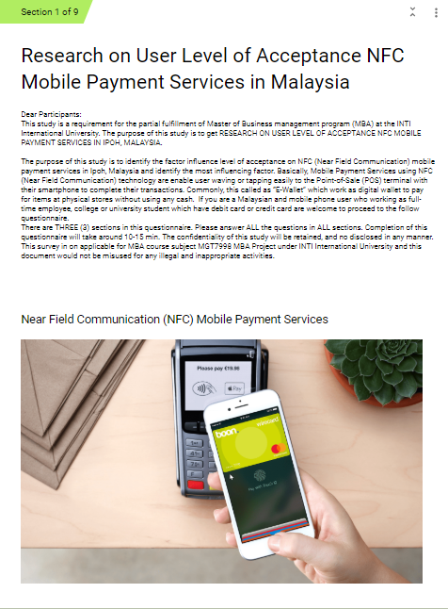

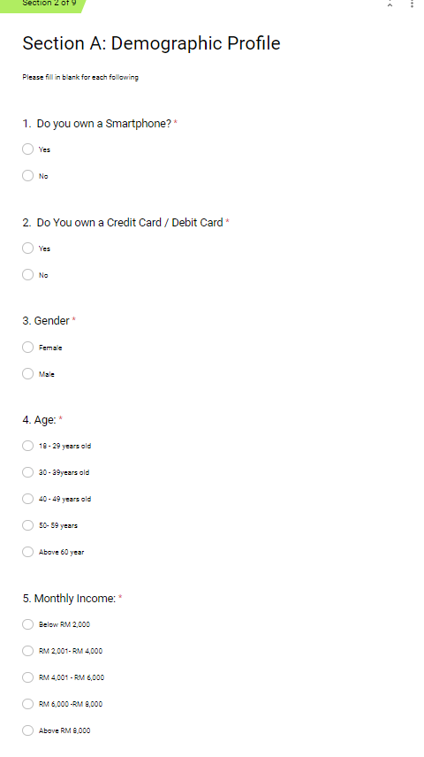

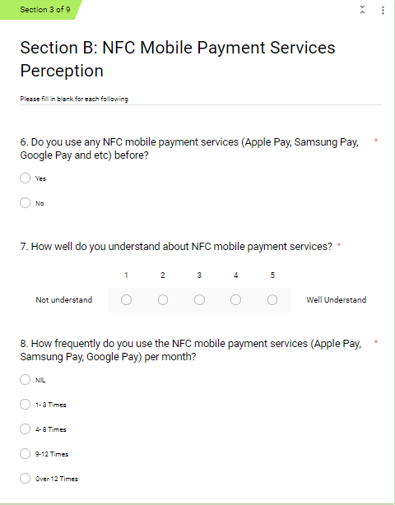

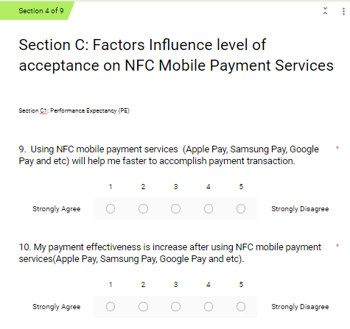

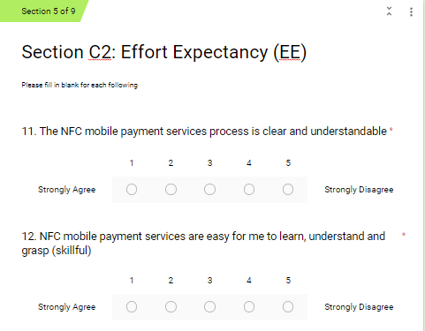

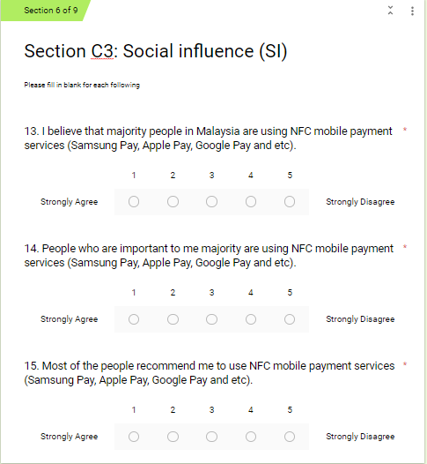

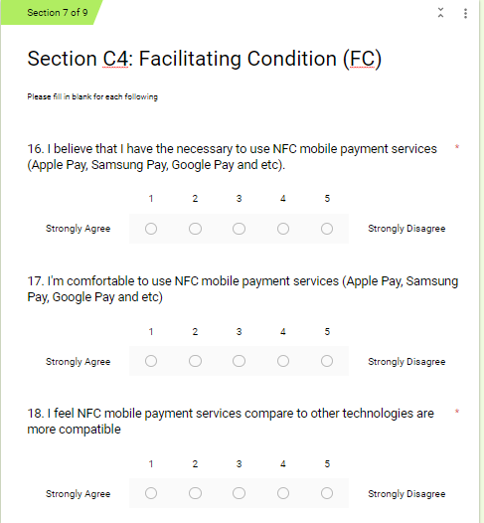

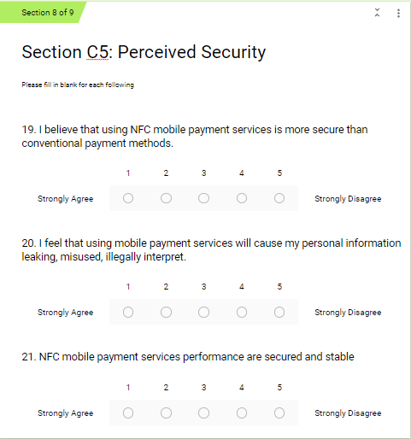

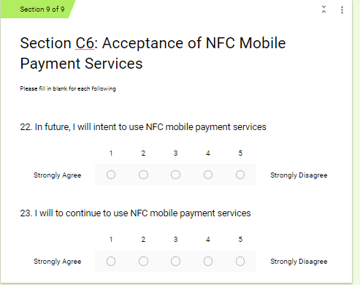

**Appendix 2- Project Paper Log**

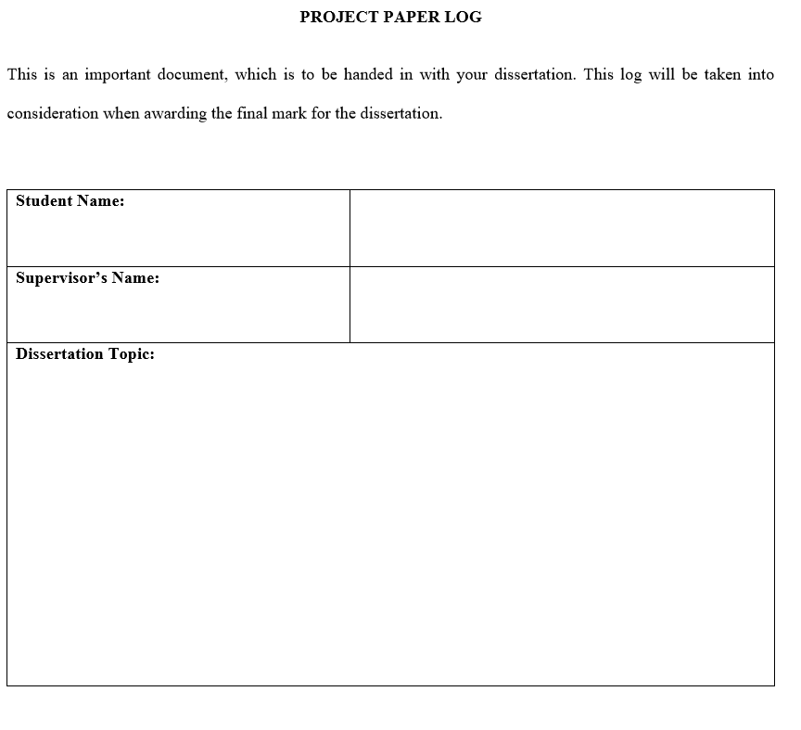

**RESEARCH ON USER LEVEL OF ACCEPTANCE**

**NFC MOBILE PAYMENT IN IPOH, MALAYSIA**

Dr. Alex Ng

GOH YEE MUN

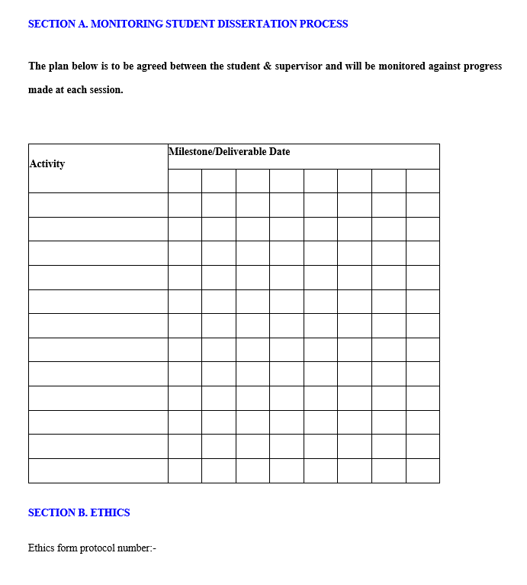

10/8

3/8

Discuss Data findings

Discuss Data Analysis

Y

Y

Y

Y

Discuss Data Collection

Discuss Questionnaire

Y

Y

Discuss Research Draft 1

Y

Y

Y

Discuss literature Review

Discuss & Write IRPP

Y

Y

Research Design, Method

Formulate Research Obj Question/Obj,

31/7

10/7

4/7

20/7

23/6

19/6

11/6

6/6

Research topic Approval

Identify Research Area

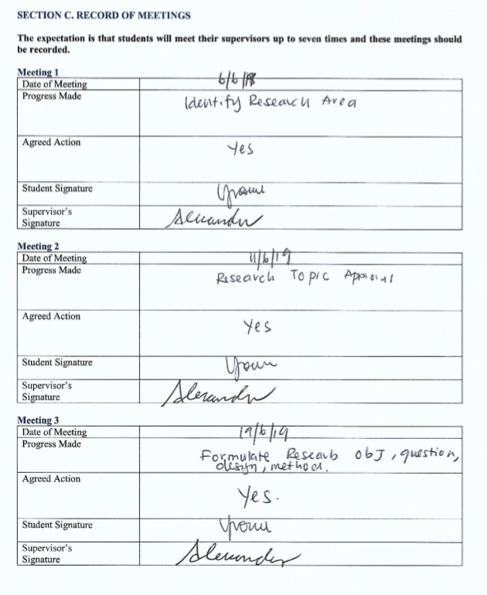

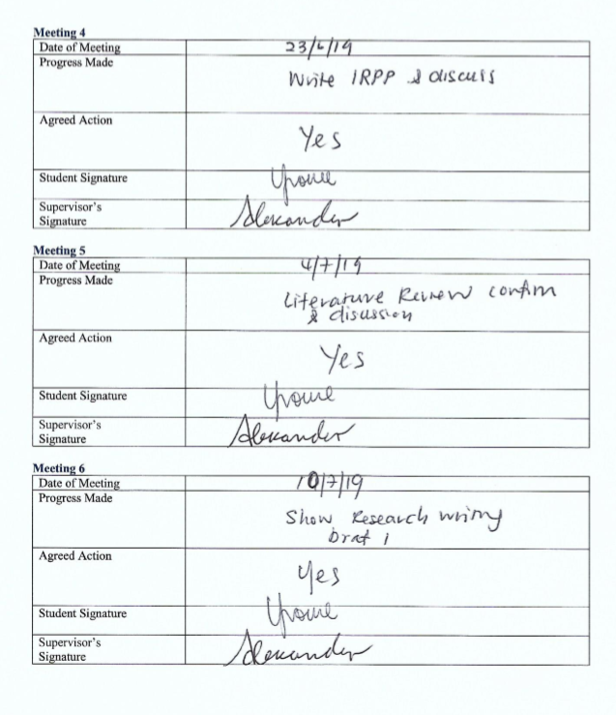

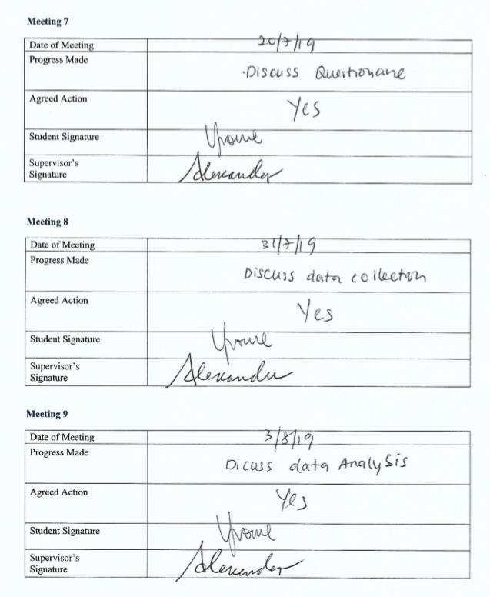

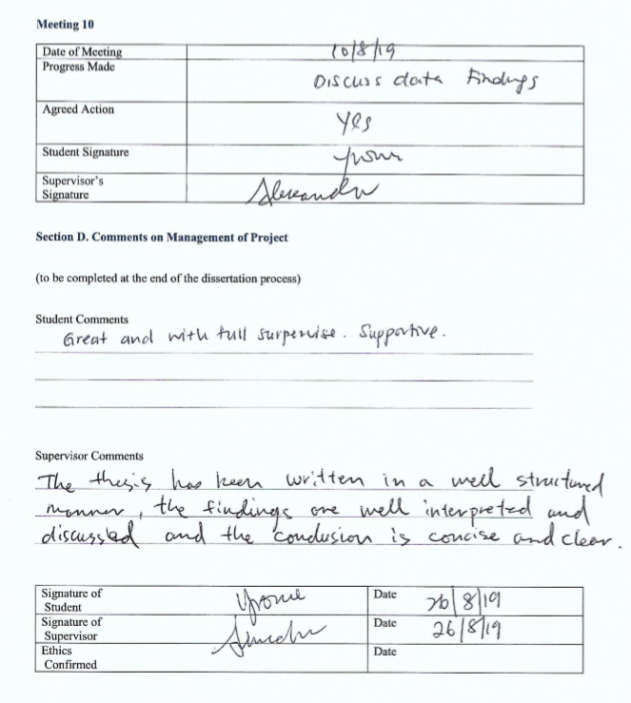

**Appendix 3- Turnitin Report**

