|  |  |
| --- | --- |
| C:\Users\ADMINI~1\AppData\Local\Temp\1566453796.png  C:\Users\ADMINI~1\AppData\Local\Temp\1566453934(1).png  C:\Users\ADMINI~1\AppData\Local\Temp\1566454065(1).png | **Research on acceptance factors of O2O application**  **DUAN RAN**  **MASTER OF BUSINESS ADMINISTRATION**  **FACULTY OF BUSINESS, COMMUNICATION & LAW**  **INTI INTERNATIONAL UNIVERSITY**  **2019** |

**RESEARCH ON ACCEPTANCE FACTORS OF O2O APPLICATION**

**DUAN RAN**

**MASTER OF BUSINESS ADMINISTRATION**

**FACULTY OF BUSINESS, COMMUNICATIONS&LAW**

**INTI INTERNATIONAL UNIVERSITY**

**2019**

**INTI INTERNATIONAL UNIVERSITY**

MASTER OF BUSINESS ADMINISTRATION

Research on acceptance factors of O2O application

Author : DUAN RAN

Student ID : I18014415

Supervisor : Ms Liew Heong Shya

Submission Date : Aug 23rd, 2019

Final Word Count : 12599

**ABSTRACT**

O2O is a new e-commerce model that combines online consumption and offline enjoyment services. The model promotes his services and products online, while using online means to complete payments. Offline is the way users experience and enjoy services and products. O2O allows almost all real-life products and services to communicate with customers in real time through the network. It integrates the powerful connectivity of the Internet and the rich product and service resources under the line. In the future, O2O will become the mainstream business model. To develop the O2O model, it is urgent to know the key factors that affect users' acceptance of products and services under the O2O e-commerce model. As a breakthrough, they will attract users to accept this emerging e-commerce model more quickly and deeply, and enable users to accept and use relevant products and services.

This paper attempts to grasp the basic characteristics and problems of O2O through the understanding and research of O2O e-commerce model. Based on the theoretical research of predecessors' users, this paper extracts the key influencing factors accepted by users of O2O e-commerce model. Exploring the interrelationship between various factors and building a user acceptance model for O2O e-commerce model. In the empirical research, through the design and distribution of the questionnaire, we obtained the data of the dizziness of these influencing factors. After the analysis of the professional data analysis software, the user acceptance model of the O2O e-commerce model was verified. The main content of this chapter is based on the results of previous data analysis, and puts forward some feasible suggestions for the development of O2O, summarizing the problems and solutions that should be paid attention to during development.

Keywords: O2O, technology acceptance model, e-commerce, user acceptance

**Acknowledgement**

During my completion of this paper, I am most grateful to my mentor, Ms Liew Heong Shya, for teaching me. In the early stages of the revision of the paper, there were a lot of mistakes and imperfections. It is Ms Liew Heong Shya who constantly helps me improve and give me advice and direction. I am very kindly coached by my teacher. I would also like to thank my examiner, Ms. Faziha for some suggestions for my thesis.

Special thanks to those who participated in my survey. They took time out of their busy schedule to fill out my questionnaire. These respondents gave enough respect to my questionnaire and they filled out each question carefully.

Finally, I would like to thank my classmates for their support and help. I am very grateful to them.

**DECLARATION**

I hereby declare that this thesis is my own work and effort and that is has not been submitted anywhere for any award. Where other sources of information have been used, they have been duly acknowledged.

Name : DUAN RAN

Student ID : I18014415

Signature : DUAN RAN

Date : Aug 21st, 2019

Table of Contents

Chapter1. Introduction 9

1.1 Background 9

1.2 Problem Statement 15

1.3 Research Objectives 16

1.4 Significance of the Study 17

1.5 Limitations 18

1.6 Scope of the Study 18

1.7 Ethical consideration 19

Chapter2. Literature review 20

2.1 Main concept definition 20

2.1.1 E-commerce definition 21

2.1.2 Characteristics of the O2O mode 22

2.2 Major literature review 25

2.2.1 Consumption innovation 25

2.2.2 Social influence 27

2.2.3 Consumer trust and perceived risk 28

2.3 Relevant theoretical models accepted by users 30

2.3.1 TAM2 model 30

2.3.2 UTAUT model 30

2.3.3 DIT model 32

2.3.4 Perceived risk theory 34

2.4 O2O User Acceptance Theory Model Construction 35

2.5 Summarize of literature review 36

2.6 Highlights of the research hypothesis 37

Chapter3. Research Methodology 39

3.1 Research Design 39

3.2 Measuring Instrument 40

3.3 Validity Tests and Reliability Tests 49

3.3.1 Validity analysis 49

3.3.2 Reliability test 50

3.4 Descriptive statistics 50

3.5 Correlation analysis 51

3.6 Regression analysis 51

3.7 Sample selection 52

3.8 Sampling method 54

3.9 Data Collection and Analysis Methods 54

Chapter 4 Data Analysis 56

4.1 Questionnaire reliability and validity analysis 56

4.1.1 Reliability Analysis 56

4.1.2 Validity analysis 57

4.2 Descriptive analysis of basic information of respondents 64

4.2.1 Individual information of the respondent 64

4.2.2 The current status of O2O use by respondents 68

4.3 Correlation analysis 73

4.4 O2O e-commerce model user acceptance regression analysis 75

4.5 Analysis summary 79

Chapter 5 Discussions, Conclusions and Recommendations 84

5.1 Analysis conclusion 84

5.2 Study Implications 87

5.2.1 Impact on the academic 87

5.2.2 Impact on the industry 88

5.2.3 Impact on the government 88

5.3 O2O e-commerce development recommendation 89

5.4 Self-reflection 92

REFERENCES 94

APPENDICES 113

# Chapter1. Introduction

## 1.1 Background

O2O is defined as Online to Offline, so the O2O combining online consumption and offline services is called O2O mode. Nowadays, many people still do not break the traditional consumption channels, and always stay at the sales channel and the shallow level of online and offline. And O2O emphasizes the users dependence formed by the service capability that runs through the whole users demand, which is the core value of the O2O model (Lee, 2017). Of course, true O2O is not so simple to understand, but the real O2O can achieve the "all-round satisfaction" of user needs, including at least: query information (price and location), access to discount (coupons, group purchase coupons), complete payment, experience consumption, comment sharing, bonus points (or rebate) and so on (Lim and Lim, 2016).

As an e-commerce model that is completely different from other e-commerce platforms, O2O model is becoming more and more popular among users, especially young people (Zhang, Chen and Wu, 2015). The success of the group-buying model has told us that the model of online payment and purchase of goods and services that can only be experienced and enjoyed offline, and the use of rich offline resources to improve the consumer experience, has been quickly accepted(Kim and Choi, 2015). In the future, O2O will become the leader of the e-commerce platform. Consumers can experience many convenient and fast services that O2O brings to them. These services will be unavailable to consumers on other e-commerce platforms. Easy to use is also one of the advantages of O2O to attract users.

In the O2O service system, O2O merchants pay more attention to the distribution and service of the entire service chain. Apart from providing regular merchant information, as well as e-coupons, group purchases and other preferential information to help merchants attract high-quality users, you can also use a large number of user reviews to maintain word of mouth and establish a brand (Jung and Kim, 2018). They are both consumers of content and contributors to content.

At the user level, a single product (service) can only meet a certain user's needs, often limited influence, and incomplete control of user needs. For example, a single group purchase website only has group purchases. Such users are greatly affected by price and have no loyalty (Zhang and Fang, 2013). At the same time, the O2O platform group purchase can satisfy all the needs of users and has higher loyalty.

At the merchant level, it is natural to say that new customers are acquired and maintained by old customers. Taking the public comment group purchase as an example, a variety of promotion methods such as electronic coupons, electronic membership cards, and trial-and-test activities can be comprehensively used to accelerate the formation of word-of-mouth and stickiness, and this constitutes the biggest difference from a single group-buying website.

If the O2O model develops into maturity, it will provide users with a super-cross-border seamless, perfect process and enjoy the experience (Sun, 2017). This series of figures has fully demonstrated that e-commerce is deeply changing the pattern of the retail industry. In the face of such a huge market, the status quo of enterprises in the actual operation process:

1. Brand first: the problem of credit system, such as the evaluation after Taobao purchase; and O2O is more through the word-of-mouth communication of social media, especially the service industry is non-standardized, it is relatively difficult to establish a credit system (PRAMESTIARA and RAHAB, 2018). Power has a big test, such as the recent success of WeChat platforms such as McDonald's, and more thanks to consumers' trust in their brands.

2, the mode is simple: the best mode, often the simplest thing. Practice has proved that O2O closed loop can be realized through the use of coupons and membership cards to attract consumers to pay the corresponding fees first and through simpler reservations.

3, convenient payment: micro-payment, Alipay and other mobile payment platforms make the payment more convenient, Imagine, in the future you go to the downstairs store to buy things or go to eat, do not need to bring a variety of cards and cash, just bring a mobile phone. That's okay, but for the business, you don't need a variety of specific POS, just need a mobile phone, 2D milk sweep, easy to complete the payment.

The main development area of O2O in China is the group purchase field where users pay online and then enjoy offline services. The city with the most frequent use of O2O services in China is Hangzhou. Hangzhou's Internet industry is developing rapidly. Consumers in the city have high dependence on Internet electronic products. Alibaba's headquarters is also in Hangzhou, so Hangzhou is the city with the most users of O2O e-commerce platforms in China.

From 2012 to 2019, China's domestic market size O2O lifestyle industry.

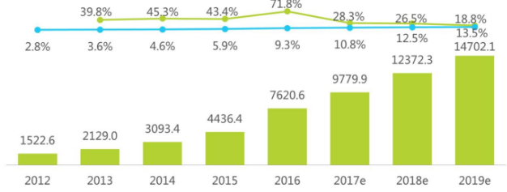

 : China's domestic market size O2O lifestyle industry

C:\Users\ADMINI~1\AppData\Local\Temp\1561395056(1).png : Growth rate C:\Users\ADMINI~1\AppData\Local\Temp\1561395110(1).png : Penetration rate

From 2012 to 2019, the scale and structure of domestic O2O living market in China

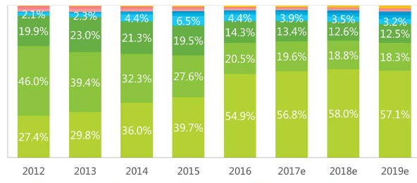

* : Online cateringC:\Users\ADMINI~1\AppData\Local\Temp\1561395388(1).png: Online educationC:\Users\ADMINI~1\AppData\Local\Temp\1561395429(1).png: Online entertainmentC:\Users\ADMINI~1\AppData\Local\Temp\1561395449(1).png :Online movieC:\Users\ADMINI~1\AppData\Local\Temp\1561395537(1).png: Online weddingC:\Users\ADMINI~1\AppData\Local\Temp\1561395585(1).png: Super home deliveryC:\Users\ADMINI~1\AppData\Local\Temp\1561395621(1).png: Online parent-childC:\Users\ADMINI~1\AppData\Local\Temp\1561395713(1).png:Online beauty maintenanceC:\Users\ADMINI~1\AppData\Local\Temp\1561395742(1).png:Domestic maintenanceC:\Users\ADMINI~1\AppData\Local\Temp\1561395780(1).png:laundry

From 2012 to 2019, O2O to store and O2O to home market size in China

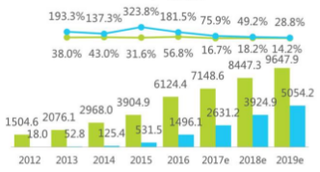

* :To store O2O market scale (one hundred million yuan)
* :Home O2O market size ($one hundred million)
* : O2O growth rate to stores (%)
* : Home O2O growth (%)

The data of the past seven years shows us the rapid development of O2O in China. Whether it is home O2O or to the store O2O has a spurt growth. At the same time, the scale of O2O in China has expanded year by year. The growth rate is at least 18.8%, and the penetration rate is increasing year by year. These data show that the development of O2O in China is still going on, and the prospect of O2O industry is very good. In the future, O2O will inevitably occupy a dominant position.

## 1.2 Problem Statement

The service model provided by O2O is completely different from the traditional business platform. It is the charm of its convenience and ease of use. O2O can greatly save users' purchase costs. O2O combines the advantages of online Internet with the rich product and service resources under the line to give users a rich experience. However, the development and development of O2O is not easy, and many problems will affect the development of O2O. This has brought some resistance to the future development of O2O (Widjaja and W., 2018).

1. Single O2O model: at present, most O2O services are still in the group buying stage, with more than 5,000 group-buying websites at most. There are many O2O models, and we must avoid the monotonous simple repeated group purchase model and other models, so as to avoid great waste of social resources (Hou, Zhang and Wang, 2015). The main theme of the O2O companies is to attract users to use the services and products that are good enough to meet a series of demands of consumers (Yu, 2018). We cannot follow the old path of rampant copycat and imitation in the traditional Internet era. This practice is a waste of social resources (Hahn and Lee, 2018).

2. Integrity

As O2O is a new e-commerce model, consumers are likely to be denied due services after payment (Hurst, 2005). Only need to merchants have certain the quality of the good faith management, can't burn your Bridges (Wang, Wang and Liu, 2016).

As conclusion, in order to find the O2O model deficiency and improve it to develop an O2O model that is more in line with user needs, it is necessary to understand the key factors that affect users' acceptance of products and services under the O2O e-commerce model. This article starts with the reasons users like O2O and infers the factors that affect users' acceptance of products and services in O2O mode.

## 1.3 Research Objectives

On the basis of the characteristics of the O2O e-business models, based on previous research results, through appropriate adjustment and innovation, four factors affecting user acceptance are proposed, namely, consumption innovation, society impact, consumer trust and perceived risk. Through empirical research on the influencing factors of individual user acceptance, explore the interpretive refining model suitable for current O2O users. According to the relationship between the model framework and the corresponding variables and influence these factors, the whole research model is finally completed. This paper proposes four questions as research questions based on these six influencing factors.

RQ1: Does the consumption innovation of the O2O model affect the user's usage intention?

RQ2: Does the user's social influence on the O2O model affect their usage intention?

RQ3: Does the user's trust in the O2O model affect their usage intention?

RQ4: Does the user perceived risk of the O2O model affect user’s usage intention?

## 1.4 Significance of the Study

Based on the previous research and data analysis of O2O, this paper summarizes the problems in the development of O2O, and proposes and improves methods for these problems to facilitate the development of O2O. On the other hand, the research results of this study can also facilitate the reference research of future generations.

## 1.5 Limitations

1. Improve the model and consider more influencing factors. For the research on user acceptance of O2O model, the paper only improves and expands the original acceptance model to some extent, taking into account some influential factors with relatively large influence relations. However, there are still many factors affecting users' acceptance of O2O e-commerce model, which need more comprehensive consideration and exploration.

2. Sample sources need to be expanded. The respondents of the questionnaire survey in this paper are mainly concentrated in the university campus and the author's private social circle, with relatively narrow channels and single sources, which are not very representative. These problems will affect the reliability of the research samples, resulting in a large number of overlapping samples.

## 1.6 Scope of the Study

This article selects users who are using or have used O2O services for research. The research area is developed areas such as Hangzhou in China. The target population is the population using O2O e-commerce services, or those who have not used but know O2O e-commerce services.

## 1.7 Ethical consideration

If the question in the questionnaire relates to the privacy of the respondent, the respondent has the right to refuse to complete the questionnaire. All O2O e-commerce platforms are operated legally. Moreover, all O2O platforms and enterprises have well fulfilled their corporate social responsibilities. It provides a good environment for all O2O users. Therefore, in terms of ethics, O2O e-commerce platform is qualified.

# Chapter2. Literature review

This chapter begins with a definition of the scope of the study and introduces the main concept definitions of this paper. Then, the author will carefully study the relevant literature on user acceptance theory at home and abroad, understand the concept and meaning of the technology acceptance model, and how other theories that may be involved in this paper, such as consumer innovation theory, innovation diffusion theory. And feel the risk theory and so on. To lay a solid foundation for the following research, to ensure that under the support of the theoretical foundation behind the body, we can fully grasp the methods, ideas and practical applications of users to accept theoretical research. The O2O model is a new thing, and it is impossible to adapt to any existing technology acceptance model. It is necessary to combine the characteristics of O2O itself to create a user acceptance model suitable for this research.

## 2.1 Main concept definition

### 2.1.1 E-commerce definition

E-commerce generally refers to the electronicization of various commercial trade activities on a global scale, including the communication of information, transactions, and other financial and business activities (Kang, 2016).

Different countries have different definitions of e-commerce, the difference being the direct difference between electronic devices and network technologies. Nowadays, e-commerce not only includes the main connotation of its shopping, but also includes logistics distribution (Patton and Jøsang, 2004).

On August 28, 2013, the China E-Commerce Research Center released a report showing that in the first half of 2013, the e-commerce market continued to grow at a high speed. As of June 2013, the national e-commerce transaction volume reached 4.35 trillion yuan, a year-on-year increase of 24.3%. Among them, B2B transaction volume reached 3.4 trillion yuan, an increase of 15.25%. The online retail market transaction volume reached more than 700 billion yuan, a year-on-year increase of 47%. In 2013, this value is expected to reach more than 1.7 billion yuan.

With the continuous improvement and development of the domestic e-commerce environment, O2O and other new formats and new models continue to expand, directly driving the growth of the scale of employees; also pulling the logistics express industry, network models, online shop decorators, full-time online stores The development of industry-related industries such as sellers.

### 2.1.2 Characteristics of the O2O mode

The O2O model is used to direct the existing online users to the physical business in the local or other areas, but the previous promotion and payment are done online, and then go to the line to use the products and services purchased before (Kim and Jeong, 2016). Since every transaction has been dealt on the Internet, with the help of a mature information system, its effectiveness is also real-time, accurate and measurable.

Therefore, the biggest advantage of O2O is that the products or services are planned and produced on demand, giving the merchants a precise and scalable promotion solution while rapidly making large-scale, and this model also gives consumers a broad platform to select high quality and low price. Products and services create a win-win situation for both parties. Real O2O can achieve all-round satisfaction of user needs, including at least: query information (price, location), get coupons, group coupons, complete payment, experience consumption, comment sharing, point rewards (or rebates), etc (Lee and Chung, 2017). Only in this way, user stickiness and path dependence can be formed, and the O2O platform will produce differentiated value.

The O2O e-commerce model provides users with a new mobile commerce experience, and its business model has its own outstanding features.

1. Information publicity

Since each transaction has been dealt with online, with the mature information system, the platform operator also has a large amount of user personal information and consumption record information (Board, 2016). The openness of information has caused users to worry about privacy. O2O e-commerce providers will abuse user information or criminals may steal user information, thus causing damage to users' interests.

2. Convenience of consumption

O2O e-commerce enables users to obtain merchant service information recommendations anytime and anywhere, and can also actively search for business information around them (Yu, 2018). After online payment, they can immediately obtain offline services, which is convenient and fast. However, in traditional e-commerce, users give up online purchase services because some entities are located far away, resulting in a decrease in business, or because of the distance, users abandon consumption after purchase, resulting in economic loss and a reduction in consumer experience (Athapaththu and Kulathunga, 2018). The convenience of O2O e-commerce consumption effectively avoids the above situation.

3. Business information is difficult to distinguish between true and false

The merchant service information obtained by the user through the O2O e-commerce platform is more detailed, but the authenticity may be problematic. There may be differences between the description of the online business information and the product service and the offline, and the consumer has no way of knowing that when the payment is paid to enjoy the service, the product service is found to be different from the previous online commitment (Lee, 2017). Such problems can lead to consumer confidence and acceptance of the O2O model. Consumers also take into account the risks he has to bear.

4. New service model

The O2O e-commerce model is a new type of e-commerce model that combines online shopping payment and offline service experience. It can be said that it is a typical representative of innovation. Therefore, the services or finished products in the O2O e-commerce model appear in front of the public, and when accepting the test of the mass consumers, it is necessary to take into account the degree of acceptance of new things by different consumers, that is, the level of innovation of consumers (이지현, KwangMin Cho and 김태중, 2018). Consumers with high-innovation consumers may be more willing to try new Internet products or services such as O2O, and they are more likely to use behaviors and have a stronger willingness to use them (Laroche, Bergeron and Barbaro‐Forleo, 2001). Consumers with low innovations may be resistant to O2O products and services, and it is not easy to accept such new things. They will feel that it is very risky to try these new things before they are used by others and passed the test (LIU and WANG, 2016).

## 2.2 Major literature review

### 2.2.1 Consumption innovation

Consumer innovation is a different attitude for different users in the face of new products and services: consumers with higher innovation will show novelty and excitement, and hope to experience and enjoy new services or products. They enjoy the excitement of new things; on the contrary, the other less innovative consumers trust the old services and products, and the original services or products are more stable and reliable for them (Yildiz, Heitz-Spahn and Belaud, 2018). Loyalty to products or services is less likely to accept new things. It can be said that it is a typical representative of innovation. Therefore, the services or finished products in the O2O model appear in front of the public, and when accepting the test of the mass consumers, it is necessary to take into account the degree of acceptance of new things by different consumers, that is, the level of innovation of consumers (Vander Schee, 2011). Consumers with high-innovation consumers may be more willing to try new Internet products or services such as O2O, and they are more likely to use behaviors and have a stronger willingness to use them. Consumers with low innovations may be resistant to O2O products and services, and accepting new things is not an easy task for consumers (Tse, 2001). They will find in these new things before anyone else to use and try to go through the inspection is very risky behavior. They will be cautious in their use and their usage intention will be low. Simultaneously, consumer innovation will also affect consumers' perception of convenience and utility of the O2O model. Previous studies of users of fresh services and products have also revealed that consumer innovation is a considerable element influencing user acceptance. In view of the previous literature study and the characteristics of the O2O model summarized in the previous article, this paper believes that consumer innovation has a very important impact on users' acceptance of O2O model products and services (Yan and Pei, 2019). When using newer Internet products such as the O2O e-commerce model, every consumer has their own opinions and attitudes. This includes a lot of consumers who like innovation. They are more accepting new things than other users. This attitude determines that these users will be exposed to new products and services earlier than other consumers.

Many domestic and foreign scholars have done a lot of research on the field of consumer innovation. It is generally believed that consumer innovation as an intrinsic individual characteristic of consumers has an important influence on the willingness of users to accept. There are also many versions of the definition of innovation by scholars at home and abroad. For example, Hirschman (1980) and Venkatraman & Price (1990) argue that consumer innovation is an innate, unobservable personality trait that reflects the consumer's inherent perception and behavioral bias (Hirschman, 1980). They define consumer innovation as an individual. Have a "personality feature." Hurtetal (1977) defines it as “the will to seek change”. The definition of consumer innovation in this paper is: the degree of acceptance of the consumer's inherent personality in the face of new things.

### 2.2.2 Social influence

When consumers make decisions, in addition to some inherent qualities of individuals, it will affect his decision-making. The influence of the surrounding environment on him can not be ignored, such as the views of people around him, and he thinks that when he takes after a certain behavior, what kind of opinions people around him will have. This includes social influence which refers to the use of the social forces of individuals or groups to change the attitudes or behaviors of others in a particular direction. Social influences can come from many individual forces or group forces associated with the subject. French and Raven (1959) argue that reward power, coercive power, referent power, legitimate power, expert power and informational power are six sources of social rights (Raven and French, 1958). The power of reward refers to the ability of individuals or social forces to provide rewards to the theme, such as the company's bonuses, the boss's verbal praise, the teacher's parents' praise of the child, etc. The repressive power is the opposite, it refers to the individual or social power. The subject's negative influence ability, such as the traffic police's punishment for drivers who violate traffic rules, the mass condemnation of unethical events, etc.; reference power refers to the pressure of individual or group power to produce consistency over the subject, such as individuals (Molm, 1985). Often want to maintain certain aspects of consistency with other members of his group to avoid being excluded; statutory power refers to the effect of groups that are legally required to others, usually such power is appropriate for position and status; Expert power refers to the effect of groups with certain strengths on others, such as the authority of experts in certain fields; the power of information refers to the influence of others with information that others do not know (Hegedűs, 2013). The platform service of the O2O e-commerce model will attract more and more users' attention and use. The opinions and cognition of the emerging models on the outside will affect the user's evaluation of O2O. At the same time, O2O mode is an important product mobile communication age. It is bound to be closely related to communication and social interaction. Interpersonal relationship is also a crucial pattern to facilitate O2O. In summary, there is reason to believe that social impact will have a certain extent affect on consumers' usage intention and behavior.

### 2.2.3 Consumer trust and perceived risk

Trust can reduce the consumer’s perceived risk, and risk is the environment on which trust depends. It is the soil for trust growth. Without the existence of risks or uncertainties, trust does not exist. Especially in China, where imitation and cottages are everywhere, consumers may choose a large e-commerce platform they trust to conduct an O2O trial and exploration. For the unknown O2O enterprises, compared with some well-known Internet platforms, consumers may think that choosing a more popular Internet platform will be relatively more insurance and less risky. Therefore, the consumer's trust in the e-commerce platform can affect his perceived risk to the platform, and also directly affect his use behavior (Atorough and Donaldson, 2012). The research on customer trust by Mayer and other scholars shows that there are several important influencing factors that have sufficient explanatory power for the influence of consumer trust: comprehensive consideration, integrity and kindness. Therefore, the author will measure the degree of trust in an O2O platform in the minds of consumers through the consumer's perception of these three influencing factors.

Consider the focus and overall characteristics of the O2O service model that may arise during the user acceptance process, this paper will select the following four risks as the dimensions of perceived risk: time risk, functional risk, privacy risk and economic risk.

Time risk refers to the risk of using O2O platform products or services to bring more time costs to consumers;

Functional risk define is the fact the products and services that consumers get through the O2O e-commerce model are not as functional as they are or otherwise available;

Privacy risk define is the personal risk privacy information being leaked when consumers purchase products or services through the O2O model;

Economic risk is that the higher economic cost of consumers when using the O2O model compared to other business models.

## 2.3 Relevant theoretical models accepted by users

### 2.3.1 TAM2 model

The full name of the TAM2 model is Technology Acceptance Model 2. This model was proposed by Venkatesh and Davis in 2000. The new theoretical model that has been improved and extended on the original TAM model is the TAM2 model. The TAM2 model is primarily about the use of social impact and cognitive tooling intent. Social influence variables are more suitable for current research in the TAM2 model. In addition, voluntary images are eliminated from this research, and this type of research is mainly based on social influence (Hidayati, Oktaviana and Ismail, 2018).

### 2.3.2 UTAUT model

Unified theory of acceptance and use of technology model was put forward by Venkatesh and Davis, referred to as UTAUT theory. Gender, age, experience and voluntary use are the four adjustment variables of the model (Ismarmiaty, 2017).

UTAUT model is considered to be a sophisticated user acceptance behavior assessment tool. An empirical study by Venkatesh found that UTAUT has a interpretation effect of up to 70% on user behavior and is more applicable and explanatory than previous theoretical models (Rempel and Mellinger, 2015).

The performance expectation measure, in which the individual feels that using the system can help improve his performance level, this structure is similarly useful in building a TAM model. Efforts to anticipate the extent of the measurement, the individual perception system will be easy to use, which is similar to the ease of use constructed in the TAM model. Social influence measures, in which the individual feels who she cares about, the extent to which she feels she should use the system. The assistance provided by the personal sensory organization that facilitates the measurement of the condition is beneficial to the extent to which his system is used. UTAUT is tested by Venkatesh et al. By using data from both organizations and performing better than the other eight existing popular adoption models.

UTAUT noted that there are intentional direct use of three factors (performance expectations, effort expectations and social influence) and the use of two direct determinants of behavior (intention and convenience). The use of technology, self-efficacy and anxiety is a direct determinant of theoretical unintentional. UTAUT includes four influencing factors (such as age, gender, experience, and use of voluntariness), with a better understanding of technology to accept individual complexity contributions. It should be noted that both TAM and UTAUT describe and explain a technique for organizational acceptance, and in previous studies, we pointed out that setting up for mobile device services is different: acceptance is a technical service that is used at the individual level and in the context of the public. . Despite these reservations, we will try to find our material in UTAUT to find out how useful the theory can be, but obviously we will have to go back to this question in some upcoming research, which may be modified to some extent UTAUT.

### 2.3.3 DIT model

E.M.Rrogers is a scholar who studies the effects and effects of communication. In the 1960s, he proposed the innovation diffusion model with the research of communication effects as the core, which is called DIT theory. The theoretical model focuses on the three aspects of mass communication and social influence and cultural influence, trying to persuade people to accept new ideas, things and products through media and other media.

EM Rogers believes innovation is a concept, practice or innovation diffusion is regarded as a novel social process by individuals or other adopting units. It is defined as a new thing or new information is transmitted through other media to influence the subjective feelings of consumers. Innovative meaning can be revealed in this social construction process.

In 1962, Rogers and Shoemaker co-authored "Innovation and Diffusion" to summarize research on innovation diffusion. This publication divides the process of innovation and communication into four stages: percipience, persuasion, decision-making and assurance, and proposes the essential assumptions of “diffusion of innovation”.

Innovative features that influence the rate of use: 1 Relative superiority: the degree to which the idea of innovation is far superior to the traditional concept that is replaced by it; 2 Compatibility: Consider the possibilities of innovation, existing value, past experience and user needs; 3 complexity: think that some innovations are extremely difficult and complex; 4 testability: innovative results can be tested and verified. 5 visibility: innovation results need to be visible to people.

Classification of Innovators: 1 Innovators: People who have new ideas will definitely go to verify and try, and people who often have some innovative ideas. 2 Early adopters: a group of people with a very high social status in social groups is usually the leader and decision-maker of the group; 3 Many early followers: people who like to communicate with friends or colleagues and exchange opinions, every decision they make is determined after careful thinking, but they will not exist as a leader in a certain team; 4 many later followers: there is no such idea at first, but people who choose to follow because of social pressure or economic pressure are usually suspicious; 5 laggards: people who have great limitations in thinking and are unwilling to break the traditional concept are all referenced to the experience of the past.

### 2.3.4 Perceived risk theory

Consumers' purchase results are not up to expectations, and consumers are not satisfied. Consumers are not sure what kind of consumption may meet their needs, and these situations create perceived risks. Perceived risk is usually present when the consumer's behavior is targeted. This is the basic assumption of the theory of perceived risk.

Perceived risk is often considered to be uncertain about the possible negative consequences of using a product or service. The Likert scale is the best way to measure perceived risk and measure its extent. Or the loss of the method by which the expected value of the method has been used is usually calculated by the probability of the potential loss or risk or the importance or risk of the risk (uncertainty component). In the following descriptions, we define the perceived risk as a possibility of losing an ideal result in the use of electronic services.

Jacoby and Kaplan (1972) from Bauer's groundbreaking work (1967) (inferred the overall measure of perceived risk. His theory is as a risk arising from several independent species of risk). A large car can reduce physical risks but increase financial risk.

## 2.4 O2O User Acceptance Theory Model Construction

Based on the analysis of the characteristics of the O2O model and the problems it may encounter in the development, at the same time, based on Chen's research on factors affecting users' acceptance of O2O published in 2011, the factors affecting the current O2O e-commerce model are extracted. This paper adds consumer innovation, social impact, consumer trust and perceived risk as external factors to the user acceptance theory model and builds a user acceptance for the O2O e-commerce model. As shown:

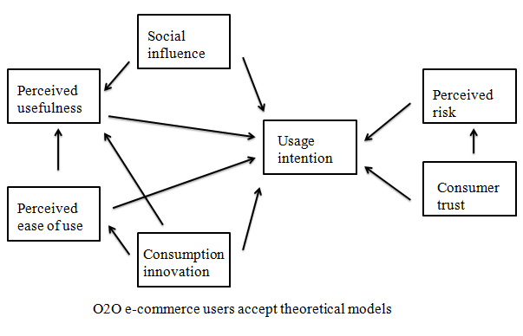

There are not many papers accepted by users studying O2O mode, such as Zhang's O2O model, which explores influence factors of Chinese public users' acceptance behavior (2013), compared with the previous models of O2O mode users accepting relevant research, such as this article. The model has more influencing factors of consumer innovation. Considering that the O2O model is still new to most consumers in China, China's e-commerce and the Internet have developed rapidly in recent years. Many consumers may not be familiar with online shopping, and Chinese consumers are relatively new. Said that the concept is more conservative, not willing to take too much risk. Therefore, consumer innovation is an important factor influencing user acceptance. For this reason, this article has deleted the influencing factor of experience. O2O is a new thing. It has relevant experience in time, and only a few people who are at the forefront of the Internet and e-commerce trends. Most Chinese consumers are not. Have such experience. Therefore, this article eliminates the use of experience.

## 2.5 Summarize of literature review

From the perspective of the development of the theoretical model of technology acceptance, the theory of technology acceptance has been constantly improved and changed to be applicable to more research fields. Relevant interpretation models have been constantly updated and evolved, and more and more research fields can be applied. However, O2O is a brand new research direction after all. It combines high technology, new life style and the Internet shopping, which is booming. It has a series of characteristics, such as innovation, risk, model uncertainty and so on. The author tries to build a model suitable for explaining emphasis of user acceptance of this new business model (Barhoumi, 2016).

As for the O2O e-commerce model, there is no relevant adoption analysis model and framework at home and abroad. Emerging Internet technologies has attracted more attention from researchers, like websites, various applications of communication software, etc. O2O needs more scholars to pay attention to users' acceptance of mobile devices (Hsieh, et. al., 2014). As an emerging business model, O2O e-commerce mode of user acceptance can study by the predecessors' research results, through the appropriate adjustment and innovation, through the empirical study of effect elements of probe feasible for present O2O interpretation model of user acceptance, as the theoretical basis for the development of the pattern in the future (Mulero and Adeyeye, 2013).

## 2.6 Highlights of the research hypothesis

Framework:

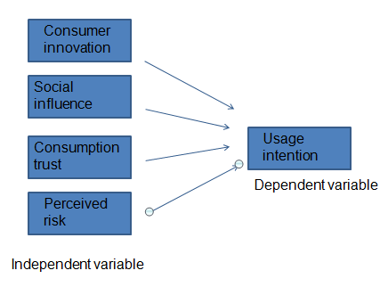

According to the characteristics of O2O mode service and the factors affecting users' acceptance of O2O mode, the framework of this paper is constructed.

H1: consumption innovation of O2O e-commerce model has a positive impact on users' usage intention.

H2: users' social influence on O2O e-commerce model has a positive impact on their usage intention.

H3: users' trust in O2O e-commerce model has a positive impact on their usage intention.

H4: users' perceived risk of O2O e-commerce mode has a negative impact on their usage intention.

# Chapter3. Research Methodology

## 3.1 Research Design

Through reading and study of the literature, and through a lot of analysis and comparative analysis of user acceptance models in various periods, combined with the unique trait of the O2O model, and taking into account a series of problems it may encounter in the future development. This paper proposes a user acceptance model for O2O. It includes the four influencing elements of consumer innovation, social impact, perceived risk and consumer trust, and through the analysis and argumentation, summed up the interrelationship and made assumptions. At the same time, a measurement problem was measured to measure the consumer's perception of these influencing factors. In the following, this paper will use the method of empirical research, design and research a reasonable questionnaire, through the release and recovery of users. The data of the variables needed by the collection are validated and processed by the data to verify the model and hypothesis proposed in this paper.

This paper uses the questionnaire method to gather users’ information. This survey method is a common method that is very suitable for empirical research. Since the model has been built in the previous chapters, and the variables are defined, the interrelationships are assumed, and the preparation work has been completed. The design work of the scale will be carried out on the basis of the previous ones.

The core details of the questionnaire are as follows:

1. Scale part

After referring to scale design of the relevant research literature, considering the unique characteristics of the problems studied in this paper, this paper uses the five-point scale method of Likert in the scale part.

2. Personal information section

The second part is basic information on demographics of the respondents' gender, age, income, education level, etc.

## 3.2 Measuring Instrument

The independent variables of this study are social influence, consumption innovation, perceived risk and consumer trust. The dependent variable is usage intention. A questionnaire is generated by designing corresponding questions around these five variables.

1. Social influence

When consumers make decisions, in addition to some inherent qualities of individuals, it will affect his decision-making. The influence of the surrounding environment on him can not be ignored, such as the views of people around him, and he thinks that when he takes after a certain behavior, what kind of opinions people around him will have. Social opinions and opinions will influence users to use the O2O e-commerce model. The more people around you recommend and promote the use, the greater the willingness and possibility of O2O users use, that is, the social impact has a positive effect on the user's willingness to use. This article uses the five questions shown in the table below to measure the impact of social impact on users:

|  |  |  |
| --- | --- | --- |
| Variable | Measurement problems | Source |
|
| Social influence | If people who around me use O2O e-commerce model, I will consider using it. | French&Raven(1959) |
|
|
| If people who around me recommend O2O e-commerce, I will consider using it. |
|
|
| The publicity of surrounding media advertising will prompt me to try to use O2O e-commerce. |
|
|
| I think it is a fashion to use O2O e-commerce. |
|
|
| Using O2O will make me gain recognition from people around me. |
|
|

Table 3.2.1

2. Consumption innovation

The O2O e-commerce model is a brand new thing that requires consumers to accept the power and willingness of new things. Therefore, consumer innovation is an important measure of whether consumers will use O2O e-commerce. This paper measures the degree of user innovation through the following three questions.

|  |  |  |
| --- | --- | --- |
| Variable | Measurement problems | Source |
|
| Consumption innovation | I am willing to accept new things and have tried many things. | Hirschman(1980)  Venkatraman&Price(1990)  Hurtetal(1977) |
|
|
| I am interested in O2O e-commerce model and willing to try. |
|
|
| People around me think I'm a person who's willing to try new things. |
|
|

Table 3.2.2

3. Perceived risk

Considering the overall characteristics of the O2O e-commerce model and the concerns that may arise during the user acceptance process, this paper will select the following four risks as the dimensions of perceived risk: time risk, functional risk, privacy risk and economic risk. This article measures the perceived risk of users through the following four questions.

|  |  |  |
| --- | --- | --- |
| Variable | Measurement problems | Source |
|
| Perceived risk | I worry that I will not get timely offline services after online consumption. | Featherman&Pavlou(2003) |
|
|
| I am worried that the offline service does not meet the standards promised by the merchant. |
|
|
| I worry that my personal information will be leaked or stolen. |
|
|
| I'm afraid I'll spend more money. |
|
|

Table 3.2.3

4. Consumer trust

The degree of user trust in the platform operator affects user usage. A large part of the enterprises entering the O2O industry may be those that have gained consumer trust in the Internet era. Can they continue to gain the trust of consumers in the O2O era? The integrity, ability and kindness of the platform operators are the three aspects that consumers must have to trust them. This paper measures the user's trust level by the user's perception of these three aspects.

|  |  |  |
| --- | --- | --- |
| Variable | Measurement problems | Source |
|
| Consumer trust | I believe O2O e-commerce service providers are enough to provide good O2O services. | Stone&Gronhaug(1993)  Featherman&Pavlou(2003) |
|
|
| I believe most O2O e-commerce providers are fair, just and trustworthy. |
|
|
| I believe most O2O e-commerce service providers are good for consumers. |
|
|
| In a word, I think O2O e-commerce service providers are trustworthy. |
|
|

Table 3.2.4

5. Usage intention

This paper measures the user's usage intention for O2O e-commerce services through the following three questions.

|  |  |  |
| --- | --- | --- |
| Variable | Measurement problems | Source |
|
| Usage intention | I am willing to use O2O e-commerce service | Ajzen&Fishbein(1975) |
|
|
| I will often use O2O e-commerce services. |
|
|
| I will recommend O2O e-commerce services to people around me. |
|
|

Table 3.2.5

## 3.3 Validity Tests and Reliability Tests

### 3.3.1 Validity analysis

The measurement results can reflect the effectiveness of the survey content is the validity. Measurement results and the content under the agreement, its validity is higher. On the contrary, low effectiveness. There are three types of validity. Efficiency is the most important condition of scientific measurement tools. In the social investigation, questionnaire or demand scale of high reliability and validity. The purpose of measurement and scope should be clear in the identification of validity. Measured content should be taken into account, analysis of the nature and characteristic, check whether the test content is consistent with the purpose of measuring (Avlund, Schultz-Larsen and Kreiner, 1993).

### 3.3.2 Reliability test

Reliability is defined the identical target repeated measurement results the degree of consistency in the same way. Reliability index is divided into stability coefficient, equivalent coefficient and internal consistent coefficient. The method of analyzing reliability is Test-retest reliability, Copy reliability method, and the reliability and reliability coefficient method (Osburn, 2000).

## 3.4 Descriptive statistics

Statistical analysis often begins with an understanding of the basic characteristics of the data (Kalton and Conway, 1963). Describe the statistical characteristic of data distribution can be divided into two categories: category said the center of the quantity, another kind said the number of mutations (or discrete). They complement each other, to reflect the overall situation of the data.

Descriptive statistical analysis is mainly carried out from the aspects of personal information of the interviewees, etc., in terms of variables (Marcoulides and Falk, 2018). Structural equation model can clearly to analyze the role of a single index on the whole and the relationship between the various indicators.

## 3.5 Correlation analysis

Correlation analysis is used when it is necessary to verify the direct correlation of more than two random variables in the same state. As a commonly used analytical method, correlation analysis is only relevant if there is a causal relationship between the variables being studied. It is mainly used to describe the degree of correlation between research factors. A positive correlation is an increase in one indicator as another indicator increases, and a negative correlation is one indicator that decreases as another indicator increases.

## 3.6 Regression analysis

Regression analysis is a common analytical method used to determine the quantitative relationship between independent and dependent variables. The regression coefficient determines the specific causal relationship between the analytical phenomena. The result is expressed by a regression equation. Therefore, the regression analysis mainly studies four problems, the regression equation, the credibility test, quantitative relationship between independent variables and dependent variables and the prediction and control using the regression equation.

## 3.7 Sample selection

This paper tries to select consumers who have used O2O services to participate in questionnaire.

1. Sampling area: Hangzhou, a developed city in China. Hangzhou has the most O2O users.

2. Target groups: Those who have used O2O e-commerce services, or those who have used but know e-commerce services. When selecting the sample size, this article uses the theory proposed by Krejcie and Morgan in 1970 to determine the sample size. This paper is a survey of the number of tables rather than a table structure, so this paper estimates the sample size according to the theory. As shown in the following table:

C:\Users\ADMINI~1\AppData\Local\Temp\1565354465(1).png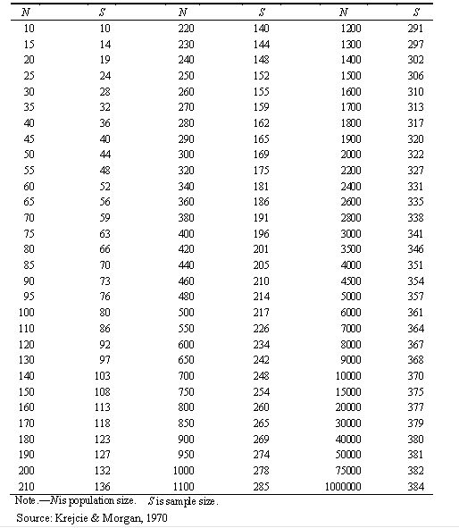

The population size of Hangzhou is more than 1 million, so the sample size is 384.

## 3.8 Sampling method

Snowball sampling interview refers to random respondents, then ask them to provide some belong to the other respondents' overall goal, and according to the formation of the clue to choose the respondents (Etikan, 2016).

In snowball sampling, first choose a group of respondents, are usually random. Respondents can provide information about the people around them after an interview. According to clue provided, we chose the following respondents. This process continues to snowball.

The principle of Snowball sampling is to use a snowball to conduct a sampling survey. The advantage of this sampling method is that the sampling range is wide and the limitations are small. And its confidentiality is very good, the general access to the government or special groups and some private information for some reasons is not convenient for people to disclose the use of snowball sampling.

## 3.9 Data Collection and Analysis Methods

This study will collect data through online questionnaire survey. This study used SPSS22.0 to analyze and process the data. Finally, the hypothesized relation is verified by structural equation model.

# Chapter 4 Data Analysis

## 4.1 Questionnaire reliability and validity analysis

### 4.1.1 Reliability Analysis

A total of 384 questionnaire samples were used for this survey, and the 384 questionnaires were analyzed for reliability. Reliability analysis is the best analytical method for measuring the reliability and consistency of a questionnaire. The value of Alpha coefficient represents the reliability of the questionnaire. If Cronbach's Alpha>=0.8, you don't need to delete any items. If Alpha < 0.8, look at the indicator to remove some of the questions, and Alpha can increase or decrease this value. The questionnaire is considered to be reliable enough when the Alpha value is >=0.7. When the Alpha value is <0, it is necessary to check the questionnaire items and modify them until Alpha>=0.7.

When Cronbach's Alpha > 0.7, indicating that the reliability of each variable of the sample meets the requirements.

| **Reliability Statistics** | | |
| --- | --- | --- |
| Cronbach's Alpha | Cronbach's Alpha Based on Standardized Items | N of Items |
| .800 | .797 | 19 |

Table 4.1.1

The analysis results show that the collected questionnaire data involves 19 scale topics, including Alpha=0.800 and standardized Alpha=0.797, which are larger, indicating that the questionnaire has higher validity and the questionnaire scale has higher internal consistency. The questionnaire has good reliability and the results are credible.

### 4.1.2 Validity analysis

Based on the results of the reliability analysis, so as to better realize the structural rationality of the whole survey, the structural validity analysis of the questionnaire based on factor analysis was carried out. First we should do Factor-adaptive KMO and Bartlett's Test. The KMO value is large, indicating that the data can be factored, usually KMO coefficient needs to be above 0.5.

| **KMO and Bartlett's Test** | | |
| --- | --- | --- |
| Kaiser-Meyer-Olkin Measure of Sampling Adequacy. | | .789 |
| Bartlett's Test of Sphericity | Approx. Chi-Square | 6246.515 |
| df | 171 |
| Sig. | .000 |

Table 4.1.2

The analysis results show that the questionnaire has a KMO=0.789, which is larger, and the test probability p value of Bartlett's Test is 0.000<0.05, indicating that the questionnaire scale is suitable for factor analysis.

| **Total Variance Explained** | | | | | | | | | |
| --- | --- | --- | --- | --- | --- | --- | --- | --- | --- |
| Component | Initial Eigenvalues | | | Extraction Sums of Squared Loadings | | | Rotation Sums of Squared Loadings | | |
| Total | % of Variance | Cumulative % | Total | % of Variance | Cumulative % | Total | % of Variance | Cumulative % |
| 1 | 4.589 | 24.151 | 24.151 | 4.589 | 24.151 | 24.151 | 3.994 | 21.023 | 21.023 |
| 2 | 4.121 | 21.688 | 45.839 | 4.121 | 21.688 | 45.839 | 3.119 | 16.414 | 37.436 |
| 3 | 2.950 | 15.525 | 61.364 | 2.950 | 15.525 | 61.364 | 2.990 | 15.734 | 53.171 |
| 4 | 1.962 | 10.326 | 71.690 | 1.962 | 10.326 | 71.690 | 2.684 | 14.127 | 67.297 |
| 5 | 1.058 | 5.569 | 77.260 | 1.058 | 5.569 | 77.260 | 1.893 | 9.962 | 77.260 |
| 6 | .978 | 5.146 | 82.406 |  |  |  |  |  |  |
| 7 | .590 | 3.104 | 85.510 |  |  |  |  |  |  |
| 8 | .475 | 2.501 | 88.011 |  |  |  |  |  |  |
| 9 | .425 | 2.236 | 90.247 |  |  |  |  |  |  |
| 10 | .344 | 1.810 | 92.057 |  |  |  |  |  |  |
| 11 | .301 | 1.586 | 93.643 |  |  |  |  |  |  |
| 12 | .285 | 1.501 | 95.144 |  |  |  |  |  |  |
| 13 | .252 | 1.328 | 96.472 |  |  |  |  |  |  |
| 14 | .212 | 1.113 | 97.586 |  |  |  |  |  |  |
| 15 | .171 | .899 | 98.485 |  |  |  |  |  |  |
| 16 | .110 | .578 | 99.063 |  |  |  |  |  |  |
| 17 | .095 | .502 | 99.565 |  |  |  |  |  |  |
| 18 | .052 | .274 | 99.840 |  |  |  |  |  |  |
| 19 | .030 | .160 | 100.000 |  |  |  |  |  |  |
| Extraction Method: Principal Component Analysis. | | | | | | | | | |

Table 4.1.3

The Total Variance Explained results illustrate that the total of 19 questionnaires with reliability can extract 5 common factors, and the variance of interpretation accounts for 77.260%. Therefore, the extracted 5 common factors are sufficient to extract and interpret the information of the original variables. The aspect is ideal.

| **Rotated Component Matrixa** | | | | | |
| --- | --- | --- | --- | --- | --- |
|  | Component | | | | |
| 1 | 2 | 3 | 4 | 5 |
| Q2 | .942 | .025 | .071 | -.032 | -.020 |
| Q4 | .902 | .025 | .054 | .008 | -.037 |
| Q3 | .900 | .030 | .027 | .004 | .057 |
| Q1 | .853 | .051 | .080 | -.025 | -.107 |
| Q5 | .852 | .107 | -.023 | .003 | .074 |
| Q10 | .071 | .952 | .000 | -.033 | .008 |
| Q9 | .042 | .908 | -.009 | -.024 | .033 |
| Q11 | .094 | .849 | -.006 | .015 | -.043 |
| Q12 | .009 | .803 | -.026 | -.035 | .012 |
| Q17 | .067 | -.033 | .852 | .129 | .028 |
| Q19 | .064 | .007 | .851 | .207 | .195 |
| Q18 | .072 | -.023 | .850 | .229 | .113 |
| Q8 | -.017 | -.027 | .172 | .948 | .033 |
| Q7 | -.026 | -.019 | .206 | .936 | .040 |
| Q6 | .000 | -.030 | .185 | .862 | .037 |
| Q13 | .007 | -.023 | .254 | .012 | .735 |
| Q15 | -.008 | .022 | .529 | .162 | .729 |
| Q14 | -.021 | .007 | .547 | .149 | .716 |
| Q16 | -.016 | .014 | -.226 | -.046 | .478 |
| Extraction Method: Principal Component Analysis.  Rotation Method: Varimax with Kaiser Normalization. | | | | | |
| a. Rotation converged in 5 iterations. | | | | | |

Table 4.1.4

According to the above-mentioned rotated factor load matrix, the 19 topics contain a total of five common factors. Among them:

Common factor one: contains five questions Q1—Q5, mainly used to reflect the social influence of the respondent on the use of O2O;

Common factor two: contains four questions of Q9-Q12, mainly used to reflect the Perceived risk when the O2O is investigated.

Common factor three: contains three questions Q17-Q19, mainly used to reflect the respondent's Usage intention for O2O;

Common factor four: contains three questions Q6-Q8, mainly used to reflect the respondent's Consumer innovation to O2O;

Common factor five: contains four questions Q13-Q16 to reflect the respondent's Consumer trust for O2O.

According to the classification of the topics included in each factor, there is a high consistency with the structure of the questionnaire hypothesis. Each factor can better measure the dimensions of the questionnaire survey, and it is considered that the design of this questionnaire has good structural validity.

## 4.2 Descriptive analysis of basic information of respondents

### 4.2.1 Individual information of the respondent

|  |  |  |  |  |  |
| --- | --- | --- | --- | --- | --- |
|  |  | Frequency | Percent | Valid Percent | Cumulative Percent |
| Sex | Male | 205 | 53.4 | 53.4 | 53.4 |
|  | Female | 179 | 46.6 | 46.6 | 100.0 |
| monthly income | <3000 | 83 | 21.6 | 21.6 | 21.6 |
|  | 3001~6000 | 173 | 45.1 | 45.1 | 66.7 |
|  | 6001~9000 | 71 | 18.5 | 18.5 | 85.2 |
|  | >9000 | 57 | 14.8 | 14.8 | 100.0 |
| Age | <18 | 12 | 3.1 | 3.1 | 3.1 |
|  | 18~25 | 74 | 19.3 | 19.3 | 22.4 |
|  | 26~35 | 264 | 68.8 | 68.8 | 91.1 |
|  | 36~45 | 17 | 4.4 | 4.4 | 95.6 |
|  | >45 | 17 | 4.4 | 4.4 | 100.0 |
| Education | Junior college or below | 48 | 12.5 | 12.5 | 12.5 |
|  | Undergraduate | 192 | 50.0 | 50.0 | 62.5 |
|  | Postgraduate | 96 | 25.0 | 25.0 | 87.5 |
|  | PhD and above | 48 | 12.5 | 12.5 | 100.0 |

Table 4.2.1 Personal basic information form

For the respondents who participated in the “O2O e-commerce model user acceptance factor research survey report”, Male had 205, accounting for 53.4%; Female had 179, accounting for 46.6%. This shows that the proportion of males and females in the group using O2O e-commerce services is not large.

The monthly income is mainly concentrated at 3001~6000 yuan, accounting for nearly half of the proportion of 45.1%, followed by 3,000 yuan or less, accounting for 21.6%, while 6001~9000 and above 9000 have a relatively small proportion, respectively 18.5% and 14.8%. This shows that the per capita income of using O2O e-commerce services is generally between 3001 and 6000 yuan.

For the age distribution, the age of the participants in the survey was 26 to 35 years old, accounting for 68.8%, followed by 18 to 25 years old, accounting for 19.3%.

For the academic survey of the respondents, the results show that the students who participated in this survey mainly concentrated in the undergraduate degree, accounting for 50% of the total; followed by the master's degree, accounting for 25.0%.

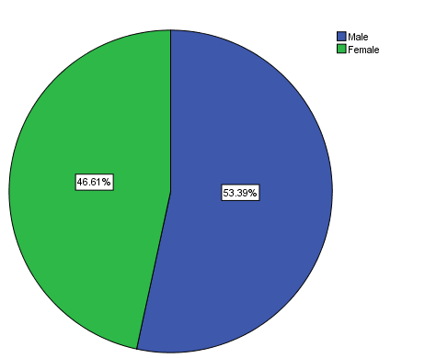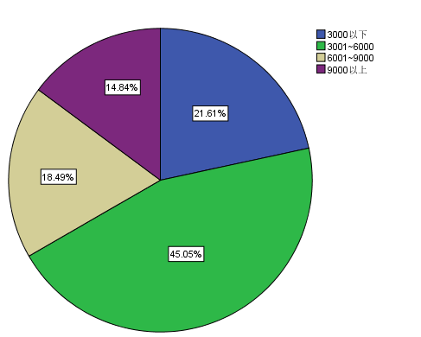

Chart 4.2.1 Chart 4.2.2

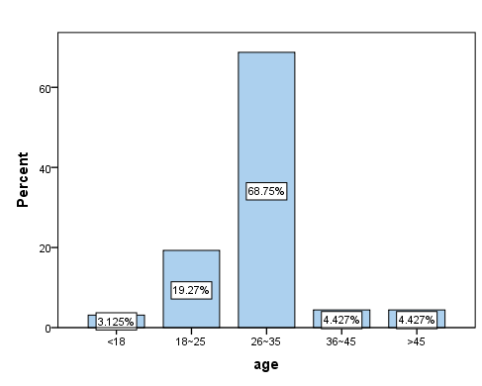

Chart 4.2.3

|  |  |
| --- | --- |
| Education | Percent |
|
| Junior college or below | 12.5% |
|
| Undergraduate | 50% |
|
| Postgraduate | 25% |
|
| PhD and above | 12.5% |
|

Table 4.2.2

It can also be seen from the pie chart of gender and income distribution that the number of males and females participating in this survey is similar; the income is mainly concentrated in the range of 3001~6000 yuan.

It can also be seen from the histograms and tables of the distribution of age and education level that the age of the respondents is mainly between 26 and 35 years old, while the number of undergraduate degrees is mostly.

### 4.2.2 The current status of O2O use by respondents

|  |  |  |  |  |  |
| --- | --- | --- | --- | --- | --- |
|  |  | Frequency | Percent | Valid Percent | Cumulative Percent |
| Frequency | Once a month and below | 55 | 14.3 | 14.3 | 14.3 |
|  | 2~3 times a month | 137 | 35.7 | 35.7 | 50.0 |
|  | Once a week | 137 | 35.7 | 35.7 | 85.7 |
|  | Once a week or more | 55 | 14.3 | 14.3 | 100.0 |
| Communication monthly cost | 50 yuan and below | 51 | 13.3 | 13.3 | 13.3 |
|  | 51~100 yuan | 104 | 27.1 | 27.1 | 40.4 |
|  | 101~150 yuan | 153 | 39.8 | 39.8 | 80.2 |
|  | 151~200 yuan | 51 | 13.3 | 13.3 | 93.5 |
|  | More than 200 yuan | 25 | 6.5 | 6.5 | 100.0 |
| Willing to spend the most amount for O2O | 50 yuan and below | 35 | 9.1 | 9.1 | 9.1 |
|  | 51~200 yuan | 105 | 27.3 | 27.3 | 36.5 |
|  | 201~500 yuan | 209 | 54.4 | 54.4 | 90.9 |
|  | More than 500 yuan | 35 | 9.1 | 9.1 | 100.0 |

Table 4.2.3 O2O use status information table

The survey results show that the frequency of O2O use is mainly concentrated 2 to 3 times a month and once a week, which account for the same proportion of 35.7%. For the monthly communication, the amount spent on communication is between 101 and 150 yuan, accounting for 39.8%, followed by 51 to 100 yuan, accounting for 27.1%. The amount that the respondents are willing to spend for O2O is mainly concentrated at 201~500 yuan, accounting for a large proportion of 54.4%, followed by 51~200 yuan, accounting for 27.3%, indicating the participation of the participants in the O2O consumption. There is a large consumption space.

|  |  |
| --- | --- |
| You use the frequency of e-commerce O2O | Percent |
|
|
| Once a month and below | 14.32% |
|
| 2~3 times a month | 35.68% |
|
| Once a week | 35.68% |
|
| Once a week or more | 14.32% |
|

Table 4.2.4 Use O2O frequency

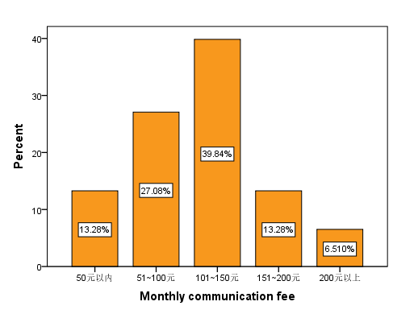

Chart 4.2.4

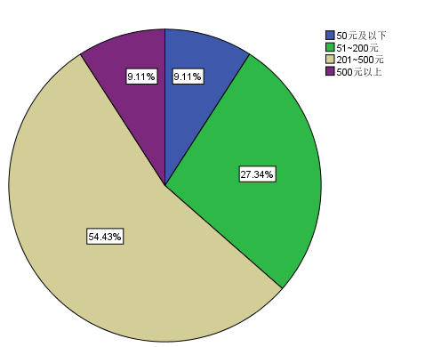

Chart 4.2.5 willing to spend the maximum amount O2O

From the frequency of O2O use, the amount of money spent on communication each month, and the amount of histograms and pie charts and tables that are willing to spend for O2O, it can be seen intuitively that the surveyed population is more frequently used for O2O, communication. It costs a lot and is willing to spend a large amount on O2O. The market for O2O has a large room for development, and most people also have a greater willingness to use it.

## 4.3 Correlation analysis

In order to analyze user acceptance factors affecting the O2O model, five common factors based on the validity analysis are averaged for the scores of the scales included in each factor, as the measurement level of the measure and the factor size, to reflect the various factors. The degree is named: Usage intention, Social influence, Consumer innovation, Perceived risk, Consumer trust, and is represented by UI, SI, CI, PR, and CT, respectively.

So as to analyze the causal relationship of variables, each variable was analyzed by Pearson correlation. The results are shown in the following table:

| **Correlations** | | | | | | |
| --- | --- | --- | --- | --- | --- | --- |
|  | | UI | SI | CI | PR | CT |
| UI | Pearson Correlation | 1 | .113* | .397** | -.027 | .508** |
| Sig. (2-tailed) |  | .027 | .000 | .594 | .000 |
| N | 384 | 384 | 384 | 384 | 384 |
| SI | Pearson Correlation | .113* | 1 | -.017 | .112* | -.003 |
| Sig. (2-tailed) | .027 |  | .739 | .028 | .950 |
| N | 384 | 384 | 384 | 384 | 384 |
| CI | Pearson Correlation | .397** | -.017 | 1 | -.051 | .212** |
| Sig. (2-tailed) | .000 | .739 |  | .314 | .000 |
| N | 384 | 384 | 384 | 384 | 384 |
| PR | Pearson Correlation | -.027 | .112* | -.051 | 1 | .004 |
| Sig. (2-tailed) | .594 | .028 | .314 |  | .942 |
| N | 384 | 384 | 384 | 384 | 384 |
| CT | Pearson Correlation | .508** | -.003 | .212** | .004 | 1 |
| Sig. (2-tailed) | .000 | .950 | .000 | .942 |  |
| N | 384 | 384 | 384 | 384 | 384 |
| *. Correlation is significant at the 0.05 level (2-tailed).  **. Correlation is significant at the 0.01 level (2-tailed). | | | | | | |

Table 4.3.1

The correlation result table shows that the correlation coefficient between UI and SI is 0.113>0 and the p-value =0.027<0.05, indicating that the user uses the UI and SI to show a significant positive correlation, with SI As the number increases, the UI will also show an increasing trend. Similarly, the correlation coefficients between UI and CI and CT are: 0.397 and 0.508, and the p-value of the coefficient significance test is <0.05, demonstrate UI has a significant positive impact with CI and CT, with increasing CI and CT. Large, UI will also show an increasing trend.

For the correlation coefficient between UI and PR: -0.027<0, it illustrates that there is a negative impact between UI and PR. As PR increases, the UI will decrease, but the p-value of the two coefficients is >0.05, certify that although there is a certain negative impact between the two, it is not significant.

## 4.4 O2O e-commerce model user acceptance regression analysis

Based on the correlation analysis results, UI and SI, CI, and CT all showed significant positive correlation, and there was a weak negative correlation between UI and PR. Therefore, in order to quantitatively measure the influence of various factors on the UI, a multiple linear regression model is established:



Where  is the intercept term, which  is the regression coefficient and  is the random error term. The regression results are shown in the table below:

| **Model Summary** | | | | |
| --- | --- | --- | --- | --- |
| Model | R | R Square | Adjusted R Square | Std. Error of the Estimate |
| 1 | .601a | .361 | .354 | .80648 |
| a. Predictors: (Constant), CT, SI, PR, CI  Table 4.4.1 | | | | |

This table shows that the established regression model can have R Square is 0.361 and Adjusted R Square is 0.354, which are larger, indicating that the model has higher model goodness of fit, and independent variable can explain variation of the dependent variable by 36.1%.

| **ANOVAb** | | | | | | |
| --- | --- | --- | --- | --- | --- | --- |
| Model | | Sum of Squares | df | Mean Square | F | Sig. |
| 1 | Regression | 139.200 | 4 | 34.800 | 53.504 | .000a |
| Residual | 246.508 | 379 | .650 |  |  |
| Total | 385.708 | 383 |  |  |  |
| a. Predictors: (Constant), CT, SI, PR, CI  b. Dependent Variable: UI  Table 4.4.2 | | | | | | |

The ANOVA results illustrate that the F value of model significance test = 53.504, and the test p value is 0.000 < 0.05, indicating the established regression model is significant and effective.

| **Coefficientsa** | | | | | | |
| --- | --- | --- | --- | --- | --- | --- |
| Model | | Unstandardized Coefficients | | Standardized Coefficients | t | Sig. |
| B | Std. Error | Beta |
| 1 | (Constant) | .409 | .282 |  | 1.450 | .148 |
| SI | .120 | .040 | .123 | 2.972 | .000 |
| CI | .317 | .044 | .303 | 7.209 | .000 |
| PR | -.030 | .046 | -.027 | -.654 | .513 |
| CT | .519 | .049 | .444 | 10.572 | .000 |
| a. Dependent Variable: UI  Table 4.4.3 | | | | | | |

The Coefficients results table shows that the regression coefficient of SI is 0.120, the t value of the coefficient significance test = 2.972, and the p value = 0.000 < 0.01, indicating that the regression coefficient of SI is significantly effective. Similarly, the regression coefficient of CI and CT showed that the p-value was <0.05, indicating that the regression coefficients of CI and CT for UI were significant. The PR value of PR for the regression coefficient of the UI is p=0.513>0.05, indicating that the regression coefficient of PR for UI is not significant.

Based on the above analysis, the fitted regression equation is:



It shows that for every additional unit of SI, the UI increases by 0.12 units on average; for every unit of CI increase, the UI increases by 0.317 units on average; for every unit of CT increase, the average UI increases by 0.519 units, indicating that CT has the greatest impact on UI. And SI is the smallest.

## 4.5 Analysis summary

Cronbach's Alpha=0.797 was obtained according to the reliability analysis, which met the reliability requirements. In the validity analysis, the questionnaire has a KMO=0.789, which is larger, and the test probability p value corresponding to Bartlett's Test=0.000<0.05, illustrate the questionnaire scale is fit for factor analysis. According to classification of the topics included in each factor, there is a high consistency with the structure of the questionnaire hypothesis. Each factor can better measure the dimensions of the questionnaire survey, and it is considered that the design of this questionnaire has good structural validity.

By describing the results of the analysis, we know that the proportion of men and women using O2O e-commerce services is almost the same. The monthly income is mainly concentrated at 3001~6000 yuan, accounting for nearly half of the 45.1%. The age is generally concentrated in 26 to 35 years old, accounting for 68.8%. Most of the students' academic qualifications are undergraduate, accounting for 50% of the total. The master's degree accounted for 25% of the total. The frequency of use of O2O by respondents was mainly concentrated 2 to 3 times a month and once a week. For the monthly communication amount is between 101~150 yuan, the amount that the respondent is willing to spend for O2O is mainly concentrated in 201~500 yuan, which indicates that the participants in this survey have a higher consumption of O2O. Descriptive analysis can be very intuitive to see that O2O's market prospects are very impressive. People using O2O e-commerce services use O2O at a high frequency, communication costs and willing to invest a lot of money in O2O e-commerce. Most people have a willingness to use O2O. This side reflects the popularity of O2O and the market operating space. So in the future, O2O will inevitably become the mainstream of the market.

The analysis results of the correlation analysis show that the user's usage intention and social influence show a significant positive correlation. As the social influence increases, the usage intention will also show an increasing trend. The same is true between user's usage intention and the consumption innovation. As the consumption innovation increases, the user's usage intention will also show an increasing trend. Similarly, the user's usage intention and consumer trust also show a significant positive correlation. As the consumer trust increases, the user's usage intention will also show an increasing trend. The correlation coefficient between the user’s usage intention and the perceived risk is -0.027<0, indicating that the user's usage intention and the perceived risk show a negative correlation. As the perceived risk increases, the user's usage intention will decrease. However, the p-value of the two coefficient tests is >0.05, indicating that although there is a certain negative correlation between the two, it is not significant.

The research hypothesis of this paper is as follows:

|  |  |  |  |
| --- | --- | --- | --- |
| Items | Research hypotheses | Significant level | Supported/Rejected |
| H1 | The consumption innovation of O2O e-commerce model has a positive impact on users' usage intention. | sig=0.000 p<0.01 | Supported |
| H2 | Users' social influence on O2O e-commerce model has a positive impact on their usage intention. | sig=0.000 p<0.01 | Supported |
| H3 | Users' trust in O2O e-commerce model has a positive impact on their usage intention. | sig=0.000 p<0.01 | Supported |
| H4 | Users' perceived risk of O2O e-commerce mode has a negative impact on their usage intention. | sig=0.513 p>0.05 | Supported but not Significant |

According to the correlation analysis, the following conclusions can be drawn:

The user's usage intention and consumption innovation show a significant positive correlation. And user's usage intention has a significant positive correlation with the social influence and consumer trust. So the first three assumptions are true and the effect is significant. The fourth hypothesis is also correct, the user's usage intention has a negative correlation with the perceived risk, but is not significant.

The result of the regression analysis is that the model has a high degree of fit, and the established model is significantly effective. The social influence, the consumption innovation and the consumer trust are significant for the regression intention of consumer’s usage intention. Perceived risk has no significant effect on the user's usage intention.

Regression equation: 

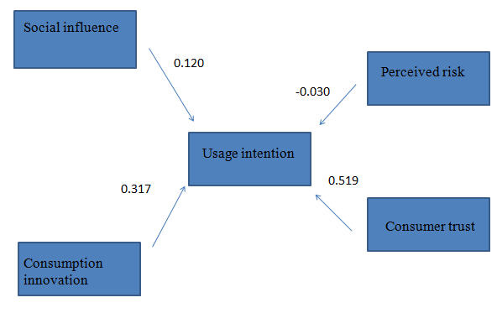

Table 4.5.1 O2O e-commerce mode user accepts behavior verification results

# Chapter 5 Discussions, Conclusions and Recommendations

In the previous chapters, through the understanding and research of the O2O model, I mastered basic characteristics and problems of O2O. Based on the theoretical research of the predecessors' users, the key to O2O model was extracted. Influencing factors, and exploring the relationship between various factors, build a O2O model. In the empirical analysis, through the design and distribution of the questionnaire, we obtained the data of the variables of these influencing factors. After analyzing the collected data, the corresponding conclusions were obtained, which verified the hypothesis and the O2O user acceptance model. This chapter is mainly for O2O to propose some feasible suggestions, to prevent problems that may be encountered in the future O2O and to develop corresponding solutions. Finally, it summarizes the shortcomings of this paper in the research, and puts forward suggestions and prospects for the continuation of the subsequent research work.

## 5.1 Analysis conclusion

In addition to the perceived negative impact on the usage intention, the other three factors have a significant positive impact on the usage intention. Consumer trust in O2O platform operators can affect user choices for O2O services. Consumption innovation significantly affects consumers' attitudes toward O2O services. Social influence will directly or indirectly influence consumers' perceptions of O2O. When people around them use O2O services, these users will also have the idea of using O2O. The following are the reasons and original intentions of this paper to propose these four variables and conduct research analysis.

H1: the consumption innovation of O2O e-commerce model is affecting users' usage intention.

Services or finished products in the O2O model appear in front of public, and it is necessary to consider the acceptance of new things by different consumers. Consumers with high-innovation consumers may be more willing to try new Internet products or services, and their willingness to use is stronger.

The result of this study is that consumption innovation has a positive positive impact on usage intention. This just verifies that the consumption innovation mentioned by Hirschman (1980) and Venkatraman & Price (1990) affects consumer acceptance of the inherent personality of new things.

H2: users' social influence on O2O e-commerce model has a positive impact on their usage intention.

As an important product of the mobile communication era, the O2O model is bound to be closely related to communication and social interaction. Interpersonal relationship is also an important way to promote. Therefore, there is reason to believe that social influence will have a certain impact on consumers' willingness to use and use behavior.

The result of this study is that social influence has a positive positive impact on usage intention, which also validates the theory proposed by French and Raven (1959) that the repressive power and influence of social reactions will have a certain impact on consumers.

H3: consumer trust in O2O e-commerce model has a positive impact on their usage intention.

China is a country where imitation and cottages are everywhere. Consumers may choose a big O2O e-commerce platform they trust to conduct an attempt and exploration.

The result of this study is that consumer trust has a positive positive impact on willingness to use. This confirms the argument that Mayer and other scholars put forward that "trust can reduce the perceived risk of consumers, and risk is the environment on which trust depends." Consumer trust has a great impact on consumers' desire to consume.

H4: users' perceived risk of O2O e-commerce mode has a negative impact on their usage intention.

For the unknown O2O enterprises, compared with some well-known Internet platforms, consumers may think that choosing a more popular Internet platform will be relatively more insurance and less risky.

The result of this study is that perceived risk has no significant negative impact on usage intention. This validates the perceived risk theory that Jacoby and Kaplan proposed in 1972: several different types of risks have an insignificant impact on consumer buying behavior.

## 5.2 Study Implications

### 5.2.1 Impact on the academic

This study validates the social influence, consumer trust, consumption innovation and perceived risk all affect the user's usage intention for O2O. It proves that the theoretical support in the literature review is correct. Academically, it provides theoretical support for models such as TAM2, UTAUT, DIT and perceived risk theory. Through a large number of data analysis, the O2O theoretical model proposed by the predecessors is verified and a new O2O theoretical model is proposed. This article can also provide a reference for scholars who want to study O2O in the future.

### 5.2.2 Impact on the industry

The significance of this study for the O2O industry is obvious. The O2O industry can improve its service system and quality against these influencing factors to meet the expected needs of customers. Although the O2O industry will definitely become the leader in e-commerce in the future, there are still many shortcomings and shortcomings. O2O merchants can judge through the conclusions of this study, aiming to improve and improve the defects in the service system. Such as security issues, confidential issues, after-sales service issues, these issues will seriously affect the subjective feelings of consumers to choose O2O platform services. Therefore, the significance of this research for the O2O industry and the entire e-commerce industry is very large.

### 5.2.3 Impact on the government

China is a developing country. However, China's GDP is increasing year by year, and the role of O2O is enormous. China wants to vigorously improve its economic level and cannot do without the development of O2O. Therefore, the O2O deficiency pointed out in this paper will become more competitive after being improved. It will attract more consumers of different ages to consume and become popular throughout the country, thus increasing China's GDP.

## 5.3 O2O e-commerce development recommendation

We explored the impact of each key influencing factor on user's usage intention. According to relevant analysis and research of data results, this paper provides some feasible suggestions for the development of O2O e-commerce from the following aspects, hoping to contribute to the development of O2O.

1. Increase the safety factor and let the user feel at ease. As can be seen from the research results of this article, users are very worried about the fraud of their own funds and property in the process of enjoying O2O services. The negative impact on users is very large, which directly affects user's usage intention. In addition, the privacy of users has also been leaked, and it is necessary to vigorously develop the security protection technology in O2O. Users can use O2O e-commerce services with confidence. At the same time, we need a guarantee of a sound service system and service mechanism. At this stage, most O2O platforms adopt real-name methods to protect consumer information. However, many illegal gangs have gradually become targeted. A single real-name system and SMS verification cannot completely block the risk of disclosure of private information. Therefore, the O2O platform needs to further complete its own protection mechanism. Perform secondary authentication or develop fingerprint or password recognition and other protection measures on the platform.

2. Improve the quality of after-sales service and offline services. Most consumers repeat the consumption of the platforms they trust. When they face an unfamiliar service platform, they usually judge the comments of the platform by other users who have used the platform. But most studies show that when consumers face platforms they trust and unfamiliar platforms, most consumers choose the platform they trust. The current problem with O2O services is that offline quality of service and after-sales service are not satisfactory to most users. The catering industry is an excellent example. Consumers order and pay online, but they can't wait for their own takeaway. Some consumers have also suffered from food packaging and food loss. These will affect consumers' evaluation of the business and consumer attitudes. In the field of after-sales service, China's Taobao is a typical example. Most consumers buy their favorite products on the platform, and the information obtained by asking the customer before purchasing is not matched with the information obtained after receiving the product. However, when they want to ask about these situations, customer service disregard and perfunctory attitude will affect the user's buying experience. There are many large O2O platforms like Taobao, and after-sales service is very important. Therefore, it is urgent to improve the level of after-sales service and offline service. The O2O service platform should have a perfect service system.

3. Add more and better service models. The O2O platform provides a number of services that consumers have never experienced before. Novelty, fashion, and innovative thinking are everywhere on the O2O platform. O2O will provide more convenient, faster and more versatile services. But this requires the platform operator to have enough imagination and ability to make the most of it. For example, the high coverage of offline channels, rapid response from online and offline, price concessions, and humanized services. I hope that in the future, we can build sustainable and customer-centric O2O products or services. With today's platform services emerging, consumers are increasingly demanding and becoming more demanding. If the services provided by the O2O platform cannot keep up with the times, can not meet the needs of consumers, and can not attract the user's desire to buy, then O2O services will gradually be eliminated. In order to avoid this situation, O2O should give full play to its advantages and continue to add new functions and services, so that it can expand new services to attract consumers to achieve a virtuous cycle, and also give users a satisfactory consumer experience. Improve the reputation of the platform.

4. Increase publicity through some media and carry out some charity activities to enhance social reputation. Today's society attaches great importance to the reputation of a company. The influence of society on a platform or even a company is enormous. Consumers have limited access to information, and news and people around them are the main source of news for most consumers. Therefore, O2O merchants must increase their publicity efforts in order to attract new customers. Promote its own advantages in the public number, Weibo and other media, so that users have a good first impression and judgment for the business. At the same time, increase the number of advertisements, so that more people have a general understanding of the platform. O2O companies and platforms also need to do some charity activities and CSR activities, which will help improve the society's evaluation of the business, enhance their reputation, and get a good chain effect.

All in all, there are still many areas where the O2O platform needs to be upgraded. These four recommendations are only suggestions for the four influencing factors mentioned in the article. O2O companies can't indulge in the current success, but constantly improve their service system, improve their service quality, and give users a better and more comfortable consumer experience. This will stand out in the e-commerce platform that stands out from the crowd.

## 5.4 Self-reflection

Through the understanding and research of O2O model, this paper grasps the basic characteristics and problems of O2O. Based on the theoretical research of predecessors, it extracts the key influencing factors of O2O e-commerce users and explores them. In the empirical research, through the design and distribution of the questionnaire, we obtained the data of the variables of these influencing factors. After data analysis of the collected data, the O2O model user acceptance model was verified. However, due to my limited ability, coupled with the objective reasons such as time and other realistic conditions, the research in this paper still has certain limitations and shortcomings. Later research has room for improvement and improvement. It is recommended to further study from the following aspects.

1. Improve the model and consider more influencing factors. For the research accepted by users of O2O e-commerce model, this paper only made some improvement and expansion on the original acceptance model, taking into account some influencing factors that have a relatively large impact relationship. However, there are still many factors affect users' acceptance of the O2O e-commerce model, which requires more comprehensive consideration and exploration. Due to the limitations of my ability, the consideration of influencing factors may not be reasonable. The model needs to be refined and optimized to make the research more practical and applicable.

2. Expand the sample source. The respondents to the questionnaire survey mainly focused on the campus of Hangzhou University and their own private communication circle. Data sources are relatively narrow and single, and they do not have good generality and generation. These limitations will have a certain impact on the rationality of the sample, resulting in a large overlap of sample individuals. No matter the age, respondents' identity and location are relatively concentrated, so the data reflects the situation is not obvious, can not clearly reflect the consumer group's acceptance of O2O services, which leads to bias in the research. Subsequent research can further strengthen this research from the source of the sample and the expansion of the sample size.

# REFERENCES

Lee, S. (2017). A Case Study of Bandi&Luni's Bookstore Using an Online to Offline(O2O) Service Design. *Journal of the Korea Industrial Information Systems Research*, 22(1), pp.117-126.

Lim, M. and Lim, G. (2016). A Study on the Satisfaction and Reuse of Real Estate O2O (Online to Offline) App Services. *Information Systems Review*, 18(3), pp.97-110.

Zhang, J., Chen, H. and Wu, X. (2015). Operation Models in O2O Supply Chain When Existing Competitive Service Level. *International Journal of u- and e- Service, Science and Technology*, 8(9), pp.279-290.

Kim, H. and Choi, B. (2015). O2O-based Social Media Marketing Method for Word-Of-Mouth Effect: Focused on the Analysis of Case Studies. *The Journal of the Korea Contents Association*, 15(7), pp.403-413.

LIU, Y. and WANG, L. (2016). The Fresh Products O2O Mode of New Development Base on the Internet of Things Era. *DEStech Transactions on Economics and Management*, (iceme-ebm).

Liu, Y. (2016). Customers' Choice between Online or Offline Channel about Search Products, Experience Products and Credence Products. *International Business Research*, 9(11), p.38.

Chang, Y., Hsu, P. and Yang, Q. (2018). Integration of online and offline channels: a view of O2O commerce. *Internet Research*, 28(4), pp.926-945.

KwangMin Cho (2018). Predicting acceptance intention of potential sports O2O service consumers based on revised model of goal-directed behavior. *Korean Journal of Sport Science*, 29(2), pp.281-297.

Jung, S. and Kim, J. (2018). A Study on the Continuous Usage Intention Factors of O2O Service. *Information Systems Review*, 20(4), pp.1-23.

Zhang, L. and Fang, S. (2013). Joint Purchase Service System Research Based on User Needs. *Applied Mechanics and Materials*, 423-426, pp.1823-1826.

Sun, Z. (2017). Effects of Shopping Motivation of O2O on Trust and Users` Intention. *The e-Business Studies*, 18(2), pp.315-329.

PRAMESTIARA, A. and RAHAB, R. (2018). The Effect of Electronic Word-of-Mouth in Social Media toward Consumer Purchase Decision with Brand Image as Moderating Variable. *JOURNAL OF RESEARCH IN MANAGEMENT*, 1(1).

Kang, T. (2016). A New Business Model for E-commerce: T-commerce and Its Implications on Financial Institutions. *International Academy of Global Business and Trade*, 12(1), pp.37-42.

Patton, M. and Jøsang, A. (2004). Technologies for Trust in Electronic Commerce. *Electronic Commerce Research*, 4(1/2), pp.9-21.

Kim, D. and Jeong, H. (2016). Factors which Influence Customers' Intention to Switch from Call-Based Driver-for-hire Services to App-Based Driver-for-hire Services Based on Online to Offline (O2O) Business Model: Focusing on Kakao Driver service. *The Journal of Society for e-Business Studies*, 21(3), pp.51-78.

Lee, J. and Chung, J. (2017). A Study on User Experience Design Process of O2O Shopping. *Advanced Science Letters*, 23(10), pp.9461-9464.

Board, E. (2016). Leader of a Strategic Research Cluster and has a Strong Track Record of Programmatic Research based around his Interest in Information Technology Evaluation. *Global Journal of Enterprise Information System*, 8(1), p.61.

Yu, L. (2018). A novel E-commerce model and system based on O2O sports community. *Information Systems and e-Business Management*.

Athapaththu, J. and Kulathunga, D. (2018). Factors Affecting Online Purchase Intention: Effects of Technology and Social Commerce. *International Business Research*, 11(10), p.111.

이지현, KwangMin Cho and 김태중 (2018). Predicting acceptance intention of potential sports O2O service consumers based on revised model of goal-directed behavior. *Korean Journal of Sport Science*, 29(2), pp.281-297.

Laroche, M., Bergeron, J. and Barbaro‐Forleo, G. (2001). Targeting consumers who are willing to pay more for environmentally friendly products. Journal of Consumer Marketing, 18(6), pp.503-520.

LIU, Y. and WANG, L. (2016). The Fresh Products O2O Mode of New Development Base on the Internet of Things Era. DEStech Transactions on Economics and Management, (iceme-ebm).

Yildiz, H., Heitz-Spahn, S. and Belaud, L. (2018). Do ethnocentric consumers really buy local products?. Journal of Retailing and Consumer Services, 43, pp.139-148.

Vander Schee, B. (2011). Students as Consumers: Programming for Brand Loyalty. Services Marketing Quarterly, 32(1), pp.32-43.

Tse, A. (2001). How much more are consumers willing to pay for a higher level of service? A preliminary survey. Journal of Services Marketing, 15(1), pp.11-17.

Yan, R. and Pei, Z. (2019). Return policies and O2O coordination in the e-tailing age. Journal of Retailing and Consumer Services, 50, pp.314-321.

Hirschman, E. (1980). Innovativeness, Novelty Seeking, and Consumer Creativity. Journal of Consumer Research, 7(3), p.283.

Raven, B. and French, J. (1958). Legitimate Power, Coercive Power, and Observability in Social Influence. Sociometry, 21(2), p.83.

Molm, L. (1985). Relative Effects of Individual Dependencies: Further Tests of the Relation between Power Imbalance and Power Use. Social Forces, 63(3), p.810.

Hegedűs, P. (2013). Groups where each element is conjugate to its certain power. Open Mathematics, 11(10).

Hidayati, A., Oktaviana, S. and Ismail, I. (2018). Analisa Perilaku Dosen dalam Memanfaatkan E-Learning di Lingkungan PNJ Menggunakan TAM2 (Technology Acceptance Model). MULTINETICS, 3(2), p.1.

Ismarmiaty, M. (2017). Analisis Model Penerimaan Dan Penggunaan Sistem Informasi Website Padamu Negeri Oleh Pengguna Menggunakan Model Unified Theory Of Acceptance And Use Of Technology (Utaut). Jurnal Matrik, 16(1), p.77.

Rempel, H. and Mellinger, M. (2015). Bibliographic Management Tool Adoption and Use A Qualitative Research Study Using the UTAUT Model. Reference & User Services Quarterly, 54(4), p.43.

Widjaja, A. and W., Y. (2018). Impact of Online to Offline (O2O) Commerce Service Quality and Brand Image on Customer Satisfaction and Repeat Purchase Intention. International Journal of Advanced Engineering, Management and Science, 4(3), pp.163-170.

Hou, F., Zhang, S. and Wang, Y. (2015). A Study on Group Buying of O2O Mode using Generalized Stochastic Petri Nets.International Journal of Smart Home, 9(3), pp.55-70.

Hahn, J. and Lee, E. (2018). Shopping Orientation Impacting Reuse Intention of O2O Services:Focusing on the Moderation of Impulse Buying Tendency. Fashion & Textile Research Journal, 20(6), pp.645-655.

Hurst, S. (2005). After You Find Your Office, Everything Else You Need to Know—Online Orientations for Newly Hired Reference Librarians. InternetReference Services Quarterly, 10(2), pp.35-42.

Wang, W., Wang, Y. and Liu, E. (2016). The stickiness intention of group-buying websites: The integration of the commitment–trust theory and e-commerce success model. Information & Management, 53(5), pp.625-642.

Mathieson, K. (1991). Predicting User Intentions: Comparing the Technology Acceptance Model with the Theory of Planned Behavior. Information Systems Research, 2(3), pp.173-191.

Deslonde, V. and Becerra, M. (2018). The Technology Acceptance Model (TAM): Exploring School Counselors’ Acceptance and Use of Naviance. The Professional Counselor, 8(4), pp.369-382.

Teo, T. (2010). An Empirical Study to Validate the Technology Acceptance Model (TAM) in Explaining the Intention to Use Technology among Educational Users. *International Journal of Information and Communication Technology Education*, 6(4), pp.1-12.

Xue, W., Pei, Y. and Li, D. (2014). Research on Comprehensive Evaluation of Network Marketing Performance in O2O Model-Measuring by GIOWA Operator. *Journal of Electronic Commerce in Organizations*, 12(4), pp.13-22.

TAN, J. (2016). Research on O2O Business Model and Strategy of Urban Distribution in Mobile Internet Environment. *DEStech Transactions on Economics and Management*, (iceme-ebm).

Xiao, L., Guo, Z. and D’Ambra, J. (2018). Benefit-based O2O commerce segmentation: a means-end chain approach. *Electronic Commerce Research*.

Yang, S., Joo, H. and Youm, S. (2019). Demand forecasting model development through big data analysis. *Electronic Commerce Research*.

Schmidt, M., Chen, J., Phan, D. and Arnett, K. (2009). Security Perceptions of e-Commerce Users. *Journal of Internet Commerce*, 8(1-2), pp.44-57.

Sun, Z. (2017). Effects of Shopping Motivation of O2O on Trust and Users` Intention. *The e-Business Studies*, 18(2), pp.315-329.

Kim, B. (2016). A Study on convergence of Mobile Smart Commerce and O2O Distributions Business Model for Small to Medium and Micro-Enterprises. *Journal of the Korea Convergence Society*, 7(5), pp.161-167.

Lu, C. and Liu, S. (2016). Cultural Tourism O2O Business Model Innovation-A Case Study of CTrip. *Journal of Electronic Commerce in Organizations*, 14(2), pp.16-31.

ZHENG, D. (2017). Logistics Distribution Optimization of Self-Ordering Platform Catering Enterprises for O2O. *DEStech Transactions on Social Science, Education and Human Science*, (icesd).

Venkatesh and Davis (2000). Research on O2O Business Model and Strategy of Urban Distribution in Mobile Internet Environment. *DEStech Transactions on Economics and Management*, (iceme-ebm).

Li, Shen and Bart (2016). Electric Current Situation of the Development of Research on Agricultural Products O2O Mode. *DEStech Transactions on Economics, Business and Management*, (icem).

Wang, L. and Kim, M. (2017). A Study on the Customer Continuance Intention of O2O E-commerce Mobile Platform. *The e-Business Studies*, 18(3), pp.187-199.

Pei, Y., Xue, W., Yang, Y., Li, D. and Li, Y. (2019). The Impacts of User Experience on User Loyalty Based on O2O Innovation Platform. *Journal of Electronic Commerce in Organizations*, 17(2), pp.79-87.

Rutter, D. and Bunce, D. (1989). The theory of reasoned action of Fishbein and Ajzen: A test of Towriss's amended procedure for measuring beliefs. *British Journal of Social Psychology*, 28(1), pp.39-46.

Ellis, A. (2004). How My Theory and Practice of Psychotherapy Has Influenced and Changed Other Psychotherapies. *Journal of Rational-Emotive &Cognitive-Behavior Therapy*, 22(2), pp.79-83.

Ajzen, I. (1991). The theory of planned behavior. *Organizational Behavior and Human Decision Processes*, 50(2), pp.179-211.

Putri, K. (2018). GAMBARAN THEORY OF PLANNED BEHAVIOR (TPB) PADA PERILAKU SARAPAN PAGI TAHUN 2017. *Jurnal PROMKES*, 6(1), p.80.

Shin, D. and Kim, W. (2008). Applying the Technology Acceptance Model and Flow Theory to Cyworld User Behavior: Implication of the Web2.0 User Acceptance. *CyberPsychology & Behavior*, 11(3), pp.378-382.

Hidayati, A., Oktaviana, S. and Ismail, I. (2018). Analisa Perilaku Dosen dalam Memanfaatkan E-Learning di Lingkungan PNJ Menggunakan TAM2 (Technology Acceptance Model). *MULTINETICS*, 3(2), p.1.

Ismarmiaty, M. (2017). Analisis Model Penerimaan Dan Penggunaan Sistem Informasi Website Padamu Negeri Oleh Pengguna Menggunakan Model Unified Theory Of Acceptance And Use Of Technology (Utaut). *Jurnal Matrik*, 16(1), p.77.

Joo, H. and Lee, E. (2016). A Study on the User Acceptance Model of Omni Channel Service Based on Unified Theory of Acceptance and Use of Technology (UTAUT). *Family and Environment Research*, 54(4), pp.405-414.

Escobar-Rodríguez, T. and Carvajal-Trujillo, E. (2014). Online purchasing tickets for low cost carriers: An application of the unified theory of acceptance and use of technology (UTAUT) model. *Tourism Management*, 43, pp.70-88.

Kunz, C. (1986). Perturbation theory of single-soliton diffusion in one-dimensional nonlinear Klein-Gordon theories. *Physical Review A*, 34(1), pp.510-517.

Lin, N. and Burt, R. (1975). Differential Effects of Information Channels in the Process of Innovation Diffusion. *Social Forces*, 54(1), p.256.

Garcia, R. and Jager, W. (2011). From the Special Issue Editors: Agent-Based Modeling of Innovation Diffusion*. *Journal of Product Innovation Management*, 28(2), pp.148-151.

San (2011). Consumers' Perceived Quality, Perceived Value and Perceived Risk Towards Purchase Decision on Automobile. *American Journal of Economics and Business Administration*, 3(1), pp.47-57.

Rachbini, W. (2018). THE IMPACT OF CONSUMER TRUST, PERCEIVED RISK, PERCEIVED BENEFIT ON PURCHASE INTENTION AND PURCHASE DECISION. *International Journal of Advanced Research*, 6(1), pp.1036-1044.

Pratiwi, H., Rosmawati, P. and Usman, O. (2019). Effect of Price, Promotion, Brand Trust, and Customer Satisfaction on Customer Loyalty in Packaging Products Mineral Water Aqua. *SSRN Electronic Journal*.

Barhoumi, C. (2016). User acceptance of the e-information service as information resource. *New Library World*, 117(9/10), pp.626-643.

Hsieh, et. al., H. (2014). More Precise: Stores Recommendation under O2O Commerce. *International Journal of Computing and Digital Systems*, 3(2), pp.91-99.

Mulero, O. and Adeyeye, M. (2013). An Empirical Study Of User Acceptance Of Online Social Networks Marketing. *South African Computer Journal*, 50(1).

Weng, X. and Zhang, L. (2015). Analysis of O2O Model’s Development Problems and Trend. *iBusiness*, 07(01), pp.51-57.

Min, Q., Ji, S. and Qu, G. (2008). Mobile commerce user acceptance study in China: A revised UTAUT model. *Tsinghua Science and Technology*, 13(3), pp.257-264.

Cheon, H. (2016). The Factors Affecting the Acceptance Intention of O2O Logistics Services8) -Focused on the Interaction Effect of Perceived Risk-. *Korean Logistics Research Association*, 26(6), pp.35-45.

Hayes, T. and McArdle, J. (2017). Should we impute or should we weight? Examining the performance of two CART-based techniques for addressing missing data in small sample research with nonnormal variables. *Computational Statistics & Data Analysis*, 115, pp.35-52.

Park, W. (2018). A Study on the Development of China's O2O Bike-sharing Industry and the Suggestions to Korea. *Journal of China Studies*, 21(1), pp.255-280.

Avlund, K., Schultz-Larsen, K. and Kreiner, S. (1993). The measurement of Instrumental ADL: Content validity and construct validity. *Aging Clinical and Experimental Research*, 5(5), pp.371-383.

Osburn, H. (2000). Coefficient alpha and related internal consistency reliability coefficients. *Psychological Methods*, 5(3), pp.343-355.

Etikan, I. (2016). Comparision of Snowball Sampling and Sequential Sampling Technique. *Biometrics & Biostatistics International Journal*, 3(1).

Kalton, G. and Conway, F. (1963). Descriptive Statistics. *Applied Statistics*, 12(3), p.195.

Marcoulides, K. and Falk, C. (2018). Model Specification Searches in Structural Equation Modeling with R. *Structural Equation Modeling: A Multidisciplinary Journal*, 25(3), pp.484-491.

Atorough.P.and Donaldson.B. (2012). The relationship between regulatory focus and online shopping-perceived risk, affect and consumers’ response to online marketing international Journal of Internet Marketing and Advertising, 7(4). P.333

# APPENDICES

Appendix 1: Reliability Analysis of All Variables

Appendix 2: Validity Analysis of All Variables

Appendix 3: Descriptive analysis of basic information of respondents

Appendix 4: Correlations Analysis

Appendix 5: Regression Analysis

Appendix 6: Initial Research Paper Proposal

Appendix 7: Proposal Defense Slides

Appendix 8: MBA Project Log Book

Appendix 9: Survey Questionnaire

Appendix 10: Turnitin Report

**Appendix 1: Reliability Analysis of All Variables**

| **Reliability Statistics** | | |
| --- | --- | --- |
| Cronbach's Alpha | Cronbach's Alpha Based on Standardized Items | N of Items |
| .800 | .797 | 19 |

**Appendix 2: Validity Analysis of All Variables**

| **KMO and Bartlett's Test** | | |
| --- | --- | --- |
| Kaiser-Meyer-Olkin Measure of Sampling Adequacy. | | .789 |
| Bartlett's Test of Sphericity | Approx. Chi-Square | 6246.515 |
| df | 171 |
| Sig. | .000 |

| **Total Variance Explained** | | | | | | | | | |
| --- | --- | --- | --- | --- | --- | --- | --- | --- | --- |
| Component | Initial Eigenvalues | | | Extraction Sums of Squared Loadings | | | Rotation Sums of Squared Loadings | | |
| Total | % of Variance | Cumulative % | Total | % of Variance | Cumulative % | Total | % of Variance | Cumulative % |
| 1 | 4.589 | 24.151 | 24.151 | 4.589 | 24.151 | 24.151 | 3.994 | 21.023 | 21.023 |
| 2 | 4.121 | 21.688 | 45.839 | 4.121 | 21.688 | 45.839 | 3.119 | 16.414 | 37.436 |
| 3 | 2.950 | 15.525 | 61.364 | 2.950 | 15.525 | 61.364 | 2.990 | 15.734 | 53.171 |
| 4 | 1.962 | 10.326 | 71.690 | 1.962 | 10.326 | 71.690 | 2.684 | 14.127 | 67.297 |
| 5 | 1.058 | 5.569 | 77.260 | 1.058 | 5.569 | 77.260 | 1.893 | 9.962 | 77.260 |
| 6 | .978 | 5.146 | 82.406 |  |  |  |  |  |  |
| 7 | .590 | 3.104 | 85.510 |  |  |  |  |  |  |
| 8 | .475 | 2.501 | 88.011 |  |  |  |  |  |  |
| 9 | .425 | 2.236 | 90.247 |  |  |  |  |  |  |
| 10 | .344 | 1.810 | 92.057 |  |  |  |  |  |  |
| 11 | .301 | 1.586 | 93.643 |  |  |  |  |  |  |
| 12 | .285 | 1.501 | 95.144 |  |  |  |  |  |  |
| 13 | .252 | 1.328 | 96.472 |  |  |  |  |  |  |
| 14 | .212 | 1.113 | 97.586 |  |  |  |  |  |  |
| 15 | .171 | .899 | 98.485 |  |  |  |  |  |  |
| 16 | .110 | .578 | 99.063 |  |  |  |  |  |  |
| 17 | .095 | .502 | 99.565 |  |  |  |  |  |  |
| 18 | .052 | .274 | 99.840 |  |  |  |  |  |  |
| 19 | .030 | .160 | 100.000 |  |  |  |  |  |  |
| Extraction Method: Principal Component Analysis. | | | | | | | | | |

| **Rotated Component Matrixa** | | | | | |
| --- | --- | --- | --- | --- | --- |
|  | Component | | | | |
| 1 | 2 | 3 | 4 | 5 |
| Q2 | .942 | .025 | .071 | -.032 | -.020 |
| Q4 | .902 | .025 | .054 | .008 | -.037 |
| Q3 | .900 | .030 | .027 | .004 | .057 |
| Q1 | .853 | .051 | .080 | -.025 | -.107 |
| Q5 | .852 | .107 | -.023 | .003 | .074 |
| Q10 | .071 | .952 | .000 | -.033 | .008 |
| Q9 | .042 | .908 | -.009 | -.024 | .033 |
| Q11 | .094 | .849 | -.006 | .015 | -.043 |
| Q12 | .009 | .803 | -.026 | -.035 | .012 |
| Q17 | .067 | -.033 | .852 | .129 | .028 |
| Q19 | .064 | .007 | .851 | .207 | .195 |
| Q18 | .072 | -.023 | .850 | .229 | .113 |
| Q8 | -.017 | -.027 | .172 | .948 | .033 |
| Q7 | -.026 | -.019 | .206 | .936 | .040 |
| Q6 | .000 | -.030 | .185 | .862 | .037 |
| Q13 | .007 | -.023 | .254 | .012 | .735 |
| Q15 | -.008 | .022 | .529 | .162 | .729 |
| Q14 | -.021 | .007 | .547 | .149 | .716 |
| Q16 | -.016 | .014 | -.226 | -.046 | .478 |
| Extraction Method: Principal Component Analysis.  Rotation Method: Varimax with Kaiser Normalization. | | | | | |
| a. Rotation converged in 5 iterations. | | | | | |

**Appendix 3: Descriptive analysis of basic information of respondents**

|  |  |  |  |  |  |
| --- | --- | --- | --- | --- | --- |
|  |  | Frequency | Percent | Valid Percent | Cumulative Percent |
| Sex | Male | 205 | 53.4 | 53.4 | 53.4 |
|  | Female | 179 | 46.6 | 46.6 | 100.0 |
| monthly income | <3000 | 83 | 21.6 | 21.6 | 21.6 |
|  | 3001~6000 | 173 | 45.1 | 45.1 | 66.7 |
|  | 6001~9000 | 71 | 18.5 | 18.5 | 85.2 |
|  | >9000 | 57 | 14.8 | 14.8 | 100.0 |
| Age | <18 | 12 | 3.1 | 3.1 | 3.1 |
|  | 18~25 | 74 | 19.3 | 19.3 | 22.4 |
|  | 26~35 | 264 | 68.8 | 68.8 | 91.1 |
|  | 36~45 | 17 | 4.4 | 4.4 | 95.6 |
|  | >45 | 17 | 4.4 | 4.4 | 100.0 |
| Education | Junior college or below | 48 | 12.5 | 12.5 | 12.5 |
|  | Undergraduate | 192 | 50.0 | 50.0 | 62.5 |
|  | Postgraduate | 96 | 25.0 | 25.0 | 87.5 |
|  | PhD and above | 48 | 12.5 | 12.5 | 100.0 |

|  |  |  |  |  |  |
| --- | --- | --- | --- | --- | --- |
|  |  | Frequency | Percent | Valid Percent | Cumulative Percent |
| Frequency | Once a month and below | 55 | 14.3 | 14.3 | 14.3 |
|  | 2~3 times a month | 137 | 35.7 | 35.7 | 50.0 |
|  | Once a week | 137 | 35.7 | 35.7 | 85.7 |
|  | Once a week or more | 55 | 14.3 | 14.3 | 100.0 |
| Communication monthly cost | 50 yuan and below | 51 | 13.3 | 13.3 | 13.3 |
|  | 51~100 yuan | 104 | 27.1 | 27.1 | 40.4 |
|  | 101~150 yuan | 153 | 39.8 | 39.8 | 80.2 |
|  | 151~200 yuan | 51 | 13.3 | 13.3 | 93.5 |
|  | More than 200 yuan | 25 | 6.5 | 6.5 | 100.0 |
| Willing to spend the most amount for O2O | 50 yuan and below | 35 | 9.1 | 9.1 | 9.1 |
|  | 51~200 yuan | 105 | 27.3 | 27.3 | 36.5 |
|  | 201~500 yuan | 209 | 54.4 | 54.4 | 90.9 |
|  | More than 500 yuan | 35 | 9.1 | 9.1 | 100.0 |

**Appendix 4: Correlation Analysis**

| **Correlations** | | | | | | |
| --- | --- | --- | --- | --- | --- | --- |
|  | | UI | SI | CI | PR | CT |
| UI | Pearson Correlation | 1 | .113* | .397** | -.027 | .508** |
| Sig. (2-tailed) |  | .027 | .000 | .594 | .000 |
| N | 384 | 384 | 384 | 384 | 384 |
| SI | Pearson Correlation | .113* | 1 | -.017 | .112* | -.003 |
| Sig. (2-tailed) | .027 |  | .739 | .028 | .950 |
| N | 384 | 384 | 384 | 384 | 384 |
| CI | Pearson Correlation | .397** | -.017 | 1 | -.051 | .212** |
| Sig. (2-tailed) | .000 | .739 |  | .314 | .000 |
| N | 384 | 384 | 384 | 384 | 384 |
| PR | Pearson Correlation | -.027 | .112* | -.051 | 1 | .004 |
| Sig. (2-tailed) | .594 | .028 | .314 |  | .942 |
| N | 384 | 384 | 384 | 384 | 384 |
| CT | Pearson Correlation | .508** | -.003 | .212** | .004 | 1 |
| Sig. (2-tailed) | .000 | .950 | .000 | .942 |  |
| N | 384 | 384 | 384 | 384 | 384 |
| *. Correlation is significant at the 0.05 level (2-tailed).  **. Correlation is significant at the 0.01 level (2-tailed). | | | | | | |

**Appendix 5: Regression Analysis**

| **Model Summary** | | | | |
| --- | --- | --- | --- | --- |
| Model | R | R Square | Adjusted R Square | Std. Error of the Estimate |
| 1 | .601a | .361 | .354 | .80648 |
| a. Predictors: (Constant), CT, SI, PR, CI | | | | |

| **ANOVAb** | | | | | | |
| --- | --- | --- | --- | --- | --- | --- |
| Model | | Sum of Squares | df | Mean Square | F | Sig. |
| 1 | Regression | 139.200 | 4 | 34.800 | 53.504 | .000a |
| Residual | 246.508 | 379 | .650 |  |  |
| Total | 385.708 | 383 |  |  |  |
| a. Predictors: (Constant), CT, SI, PR, CI  b. Dependent Variable: UI | | | | | | |

| **Coefficientsa** | | | | | | |
| --- | --- | --- | --- | --- | --- | --- |
| Model | | Unstandardized Coefficients | | Standardized Coefficients | t | Sig. |
| B | Std. Error | Beta |
| 1 | (Constant) | .409 | .282 |  | 1.450 | .148 |
| SI | .120 | .040 | .123 | 2.972 | .000 |
| CI | .317 | .044 | .303 | 7.209 | .000 |
| PR | -.030 | .046 | -.027 | -.654 | .513 |
| CT | .519 | .049 | .444 | 10.572 | .000 |
| a. Dependent Variable: UI  Table 4.4.3 | | | | | | |

**Appendix 6: Initial Research Paper Proposal**

**INTI International University**

**Initial Research Paper Proposal**

|  |  |  |  |
| --- | --- | --- | --- |
| Student Name | DUAN RAN | ID No | I18014415 |
| Broad Area | Marketing | | |
| Concise Title | Research on acceptance factors of O2O application | | |
| Problem Definition | O2O is a new type of e-commerce model, whose function is to combine online consumption with offline services. The full name of O2O is Online To Offline. In the future, O2O will inevitably become the mainstream business model. Therefore, it is crucial to understand the factors that influence users' acceptance of O2O (Jing, 2018).  This study is divided into three parts. (1) Analysis of the status quo and existing problems of O2O. (2) Research and analysis of relevant technical research theories at home and abroad. (3) Analyze various influencing factors, propose hypotheses, and construct the initial model for verification.  As an emerging business model, O2O has been explored and studied by many scholars in recent years (Li, Shen and Bart, 2016, Wang and Kim, 2017, Pei et al., 2019).  This study will introduce the O2O e-commerce model and focus on the current development status and possible problems of the O2O model. The background of O2O generation will also be elaborated. This paper mainly studies the factors that influence users' acceptance of O2O.  O2O platforms can also be called "Online Wanda" platforms. It can solve all the problems of business settlement. And into the mature O2O can bring perfect experience for users to enjoy the super service. E-commerce is changing the retail landscape, the future O2O will become the mainstream business model. Therefore, it is of great importance to study the factors influencing users' acceptance of e-commerce under the O2O model (Li, Shen and Bart, 2016).  Domestic and foreign studies on the factors influencing user acceptance of e-commerce under O2O model are very rare. It is original. Users' acceptance of O2O determines the development of O2O platforms and the growth of domestic GDP. Is closely related to the interests of the state (Pei et al., 2019).  Questionnaires were designed around the influencing factors such as perceived usefulness, perceived ease of use, social influence and so on. | | |
| Research Questions or Objective | RQ1: Does the consumption innovation of the O2O model affect the user's usage intention?  RQ2: Does the user's social influence on the O2O model affect their usage intention?  RQ3: Does the user's trust in the O2O model affect their usage intention?  RQ4: Does the user perceived risk of the O2O model affect user’s usage intention? | | |
| Scope of study | The sample areas of this study are in relatively developed areas such as Hangzhou and Shanghai in China. The target population is those who have used or know O2O. The research method is questionnaire survey. The analysis methods are descriptive analysis, reliability analysis and regression analysis. | | |
| Significance of the Research | By establishing O2O e-commerce user acceptance model, this study studies the factors influencing user acceptance of O2O. The created model is helpful to the academic circle. Understanding the factors that affect users' acceptance of O2O can improve the population of users, increase GDP and bring considerable value. In the future, O2O will definitely enter people's vision, stimulate the development of e-commerce, and more and more platforms can provide convenience (Yu-Fei Shang, Yao Chen and Hong-Seop Kim, 2017). | | |
| Literature Review | As a result of a study by Li, Shen and Bart in 2016 can be obtained the influence of O2O business model on current enterprise value. According to Wang and Kim in 2017, it can explain the influence of O2O e-commerce mobile platform on customers. According to the research results of Pei et al. in 2019, it can be proved that the continuous innovation of O2O will affect the loyalty of platform users.  H1: consumption innovation of O2O e-commerce model has a positive impact on users' usage intention.  H2: users' social influence on O2O e-commerce model has a positive impact on their usage intention.  H3: users' trust in O2O e-commerce model has a positive impact on their usage intention.  H4: users' perceived risk of O2O e-commerce mode has a negative impact on their usage intention. | | |
| Research methodology | Use the snowballing survey method. The reason is that we need to know about the O2O population and the sample size is too large.  The sample areas of this study are in relatively developed areas such as Hangzhou in China.  Data were collected by questionnaire survey.  Use the Likert scale. There are five levels of measurement.  The analysis tool is SPSS22.0. Descriptive analysis, reliability analysis and regression analysis were used. | | |

**Appendix 7: Proposal Defense Slides**



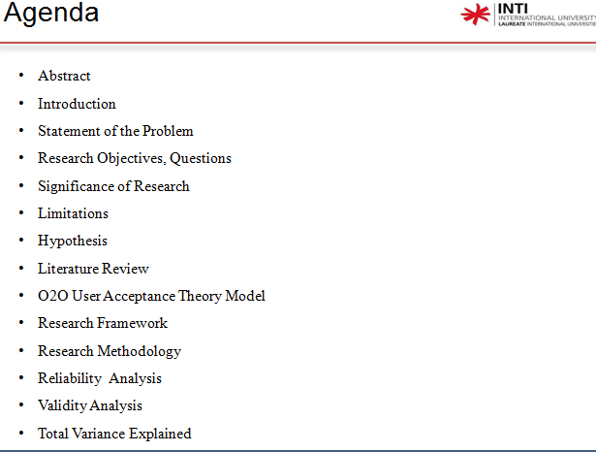

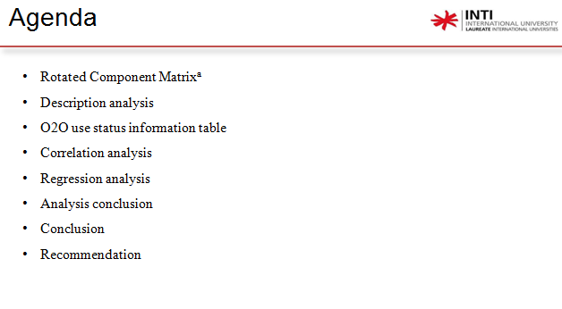

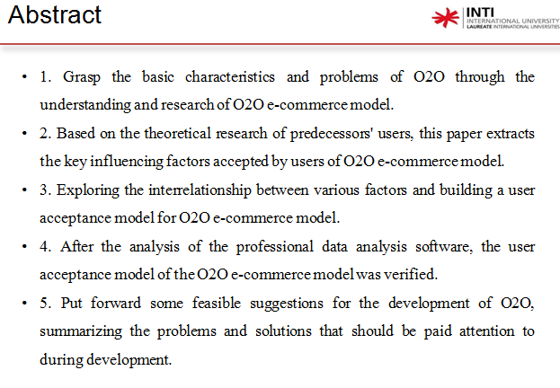

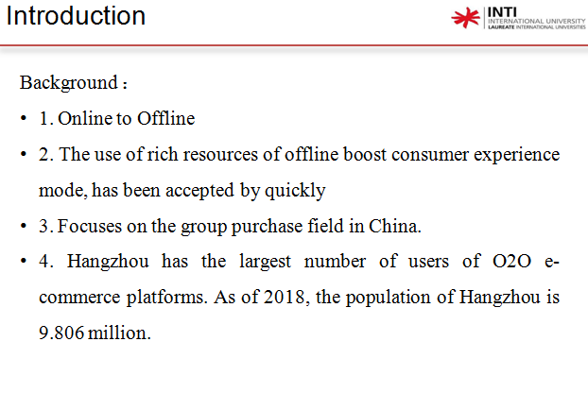

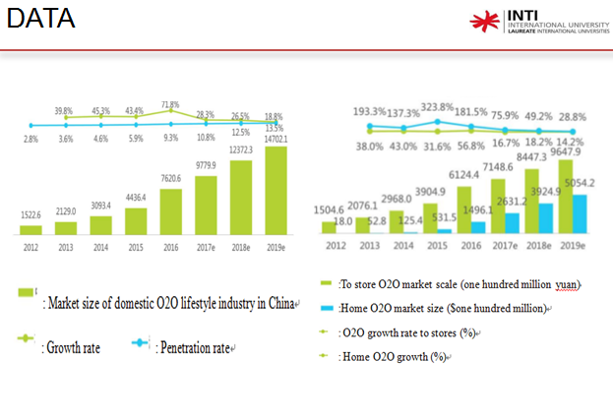

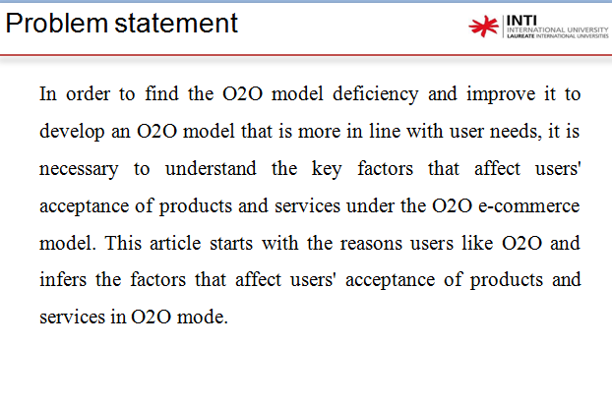

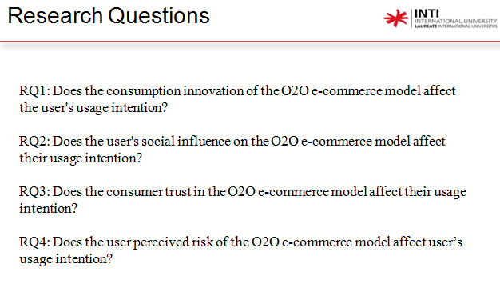

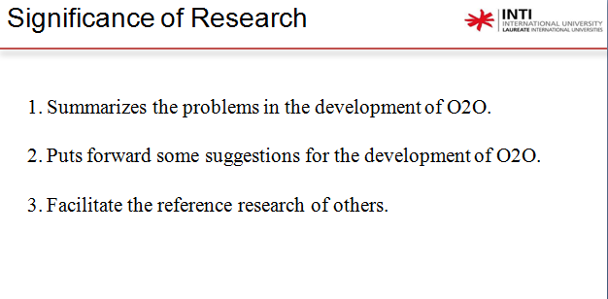

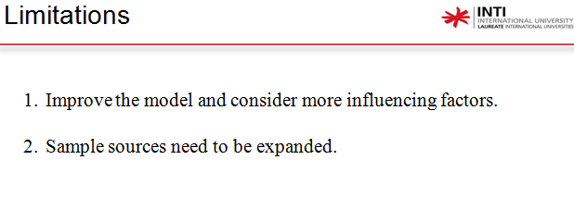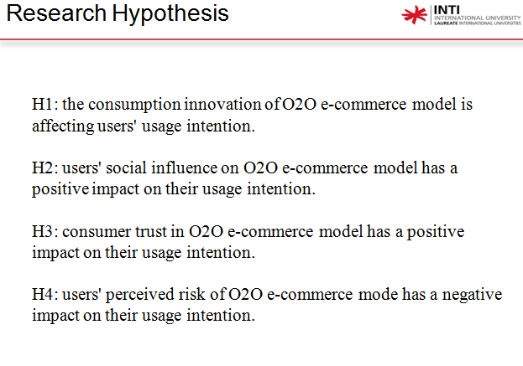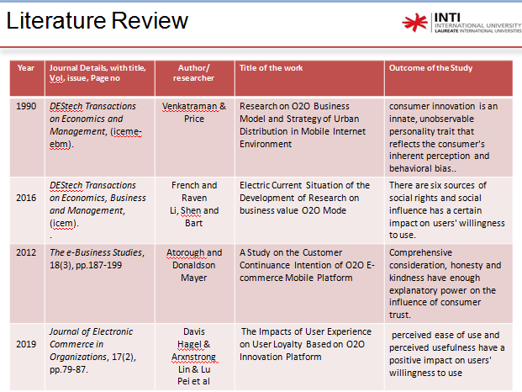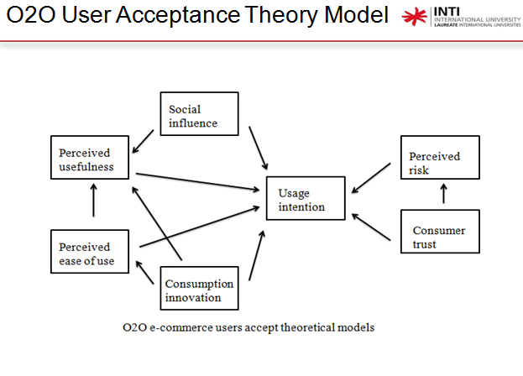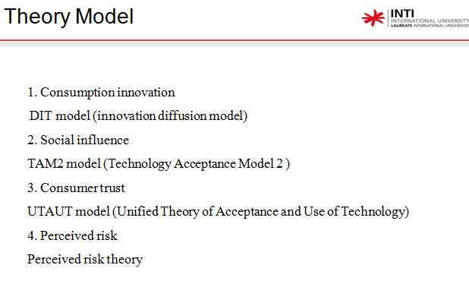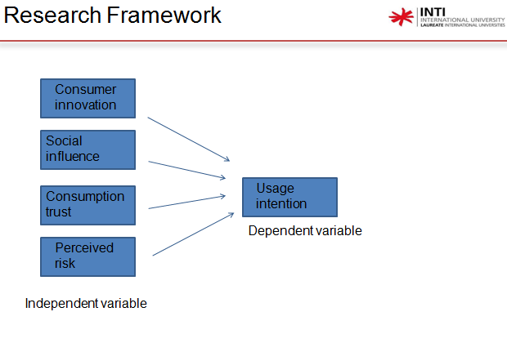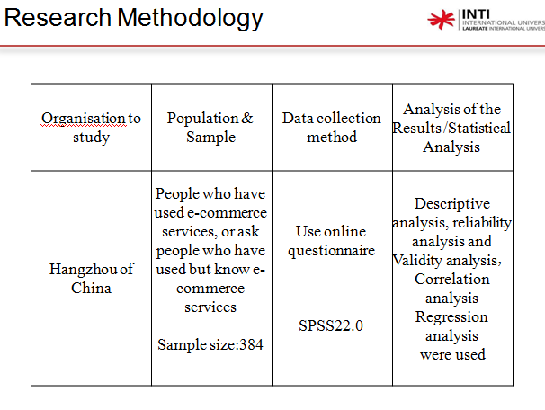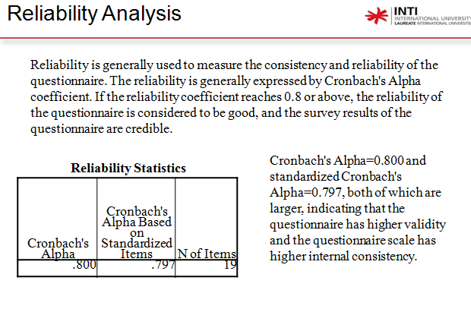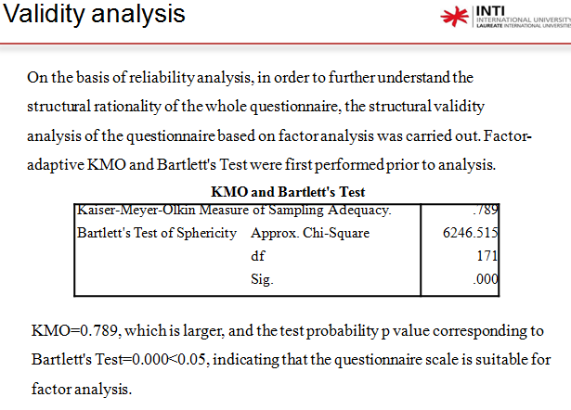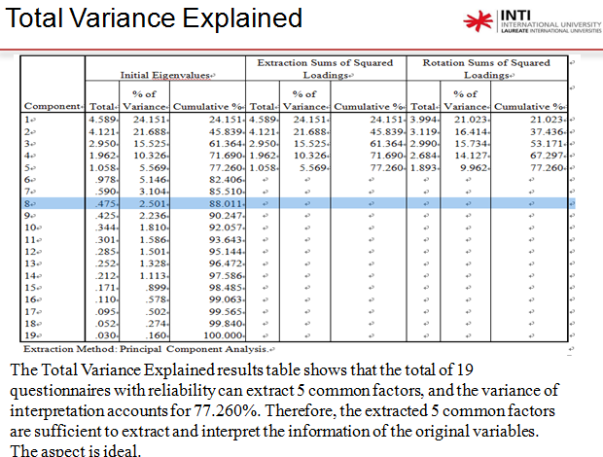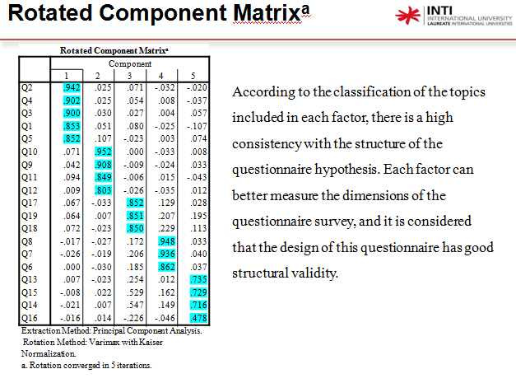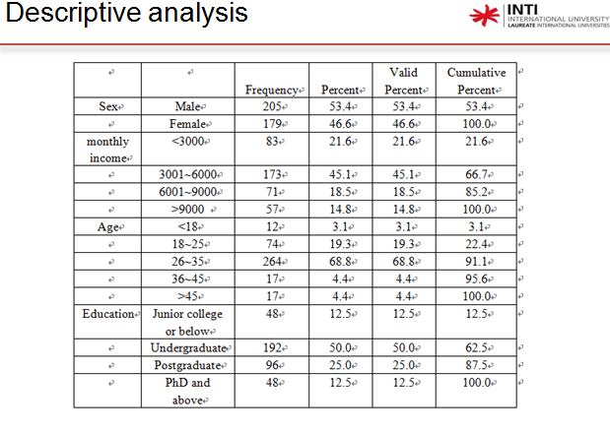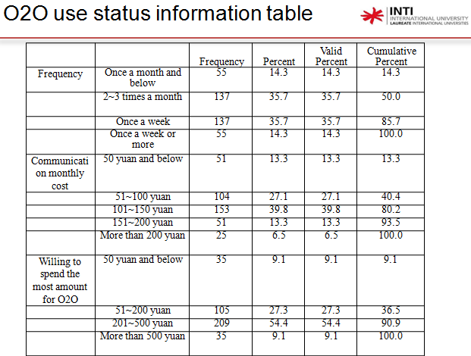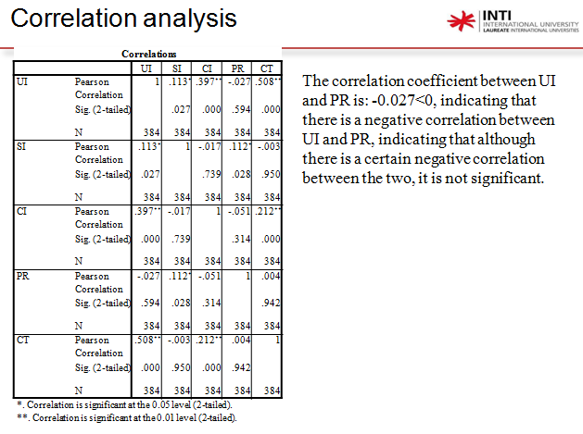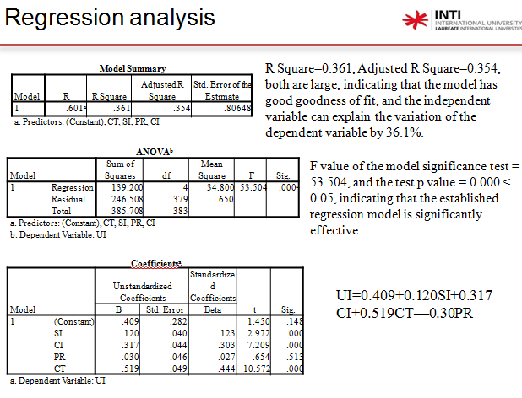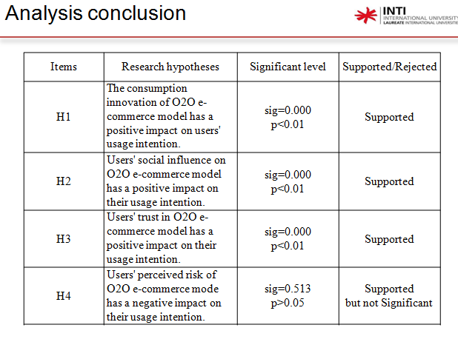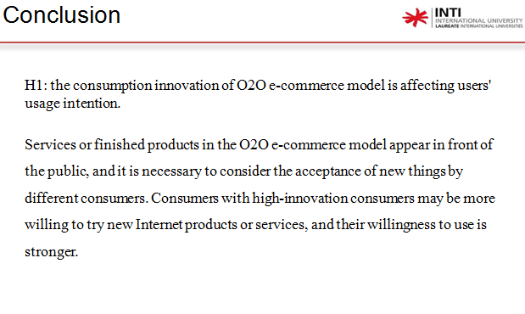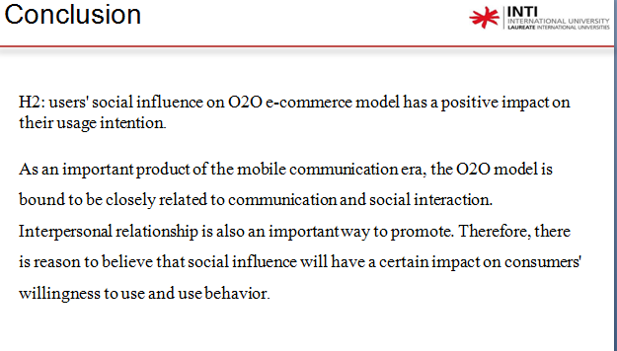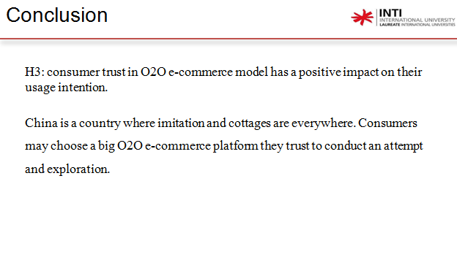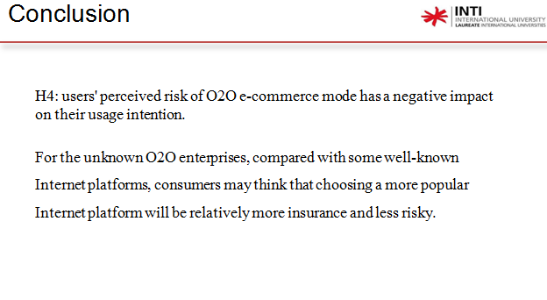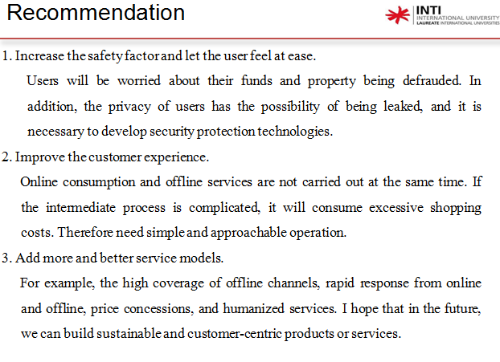

**Appendix 8: MBA Project Log Book**

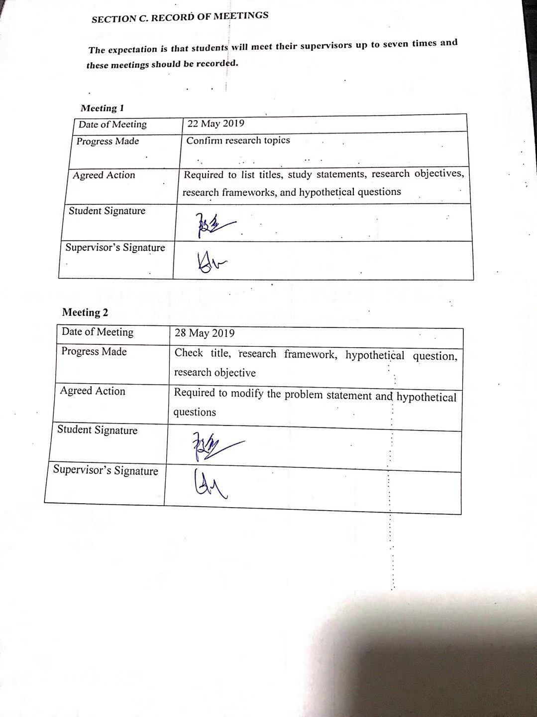



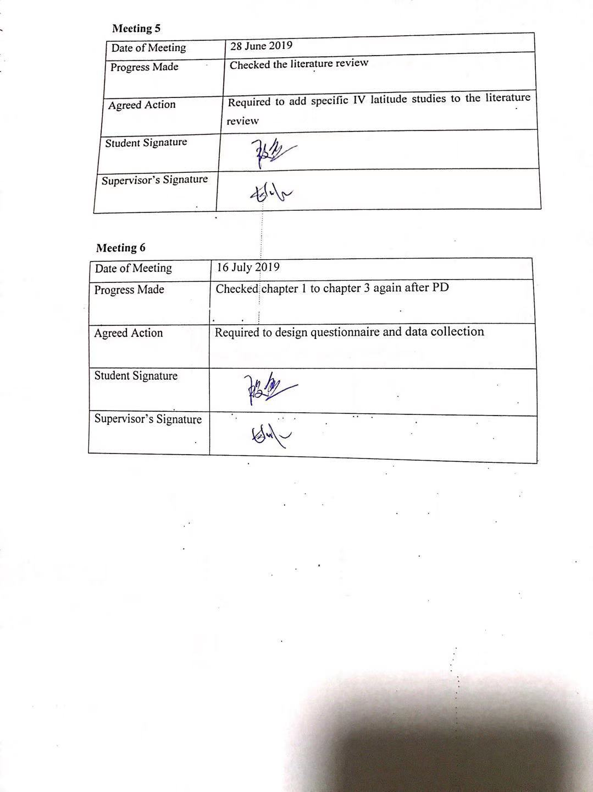

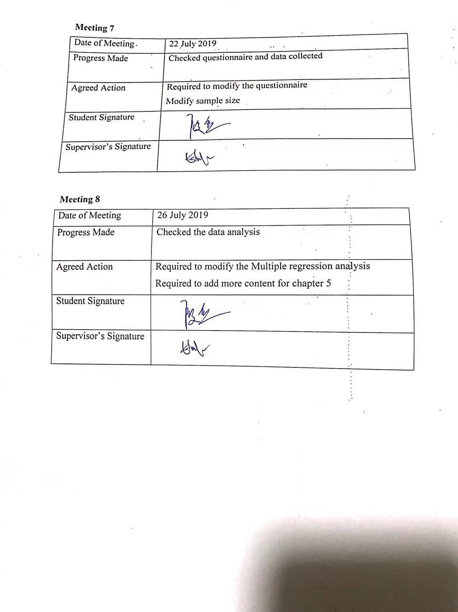





**Appendix 9: Survey Questionnaire**

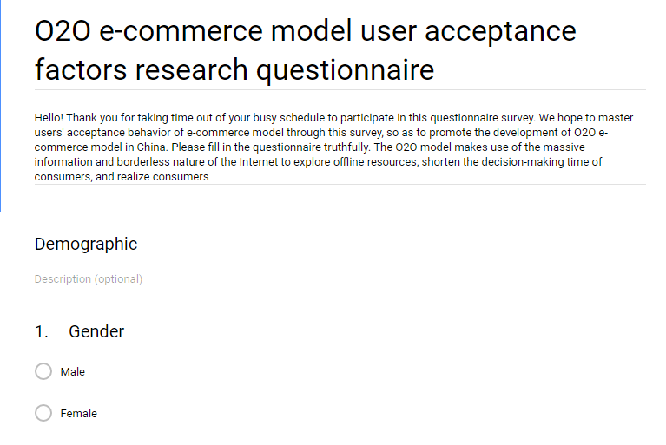 

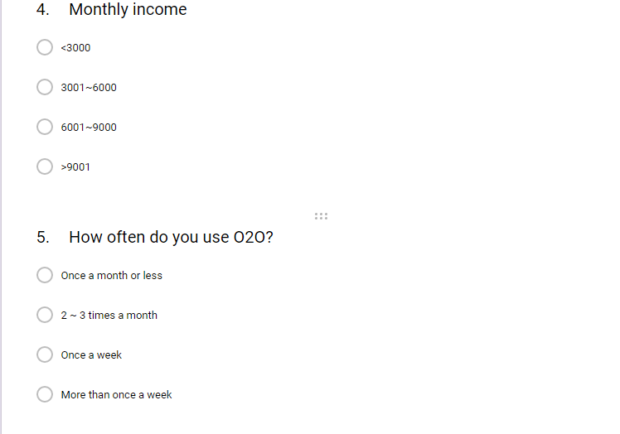 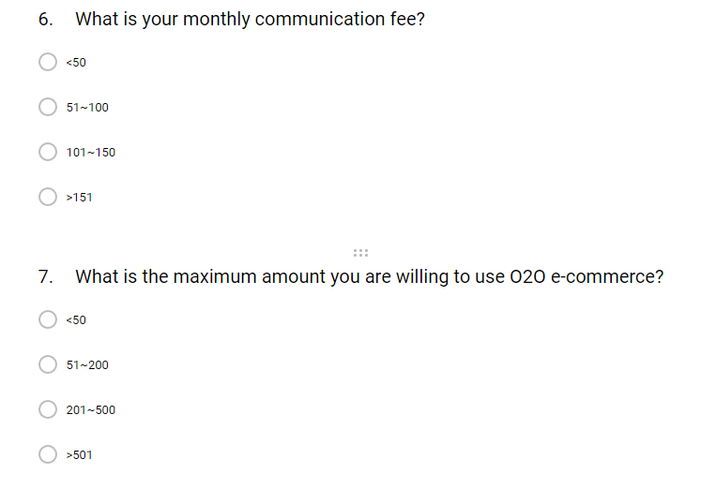 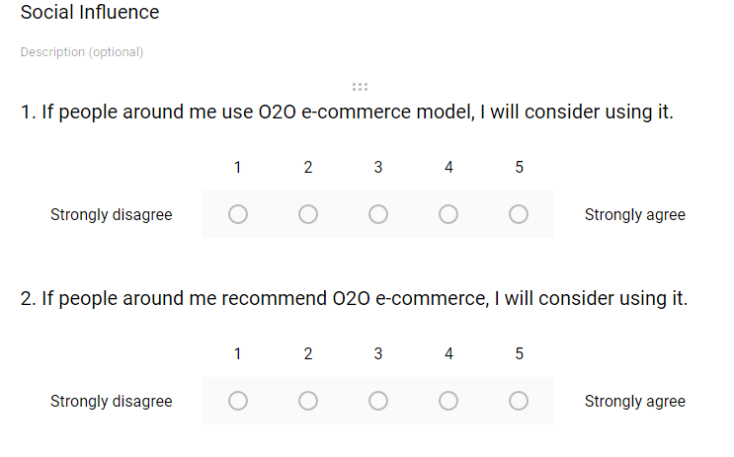 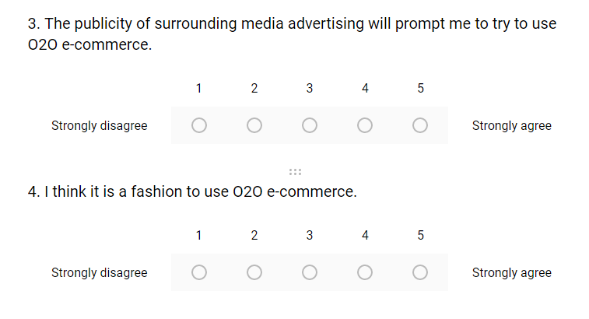 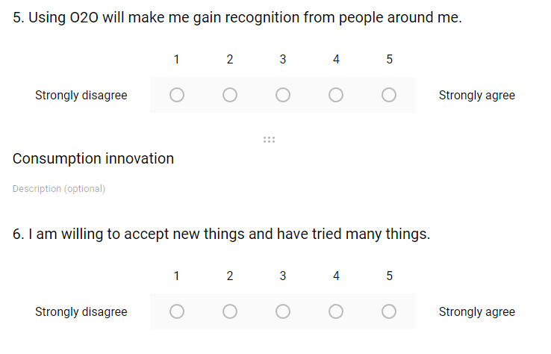 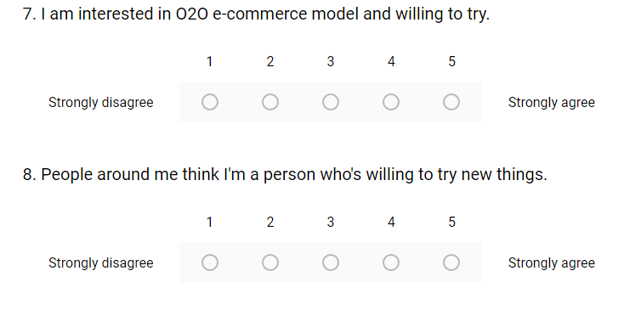 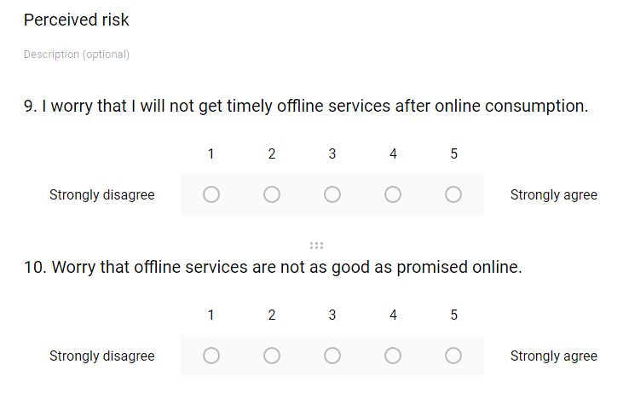 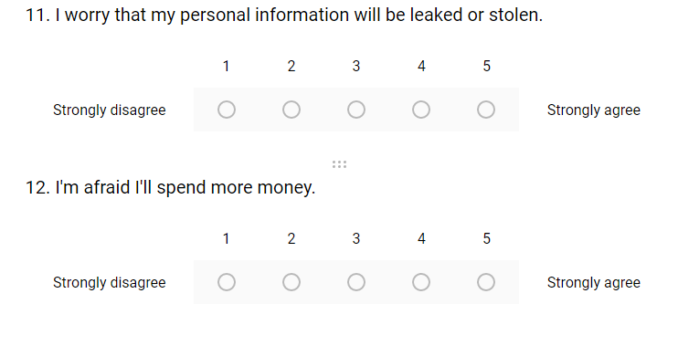 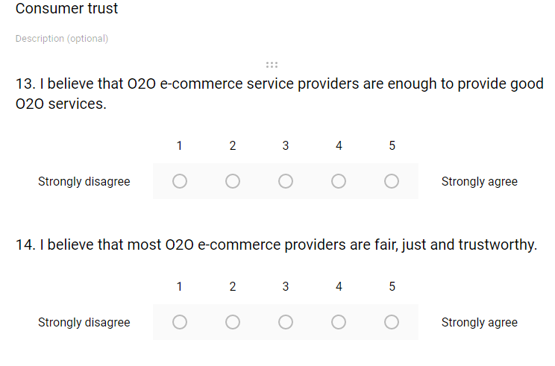 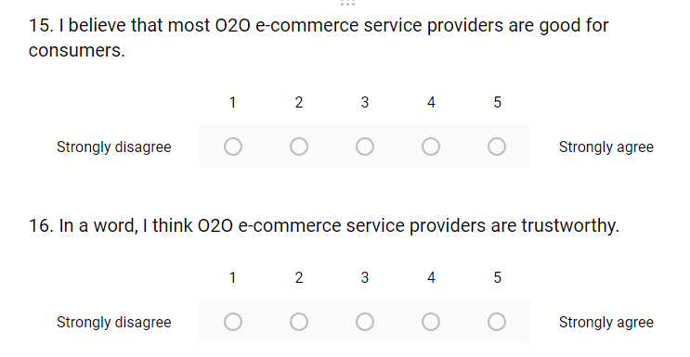 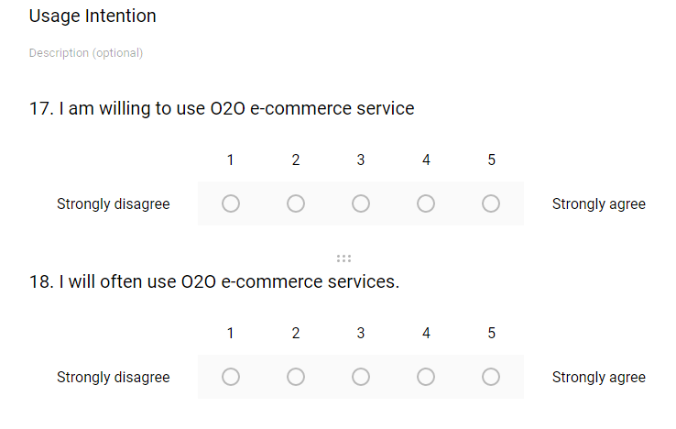 

**Appendix 10: Turnitin Report**

