

**Relationship between the SERVQUAL dimensions and Customer Satisfaction of travel agencies in China**

Student’s Name: ZHAO QILI

Identification Number: I18015456

Program: MBA

Supervisor: Dr Wong Chee Hoo

**Acknowledgement**

Special thanks to my supervisor, Dr. Wong Chee Hoo for his time and advice during the preparation for this project and patience in guiding the students on how to start and end the Project systematically. Last but not least, thanks to the second panellist, Dr.Abidah Saad for her encouragement and valuable comments in this project. I would like to take this opportunity to thank the management, lecturers and staffs from INTI International University for their great support and assistance provided.

During the course of MBA, I am glad to know many new course mates who have been very helpful and support in whatever way possible. A big thank you to them! Thanks to all survey respondents who had spent their effort to participate in the survey.

目录

CHAPTER 1 ：BACKGROUND 4

1.1 INTRODUCTION 4

1.2 PROBLEM STATEMENT 5

1.2.1 TOURIST RIGHTS CANNOT BE GUARANTEED 6

1.2.2 LOW LEVEL OF SERVICE STANDARDIZATION 6

1.3 RESEARCH OBJECTIVES 7

1.4  SIGNIFICANCE OF THE STUDY 7

1.4.1 THEORETICAL SIGNIFICANCE 7

1.4.2 PRACTICAL SIGNIFICANCE 8

1.5 LIMITATIONS OF THE STUDY 9

1.6 SCOPE OF THE STUDY 9

1.7 ETHICAL CONSIDERATION 10

CHAPTER 2 : LITERATURE REVIEW 10

2.1 THEORY REVIEW 10

2.1.1 SERVICE QUALITY 10

2.1.2 SERVICE QUALITY OF TRAVEL AGENCY 12

2.1.3 SERVQUAL MODEL 13

2.2 CUSTOMER SATISFACTION THEORY 15

2.2.1 MEASURING CUSTOMER SATISFACTION 15

2.2.2 SERVICE QUALITY AND CUSTOMER SATISFACTION 16

2.3 DEPENDENT VARIABLE 16

2.3.1 CUSTOMER SATISFACTION 16

2.4 INDEPENDENT VARIABLES 17

2.4.1 TANGIBLE 18

Journal 18

2.4.2 RELIABILITY 21

Journal 21

2.4.3 RESPONSIVENESS 23

Journal 23

2.4.4 ASSURANCE 26

Journal 26

2.4.5 EMPATHY 28

Journal 28

2.5 RESERCH MODEL 31

2.6 DEVELOPMENT OF RESEARCH FRAMEWORK 32

2.7 HYPOTHESES 33

2.7.1 TANGIBLE AS AN SERVQUAL DIMENSION 33

2.7.2 RELIABILITY AS AN SERVQUAL DIMENSION 34

2.7.3 RESPONSIVENESS AS AN SERVQUAL DIMENSION 34

2.7.4 ASSURANCE AS AN SERVQUAL DIMENSION 35

2.7.5 EMPATHY AS AN SERVQUAL DIMENSION 35

H5: Empathy has a significant positive impact on customer satisfaction. 35

CHAPTER 3 ：RESEARCH METHODOLOGY 36

3.1 RESEARCH DESIGN 36

3.2 THE STUDY OF POPULATION，UNIT OF ANALYSIS AND SAMPLING DESIGN 36

3.2.1 TARGET POPULATION 36

3.2.2 UNIT OF ANALYSIS 36

3.2.3 SAMPLING FRAME AND SAMPLING LOCATION 37

3.2.4 SAMPLING TECHNIQUES 37

3.2.5 SAMPLE SIZE 37

3.3 DESIGN AND PROCEDURE 38

3.4 MEASUREMENT INSTRUMENT 38

3.4.1 SCALES MEASUREMENT 39

3.4.2 QUESTIONNAIRE DESIGN 39

3.4.3 PILOT STUDY 40

3.4.4 FACTOR ANALYSIS 40

3.4.5 VALIDITY AND RELIABILITY TEST 41

3.5 DATA ANALYSIS 41

3.5.1 CORRELATION ANALYSIS 41

3.5.2 REGRESSION ANALYSIS 42

CHAPTER 4: RESEARCH FINDINGS 42

4.1 OVERVIEW 42

4.2 PILOT TEST 43

4.2.1 Factor analysis-pilot test 43

4.2.2 DATA RELIABILITY 45

4.3 DESCRPTIVE STATISTICS 47

4.3.1 Personal Demographics 47

4.4 PRELIMINARY DATA ANALYSIS 51

4.4.1 FACTOR ANALYSIS 51

4.4.2 RELIABILITY TEST 53

4.4.3 REGRESSION ANALYSIS 53

4.4.4 CORRELATION ANALYSIS 55

4.5 HYPOTHESES TESTINFG 56

4.6 SUMMARY OF KEY RESEARCH FINDINGS 59

4.7 SUMMARY 61

CHAPTER 5 ： DISCUSSION AND CONCLUSION 61

5.1 OVERVIER 61

5.2 DISCUSSION OF FINDINGS AND RECOMMENDATION  62

5.3 CONTRIBUTIONS 65

5.3.1 CONTRIBUTIONS TO ACADEMIA 65

5.3.2 CONTRIBUTIONS TO INDUSTRY 65

5.4  LIMITATION 65

5.5 FUTURE STUDY OF RESEARCH 66

5.6 PERSONAL REFLECTION 67

5.7 CONCLUSION 67

REFERENCE 67

Appendix A: Survey Questionnaires 79

Appendix B: Statistical Analysis Result 86

Appendix C: Record of meetings 102

Appendix D: Comments on Managment of project 106

**ABSTRACT**

China's tourism industry has experienced vigorous development in the fierce competition, and the tourism consumption market is extremely hot. In this consumer market, travel agencies are not the main force to stimulate tourists' consumption. The quality of travel agency services is directly related to the quality of tourism and the image of the entire tourism industry in China. As a travel agency of the industry window, its service level has become the focus of widespread concern. The degree of satisfaction of tourists following a travel agency depends on the perceived quality of travel agency services. Therefore, the evaluation of tourist satisfaction is an important method for the evaluation of travel agency service quality.

Through investigation and practice, this paper interviews with travel agency managers, tour guides, tourists, etc., and combines the research on travel agency service products, service quality, customer satisfaction theory and other literatures to construct a set of indicators for tourists to evaluate the service quality of travel agencies. Through the indicator system, the questionnaire of tourist satisfaction questionnaire and the questionnaire of each indicator weight are designed. The author conducted a survey of tourists who had traveled with the travel agencies of Xiamen City, and used statistical software to process the survey data, analyze the travel agency service attribute factors that affect the tourists' satisfaction, and the overall satisfaction level of the tourists' services to the travel agency. The satisfaction level of each service project, the key service factors affecting the satisfaction of tourists and the impact of tourist satisfaction on the loyalty of travel agencies.

The research results show that tourists evaluate the attitude of travel agency service satisfaction through five service attributes: assurance, reliability, perceptibility, responsiveness and empathy. Among them, the guarantee and reliability have the greatest impact on the satisfaction of tourists. Among the key indicators that affect the satisfaction of tourists, tour guide business services, tour arrangement services and tour guide support services are the key factors affecting the satisfaction of tourists. Through empirical analysis, the higher the satisfaction of tourists with the travel agency service, the more willing to follow the travel agency to travel and recommend to friends and relatives.

**Keywords: Travel agency service quality SERVQUAL MODEL Customer Satisfaction**

# CHAPTER 1 ：BACKGROUND

## 

## 1.1 INTRODUCTION

The Chinese tourism industry has witnessed an incredible boom in the past 20 years. With the development of Chinese economy and the improvement of people's living standard, tourism has become one of the frequent economic activities of modern people. Consumers travel more and more times, travel experience is more and more rich, tourists pay more attention to the essence of tourism consumption (Shah, 2016). The tourism with low service level in the past has become more and more dissatisfied, and people's tourism consumption has shifted from "irrational consumption" to "rational consumption". They pay more attention to personal feelings in consumption attitude, such as comfort, convenience, safety, cleanliness, pleasure and fun (Weigert, 2018). In terms of price and quality of tourism consumption, contemporary consumers no longer give priority to the price factor, but pay more attention to the quality of tourism service (Haghighat, 2017). Therefore, when choosing trip agency, consumers will be more interested in the travel agency's brand, they will choose some travel agencies with better market tendencies, reputation and able to provide quality services (Kim-Soon, 2014).

With the improvement of consumer culture level and self-quality, consumer awareness is gradually strengthening, consumer taste is also constantly improving, and the demand for service quality has become higher and higher (Monaco, 2018). Tourists are not satisfied with the regular services provided by traveling agencies, but require more professional and personalized services on the basis of enthusiasm and thoughtful service. They also require the reception staff and tour guides of travel agencies to have rich knowledge. With deeper cultural cultivation, as the traveler's legal awareness and self-protection awareness increase, travel agency services are not in place or slightly wrong, they will file quality complaints or claims (Vivek, 2014).

In China's tourism industry, the travel agency industry is the latest open industry. With the involvement of foreign travel agencies in various forms of China's travel agency industry, and the use of network chain advantages, the formation of a "one-stop" reception system for overseas customers, so as to monopolize all profits (Yang, 2016). International travel agency a high standard of service to the Chinese travel agency has brought the huge pressure, travel agency industry competition is no longer the number. The service quality of China travel service is more serious than at any time in the relationship with travel agency's survival. In the face of fierce market competition, travel agencies should formulate customer satisfaction strategies and build their own brands to ensure the healthy development of travel agencies (Pansari&Kumar, 2017).

In recent years, innovation in information and communication technologies is reshaping the way travel distribution channels operate. Despite the rise and decline of web-based distribution channels, travel agency commissions for hotels and airlines, travel agencies seem to remain a popular choice (Lewis, 1998). As suggested in a recent study by Grønflaten (2009), in terms of information channels, there is about a 4.5 times greater chance of a group representative consulting trip agent in a face-to-face interaction than using the Internet as the main channel of information when organizing a tour. Word "healthy, safe, healthy, high quality" high-quality travel experiences from modern highly attention, visitors to the future of tourism service quality put forward higher request. Travel agency business in China should be adjusted, can no longer blindly pursue sales price competition. The focus of the tourism industry should be off to industry service quality and service level, improve the quality of tourism products, so as to improve the satisfaction of tourists (Petrick&Backman, 2012).

## 1.2 PROBLEM STATEMENT

The 21st century is the era of service economy. The quality of service has become the focus of people's life (Truong & King, 2015). Compared with developed countries in service industries, China's tourism industry has developed relatively late. China's tourism market is chaotic, and the poor quality of service fails to satisfy tourists materially and spiritually as expected (Benur & Bramwell, 2015).

Various kinds of tourism disputes and complaints are frequent, and the number of tourism complaints is growing slowly, among which travel agency complaints account for the largest proportion. At present, the overall service quality of travel agencies in China is low, and the awareness of brand competition is weak. Tourists are unable to get a high quality tourism experience (Cheng&Ai, 2017). The service market chaos of Chinese travel agencies mainly reflects the following aspects:

### 1.2.1 TOURIST RIGHTS CANNOT BE GUARANTEED

1. Travel agencies arbitrarily lower service level standards, shorten travel itineraries, increase shopping time, force tourists to shop, participate in self-funded projects, and arbitrarily compose groups and transfer groups without seeking the consent of tourists, resulting in no responsibility when accidents occur. Clearly, the rights of tourists cannot be guaranteed.

2. Contract breaches, using a unilaterally formatted contract, intended to reduce or exempt one’s responsibility.

3. Travel safety issues, the travel vehicle is seriously overloaded, which has damaged the personal and property safety of consumers.

4. False prices, the quotation is lower than the cost, or the price reduction competition such as “zero group fee” and “negative group fee” is used to compete for the source of tourists. However, various methods are adopted in the course of tourism, and the quality of the tourism service is reduced.

### 1.2.2 LOW LEVEL OF SERVICE STANDARDIZATION

China's tourism service standardization work started late, although it has been gradually carried out, but China's service situation is still very large compared with the developed industrial countries, this gap is not mainly in the "hardware" aspect, but in the "software" aspect that is, in the management and service (Tsang, Lee & Qu, 2015). There are no clear provisions and requirements on staff's service attitude, service speed, service comfort, service safety and confidentiality, and a complete set of service quality system documents are lacking.

## 

## 1.3 RESEARCH OBJECTIVES

The research objectives of this paper mainly include:

We designed this study to assess the level of satisfaction of travellers currently operating travel agencies in China using a slightly modified SERVQUAL tool (Parasuraman et al., 1988). The study included an analysis of the impact of each individual SERVQUAL component on customer satisfaction. Although the influence of SERVQUAL dimension on customer satisfaction has been widely studied in previous studies, few studies have analyzed the above variables in the context of travel agencies. The contribution of this study is to identify three new factors of travel agency satisfaction, namely loyalty, diligence and tangibility (Robledo, 2001). These factors reflect an important part of the overall quality of travel agencies. Similar to loyalty, employees' ability to provide fast, accurate and reliable services is the most important incentive for consumers to be satisfied with travel agencies. The results of the research conducted also suggest that a number of factors need to be carefully considered when designing marketing strategies (Kouthouris & Alexandris, 2005).

## 1.4  SIGNIFICANCE OF THE STUDY

### 1.4.1 THEORETICAL SIGNIFICANCE

This paper studies the relationship between service quality and customer satisfaction of travel agencies. Establish the relationship model between service quality SERVQUAL travel agency and tourist satisfaction dimension. Tourism satisfaction that enriches relevant theories and complements relevant theories of service quality of travel agencies (Zeithaml, berry & Parasuraman, 2014).

### 

### 1.4.2 PRACTICAL SIGNIFICANCE

This research studies the market status of Chinese travel agencies through questionnaire survey. Establish the relationship model between service quality and tourist satisfaction of travel agencies., and improves the evaluation index system of tourist satisfaction, so that customers can evaluate travel agencies more scientifically (Collier&Bienstock, 2006). At the same time, it can also allow travel agencies to more accurately evaluate the advantages and disadvantages of the services provided, and improve service quality. Provide effective Suggestions to travel agencies based on the problems found in the survey. This will help travel agencies improve service quality and optimize tourism products (Cao, Zhang & Seydel, 2005). After China's entry into World Trade Organization (WTO), the tourism industry market is gradually opening up, and China's travel agencies are facing the challenge and threat of powerful foreign travel agencies, and the market competition is more fierce (Robledo, 2001). Domestic travel agencies in order to survive and develop, make their products and service quality standards and international standards, so travel agencies choose customer satisfaction strategic management emerged (Chand, 2014). The travel agency chose this development strategy to adapt to the changes in the new business environment of China's travel agencies. The tourism values orientation of tourism consumers is the key factor to attract customers. It requires the transfer from travel agency facilities to the quality of service (Chand, 2014). The service quality is good, the tourists are satisfied, the word of mouth is good, the loyalty of the tourists will also increase, and the complaints will be reduced. Therefore, “customer satisfaction” is the basic factor for the success of travel agencies, and it is also a necessary condition for the sustainable development of travel agencies (Bansal, Gaur & Chauhan, 2016). In order to improve the service quality and put forward the strategy of customer satisfaction management, travel agencies must start from the satisfaction of tourists. It is important to know what aspects of travel consumers' satisfaction and dissatisfaction are. Understand the key factors of tourists' evaluation of service quality. According to these factors, how to do travel agencies evaluate the service quality of themselves and their competitors (Atilgan, Akinci & ksoy, 2015). To understand these, only through the travel consumer satisfaction survey. Understand their demand for the products and services provided by traveling agencies and the influencing factors, so as to concentrate enterprise resources and maximize the satisfaction of tourism consumers' key services (Ruiqi & Adrian, 2009). Therefore, this paper will discuss the theory of travel agency customer satisfaction in-depth.

## 1.5 LIMITATIONS OF THE STUDY

Although some achievements have been made in the study of tourist satisfaction of travel agencies. There are still some problems and shortcomings in this study, which need to be further improved, and there are still areas for further study.

1. This study is only based on travel agencies, and the results cannot be extended to other economic sectors. Due to the lack of continuous investigation, this investigation is not dynamic.

2. The satisfaction evaluation index proposed in this paper is more suitable for the customer satisfaction evaluation of package Tours. However, it is not completely applicable to the evaluation of individual customer service satisfaction.

3. There are not enough survey samples to determine the weight of indicators, which may have a certain impact on the authenticity of the research results.

4. Travelers' expectation of the service quality of travel agencies and the services they enjoy in actual travel will affect the results of customers' evaluation of the service quality of travel agencies. However, the expected service of travelers is subjective and cannot be actually measured.

5. The satisfaction evaluation index used to analyze the service level of travel agencies does not cover a wide range of service items. There is no mention of the evaluation index of whether the travel agencies' handling of tourist complaints makes tourists satisfied.

## 1.6 SCOPE OF THE STUDY

This paper studies the factors of tourists' satisfaction with travel agencies. To explore this question, we took Chinese travel agencies as research objects and studied the influence of five SERVQUAL individual dimensions (assurance, reliability, tangible, responsiveness, empathy) on tourist satisfaction.

## 1.7 ETHICAL CONSIDERATION

The collection of data ensures that participants participate in the research voluntarily if they fully understand the problem. The research process will not cause psychological or physical harm to the participants and will not bring pressure to the participants. The content of the questionnaire is guaranteed not to reveal the privacy of the participants. The authenticity of the data is guaranteed during the research.

# CHAPTER 2 : LITERATURE REVIEW

## 2.1 THEORY REVIEW

### 2.1.1 SERVICE QUALITY

Service quality is one of the most important conditions to maintain competitive advantage and establish customer relationship. The definition of service quality includes "the overall evaluation of a particular service company, the result of which is the comparison between the company's performance and customers' overall expectations of how the company should perform and the actual delivered content (Parasuraman et al, 1988). Service quality refers to the difference between the expectation of service performance and the perceived level of service received by customers before they encounter service (Asubonteng, 1996). Quality of service is defined as consumers' overall advantage or advantage view of service entities". It is a form of attitude, the result of comparing expectations with accepted performance perceptions (Zeithaml, 1987). A Service is any behavior or behavior resulting from contact between two parties (provider and receiver) that is invisible in nature (Kotler, 2003). Service can is also defined as a set of intangible characteristics, and the overall end result of the service leads to the satisfaction of customers' needs and expectations (Michael, 2003). The definition of quality of service varies, and may vary from literature to literature, but the essence is the same. The meaning of quality of service may vary in wording, but it mainly involves determining whether the perceived service experience exceeds or fails to meet customer expectations (Ojo, 2010).

In service quality research, the most widely used model is the expectations- perceptions gap model known as SERVQUAL, which states that service quality, as perceived by consumers, stems from a comparison of expectations of the service to be received and the perceptions of service performance of a company. The term “expectation” used in the service quality literature is perceived differently than what is found in the consumer satisfaction liter- ature. Expectations in the service quality literature are viewed normatively as reflecting what consumers desire or want from a service, whereas in the consumer satisfaction literature expectations are viewed more as predictions made by consumers as to what they might expect during a service transac- tion. A redefinition of expectations as to what the customer would expect from excellent service organizations was made by Parasuraman, Berry, and Zeithaml (1991). The wording now focuses on what the customers would expect from organizations delivering excellent service rather than what the service providers should offer.

The original objective in the development of SERVQUAL was to provide a service quality instrument that could be used across a broad range of services and industries requiring only minor modifications. SERVQUAL is a research instrument consisting of two sections ascertaining consumers’ general expec- tations for quality of services to be received compared against an assessment of perceptions of a firm’s specific service quality received. The original instru- ment contained 22 statements, each of which related to one of the five major dimensions. Each statement appeared in two forms; one designed to measure expectations about the service dimension and the other about the particu- lar organization whose service is being assessed. In this way the instrument sought to capture both expectations and perceptions of services. The gap score is then calculated for each statement for each dimension. In principle the gap scores allowed for further analysis in a number of ways, including:

1. Identification of those dimensions where expectations are being exceeded and falling short;

2.Analysis of service quality over time to assess the impact that specific quality initiatives may be having;   
3.Comparing service quality between competing providers;   
4.Analysis of different dimensions of the service and importance to the customers;   
5.Analysis of service quality dimensions as perceived by different customer groups.

While analysis of the service quality gaps can be important, this research will focus on the latter two items and will only measure the expectations portions without the perceptions of actual service by a provider. For the purposes of this study it was determined to pursue an adapted measure of the SERVQUAL instrument for the purpose of studying service quality expectations (predictive standard) in the nonprofit sector (Vaughan & Shiu, 2001).

### 2.1.2 SERVICE QUALITY OF TRAVEL AGENCY

According to Gronroos, service quality of travel agencies is not only related to service results, but also related to service process. The quality of tourists' actual experience is mainly composed of technical quality and functional quality.

Technical quality: Refers to the result dimension of travel agency service operation. Service items, facilities and equipment and service quality standards provided by traveling agencies that can meet the needs of tourists. (VanRie, Semeijn&Pauwels, 2014). It is reflected in whether the objective requirements of tourists are met. Whether the food, accommodation and transportation of tourists are worth the money and meet the agreed standards (Chen, et al.2016).

Functional quality: Refers to the process dimension of the interaction between tourists and service providers. It is mainly reflected in the service attitude, service process and service method of travel agency staff. Among them, the attitude of tour guides in providing services to tourists is the most critical part that affects the functional quality. The recognition of this dual influence indicates that the customer's perception of service quality is jointly determined by three factors: functional quality, technical quality and corporate image (Pao,Wu&Pan, 2015).

"Travel agency management" (1994) The service quality of travel agencies is mainly reflected in the satisfaction of tourists' material and spiritual needs. Specifically includes three aspects of content: First of all, the quality design of travel agency products that is, the most important is to require travel agency to design routes and programs. To meet the needs of tourists of different levels, meet the quality and price; Second, the actual reception service quality of travel agency staff. That is, travel agency outlets and tour guides should provide warm and thoughtful, timely service, so that tourists in material and spiritual satisfaction; Third, the environmental quality of travel agencies. Mainly the reception, finance and other departments of travel agencies, as well as the work quality of scenic spots, restaurants, motorcade and other cooperative units. These three aspects determine the service quality of travel agencies.

### 2.1.3 SERVQUAL MODEL

Service quality is evaluated by measuring perceived service quality using a model originally developed by Parasuraman et al. (1988). This assessment tool came to be known as SERVQUAL (Shafiq, Mostafiz & Taniguchi, 2019). Initially, there are ten dimensions (reliability, responsiveness, competence, accessibility, politeness, communication, credibility, security, empathy and tangible assets) that can be used to measure service quality (Rod et al., 2008). New perspective is put forward, the quality of service can function to evaluate quality dimensions, the five components: reliability, responsiveness, affordable, empathy and tangibles five dimensions, these five dimensions by the designer of the SERVQUAL instrument identified as the five key dimensions of quality (Roslan, 2015). SERVQUAL is commonly used in the service industry of service quality and customer satisfaction measurement model (Gencer & Akkucuk, 2017). It is effective, reliable, and widely applicable to service industry organizations; And it is more widely used than other competing models (Munusamy , 2010). SERVQUAL is widely used in research related to the hotel and tourism industries (Pizam, 2016). It not only illustrates the quality of the services provided, but also helps to determine the gap between the services provided by the service providers and the services customers think they receive (Weitz & Wensley, 2002). It is also useful to estimate the gap between customers' expectations and the perceptions they actually receive (Pikkemaat & Peters, 2006).

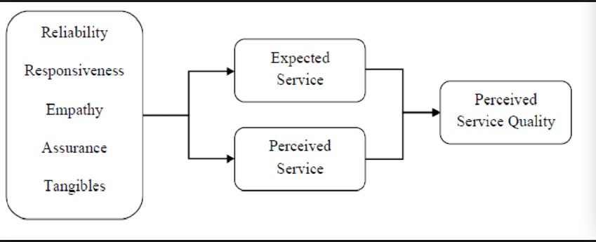(FIGURE 1)

FIGURE 1: SERVQUAL model

SOURCE : Shafiq, A., Mostafiz, M. and Taniguchi, M. (2019)

For more than two decades, the SERVQUAL model has been used as the basis for introducing the many different instruments used to measure overall quality of service. However, this model is not without its critics (Andersson, 1992). Buttle (1996) offers one of the most comprehensive SERVQUAL criticisms at both theoretical and operational levels. In view of these criticisms, some authors have modified the original SERVQUAL and devel-ed models related to the hospital sector, such as HOLSERV, which contains 27 question items (Wong, 1999). LODGSERV, which includes 26 question items (Knutson, 1990). Perhaps the most famous alternative to SERVQUAL is SERVPERF proposed by Cronin and Taylor (1992). It has led to a lot of discussion about which of the two models is more effective in predicting service quality. Carrillat et al. (2007) finally determined that both models are good indicators of overall service quality.

## 

## 2.2 CUSTOMER SATISFACTION THEORY

### 2.2.1 MEASURING CUSTOMER SATISFACTION

Fonseca (2009) believes that service quality itself equals satisfaction. The importance of measuring customer satisfaction comes from the increase of satisfaction, which in turn increases loyalty (Hesket, 1994). Although quality of service has been the subject of numerous studies over the past three decades, there are still some differences among researchers on the interpretation of this term (Oliver, 1997). In general, there are two different approaches to quality of service. According to the first method, service quality is based on comparing customer's expectation of the delivered service with actual customer's perception of the delivered service (Iacobucci, 1994). The second method Pantouvakis (2010) suggests that the measurement of service quality should only include customer perception. It is interesting to analyze the relationship between service quality and customer satisfaction.

Many authorities claim that quality is only one of the factors leading to satisfaction (Salvatore, Gennaro & Manfreda, 2017). They propose that measuring satisfaction should include other factors, such as perceived value, perceived image and price (Salvatore & Venuleo, 2017). Travel satisfaction should be measured carefully. Visitor satisfaction often represents a mixture of pre-departure expectations and overall experience during and after the trip.

In the measurement of customer satisfaction, the researchers face many problems and challenges (Tanzilli, Colli & Corno, 2016). Satisfaction is a potentially variable, including customers' subjective perception of product or service quality. In addition, satisfaction is measured not only based on the customer's experience, but also on their expectations of the quality of the product/service. Other problems arise if the measured attributes are not appropriate or the sample is not representative. It is important for researchers to identify and isolate the relevant variables, the attributes that will be measured. In addition, measuring overall satisfaction alone is not a good idea. Instead, it is necessary to select several parameters to determine customer satisfaction with the product/service. Finally, it is necessary to identify the main causes of satisfaction and isolate the variables associated with satisfaction.

### 2.2.2 SERVICE QUALITY AND CUSTOMER SATISFACTION

Service quality and customer satisfaction are two similar concepts. There is a close relationship between customer expectation service level and customer perception service level. However, many scholars try to compare the relationship between the two that is, whether customer satisfaction affects service quality or service quality affects customer satisfaction (Arslan, 2014). Customer satisfaction and quality are major issues affecting all organizations, whether large or small, profitable or non-profit, global or local. In today's competitive market, quality and customer satisfaction have long been considered key factors for success and survival (Zeithaml, Bitner & Gremler, 2006). As developed economies become more service-oriented, this means that customer impressions play a crucial role in this area. The company provides services for customers, and the overall attitude of customers to the company is determined by the relationship between service quality and customer satisfaction. Different studies are conducted on the positive relationship between service quality and customer satisfaction. In other words, if the service quality decreases rapidly, customer satisfaction decreases sharply, and if the service quality increases rapidly, customer satisfaction will increase rapidly. It can be concluded that there is a relationship between service quality and customer satisfaction, which can be studied through SERVQUAL dimension (Nupur, 2010). The evaluation model proposed by Woodside et al. (1989) emphasizes the relationship between perceived service quality, customer satisfaction and purchase interest. It is fair to say that the customer-centric philosophy and the principle of continuous improvement of service levels have proven that customer satisfaction is one of the major concerns of all types of business organizations (Arokiasamy, 2013). Mittal and Frennea (2010) interpreted customer satisfaction as consumers' evaluation of products or services after consumption in their research.

## 2.3 DEPENDENT VARIABLE

### 2.3.1 CUSTOMER SATISFACTION

Customer satisfaction is a relatively new concept in marketing, which comes from the customer satisfaction strategy put forward by Japanese enterprises (Gencer&Akkucuk, 2017). In literature of customer satisfaction research, there are different definitions of customer satisfaction, so far there is no uniform definition (Kim-soon, 2014). Different research purposes, scholars define customer satisfaction from different perspectives. Kotler et al. (2017) defined customer satisfaction as the pleasure or disappointment caused by the comparison between the perceived service performance and the actual service quality (Forozia , 2013). It is an assessment of the customer's experience with the service provided. The evaluation is also based on the comparison of customers' perception and expectation before the purchase with the actual service provided (Rao&Sahu, 2013). Therefore, when the service provided meets the needs of the customer, the customer will be satisfied, while the dissatisfaction is due to the service provider's inability to perform the service expected by the customer (kim-soon, 2014). At present, in the definition of customer satisfaction, the definition generally recognized by the academia is proposed by (Olivet, 1997). He believes that customer satisfaction is a psychological reaction of customers after their needs are satisfied, and a judgment of the characteristics of products and services or the degree to which products and services meet their needs (Gencer & Akkucuk, 2017). He pointed out that customer satisfaction is mainly determined by three types of customer evaluation :

1. The overall impression of customers on their consumption results, i.e. the evaluation of the pros and cons of this consumption, and the emotional reactions generated by customers, such as happiness and sadness.

2. The comparison results of customers on products and services that is, the actual performance of customers on products and services is compared with a certain standard to judge whether the actual performance meets or exceeds their own comparison standards.

1. Customers' attribution of their consumption results that is, customers think who should be responsible for their consumption results. Customer satisfaction has been identified as one of the key factors for the success of the service industry. Multidimensional service essence is directly related to customer satisfaction (Azmian, 2012).

## 2.4 INDEPENDENT VARIABLES

SERVQUAL is the most commonly used service quality and customer satisfaction measurement model in the service industry (Roslan, 2015). It is effective, reliable, and widely applicable to service industry organizations; And it is more widely used than other competing models (Munusamy, 2010). SERVQUAL is widely used in research related to the hotel and tourism industries (Pizam, 2016). It not only illustrates the quality of the services provided, but also helps to determine the gap between the services provided by the service providers and the services customers think they receive (Weitz & Wensley, 2002). It also helps to estimate the gap between customers' expectations and the perceptions they actually receive (Pikkemaat & Peters, 2006). SERVQUAL has five dimensions, which elaborate as follows:

### 2.4.1 TANGIBLE

|  |  |
| --- | --- |
| **Table1: Significant relationship between tangible and customer satisfaction** | |
| Author (year） | Journal |
| Tsu-Wei Yu, Tso-Jen Chen. (2019) | Journal of Travel & Tourism Marketing 35:9, 1175-1186 |
| TengHsu-Ju, Hsu-Ju Teng (2018) | Internet Research 28:2, 333-350. |
| Cong Li, Jiangmeng Liu. (2019) | Computers in Human Behavior 72, 132-139. |
| Zeithaml, Bitner & Gremler(2018) | Services marketing. |
| Delgado & Ballester(2019) | Number of items |
| Bitner (2018) | The Impact of Physical Surroundings on Customers and Employees. Journal of Marketing, 56(2), p.57. |
| ZhaoXiaofei, Xiaofei Zhao, (2019) | Internet Research 27:2, 233-255. |
| Russell & Ward (2017) | Annual Review of Psychology, 33(1), 651-688. |
| Berry & Parasuraman (2019) | Marketing services: competing through quality. New York: Free Press. |
| Inés Küster, Natalia Vila, Pedro Canales.(2017) | European Journal of Management and Business Economics 25:3, 111-120 |
| Santos (2018) | Managing Service Quality, 12(5), 292-302 |
| Zeithaml (2018) | Services marketing. |
| FarahMaya F., Maya F. Farah.(2019) | International Journal of Bank Marketing 35:1, 147-172. |
| David Gligor, Siddik Bozkurt, Ivan Russo (2018) | *Journal of Business Research* **101**, 59-69. |
| Dean Creevey (2019) | *Journal of Travel & Tourism Marketing* **36**:6, 679-691. |
| Mar Gómez, Carmen Lopez, Arturo Molina (2018) | *Computers in Human Behavior* **96**, 196-206. |
| Vikas Arya, Hemraj Verma, Deepa Sethi (2017) | *IIM Kozhikode Society & Management Review* **8**:2, 87-103. |
| HinsonRobert (2018) | Journal of Research in Interactive Marketing 13:2, 204-226. |

Tangible this is the tangible aspect of service, including tangible facilities, service provider staff, equipment and materials used to communicate with customers (Presley, 2009). The application of tangible factors varies by industry (Aleshaiwy, 2015). The part that customers can directly see or perceive in the process of enjoying travel agency services is real and tangible. From a tourism perspective, tangible factors include the car equipment used on the trip, the comfort of the hotel and the clean and tidy appearance of the travel agency (Giannakos, 2012). Service companies can make good use of tangible factors to improve their image, provide continuity, and indicate quality to customers, or even combine them with another element to create a service quality strategy (Zeithaml, Bitner & Gremler , 2009).. In other words, the tangible dimension is about creating first hand impressions. A company should want all their customers to get a unique positive and never forgetting first hand impression, this would make them more likely to return in the future (Delgado & Ballester, 2004).

Tangibility affects both consumers and employees in a service organization. Bitner (1992) proposed three different environmental dimensions: environmental conditions, spatial layout, functions and signs. While the surrounding environment may include temperature and music, the spatial layout and functions may include furniture and layout features. Signs can include symbols, crafts, signs, and decorative styles. All these dimensions should create an overall perception of service escape, activating internal cognitive, emotional and physiological responses with customers and employees (Bitner, 1992). These are mediated by personality traits and situational factors. Then, customers' internal reactions can influence their behavior, including staying longer, returning to the same location or avoiding.

Wakefield and Blodgett (1999) argue that "the tangible physical environment may more directly affect the emotional response of consumers". This is a reaction that encourages and forces people to stay or leave (Russell & Ward, 1982). In addition, people's cognition, emotion and behavior are greatly affected by physical environment (Russell & Ward, 1982; Schbangenberg, crowley & Henderson, 1996). Berry & Parasuraman (1991) suggest that consumers develop their understanding of the relationship between the context of a given service and the "quality" of the service they may expect. In addition, it has been proven that consumers rely on the physical and tangible evidence available to them to assess the quality of intangible service components (Namasivayam, 2004).

Parasuraman (1988) argues that tangible means the appearance of tangible facilities, equipment, personnel and communications materials. The tangible property of travel agency refers to the equipment with modern appearance. The tangible facilities of travel agency are visually attractive. The staff of travel agency looks clean and tidy. Therefore, from these two information about service quality, researchers get that tangible service quality dimension refers to the appearance of tangible environment and facilities, equipment, personnel and communication mode. Santos (2002) referred tangibility to exterior and interior of physical features, tools, equipment, exterior of human resources, communication materials and other physical features being used by service providers to offer and deliver services. Aspects in the tangible factor are for example has up-to-date equipment, physical facilities are visually appealing and materials are visually appearing. Tangibles relate to the physical cues that are a component part the service delivery process (Zeithaml et al, 2000; O’Neill & Palmer, 2003).

### 2.4.2 RELIABILITY

|  |  |
| --- | --- |
| **Table1: Significant relationship between reliability and customer satisfaction** | |
| Author (year） | Journal |
| Rodney Graeme Duffett. (2015) | Internet Research 25:4, 498-526. |
| Abubaker Shaouf, Kevin Lü, Xiaoying Li. (2016) | Computers in Human Behavior 60, 622-634. |
| BarhoumiChokri, Chokri Barhoumi. (2016) | Reference Services Review 44:3, 341-361 |
| Estrella-RamonAntonia, Antonia Estrella-Ramon (2018) | Internet Research 26:5, 1072-1092 |
| Urvashi Tandon, Ravi Kiran, Ash N Sah. (2017) | Information Development 32:5, 1657-1673. |
| Presley (2019) | The Impact of Physical Surroundings on Customers and Employees. Journal of Marketing, 56(2), p.57. |
| Daskalakis (2018) | Journal of Internet Commerce 16:4, 364-384. |
| Berry, Parasuraman and Zeithaml (2017) | ournal of Retailing and Consumer Services 48, 87-99. |
| Daskalakis (2008) | Journal of Global Information Management 27:2, 59-77 |
| Zeithaml (2018) | Journal of Travel & Tourism Marketing 35:9, 1175-1186. |
| Lei Huang, Amelia Clarke (2019) | Journal of Marketing Analytics 92. |
| AichnerThomas, Thomas Aichner. (2019) | Marketing Intelligence & Planning 37:3, 242-257. |
| Agnès Helme-Guizon, Fanny Magnoni (2019) | Journal of Marketing Management 35:7-8, 716-741. |
| Tony Cooper, Constantino Stavros, Angela R. Dobele.(2019) | *Journal of Brand Management 26:3, 240-254.* |
| Ethel Claffey, Mairead Brady.(2019) | *Journal of Marketing Management 27, 1-33* |
| Adrien Lecossier, Marc Pallot, Pascal Crubleau, Simon Richir. (2019) | *Artificial Intelligence for Engineering Design, Analysis and Manufacturing 33:02, 172-187.* |
| Ya-Yun Cheng (2018) | *Electronic Commerce Research and Applications 35, 100849.* |
| Roderick J. Brodie (2019) | Journal of Service Research 22:2, 173-188. |

The reliability Service Quality refers to how the company are performing and completing their promised service, quality and accuracy within the given set requirements between the company and the customer. Reliability is just as important as a goof first hand impression, because every customer want to know if their supplier is reliable and fulfil the set requirements with satisfaction (Delgado & Ballester, 2017). When the travel agency promised to do something by a certain time, it did it. When you have problems, the travel agency shows a Genuine interest in solving them. The travel agency performs the service right the first time. The travel agency provides its service at the time it promises to do so.

Reliability refers to the ability to consistently and reliably deliver promised services (Presley, 2019). Delivering on time is very important for the tourism industry. Failure to fulfill promises will lead to negative emotions of customers, which may bring negative corporate image to travel agencies. More specifically, it means that the company deliverers service provision, problem resolution, and pricing according to their promises. In this way, firms can keep their customers loyal to them (Zeithaml, Bitner & Gremler, 2009). This dimension almost always has a significant impact on customer satisfaction and is a source of competitive advantage (Aleshaiwy, 2015). It means that travel agencies actively fulfill various commitments to customers, and strive to do a good job, strictly fulfill their responsibilities and obligations, so that customers rest assured and trust. For example, after signing the contract, the travel agency shall provide customer service in accordance with the terms of the contract, and shall not increase the items and activities other than the contract at will, and shall not change the travel route (Giannakos et al, 2012).

Berry, Parasuraman and Zeithaml (1994) stated that reliability is an important element and it was supported that regardless of service industries types, reliability will remain to be one of the key elements. Daskalakis (2018) explained that reliability focuses on reducing travel time, as well as, reducing travel time variability since such variability may lead to vagueness of arrival time.

The reliability Service Quality Dimension refers to how the company are performing and completing their promised service, quality and accuracy within the given set requirements between the company and the customer. It means that the company provides a service to its customer at a time without making any errors and delivers what it promised during the time that was agreed upon. Reliability is considered as the most important dimension of service quality (Zeithaml, 2018).

### 2.4.3 RESPONSIVENESS

|  |  |
| --- | --- |
| **Table1: Significant relationship between responsiveness and customer satisfaction** | |
| Author (year） | Journal |
| Pappas, (2017) | *EuroMed Journal of Business* **11**:1,  132-158. |
| Aleshaiwy, (2015) | *British Food Journal* **118**:12, 2963-2980. |
| Giannakos (2012) | *Information Systems and e-Business Management*  **15**:1, 21-50. |
| Bigne, (2019) | *Telematics and Informatics* **35**:6, 1617-1642. |
| Barlett and Han, (2017) | *Asia Pacific Journal of Marketing and Logistics* **30**:5,  1294-1318. |
| Lídia Silveira Pina, (2019) | *Journal of Promotion Management* **25**:3, 304-313. |
| Polegato Rosemary, Rosemary Polegato, BjerkeRune, (2019) | *Journal of Services Marketing*, ahead of print |
| Subhajit Bhattacharya, Vijeta Anand. (2019) | Global Business Review |
| Seyed Alireza Mirbagheri, Manoochehr Najmi. (2019) | Psychology & Marketing 36:4, 376-394. |
| PoulisAthanasios, Athanasios Poulis, (2019) | *Information Technology & People* **32**:2, 387-404. |
| Lenka Ližbetinová, Peter Štarchoň, Silvia Lorincová, (2019) | Sustainability 11:8, 2302. |
| Suha Fouad Salem, Sharif Omar Salem. (2019) | Global Business Review |
| Scott Sanders, Yi Jasmine Wang, Qi Zheng. (2019) | Communication Research Reports 36:2, 179-189. |
| SinghSapna, Sapna Singh.(2019) | *Journal of Fashion Marketing and Management: An International Journal 23:1, 2-16.* |
| FetscherinMarc, Marc Fetscherin, (2019) | *Journal of Product & Brand Management* **28**:2, 133-139. |
| ThompsonScott A., Scott A. Thompson, (2019) | *Journal of Product & Brand Management 28:2, 140-153.* |
| FernandesTeresa, Teresa Fernandes, (2018) | *Journal of Product & Brand Management 28:2, 274-286.* |
| CoelhoArnaldo, Arnaldo Coelho,(2019) | Journal of Product & Brand Management 28:2, 154-165. |

Sensitivity also known as responsiveness, refers to the willingness of service providers to help or help customers by providing timely and accurate services (Presbury, 2009). From the perspective of the tourism industry, it refers to the staff of the travel agency and is often considered another key factor in the quality of service (Pappas, 2017). This is because employees need to respond to the needs and requirements of guests in a timely manner (Aleshaiwy, 2015). That is, the accuracy and speed of travel agency's response to customers' demands. For example, can travel agencies take emergency measures to deal with emergencies quickly, and can they find out and properly solve the changes in customers' physical conditions in time? Failure to respond in a timely manner will reduce customer satisfaction. The corresponding degree of travel agency is directly proportional to the perceived value of customers (Giannakos, 2012).

Responsiveness means Staffs at the travel agency tell you exactly when services will be performed (Bigne, 2019). Staffs at the travel agency give you prompt service. Staffs at the travel agency are always willing to help you. Staffs of the travel agency are never too busy to respond to your request. The responsiveness Service Quality Dimension refers to the willingness of the company to help its customers in providing them with a good, quality and fast service. This is also a very important dimension, because every customer feels more valued if they get the best possible quality in the service.

Responsiveness was defined as the willingness and capability of employees (Allred and Addams, 2019). Perception on willingness of employees to respond accurately, and the dependability and speed of employees to entertain consumers can be captured in this dimension (Barlett and Han, 2017).

The responsiveness Service Quality Dimension refers to the willingness of the company to help its customers in providing them with a good, quality and fast service. This is also a very important dimension, because every customer feels more valued if they get the best possible quality in the service. It also means that the employees of a service organization are ready to help customers and respond to their demand as well as to notify customers when service will provide, and then give quick service. If a service fails to occur, the ability to recover quickly and professionally can generate very positive perceptions of quality (Hernon & Nitecki, 2018).

### 2.4.4 ASSURANCE

|  |  |
| --- | --- |
| **Table1: Significant relationship between assurance and customer satisfaction** | |
| Author (year） | Journal |
| Xianjin, (2017) | 3 |
| Vogel and Pettinari , (2018) | 3 |
| Gao & Wei, (2018) | 4 |
| KumarJitender, Jitender Kumar, (2019) | Journal of Product & Brand Management 28:2, 216-230. |
| Barlett and Han, (2017) | Number of items |
| DessartLaurence, Laurence Dessart, (2019) | *Journal of Product & Brand Management 28:2, 188-199.* |
| Osuna RamírezSergio Andrés, (2019) | *Journal of Product & Brand Management, ahead of print* |
| Joana César Machado, Leonor Vacas-de-Carvalho, (2019) | Journal of Business Research 96, 376-385. |
| CooperTony, Tony Cooper, (2019) | Journal of Product & Brand Management, ahead of print. |
| Giovanni Pino, Alessandro M. Peluso, (2019) | *Journal of Hospitality Marketing & Management 28:2, 189-216.* |
| Frasquet-DeltoroMarta, Marta Frasquet-Deltoro, (2019) | Internet Research 29:1, 218-244. |
| PariharPrateeksha, Prateeksha Parihar, (2019) | Marketing Intelligence & Planning 37:1, 66-79. |
| KumarJitender,Jitender Kumar, NayakJogendra Kumar, (2019) | Journal of Consumer Marketing 36:1, 168-177. |
| Lindsay McShane, Ethan Pancer, (2019) | *Journal of Business-to-Business Marketing 26:1, 1-18.* |
| Vittoria Marino, Letizia Lo Presti. ,(2019) | *International Journal on Media Management 21:1, 3-23.* |
| Mateus Ferreira, Felipe Zambaldi(2019) | *International Journal on Media Management 21:1, 45-64.* |
| George Rossolatos. (2018) | *SSRN Electronic Journal .* |
| Jenely Dayana Villamediana-Pedrosa,(2019) | Current Issues in Tourism 13, 1-21. |

Assurance refers to the understanding and politeness of service providers, as well as the ability of service providers to provide confidence and trust when contacting and providing services to customers (Presbury, 2009). Travel agencies are highly required to instill confidence in their guests to ensure that they feel safe during their travels. This dimension also has a significant impact on guest satisfaction (Aleshaiwy, 2015). Credibility means that travel agencies do not hide, deceive customers, the service provided is standard and safe (Xianjin, 2017). Tour guides have rich experience and professional knowledge, can serve tourists in a full range.Staffs of the travel agency are consistently courteous with you. Staffs of the travel agency have knowledge to answer your question. Tourists from the registration to the completion of the tour, in the whole travel agency one-stop service process and travel agency to maintain a pleasant exchange (Giannakos, 2012). Vogel and Pettinari (2018) stated that service providers must ensure that consumers feel safe while patronising services as it will lead to an increment of trust and confidence among passengers toward employees and service providers.

Assurance also involves the following features such as competence, politeness, effective communication and general attitude that serve customer effectively and efficiently. The behaviour of staff gives customers confidence in the company that makes customers feel safe as long as the staff are respectful and always have the necessary knowledge to answer customer questions. In addition, assurance dimension of SERVQUAL dresses the competence of the organization, the courtesy extended to its customers, and the operational security. Competence belongs to the knowledge and skills of the organization in performing its service. Their knowledge and the way they interact with the customer inspires confidence in the organization (Gao & Wei, 2018).

### 2.4.5 EMPATHY

|  |  |
| --- | --- |
| **Table1: Significant relationship between empathy and customer satisfaction** | |
| Author (year） | Journal |
| Xinyu Lu. 2018. | Journal of Global Marketing 31:5, 295-307. |
| Yusuf BİLGİN. (2018) | İnsan ve Toplum Bilimleri Araştırmaları Dergisi 7:3, 2204-2231. |
| MarinoVittoria, Vittoria Marino, (2018) | Journal of Service Theory and Practice 28:5, 682-707. |
| Lara Stocchi, Nina Michaelidou, (2019) | Journal of Marketing Management 34:13-14, 1196-1226. |
| Apiradee Wongkitrungrueng, Nuttapol Assarut. (2018) | Journal of Business Research 96, 376-385. |
| Jiseon Ahn, Ki-Joon Back. (2019) | *International Journal of Hospitality Management 75, 144-152.* |
| Ismail Erkan, Chris Evans. (2019) | *Journal of Marketing Communications 24:6, 617-632.* |
| RamadanZahy, Zahy Ramadan, (2019) | Marketing Intelligence & Planning 36:5, 558-571. |
| Linlin Liu, Matthew K.O. Lee, (2019) | International Journal of Information Management 41, 1-13. |
| Manuel Alonso-Dos-Santos, (2019) | *Journal of Business Research 89, 273-279.* |
| BadrinarayananVishag, Vishag Badrinarayanan, (2019) | Journal of Product & Brand Management 27:4, 363-374. |
| MartinsCarla, Carla Martins, PatrícioLia, (2019) | Journal of Services Marketing 32:4, 443-461. |
| SigalaMarianna, Marianna Sigala. (2019) | International Journal of Contemporary Hospitality Management 30:7, 2698-2726. |
| Pedro Simões Coelho, Paulo Rita,(2019) | *Journal of Retailing and Consumer Services 43, 101-110* |
| Catherine Armstrong Soule, Sara Hanson.(2019) | *Journal of the Association for Consumer Research 3:3, 260-276.* |
| Graeme McLean. 2018. (2019) | *Computers in Human Behavior 84, 392-403.* |
| Triantafillidou Amalia, Amalia Trianta fillidou, (2018) | *Journal of Research in Interactive Marketing 12:2, 164-192.* |
| Swaleha Peeroo, Martin Samy, (2019) | Journal of Marketing Communications 2, 1-23. |

Empathy means that service providers understand every customer's needs and provide services to customers in a caring manner (Presbury, 2009). From the perspective of tourism, this dimension involves the communication between tour guides and tourists in order to understand the needs of guests and maximize the attention of guests. Although many travel agencies provide facilities for guests, the improper behaviors of employees often make the guests dissatisfied (Aleshaiwy, 2015). Empathy means that the relevant staff of the travel agency can be heart-to heart and consider problems for customers from the perspective of customers. Actively communicate with customers, listen to their real needs, take care of customers, and accept customers' opinions with an open mind (Giannakos, 2012).

Empathy as like the travel agency gives you individual attention. The travel agency has opening hours convenient to its entire guest. The travel agency has staffs who give you personal attention. The travel agency has your best interest at heart. The staffs of the travel agency understand your specific need The empathy Service Quality Dimension refers to how the company cares and gives individualized attention to their customers, to make the customers feeling extra valued and special. The fifth dimension are actually combining the second, third and fourth dimension to a higher level, even though the really cannot be compared as individuals. If the customers feel they get individualized and quality attention there is a very big chance that they will return to the company and do business there again.

Empathy is defined as the psychological state of putting oneself in the situation and problems of others, and the ability to understand the psychological state and viewpoints of others (Varca, 2004). On the other hand, Andreassen(1995) points out that empathy is to understand the needs and desires of consumers, as well as to provide and provide services with personal attention (Wheelwright, 2004). This is an inherent sensitivity that will lead you to have more ability to recognize the inner qualities of character (Hackney, 1978).

The empathy refers to how the company cares and gives individualized attention to their customers, to make the customers feeling extra valued and special. It includes access, communication and understanding the needs of customer. It is concerned with providing care and individual attention for customer. In this dimension, the organization understands the problems of customers and results in their favour, as well as customers with individual personal attention. Empathetic organization didn’t lose touch of what it is like to be a customer of their own organization. As such, empathetic organizations understand the needs of their customer and make their services accessible to them. Parasuraman et al. (1985) defined empathy as the caring and individual attention the firm provides its customers. It involves giving customers individual attention and employees who understand the needs of their customers and convenience business hours.

All of those elements are equally important in order to obtain one hundred percent of quality and have different influence on the final service quality. Customers use those five dimensions to organize information about service quality in their minds. Depending on a situation, sometimes all the dimensions are used, and at other times not. Although this model is found relevant for a variety of service business and therefore widely used, some researchers suggest that cross-cultural aspect is missing on those dimensions. Individuals from different backgrounds seek different experiences from the same set of service and also perceive actual experiences differently. This has to be taken into account when applying these dimensions (Zeithaml, Bitner & Gremler, 2009).

## 

## 2.5 RESERCH MODEL

SERVQUAL is a famous service quality evaluation research tool, which well covers the dimensions that customers consider when evaluating service quality. SERVQUAL has been used in numerous studies to assess service quality in the banking tourism industry (Arasli, 2005). However, not enough research has been done to assess the relationship between the SERVQUAL dimension and customer satisfaction, nor the impact of the SERVQUAL dimension on improving customer satisfaction. Therefore, this will form the conceptual framework of this paper, by using the five SERVQUAL dimensions Parasuraman et al. (1988) provided to assess the impact of each service quality dimension (tangible, reliability, responsiveness, assurance and empathy) on travel agency customer satisfaction in China. Therefore, to test the effect of each SERVQUAL dimension on customer satisfaction, we established the following assumptions, as shown in FIGURE 3. This model consists of six potential variables :tangibility, responsibility, assurance, responsiveness and empathy (Ying, 2016).

Previous research results show that high service quality level is correlated with high customer satisfaction (Cronin, 2000). Zeithaml et al. (1996) also proved that customer's perception of service quality is the key factor leading to customer satisfaction. Early studies have focused on the relationship between service quality (which is treated as an entity and not classified as an SERVQUAL component) and customer satisfaction. However, as mentioned earlier, only a few studies to date have focused on analyzing the correlation between each SERVQUAL component and customer satisfaction. However, as Zhou (2004) has studied, the overall approach is not always desirable, especially when looking at the relationship between service quality and satisfaction. Therefore, it is useful to establish a relationship between each individual SERVQUAL component and customer satisfaction (변윤상, 2017). When we refer to service organizations, the travel industry has conducted extensive research on the relationship between individual SERVQUAL components and satisfaction (Yavas, 2009).

## 2.6 DEVELOPMENT OF RESEARCH FRAMEWORK

The framework of this study is based on SERVQUAL model. The authors suggest that the dimensions of SERVQUAL are generic and capture constructs of service encounter quality (Raajpoot 2004).

This study measures the service quality of travel agencies from the perspective of customers. The influence of the five dimensions on customer satisfaction and the understanding of the relative importance of these service quality dimensions are conducive to improving the service quality of China's travel agencies (Brady & Robertson, 2001). On this basis, we developed the theoretical framework of this study.（FIGURE 2)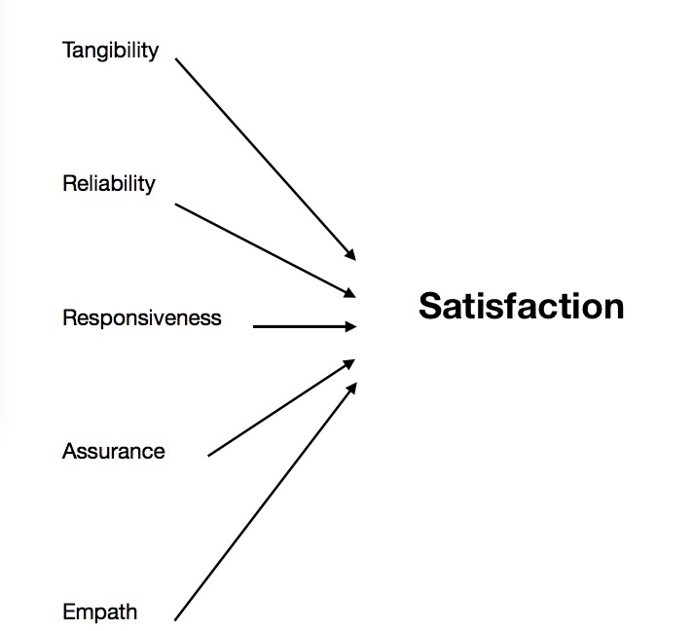

FIGURE 2 : Research Framework

## 2.7 HYPOTHESES

### 

### 2.7.1 TANGIBLE AS AN SERVQUAL DIMENSION

Tangible factors include appearance, physical possibilities, equipment, staff, and communication goods. All of these dimensions provide the image that the customer considers when evaluating quality; Such as amenities in the organization's physical environment. SERVQUAL model represents the degree of satisfaction associated with exposure to uncertainty and pathways that individuals encounter in their first expectation (Prasadh, 2016). Based on previous empirical evidence, the hypothesis of this study is described as follows:

H1: Tangibility has a significant positive impact on customer satisfaction.

### 2.7.2 RELIABILITY AS AN SERVQUAL DIMENSION

Reliability depends on handling customers services problems; performing services right the first time; provide services at the promised time and maintaining error-free record. Furthermore, they stated reliability as the most important factor in conventional service (Parasuraman & Zeithaml, 1988). Reliability also consists of accurate order fulfillment; accurate record; accurate quote; accurate in billing; accurate calculation of commissions; keep services promise.

Reliability refers to customer handling and handling of matters related to service implementation, demonstration at the first execution of service, timely service and keeping error-free records (Byun & Cho ,2017). Pallasuraman et al. (1988) argue that reliability is the most critical component of conservative services, including the true spirit of correct order execution and placement, correct records; Correct citation; Accurate billing; Results are more reliable than instructions; And provide promised services. The reliability of travel agency services is also seen as a more important factor.Therefore, we developed the following hypothesis for this study:

H2: Reliability has a significant positive impact on customer satisfaction.

### 2.7.3 RESPONSIVENESS AS AN SERVQUAL DIMENSION

Responsiveness defined as the willingness or readiness of employees to provide service. It involves timeliness of services (Parasuraman & Zeithaml, 1988). It is also involves understanding needs and wants of the customers, convenient operating hours, individual attention given by the staff, attention to problems and customers‟ safety in their transaction (Kumar & Manshor, 2009).

Responsiveness refers to the desire to help customers and provide service quickly. This aspect of service quality emphasizes sensitivity and vigilance to customer requirements, problems and complaints.

H3: Responsiveness has a significant positive impact on customer satisfaction.

### 2.7.4 ASSURANCE AS AN SERVQUAL DIMENSION

Assurance is the reliability of knowledge and the polite behavior of employees refers to the ability and value of service to express assurance and self-assurance. This dimension of service quality is particularly important in situations of high risk.

H4: Assurance has a significant positive impact on customer satisfaction.

### 2.7.5 EMPATHY AS AN SERVQUAL DIMENSION

The empathy dimension of SERVQUAL is described in terms of the customer care and personal care of travel agency employees. Parasuraman et al. (1985) hold that the characteristic of empathy is to provide consumers with care and personal consideration for problems in travel. It discusses individual concerns about the organization's staff, who know the needs of customers and the facilities that need to be provided during working hours. Apornak (2017) and Parasuraman et al. (1988) acknowledge the existence of reliability and empathy as dimensions in the SERVQUAL model. Johnson et al. (2002) described empathy as an efficiency that makes customers feel welcome through the implementation of interactive attitudes among travel agency employees (Tandon, 2018).

# H5: Empathy has a significant positive impact on customer satisfaction.

# CHAPTER 3 ：RESEARCH METHODOLOGY

## 

## 3.1 RESEARCH DESIGN

The types of research and research questions and research objectives determine the methods of data collection (Tull & Hawkins, 1987). The research at hand is formal, communicative, descriptive, cross-sectional, and statistical, so the survey method is suitable for data collection (Cooper & Schindler, 2008).

The questionnaire of this study adopted Marinkovi difference and almost no changes were made in order to adapt to this study. Modification is mainly about grammar and sentence structure. Use the past tense in the sentence to match the context because only those customers who have already served will be contacted. In all these changes, the meaning of the problem remains the same.

## 3.2 THE STUDY OF POPULATION，UNIT OF ANALYSIS AND SAMPLING DESIGN

### 

### 3.2.1 TARGET POPULATION

Sample candidates were those who had used travel agency services at least once in the past year. The survey was conducted in XiaMen. The survey was conducted from the 15th of June, 2019 to the 20th of July.

### 3.2.2 UNIT OF ANALYSIS

An analysis unit is the aggregate level of data collected during the subsequent data analysis phase. This paper takes individuals as the unit of analysis, mainly through the satisfaction survey of Chinese tourism consumers on travel agencies, so as to improve the service quality of travel agencies.

### 

### 3.2.3 SAMPLING FRAME AND SAMPLING LOCATION

The sample for the survey consisted of people who had used travel agency services at least once in the past year.

The city of Xiamen was used for data collection because it is generally acknowledged to be the capital of tourism in South East China. The tourism industry is more advanced and XiaMen has more travel agents than most of the other cities and regions in China. There are now around 377 travel agents in Xiamen (Travel.xm.gov.cn, 2019).

### 

### 3.2.4 SAMPLING TECHNIQUES

We used a convenient sample size to collect data. Convenience sampling is probably the easiest sampling method because participants are selected based on availability and willingness to participate. Useful results are available, but the results are prone to significant bias because those who volunteer may differ from those who choose not to participate (volunteer bias), and the sample may not represent other characteristics, such as age or gender. We assumed that conducting an online-based survey would yield quite low response rates and therefore, we strongly believed that the best way to collect data was to have questionnaires administered to candidates who were willing to take part in the survey. All those who wanted to participate received questionnaires and upon completion returned them to the poll-takers. Sample candidates are those who have used the service in China at least once in the past 12 months. The survey was conducted in three Chinese cities.

### 3.2.5 SAMPLE SIZE

We distributed 200 questionnaires at the above locations with the aim of collecting at least 100 responses.

## 3.3 DESIGN AND PROCEDURE

Generally, research design means a structure to plan and execute a particular research.Research design is the crucial part of the research as it includes all the four important considerations: the strategy, the conceptual framework, the identification of whom and what to study on and the tools and procedures to be used for collecting and analyzing data.The research design basically is divided into several types for example qualitative research and quantitative research.

This study adopts quantitative research method. Customer satisfaction is studied by means of questionnaire survey. Data provided by 400 consumers participating in the survey are tested by data analysis, reliability and validity test, t-test and regression analysis.The main purpose of this study is to study the impact of different dimensions of service quality on tourism consumer satisfaction and to evaluate the level of tourist satisfaction of Chinese travel agencies.

This study adopts convenience sampling procedure. Convenience sampling is sometimes known as opportunity, accidental or haphazard sampling sampling. It is a type of non-probability sampling which involves the sample being drawn from that part of the population which is close to hand, that is, a population which is readily available and convenient. The researcher using such a sample cannot scientifically make generalizations about the total population from this sample because it would not be representative enough (Michael, 2011). This type of sampling is most useful for pilot testing.

Convenience sampling differs from purposive sampling in that expert judgment is not used to select a representative sample. The primary selection criterion relates to the ease of obtaining a sample. Ease of obtaining the sample relates to the cost of locating elements of the population, the geographic distribution of the sample, and obtaining the interview data from the selected elements (de Leeuw, Hox & Huisman, 2003).

## 3.4 MEASUREMENT INSTRUMENT

A service for measuring quality that provides a modified version of the SERVQUAL schema with the use of 17 statements. There's this old model, tangibility, reliability, responsiveness, assurance and compassion there there are quality problems involved. Each aspect is measured using a questionnaire in two to four statements (Parasuraman, 1985).

Satisfaction is measured by using the same parameters in the customer satisfaction index (ACSI) model in the United States, including complete satisfaction, performance, all below or above expectations and performance of relatively ideal services in a particular category. Results measured from descriptive statistics of standard types (arithmetic mean and standard deviation), together with factor and regression analysis. The various factors that affect are tested through a general pattern. Individual factors of statistical significance were determined by multiple regression analysis (Stem, 1977).

### 

### 3.4.1 SCALES MEASUREMENT

In statistics, there are four data measurement scales: nominal, ordinal, interval and ratio. The study mainly used the scale of nominal and ordinal. Nominal scales are used for labeling variables, without any quantitative value. “Nominal” scales could simply be called “labels.” Here are some examples, below. Notice that all of these scales are mutually exclusive and none of them have any numerical significance. A good way to remember all of this is that “nominal” sounds a lot like “name” and nominal scales are kind of like “names” or labels.

Ordinal scales are typically measures of non-numeric concepts like satisfaction, happiness, discomfort, etc. This study is mainly to measure customer satisfaction on ordinal scale. Respondents were requested to score each of the questionnaire items using a 5-point likert scale ranging from very low expectation (1) to very high expectation (5) and from very dissatisfied (1) to very satisfied (5).

### 

### 3.4.2 QUESTIONNAIRE DESIGN

The questionnaire was designed based on the revised five-dimensional SERVQUAL scale proposed by Parasuraman et al. (1991). It was suggested that modifications might be needed to reflect specific characteristics of specific industries (Stafford 1999).

Although most of the 22 projects with five dimensions were retained, they were modified with reference to the empirical studies of Atilgan et al. (2003) and Johns et al. (2004), considering the specific background of the study. In addition, due to linguistic reasons, such as the expectation and perception of English words are difficult to express in simple Chinese, the wording is modified to make the meaning clearer. The translation is verified by an established program (McGorry ,2000).

The final questionnaire is composed of two parts. The questionnaire is composed of two parts. The first part includes screening and demographic questions, which are designed to accept only appropriate respondents' answers. The second part tries to establish the important role of individual factors in choosing travel agency. This section constitutes the five dimensions of SERVQUAL, using an adapted version of the SERVQUAL model with 17 statements to measure the quality of service delivery. According to the original model, physicality, reliability, responsiveness, security and empathy are incorporated into the quality dimension (Setó-Pamies, 2012). Each dimension was determined by two to four statements in the questionnaire. (Appendix for details)

### 

### 3.4.3 PILOT STUDY

SPSS was used for data analysis. First, descriptive statistics were used to investigate the demographic characteristics of participants and measure satisfaction with online booking. Secondly, correlation analysis and regression analysis are used to measure the correlation between dependent variables and independent variables.

### 3.4.4 FACTOR ANALYSIS

Considering that we use 17 attributes to measure the service quality of travel agencies, in order to better understand the impact of service quality on customer satisfaction, we want to conduct additional analysis. Through factor analysis, we divide The 17 service quality attributes of The travel agency for three new factors .

Factor 1: High fidelity

Factor 2: Assiduity

Factor 3: Tangibility

Interpretation of each factor:

Factor 1 is that this factor includes quality of service attributes related to reliability and responsiveness dimensions and two attributes belonging to assurance dimension.

Factor 2 which includes the remaining two guarantee properties, and the attractor belonging to empathy.

Factor 3 tangibility only includes attributes related to tangibility.

### 3.4.5 VALIDITY AND RELIABILITY TEST

Validity analysis is also called validity test, which verifies the rationality of the questionnaire structure. The validity of the questionnaire was tested by factor analysis. The purpose of reliability analysis is to check whether the scale is stable and consistent in measuring related variables. Specifically, it means to test the degree of consistency between various factors in the scale and whether the two measurements are consistent. Reliability analysis of each factor was carried out by calculating Cronbach's alpha coefficient value. The validity of the questionnaire was measured by the Kaiser- meyer-olkin (KMO) Bartlett spherical test.

## 3.5 DATA ANALYSIS

### 

### 3.5.1 CORRELATION ANALYSIS

Correlation analysis is a common statistical method to analyze the degree of correlation between variables. The correlation degree among variables is determined by the absolute value of Pearson correlation coefficient, and the larger the absolute value is, the higher the correlation degree is. The correlation coefficient is positive for positive correlation and negative for negative correlation. The results were obtained by correlation analysis between customer satisfaction and 8 factors.

### 3.5.2 REGRESSION ANALYSIS

Regression analysis is a statistical method to analyze the interdependence between dependent variables and independent variables. That is to study how the change of one or several dependent variables will affect the dependent variable. In this paper, tourist satisfaction is the dependent variable and the extracted five factors are independent variables.

# 

# CHAPTER 4: RESEARCH FINDINGS

## 4.1 OVERVIEW

In this survey we used a convenient sample size to collect data. The candidate sample is a candidate who has used Xiamen travel agency services at least once in the past 12 months. The survey was held in Xiamen, China from July 15 to August 2, 2019. The main data of Xiamen is mainly collected through online or telephone interviews. We strongly believe that the best way to collect data is to conduct a survey of candidates who are willing to participate. All survey participants who want to participate will receive the questionnaire and return it to the voter upon completion. Of the 384 questionnaires distributed, 296 were fully filled out and returned to voters. There are three cases in this survey to determine the invalid questionnaire: one questionnaire has one service indicator not answered; the same service indicator selects two answers; one questionnaire only selects the same option.

## 4.2 PILOT TEST

In the pilot test, only 40 responses will be analyzed to check if any items are not valid or reliable. Both factor analysis and reliability test are done in this stage.

### 4.2.1 Factor analysis-pilot test

In the second chapter above, the service quality dimension affecting the customer satisfaction of tourism industry is analyzed, and the empirical analysis method is used to analyze the satisfaction degree of the service quality of the travel agency through which service dimensions are used by tourists. In order to determine the quality of service dimension that affects travel agency traveller satisfaction, the KMO test and the Bartlett sphere test are used for factor analysis. For each group of projects, the KMO value must be at least > 0.5 (0.5-0.6 is tragic, but in some cases still acceptable), and the loading factor for each item must be > 0.5. Table 4-1 is used to display the KMO value and the factor load for each item. As can be seen from the table, all hypotheses `KMO can be (except for Empathy2 at 0.517, which is problematic before the initial test).

|  |  |  |
| --- | --- | --- |
| Hypothesis(IV) | Items | Factor loading |
| Tangibility has a significant positive impact on customer satisfaction. | Tangibility1  Tangibility2  Tangibility3  Tangibility4 | 0.768  0,663  0.664  0.851 |
| Reliability has a significant positive impact on customer satisfaction. | Reliability1  Reliability2  Reliability3 | 0.766  0.713  0.643 |
| Responsiveness has a significant positive impact on customer satisfaction. | Responsiveness1  Responsiveness2  Responsiveness3 | 0.771  0.712  0.808 |
| Assurance has a significant positive impact on customer satisfaction. | Assurance1  Assurance2  Assurance3  Assurance4 | 0.828  0.734  0.687  0.674 |
| Empathy has a significant positive impact on customer satisfaction. | Empathy1  Empathy2  Empathy3  Empathy4 | 0.715  0.517  0.631  0.728 |
| Hypothesis(DV) | Items | Factor loading |
| Customer Satisfaction | Satisfaction 1  Satisfaction 2  Satisfaction 3  Satisfaction 4 | 0.736  0.750  0.727  0.833 |

Table 4-1 : Factor analysis results for pilot test.

### 4.2.2 DATA RELIABILITY

Before the research and analysis, the reliability degree of the designed tourist satisfaction index evaluation questionnaire is analyzed. The Cronbach alpha coefficient is currently the most commonly used to measure the credibility of the cumulative Likert scale.

The reliability factor indicates the reliability of the test. It is represented by the letter "a" and is represented as a number between 0 and 1.00, a = 0 means no reliability, and a = 1.00 means perfect reliability. Don't expect to find a test with perfect reliability. Typically, you treat the reliability of the test as a decimal, for example, a= 0.80 or a = 0.93. The greater the reliability factor, the higher the repeatability or reliability of the test score. Table 4-1 serves as a general guideline for explaining test reliability. However, do not select or reject the test based solely on the size of its reliability factor.

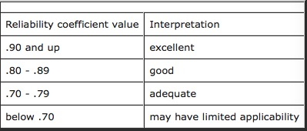

Table 4-2. General Guidelines for

Source: Hr-guide.com, 2019

First, we used the Cronbach alpha coefficient to measure the reliability factor of the survey project through a reliability analysis of 40 samples. The a coefficient is generally above 0.7. The reliability of the questionnaire is relatively high. According to the reliability results in Table 4-3, the a coefficient of each survey item is greater than 0.7. Therefore, this survey can show that the questionnaire reflects the high reliability of consumers' satisfaction with the service quality of travel agencies.

|  |  |  |
| --- | --- | --- |
| **IV** | Number of items | Chronbach`s Alpha |
| Tangibility | 4 | 0.892 |
| Reliability | 3 | 0.830 |
| Responsiveness | 3 | 0.877 |
| Assurance | 4 | 0.892 |
| Empathy | 4 | 0.831 |
| **DV** | Number of items | Chronbach`s Alpha |
| Customer Satisfaction | 4 | 0.811 |

Table 4-3 Reliability test results for pilot test

## 4.3 DESCRPTIVE STATISTICS

In this section, demographic information, including personal information such as gender age and education level, will be analyzed.

### 4.3.1 Personal Demographics

As stated in the chapter overview, 296 responses were from consumers who had participated in Xiamen travel agency services in the past year. Of the 296 respondents, 142 (47.97%) were male and 154 (52.03%) were female, as shown in Figure 4-6. In addition, as shown in Figure 4-7, the majority of respondents were between 32-40 years old and 32.43%. The second highest respondent's age category was 21-30 years old, with 69 respondents (23.31%), then 22.64% of respondents were between 41-50 years old, and 21.62% were over 50 years old. Then, as shown in Figure 4-8, the majority of respondents were polyrechnic school, accounting for 97, an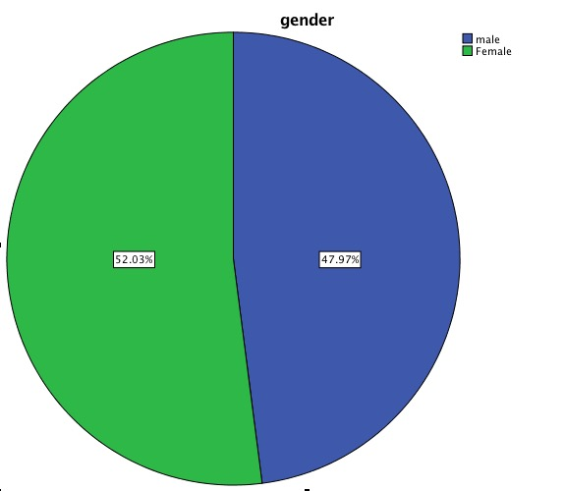 undergraduate students accounted for 92.

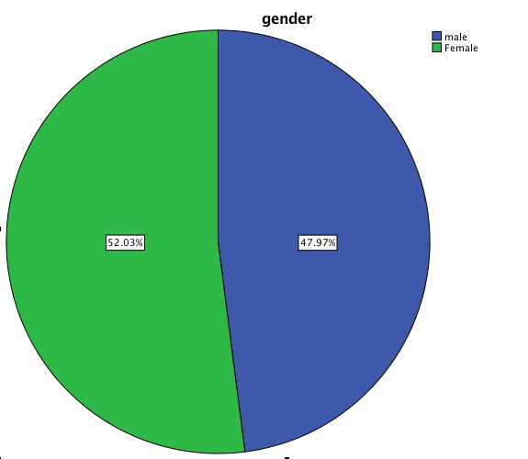

Figure 4-6 Pie chart for gender of respondents.

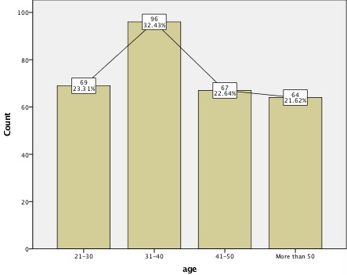

Figure 4-7 : Bar chart for age of respondents.

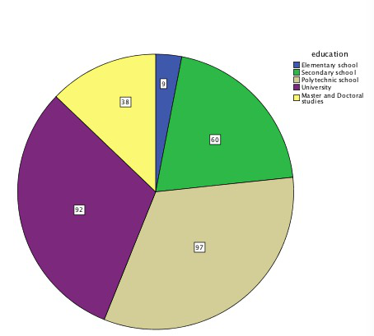

Figure 4-8 : Bar chart for education level of respondents.

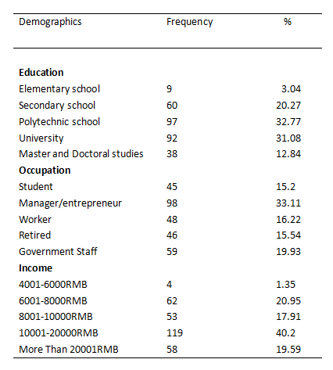

Figure 4-9: Descriptive statistics of respondents’ characteristics (n = 296)

From Figure 4-9, it shows that the consumer occupations involved in the survey are 33.11% of managers or entrepreneurs, and the proportion of government officials and retired workers is 19.93%, 15.54 and 16.22% respectively. From the income project, it can be intuitively seen that the monthly income of 10001-20000rmb is the largest (40.2%). We can reason that most of the consumers who participate in the travel agency's services are those with good incomes.

## 4.4 PRELIMINARY DATA ANALYSIS

In the preliminary test, all data were tested and analyzed after considering the test results. It can be seen from the analysis of the pilot test factors that some factors must be removed due to their lower factor load (less than 0.5), so these factors will not be used in the preliminary test. In this section, factor analysis, reliability testing, and hypothesis testing will be performed. In order to check which factors have a measurable impact on consumer satisfaction, which factors are not.

### 4.4.1 FACTOR ANALYSIS

For each hypothetical term, the KMO value must be greater than 0.5, and preferably it is greater than 0.6, and the factor load must be 0.5 or higher. Table 4-6 shows the results of the factor analysis for the preliminary data. The factor of elimination is marked with X. In addition, Tangibility1x and Empathy4x and Satisfaction 3X will be disqualified because their value is shown as 0.498 and 0.492 and 0.493 As for KMO, they are all ok and can be used for follow-up testing.

|  |  |  |
| --- | --- | --- |
| Hypothesis (IV) | Items | Factor loading |
| Tangibility has a significant positive impact on customer satisfaction. | Tangibility1X  Tangibility2  Tangibility3  Tangibility4 | 0  0,594  0.530  0.669 |
| Reliability has a significant positive impact on customer satisfaction. | Reliability1  Reliability2  Reliability3 | 0.539  0.716  0.745 |
| Responsiveness has a significant positive impact on customer satisfaction. | Responsiveness1  Responsiveness2  Responsiveness3 | 0.616  0.841  0.812 |
| Assurance has a significant positive impact on customer satisfaction. | Assurance1  Assurance2  Assurance3  Assurance4 | 0.617  0.710  0.595  0.662 |
| Empathy has a significant positive impact on customer satisfaction. | Empathy1  Empathy2  Empathy3  Empathy4x | 0.689  0.565  0.687  0 |
| Hypothesis (DV) | Items | Factor loading |
| Customer Satisfaction | Satisfaction 1  Satisfaction 2  Satisfaction 3X  Satisfaction 4 | 0.693  0.714  0  0.785 |

Table 4-4 Factor Analysis

### 4.4.2 RELIABILITY TEST

After the factor analysis is completed, 2 items are removed and the next step can be continued. Which is the reliability test, Table 4–7 shows the Cronbach`s Alpha reliability test results for each factor. As can be seen from the table, Chronbach's Alpha is 0.7 and above for all factors, which means that all factors can be used for further analysis.

|  |  |  |
| --- | --- | --- |
| **IV** | Number of items | Chronbach`s Alpha |
| Tangibility | 3 | 0.748 |
| Reliability | 3 | 0.711 |
| Responsiveness | 3 | 0.705 |
| Assurance | 4 | 0.748 |
| Empathy | 3 | 0.801 |
| **DV** | Number of items | Chronbach`s Alpha |
| Customer Satisfaction | 3 | 0.829 |

Table 4-5 Reliability test

### 4.4.3 REGRESSION ANALYSIS

**1. MULTIPLE REGRESSION ANALYSIS**

What is the relationship between the five dimensions of travel agency service quality and the overall satisfaction of consumers? What is the importance of the overall satisfaction of consumers? This section uses multiple linear regression models to predict between them. Relationship. When establishing the regression equation, stepwise is used to enter the regression equation with guarantee, reliability, perceptibility, reactivity and empathy. The significance level is set to 0.05. The analysis results are shown in Table 4-6:

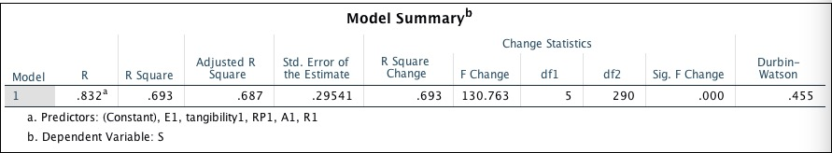

Table 4-6 model summary

R² is used to explain to what extent the regression equation obtained explains the proportion of the total variation of the dependent variable by all independent variables. The closer R² is to 1, the better the linear relationship between the dependent variable and the independent variable, according to Table 4-6 R²: 0.693, indicating that there is a linear correlation between the overall consumer satisfaction and the five influencing factors, P (significant level) = 0.000, less than the set significance level of 0.05, indicating that the linearity correlation between tourist satisfaction and each impact factor is significant.

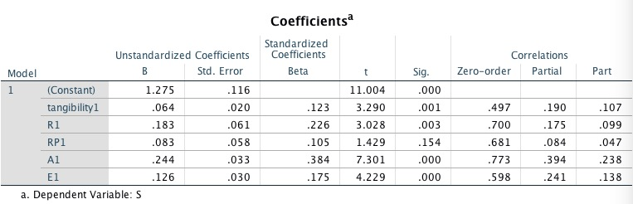

Table 4-7 Coefficients

From the table 4-7 regression coefficient table, the relationship between the overall satisfaction of the consumer and the five influencing factors is obtained. The T-test is to detect whether each independent variable is linearly related to the linearity of the cross-correlation. According to the T value of Table 4-7. And a significant level, indicating that the five impact factors are linearly related to consumer satisfaction, respectively.

Therefore, the five impact factors of guarantee, reliability, responsiveness, perceptibility and empathy can be used to explain the satisfaction of consumers with the quality of travel agency service when they travel with travel agencies.

### 4.4.4 CORRELATION ANALYSIS

The statistical test tells us whether the correlation is significantly different from zero; the absolute value of the correlation coefficient is an effect size that summarizes the strength of the relationship.Cohen suggested that d=0.2 be considered a 'small' effect size, 0.5 represents a 'medium' effect size and 0.8 a 'large' effect size. This means that if two groups' means don't differ by 0.2 standard deviations or more, the difference is trivial, even if it is statistically significant. We can directly see the influence of five factors on the dependent variable in Table 4-8. They have the maximum A1 coefficient of 0.7, then the R1 coefficient is 0.7, the RP1 coefficient is 0.651, and E1 is 0.598. The smallest is Tangibility1 is 0.497.

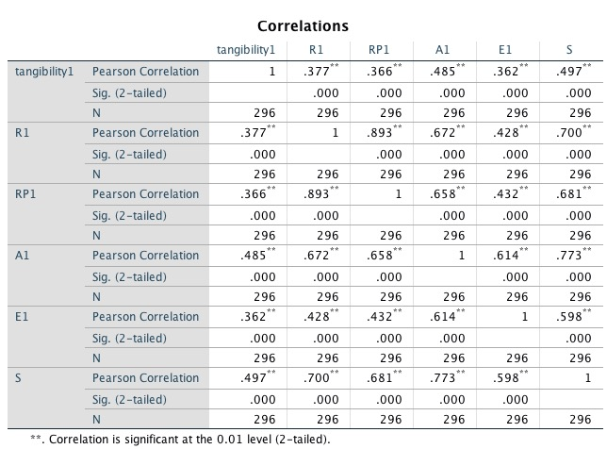Table 4-8 correlations

## 4.5 HYPOTHESES TESTINFG

Hypothesis testing is an act in statistics of an analyst tests an assumption regarding a population parameter. Hypothesis testing is a process by which an analyst test a statistical hypothesis, the method employed by the analyst depends on the nature of the data used, and the goals Of the analysis, which is to either accept or reject the null hypothesis.

In this article, five hypotheses are proposed. These five hypotheses are tested using multiple regression equations. From Table 4-9 we can see that P (significant level) = 0.000, less than the set significance level of 0.05, which proves that the regression model was statistical significant and the proposed model is fit .This was based on the assumption That the level of significant was 0.05.

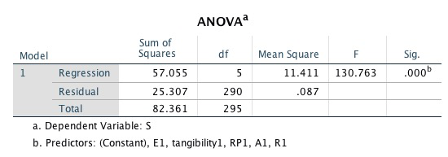

Table 4-9 ANOVA

According to Table 4-10, the value of the R² is 0.693. This means that approximately 70% of variance of the dependent variables was able to explain by the variation of the 5 independent variables proposed in this research. Meanwhile, there 30% of Variance in the dependent variable could be explained by the variation of factors that were outside of the scope of this research. In other words, there should be other influencing factors not only empathy, assurance, responsiveness, reliability, tangibility, which also could influence Customer satisfaction.



Table 4-10 model summary result

In terms of multilinearity, the variance expansion factor should be emphasized. The value of the variance expansion factor is less than 10, indicating that future analysis can be performed and performed. In the case where the assumption that multiple regression is ensured is complete, we can see the regression coefficients in Table 4-11.

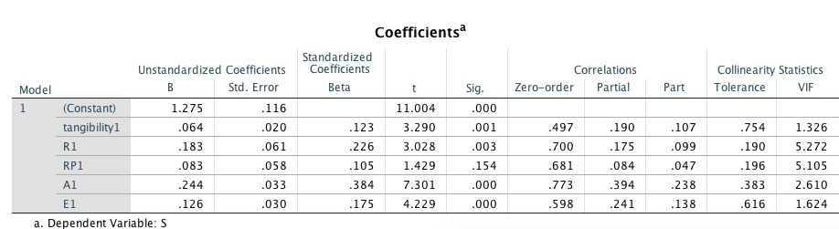

Table 4-11 coefficients results

H1: Tangibility has a significant positive impact on customer satisfaction. According to Table 4-10, the independent variable tangibility1 achieved the statistical significance, was 0.001 (p-value < 0.05), which means that H1 is acceptable.

H2: Reliability has a significant positive impact on customer satisfaction. According to Table 4-10, the independent variable R1 achieved the statistical significance, was 0.003 (p-value<0.05), which means that H2 is acceptable.

H3: Responsiveness has a significant positive impact on customer satisfaction. According to Table 4-10, the independent variable RP1 does not achieve the statistical significance, was 0.154 (p-value >0.05), which means that H3 is unacceptable, and the assumption is not true. of.

H4: Assurance has a significant positive impact on customer satisfaction. According to Table 4-10, the independent variable A1 achieved the statistical significance, was 0.000 (p-value<0.05), which means that H4 is acceptable.

H5: Empathy has a significant positive impact on customer satisfaction. According to Table 4-10, the independent variable E1 achieved the statistical significance, was 0.000 (p-value < 0.05), which means that H5 is acceptable.

## 

## 4.6 SUMMARY OF KEY RESEARCH FINDINGS

Factor analysis carried out in this research that data collected and proposed variable were acceptable for future analysis.Reliability test proved the variable in this research. In addition ,correlation test showed that the variables were well correlated with each other solidifying the competency of the variables. With the suitable and correlated variables, this research could be taken forwards hypothesis testing. The summary of the hypothesis testing was table 4-12 shown as below.

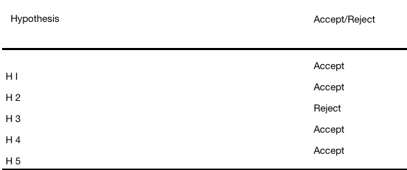

Table 4-12 Hypothesis Finding

For Hypothesis 1, this hypothesis is mainly to study whether the tangible dimension of the quality of service provided by travel agencies has a positive impact on consumer satisfaction. The tangibility is also included in the research, such as the modern equipment used by travel agencies, internal facilities, employee dress and brochures, flyers and price lists on travel destinations. The tangible results obtained in similar studies of service quality and customer satisfaction have a positive impact on customer satisfaction (Rizwan Raheem AHMED et al, 2017).

For Hypothesis 2, this hypothesis focuses on whether the reliability dimension of service quality has a positive impact on customer satisfaction. Mainly reflected in the travel agency's commitment to the customer is met within the agreed time frame, the staff to solve the customer's problems in a sincere manner, and the accuracy of the service. The result of this hypothesis is accepted, that is, the reliability dimension of service quality has a positive impact on customer satisfaction.

For Hypothesis 3, this hypothesis focuses on whether the responsiveness dimension of service quality has a positive impact on customer satisfaction. For example, employees provide timely and up-to-date services to their customers, and employees are always ready to help customers. The final result of this hypothesis is rejected, which means that the responsiveness dimension of service quality has no positive impact on customer satisfaction.

For Hypothesis 4, this hypothesis focuses on whether the assurance dimension of service quality has a positive impact on customer satisfaction. For example, the customer has all the travel arrangements for the hotel, the room, the traffic is full of confidence, the staff's professional knowledge reserves and service etiquette. The result of this hypothesis is accepted, which means that the quality of service quality has a positive impact on customer satisfaction.

For Hypothesis 5, this hypothesis focuses on whether the empathic dimension of service quality has a positive impact on customer satisfaction. For example, the employee's attention to the visitor is throughout the trip, as well as the satisfaction of the customer's needs. The result of this hypothesis is accepted, that is, the empathic dimension of service quality has a positive impact on customer satisfaction.

## 4.7 SUMMARY

Based on 40 samples, the original 40 questionnaires were tested by factor analysis of four factors related to the dependent variable (DV) and 22 items related to the independent variable (IV). The reliability test was then carried out and Cronbach's Alpha value exceeded 0.7.

Subsequently, in the preliminary test, factor analysis was performed on 296 samples using 22 items. However, since the factor load is below 0.5, there are two issues that need to discard the argument group: Tangibility1x and Empathy4x and dependent variable (DV) Satisfaction 3X. Then carry out a reliability test and meet Cronbach's Alpha value of more than 0.7. Therefore, the subsequent hypothesis test can only be carried out with the remaining 19 projects, which are from 3 projects of DV and 17 projects from IV.

# CHAPTER 5 ： DISCUSSION AND CONCLUSION

## 5.1 OVERVIER

The final chapter of this study presents a discussion and recommendations for the hypothetical results. The research's contribution to academia and the industry was identified as a possible future study. Some of the limitations faced in this study and the personal reflection of the study have been highlighted.

## 5.2 DISCUSSION OF FINDINGS AND RECOMMENDATION

The purpose of this study was to determine the factors that influence consumer satisfaction in participating in Xiamen's travel agency services in China through the SERVQUAL dimension. The five dimensions of this study are tangibility, assurance, empathy, reliability, and responsiveness. Five research questions were formed to test hypotheses based on the collected data. The results show that the four SERVQUAL dimensions (tangibility, assurance, reliability and empathy) are important factors in triggering customer satisfaction. This conclusion is consistent with the findings of Jamal and Anastasiadou (2009). This study shows that reliability, tangibility, assurance and empathy have a significant impact on satisfaction, while in terms of reactivity, significance is not confirmed. In addition, our findings are similar to those of Lam and Zhang (1999). Their research confirmed the significant impact of the travel agency's four SERVQUAL components on customer satisfaction. According to their research, reliability, tangibility, assurance, and empathy are the most important triggers for satisfaction, which almost showed the same results in our research. Other studies have emphasized that reliability is a factor in customer satisfaction (Chakraborty et al., 2007).

For Hypothesis 1, this hypothesis is mainly to study whether the tangible dimension of the quality of service provided by travel agencies has a positive impact on consumer satisfaction. The tangibility is also included in the research, such as the modern equipment used by travel agencies, internal facilities, employee dress and brochures, flyers and price lists on travel destinations. The tangible results obtained in similar studies of service quality and customer satisfaction have a positive impact on customer satisfaction (Rizwan Raheem AHMED et al, 2017).

Researcher Veljko (2016) also supports that tangibility has a significant impact on customer satisfaction. In his research, the results are that reliability, tangibility and empathy have a significant impact on satisfaction, while in reactivity and assurance In terms of degree, the significance was not confirmed.

For Hypothesis 2, this hypothesis focuses on whether the reliability dimension of service quality has a positive impact on customer satisfaction. Mainly reflected in the travel agency's commitment to the customer is met within the agreed time frame, the staff to solve the customer's problems in a Sincere manner, and the accuracy of the service. The result of this hypothesis is accepted, that is, the reliability dimension of service quality has a positive impact on customer satisfaction. However, Researcher Zhou (2017) proposes five quality of service dimensions to the customer. Satisfaction is very important, but reliability is the most important determinant of customer satisfaction, and tangible assets are the least important. The unsatisfactory quality of service that customers feel in the research means that travel agencies should pay more attention to the improvement of service quality, especially in the first fulfillment of service rights and completion of commitment tasks. This means that travel agencies should not exaggerate the quality of their promised services, which may result in higher expectations for customers. Otherwise, when the agent is unable to perform the service as promised, the customer expectation is difficult to meet and the quality of service is low.

For Hypothesis 3, this hypothesis focuses on whether the responsiveness dimension of service quality has a positive impact on customer satisfaction. For example, employees provide timely and up-to-date services to their customers, and employees are always ready to help customers. The result is consistent with the results of Jamal and Anastasiadou (2009). Reliability, tangibility, and empathy have a significant impact on satisfaction, while saliency has not been proven in terms of reactivity and assurance. We can be sure that Xiamen's travel agencies have not succeeded in creating satisfaction among our customers. It is clear that future management must pay special attention to these important issues as they are some of the most important prerequisites for building long-term relationships with customers. Customer-oriented assumptions of business activities begin with understanding and anticipating the needs and desires of customers and ending with providing expected value and customer satisfaction. Feedback from customer needs is a necessary input to design and create the right marketing strategy.

For Hypothesis 4, this hypothesis focuses on whether the assurance dimension of service quality has a positive impact on customer satisfaction. For example, the customer has all the travel arrangements for the hotel, the room, the traffic is full of confidence, the staff's professional knowledge reserves and service etiquette. The result of this hypothesis is accepted, which means that the quality of service quality has a positive impact on customer satisfaction. Researcher PARASURAMAN (2017) also yielded similar results. In order to improve the quality of service, travel agencies also need to understand customer expectations in advance, improve management skills and the quality of service personnel to improve service performance.

For Hypothesis 5, this hypothesis focuses on whether the empathic dimension of service quality has a positive impact on customer satisfaction. For example, the employee's attention to the visitor is throughout the trip, as well as the satisfaction of the customer's needs. The result of this hypothesis is accepted, that is, the empathic dimension of service quality has a positive impact on customer satisfaction. Researcher AHMED (2018) stated the empathic dimension of service quality has a positive impact on customer satisfaction.

In order to establish a close relationship with customers, service organizations need to ensure good interaction with customers and a high level of quality in the service delivery process (Simon, 2007). Building a long-term relationship with customers reshapes the philosophy of traditional business practices, close to the main assumptions of modern marketing, which means that customer satisfaction and loyalty are key factors in business success. Therefore, the sale of products and services should not be interpreted as the end of marketing activities, but should be interpreted as the beginning of establishing and developing long-term and mutually beneficial relationships.

Failure to understand the importance of customer orientation can cause problems for service organizations in designing successful customer satisfaction programs. Achieving this goal requires coordination of functions across all departments and the active involvement of top management. Without the sincere support of top management, marketers cannot design or implement effective customer satisfaction programs. Management's continued focus on ongoing customer issues and needs and participation in the analysis of market research results is critical to the company's pursuit of better performance and improved market position.

## 

## 5.3 CONTRIBUTIONS

### 

### 5.3.1 CONTRIBUTIONS TO ACADEMIA

Future research can first determine the factors affecting consumer satisfaction in participating in Xiamen's travel agency services in China based on the results of this study through five dimensions of SERVQUAL. The five dimensions of this study are tangibility, assurance, empathy, reliability, and responsiveness. The results show that the four SERVQUAL dimensions (tangibility, assurance, reliability and empathy) are important factors in triggering customer satisfaction.

### 

### 5.3.2 CONTRIBUTIONS TO INDUSTRY

There are many studies on consumer satisfaction or other similar terms in the tourism industry. These studies are important for travel agencies to understand the quality of service. Research service quality affects traveler satisfaction through the proposed research model. The research itself is also related to a wide range of service organizations that are committed to fostering long-term relationships with customers. Therefore, this study provides an idea and advice for the industry to further explore the current status of China's tourism service quality.

Reviewing the hypothesis in this study, we examine how service quality affects traveler satisfaction through proposed research models, but the research itself is also related to a wide range of service organizations that are committed to fostering long-term relationships with customers.

## 

## 5.4  LIMITATION

Although this paper has achieved some value in the satisfaction of travel agency tourists, there are still many problems in the research of the thesis and the problems that need to be discussed.

1. This paper is used to analyze the quality of service of travel agencies. The quality of service indicators involved in the evaluation indicators are not very broad. For the tourists complaining about complaints, the travel agency's evaluation of whether to make tourists satisfied is not mentioned.

 2. The satisfaction assessment indicators designed are only applicable to the satisfaction evaluation of tourists' overall package price service, but these indicators are not fully applicable to the evaluation of individual customer service satisfaction.

 3. The small number of survey samples that determine the weight of the indicator may affect the true extent of the research results.

 4. Tourists' evaluation of the satisfaction level of travel agency service is not only affected by the quality of service they actually experience, but also by the expected quality of service. However, due to the technically difficult expectations of tourists' service quality, this paper directly investigates The level of travel agency services experienced by tourists.

## 

## 5.5 FUTURE STUDY OF RESEARCH

1. The index system designed in this thesis is only designed around the travel agency's “food, housing, travel, tourism, purchase, entertainment”. However, with the increase of travel agency service projects, the service content of the indicator system should also be increased to be comprehensive. Reflect the service level of the travel agency.

2. In the data collection of indicator weights, the sample size should be increased, and combined with other kinds of weight evaluation methods, the weight of the determined indicators is closer to the real situation.

3. Increase research on the expected quality of service for tourists to see if there is any difference in the conclusions of the evaluation of satisfaction with the quality of travel agency services.

4. This paper only studies the satisfaction of travel agency service quality on tourists. The influence of travel agency on public image, public word of mouth and market communication is the focus of future research.

## 

## 5.6 PERSONAL REFLECTION

This research brought me a new experience on how to conduct research and also made me aware of the challenges that academia faces when conducting a good research. The systematic organization of the research process taught me a new knowledge, meticulous in stating the text and statements, because researchers should not bias and draw conclusions without proper documentation support. A large number of reading journals have improved my knowledge of reading research papers.

The results of this study are expected, but the responsiveness dimension is not a factor influencing consumer satisfaction, which surprised me. However, this assumption may not represent the entire tourism industry.

## 

## 5.7 CONCLUSION

This chapter discusses the results of the hypothesis by interpreting the hypothesis results, combining the support of relevant literature and possible suggestions.By studying the hypothesis results, the research objectives and research questions are answered. This research has a certain contribution to academia and tourism, and can be further improved in future research. Due to time and experience limitations, this study does not represent the overall situation of the Chinese tourism market.

# 

# REFERENCE

Arasli, H., Mehtap-Smadi, S. and Katircioglu, S. T., (2005), Customer service quality in the Greek Cypriot banking industry, Managing Service Quality, Vol. 15, no.1, pp. 41-56.

Agencies Customer in South Sumatra Indonesia. IOSR Journal of Business and Management, 19(05), pp.31-40.

Apornak, A. (2017). Customer satisfaction measurement using SERVQUAL model, integration Kano and QFD approach in an educational institution. International Journal of Productivity and Quality Management, 21(1), p.129.

Atilgan, E., Akinci, S. and Aksoy, S. (2015). Mapping service quality in the tourism industry. Managing Service Quality: An International Journal, 13(5), pp.412-422.

Ali, S. S. and Kaur, R. (2018) ‘An analysis of satisfaction level of 3PL service users with the help of ACSI’, Benchmarking: An International Journal, 25(1), pp. 24–46. doi: 10.1108/BIJ-10-2016-0163.

Arslan et al., (2014), Effect of Service Quality Dimensions on Customer Satisfaction : A Comparative Analysis of Pakistan Telecom Sector, Research on Humanities and Social Sciences (Paper), 2224-5766 ISSN. Vol.4, no.19.

Atilgan, E., Akinci, S. and Aksoy, S. (2003) ‘Mapping service quality in the tourism industry’,Managing Service Quality, 13:5, 412-422.

Andreassen, T. W. (1995), “(Dis) Satisfaction with public services: The case of public transportation”, Journal of Service Marketing, 9(5), 30-41.

Antoni Serra-Cantallops, José Ramon-Cardona, Fabiana Salvi, (2018) "The impact of positive emotional experiences on eWOM generation and loyalty", Spanish Journal of Marketing - ESIC, Vol. 22 Issue: 2, pp.142-162, <https://doi.org/10.1108/SJME-03-2018-0009>.

Allred, A. and Addams, H.L. (2000), “Service Quality at Banks and Credit Unions: What do their customers say?”, International Journal of Bank Marketing, 18(4), 200-207.

Bansal, A., Gaur, G. and Chauhan, V. (2016) ‘Analysis of Service Quality Provided by GoIbibo.com in Tourism Industry’, Global Journal of Enterprise Information System, 8(2), pp. 40–47. doi: 10.18311/gjeis/2016/7659.

Bitner, M. (1992). Servicescapes: The Impact of Physical Surroundings on Customers and Employees. Journal of Marketing, 56(2), p.57.

Balaji, M. S. (2009) ‘Customer Satisfaction with Indian Mobile Services’, IUP Journal of Management Research, 8(10), pp. 52–62. Available at: http://search.ebscohost.com.ezproxy.inti.edu.my:2048/login.aspx?direct=true&db=bth&AN=44622004&site=ehost-live (Accessed: 23 June 2019).

Benur, A. and Bramwell, B. (2015). Tourism product development and product diversification in destinations. Tourism Management, 50, pp.213-224.

Berry, L.L., Parasuraman, A. and Zeithaml, V.A. (1994), “Alternative Scales for Measuring Service Quality: A Comparison Assessment Based on Psychometric and Diagnostic Criteria”, Journal of Retailing, 70(3), 201-230.

Barlett, J.E., and Han, F. (2007), “Analysis of service quality in restaurants in China: An eastern perspective”, ABR and TLC Conference Proceedings.

Berry, L., & Parasuraman, A. (1991). Marketing services: competing through quality. New York: Free Press.

Collier, J. E. and Bienstock, C. C. (2006), “Measuring service quality in e-retailing,” JOURNAL OF SERVICE RESEARCH, 8 (3), 260-275.

Cao, M., Zhang, Q. Y., and Seydel, J. (2015), “B2C e- commerce web site quality: An empirical examination,” INDUSTRIAL MANAGEMENT & DATA SYSTEMS, 105 (5-6), 645-661

Chand, M. (2014) ‘Measuring the service quality of Indian tourism destinations: an application of SERVQUAL model’, International Journal of Services Technology & Management, 13(3/4), pp. 218–233. doi: 10.1504/IJSTM.2010.032079.

Chen, H. et al. (2016) ‘Conceptualizing and Measuring Service Quality: Towards Consistency and Clarity in its Application to Travel Agencies in China’, Journal of Quality Assurance in Hospitality & Tourism, 17(4), pp. 516–541. doi: 10.1080/1528008X.2015.1133365.

Chang, K.-C. (2015) ‘How travel agency reputation creates recommendation behavior’, Industrial Management & Data Systems, 115(2), pp. 332–352. doi: 10.1108/IMDS-09-2014-0265.

Chieh, W. (2013) "Tourist experience expectations: questionnaire development and text narrative analysis", International Journal of Culture, Tourism and Hospitality Research, Vol. 7 Issue: 1, pp.93-104. doi:10.1108/17506181311301390.

Chinho L. (2014) "Factors affecting online repurchase intention", Industrial Management & Data Systems, Vol. 114 Issue: 4, pp.597-611, https://doi.org/10.1108/IMDS-10-2013-0432

Chen, C.-F. and Kao, Y.-L. (2010) ‘Relationships between process quality, outcome quality, satisfaction, and behavioural intentions for online travel agencies - evidence from Taiwan’, Service Industries Journal, 30(12), pp. 2081–2092. doi: 10.1080/02642060903191108.

Cronin, J. J., Jr., Brady, M. K., & Hult,G.T. M. (2000) Assessing the effects of quality, value, and customer satisfaction on consumer behavioral intentions in service environments. Journal of Retailing,76. 193– 218

De Leeuw, E., Hox, J., & Huisman, M. (2003). Prevention and treatment of item nonresponse. Journal of Official Statistics, 19, 153–176.

Dessart, L., Veloutsou, C. and Morgan-Thomas, A. (2015) ‘Consumer engagement in online brand communities: a social media perspective’, Journal of Product & Brand Management, 24(1), pp. 28–42. doi: 10.1108/JPBM-06-2014-0635.

Daskalakis, N. G. (2008), “Users’ perceptive evolution of bus arrival time deviations in Stochastic Networks”, Journal of Public Transportation, 11(4), 25-38.

English.xm.gov.cn. (2019). XIAMEN MUNICIPAL PEOPLE'S GOVERNMENT. [online] Available at: http://english.xm.gov.cn/citytour/travelagencies/201611/t20161110_1376959.html [Accessed 30 Jun. 2019].

Fornell C, Johnson M D, Anderson E W et al. (1996), “The American Customer Satisfaction Index: Nature, Purpose and Findings”, Journal of Marketing, Vol. 60, No. 4, pp. 7-18.

Forozia, A., Zadeh, M.S. and Gilani, M.H. (2013), “Customer satisfaction in hospitality industry: Middle East tourists at 3 star hotels in Malaysia”, Research Journal of Applied Sciences, Engineering and Technology, Vol. 5 No. 17, pp. 4329-35.

Fuller, G. (1994). Travel agency management. Cincinnati: South-Western Pub. Co.

Ganesan Shankar (1994), “Determinants of Long-Term Orientation in Buyer-Seller Relationships”, Journal of Marketing, Vol. 58, No. 2, pp. 1–19.

Grønflaten, Ø. (2009). Predicting Travelers’ Choice of Information Sources and Information Channels. Journal of Travel Research, 48(2), pp.230-244.

GÖKCEK, H. A., ÇARIKÇIOĞLU, P. S. and YÜKSEL, C. A. (2019) ‘The Effect of Consumer Decision Making Styles on Cognitive Di̇ssonance along with the Role of the Perceived Risk as a Moderator in Online Shopping’, Journal of Academic Research in Economics, 11(1), pp. 118–127.

Gao,Y..& Wei, W. (2004). Measuring Service Quality and Satisfaction of Student in Chinese Business Education. The Sixth Wuhan International Conference on E- business.

Haghighat, N. (2017), “Airline service quality evaluation: a review on concepts and models”, Economics, Management and Sustainability, Vol. 2 No. 1, pp. 31-47.

Hernon, D. A. Nitecki. (2001). Service Quality: A Concept Not Fully Explored Library Trends. 49(4): 687-708.

Hery, H. (2016). A Study of Customer Satisfaction On Online Trading System Application of Securities Company in Indonesia Using Servqual. CommIT (Communication and Information Technology) Journal, 9(1), p.19.

Ha, H.-Y. et al. (2016) ‘Temporal effects of information from social networks on online behavior’, Internet Research, 26(1), pp. 213–235. doi: 10.1108/IntR-03-2014-0084.

Johnson, M., Herrmann, A. and Gustafsson, A. (2002). Comparing customer satisfaction across industries and countries. Journal of Economic Psychology, 23(6), pp.749-769.

Jovović, M., Femić-Radosavović, B. and Lipovina-Božović, M. (2017). Comparative Analysis of Results of Online and Offline Customer Satisfaction & Loyalty Surveys in Banking Services in Montenegro. Journal of Central Banking Theory and Practice, 6(2), pp.65-76.

Kaur, M. and Sharma, N. (2015) ‘Electronic Service Quality and Customer Satisfaction: A Study of Customer Loyalty with Special Reference to Tourism Industry’, Amity Business Review, 16(2), pp. 100–114.

Kumar, M. K., & Manshor, A. (2009). Determining the Relative Importance of Critical Factors in Delivering Service Quality of Banks: An Application of Dominance Analysis in SERVQUAL Model. Managing Service Quality, 19(2), 211 – 228.

Kim M, Park M and Jeong D (2004), “The Effects of Customer Satisfaction and Switching Barrier on Customer Loyalty in Korean Mobile Telecommunication Services”, Telecommunications Policy, Vol. 28, No. 2, pp. 145-59.

Kouthouris, C. and Alexandris, K. (2005) ‘Can service quality predict customer satisfaction and behavioral intentions in the sport tourism industry? an application of the SERVQUAL model in an outdoors setting’, Journal of Sport & Tourism, 10(2), pp. 101–111. doi: 10.1080/14775080500223165.

Kim-Soon, N., Rahman, A. and Visvalingam, L. (2014), “SERVQUAL: can it be used to differentiate guest’s perception of service quality of 3 Star from a 4 star hotel”, International Business Research, Vol. 7 No. 7, pp. 38-47.

Kim-Soon, N., Rahman, A. and Visvalingam, L. (2014). SERVQUAL: Can It Be Used to Differentiate Guest’s Perception of Service Quality of 3 Star from a 4 Star Hotel. International Business Research, 7(7).

Kotler, P., Armstrong, G., Ang, S., Tan, C., Yau, O. and Leong, S. (n.d.). Principles of marketing.

Lau, M.M., Cheung, R., Lam, A.Y.C., Chu, Y.T. (2013), Measuring Service Quality in the Banking Industry: A Hong Kong Based Study, Contemporary Management Research, Vol. 9, no. 3. pp. 263-282.

Levy, L., Karst, K. and Winkler, A. (2000). Encyclopedia of the American constitution. Detroit: Macmillan Reference USA.

Munusamy, J., Chelliah, S. and Mun, H.W. (2010), “Service quality delivery and its impact on customer satisfaction in the banking sector in Malaysia”, International Journal of Innovation, Management and Technology, Vol. 1 No. 4, pp. 398-404.

Marinković, V. et al. (2013) ‘Investigating the Impact of SERVQUAL Dimensions on Customer Satisfaction: The Lessons Learnt from Serbian Travel Agencies’, International Journal of Tourism Research, 15(2), pp. 184–196. doi: 10.1002/jtr.884.

Monaco, S. (2018), “Tourism and the new generations: emerging trends and social implications in Italy”, Journal of Tourism Futures, Vol. 4 No. 1, pp. 7-15.

McGorry, S.Y. (2000) ‘Measurement in a cross-cultural environment: survey translation issues’, Qualitative Market Research: an International Journal, 3:2, 74-81.

Namasivayam, K. (2004). The impact of intangibles on consumers' quality ratings using the star/diamond terminology. Foodservice Research International, 15(1), 34-40.

Pizam, A., Shapoval, V. and Ellis, T. (2016). Customer satisfaction and its measurement in hospitality enterprises: a revisit and update. International Journal of Contemporary Hospitality Management, 28(1), pp.2-35.

Pikkemaat, B. and Peters, M. (2006). Towards the Measurement of Innovation—A Pilot Study in the Small and Medium Sized Hotel Industry. Journal of Quality Assurance in Hospitality & Tourism, 6(3-4), pp.89-112.

Pansari, A., & Kumar, V. (2017). Customer engagement: the construct, antecedents, and consequences. Journal of the Academy of Marketing Science, 45(3), 294-311.

Petrick, J. and Backman, S. (2012). An Examination of the Determinants of Golf Travelers’ Satisfaction. Journal of Travel Research, 40(3), pp.252-258.

Parasuraman, A., Zeithaml, V., & Berry, L. (1988). SERVQUAL: Multiple-item scale for measuring consumer perceptions of service quality. Journal of Retailing, 64, 12–40.

Pao, H.-W., Wu, H.-L. and Pan, W.-H. (2015) ‘How does a new institution spread? Travel agencies’ adoption of the service quality assurance programme’, Service Industries Journal, 30(7), pp. 1047–1061. doi: 10.1080/02642060802298350.

Parasuranman, A., Berry, L.L. and Zeithaml, V.A. (1991) ‘Refinement and reassessment of the SERVQUAL scale’, Journal of Retailing, 67: 4, 420-450.

Pappas, I. O. et al. (2014) ‘Moderating effects of online shopping experience on customer satisfaction and repurchase intentions’, International Journal of Retail & Distribution Management, 42(3), pp. 187–204. doi: 10.1108/IJRDM-03-2012-0034.

Parasuraman, A., Zeithaml, V.A. and Berry, L.L. (1985). A conceptual model of service quality and its implications for future research. Journal of Marketing , 49(4), 41-50

Parasuraman, A. (1994). Alternative scales for measuring service quality: A comparative assessment based on psychometric and diagnostic criteria. Journal of Retailing, 70(3), pp.193-194.

Raajpoot , N. (2004) ‘Reconceptualizing service encounter quality in a non-western context’, Journal of Service Research, 7:2, 181-201.

Ruiqi, Z. and Adrian, P. (2009) ‘Using Servqual to Measure the Service Quality of Travel Agents in Guangzhou, South China’, Journal of Services Research, 9(1), pp. 87–107.

Robledo, M. A. (2001). Measuring and managing service quality: integrating customer expectations. Managing Service Quality, 11, 1, 22–31.

Roslan, N., Wahab, E. and Abdullah, N. (2015). Service Quality: A Case Study of Logistics Sector in Iskandar Malaysia Using SERVQUAL Model. Procedia - Social and Behavioral Sciences, 172, pp.457-462.

Rao, P.S. and Sahu, P.C. (2013), “Impact of service quality on customer satisfaction in hotel industry”, IOSR Journal of Humanities and Social Science, Vol. 18 No. 5, pp. 39-44.

Ryan, C. (2000) ‘Tourist experiences, phenomenographic analysis, post-postivism and neural network software’, International Journal of Tourism Research, 2(2), pp. 119–131. doi: 10.1002/(SICI)1522-1970(200003/04)2:2<119::AID-JTR193>3.0.CO;2-G.

Russell, J., & Ward, L. (1982). Environmental psychology. Annual Review of Psychology, 33(1), 651-688.

Setiawan, H. and Sayuti, A. (2017). Effects of Service Quality, Customer Trust and Corporate Image on Customer Satisfaction and Loyalty: An Assessment of Travel Agencies Customer in South Sumatra Indonesia. IOSR Journal of Business and Management, 19(05), pp.31-40.

Stem, D., Dunn, R., Tull, D. and Hawkins, D. (1977). Marketing Research: Meaning, Measurement and Method. Journal of Marketing Research, 14(2), p.273.

Shah, K. (2016). Industrial marketing management. Industrial Marketing Management, 7(2), pp.150-151.

Shafiq, A., Mostafiz, M. and Taniguchi, M. (2019). Using SERVQUAL to determine Generation Y’s satisfaction towards hoteling industry in Malaysia. Journal of Tourism Futures, 5(1), pp.62-74.

Salvatore S., Gennaro A., Calogiuri S., & Manfreda A. (2017), Logics of Value Construction. For a semio-dialectical approach to organization and social action. Forthcoming.

Salvatore, S., & Venuleo, C. (2017). Liminal transitions in a semiotic key: The mutual in-feeding between present and past. Theory & Psychology, 27(2), 215-230.

Selnes Fred (1998), “Antecedents and Consequences of Trust and Satisfaction in Buyer-Seller Relationships”, European Journal of Marketing, Vol. 32, Nos. 3 & 4, pp. 305-322.

Stafford, M., Prybutok, V., Wells, B. and Kappelman, L. (2011). Assessing The Fit And Stability Of Alternative Measures Of Service Quality. Journal of Applied Business Research (JABR), 15(2), p.13.

SZARUCKI, M. and MENET, G. (2018) ‘Service Marketing, Value Co-Creation and Customer Satisfaction in the Airsoft Industry: Case of a Technology-Based Firm’, Business, Management & Education / Verslas, Vadyba ir Studijos, 16(1), pp. 94–107. doi: 10.3846/bme.2018.2138.

Setó-Pamies, D. (2012) ‘Customer loyalty to service providers: examining the role of service quality, customer satisfaction and trust’, Total Quality Management & Business Excellence, 23(11/12), pp. 1257–1271. doi: 10.1080/14783363.2012.669551.

Shin-Yuan Hung, Chen, C. C. and Ning-Hung Huang (2014) ‘An Integrative Approach to Understanding Customer Satisfaction with E-Service of Online Stores’, Journal of Electronic Commerce Research, 15(1), pp. 40–57.

Santos, J. (2002), “From intangibility to tangibility on service quality perceptions: A comparison study between consumers and service providers in four service industries”, Managing Service Quality, 12(5), 292-302

Tandon, U., Kiran, R. and Sah, A. N. (2018) ‘The influence of website functionality, drivers and perceived risk on customer satisfaction in online shopping: an emerging economy case’, Information Systems & e-Business Management, 16(1), pp. 57–91. doi: 10.1007/s10257-017-0341-3.

Tanzilli, A., Colli, A., Del Corno, F., & Lingiardi, V. (2016). Factor structure, reliability, and validity of the Therapist Response Questionnaire. Personality Disorders: Theory, Research, and Treatment, 7(2), 147-158.

Tsang, N. K. F., Lee, L. Y.-S. and Qu, H. (2015) ‘Service quality research on China’s hospitality and tourism industry’, International Journal of Contemporary Hospitality Management, 27(3), pp. 473–497.

Truong, T. and King, B. (2015). An evaluation of satisfaction levels among Chinese tourists in Vietnam. International Journal of Tourism Research, 11(6), pp.521-535.11.

Travel.xm.gov.cn. (2019). List of travel agencies engaged in domestic and inbound tourism - xiamen culture and tourism bureau. [online] Available at: http://travel.xm.gov.cn/hygl/qyml/lxs/201612/t20161208_1513656.htm [Accessed 30 Jun. 2019].

Vivek, S.D., Beatty, S.E. and Morgan, R.M. (2014), “Consumer engagement: exploring consumer relationships beyond purchase”, Journal of Marketing Theory and Practice, Vol. 20 No. 2, pp. 122-146.

Van Riel, A., Semeijn, J., & Pauwels, P. (2004). Online travel service quality: The role of pre-trans- action services. Total Quality Management and Business Excellence, 15(4), 475–493.

Vogel, M., J. Pettinari (2002), “Personal safety and transit paths, environments, stops and stations”, Final report Centre for Transportation Studies, Minneapolis, MN.

Varca, P.E. (2004), “Service skills for service workers: Emotional intelligence and beyond”, Managing Services Quality: An International Journal, 14(6), 457-467.

Weigert, M. (2018). Jumia travel in Africa: expanding the boundaries of the online travel agency business model. Tourism Review.

Wakefield, K. L., & Blodgett, J. G. (1994). The importance of servicescapes in

leisure service settings. Journal of Services Marketing, 8(3), 66-76.

Wu, H.-C., Cheng, C.-C. and Ai, C.-H. (2017) ‘A Study of Experiential Quality, Equity, Happiness, Rural Image, Experiential Satisfaction, and Behavioral Intentions for the Rural Tourism Industry in China’, International Journal of Hospitality & Tourism Administration, 18(4), pp. 393–428.

Xianjin Zha, Jing Li, Yalan Yan, (2013) "Information self-efficacy and information channels: Decision quality and online shopping satisfaction", Online Information Review, Vol. 37 Issue: 6, pp.872-890, https://doi.org/10.1108/OIR-09-2012-0156

Yang, Y. (2016) ‘Agglomeration Density and Labor Productivity in China’s Tourism Industry’, International Journal of Tourism Research, 18(5), pp. 434–446.

Ying San Lim et al. (2016) ‘Customers’ online website satisfaction in online apparel purchase: A study of Generation Y in Malaysia’, Asia Pacific Management Review, 21(2), pp. 74–78. doi: 10.1016/j.apmrv.2015.10.002.

Zeithaml, V., Berry, L. and Parasuraman, A. (2014). The Behavioral Consequences of Service Quality. Journal of Marketing, 60(2), p.31.

변윤상 and 박정열 (2017). Effects of CRM Success Factors on Job & Customer Performance in Banking Sectors: Focused on the Mediating Effect of Internal Member Satisfaction. Journal of Distribution Science, 15(1), pp.57-70.

Zeithaml V. A. (2000) . “ Service Quality , Profitability, and the Economic Worth of Customers : Whal We Know and What We Need to Learn “. Journal of the Academy of Marketing Science. 28(1) ,. 67-85.

Zeithaml, V., Bitner, M. and Gremler, D. (n.d.). Services marketing.

# Appendix A: Survey Questionnaires

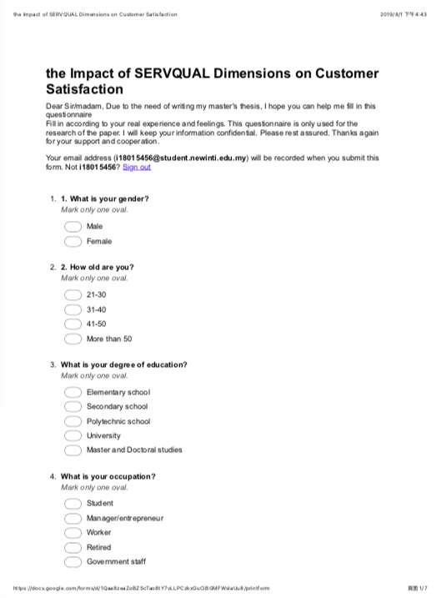

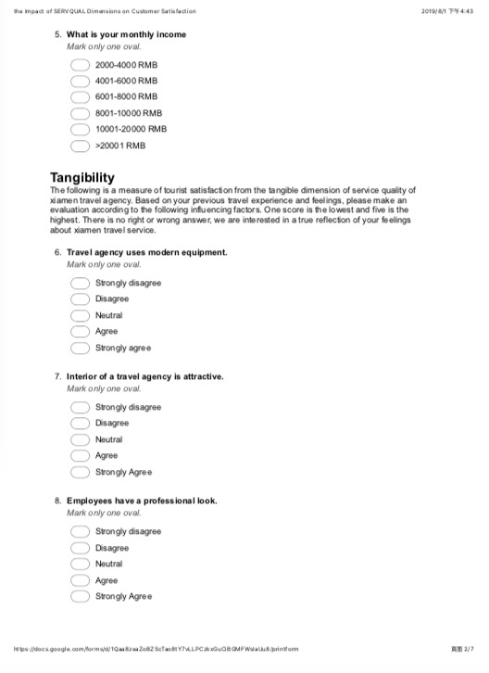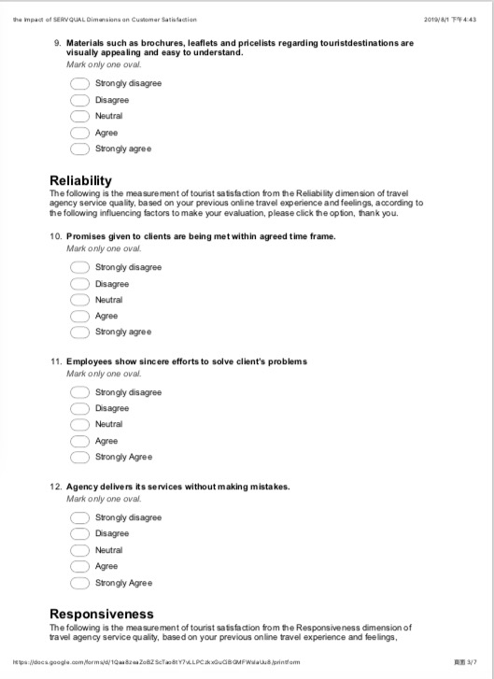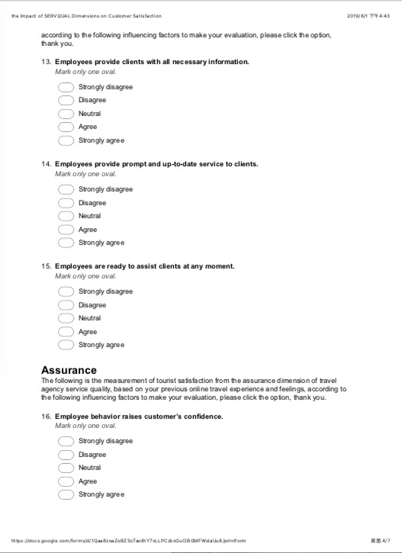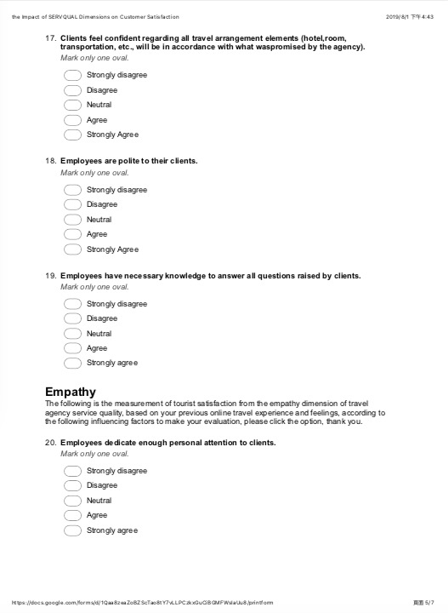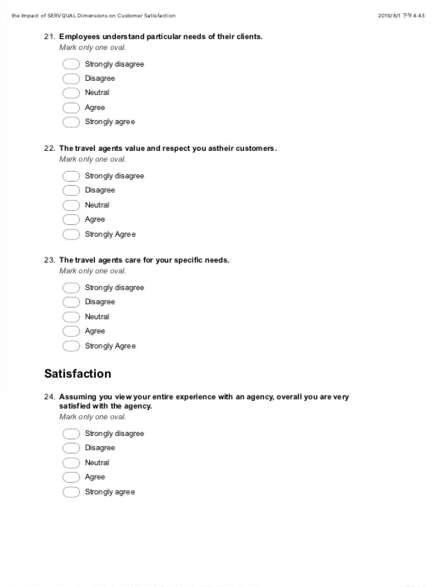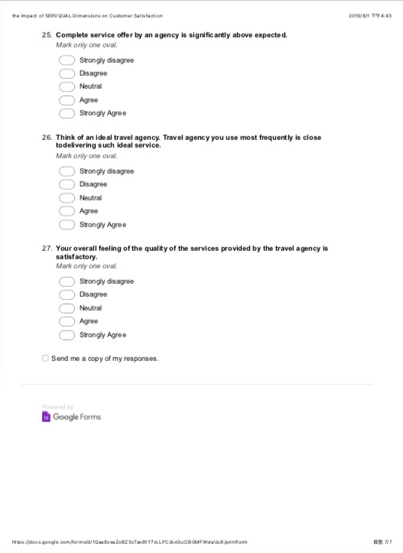

# Appendix B: Statistical Analysis Result

PILOT TEST Factor Analysis - ALL IV

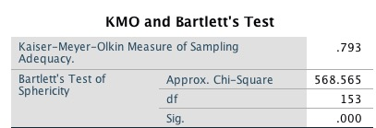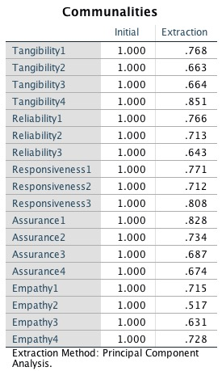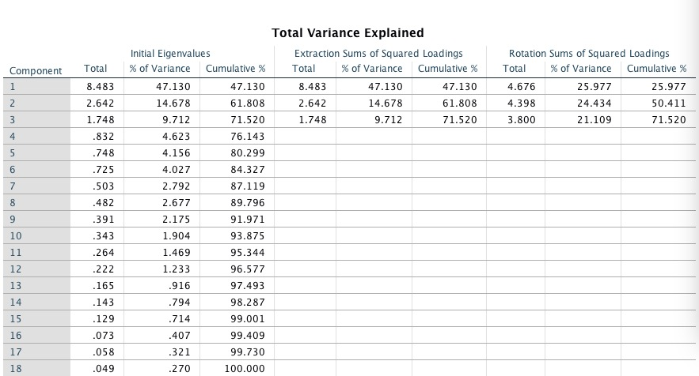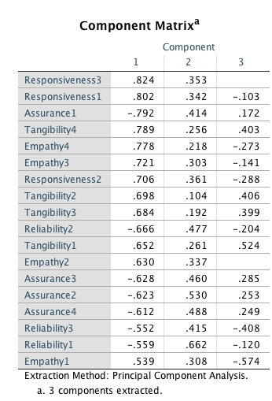

**PILOT TEST Reliability - ALL IV**

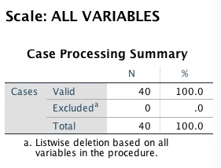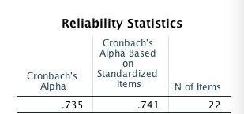

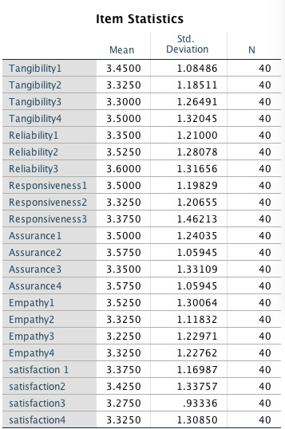

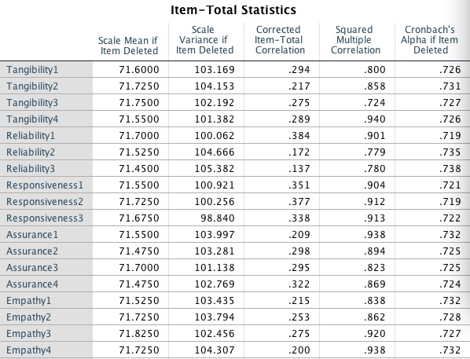

**PILOT TEST Factor Analysis - DV**

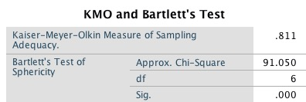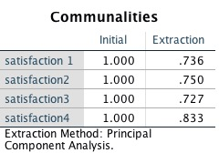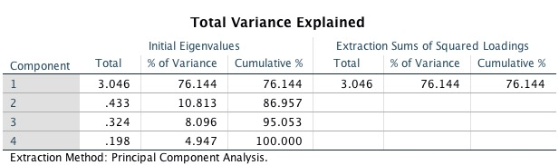

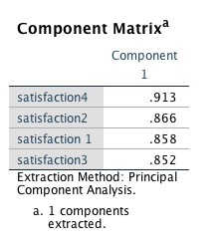

**PILOT TEST Reliability -DV**

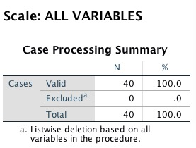

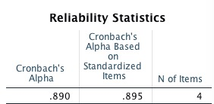

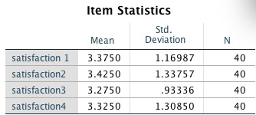

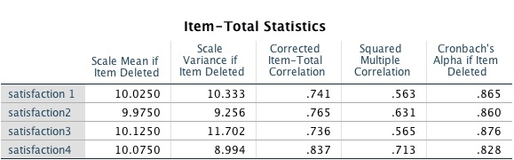

**Factor Analysis - ALL IV**

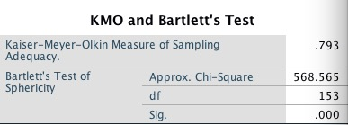

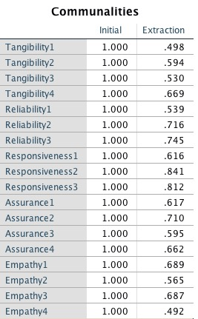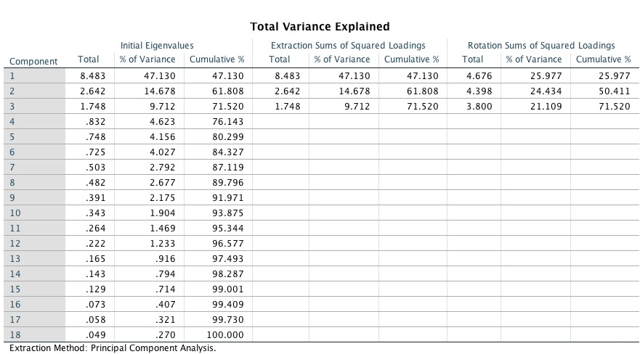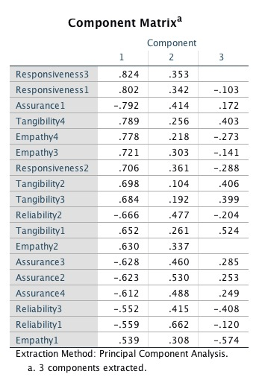

**Reliability -AII IV**

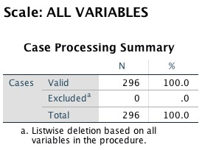

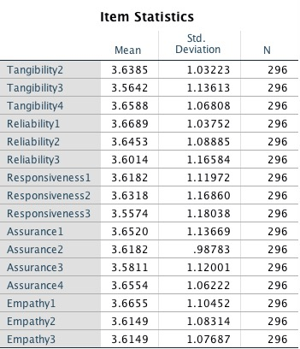

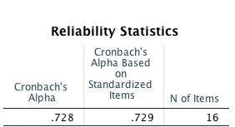

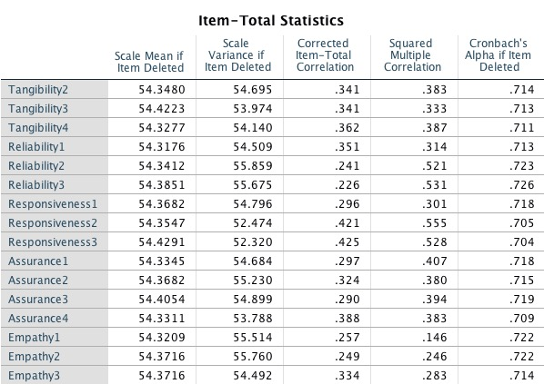

**Factor Analysis -DV**

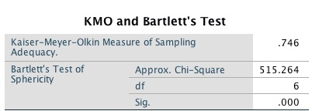

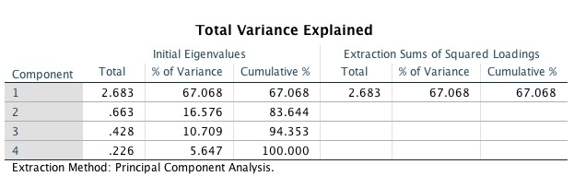

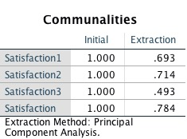

Reliability - DV

1. 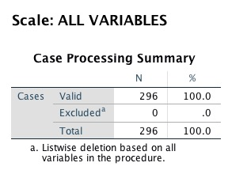

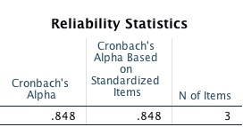

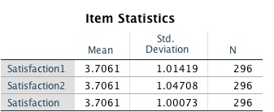

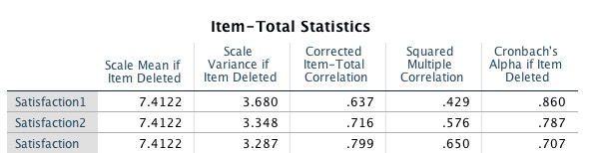

**Appendix C: Record of meetings**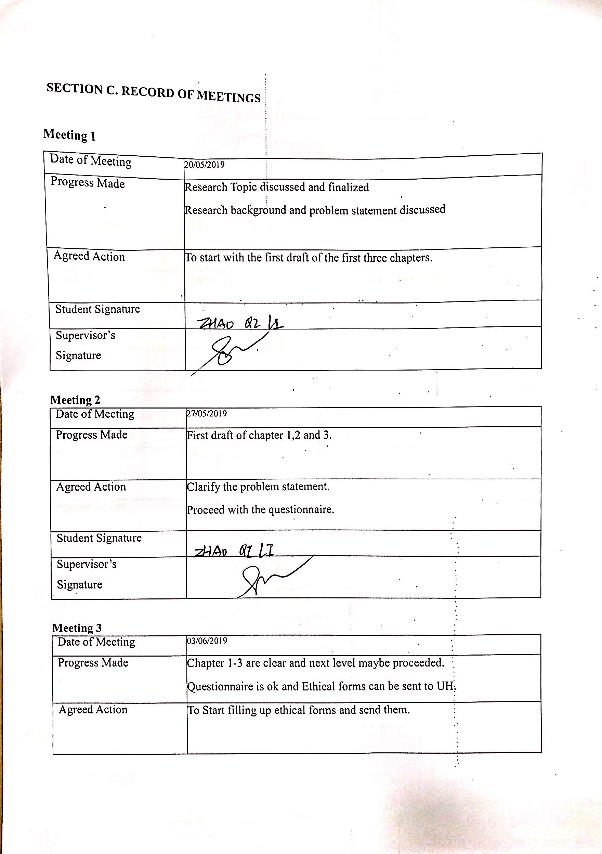

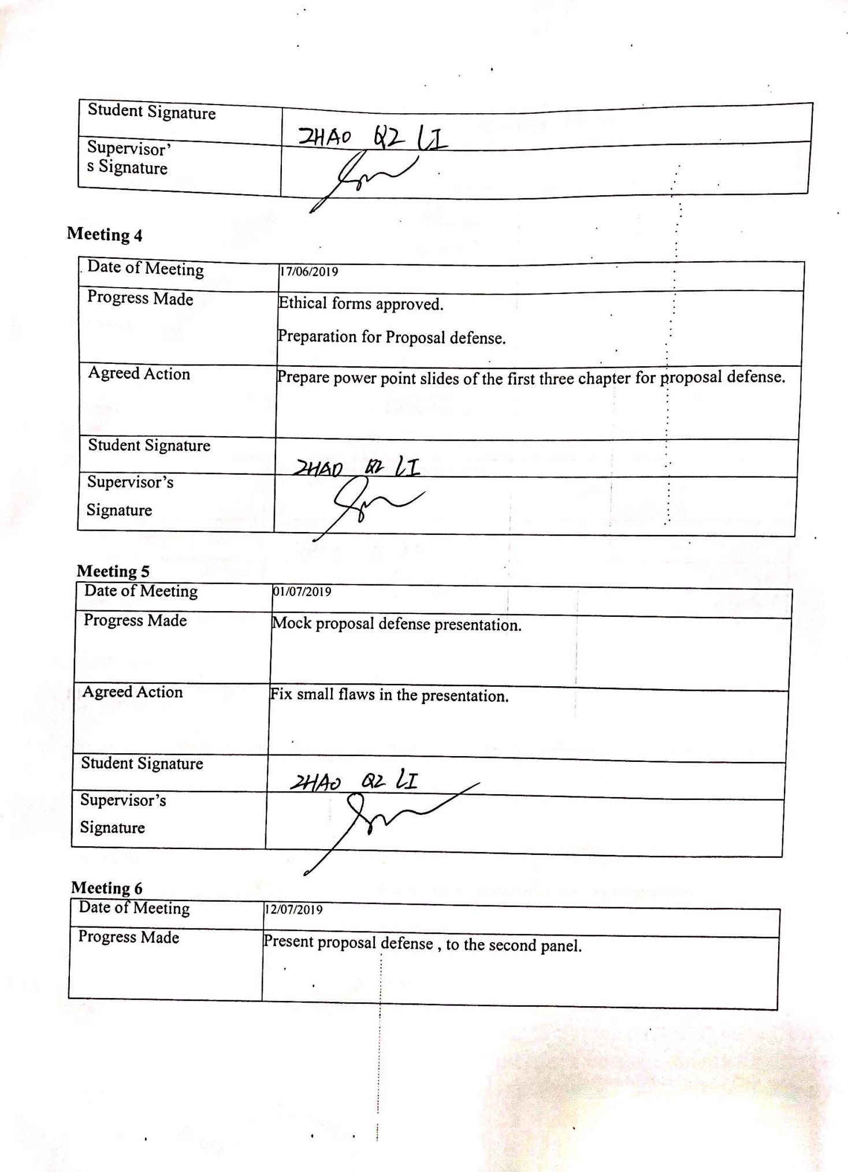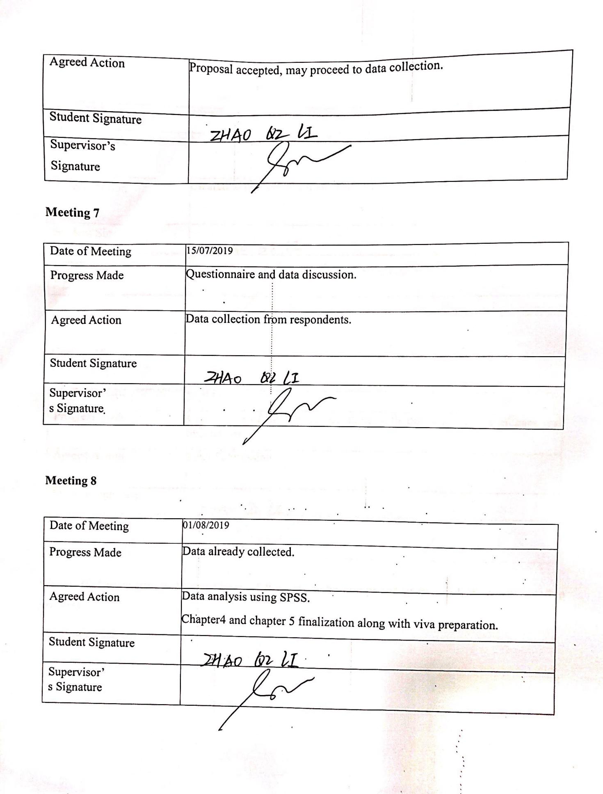

# Appendix D: Comments on Managment of project

