**INTI INTERNATIONAL UNIVERSITY**

MASTER OF BUSINESS ADMINISTRATION

Dissertation Title:

Customer Satisfaction with Samsung Mobile Phones in Saudi Arabia

**Author: Mohammed Salem Omar Banasr**

**Student ID: I18015004**

**Protocol number: cBUS/PGT/CP/04089**

**Supervisor: Dr. Arasu Raman**

**Submission Date: May. 6th, 2019**

**Final Word Count: 20,710**

**ACKNOWLEDGEMENT**

First of all, I would like to thank Dr Arasu for his supervision, valuable guidance and advice throughout this research. I would like to convey my appreciation for your patience as I have been asking many questions in many in several occasions whenever I face any problem or get stuck with my research over the semester. Your inspiration not only allowed me to implement and learn much about marketing research methods, but I started to be interested in research as it is even motivating me to enter the doctoral program for a further research in the future.

In addition, I appreciate your readiness to sacrifice your precious time, no matter how much busy you were during that time, which has taught me how to be professional when it comes to jobs. I am very thankful for your timely and prompt response to my several messages and emails during my research. Without promptly responding to my questions I could not imagine how much at loss and worried I could have been. Furthermore, I want to gladness for the consultations and meetings whenever I needed to make an appointment with you. Through inspiring discussions, I can clearly understand my logic about this research.

Finally, I would like to thank my family for helping me with the MBA research and all my friends who were great of a support morally and physically. I would also like to all show my appreciation to everyone who took part in the survey and the people who helped hand out the questionnaire in Saudi Arabia. Thank you for everything you did for me.

**DECLARATION**

I hereby declare that I understand the meaning of “Plagiarism” and “Intellectual Property Rights”. This thesis is hereby acknowledged as my own work and effort, which has not been submitted anywhere for any award. Where other sources of information have been used, they have been duly acknowledged.

Name: Mohammed Salem

Student ID: I18015004

Signature: Mohammed

Date: May. 06th, 2019

Contents

Abstract 7

Operations Definitions 8

**CHAPTER 1: INTRODUCTION 9**

1.0 Overview 9

1.1 Background of the study 9

1.2 Problem Statement 11

1.3 Research Objectives 12

1.4 Research Questions 12

1.5 Significance of the study 13

1.6 Significance to Academics 13

1.7 Significance to the Industry 14

1.8 Scope and Limitation of Study 14

1.9 Organization of Chapters 15

**CHAPTER 2: LITERATURE REVIEW 17**

2.0 Overview 17

2.1 Customer satisfaction 17

2.1.2 Global view on customer satisfaction 19

2.1.2 Customer Satisfaction in Saudi Arabia 21

2.2 Factors influencing customer satisfaction 23

2.2.1 Price 23

2.2.2 Perceived quality 25

2.2.3 Brand Awareness 27

2.3 Gap in the Literature 28

2.4 Grounded Theory 29

2.4.1 Theory of Reasoned Action (TRA) 29

2.5 Conceptual Framework 30

2.6 Hypotheses 30

3.0 Conclusion 31

**CHAPTER 3: RESEARCH METHODOLOGY 32**

3.0 Overview 32

3.1 Summary of Research Design 33

3.2 Questionnaire Design 34

3.3 Measurement Table 35

3.4 Pilot Test for customer satisfaction 36

3.5 Factor Analysis for customer satisfaction 36

3.6 Reliability Test for customer satisfaction 37

3.7 Descriptive Information 38

3.8 Hypotheses Testing for customer satisfaction 38

3.9 Multiple Regressions for customer satisfaction 39

3.10 One-Way ANOVA: P/F value for customer satisfaction 39

3.11 Beta Coefficient (Standardized) for customer satisfaction 40

3.12 Conclusion 40

**Chapter 4: RESULTS AND DISCUSSION 42**

4.0 Overview 42

4.1 Pilot test for customer satisfaction 42

1. Factor Analysis for customer satisfaction 42

A. KMO Bartlett’s test of Sphericity for customer satisfaction 43

B. Factor Loading for customer satisfaction 44

C. Eigenvalue Table for customer satisfaction 45

2. Reliability Test for customer satisfaction 47

4.2 Demographic profile of respondents 48

4.3 Preliminary Analyses for customer satisfaction 49

A. Factor Analyses for customer satisfaction 49

A. KMO Bartlett’s test of Sphericity for customer satisfaction 49

B. Factor Loading for customer satisfaction 50

C. Eigenvalue for customer satisfaction 52

B. Reliability Test for customer satisfaction 54

4.4 Hypotheses Testing for customer satisfaction 55

A. Linear regression for customer satisfaction 55

B. Multiple regressions for customer satisfaction 58

4.6 Conclusion 61

**CHAPTER 5: Conclusion and Recommendation 62**

5.0 Overview 62

5.1 Summary 62

5.2 Limitations of the Study 63

5.3 Conclusion 64

5.4 Recommendation for Samsung mobile phone 65

5.4.1 Promotion plan recommendation for Samsung mobile phone 66

5.4.2 Recommendation for Further Research 67

5.5 Personal Reflection 68

6.0 Reference 69

7.0 Appendix 81

# Abstract

In recent years, with the continuous improvement of technology and the growing competition in the mobile phone industry, the Smart Phones Market in Saudi Arabia has been rapidly developing in terms of innovation with different versions and brand being introduced. Samsung’s ‘Fast Follower’ innovative strategy as proved to be successful in the last decade. However, even with greater sales in smart phones as compared to one of the market leader and its main competitor apple, Samsung is currently competing mostly on sales rather than innovation because of the couple incidents of the phone blasting off. Therefore this study will look in to customer’s satisfaction with Samsung mobile phones in Saudi Arabia considering whether factors such as: price, perceived quality and brand awareness has influence on the satisfaction level. The same factors influencing satisfaction are examined based on the current research gaps to recommend ways in which Samsung can improve its domination in the mobile industry in Saudi Arabia. The tool used for the analyses and to identify the variable’s loadings and the relationships is SPSS. Before distributing the entire 384 questionnaire, a sample of only 40 questionnaires will be first taken to conduct the pilot test to ensure the feasibility of the questionnaire’s items or constructs, afterwards the final data collection and the proper tests was executed to evaluate the presence and level of relationships between the variables in the study. The results showed that price does not have a significant relationship with customer satisfaction with Samsung mobile phones in Saudi Arabia, whereas perceived quality and brand awareness does and based on that a recommendation was formulated. Moreover, a promotion plan for Samsung mobile phones in Saudi Arabia that focuses on perceived quality and brand awareness produced.

**Key Words:** Customer satisfaction, price, perceived quality, brand awareness, customer expectation, Perception

# Operations Definitions

|  |  |  |
| --- | --- | --- |
| **Sr. No** | **Keywords** | **Definitions** |
| 1 | Customer satisfaction | Customer satisfaction is an individual's feeling of disappointment or pleasure that results from a product’s evaluation outcome or performance with her/his expectations. (Kotler and Keller, 2016). |
| 2 | Price | Price is defined as the amount a customer must provide to obtain or acquire a service or product (Isoraite, 2016). |
| 3 | Perceived quality | Perceived quality is described as a judgment done by customers on a product or service to see if it meets their needs (Yoon and Kim, 2011). |
| 4 | Brand awareness | Brand awareness is the likelihood of a consumer being aware of the availability and existence of a company's service or product (Hussein, 2012). |

# CHAPTER 1

# INTRODUCTION

## 1.0 Overview

This chapter is about the introduction over the topic customer satisfaction with Samsung mobile phones in Saudi Arabia. Starting off, the background of the study and the phenomenon of the article research will be explained. Next, Problems with the dependent variables of consumer satisfaction and the gaps in this research will be presented in the problem statement. Finally, the research questions and objectives will be laid out and reasons to why these two items are needed will be given.

## 1.1 Background of the study

Nowadays, there are different mobile phone brands each with different features creating a dilemma for customers on which phone to buy (Milutinovic, Barac and Despotovic Zrakic, et al, 2011). According to Seongwon, Kwangeak and Bonggyou (2011), this has even worsened after the creation of smartphones since the offers and opportunities that companies are proposing are endless. Moreover, over the past fifteen years, mobile communications have been developed in a very important way making mobile phones a multimedia that allows its users to play music, take pictures and receive and make calls (Deng, Kee Wei and Zhang, 2013). When the mobile devices are assembled the creators focuses not only on functionality but also on the design and aesthetics of the handset (Bayraktar, Tatoglu, and Turkyilmaz, 2012).

In the current economic situation, the mobile communications industry has been characterized by a great level of technical competition, diving companies to focus on customer satisfaction, which is very essential for every business success (Deng, Kee Wei and Zhang, 2013). This was supported by Smith, Sabo and Auld (2015) where the authors stated that in a business environment like mobile phone industries, where rapid change is constant, customer satisfaction is a crucial factor for companies to improve and maintain profitability. Previous researches (Bayraktar, Tatoglu, and Turkyilmaz, 2012; Deng, Kee Wei and Zhang, 2013; Seongwon, Kwangeak and Bonggyou, 2011) have established that customer satisfaction contributes to company’s profitability and brand awareness and claim that the higher customer satisfaction is the higher market shares the company can get (Milutinovic et al, 2011).

Saudi Arabia is a huge market for smart phone companies and it is growing bigger and bigger day by day (Tan and Toe, 2002). There is an increasing demand for high quality smart phones that the number of mobile subscription has outnumbered the country’s population (Barsky, 1992). According Tan and Toe (2002), there are many customers who are subscribed to more than one service. As of 2015, the number of mobile subscriptions in Saudi Arabia reached 50.1 million, against the total population of 30 million (Statista, 2016).

Samsung Electronics is a multinational corporation established in Samsung town, Seoul that creates and assembles various electronic items (Saardchom, 2014). The company was ranked number one worldwide among smart phone market with a 22.8 % market share in 2016 (IDC, 2016). However, this is not the case in Saudi Arabia as statistics has shown a significant decrease in the number of Samsung mobile phone users (Statcounter, 2019). Samsung is losing its shares in Saudi Arabia to other mobile brands like Iphone and Huawei (IDC, 2016).

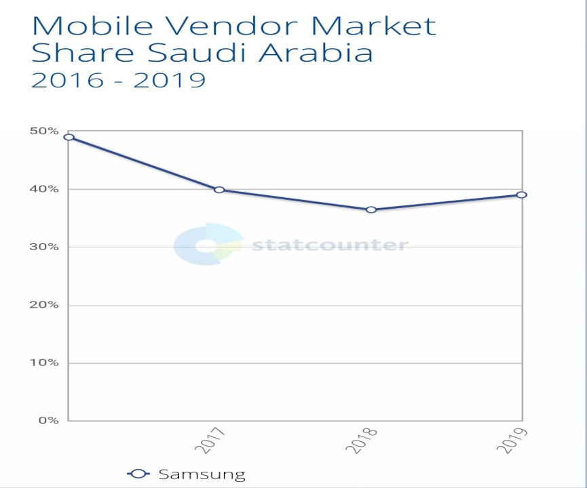

Figure 1: Mobile vendor market share Saudi Arabia 2016 - 2019

Source: Statcounter (2019)

## 1.2 Problem Statement

Nowadays, smartphone users have many operating systems and brands to choose among (Hurk, 2013). There are many factors that can influence the level of customer satisfaction of smartphones, especially Generation X (Park and Lee, 2012). According to Alfawareh and Jusoh (2014), more than 50% of Saudi Arabian citizens own a smartphone indicating that vendors and smartphone developers have a huge market in the country as a large number of people have at least one smartphone that they use every day.

The introduction of new smartphone brands in Saudi Arabia is putting a slow death to Samsung, as it has had several incidence of the phone blasting off, leading to customers to shift to another brands (Hurk, 2013). Moreover, according Park and Lee (2012) other mobile phone companies that have high market shares in the country, unlike Samsung are aggressive with their advertising, promotional and marketing effort focusing on adding new features, creating added value, lowering prices, and advertising and promoting campaigns. However, Alfawareh and Jusoh (2014) argued that advertisement and the variety of new systems introduced by mobile phone manufacturers alone are not sufficient factors that dissatisfy a customer but also factors like poor customer support, poor service coverage and ad agencies, interruption while speaking with others, improper communication and network busy problems plays important roles too.

In addition, there is a gap with literature review of this research (Lee and Park, 2012). There are many past documents (Alfawareh and Jusoh, 2014; Mansoor and Jalal, 2011; Singh, Dhayal and Shamim, 2014) elaborating about the factors affecting customer satisfaction. However, in the mobile phone industry these factors are highly dependent on the version and nature type of the electronic product (Barskey and Labagh, 1992). Therefore, factors influencing Samsung mobile phone user’s satisfaction might be different, hence, this research will use factors used by the same study in Korea using price, perceived quality and brand awareness (Hurk, 2013) and ascertain if the outcomes are similar or not. Moreover, literatures written on this topic in English in Saudi Arabia are very few in number (Singh, Dhayal and Shamim, 2014), it can be said that translating the idea from the original idea would not be accurate if it is mentioned in the past literature.

Besides, statistics has shown that Samsung market share compared to other mobile phone in Saudi Arabia has dropped to negative one percent (Statista, 2016). That is why a need for more study to be done on this topic to understand the factors influence customer satisfaction with Samsung mobile phones in Saudi Arabia.

## 1.3 Research Objectives

Research objectives are defined in a clear and concise way as a statement of the research intent required to guide academic research and are usually placed in the introductory part of the study protocol (Farrugia, Petrisor and Farrokhyar el. at., 2010). Hanson (2006) argues that clear and specific research objectives of a study will be a great help in calculating the sample size of the study as well as helping to draw the research design as well as the development of the research.

The main purpose of this study (broad purpose) is to reaffirm the relationship between influencing factors (perceived quality, brand awareness and price) and customer satisfaction with Samsung mobile phone in Samsung in Saudi Arabia. Specific goals include:

**RO1:** To determine whether price has a significant relationship with customer satisfaction with Samsung mobile phones in Saudi Arabia.

**RO2:** To determine whether perceived quality has a significant relationship with customer satisfaction with Samsung mobile phones in Saudi Arabia.

**RO3:** To determine whether brand awareness has a significant relationship with customer satisfaction with Samsung mobile phones in Saudi Arabia.

## 1.4 Research Questions

The first step of a research project is research questions which are questions of a particular area of ​​interest or problem referring to a comprehensive and general list of questions needed to start a research process in a particular research area (Farrugia et al., 2010). Research question are more important than research objective that is why it must be placed post-project objectives (Sekaran and Bougie, 2016).

**RQ1:** Does price has a significant relationship with customer satisfaction with Samsung mobile phones in Saudi Arabia?

**RQ2:** Does perceived quality has a significant relationship with customer satisfaction with Samsung mobile phones in Saudi Arabia?

**RQ3:** Does brand awareness has a significant relationship with customer satisfaction with Samsung mobile phones in Saudi Arabia?

The reason why the above factors were chosen is because the same study was conducted in India by Bilal in 2012 and this research will to verify whether the same results apply in Saudi Arabia or not, meaning that the this study will use the same phenomenon and variables but within a different context

## 1.5 Significance of the study

In the previous years, Samsung mobile phones market-share in Saudi has been decreasing as shown in Figure (1), therefore this study will reveal and show whether the factors mentioned included price, perceived quality and brand awareness really has an influence on customers satisfaction. This study will benefit and help more understand what is causing Samsung phone market to gradually decrease. Simply put, the research will solely focus on Samsung brand and how it can sustain or improve customer satisfaction through its features (price, perceived quality and brand awareness)

## 1.6 Significance to Academics

This section highlights the significance of studying the factors affecting customer satisfaction in Saudi Arabia when it comes to Samsung mobile phone. There has been little research done on this topic and the already existing researches are written the Arabic language; while the one written in English are very few. Therefore, this research will be contributing and of help for those who are conducting similar studies in the future and do not know Arabic language. Moreover, factors that influences customers satisfaction with Samsung mobile phones in Saudi Arabia are a lot in number, but studies that are specified to price, perceived quality and brand awareness are limited. Thus, this research will give more evidence regarding the influencing factors for future researchers.

## 1.7 Significance to the Industry

There is a high demand for smartphones in Saudi Arabia as it market is huge and is increasing each year with high number of mobile subscription, therefore attractive more smartphone brands to extend their business in country creating competition for Samsung. Moreover, some brands go through illegal means to gain profits by either selling counterfeit products or falsely advertise about their products like price or quality to attract and misguide customers to purchase. Due to that problem, this research will not only help Samsung’s share to improve by understanding the customer’s needs but also perhaps inspire officials to take actions and establish rules and regulations to protect customers.

# 1.8 Scope and Limitation of Study

**Scope**

This research will focus on the factors that influence customer’s satisfaction with Samsung mobile phones in Saudi Arabia. More specifically, it will consider three factors including price, perceived quality and brand awareness to determine how it affects customer’s satisfaction. The target of the study are the people who owns Samsung mobile phones in Saudi Arabia including foreigner (residents, expats and students) to have a fair and accurate data. Moreover, the analysis will be done from the data collected from the respondents which will be used in the future as an evidence to support the outcome of the study.

**Limitation**

The main limitation of the study is the time factor as the research has to be completed within 4 months frame. Saudi Arabia is a huge country with different cities and different regions with different cultures, income level and lifestyle that is why to obtain an accurate result, information from customers in different regions need to be collected. In addition, those people who live in an urban area of cities may have different perspective on the phenomena than those who live in the rural area; therefore data need to be obtained from each distinct within the city. However, as stated earlier due to the time constrains, the survey cannot be fairly distributed, indicating the data obtained might not be strong and accurate to support the outcome. Moreover, the sample will only be collected from 380 customers rather than the millions of people who owns a Samsung mobile phones in the country, plus since convenient random sampling will be used to obtain data, the information collected from respondents might not accurate as per some of them are not interested to do so.

# 1.9 Organization of Chapters

There are five chapters in this research, which will be explained below.

Chapter 1: Introduction

This chapter is about the introduction over the topic customer satisfaction with Samsung mobile phones in Saudi Arabia. Starting off, the background of the study and the phenomenon of the article research were explained. Next, problem statement was laid out, research objectives and questions were given and the Significance of this Study, Scope and Limitation were illustrated and lastly how the chapters were organized was stated.

Chapter 2: Literature Review

In chapter 2 the phenomenon of the study which is customer satisfaction was explained and all variables of this research are reviewed from relevant existing literatures associated with the study. Moreover, related literatures from both marketing disciplines and social science are reviewed to determine the constructs and independent variable that will be used in this research and lastly the gaps of the study and the limitations were explained.

Chapter 3: Research Methodology

This chapter is a detailed picture of the various approaches to this study, and a study of research methodology that presents statistical research techniques for data collection and analysis methods. It explains the different methods used starting from data collection and what tests are used in this study

Chapter 4: Data Analysis and Findings

This chapter describes the results obtained from analyzing and testing the obtained data and summarizes the outcomes from the results to back up the purpose of this study.

Chapter 5: Conclusion

This is the last chapter of the study. It concludes the results and outcomes of the study and based on what is found, recommendations for future studies and for this study is presented. In addition, personal reflection and limitations of this study will be laid out in this chapter.

# CHAPTER 2

# LITERATURE REVIEW

# 2.0 Overview

In chapter 2 the phenomenon of the study will be about customer satisfaction where all variables of this research will be reviewed from relevant existing literatures associated with the study. Starting off, the definition of customers satisfaction and applicable past academic researchers are assessed and the dependent variables for this study is thus set appropriately. Second, in order to have clear picture about customer’s satisfaction, related literatures from both marketing disciplines and social science are reviewed to determine the constructs and independent variable that will be used in this research. Lastly, this part is intended to provide ample explanation of the critiques, previous studies and definitions, besides examining the research gaps that is related with the study which will aid in improving the managerial and academic value of this research.

# 2.1 Customer satisfaction

According to Kotler and Keller (2016) customer satisfaction is an individual's feeling of disappointment or pleasure that results from a product’s evaluation outcome or performance with her/his expectations. Moreover, it has been described as a person's attitude-like judgment toward a service or a product after purchase or a series of consumer product interactions (Kaur, 2017). Sharmin (2012) also defined customer satisfaction in a similar way, where the author states that customer’s satisfaction is a reaction to the outcome of what the individual has expected and the actual performance of the product. Based on this view, Maharjan, Kabu and Sonya (2017), stated that customers satisfaction is a marketing concept that is one the top key determinant of a company's success and a tool to identify how good is the product or service provided by the company.

In the philosophy of modern business, customer-orientation and the application of the main ideologies of constant enhancement, validates the significance of analyzing and evaluating customer satisfaction (Sharmin, 2012). In other words, customer satisfaction is regarded as a standard for performance excellence standardization and standardization in various businesses (Anderson, 2012). It also assists investors in identifying potential market opportunities (Evangelos and Yannis, 2010).

According to Jayasankaraprada and Kumar’s (2012), customer’s satisfaction is a customer’s psychological response to an assessment of product or service outcome in relation to prior expectation. It is the results of comparing actual performance with the expected performance (Ranaweera, Stanisic and Stanic, 2017). Based on this view, Anderson (2012) stated that customer’s satisfaction can be considered as a ways to determine the performance of a service or product and the company’s position in the competitive market environment. The performance of the service or product is greatly influenced by the expectation of the customer and in the smart phones context, the brand performance depends upon attributes and features that the customers expects which can be in any form like functionality, style, software or hardware (Sharmin, 2012).

However, Smith, Sabo and Auld (2015) argued that customer’s satisfaction from company’s perspective is different; the authors stated that for companies, customer’s satisfaction is the desire to satisfy customers, whereas for customers it is the level of happiness felt. Creating customer satisfaction is one of the ways to improve a company's economic performance (Anderson, 2012). For example, a study done by Ranaweera, Stanisic and Stanic (2017) found that high level of customer satisfaction leads to customer retention.

Moreover, customer satisfaction is also considered to influence other phenomena like repeat purchase behavior, customer purchase intentions and also believed to have a direct relationship with customers' willingness to pay high prices (El-Said and Fathy, 2015). Jayasankaraprada and Kumar’s (2012) study concluded that companies can gain a competitive advantage by satisfying their customers. Based on this view, achieving higher level of customer satisfaction has grown up to be a main objective for organizations to achieve because a study conducted by El-Said and Fathy (2015) concluded that customers who are satisfied tend to stick with the brand for future purchase while customers who are not satisfied are more likely to switch to other brands. According to Jayasankaraprada and Kumar’s (2012), repeated purchase by customers will increase company’s profit.

## 2.1.2 Global view on customer satisfaction

The concept of customer satisfaction every day is broadening with various definitions and ideas (Oliver, 2014). Various researchers (Barsky, 1992; Kotler and Armstrong, 2012; Warr and Inceoglu, 2012) since the 1960's, have been conducting studies on customer satisfaction and based on that, many models on customer behavior has been built like Sprowls and Asimow (1962) model which shows that customers who are satisfied with a product offer, repeatedly purchase it. Customer satisfaction as described by Ranaweera, Stanisic and Stanic, (2017) it is a perception that customers develops after using or acquiring a service or a product. However, Sharmin, (2012) argued that customer’s satisfaction is a result of experience encounter and service rendered with service provider.

According to Kaura and Daura, (2012) despite the various definitions of customer satisfaction, following the expectancy-confirmation and disconfirmation are a common approach to describe customer’s satisfaction. From this point of view, customer satisfaction is delineated as the buyer’s assessment that the service or product achieve or not achieve the buyer's expectations (McColl-Kennedy, 2015). In other words, customer satisfaction involves product post-usage assessment regarding a problem or service quality, given there is a pre-consumption expectation (Sharmin, 2012).

In view of this expectancy - confirmation / distrust confirmation, customer satisfaction happens in the case of a consumer’s post-assessment of a particular buying experience (or experiences), depending upon the consumer’s expectations and quality perceptions, and confirmation/disconfirmation or the difference between expected and actual quality (Dominic and palumbo, 2013). Customer expectations may include appropriate services, anticipated services and desired services; The desired service customers wants is the quality of service customers expect to have prior consumption; appropriate services is the quality of service that the customer is willing to receive, and the expected service is the quality of service that the customer expects to acquire (Oliver, 2014). In addition, not every customer have the same level of expectation because for some customers when a product or service fails to meet the expected quality, it is regarded as poor but for other customers who has low expectation, the product or service may be considered as high quality (Zeithaml and Bitner, 2013). However, some researchers argued that identifying what customers expect is only the first step in trying to satisfy a customer because there are other factors that influence customers when evaluation process like the price, external commutation from the service provider, past experience of service, personal needs and word of mouth communication (Zeith et al. 2013).

According to Zeithaml and Bitner, (2013), customer’s satisfaction can be influenced by the perception customers have on the size, quality and price of a commodity and the comparison between other similar product standard and performance. However, quality perception may be based on concepts of anomalies, but satisfaction is based on the perception of predictive anticipations and other standards of perceived quality (Manjunath and Reginald, 2016). That is why if the quality is better than the predicted performance, customers can be satisfied with the lower quality (Cerri, 2012). It is therefore necessary to confirm the use of the predictive expectations for satisfaction and the ideal expectations of quality (Zeithaml and Bitner, 2013).

Researchers (Cerri, 2012; Dominic and palumbo, 2013; Oliver, 2014) recently have acknowledged the importance of customer’s satisfaction and many have categorized it as one of the strategic issue that organizations should address (McColl-Kennedy, 2015). Customer’s satisfaction is a point factor for survival in the business world that is why the prime objective of organizations is to create and maintain customer satisfaction at an optimum level (Kaura and Daura, 2012). Companies with full understanding on how to satisfy and deliver satisfaction have a better chance to enhance profitability and gain a competitive advantage over its competitors (Dominic and palumbo, 2013). According to Kim, Knutson and Vogt (2015) in order for organization to create and maintain competitive advantage in today's business environment, customer’s satisfaction is an important element to be preserved.

In general, customer satisfaction is influenced by experience the customer with the product or service provider (Kotler and Armstrong, 2012). Customer satisfaction is determined by the cumulative experience rate during consumption or acquisition of product or service, and customer satisfaction can be also created through an emotional evaluation process, which is possible depending on the consumer's purchasing experience (Sharmin, 2012). However, according to Kaura and Daura (2012), researches on customer satisfaction indicated that factors other than expectation, performance, past experience and disconfirmation influence the equity of the formation process resulting in overall customer satisfaction.

After going through the literature, a commonly accepted view of customer satisfaction is an overall measure that includes a customer's cumulative assessment of all transactions with the organization.

## 2.1.2 Customer Satisfaction in Saudi Arabia

As some researchers (Arokiasmy, 2014; Cerri, 2012; Quddus and Hudrasyah, 2014) in Saudi Arabia stated, there are several approaches to identify customer satisfaction level because the degree of satisfaction differs from customer to customer. Moreover, customer satisfaction level is not the same and cannot be measured using the same method in every industry in the country (Arokiasmy, 2014). Regarding the mobile phone industry here are various approaches in determining customer satisfaction for electronic products (Barsky 1992). However, according to Pourkiani (2014), since satisfaction is a disappointed or pleased feeling by the customer after comparing the performance of the product with the expected performance, there are three elements that can measure customer satisfaction which are:

* Attribute related to service, likely resolution of problem, complaint handling, delivery and warranty or guaranty.
* Attributes related to purchase, likely company competence, company reputation, acquisition, convenience or easy, price, courtesy, and communication.
* Attribute related to product, like feature, versions.

According to Kitapci et al (2013), Due to the fact that Saudi Arabia’s economy is well-off and the purchasing power of its citizen is high, service quality of electronic products has higher influence on customer satisfaction than price. This was also supported by Quddus and Hudrasyah (2014) where the author stated that customer satisfaction is the perfect coordinator between customer loyalty and product or service quality. Customer satisfaction is a strong intangible asset similar to product and service quality that could be attained through meeting the expectation of customers (Jayasankaraprasad and Kumar, 2012). That is why most of the studies in Saudi Arabia have focused on the importance of the relationship between customer satisfaction and service or product quality and establish that satisfaction is an outcome of customer first-hand experience during product or service encounter (Quddus and Hudrasyah, 2014).

Customer satisfaction in the country has been suggested to be driven by service quality (Kitapci et al, 2013). According to Cerri (2012) satisfaction of services for cognitive-oriented consumers is the result of emotional consumers. The causal relationship between customer satisfaction and quality of a service is a topic of great academic discussion and yet agreement has not yet reached (Januarko, Adiwibowo and Kusumawati, 2018). The studies conducted to investigate the relationship between perceived quality and the actual quality that are not consistent with pre-purchase expectations also specified that customer satisfaction as a function of disconfirmation and perceived quality (Cerri, 2012). It was also found that purchasing intentions greatly influenced by customers who had less expectations that those who has higher expectation (Arokiasmy, 2014).

Moreover, as described by to Karimi and Kashani (2012), customer satisfaction is highly affected by quality, which if done in the right way will eventually leads to profitability. Satisfaction is the evaluation of a customer's service and goods by the degree of satisfactory desire (Arokiasmy, 2014). Kitapci (2013) reported that excellent service quality and customer satisfaction are essentially considered to improve business performance by service providers in Saudi Arabia. In addition, it has a positive impact on company's sales after drawing new customers and keeping the existing ones (Cerri, 2012). This was also supported by Arokiasmy (2014) where the author found that customer satisfaction is essential to customer loyalty and retention, and is essential for achieving economic goals such as market share, return of investment and profitability (Cerri, 2012). When customers are satisfied with the products and services of a particular organization, it encourages them to repeat purchases and generate positive words of mouth, which will increase sales (Arokiasmy, 2014). According to Karimi and Kashani (2012), the most important factors in attracting customers are human and technical factors such as Maintaining customer relation, communication and friendly treatment and simplifying claims handling. In customer satisfaction, quality plays a key role and is considered as an organization's survival method and ways to get profit and its characteristics and features must exist in a product or service to meet the consumer’s needs (Pourkiani et al., 2014). According to Arokiasmy (2014), customer satisfaction ultimately impacts the amount of profit an organization makes.

`Pourkiani (2014) mentions more about the significance of many studies that have been done in Saudi Arabia that examined the impact of customer satisfaction on customer loyalty and repeat purchase in which both of them conveyed related message. First, customers who are satisfied with a certain experience of a product or service share how his thoughts with an average of six to seven people and many customers do not complain about the unpleasant experience the customer have had, but instead share their unfortunate experience with more than ten people but companies need to realize and are different in each industry (Jayasankaraprasad and Kumar, 2012). Second, many customers do not complain about the unpleasant experience but it might different from one industry to another (Pourkiani, 2014). Finally, companies think that dealing with customer satisfaction is not as expensive as recruiting new customers. In fact, it is only 25 percent of recruiting new customers (Jayasankaraprasad and Kumar, 2012).

# 2.2 Factors influencing customer satisfaction

## 2.2.1 Price

Price is defined as the amount a customer must provide to obtain or acquire a service or product (Isoraite, 2016). According to Ehmke, Fulton and Lusk (2016) price shows a reasonable evaluation of the product quality for example, high quality products always maintain high prices. Ehmke, Fulton and Lusk (2016) supported this statement, noting that prices are being considered by consumers as a quality indicator, mainly when consumers have little knowledge about the particular product. Simply put, when a consumer is unfamiliar with a product, quality is measured using the tag price, which means the higher the price the higher the quality is (Singh, 2012). Moreover, price can help customers know the worth of a service or product (Aldhaban, 2012). The more customers feel that the price justifies the quality of a product, the more higher the satisfaction level will be (Pour, Nazari and Emami, 2012). However, this was contradicted by Bei and Chiao (2001) where the author stated that price has no effect on customer satisfaction, instead it is a function of other factors like personal experience and quality of the product.

On the other hand, for companies price is also important because it can identify market capabilities by looking into the products and services the companies offer (Owomoyela, Olasunkanmi and Oyeniyi, 2013). According to Aldhaban (2012), one of the factors that are important in the marketing mix is the role of the price of a product or service in the formation of customer satisfaction. Moreover, this was supported by Al-Badi (2015) by stating that companies, out of the entire marketing mix tool uses price to attain its marketing objectives.

Pricing strategies must be coordinated with promotion decision, distribution and product design to create an effective and consistent marketing program (Pour, Nazari and Emami, 2012). Organizations usually place a price to a product or service first and then adjust other marketing mix decisions to the amount of price the customer is willing to charge (Aldhaban, 2012). Pricing is essential for setting a position to product in a market and determines design and competition (Owomoyela, Olasunkanmi and Oyeniyi, 2013).

Price allows the corresponding product to sell well in proportion to the capacity of the target consumer (Pour, Nazari and Emami, 2012). An important factor in determining pricing is the cost incurred to produce the service or product that includes various costs such as raw material costs, transportation costs, labor costs, advertising costs and design costs (Singh, 2012). According to Isoraite (2016), prices are calculated based on the cost incurred to produce that product or service; in addition the author also suggested that pricing is always an important part of determining consumer behavior. Having good pricing strategy including discounts, finance, price list and others can improve profit margin for companies and the right and proper price will lower the risk of losing customers to competitors (Pour, Nazari and Emami, 2012). Based on the industry and market, pricing methods can be as follows.

Value based – This method uses customer’s perception on the value of product or service to set price (Isoraite, 2016). For example, as stated by Aldhaban (2012) some travellers would rather choose a hotel with good customer response and high reputation like Beverly Hills hotel, instead of going to a cheaper hotel.

Cost based – This method of pricing is the most common way of pricing, where product’s cost is calculated and based on the outcome a price is set; most product's cost of production is continually increasing causing a sharp raise on price (Al-Badi, 2015).

Demand based – The law of demand explains the relationship between demand and price by stating that the higher the price goes the lower the demand gets (Isoraite, 2016).

Discount based – usually discounts are related with advertising, where the price of a product is reduced to enlarge market shares and attract more customers (Al-Badi, 2015).

Competition based – In this present highly competitive market, organisations based on its competitors compete for the price of a product by adjusting the price to the right value to stay competitive and higher its revenues (Isoraite, 2016).

Unprofitable guide based – This strategy is usually used when an organisation wants to get rid of its products or want to gain quick cash by selling the products lower than its production cost, especially this is applicable to newly opened stores (Al-Badi, 2015).

Psychological based – Today, by using psychological promotion strategies like by setting prices to make products look cheaper such as RM 19.99 instead of RM 20 companies can make more customers and enhance its profits (Isoraite, 2016).

## 2.2.2 Perceived quality

Yoon and Kim (2011) described perceived quality as a judgment done by customers on a product or service to see if it meets their needs. On the other hand, Chen and Chang (2013) described perceived quality as the consumer's discretion, based on external components of the service or product.

Customer satisfaction is affected by the perceived quality in a direct relationship which means that the more the quality of a product meets customer’s expectation, the higher customer’s satisfaction is (Mathur and Qiu, 2012). According to Asma, Abdul, Muhammad et al. (2015), customers have perception of price, style and product quality before purchasing the product. However, according to Chen and Chang (2013) perceived quality concept differs from the manufacturers and customers point of view. For companies, the quality description (which customers presume) is set based on the market point of view, whereas for consumers, product quality perceptions are compared to their expectations (Mathur and Qiu, 2012).

Moreover, Customers recognized perceived quality as feature that is specific to service and product capabilities that is expected to be there when used (Mathur and Qiu, 2012). Customers estimates the perceived quality if whether it meets expectation or not by how much happiness gained post-usage of the product (Chen and Chang, 2013). Thus, when perceived quality is considered as an overall as an overall evaluation, it is suggested that perceived quality is understood as a source of satisfaction (Asma, Abdul, Muhammad et al., 2015).

**Equation =** Product perception - Product expectation = perceived product quality

The above equation explains customer satisfaction and its effects by describing that when customer’s perceived quality of a product is fulfilled, the level customer satisfaction will increase, it also explains that the organization’s management can control and manage customer’s perception of quality by the description the company conveys to the customers (Asma, 2015). Thus, the outcome feeling of customers based on the perceived quality can be good or bad; good meaning the customer is satisfied and bad meaning the customer is not satisfied (Caruana, 2013).

A study conducted by Thuy and Chi (2015) found that perceived quality is one of the most influential factors for customer satisfaction and proved the hypothesis that the level of customer satisfaction and perceived quality were positively related. In addition, Asma (2015) conducted the same study to find out the relationship between customer satisfaction and perceived quality where a sample of 226 respondents with a response rate of 92% were used and the author also ascertained the hypothesis that customers perceive higher quality products increases the customer’s satisfaction of using a product. However, this was contradicted by Januarko, Adiwibowo and Kusumawati (2018) where the authors stated that perceived quality has no effect on customer satisfaction.

Thuy and Chi (2015) also stated that perceived quality and satisfaction are applied interchangeably. However, Asma (2015) found differences in perceived quality and satisfaction where the author explained that satisfaction can come from dimensions such as loyalty and expectations. On the other hand, perceived quality is a controllable element of a product, whereas satisfaction cannot be controlled because the satisfaction evaluation is done the consumer himself (Mathur and Qiu, 2012). In short, perceived quality is more likely to be a factor that affects satisfaction (Caruana, 2013).

## 2.2.3 Brand Awareness

Brand awareness is the likelihood of a consumer being aware of the availability and existence of a company's service or product, and generating this awareness in the company is one of the important ways in promoting the company's services and products (Hussein, 2012). Moreover, brand awareness is the ability to recognize a brand as a brand (Zeithaml et al., 2013). A brand recognition is a customer's ability to search for a brand when considering a product category for example, an African woman wants to buy a reproductive diet for her family and thinks of the "Hu Fu" of the Bulsho cooperative (Hussein, 2012).

According to Ahmad and Sherwani1 (2015), brand awareness as an important factor that can affects customer purchase intention and customer's satisfaction. The study gained more support from Bravo and Pina (2012) explaining that it will stimulate purchasing when customers are aware of the product.

Products promoting through brand awareness are one of the effective and easiest ways to promote product-related commodities because there are a few variations, which makes brand awareness relatively competitive and easy to get recognition especially if the brand name is huge (Hussein, 2012). Consumers make fast decisions on whether to buy a products or not if the customer recognize or know the brand (Ahmed, 2014). The more customers are able to remember, recognize and maintain their brand, the more likely the company is larger than its competitors and customers will shop there often (Hussein, 2012). This is good against competitors because customers who know the trust and brand overlook price and other quality defects (Ahmed, 2014). It makes customers confident with and trust brand, making it part of their lifestyle (Ahmad and Sherwani1, 2015).

Moreover promoting brand helps consumers gain brand awareness by getting to know their brand (Ahmed, 2014). Highly recognized products are rated higher quality products (Bravo and Pina, 2012). However, according to Ahmad and Sherwani1 (2015) consumers who are highly dissatisfied with a product or service may actually become more aware of that product or service due to the dissatisfaction but in a bad way. In other words, both high dissatisfaction and satisfaction levels can create a sturdy connection to consumers' minds for a company (Bravo and Pina, 2012).

According to Bilal and Malik (2014) Brand awareness is also crucial in brand communications that connect brands and consumers until it can communicate continuously and recognize the brand. Customers can recognize brands and differentiate them from other brands, thus creating a buying intention for the brand (Ahmad and Sherwani1, 2015). In addition, Bilal and Malik (2014) showed that a brand will form a good image when it gets a higher level of awareness. Bravo and Pina (2012) supported the conclusion that the higher the brand awareness of the product, the higher the market share it will get.

Subsequently, brand awareness can play an important part when brands compete with other brands and enter new markets (Zeithaml et al., 2013). Brand awareness can be described as how consumers engage with the brand (Hussein, 2012). As a result, when a company expands to a new market, consumers are more knowledgeable and know more about brands, so brands are attracting consumers at higher-level (Zeithaml et al., 2013).

# 2.3 Gap in the Literature

There are many literature conducted in Saudi Arabia that talks about the factors that influence consumer satisfaction (Mansoor and Jalal, 2011). However, the factors influencing consumer satisfaction of electronic products are thought to be very much reliant on the nature of the type and version of the electronic product (Wei, 2011). Therefore, for customer satisfaction with Samsung mobile phones in Saudi Arabia the influencing factors may differ, hence, this research is focused on ascertaining the possible factors influencing consumer satisfaction with Saudi Arabia’s context (Mansoor and Jalal, 2011).This is because such documents and studies written in English in Saudi Arabia are very few and the ones translated to English might not be accurate when re-writing from the original theme in the past literature is referred.

From the information above, it is clear that this study needs to be conducted to reaffirm whether factors like consumers' perceived quality, level of awareness and price affect Saudi Arabian consumer satisfaction level in the country. Reviews are reasonably cooperative to detecting the gaps and provide ideas for conducting a paper in a precise way.

# 2.4 Grounded Theory

## 2.4.1 Theory of Reasoned Action (TRA)

According to Schulman (2012) the rational behavior theory (TRA) proposed by Martin Fishbein and Icek Ajzen as an extension of the previous model related to attitude theory from 1975 to 1980 is associated with "consumer satisfaction". The TRA model was suggested to anticipate behavioral intentions in relation to subjective norms and behavioral attitude (Cheung and Vogel, 2013).

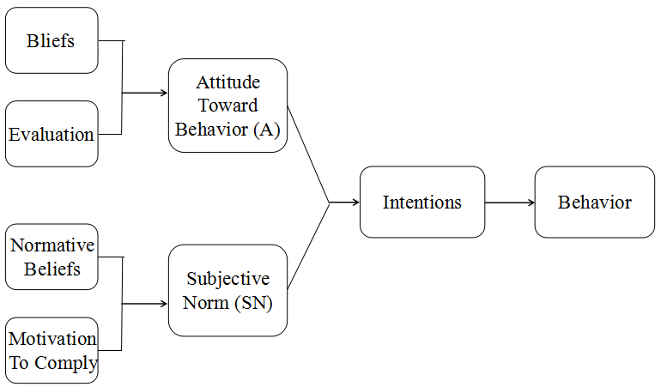

Figure 2: Theory of Reasoned Action (TRA)

Source: Southey (2011)

Behavioral attitudes are determined by whether a person's assessment of behavior is positive or negative (Hsu, 2012). Subjective norms can be viewed as social attributes that determine whether an individual performs an act (Astuti and Martdianty, 2012).

In this study, TRA is used to prove factors (price, perceived quality, brand awareness) that influence consumers' satisfaction level. The idea of attitude toward behavior as consumer’s consistent attitudes along with the beliefs is predicted to influence consumer attitude as well as consumers' satisfaction level. Subjective norms (social attributes), which are normative beliefs of consumers, can be influenced by factors such as work, family and friends (Schnusenberg and Jong, 2012).

# 2.5 Conceptual Framework

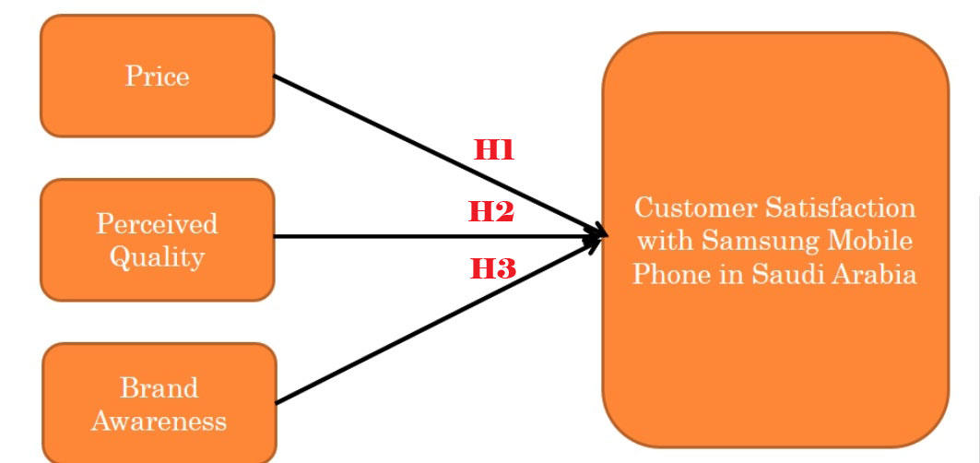

Figure 3: Conceptual Framework

# 2.6 Hypotheses

The purpose of this study is to study the possible factors which might influence the consumer satisfaction with Samsung mobile phones in Saudi Arabia. The focus will be on three factors that price, perceived quality and brand awareness with the accordance of the research questions as under.

H1: Price has a significant influence on customer satisfaction with Samsung mobile phones in Saudi Arabia.

H2: Perceived quality has a significant influence on customer satisfaction with Samsung mobile phones in Saudi Arabia**.**

H3: Brand awareness has a significant influence on customer satisfaction with Samsung mobile phones in Saudi Arabia.

# 3.0 Conclusion

This chapter presents a review of the literature on past research that explains dependent variables (customer satisfaction) and independent variables (price, perceived quality, brand awareness) from both perspectives of local and global variables. In succession, the linkage between dependent and independent variables were explored, a conceptual framework was established and the literature gap was pointed out from the context prospective and the theory of theoretical behavior (TRA) employed in this study. The literature research in overall has contributed to a better understanding of the project topic and can help perform additional study on the topic.

# CHAPTER 3

# RESEARCH METHODOLOGY

# 3.0 Overview

This chapter is a detailed picture of the various approaches to this study, and a study of research methodology that presents statistical research techniques for data collection and analysis methods. All of these efforts will ultimately focuses on the research topic that is customer satisfaction with customer satisfaction with Samsung mobile phones in Saudi Arabia. As for the structure for this chapter, the "three designs" will be explained in the first stage by including the time horizon and unit of analysis. This is to set and highlight the process of this study, dealing with sampling design, questionnaire design, and research design. Moreover, chapter three will emphasis on the measurement of this study, data analysis and the statistical techniques used in data collection methods. Finally, a summary roughly based on what is found or covered in this chapter (if any) will be given and will be concluded with a preliminary explanation for the next chapter.

## 3.1 Summary of Research Design

Study Setting

Types of investigation

Extent of researcher interference

Measure-ment and Measures

Purpose of the Study

It is a quantitative based correlation design as it is to determine whether relationship exist between variables

Minimum, as the conduction of this research does not interrupt the normal works of the respondents

Please refer to the measurement table

Non-contrived, as this research is studying the phenomenon since it occurs naturally, no manipulating of this study setting is evident

This study is describing the phenomenon (customer satisfaction) and verifying in the constructs in different context

PROBL E M

S T A T EM E N T

Data Analysis

Please refer to chapter four for data analysis

Sampling Design

Data Collection Method

Time Horizon

Unit of Analysis

Non-probability convenient sampling because of the time constraint as only 10 weeks is given and the response rate is higher. It is estimated that Samsung mobile users in KSA is 12000 as per statista (2016). Therefore according Krejcie and Morgan (1970) the sample size should be 384 or more

The unit of analysis is individual, since distributing questionnaire to customers and customers are individuals.

Please refer to the questionnaire design table

Cross Sectional because data collection from respondents is done only one time. There is no repetition of collecting data from the same respondent twice

## 3.2 Questionnaire Design

Table 2- Questionnaire

|  |  |  |  |
| --- | --- | --- | --- |
| **Section** | **Items/Questions.** | **No. Of Questions** | **Reference** |
| 1 | Demographic | 3 | Bilal and Ali (2013); Ismail and Soehod (2012) |
| 2 (IVs) | Price | 3 | Yan et. al. (2010); Zhang (2010) |
| Perceived quality | 3 | Ahmad and Sherwani (2015); Tanish and Maftukhah (2015) |
| Brand awareness | 3 | Sukumar (2013); Hussein (2012) |
| 3 (DV) | Customer satisfaction | 4 | Namasivayam, Prakash and Krishnakumar (2014); Ragupathi and Prabu (2015) |

In this section questions from related researches are either adapted or adopted by translating or modifying original ideas into suggested questions. First, the demographic profile is three items which are adapted from a research done by Ismail and Soehod (2012) and Bilal and Ali (2013). In addition, as for the independent variables, each IV in the questioner has 3 items. Questions related to price are adopted from researches of Yan et. al. (2010) and Zhang (2010), questions related to perceived quality are adapted from Ahmad and Sherwani (2015) and Tanish and Maftukhah (2015) whereas questions related to brand awareness is adapted from Sukumar (2013) and Hussein (2012) research. In addition, as for the dependent variable, questions related to consumer satisfaction are adapted from research done by Namasivayam, Prakash and Krishnakumar (2014) and Ragupathi and Prabu (2015). In the mentioned literature, for items that are adopted from the corresponding study, there are same items in the corresponding research; meanwhile for the items that are adapted from the corresponding research, there are similar ideas or items in the corresponding research.

## 3.3 Measurement Table

Rossi and Crenna (2018) defined measurements as outcomes gotten after evaluating something and are commonly conveyed in numbers, making values ​​more meaningful and useful in certain ways but acting as labels. Because this study is a quantitative research, a measurement of hypothesis testing, pilot test and descriptive information (demographic profile) will be performed to confirm that all data are statistically significant. The summary of the measurement table can be found below in table 2

Table 2- Measurement table

|  |  |  |
| --- | --- | --- |
| Tests | Purpose or Function | Rule of thumb |
| Factor Analysis (Pilot and Preliminary tests) | To determine whether there is a need for reducing the number of factors from a larger number of measured variables (Hair et al, 2014). |  |
| 1. KMO | To test sampling adequacy (Paille, 2012). | >0.6 (Zikmund et. Al., 2013). |
| 2.Factor loading | To check whether the items are usable and acceptable (Bolarinwa, 2015). | Loadings>0.6 (Hair et al, 2014). |
| 3. Eigenvalue | To ensure that the construct and dimensions are appropriate for the study (Matthews and Ross, 2014). | >1 valid factor (cooper and schinder, 2013). |
| Reliability Test (pilot and preliminary tests) | To evaluate the internal consistency and stability of the measurement (Sekaran and Bougie, 2011). | Cronbach alpha between 0.70 and 0.90 (Hair et al, 2010). |
| Demographic Profile |  |  |
| Hypotheses testing (Multiple Regression) | To check the goodness of fit R2 of regression model ( Sekaran and Bougie, 2011). | R2 near to 1= dependent variable can be explained by regression model (Schmidheiny, 2016). |
| One-Way ANOVA  (Krusal-Wallis) | To show the extent of variance with in a respondent or between respondents (Sedgwick, 2012). | Significance: p<0.05  Strength and direction “r” ranging from -1 to 1 (Sekaran and bougie 2011). |
| Beta Coefficient | To identify the factor with the highest influence (Zohrabi, 2013). |  |

# 3.4 Pilot Test for customer satisfaction

Pilot testing is defined as a small preliminary study used to assess the effects of time, side effects, cost, relevance, and sample size to determine whether the performance of an entire study is relevant and adequate before conducting the actual overall study (Matthews and Ross, 2014). It is like a "dress rehearsal" for the entire process of the study to identify whether the problems that exist before executing the survey can be resolved (Sekaran and Bougie, 2016). If a questionnaire is chosen as a method of data gathering, the survey should be conducted as a preliminary test to enhance the questionnaire so that respondents can completely comprehend and provide accurate answers (Bolarinwa, 2015). For this study, the size of the sample to be assessed by the pilot test is 40, which is 10% of the total sample size 384. This because according to Sekaran and Bougie (2016) the sample size of the pilot test should be 10% and not less than 38 items of the total sample size to enhance the effectiveness of the questionnaire.

# 3.5 Factor Analysis for customer satisfaction

Yong and Pearce (2013) defined factor analysis as a statistical tool used to examine the correlated and observed variables relationship, making it easy for respondents to understand. The main aim of this tool is to identify whether the items used in the research are right for the study or not, and whether if there are so many factors in the study, therefore that some factors need to be eliminated (Biglari, Saeidi and Karimyan et. al., 2018). Factor analysis is vital because it is perceived as a way of data deduction aimed at eliminating some of the variables from studies that share common differences so that they cannot be observed (Sekaran and Bougie, 2016). Simply put, factor analysis can assist to eliminate similar items to leave only the crucial variables that make it easier for investigators to execute their research more efficiently and effectively (Yong and Pearce, 2013).

Moreover, when conducting the pilot test for factor analysis, other three test will be conducted including, Factor Loading, Eigenvalures and KMO Barlett`s test of Sphencity. As for Eigenvalues test, the Eigenvalue for every independent variable in this study should be greater than one, in case if it is less than one then the independent variable should be removed or rewritten. This is because according to Sekaran and Bougie (2016), a values less than one indicates that the independent variable is not the correct one. On the other hand for the KMO Barlett`s test, the dependent variables and independent variables should be tested separately and the results from every variable should be greater than 0.6. If the value of the dependent variable’s KMO is less than 0.6, it indicates that the statistical significance is lacking and further questions need to be added; meanwhile if the KMO of the independent variable is less than 0.6, it means that the factor implements is not the correct (Zohrabi, 2013). The last test for the pilot test which is factor loading, similar to the KMO the dependent variables and independent variables should be tested separately and the results from every item should be greater than 0.6 (Kong and Liu, 2018). However, according to Sekaran and Bougie (2016) an item can be kept if the factor analysis value lies between 0.5 and 0.6 and should be changed or removed if less than 0.5.

# 3.6 Reliability Test for customer satisfaction

According to Rovai, Baker and Ponton(2013), Reliability testing refers to the statistical tool adapted to identify the internal consistency of variables in the factors to ensure that the data gathered is dependable and that the tools implemented in the study are useful for analysis. Reliability test is important to any statistical surveys because it helps investigators to examine the gathered data and ensure that the data is reliable during analysis to gat get more accurate results (Zohrabi, 2013).

For reliability testing, the Cronbach alpha value should be greater than 0.7. However, according to Horodnic, Ursachi and Zait (2015) an item can be kept if the Cronbach alpha value lies between 0.6 and 0.7 and should be changed or removed if less than 0.6. Reliability test is based on an internal consistency test to tell whether responses from the pilot respondents’ are consistent and to show the degree of understanding of the item within the questionnaire. This was also backed up by Sekaran and Bougie (2016) by stating that it indicates the degree of which whether the test is stable and consistent when measuring and analyzing the data. If the test itself is consistent, it means that the test is stable over time and within itself.

In this research, the reliability test will be implemented and any questions with a Cronbach Alpha less than 0.7 will either replaced with another question from relevant researches or eliminated from the survey.

# 3.7 Descriptive Information

Bonaldo and Pereira (2016) defined demographic profile as the personal information obtained from the respondents like education background, religion, marital status, gender, age and so on for the aim to obtain more understanding about the population under research. For this study, because the unit of analysis is individuals who own Samsung mobile phone in Saudi Arabia, the demographic information that will be asked are gender, age, income level and profession. One of the demographic questions that were selected is age and this because according to Kitapci et al (2013) people in different age groups have different things they look for in a phone which will affect their level of satisfaction. Another question is gender and profession which as stated by Pourkiani (2014) that people who have different profession depending on the gender, look for different things that might be of use to their profession therefore affecting their satisfaction. The last demographic that will be asked is the level of income and is because Kitapci et. al (2013) said that the customer’s level of income will affect the type of phone the customers buy, therefore resulting in different satisfaction level.

# 3.8 Hypotheses testing for customer satisfaction

According to Sekaran and Bougie (2016), hypotheses testing refers to the statistical tool that test whether the hypotheses at the proposed level is significant or not by comparing it with the null hypotheses. The hypothesis is rejected only when the outcome is lower than the pre-set significance level. Simply put, according to Zikmund et. al (2013) hypotheses testing is conducted by researchers to identify whether hypotheses can be accepted or not. Hypothesis testing is very vital because it allows investigators to get an idea of what outcome to look for an accurate study and to keep the whole study procedure reliable and scientific (Park and He, 2017). According to Sekaran and Bougie (2016), hypothesis testings’ function is to asses two mutually excluded statements to identify the best to describe and support the outcome from the data.

# 3.9 Multiple Regressions for customer satisfaction

According to Schmidheiny (2016), multiple regressions refer to the statistical tool that is generally used to determine the relationship between one dependent variable and different independent variables by looking at the alpha value. If the alpha value is less than the relationship is statistically significant, however if it greater than 0.05 it is not significant (Badgujar and Wani, 2018). Multiple regressions are essential tests because it helps research conductors to identify if hypotheses can be accepted or not (Schmidheiny, 2016). In this study, multiple regressions are needed because there are three independent variables (price, perceived quality and brand awareness) and one dependent variable (consumer satisfaction) that will be needed to analyze statistical relationships.

According to Sekaran and Bougie (2016), the results of multiple regressions analysis shows statistical results that can tell whether there is model fit between dependent and independent variables. This can be done by looking in to the R2 value; If R2 value is greater than 0.5 then the model is said to be fit, however if it is less than 0.5 the model is not fit meaning that the variability between the dependent and independent variables in the study is influenced by other constructs or factors, which imply that the current study framework is not appropriate (Zikmund et al., 2013).

# 3.10 One-Way ANOVA: P/F value for customer satisfaction

Sedgwick (2012) defined One-Way ANOVA as a as a statistical tool to determine whether there is a variance that exist between the means of a number of independent variables (usually more than three). If the in the results the P-value is less than 0.05, there is significant variance between the means of the independent variables under study (Sekaran and Bougie, 2016). Moreover, for this current study One-Way ANOVA is required to be done since this study contains three independent variables which need to be examined whether a considerable level of variance exist between the mean of each other (Sedgwick, 2012).

According to Zikmund et. al (2013), If the factor is ordinal and F value is found to be significant, it can be said that the kind of variance present in the data would show the difference between groups. However, if the data is scale data, the recommend tool to be applied are Dunnett's post-hoc test or Kruskal-Wallis (Sekaran and Bougie, 2016). As for this study, for the ordinal data the likert scale is used therefore the post-hoc tests within one-way ANOVA using Kruskal-Wallis will be implemented to ensure the equality of variances or means among respondents.

# 3.11 Beta Coefficient (Standardized) for customer satisfaction

Zohrabi (2013) defined standardized Beta Coefficient as a statistical tool to determine how robust effect that dependent variable (DV) get from every independent variable (IV). When interpreting the results, the greater the value of the beta coefficient, the higher the influence of the independent variable has on the dependent variable (Sekaran and Bougie, 2016). In this study, beta coefficients are needed to determine the impact of three influential factors of price, perceived quality and brand awareness have on customer satisfaction with Samsung mobile in Saudi Arabia. According to Zohrabi (2013) The greater the Beta Coefficient, the higher the relationship between dependence and independency factors, and such statistical reasoning will be of use to increase the understanding of the phenomenon under study.

# 3.12 Conclusion

This chapter summarizes this research methodology in which three designs (research design, sampling design, and questionnaire design) are deployed. A summary box for the research design was given, introducing elements like the unit of analysis and the time span. Subsequently, in the summary for the statistical measurement, it introduced pilot tests by specifying factor analysis, reliability testing, and correlation matrix analysis. Moreover the boxes explained the statistical measures of explanatory information, preliminary tests, and hypothesis testing. Measurements provide in-depth statistical information that provides inferential results on the phenomenon under study to better explain the phenomenon. This chapter lists all methodologies used in this study are listed and theoretical foundation for future chapters are laid out.

# Chapter 4

# RESULTS AND DISCUSSION

# 4.0 Overview

As stated in the last chapter, the data gathering and what tests will be performed were listed. In this chapter, according to the proposed methodology the analysis will be conducted, moreover results from the tests will be discussed. The tool used for the analyses and to identify the variable’s loadings and the relationships is SPSS. Before distributing the entire 384 questionnaire, a sample of only 40 questionnaires will be first taken to conduct the pilot test to ensure the feasibility of the questionnaire’s items or constructs, afterwards the final data collection and the proper tests will be executed to evaluate the presence and level of relationships between the variables in the study.

# 4.1 Pilot test for customer satisfaction

For this study, the size of the sample to be assessed by the pilot test is 40, which is 10% of the total sample size 384. This because according to Sekaran and Bougie (2016) the sample size of the pilot test should be 10% and not less than 38 items of the total sample size to enhance the effectiveness of the questionnaire.

# 1. Factor Analysis for customer satisfaction

Yong and Pearce (2013) stated that factor analysis is a statistical tool used to examine the correlated and observed variables relationship, making it easy for respondents to understand. The main aim of this tool is to identify whether the items used in the research are right for the study or not, and whether if there are so many factors in the study, therefore that some factors need to be eliminated (Biglari, Saeidi and Karimyan et. al., 2018).

### A. KMO Bartlett’s test of Sphericity for customer satisfaction

KMO Barlett`s test, the dependent variables and independent variables should be tested and the results from the variables should be greater than 0.6. If the KMO of the independent variable is less than 0.6, it means that the factor implements are not the correct (Zohrabi, 2013).

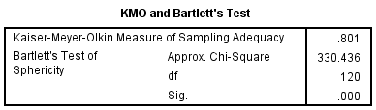

**Interpretation**

KMO Barlett`s test was conducted for the independent variables and the outcome of the significance value is greater than 0.6. The value of the dependent variable’s KMO is 0.801 which is greater than 0.6, indicating that the statistical significance is sufficient and further questions need not to be added. Therefore, since the KMO requirement is met by the dependent variables, the sample is adequate and investigator can continue with factor loading. Moreover, the significance value is 0.000, which is less than 0.05 (p value <0.05), indicating that the data is valid and the study reliable. Therefore, since the KMO requirement is met by the variables, the sample is adequate and investigator can continue with factor loading.

**Discussion**

The Kaiser-Meyer-Olkin (KMO) test processes how well data fits into the factor analysis (Sedgwick, 2012). This test identifies the sampling suitability for every element in the construct and the entire model (Biglari, Saeidi and Karimyan et. al., 2018). Statistics are a way to assess the variance between constructs, which can be a general variance (Sedgwick, 2012). The lesser the ratio, the better the items is for factor analysis. Usually the KMO value is between 0 and 1. When analyzing the rule of thumb, according to Sedgwick (2012) the following can be referred to:

1. A KMO outcome between 0.8 and 1 show that the sampling is consistence and acceptable.

2. A KMO outcome that is between 0.5 and 0.6 shows that the sampling is not consistence and not acceptable. However, some researchers believe that any value above 0.5 is acceptable.

3. A KMO outcome that is lower than 0.5 indicated that when comparing the [entire correlations](https://www.statisticshowto.datasciencecentral.com/partial-correlation/) there is a huge partial correlations, meaning that there are prevalent correlations which is not preferred when conducting a factor analysis.

### B. Factor Loading for customer satisfaction

This research for factor loading the chosen method is by using orthogonal (varimax) rotation method. It is used to get the most of the differences of the factor loading that are normally squared through the variables for every factor. When implementing this method, there are many benefits that could be gained like total variance percentage and the total eigenvalue do not affect each other as the entire procedure of the rotation will not alter all factor’s angle (Kaiser, 1974).

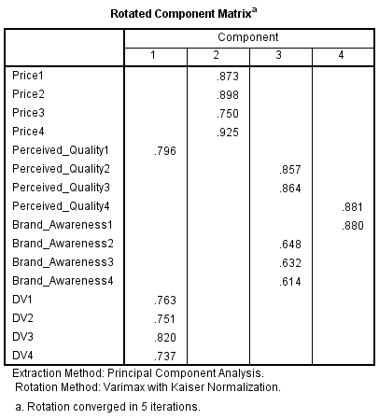

**Interpretation**

For factor loading testing, the dependent variables and independent variables are tested. The outcome from the independent variable showed that almost all item’s value are greater than 0.6 which considered acceptable (Kong and Liu, 2018). Similarly, the factor loading of the dependent variable showed that almost all item’s value are greater than 0.6 which considered also acceptable (Zohrabi, 2013). Therefore, since the requirements are met by both the dependent variables and independent variables, the items are usable and investigator can continue with eigenvalue test.

**Discussion**

Factor loading is associated with Principal Component Study; nevertheless the two are not the same (Zohrabi, 2013). There have been numerous arguments about the differences between the two approaches (Kong and Liu, 2018). Compared to factor loading, principal Component Analysis is a more plain kind of exploratory factor study invented before high-speed processors. The rule of thumb is used to interpret factor loadings (Zohrabi, 2013). According to empirical rules in empirical factor analysis, the outcome value should be 0.7 or higher to ensure that the extracted independent variables are displayed through certain factors (Kong and Liu, 2018). This could be translated to 0.7 of the indicators was elaborated through factors. However, the 0.7 standard is larger and this measure might not be well achieved through the real-world data especially for exploratory purposes, this the reason why academics should use lower values such as 0.4 for the entire central element, Under any circumstances, the factor load should be investigated through theory and not through random cutoff levels (Kong and Liu, 2018).

### C. Eigenvalue Table for customer satisfaction

The Eigenvalue ​​for certain factors indicate inconsistency within all variables. If the Eigenvalue is greater than one, it is regarded as significant. According Sekaran and Bougie (2016), a total dispersion of 50% or more is regarded as satisfactory. The eigenvalues for this study can referred to in the below table.

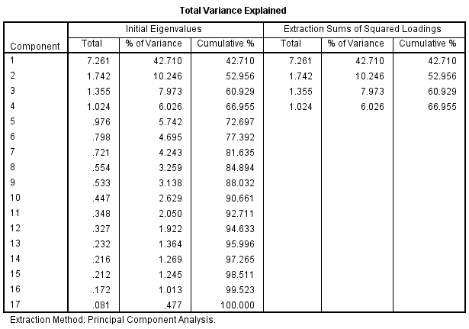

**Interpretation**

Eigenvalue for every independent and dependent variable in this study should be greater than one to ensure that the construct and dimensions are appropriate for the research. In this research, four variables were analyzed using the main components analysis in data extraction which is price, perceived quality, brand awareness and customer satisfaction with the setting of eigenvalue greater than one set the full variance explained as 66.99%. Moreover, as can be seen from the above table all the eigenvalues are above one, therefore the construct and dimensions are appropriate for the study.

**Discussion**

Eigenvalues ​​are a special set of scalars that are sometimes associated with linear roots, characteristic values, and linear equations (also called matrix equations), also called appropriate values ​​or potential roots (Kong and Liu, 2018). According to the outcomes in this table represents the percentage of each variable that can be accounted for by the retained factor. Variables with a higher result ​​are well signified in the common element column, and factors with smaller values ​​are not showed well (Sekaran and Bougie, 2016). In this study, there is no particularly low result; it is just a repeated difference in the extracted factors. This outcome can be found on the diagonal of the regenerated correlation matrix.

## 2. Reliability Test for customer satisfaction

According to Rovai, Baker and Ponton (2013), Reliability testing refers to the statistical tool adapted to identify the internal consistency of variables in the factors to ensure that the data gathered is dependable and that the tools implemented in the study are useful for analysis. Reliability test is important to any statistical surveys because it helps investigators to examine the gathered data and ensure that the data is reliable during analysis to gat get more accurate results (Zohrabi, 2013). The reliability test for this study can be seen in the table below.

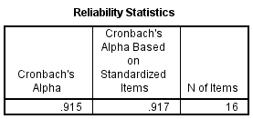

**Interpretation**

For reliability testing, the Cronbach alpha value should be greater than 0.7(Matthews and Ross, 2014). However, according to Horodnic, Ursachi and Zait (2015) an item can be kept if the Cronbach alpha value lies between 0.6 and 0.7 and should be changed or removed if less than 0.6. As can be seen from the above table, the Cronbach alpha value is 0.917 which is greater than 0.7, indicating the data has an excellent reliability and is consistency.

**Discussions**

Reliability test is based on an internal consistency test to tell whether responses from the pilot respondents’ are consistent and to show the degree of understanding of the item within the questionnaire (Rovai, Baker and Ponton, 2013). This was also backed up by Sekaran and Bougie (2016) by stating that it indicates the degree of which whether the test is stable and consistent when measuring and analyzing the data. If the test itself is consistent, it means that the test is stable over time and within itself and as can be seen from the table above it meets the criteria which means items in the questionnaire are reliable and indicates high internal consistency (Rovai, Baker and Ponton, 2013).

# 4.2 Demographic profile of respondents

According to Dierckx (2013) demographic test results can deliver overall information about the distribution and population of a study. This part will present the outcomes of the demographic characteristics of the participants by describing the socio-demographic characteristics like gender, income level and age. The table below in 4.2.1 shows the socio-demographic profile of the participants in this study.

|  |  |  |  |
| --- | --- | --- | --- |
| **Summary of questionnaire table** | | | |
| Items |  |  | Quantity |
| Questionnaires Distributed |  |  | 384 |
| Questionnaires Collected |  |  | 328 |
| Questionnaires Used for Analysis |  |  | 328 |

As can be seen from the above summary of the questionnaire table in this study a total of 384 participants were anticipated, however only 328 were received back. Moreover the entire data that was gathered was usable as the investigator online questionnaire (Google docs).

|  |  |  |  |  |  |  |
| --- | --- | --- | --- | --- | --- | --- |
|  | Items |  | Frequency |  |  | Percentage |
| Gender | **Male** |  | **217** |  |  | **66.2** |
|  | **Female** |  | **111** |  |  | **33.8** |
| Age | **18-20** |  | **39** |  |  | **11.9** |
|  | **20-30** |  | **211** |  |  | **64.3** |
|  | **30-40** |  | **64** |  |  | **19.5** |
|  | **>40** |  | **14** |  |  | **4.3** |
|  | **Total** |  | **328** |  |  | **100** |
| Profession | **Employee** |  | **113** |  |  | **34.5** |
|  | **Businessmen** |  | **34** |  |  | **10.4** |
|  | **Student** |  | **118** |  |  | **36.0** |
|  | **Other** |  | **63** |  |  | **19.2** |
|  | **Total** |  | **328** |  |  | **100** |
| Income Level | **<1000** |  | **78** |  |  | **23.8** |
|  | **1000-3000** |  | **105** |  |  | **32.0** |
|  | **3000-5000** |  | **98** |  |  | **29.9** |
|  | **>5000** |  | **47** |  |  | **14.3** |
|  | **Total** |  | **328** |  |  | **100** |

According to the table above, more than half of respondents in this study are in their twenties accounting for 64.3% and the majority of the participants were men with 66.2% of all respondents. The participants who earn a mid-level income scored the highest with 32% and the lowest salary earners in this survey group accounted for almost 23.8% of the respondent pool resulted in marginally distorted results. For the profession of the respondent 36% of the participants were students followed by 34.5% employees with businessmen being the least with 10.4%.

# 4.3 Preliminary Analyses for customer satisfaction

## A. Factor Analyses for customer satisfaction

As Factor analysis has been done for the pilot test, it will be done again for the preliminary testing to reach the final results. Factor analysis is vital because it is perceived as a way of data deduction aimed at eliminating some of the variables from studies that share common differences so that they cannot be observed (Sekaran and Bougie, 2016).

### A. KMO Bartlett’s test of Sphericity for customer satisfaction

Similar to the pilot testing, the dependent variables and independent variables should be tested and the results from the variables should be greater than 0.6. If the KMO of the independent variable is less than 0.6, it means that the factor implements are not the correct (Zohrabi, 2013).

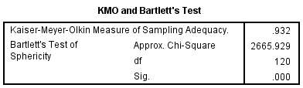

**Interpretation**

KMO Barlett`s test was conducted for the independent variables and the outcome of the significance value is greater than 0.6. The value of the dependent variable’s KMO is 0.754 which is greater than 0.6, indicating that the statistical significance is sufficient and further questions need not to be added. Therefore, since the KMO requirement is met by the dependent variables, the sample is adequate and investigator can continue with factor loading. Moreover, the significance value is 0.000, which is less than 0.05 (p value <0.05), indicating that the data is valid and the study reliable. Therefore, since the KMO requirement is met by the variables, the sample is adequate and investigator can continue with factor loading.

**Discussion**

The Bartlett's Test of Sphericity is a way to evaluate the null hypothesis to identify whether an identity matrix is included in the correlation matrix (Schmidheiny, 2016). Considering into account the assessment deliver the minimum level to pass to the next test (Kong and Liu, 2018). Moreover, this test is a procedure that is statistical in nature that helps to assess the quality of the correlations between the independent and dependent variables to see if it meets the requirement (Schmidheiny, 2016).

### B. Factor Loading for customer satisfaction

Similar to the pilot testing, for factor loading the chosen method is by using orthogonal (varimax) rotation method. It is used to get the most of the differences of the factor loading that are normally squared through the variables for every factor. The outcome of the test can be seen in the table below.



**Interpretation**

For factor loading testing, the dependent variables and independent variables are tested separately. The outcome from the independent variable showed that almost all item’s value are greater than 0.6 which considered acceptable (Kong and Liu, 2018). However, some item’s value between 0.5 - 0.6 but according to Sekaran and Bougie (2016) an item can be kept if the factor analysis value lies between 0.5 and 0.6, therefore it can be kept; Similarly, the factor loading of the dependent variable showed that almost all item’s value are greater than 0.6 which considered acceptable (Kong and Liu, 2018). Therefore, since the requirements are met by both the dependent variables and independent variables, the items are usable and investigator can continue with eigenvalue test.

**Discussion**

A significant part of the factor analysis that essential to be mentioned is the Rotated Component Matrix (Rovai, Baker and Ponton, 2013). When determining the number of elements to be tested, it is also a way to assess whether the variable is correlated to more than one element. Rotation maximizes usage is that it preserve questions with high loading value and limits questions with low loading value, creating a more simplified and interpretable outcome (Kong and Liu, 2018). There are two general rotation methods, which are oblique rotation and orthogonal rotation (Rovai, Baker and Ponton, 2013). The oblique rotation creates a correlated factor, whereas the orthogonal, which is the type of test used in this research, is a varimax rotation type that creates a non-correlated factor structure (Kong and Liu, 2018). Regardless of the rotation techniques adopted, the main goal is to interpret the results more easily and to create a more concise solution (Rovai, Baker and Ponton, 2013).

### C. Eigenvalue for customer satisfaction

The Eigenvalue ​​is used identify if there is any inconsistency within all variables. If the Eigenvalue is greater than one, it is regarded as significant. According Sekaran and Bougie (2016), a total dispersion of 50% or more is regarded as satisfactory. The eigenvalues for the preliminary test can be found in the below table.

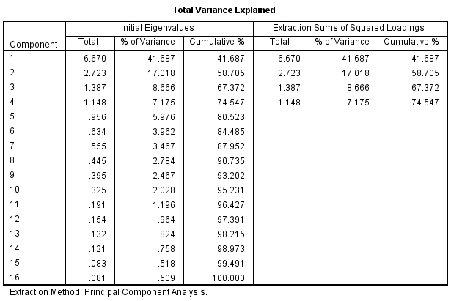

**Interpretation**

Eigenvalue for every independent and dependent variable in this study should be greater than one to ensure that the construct and dimensions are appropriate for the study. For this study, four variables were analyzed using the main components analysis in data extraction which is price, perceived quality, brand awareness and customer satisfaction with the setting of eigenvalue greater than one set the full variance explained as 59.61%. As can be seen from the above table all the eigenvalues are above one, therefore the construct and dimensions are appropriate for the study.

**Discussion**

Eigenvalue that has been extracted are four items that explains 74% of the total variance in this study. Each column represents a thing like:

**1.** **Factor:** The preliminary factor is equal to the amount of variables used for factor analysis (Kong and Liu, 2018). Though, not entire 16 factors are kept. In the above table, only the first four elements are kept (Dierckx, 2013).

**2.** **Initial Eigenvalues:** initial Eigenvalue is the difference in factors (Sekaran and Bougie, 2016). Since the factor analysis of the correlation matrix was performed, the variables were consistent, indicating the difference of each variable is 1 and the overall number of variance is the sum of variables adopted in the study which in this research is 16.

**3.** **Total:** This part illustrates the actual eigenvalue (Rovai, Baker and Ponton, 2013). The first element always has the highest eigenvalue since it considers the largest variance, and the following element occupies the remainder of the variance whenever possible (Kong and Liu, 2018). Thus, each succeeding element will be less of a value than that the previous on in variance.

**4.** **Percent of variance:** This part shows the overall percentage of variance that every factor accounted for (Dierckx, 2013).

**5. Cumulative percent:** This part explains the increasing percentage of difference described by the existing and entire previous factors (Kong and Liu, 2018). For instance, the value in the fourth row is 66.97%, indicating that the previous four elements account all together 66.97% of the entire variance.

**6. Extraction Sums of Squared Loadings:** The sum of factor in this pane of the table is parallels to the amount of coefficients held (Dierckx, 2013). Because we need to keep four elements in this research, therefore four rows can be seen, one for each retained element. The outcomes ​​in this pane of the above figure are designed in the same way as ​​the pane next to it. However, the values here ​​are founded on a general variance. This distribution is always smaller than the total distribution (Sekaran and Bougie, 2016).

**7. Rotation Sums of Squared Loadings:** The outcomes ​​in this part accounts for the variance distribution subsequent to the varimax rotation (Kong and Liu, 2018). Because Varimax rotation attempts to exploit the variance of every element, the calculated variance amount is redistributed to the four extraction element (Sekaran and Bougie, 2016).

## B. Reliability Test for customer satisfaction

Reliability test is conducted again for the preliminary as it is vital to every statistical survey because it helps investigators to assess the gathered data and ensure that the data is reliable during analysis to gat get more accurate results (Zohrabi, 2013). The reliability test for this study can be seen in the table below.

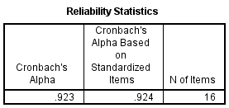

**Interpretation**

For reliability testing, the Cronbach alpha value should be greater than 0.7(Matthews and Ross, 2014). However, according to Horodnic, Ursachi and Zait (2015) an item can be kept if the Cronbach alpha value lies between 0.6 and 0.7 and should be changed or removed if less than 0.6. As can be seen from the above table, the Cronbach alpha value is 0.923 which is greater than 0.7, indicating the data has an excellent reliability and is consistency.

**Discussion**

Reliability tests can be done in four different ways like, the parallel-forms reliability test which is used is used to assess two test results consistency that are done using the same method (Zohrabi, 2013). The second type which is adopted in this study is the internal consistency reliability test which tests the reliability of the questions in the analysis from the outcome (Horodnic, Ursachi and Zait, 2015). The third type of reliability test is the inter-rater (or inter-observer) reliability test which is used to evaluate how much different variables yield consistent values with a similar construct (Zohrabi, 2013). The last type of reliability test is the test-retest reliability test which focuses more on evaluating consistence over a period of time; compared to the other test, test-retest reliability test main focus is on time element (Horodnic, Ursachi and Zait, 2015).

# 4.4 Hypotheses testing for customer satisfaction

According to Sekaran and Bougie (2016), hypotheses testing refers to the statistical tool that test whether the hypotheses at the proposed level is significant or not by comparing it with the null hypotheses. The hypothesis is rejected only when the outcome is lower than the pre-set significance level. For this research, both linear regression and multiple regressions will be conducted and the results will be assessed accordingly.

## A. Linear regression for customer satisfaction

Linear regression is the subsequent test that is done after correlation. It is a tool that aims to predict the value of a variable depending on the value of another variable. The variable that is forecasted is the dependent variable (or sometimes called a result variable). The variable used to predict the value of dependent variable is the independent variable (or sometimes called the predictor variable).

**1. Linear regression for IV1 (Price)**

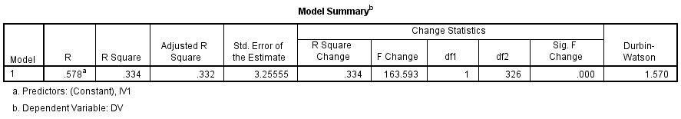

In the linear regression analysis, based on table … the summary of the model. The fitness of the model is weak: the corrected determination coefficient is 0.332, the determination coefficient R squared is 0.334 and the correlation coefficient R is 0.578, which shows that the 33.4% variances of the dependent variable can be explained by the independent variable (brand awareness). Moreover, the Durbin-Watson value is 1.570, showing that the variables have no clear correlation and the residuals are independent from each other, however the precision of the model is low. The regression model of this study is not highly descriptive of the dependent variables.

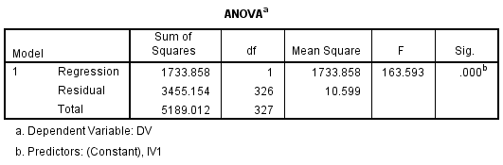

As can be seen from the above table 4.17, F test of 163.593 (sig. = 0.000) illustrates that the whole regression is significant. The adequacy of regression is considered moderate to high, and thus the hypotheses and framework of this research indicate moderate to high predictive fitness when taken as a whole.

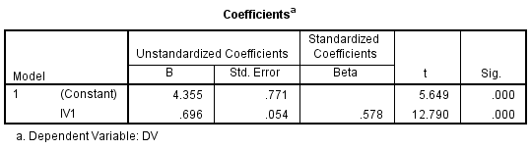

The above table explains the outcome of the structural relationships among the independent and the dependent variables. Based on the results, it illustrates the hypothesis H1 individually has a significant influence on customer satisfaction with Samsung mobile phones in Saudi Arabia.

**2. Linear regression for IV2 (Perceived quality)**

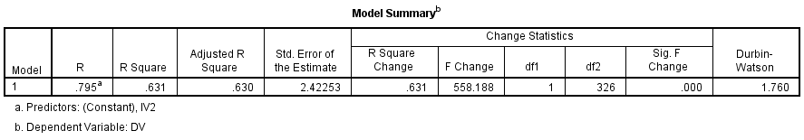

In the linear regression analysis, based on the summary of the model, the fitness of the model is moderately good: the corrected determination coefficient is 0.630, the determination coefficient R squared is 0.631 and the correlation coefficient R is 0.795, which shows that the 63.1% variances of the dependent variable can be explained by the independent variable (perceived quality). Moreover, the Durbin-Watson value is 1.760, showing that the variables have no clear correlation and the residuals are independent from each other, which means the precision of the model is higher. The regression model of this study is highly descriptive of dependent variables.

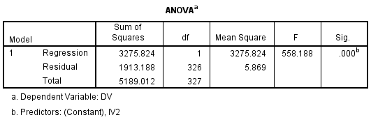

As can be seen from the above table 4.17, F test of 558.188 (sig. = 0.000) illustrates that the whole regression is significant. The adequacy of regression is considered moderate to high, and thus the hypotheses and framework of this research indicate moderate to high predictive fitness when taken as a whole.

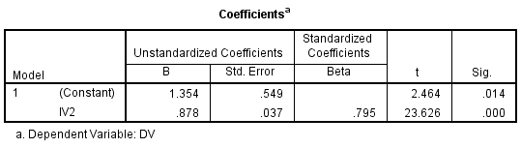

Moreover, the above table explains the outcome of the structural relationships among the independent and the dependent variables. Based on the results, it illustrates the hypothesis H2 individually has a significant influence on customer satisfaction with Samsung mobile phones in Saudi Arabia.

**3. Linear regression for IV3 (Brand awareness)** 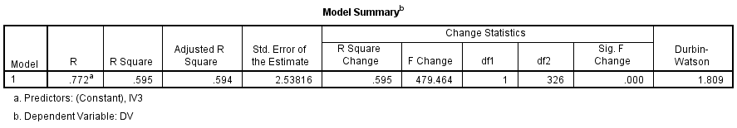

In the linear regression analysis, based on table above, the fitness of the model is moderately good: the corrected determination coefficient is 0.594, the determination coefficient R squared is 0.595 and the correlation coefficient R is 0.772, which shows that the 59.9% variances of the dependent variable can be explained by the independent variable (brand awareness). Moreover, the Durbin-Watson value is 1.809, showing that the variables have no clear correlation and the residuals are independent from each other, which means the precision of the model is higher. The regression model of this study is highly descriptive of dependent variables.

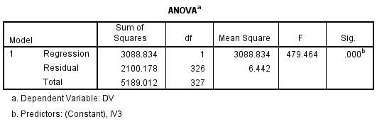

As can be seen from the above table 4.17, F test of 479,484 (sig. = 0.000) illustrates that the whole regression is significant. The R2 of 0.631 in table 4.16 demonstrations that 77.2% of the variation in rating of customer satisfaction can be described by the regression model or the study constructs. Moreover, the above table explains the outcome of the structural relationships among the independent and the dependent variables. Based on the results, it illustrates the hypothesis H3 individually has a significant influence on customer satisfaction with Samsung mobile phones in Saudi Arabia.

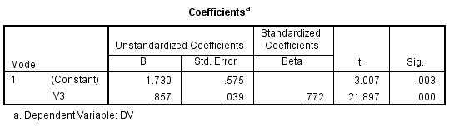

Moreover, the above table explains the outcome of the structural relationships among the independent and the dependent variables. Based on the results, it illustrates the hypothesis H3 individually has a significant influence on customer satisfaction with Samsung mobile phones in Saudi Arabia.

## B. Multiple regressions for customer satisfaction

According to Schmidheiny (2016), multiple regressions refer to the statistical tool that is generally used to determine the relationship between one dependent variable and different independent variables by looking at the alpha value. If the alpha value is less than the relationship is statistically significant, however if it greater than 0.05 it is not significant (Badgujar and Wani, 2018).

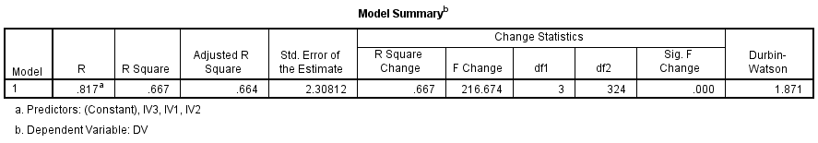

In the multiple regression analysis, based table the table above summary of the model, the fitness of the model is moderately good: the corrected determination coefficient is 0.664, the determination coefficient R squared is 0.667 and the correlation coefficient R is 0.817, which shows that the 66.7% variances of the dependent variable can be explained by the independent variable (price, perceived quality and brand awareness). Moreover, the Durbin-Watson value is 1.871, showing that the variables have no clear correlation and the residuals are independent from each other, which means the precision of the model is higher. The regression model of this study is highly descriptive of dependent variables.

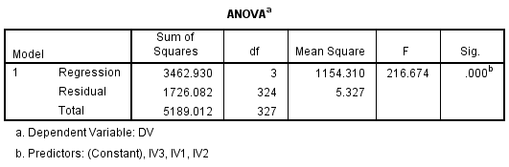

As can be seen from the anova above table 4.17, F test of 216.674 (sig. = 0.000) illustrates that the whole regression is significant. The adequacy of regression is considered moderate to high, and thus the hypotheses and framework of this research indicate moderate to high predictive fitness when taken as a whole.

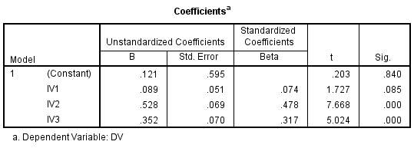

The above table explains the outcome of the structural relationships among the independent and the dependent variables. According to Hair et al. (2014), beta-value is used to assess how strong influence does the independent variable has on the dependent variable.

**Discussion**

From the below table based on the results, it illustrates the last two hypothesis H2 and H3 can be accepted and H1 is rejected based on the result. Details of the test results are displayed below:

|  |  |
| --- | --- |
| **Hypotheses** | **Status** |
| Hypothesis 1 | rejected |
| Hypothesis 2 | accepted |
| Hypothesis 3 | accepted |

Therefore, from Table 4.4, it can also be concluded that the equation for the regression line is:

Y= 0.121 - 0.089 (Price) + 0.528 (Perceived quality) + 0.352 (Brand Awareness)

***Hypothesis 1:*** Price has a significant influence on customer satisfaction with Samsung mobile phones in Saudi Arabia.

The relationship between price and customer satisfaction with Samsung mobile phones in Saudi Arabia was evaluated. From the table above it shows that it does not have a positive significant relationship for the variable (β =0.089, sig. = 0.085).

**Therefore, Hypothesis 1 is rejected.**

***Hypothesis 2:***  Perceived quality has a significant influence on customer satisfaction with Samsung mobile phones in Saudi Arabia.

The relationship between perceived quality and customer satisfaction with Samsung mobile phones in Saudi Arabia was evaluated. From the table above it shows that it does have a positive significant relationship for the variable and from the beta value it indicates that it has a higher influence on the dependent variable than the third independent variable (β =0.478, sig. = 0.00).

**Therefore, Hypothesis 2 is accepted.**

***Hypothesis 3:*** Brand awareness has significant influence on customer satisfaction with Samsung mobile phones in Saudi Arabia.

The relationship between brand awareness and customer satisfaction with Samsung mobile phones in Saudi Arabia was evaluated. From the table above it shows that it does have a positive significant relationship for the variable and from the beta value it indicates that it has a lower influence on the dependent variable than the second independent variable (β =0.317, sig. = 0.00).

**Therefore, Hypothesis 3 is accepted.**

# 4.6 Conclusion

To wrap this chapter, data analysis is conducted by the results provided above. In this chapter, the investigator first performed a pilot test before the entire test deployment to verify the suitability of the data. Data are tested sequentially by factor analysis, reliability testing, and hypothesis testing to be sure that the adapted items are relevant and appropriate to this research. Moreover, the investigator conducted preliminary tests linear regression and multiple regressions separately to verify the hypothesis significance to the proposed dependable variable. The following chapter will explore further the discussion of the results illustrated in this chapter and provide implications and recommendations to support the findings.

# 

# CHAPTER 5

# Conclusion and Recommendation

# 5.0 Overview

This chapter summarizes what was done in chapters 1 to 4 above and provide a conclusion of the entire study. It will include a summary, marketing and policy recommendations, address limitations of the full study, provide additional recommendations for future researches, and finally a conclusion of what have been discussed. From this study, the entire research can be summarized as follow.

# 5.1 Summary

This study analyzed the customer satisfaction with Samsung mobile phones in Saudi Arabia. It assessed three factors that are expected to affect customer satisfaction with Samsung mobile phones in Saudi Arabia with the aim of identifying the reason of why is Samsung mobile phone share in Saudi Arabia has been decreasing in the past few years and come up with a recommendation improve the situation. Through the questionnaire, customers seem to be not very familiar with Samsung phone features and believe that other brands offer better products and service. This indicates that Saudi Arabian customers are very interested in other mobile phone brands other than Samsung because of lack of information and knowledge about how to use the product. The aim of this research is to deliver insight into Samsung’s phone market in the country to help them act better to improve the situation. Moreover for customers it will help them get more insight about Samsung’s brand phone mobile

This research performed several tests including factor analysis, reliability test, descriptive analysis and multiple regression to analyze the data, whereby Descriptive analysis to identify variable characteristics in terms of relative proportions, standard deviation, standard deviation, frequency and distribution; reliability test was performed to assess the internal consistency of the items before factor analysis; factor analysis was implemented to decrease the number of variables to an appropriate level and group the elements that represent variables into items into independent dimensions; Multiple regression analyzes was executed to demonstrate statistical significance between dependent and independent variables and were used to statistically confirm whether the relationship between dependent and independent variables is affected by other factors.

In this research, a total number of 384 was expected, however 328 was only received back. The survey questions was structured in a way to determine the customer’s satisfaction in Saudi Arabia in regards to price, perceived quality and brand awareness. The analysis was done based on the surveys outcome (328 respondents). Overall the results shows indicate that price is not that much of an important factor that determine the level of satisfaction, whereas perceived quality and brand awareness has an influence on customers satisfaction.

# 5.2 Limitations of the Study

This study has a time limit of 14 weeks. Saudi Arabia is a large-scale country with different living standards, cultures and income levels. To obtain more accurate baseline data, the researcher needs to collect information from customers in every region or province in Saudi Arabia that tend to buy Samsung mobile phones. In addition, even in Riyadh the capital city itself the people who are living in downtown and people who are living around the city have different attitudes towards Samsung mobile phones. The main information that is needed to be collected must be gathered from each city in the country. However, because of the limited time the researcher could not distribute and collect an effective questionnaire for respondents from all over the country, so the basic information collected may not be as powerful and accurate as to support the outcomes.

In addition, even though the ineffective items that was deleted before proceeding with the analysis of SPSS, there may still be inaccurate data for the remaining questionnaire from respondents to the proposed question, especially the items for the variables in this research. Meaning that the respondents might just fill the results with being fully honest or accurate and these data can still lead to inaccurate results.

Besides, in the social demographic descriptive analysis, it illustrates that 64.3% of the participants are within the age range of 20 – 29 years old. It could result of the data gathered being centralized in this age range, which may also lead to results which are no accurate.

Also, since some of the studies and literatures the investigator looked into and referenced regarding customers satisfaction in Saudi Arabia are written in Arabic, there may be imprecisions in the translation for this research when quoting and citing ideas from past studies. This also can lead to information being in accurate.

# 5.3 Conclusion

Samsung’s market share reduction in Saudi Arabia has become the major problem of the brand in the country. Even though Samsung has been trying to implement new ideas and different marketing strategies to enhance the situation, it still has not shown any positive improvement until today. Therefore, to identify the causes the research questions were set out and assessed and the results were as follows:

**RQ1:** Does price has a significant relationship with customer satisfaction with Samsung mobile phones in Saudi Arabia?

The relationship between price and customer satisfaction with Samsung mobile phones in Saudi Arabia was evaluated. From the analysis in chapter 4 it shows that price does not have a significant relationship with customer satisfaction with Samsung mobile phones in Saudi Arabia.

**RQ2:** Does perceived quality has a significant relationship with customer satisfaction with Samsung mobile phones in Saudi Arabia?

The relationship between perceived quality and customer satisfaction with Samsung mobile phones in Saudi Arabia was evaluated. From the analysis in chapter 4 it shows that price does not have a significant relationship with customer satisfaction with Samsung mobile phones in Saudi Arabia.

**RQ3:** Does brand awareness has a significant relationship with customer satisfaction with Samsung mobile phones in Saudi Arabia?

The relationship between brand awareness and customer satisfaction with Samsung mobile phones in Saudi Arabia was evaluated. From the analysis in chapter 4 it shows that price does not have a significant relationship with customer satisfaction with Samsung mobile phones in Saudi Arabia.

As Saudi Arabia is a developed country with most of its citizens are financially well off, that is promotions in the form of price reduction has not been effective and costly making the situation worse. For example, as the outcome of data analysis has shown, Samsung mobile phone customers are willing to pay more than 3000 SAR to purchase its product, however would rather buy another phones brand Samsung phones are not stylish because they believe that Samsung mobile phones are not stylish in appearance and find it difficult to use the phone. Therefore Samsung need to change the way it market and promote its phone in a way that it can increase sales and customer’s satisfaction at the same time.

# 5.4 Recommendation for Samsung mobile phone

Samsung mobile phones in Saudi Arabia from year 2010 to 2015 were a hot issue among people in the country. However since 2016, Samsung mobile share has been decreasing steadily and from the analysis in this study, lack of knowledge about the product, its functions and the brand image going bad because of explosions seems to be the causes of it. Therefore, to shed more light on Samsung phone, increase awareness of the brand and change the perception of the customers, Samsung needs to develop a marketing strategy that could address those issues. For marketers, a very important factor in creating a customer's belief in promoting a property to marketers is to provide the right information to buy the ideal property for their customers. Therefore, it is important for marketers to consider how buyers will assess and select phone products, as customers will have different taste and things they are looking for when purchase a mobile phone.

As Saudi Arabia’s policy on electronic products in recent years have been improving and change to the better, marketers are encouraged to always keep an eye on alterations of policies set by the government and firmly react to them to evade any possible losses. Wherever possible, marketers may take advantages of the government policies to attract more customers.

Since price seems to have less influence on customer satisfaction, marketers need to focus less on it and more on creating awareness and improving the image of the brand as people are getting bad impressions due to the blasting of Samsung mobile phones, leading them to be less satisfied and switch to another. Thus when marketing strategies are formulated for Samsung phone, marketers can incorporate ideas that shows how safe is Samsung phones are and include information of what new features were added and how to use them.

## 5.4.1 Promotion plan recommendation for Samsung mobile phone

Since the results from the research showed that price is a less of an important for customers when deciding to by Samsung mobile phone in Saudi Arabia, other means like perceived quality and brand awareness will be taken in to account when making this promotional plan. The promotion plan should primary target should be the people between the age 18 – 25 years old people because they are the group of people who uses social media almost everyday spending a large amount of time on it. This type of promotion plan should be used by Samsung to reach to its audience and create more awareness to the brand. Adding to that, the primary way of promotion should be advertising Samsung's mobile phones throughout Google, Twitter, Facebook, YouTube, Magazines and TV. Social media is a network platform which could connect Samsung with its potential and target customers directly and effectively on a much personal level. Promotion through social media could be done in different forms like photos and videos with links and description to the mobile phone that is been advertised. In the description written about the phone, it should focus on the quality and features that the customers will get if they purchase the phone because from the perceived quality place an important role in the customer’s satisfaction. A suggested flyer or promotional design could be:

**Figure 4: Promotion flyer for Samsung mobile phone in Saudi Arabia**

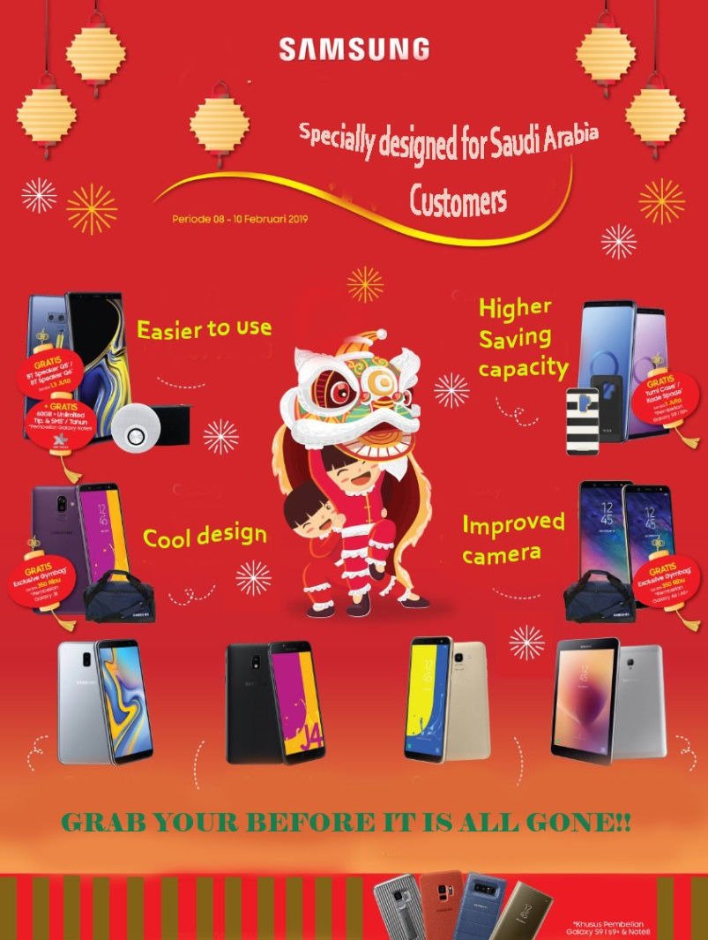

To create a brand awareness that is more effective, the usage of popular singers and actors among young people to be the ambassador of the brand to attract more customers is another key factor that could drive Samsung to success. Moreover, for offline promotions, flyers can be distributed and a stuff incentive programs should be adopted, which could be an effective way to attract customers and increase the volume of sales at the same time.

# 5.4.2 Recommendation for Further Research

As for customer satisfaction with Samsung mobile phones in Saudi Arabia, further studies are recommended to be continued in the future to assess and re-confirm more factors that can influence customer satisfaction with Samsung mobiles to help both the academic world to obtain more detailed references for future studies and Samsung company particularly in Saudi Arabia to promote their products with the proper strategy in a way that creates a positive image in the mind of the customers. In addition for future studies in this area, it recommended that similar studies can be written in English as presently there exist a big literature gap that there are many researches being carried out about the factors that influence the customer satisfaction of Samsung mobile phone in Saudi Arabia written in Arabic language. In this manner, a lot of international researchers cannot simply reach to the study that has been done in a language that the researcher cannot understand, which lead to many good future studies on how to improve Samsung situation being killed in the cradle.

Furthermore, from the outcome of this research, future studies is recommended to re-confirm the accurate reason why people in Saudi Arabia do not care about price of Samsung’s product and do not think there is relationship between their level of income and decision on whether to buy Samsung mobile phone or not.

# 5.5 Personal Reflection

The researcher has done a lot of study in writing literature reviews and has identified numerous academic articles to obtain a deeper knowledge and understanding of Samsung mobile phone industry. Moreover, once the research was completed, the investigator has got a better idea of the rational behavior theory (TRA) and how it is used to identify customer satisfaction. The main benefit of this study for investigator is that the investigator has learned how to employ SPSS to execute results and analyze data in a study. This selected topic of study is a topic in which the researcher has a very great interest in, which will help the researcher identify the direction of future career is the main aim is to work at Samsung Corporation after graduation. And under Dr. Arasu’s direction, investigator has erudite how to effectively complete studies in a limited period of time with high-quality.

Generally speaking, with Dr. Arasu’s professional guidance, the investigator have gained a lot of knowledge of the overall research and learning in an enjoyable and valuable way. It was a big relief for the research to have obtained 328 valid responses for the questionnaire in a very short period of time and to have finished the study in a successful way and on time.

# 6.0 Reference

Ahmad, F., and Sherwani1, N. U. (2015). An Empirical Study on the effect of Brand Equity of Mobile Phones on Customer Satisfaction. International Journal of *Marketing Studies*. Volume 3, Issue (2), pp. 25-27

Ahmed, Z. (2014). Effect of brand trust and customer satisfaction on brand loyalty in

Bahawalpur. *Journal of Sociological Research*, Volume 4, Issue (1), pp. 116-122

Adil, M. (2013). The relationship between service quality and customer satisfaction in India’s rural banking sector: An item analysis and factor-specific approach. *The Lahore Journal of Business*. Volume 1 Issue (2) pp. 43-63.

Al-Badi, K. (2015). The Dimensions of Marketing Mix. *Management and Organizational Studies,* Volume 2, Issue (1), pp. 136-142.

Aldhaban, F. (2012). Exploring the Adoption of Smartphone Technology: Literature Review. In Technology Management for Emerging Technologies (PICMET), 2012 Proceedings of PICMET'12, IEEE, pp. 2758-2770.

Alfawareh, H.M., Jusoh, S. (2014). Smartphones usage among university students: Najran University case. *International Journal of Academic Research*, Volume 6, Issue (2), pp. 321-326

Anderson, E. W., Fornell, C., and Lehman, D. R. (2012). Customers satisfaction, market share, and profitability: Findings from Sweden. *Journal of Marketing*, Volume 58, Issue (3), pp. 63-66.

Anderson, E. W., and Sullivan, M. W. (2012). The antecedents and consequences of customer satisfaction for firms. *Marketing Science*, Volume 12, Issue (2), pp. 125-143.

Astuti, R. and Martdianty, F. (2012). Students` Entrepreneurial Intentions by Using Theory of Planned Behavior. *Journal of Management.* pp. 100-143.

Badgujar, T. and Wani, V. (2018). Stamping Process Parameter Optimization with Multiple Regression Analysis Approach. *Materials Today: Proceedings,* Volume 5, pp. 4498–4507.

Barskey J. and Labagh, R. (1992). A Strategy for Customer Satisfaction. *Cornell Hotel and Restaurant Administration Quartery*. Volume 33, Issue (5), pp. 32 – 40.

Bayraktar, E., Tatoglu, E., Turkyilmaz, A., Delen, D., and Zaim, S. (2012). Measuring the Efficiency of Customer Satisfaction and Loyalty for Mobile Phone. Expert Systems with Applications, Volume 39, Issue (1), pp. 99-106.

Bei, L. T and Chiao, Y.C. (2001). An Integrated Model for The Effects of Perceived Product, Perceived Service Quality, and Perceived Price Fairness on Consumer Satisfaction and Loyalty. *Journal of Consumer Satisfaction*, Dissatisfaction and Complaining Behavior. Issue (14). pp.125-140

Biglari, H., Saeidi, M., Karimyan, K., Narooie, M. R. and Sharaf, H. (2018). Data for factor analysis of hydro-geochemical characteristics of groundwater resources in Iranshahr. *Data in Brief*, Volume 19, pp. 548–563.

Bilal, A., and Malik, F. M. (2014). Impact Of Brand Equity and Brand Awareness on Customer’s Satisfaction. International *Journal of Modern Management and Foresight*. Volume 1, Issue (2), pp. 18-20

Bolarinwa, O. (2015). Principles and Methods of Validity and Reliability Testing of Questionnaires Used in Social and Health Science Researchers. *Nigerian Postgraduate Medical Journal*, volume 22, Issue (4), pp. 195.

Bonaldo, L. and Pereira, L. N. (2016). Dropout: Demographic profile of Brazilian university students. *Procedia - Social and Behavioral Sciences,* 228, pp.138 – 143.

Bravo R, Montaner T, and Pina J M. (2012). Corporate Brand Image of Financial Institutions. *Journal of Product and Management*. Volume 5, Issue (3), pp. 35-39

Caruana, A. (2013). Service loyalty: The effects of service quality and the mediating role of customer satisfaction. *European Journal of Marketing*, Volume 36, Issue (7/8), pp. 811-828.

Cerri, S. (2012). Exploring the relationships among service quality, satisfaction, trust and store loyalty among retail customer. *Journal of Competitiveness*, Volume 4, Issue (4), pp. 16-35.

Chen, Y. S., and Chang, C. H. (2013). Towards green trust: The influences of green perceived quality, green perceived risk, and green satisfaction. Management Decision, Volume 51, Issues, (1), pp. 63-82

Cheung, R. and Vogel, D. (2013). Predicting user acceptance of collaborative technologies: An extension of the technology acceptance model for e-learning. *Computers and Education*, Volume 6, Issue (3), pp.160-175.

Creswell, J. W. (2013). Qualitative Inquiry and Research Design (3rd ed.). Thousand Oaks, CA: Sage Publications.

Cooper, R., and Schinder, S. (2013). Business Research Methods. New York: McGraw Hill.

Deng, Z., Lu, Y., Kee Wei, K., and Zhang, J. (2013). Understanding Customer Satisfaction and Loyalty: An Empirical Study of Mobile Instant Messages in China. International Journal of Information Management, Volume 30, Issue (4), pp. 289–300.

Dominici, G. and Palumbo, F. (2013). The drivers of customer satisfaction in the hospitality industry: applying the Kano model to Sicilian hotels. *International Journal of Leisure and Tourism Marketing*, Volume 3, Issue (3), pp. 215-236

Ehmke, C., Fulton, J. and Lusk, J. (2016). Marketing’s Four P’s: First Steps for New Entrepreneurs. *Department of Agricultural Economics*.

El-Said, O. and Fathy, E. (2015). Assessing University Students' Satisfaction with on Campus Cafeteria Services. Tourism Management Perspectives, Volume 16, pp.318–324.

Evangelos, G and Yannis, S. (2010). Customer Satisfaction Evaluation: Methods for Measuring and Implementing Service Quality. London: Springer.

Farrugia, P., Petrisor, B. A., Farrokhyar, F and Bhandari, M. (2010), Research questions, hypotheses and objectives. *Canadian Journal of Surgery*, [e-journal] Volume 53, Issue (4), pp.278.

Hanson, B. P. (2006). Designing, conducting and reporting clinical research. *A step by step approach: Injury*, [e-journal] Volume 37, Issue (1), pp. 583-594.

Hair, J., Black, W., Babin, B., Anderson, R., and Tatham, R. (2006). Multivariate data analysis (6th ed.). Uppersaddle River, N.J.: Pearson Prentice Hall

Hair, J. F., Ringle, C. M., and Sarstedt, M. (2011). PLS-SEM: indeed a silver bullet. *Journal of Marketing Theory and Practice*, Volume 19, Issue (2), pp. 139-151.

Hair, J. F., Hult, G. T. M., Ringle, C. M., and Sarstedt, M. (2014). *A Primer on Partial Least Squares Structural Equation Modeling (PLS-SEM)*. Thousand Oaks: Sage.

Horodnic, I., Ursachi, G. and Zait, A. (2015). How Reliable are Measurement Scales? External Factors with Indirect Influence on Reliability Estimators. *Procedia Economics and Finance*, Volume 20, Issuse (15), pp. 679-686.

Hsu, M. (2012). A Study of Internship Attitude, Subjective Norm, Perceived Behavioral Control, and Career Planning of Hospitality Vocational College Students. *Journal of Hospitality, Leisure, Sport and Tourism Education,* pp.5-11*.*

Hu, Y. J. (2012). Exploring the relationship between perceived risk and customer involvement, brand equity and customer loyalty as mediators. *The International Journal of Organizational Innovation*, Volume 5, Issue (1), pp. 224-230.

Hurk, A. (2013). *Social media crisis communications*. 1st ed. Indianapolis, Ind.: Que.

IDC: Smartphone vendor market share. (2016). [Online], Available from: <http://www.idc.com/prodserv/smartphone-market-share.jsp> [Accessed on 24 Oct 2018]

Hussein, A. (2012). Customer’s satisfaction and brand awareness Case: Bulsho Cooperative, Finland, HAAG'A-HELIA".

Isoraite, M. (2016). Marketing Mix Theoretical Aspects. *International Journal of Research - Granthaalayah*. Volume 4, Issue (6), pp. 25-37.

Januarko, Adiwibowo and Kusumawati (2018). The Impact of Product Quality and Price on Customer Satisfaction with the Mediator of Customer Value. Volume 20, Issue (8), pp. 1-7

Jayasankaraprasad, C., and Kumar, P. V. V. (2012). Antecedents and consequences of customer

satisfaction in food and grocery retailing: An empirical analysis. Decision, Volume 39, Issue (3), pp. 101-140.

Karimi, M., and Kashani, B. H. (2012). Paper customer preference of private insurance covers in Iran. *African Journal of Business Management*, Volume 6, Issue (11), pp. 4276-4281.

Kasiri, L. A., Guan Cheng, K. T., Sambasivan, M., and Sidin, S. M. (2017). Integration of standardization and customization: Impact on service quality, customer satisfaction, and loyalty. *Journal of Retailing and Consumer Services*, Volume 35, pp. 91-97

Karatepe, M. (2013). Service Quality, Customer Satisfaction and Loyalty: The Moderating Role of gender.

Kaur, N. (2018). Attaining Customer Loyalty: The Role Of Customer Satisfaction. *Kaav International Journal Of Economics, Commerce and Business Managment*, Volume 5, Issue 1, pp.145-149.

Kaura, V., and Daura, S. K. (2012). Role of Customers and Employees in Service Delivery and Customer Satisfaction: Survey Evidence from Banks in Rajasthan. *IUP Journal of Bank Management*, Volume 11, Issue (4), pp. 121-12

Khadka, K. and Maharjan, S. (2017). Customer Satisfaction and Customer Loyalty. *A Thesis on Centria University of Applied Sciences*,

Kim, M., Vogt, C.A. and Knutson, B.J. (2015). Relationships among customer satisfaction, delight, and loyalty in the hospitality industry. *Journal of Hospitality and Tourism Research*, Volume 39, Issue (2), pp.170-197.

Kitapci, O., et al. (2013). The paths from service quality dimensions to customer loyalty: An application on supermarket customers. *Management Research Review*, Volume 36, Isuue (3), pp. 239-255.

Kotler, P. and Armstrong, G. (2016). Principles of Marketing. 16th Edition, Pearson Education Limited, Essex, England.

Kotler, P. and Keller, K. (2016). Marketing Management. 15th Edition, Prentice Hall, Saddle River.

Lee, S., Liaw, M. and Rha, Y. (2016). International Students? Perception on University Cafeteria in Malaysia. *Culinary Science and Hospitality Research*, Volume 22 Issue (6), pp.24-32.

Macdonald, E. K., and Sharp, B. M. (2000) Brand Awareness Effects on Consumer Decision Making for a Common, Repeat Purchase Product A Replication*. Journal of business Research*, Volume, 48 Issue (1), pp. 5-15.

Maharjan, Kabu Khadka and Soniya. (2017). Customer satisfaction and customer loyalty. Centria University

Manjunath, S. and Reginald, S. (2016). Customer Satisfaction in Fast Food Industry: A Case Study of Mysore. IJRFM, Volume 6 Issue (5).

Mansoor, D. and Jalal, A. (2011). The Global Business Crisis and Consumer Behavior: Kingdom of Bahrain as a Case Study. *International Journal of Business and Management*, Volume 6, Issue (1), pp. 104-115.

Mathur, S., and Qiu, C. M. (2012). Single package size as a signal of quality: Theory and evidence. Working paper, Department of Marketing. McGill University.

Matthews, B. and Ross, L. (2014). Research Methods. 2nd edition. *Pearson Education Limited*, pp. 15-96.

Mccoll-kennedy, J.R. (2015). Fresh perspectives on customer experience. *Journal Of Services Marketing*, Volume 29 Issue (6-7), pp. 430-435.

Mill, R.C., (2011). A comprehensive model of customer satisfaction in hospitality and tourism: Strategic implications for management. *International Business and Economics Research Journal (IBER)*, Volume 1 Issue (6).

Milutinovic, M., Barac, D., Despotovic Zrakic, M., Markovic, A., and Radenkovic, B. (2011).

Developing Mobile Application for Learning Japanese Language – FONJAPGO. Management, Volume 16, Issue (60), pp. 27-34.

Namasivayam, S. Prakash, M. and Krishnakumar, M. (2014), “A Study on Customer Satisfaction towards Samsung Smart Phones with reference to Coimbatore City”, *Indian Journal of Applied Research,* Volume 4, Issue (5).

Nawab, S. Bhatti, K, K. (2011). Influence of Employee Compensation on Organizational Commitment and Job Satisfaction: A Case Study of Educational Sector of Pakistan. International Journal of Business and Social Science. Volume 2, Issue (8), pp. 25-32.

Owomoyela, S., Olasunkanmi, O. and Oyeniyi, K. (2013). Investigating the impact of marketing mix elements on consumer loyalty: an empirical study on negerian breweries PLC. *Interdisciplinary journal of contemporary research in business*. Volume 4, Issue (11). pp. 485-496.

#### Paillé, P and Raineri N. (2015). Linking perceived corporate environmental policies and employees eco-initiatives: The Influence of perceived organizational support and psychological contract breach. Journal of Business Research, Volume 68, pp. 2402-2411.

Park, S. and He, X. (2017). Hypothesis Testing for Regional Quantiles. *Journal of Statistical Planning and Inference*, 191, pp. 13–24.

Park, N. and Lee, H. (2012). Social Implications of Smartphone Use: Korean College Students' Smartphone Use and Psychological Well-Being. CyberPsychology, Behavior and Social Networking, Volume 15, Issue (9), pp. 491-497

Pour, B., Nazari, K. and Emami, M. (2012). The effect of marketing mix in attracting customers: Case study of Saderat Bank in Kermanshah Province. *African Journal of Business Management,* Volume 7, Issue (8), pp. 654-678.

Pourkiani, M., et al. (2014). Service quality effect on satisfaction and word of mouth in insurance industry. *Management Science Letters*, Volume 4, pp. 1773-1780.

Quddus, F. S. A., and Hudrasyah, H. (2014). The Influence of Service Quality Dimensions on Customer Satisfaction and Customer Loyalty in PT. JNE North Bandung Area. *Journal of Business and Management*, Volume 3 Issue (5), pp. 546-556.

Radojevic, T., Stanisic, N. and Stanic, N., (2017). Inside the Rating Scores: A Multilevel Analysis of the Factors Influencing Customer Satisfaction in the Hotel Industry. Cornell Hospitality Quarterly, Volume 58, Issue (2), pp.134-164.

Rahi, S. (2017). Research Design and Methods: A Systematic Review of Research Paradigms, Sampling Issues and Instruments Development. *International Journal of Economics and Management Services*, Volume 6, Issue (2), pp. 1-5.

Ragupathi, M. and Prabu, G. (2015). “A study on customer satisfaction towards smart phone Users”, *International Journal of Applied Research,* Volume 1, Issue (10), pp. 270-274.

Retico, A., Arezzini, S., Bosco, P., et at., (2017). ARIANNA: A research environment for neuroimaging studies in autism spectrum disorders. *Computers in Biology and Medicine*, Volume 87, pp. 1–7.

Rossi, G. and Crenna, F. (2018). A formal theory of the measurement system. *Measurement*, Volume 116, pp.644–651.

Rovai, A., Baker, J. and Ponton, M. (2013). Social Science Research Design and Statistics: A Practioner`s Guide to Research Methods and SPSS Analysis. 1st edition. Watertree Press LLC.

Saardchom, N. (2014). Design Patent War: Apple versus Samsung South Asian Journal of Business and Management Cases, Volume 3, Issue (2), pp. 221 - 228

Saif, N., Razzaq, N., Amad, M., and Gul, S. (2012). Factors Affecting Consumers’ Choice of Mobile Phone Selection in Pakistan. *European Journal of Business and Management*, Volume 4 Issue 12, pp. 16–26.

Salamin, H. and Hassan, E. ( 2016). The Impact of Pricing on Consumer Buying Behavior in Saudi Arabia : Al-Hassa Case Study. *European Journal of Business and Management*, Volume 8, Issue (12), pp. 62-73.

Schmidheiny, K. (2016). Linking Tele-connection Patterns to European Temperature - A Multiple Linear Regression Model. *Meteorologische Zeitschrift*, Volume 24, Issue (4), pp. 411-423.

Schnusenberg, O. and Jong, P. (2012). Predicting Study Abroad Intentions Based on the Theory of Planned Behavior. *Journal of Innovative Education,* 10, pp. 337-361.

Sekaran, U. and Bougie, R. (2011). Research Methods for Business: A Skill Building Approach.

Seongwon, P., Kwangeak, K., and Bonggyou, L. (2011). Developing English Learning Contents for Mobile Smart Devices. In P.J. James, Y.T. Laurence and L. Changhoon (Eds.), Future Information Technology (pp. 264-271): Springer Berlin Heidelberg.

Sharmin, W. (2012). Customer satisfaction in business: A case study of Moon Travel LTD, Finland. Undergraduate. Laurea University of Applied Sciences.

Singh, A., Dhayal, N. and Shamim, A. (2014). Consumer Buying Behaviour. *IRJMSH*, 5(12), pp. 17-21.

Smith, S., Cunningham-Sabo, L., and Auld, G. (2015). Satisfaction of middle school lunch program participants and non-participants with the school lunch experience. *The Journal of Child Nutrition andamp; Management*, Volume 39, Issue (2).

Southey, G. (2011). The Theories of Reasoned Action and Planned Behaviour Applied to Business Decisions: A Selective Annotated Bibliography. *Journal of New Business Ideas and Trends,* Volume 9, Issue (1), pp. 43-50.

Sprowls, R. and Asimow, M. (1962). A Model of Customer Behavior for the Task Manufacturing Corporation, Management Science, Volume 8, Issue (3), pp. 311-324

Statista. (2016). Samsung web traffic changes. [Online], Available from: <http://statista.com>

Stefano, N., Casarotto Filho, N., Barichello, R. and Sohn, A. (2015). A fuzzy SERVQUAL based method for evaluated of service quality in the hotel industry. Procedia CIRP, 30, pp. 433-438.

Sultan, P. and Wong Y. (2013). Antecedents and consequences of service quality in a higher education context: a qualitative research approach. *Quality assurance in education,* Volume 21, Issue (1), pp. 70-95.

Sukumar (2013). “A Study of consumer attitude towards Samsung Mobile instruments in Dindigul district, Tamilnadu, India”, *IRACST – International Journal of Commerce, Business and Management (IJCBM),* Volume 2, Issue (2).

Tan, M. and Teo, T. S. (2002). Factors influencing the adoption of Internet banking. *Journal of the Association for Information System*, Volume 1, Issue (1)

Tanish, T. and Maftukhah, I. (2015).The Effects of Service Quality, Customer Satisfaction, Trust and Perceived Value Towards Customer Loyalty. *Journal Dynamical Management, Volume* 6, Issue (1)

Thuy, T. N. and Chi, T. K. (2015). Factors Influencing Customer Perceived Quality and Purchase Intention toward Private Labels in the Vietnam Market: The Moderating Effects of Store Image. Volume 5, Issue (4), pp. 45-7

Warr, P. B. (2012). How to think about and measure psychological well-being. In M. Wang, R.

R. Sinclair, and L. E. Tetrick (Eds.), Research methods in occupational health psychology. New York: Routledge.

Wei, Z. (2011). A research on Chinese consumers’ buying behaviour towards mobile phone cases – Case company: Mozo Oy. *HAAGA-HELIA*, pp. 1-72.

Yoon, C., and Kim, S. (2011). Developing the causal model of online store success. *Journal of Organizational Computing and Electronic Commerce*, Volume19, Issue (4), pp. 265–284.

Yong, A. and Pearce, S. (2013). A Beginner`s Guide to Factor Analysis: Focusing on Exploratory Factor Analysis. *Tutorials in Quantitative Methods for Psychology*, Volume 9, Issue (2), pp. 79-94.

Zeithaml, V., A. and Bitner, M, J. (2013). Service Marketing: Integrating Customer Focus Across the Firm. USA: McGraw-Hill, Volume 3, pp.1-2.

Zikmund, W., Babin, B., Carr, J. and Griffin, M. (2013). Business Research Methods. CENGAGE Learning Custom Publishing.

Zohrabi, M. (2013). Mixed Method Research: Instruments, Validity, Reliability and Reporting Findings. *Theory and Practice in Language Studies*, Volume 3, Issue (2), pp. 1-9.

# 7.0 Appendix

**Appendix – 1 Literature review**

|  |  |  |  |  |  |
| --- | --- | --- | --- | --- | --- |
| Sr. No | Author(s) | DV | IV | Anti-thesis | Context |
| 1 | Kotler and Keller (2014) | Customer satisfaction is an individual's feeling of disappointment or pleasure that results from a product’s evaluation outcome or performance with her/his expectations. |  |  |  |
| 2 | Zeithaml and Bitner (2013) |  | Factors affecting customer satisfaction |  | USA: McGraw-Hill |
| 3 | Januarko, Adiwibowo and Kusumawati (2018) | perceived quality as an assessment done by customers on a product or service to see if it meets their needs |  | Perceived quality has no effect on customer satisfaction | Batik betawi loyalty in Indonesia |
| 4 | Barsky (1992) |  | Determinants of customer satisfaction |  | Restaurant Administration |
| 5 | Karatepe (2013) | Service quality is defined as customer’s expectations of actual service outcome and how customers feel of the end result after acquiring the service. |  |  |  |
| 6 | Bei and Chiao (2001) |  |  | Price has no effect on customer satisfaction | Smart phone |
| 7 | Thuy and Chi (2015) |  | Quality perception was one of the most influential factors for customer’s satisfaction |  |  |
| 8 | Fulton and Lusk (2016) |  | Price is the most influencing factor in customer satisfaction |  |  |
| 9 | Hussein (2012) |  | Brand awareness is one of the factors that can affect a customer’s satisfaction |  |  |

**Appendix 2 – Questionnaire**

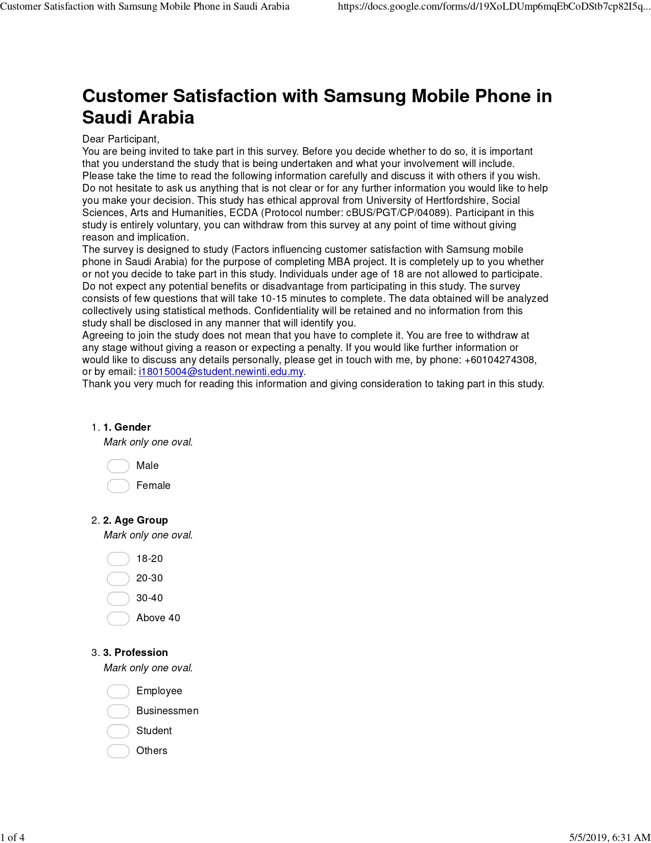

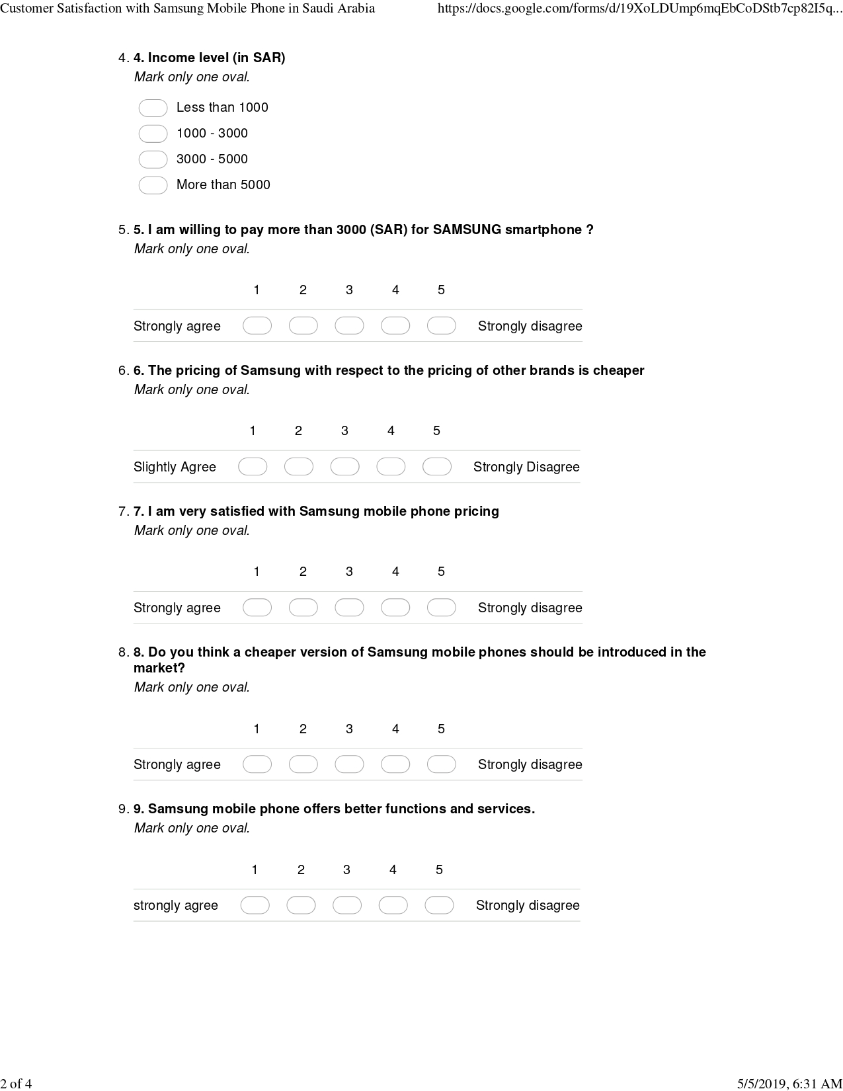

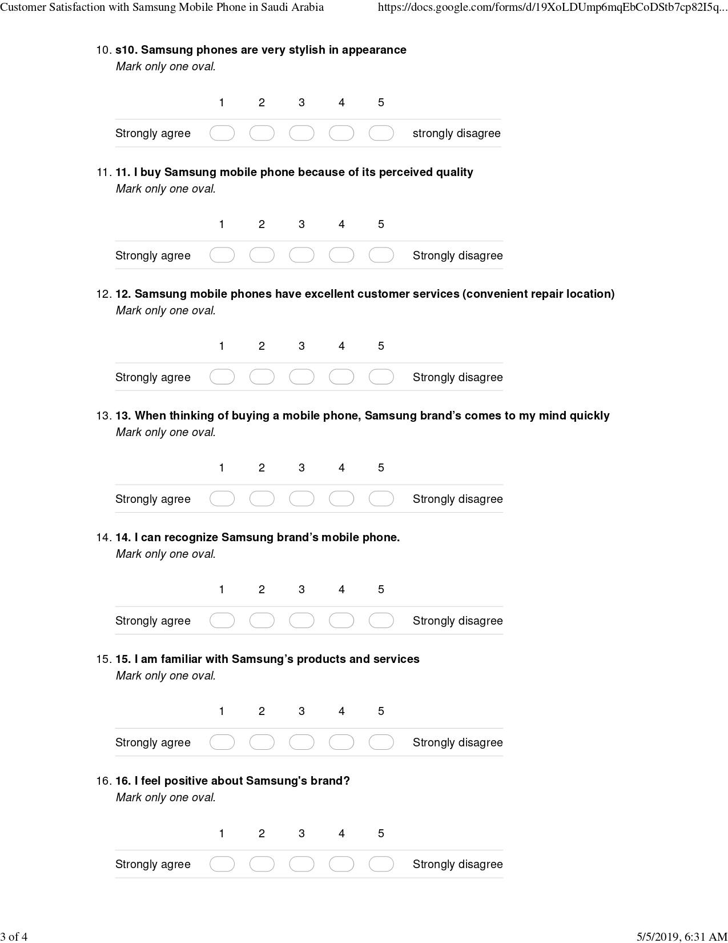

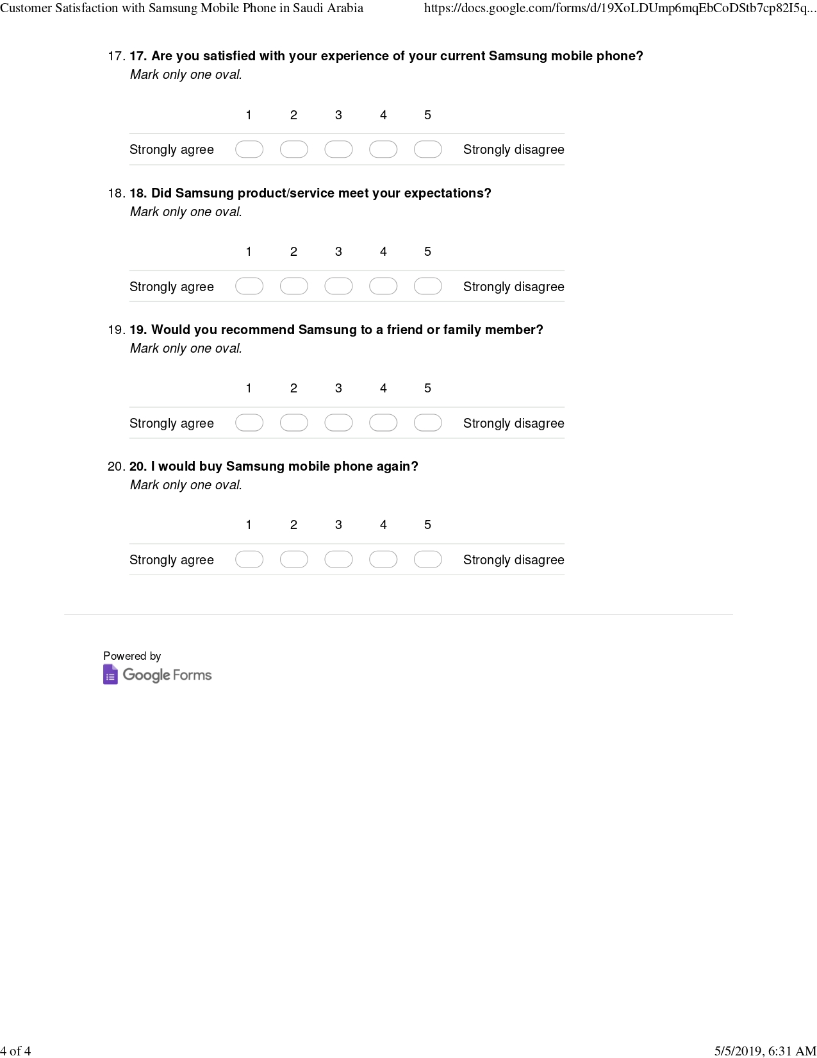

**Appendix 3 – MBA Project log**

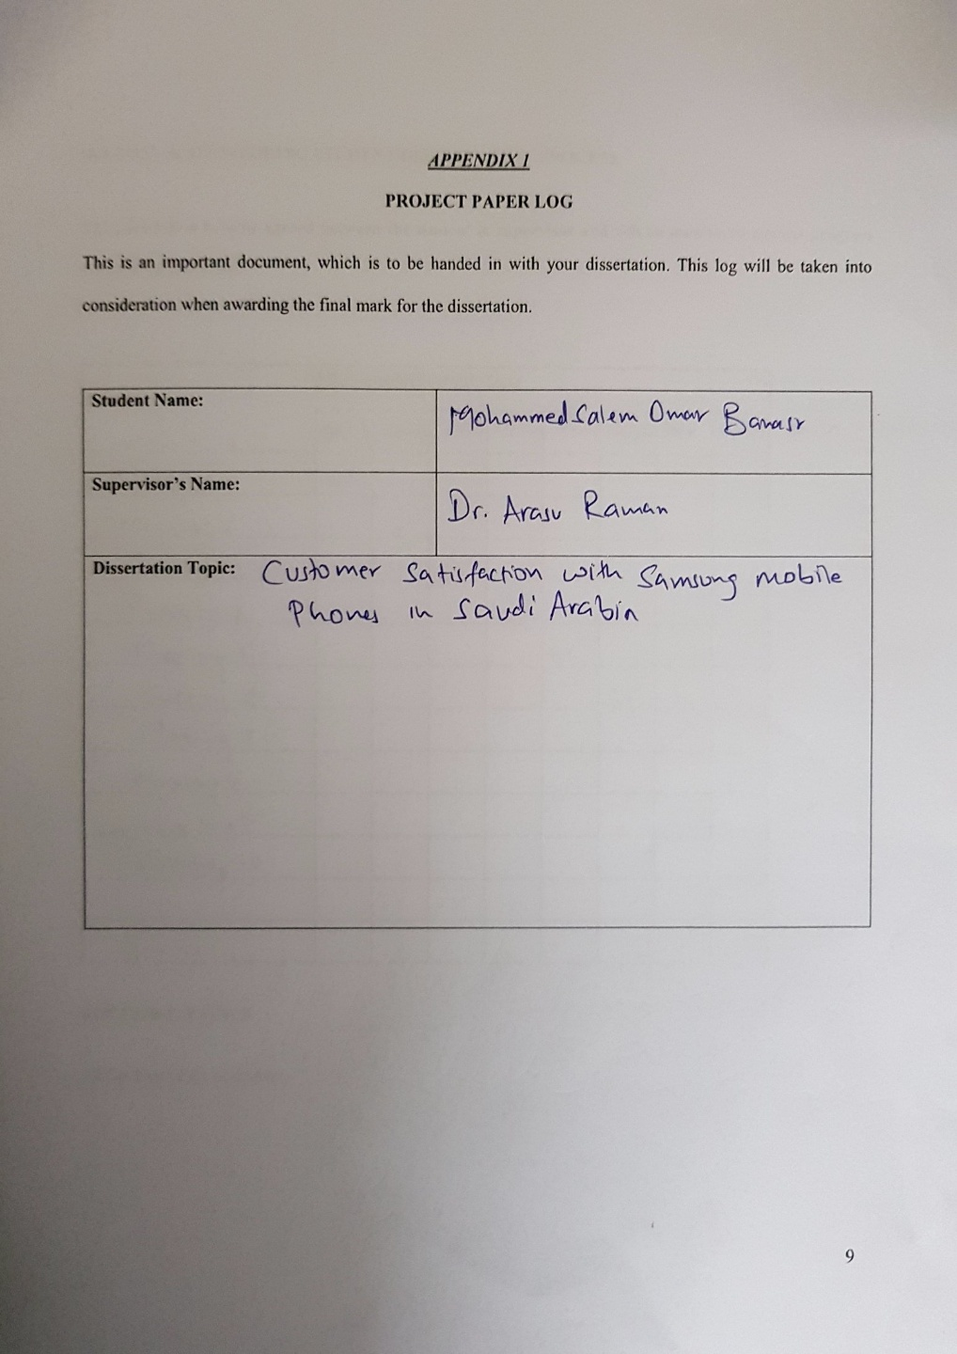



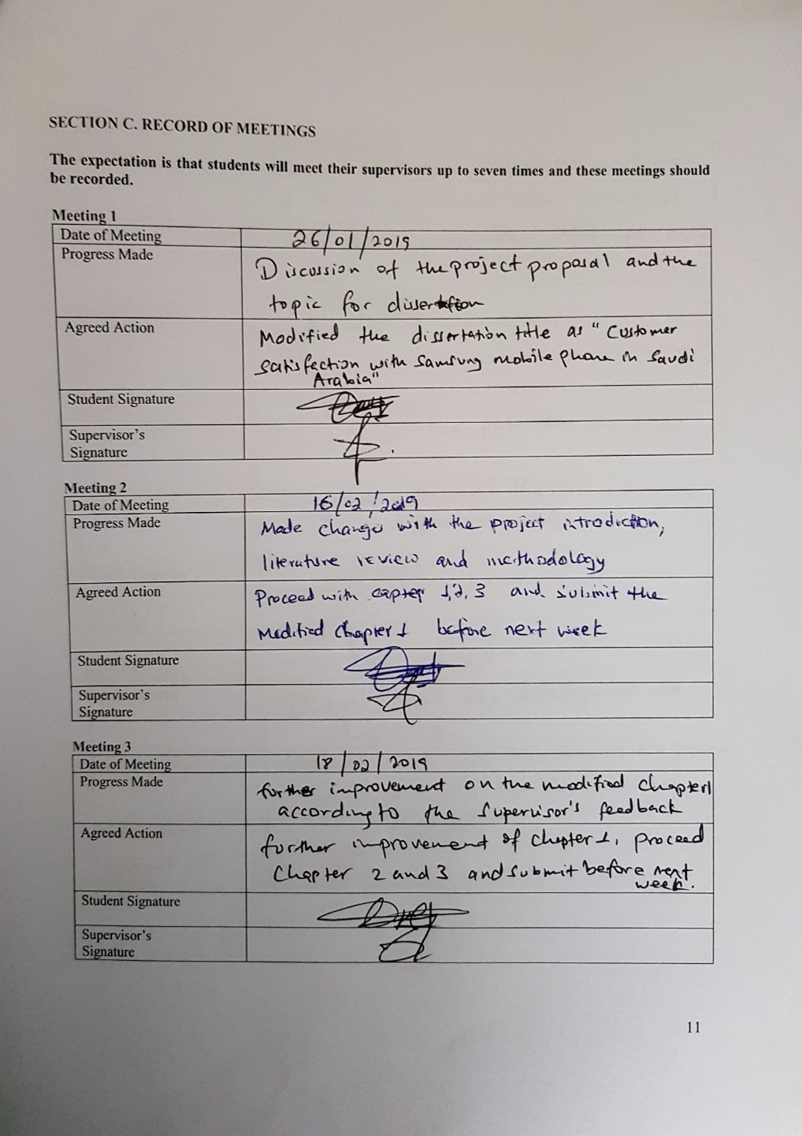

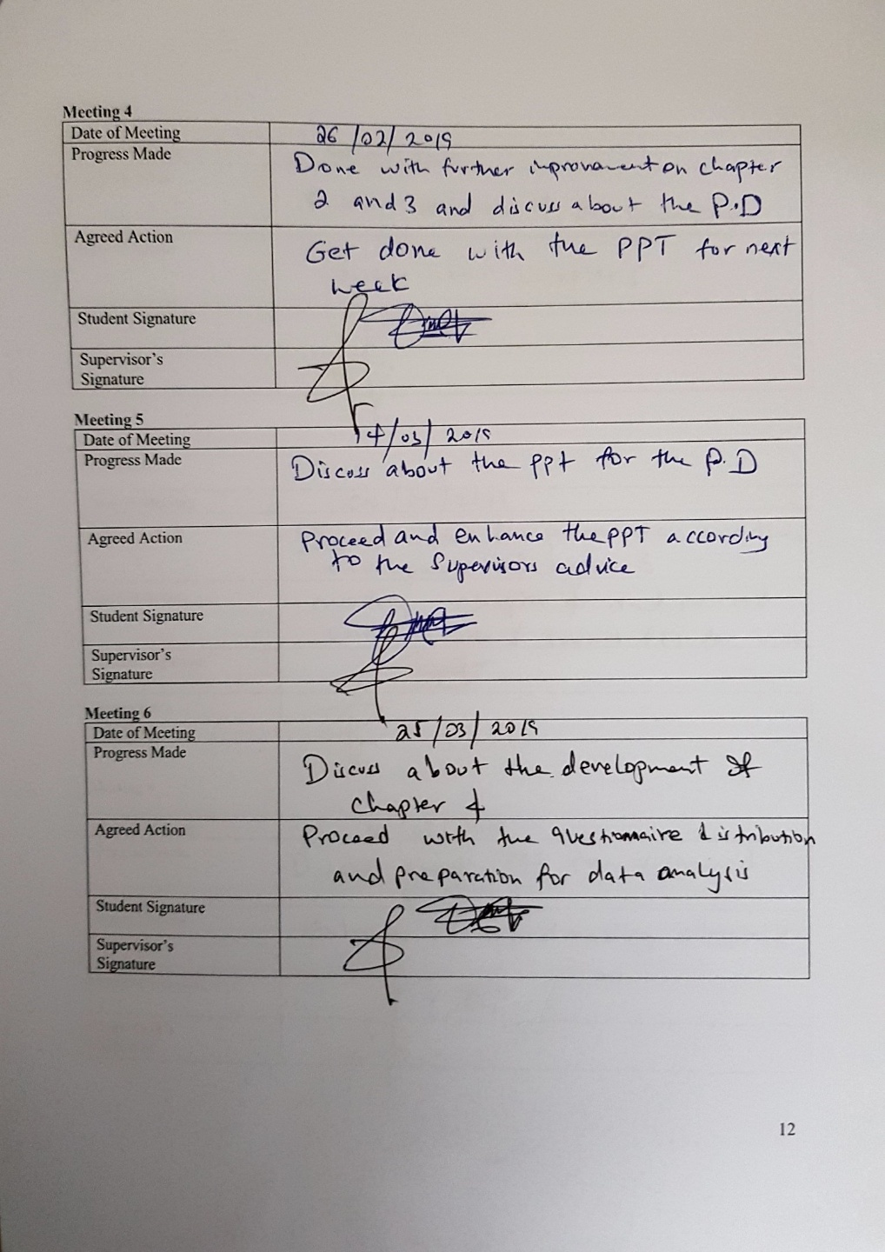

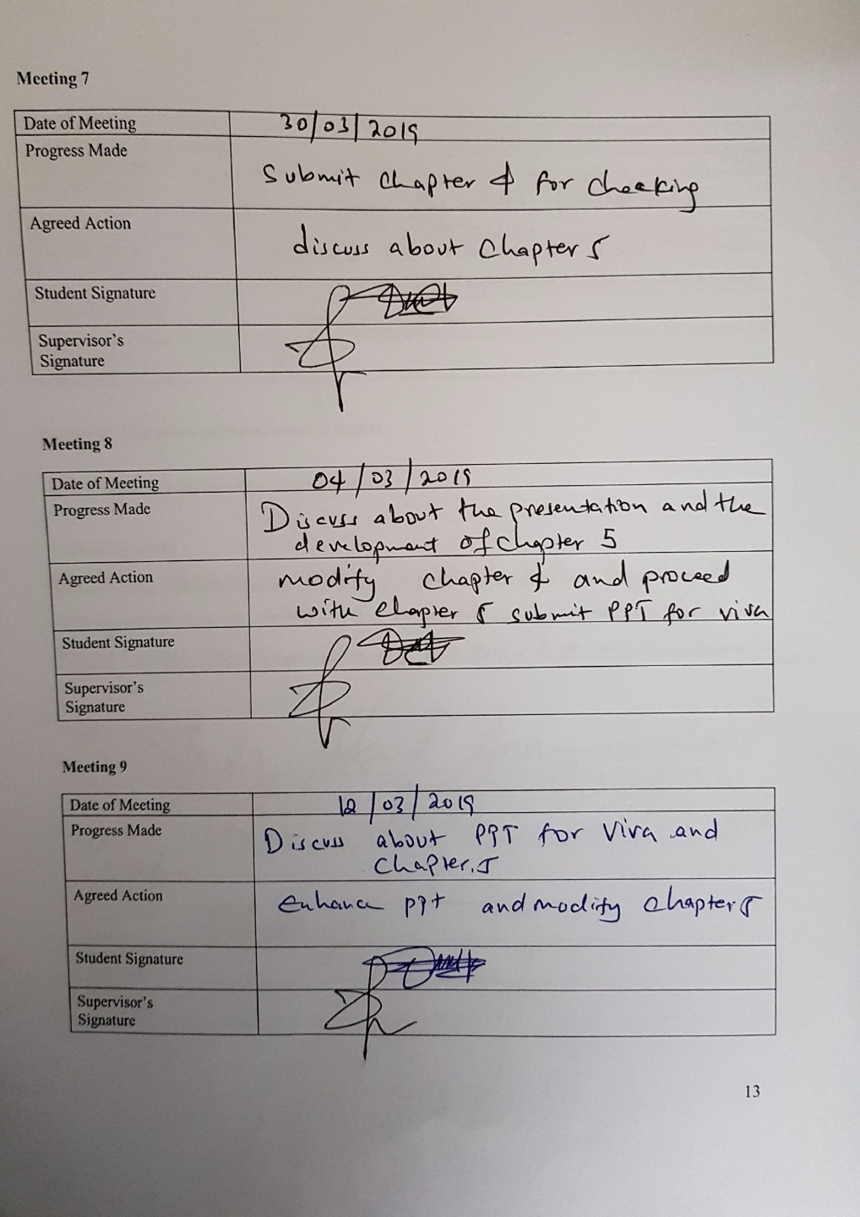

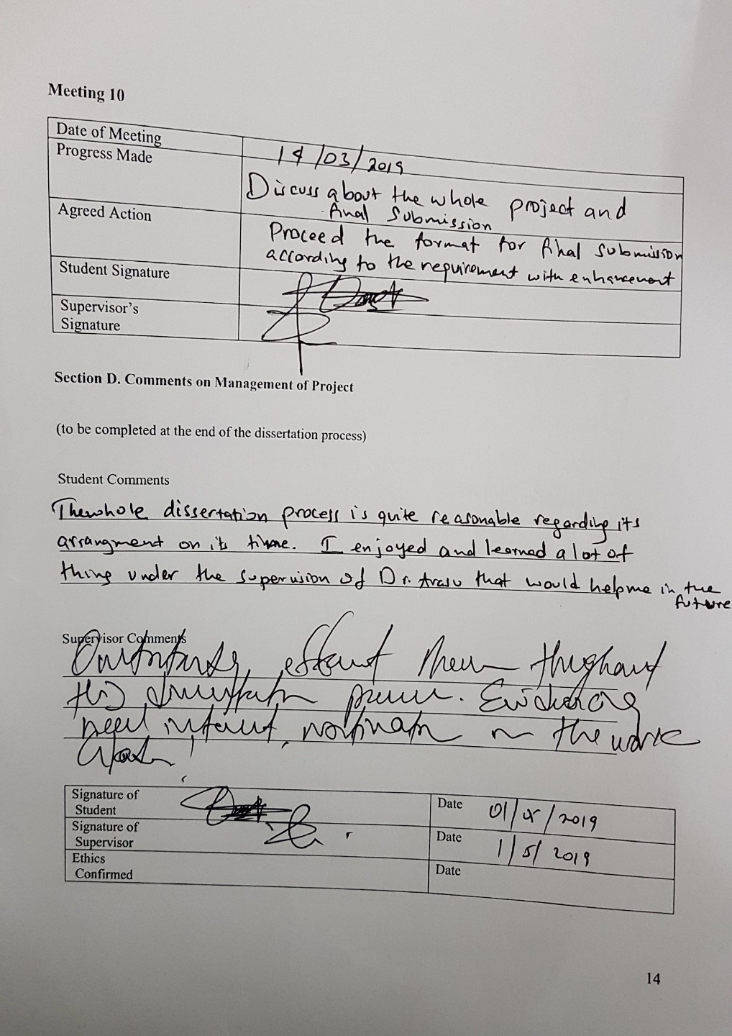**Appendix 4 – Ethics form approval**

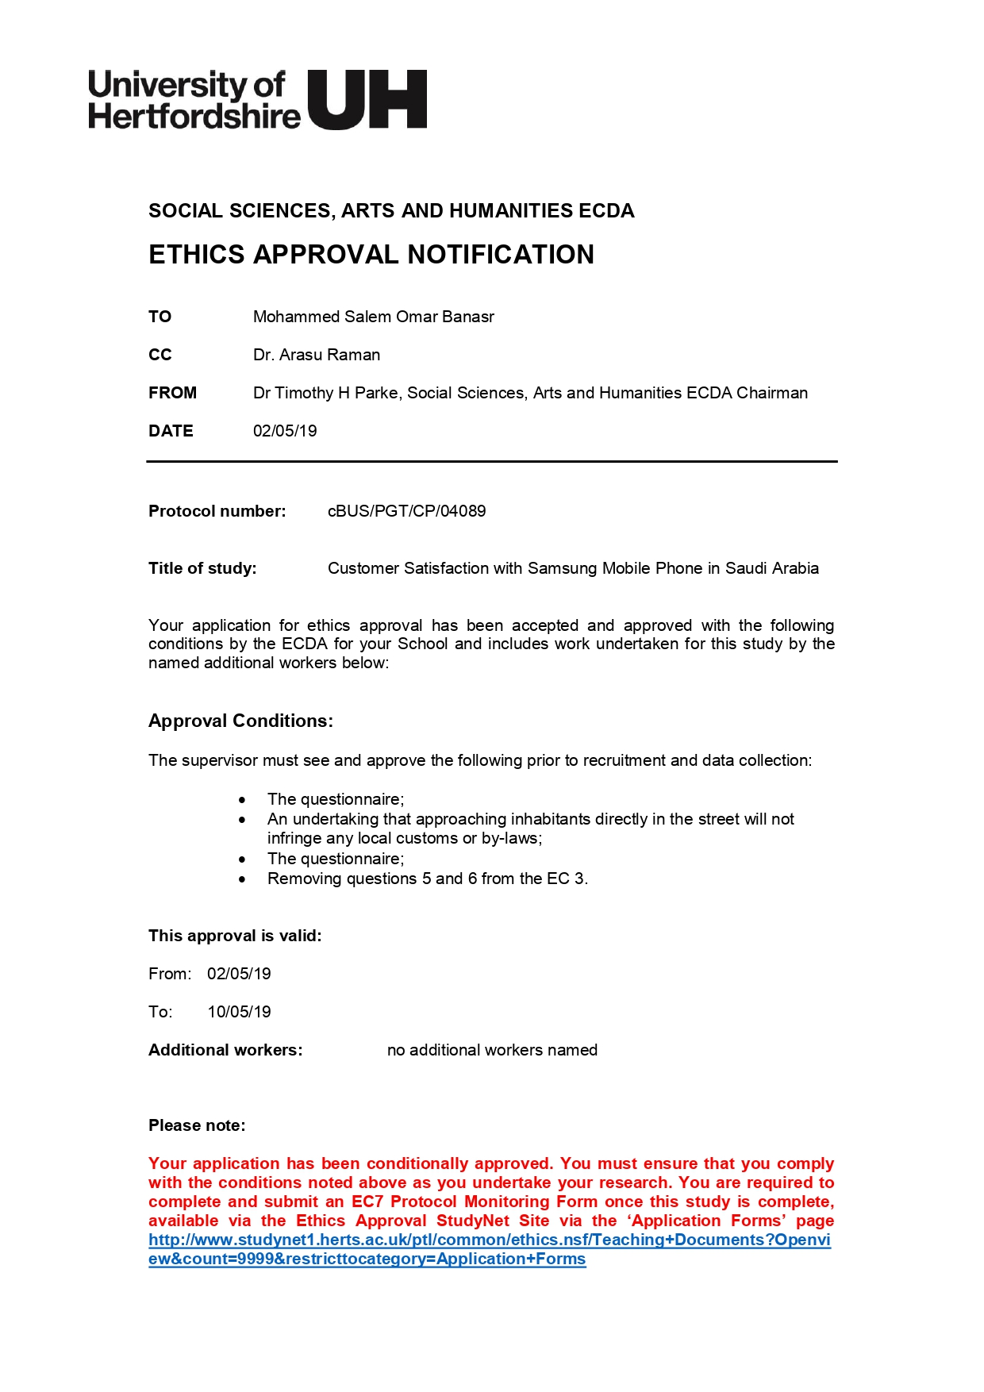

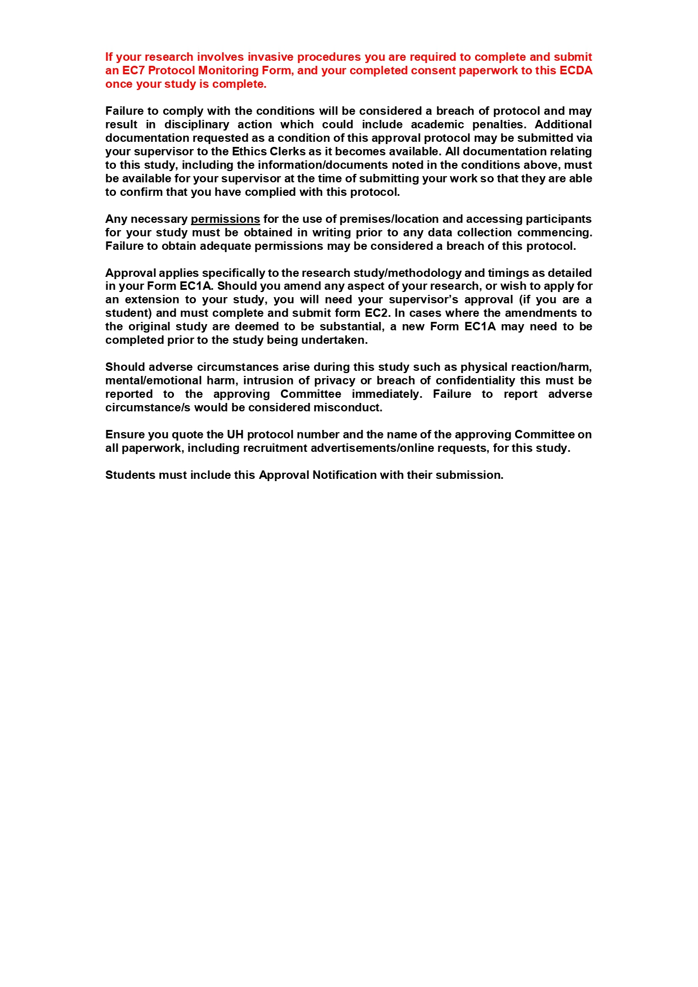

**Appendix 5 - Turnitin Report** 