
MASTER OF BUSINESS ADMINISTRATION
Module Name | MBA Project | Module Code |  | MGT7998
Module Leader | Dr. Syriac Nellikunnel Devasia |  | Individual Assignment  Title - Influences of Social Media Marketing on Purchase Intention in Food and Beverage Industry in Dhaka, Bangladesh
Student Name | Osama Mainul Islam Bhuiya | Student ID |  | I14005023  (Dual Award)
Student’s Declaration | I certify that this assignment is my own work and where materials have been used from published sources, they have been properly acknowledged. I understand I will receive a mark of 0% for this assignment and may receive further penalties if the content is found to be plagiarised.  Signed: ____________________________________________  Date: ______________________________________

Contents
Chapter 1 6
INTRODUCTION 6
1.0 Overview: 6
1.1 Background of Study: 6
1.2 Problem Statement: 7
1.3 Research Objectives: 8
1.4 Research Questions: 9
Chapter 2 10
LITERATURE REVIEW 10
2.0 Overview: 10
2.1 Purchase Intention: 10
2.1.1 Global Perspectives on Purchasing intentions: 11
2.1.2 Bangladesh’s Perspective of Purchase intention: 12
2.2 Factors influencing Purchase Intention: 14
2.2.1 Electronic Word of Mouth (eWOM) Communication: 14
2.2.2 Social Networking Sites: 16
2.2.3 Mobile Social Media Applications: 18
2.3 Gaps in Literature: 20
2.4 Theory of Reasoned Actions: 21
2.5 Theoretical Framework of Purchase Intention: 22
2.6 Hypotheses: 23
2.7 Conclusion: 23
Chapter 3 24
RESEARCH METHODOLOGY 24
3.0 Overview: 24
3.1 Summary of Research Design: 25
3.2 Questionnaire Design: 26
3.3 Measurement Table: 27
3.4 Conclusion: 28
Chapter 4 29
Data Analysis and Findings 29
4.0 Overview: 29
4.1 Pilot Testing: 29
4.1.1 Factor Analysis (for Pilot Testing): 29
4.1.2 Reliability Test – Cronbach Alpha 34
4.2 Respondents Demographic Profile: 34
4.3 Preliminary Analysis: 36
4.3.1 Factor Analysis 36
4.3.2 Reliability Test for Preliminary Analysis: 40
4.4 Hypotheses Testing: 40
4.4.1 Multiple Regression Table: 41
4.4.2 One-Way ANNOVA Table: 42
4.5 Summary of Findings: 43
4.6 Conclusion: 43
Chapter 5 45
Conclusion and Recommendations 45
5.0 Overview: 45
5.1 Summary: 45
5.2 Contribution: 46
5.2.1 Contribution to Industry 46
5.2.2 Contribution to Literature 46
5.3 Recommendation: 46
5.4 Limitations of Study: 47
5.5 Future Research Direction: 47
5.6 Conclusion: 48
5.7 Self-Reflection: 48
6.0 References: 49
7.0 Appendix: 56

Abstract:

The phenomenon of Social Media Marketing is becoming immensely common in Bangladesh, as businesses and service providers now have an effective method to advertise as well as achieve the business marketing objectives. This marketing strategy has shown its influence by creating restaurant and food purchase intentions by sharing of knowledge over the internet platform, even though this concept is still relatively new within the Bangladeshi food industry. Additionally, there is quite few academic researches that has been undertaken to observe and analyze the relationship between the aspects of social media marketing and purchase intention.
Thus, this research and study has been undertaken to close the gap by defining the factors of social media marketing along with purchase intention in the context of Dhaka, Bangladesh. The sub factors chosen as constructs of this research are electronic word-of-mouth (eWOM), social network sites (SNS) and social media applications. The depth of the research demonstrates related literatures and appropriate measurement models that relates to all chosen research variables. On the other hand, a self-administered questionnaire was distributed within mostly college students with science research requirements mentioned and correlation study design was applied for the research method. Serially, few statistical tests were initiated to assure reliability, validity and accuracy of the research.

Keywords: Purchase Intention, Social Media Marketing (SMM), Social Networking Sites (SNS), Electronic Word of Mouth (eWOM), Mobile Applications, Bangladesh.

Operations Definitions:
Sr. No | Keywords | Definitions
1 | Purchase Intention | Purchase intention is a type of decision-making that inspects reasons to buy a particular brand of product by an individual consumer (Akbariyeh, Mirabi and Tahmasebifard, 2015).
2 | Social Media Marketing (SMM) | Social Media Marketing is a method of change of process on how people and customers access information for sharing, writing and reading purposes (Giunta, 2018).
3 | Social Networking Sites (SNS) | These are services on the internet that allow individuals to construct a public or semi-public profile inside a system, creating a list of users that share connections and are able to analyse and navigate through the list of connections and of those created by others within the system (Ern, 2016).
4 | Electronic Word of Mouth (eWOM) | This refers to the dialogues and conversations happening through the online or internet platform for brands, products or services that is not commercially but interactively motivated (Baker, 2016)
5 | Mobile Applications | Also called mobile apps, it is a term used to describe Internet applications that run on smartphones and other mobile devices (Beal, 2018).
5 | F&B Industry | This is the Food and Beverage industry, and includes all organizations involved with preparing raw food materials, packaging, as well as the supply chain related around it. Additionally, it includes all kinds of beverages as well (Maras, 2015). However, in this study, F&B industry is mainly about restaurants and food delivery services.

Chapter 1

INTRODUCTION

1.0 Overview:
This research paper demonstrates a literature review of the purchase intention, an evolution of social media marketing along factors influencing purchase intention. The man objective of this research is to primarily investigate the aspects and factors influencing purchase intention using social media marketing techniques on food products and services purchasing. The study focuses on college and university students in gathering the primary data from self-administered questionnaires that will be further analyzed and studied upon in the following sections.

1.1 Background of Study:
The new era of media is taken over by the social media channels, as a new and innovative methods used by the marketers to market and advertise the products and services (Neti, 2011). This has made it a part of marketing method for organizations. Accompanied with upgraded technology, several businesses depend on social media to connect directly to involved consumers or to attract potential ones. In marketing perspectives, social media has turned out to be a better and a worthwhile marketing medium compared to traditional marketing strategies that has transformed the way in which consumers judge, choose as well as share information (Patino, Pitta, & Quinones, 2012). Moreover, social media helps geographically scattered group of people involved in social platforms and this had increasingly become a new market place for organizations, as social media made it convenient in sharing of information faster, easier and global (Akar and Topcu, 2011).
Even a decade back, businesses required massive and extended marketing budgets, campaigns and advertising investments, whereas, now a video posted online can create celebrities within a day (McCafferty, 2014). Communicating through social media platforms has formed a new batch of consumer socialization which has important significance on consumer’s purchase intentions (Cetina, Dumitrescu, Tichindelean, et al., 2013).

Among the organizations adapting to SMM, F&B industries are finding new and innovative ways to engage the customers with the business activity through using social media. Researcher done by Hajli (2014) stated that, the use of social media platforms in this technologically advanced-era is mostly dominated by generation Y consumer in the F&B industry.
Accordingly, studies identified that effects in social media allowing several F&B companies to depend on multiple media touch points in targeting to establish the brands (Poon, 2014). Advanced technological methods is allowing the F&B companies to explore new methods to develop better understanding of customer acquisition and potential retention (Dolan, 2013).
Furthermore, F&B companies use social media platforms to gather consumer feedback to improve the respective businesses (Saaid, 2013). F&B companies in the industry will be able to achieve competitive advantages through implementing social media as its marketing medium. In recent few years, the trend of using social media has dramatically increased by the current generation, as the result of advanced technologies (Halim, Krisnan and Perumal, 2017).
In recent studies, there are about 12 Million dynamic flexible web-dependent social networking accounts, mostly Facebook, in Bangladesh, which gives brands from all industries almost 25% of active internet population to transact with. Therefore, the digital revolution, with Social Media Marketing, is the main media with two-way primary correspondence to potential outcomes and customers, providing opportunities that are gigantic for brands (Bruhi, 2016).

1.2 Problem Statement:
For the perspective of Bangladesh, Business to Customer (B2C) websites have recently become quite popular for the growth of financial success of internet-based home delivery of food along with choices of restaurants and cafes, for instance namely FoodPanda and HungryNaki. This has come as a favorable circumstance to citizens of the capital, Dhaka, due to the high levels of traffic in major areas like Dhanmondi and Gulshan, at times when the residences would prefer to go out to dine.

Even though the fierce competition within local businesses and foreign-backed organizations in the B2C industry, 28 businesses in particular, the online-based food delivery business is anticipated to determine the future establishment of the B2C sector, the only inevitable aspect is the technology and its usage’s sustained growth (Chowdhury, 2016).
This study aims to prove that social media marketing along with social networking sites play a significant role in the life of employees, nuclear families and the students at universities and colleges. It is also seen that marketing communication and customer responses are immense in the highly technological-adopted markets.
However, in Bangladesh, there are very few works and studies that have been done to demonstrate this phenomenon (Akhtar, 2016). The people involved are at the forefront of this technological revolution and are more embracing towards its usages. Therefore, this particular research aims to reduce the gap by observing and analyzing the probable social media marketing factors that influence the purchase intention of consumers with regards to the Food and Beverage industry in Bangladesh.

1.3 Research Objectives:
Research objectives elaborates the main aim of the specific research and what can be expected to achieve from this research study (Tabachnick and Fidell, 2013). This descriptive research aspires to achieve the research objectives as follows:
RO1 : To determine whether SMM has a significant relationship with purchase intention towards food and beverage industry in Bangladesh.
RO1a : To determine whether eWOM has a significant relationship with purchase intention towards food and beverage industry in Bangladesh.
RO1b : To determine whether Social Networking Sites (SNS) has a significant relationship with purchase intention towards food and beverage industry in Bangladesh.
RO1c : To determine whether mobile applications has a significant relationship with purchase intention towards food and beverage industry in Bangladesh.

1.4 Research Questions:
Research Questions are prepared with intention to centralize and guide the study to achieve the intended research objectives (Tabachnick and Fidell, 2013). This research will try to answer the following research questions:
RQ1 : Does SMM have a significant relationship with purchase intention towards food and beverage industry in Bangladesh.
RQ1a : Does eWOM have a significant relationship with purchase intention towards food and beverage industry in Bangladesh.
RQ1b : Does SNS have a significant relationship with purchase intention towards food and beverage industry in Bangladesh.
RQ1c : Does mobile applications have a significant relationship with purchase intention towards food and beverage industry in Bangladesh.

Chapter 2

LITERATURE REVIEW

2.0 Overview:
This chapter reviews all the related existing literature on this research. The phenomenon discussed further in the chapter is purchase intention of consumers influenced by a few factors. In the beginning, the chapter defines purchase intention as the independent variable and discusses college students and working individuals as the target audience. It is then followed by extensive reviews and critiques of the development of social media marketing and a few of the factors that influence marketing done through social media, for instance using social network sites, electronic word of mouth and using mobile application in manipulating purchase intention. The last part of this chapter addresses the gaps found in the literature that is related to the research objective of this project.

2.1 Purchase Intention:
Consumer’s purchase intentions are one of the prime inputs that are used by marketing managers for the purpose of future forecast of sales and additionally to determine what actions to take which will effect the individual customers purchasing behavior (Morwitz, 2014). In case of online, purchase intention refers to the consumer’s willingness to be involved in an online transaction (Sien, 2015). In this era, marketers and marketing specialists require clear strategies within the complete understanding of what encourages the intention of consumers to repurchase a brand (Akbariyeh, Mirabi and Tahmasebifard, 2015).
Morwitz (2014) also discusses that, apart from marketers, managers also employ purchase intention measures to have a good understanding of what consumers will do in a marketplace, as it is a significant indicator of future consumer behavior, even though it is an imperfect indicator. This chapter further examines the global perspective as well as the perspectives of the location in topic, Dhaka, Bangladesh. Along with factors which as mentioned earlier, social networking sites, electronic word of mouth and mobile applications in depth as influences in purchasing intentions.
Impact of mobile eWOM trust on customer purchase intentions can be explained by addressing the literature on both mobile services and eWOM. Influence of willingness. Decision making. Interest Development.

2.1.1 Global Perspectives on Purchasing intentions:
There were numerous studies conducted (Anwar, Haque, Yasmin, et. al., 2015), regarding the country of origin, which essentially proved to be an important tool in the measurability of consumer behavior and overall international marketing. Thus, this phenomenon’s integral position and in-depth literature is valuable to the marketers, managers and for a business as a whole (Anwar, et. al., 2015). Another aspect is the phenomenon of globalization, this enhances the exchange of information, technology, goods and services among the different people in different countries, communities and cultures (Latif, Rana and Rehman, 2018). It is also discussed by Rashid, Younus and Zia (2015), that the reduction of international trade barriers, flexible international trade agreements between countries and nations, advancements in information technology and transportation technologies has made it more convenient with communication and to be connected with the whole world. Along with this there are few other factors just as significant and influence on consumer’s purchase intention worldwide (Rashid, et. al., 2015).
In the aspect of globalization, companies are usually unaware of specific country’s regulations, legal requirements, cultural norms, availability of products to local tastes and the purchasing behavior of its citizens. Thus, now companies are trying to focus more towards the individuals of different cultures and nations, as well as researchers are putting more interest in studying concepts of culture to help companies in strategizing to target more foreign consumers (Latif, et. al., 2018). As mentioned earlier, advancements in technology has enhanced and influenced individuals purchase intention greatly, the raising number of personal wireless devices with internet connections are assisting in social networking sites and applications to grow vastly all over the world and has a greater effect on the young and upcoming generation of people (Khan and Mehmood, 2011).
In other words, Social media substantially influences in the overall consumers decision making within the aspects of sharing information, increasing awareness, forming attitudes and opinions, purchasing as well as post-purchase experience evaluation (Rudro, 2017).
Khan and Mehmood (2011) further discusses that social media and networking sites are mostly used by young generation individuals, with a research finding that young adults spend about 30 minutes of daily activity in using Facebook. The same is not the case for older generation of people, specially ages 55 and above, thus, the social media penetration is less for older age groups.
In the case of Food and Beverage industry, social media became an inseparable element of out-going people all over the world. Out-goers constantly post pictures of the activities and objects and of the places visited and utilized, which is used as an advantage of marketers in this industry, specifically restaurants. People don’t tell each other about new places and foods, instead just post pictures or provide reviews of the judgements, which proves to be a deciding factor for others who are attracted or willing to visit the place or eat the food (Rudro, 2017).
Even though television commercials are still the most dominating source of advertisement and marketing of food products, however the food businesses are now concentrating more on digital marketing opportunities, as more consumers are spending majority of the time online. This type of marketing includes advertising through the medium of by placement of ads in popular websites specifically within differentiated demographics group, promoting through food product branded website, through mobile device applications and popular social media sites (Arshonsky, Bragg and Eby 2017).
A recent report revealed by Food and beverage industry executives from Philippines that nearly half (49 percent) of promotion contribution comes from social media, which is the main method of attracting and retaining customers, while print advertising has 46 percent. Other digital media elements are online advertising, email, search engines as well as digital coupons are also implemented to engross customers for the convenience of purchasing and gathering information. However, to go in depth, shopping grocery through online has a lower market penetration rate at only 1 percent in the Philippines, which is similar to some other Asean countries except for Singapore. The highest online penetration for packaged foods is South Korea in Asia with almost 51 percent fresh produce (Siguebisnar, 2017).

2.1.2 Bangladesh’s Perspective of Purchase intention:
Social media platforms are implemented to reduce management administrative costs along with processing cycle time, streaming of business activities, and upgrading the relationships of both business partners and customers. Various studies including Rahman (2016) closely examines the aspects influencing consumer’s perception and attitudes to make social media product or service purchases using online shopping mediums.
The attitudes of online shopping could be defined as either a consumer’s positive or a negative feeling related to establishing the purchasing intention and behavior online (Rahman, 2016).
One of the factors mentioned above, is perceived value factor of purchase intention which implies the relationship between product and consumers, the ultimate conclusion is that the higher the perceived value, the higher the intention to purchase, this higher perceived value enhances and influences purchase decision. The perceived value of a product has two dimensions that are tangible and intangible (Rashid, et. al., 2015).
Ern (2016) suggestes that publicizing and advertising using social media marketing strategies indeed directly shape up college student consumer’s purchasing behavior and intention specifically, however, the majority of the success of social media marketing goes hand in hand with the right publicity messages that are posted on social media platforms. The branding credibility of the organizations also the ability of the organizations to enlighten and build long term consumer purchasing intention and attitude. Also, social media marketing has to be equipped with customer-generated contents to maximize the efforts to influence the purchase intention (Del Buono, 2015).
The key is to enable consumers to engage at such a particular level that they want to know more about the brand and products through the social media platform. Also, when consumers have a higher perceived quality or benefit over specific product or services from the social media platform, this mostly is positive significance over the emotional value perception which leads to stronger purchase intention (Ern, 2016). If the method is used accurately, social media marketing can help organizations in gathering powerful intention and data on the lifestyle and eventually drive and create more meaningful connections (Bosselman, Mayfield and Tang,2014).
The use of social media platforms in Bangladesh for the use of commercial purposes is still in a developing stage. Business to consumers (B2C) social media is effectively more routine in Bangladesh, and a very limited activity level of Business to Business (B2B) is conducted. However, progression in Bangladesh is rapid in development of both information and internet communication technologies (Howladar and Islam, 2012).

In a wholesome perspective, in today’s world, every 60 seconds on Facebook 510,000 comments are posted, 293,000 statuses are updated, and 136,000 photos are uploaded, every day. On average, Google processes over 40,000 search queries every second, which interprets to over 3.5 billion searches per day and every minute, on Twitter over 350,000 tweets, which is over 500 million tweets tweeted per day and roughly around 200 billion tweets done per year. In the case of Bangladesh, the capital city Dhaka, is in the top three most densely populated city in the world, with around 23,234 people living per square kms area, was ranked second in terms of the most active Facebook users in the whole world, based on a recent research. The country has a population of 164 million people, among which around 63.3 million are internet users. And among those 63.3 million users, 26 million people are highly active social media users (Rudro, 2017).

2.2 Factors influencing Purchase Intention:

2.2.1 Electronic Word of Mouth (eWOM) Communication:
The landscape of traditional marketing techniques has been influenced through social media. Even though the structures of the marketing techniques are the same, the social media is assisting in development of both customers (individuals) and companies to create better and more potential relationships as well as help in retaining customers (Ern, 2016). As mentioned earlier, the social media phenomenon contributes massively to consumer decision making mentality and process, influencing the overall awareness, opinion forming capabilities, attitudes, along with purchase and post-purchase evaluating experience (Rudro, 2017).
Studies have found that on an average, 2.4 billion daily conversations take place within the social media platforms, that involves a brand-name, this triggered marketing managers in starting to invest time and money heavily in methods to directly influence, observe and understand consumers word-of-mouth patterns through the internet. In recent times, more and more companies are starting to use social media applications platforms to gather both positive and negative information and mentions regarding the products and services and also to be involved with the respective target customer audience (Ern, 2016).

Thus, Electronic Word of Mouth (eWOM) is now becoming an influential marketing tool, mainly because internet is the preeminent cost-effective instrument of dissemination of information about products and services (Shah, Xiangbin and Zhai, 2018). Through the help of using Internet, interpersonal communication of WOM about products and services are increasing and can reach to the consumers in all corners of the world, in simple, anyone can easily have access to the shared opinions and information provided by individuals who are living far away, on different countries. Additionally, eWOM allows the social interactions between different consumers, where they conveniently receive product-related information and express own opinions (Wensi, 2017). This type of discussion creates “oppositional loyalty”. This loyalty encourages consumers of a product to perceive the competitor’s products in a negative mentality, limiting the consumer from using the competitor’s products and keeps other business from entering the particular market (Rudro, 2017).
eWOM is a model on how new methods shapes traditional WOM and eWOM, this is no longer a face to face system whereas now it is presented in a highly structured format and tends to be parallel. In other words, eWOM concept can be shown as an online dialogue between consumers if there is a common element between the consumers. However, in the case of applying to business context, eWOM is defined as an effect of electronic commerce through consumer-generated images, reviews and tags which serve as a source of value and information for other consumers who are potential buyers or spending decision makers (Ern, 2016). This factor is now becoming tremendously popular in China and the development in eWOM in China is a result of the boost of Chinese Internet users.
Towards the end of 2016, the Internet users in China was around 731 million, with a penetration rate of 53.2%. So, the previous studies conclude that Chinese people are more likely to be influenced by eWOM, compared to consumers in other countries (Wensi, 2017).
Moreover, eWOM has been widely observed as a trustworthy mechanism of customer’s purchasing decision when compared to other communication tools and channels. These communication methods are believed to more gain competitive advantage and more loyal customers (Ern, 2016). At a later stage. the usage of eWOM further established into “co-creation” and “crowd sourcing” marketing tools to gather inputs and feedbacks that have a higher emotional content and are more credible, in the case of emotions being closely linked to a natural instinct of individual spending (Keller, 2012).
The keywords that would be used to analyze this variable in depth would be Quality relevance, which is defined as the extent to which the advertisement and messages are useful and applicable in decision making. Quality Accuracy is the reliability of arguments and messages done online through eWOM and online reviews and shows the perception of the customers towards a product or service (Cheung and Thadani 2012). To understand the customers perception on overall quality and superiority of products and services, Perceived quality is taken into consideration. Consumers perceive highly advertised products to having higher quality and associate them with brands (Schivinski and Dabrowski 2015).
In the perspective of comparison, WOM the ability to create greater significance offline to eWOM which remains more challenging as more accurate, detailed and rich information are usually transmitted using verbal cues (Baker, 2016). Thus, combining with customer traits like context specific marketing and brand loyalty will hence influence eWOM’s final effect on consumer purchase intensions. As a result, using eWOM with a careful management approach of branding attitude, through the social media platform, will establish increased purchase intension within a short period of time. Whereas if managed inappropriately, it will result in a deterioration of brand name along with negative purchase intensions (Mueller and Wolny, 2015).

2.2.2 Social Networking Sites:
Facebook and LinkedIn are the prime examples of Social Network Sites (SN), has integrated into the daily lives and commonly used by organizations to customize and modify the target market size and demographic of population, depending on the respective needs and products (Ern, 2016). In other terms, SNS is defined as web-based platform that provides means for consumers to interact using social links, through the means of a profile (Jackson and Wang, 2013). The complexity of creating businesses with the medium of SNS has increased and starting to be particularly challenging for traditional businesses to start taking initiatives towards e-business (Ern, 2016).
Social media’s ability to customize its target market has proven in measuring purchase intension more effectively through engagement metrics built within SNS (VanAuken, 2015).
Analyzing customer responses using the like, comment and share features has enhanced two ways communication from consumer to organization, therefore enabling businesses to understand topics, posts or contents that are constructed over social media platforms making it more effective in raising purchase intentions (Guesalaga, 2016). Moreover, the features of likes, comments and shares are observed to be as behavioral intentions, which easily enables organizations to analyze the emotional as well as intentions of customers more accurately (Pederson and Solem, 2016).
Additionally, SNS also enables organizations to establish and derive more effective content strategies that creates more viral effects which is faster than traditional platforms, in this aspect content can be modified in a more fresh, authentic, visual and relevant contexts and can be cross-utilized with one and another within SNSs (VanAuken, 2015).
Besides, SNS facilitates conversations among organizations and customers just before a purchase is confirmed. Utilizing SNS to achieve social strategies has made organizations more manageable in converting purchase intentions towards actual sales. Ern (2016), also explains that these conversations lead to deeper understanding of an organization’s brand, which creates purchase intention as well as brand love, as the willingness to endorse the particular brand through the interactions in platforms such as SNS is done.
To explain Social Network Sites in depth, some keywords have been taken into account, these start off with sharing the knowledge, this is done through interactions and communication within consumers about certain products and services. This also serves the purpose of knowing how satisfied customers are with the products or services by analyzing their reviews and discussion about the particular items. These interactions within the online communities bring up the interests of consumers through politics, activities, foods and other services and products. This helps each other with educational purposes as well as helps share experience, along with influencing their purchase intentions (Hussain, Husnain and Toor, 2017).
As SNSs are merely platforms that help in facilitating creative social media strategies to establish and promote purchase intentions, however, VanAuken (2015) argued that the actual foundation of purchase intention is still under other contributing factors such as a solid brand strategy and the ability of organizations to create emotional commitment and brand love in regard to the organization’s product or services. Kozinets (2014) suggests that only in successful co-creation of content in SNS by organizations as well as customers, will lead to effective sharing of information regarding brand, better communication of the products or services and will eventually lead to purchase intention.
SNS’s ability to leverage on visuals for instance, short videos in YouTube could create value strategies that could effectively lead to purchase intention, whereas potential purchase behaviour depends on the momentum of organizations in utilizing the SNS factor (Ern, 2016).

2.2.3 Mobile Social Media Applications:
Mobile applications, with the abbreviation of the word “app” is a raising and spreading phenomenon, where the mobility platform gathers attention of organizations to promote connections and services for individuals or customers (Ern, 2016). Wozniak (2013) defines mobile applications as just a piece of software which operates in the presence of Internet, either on a computer or any individual mobile devices. Social media platforms have embraced its usefulness specifically to business organizations, when social media continue to expand its operations and functions, from generic SNSs interaction features and automatic answering to co-creation of user-self services functions, which if applied properly, can create synergies in the existing marketing strategies (Wu, 2016).
Facebook is one of the most popular household names in the commercial and marketing world. Towards the end of 2016, Facebook had a total number of 1.86 billion monthly active users. As the leader of market for internet users, Facebook has a usage penetration of above 80% currently.
Furthermore, the active users can also join different user groups depending on the school, college, workplace, whereas Facebook can categorize the respective contacts into the list. Additionally, the users can collaborate and connect with the wide options of social games on Facebook as well as on the photo sharing application like Instagram (Timilsina, 2017). Moreover, Facebook’s vice president of small business/enterprises, Dan Levy has said that paid advertisement facility of Facebook has become comparatively effective and it’s better if the companies could put effort to the respective Facebook pages in order to grow the business and boost marketing (Albergotti Janofsky and, Loten, 2014).
Another increasingly popular application is Instagram this allows its users to take photo and share it among the followers and also with other social sites like Facebook, which owns Instagram. The main feature of Instagram is the fact that the user can choose a picture and modify it into some admirable beautiful image and make it more fancier according to self-desire and taste (Timilsina, 2017). Instagram was launched in 2010 and was initially made available just to the iPhone users. However, another Android version was launched in 2011 and the popularity started sky-rocketing between July 2011 and July 2012, where the user of Instagram rose by 17.319%, resulting to an extraordinary growth and trend in the history of social media (Currid, 2013).
Ern (2016) did testify that the implications of mobile marketing will at first create brand attitude as well as brand equity which will eventually establish positive purchase intention among consumers. Additionally, a few other reasons to tap into a solid social media marketing strategy compared to the traditional ones, which are – boost up traffic numbers, facilitation in natural discovery of new content, building strong relationships, along with utilizing a cheap alternative to the traditional marketing strategy (Lee, 2013).
Globally around 3.6 billion people are busy operating smartphones. Almost about 75% and 70% of revenues of Facebook and Twitter respectively is earned from advertising in mobile applications. Mobile technologies have allowed consumers to explore, discover, purchase, and engage with products and services anytime, anywhere. It was calculated that by 2018, such a seamless and convenient digital experience with just finger tap will influence around $2.2 trillion within brick-and-mortar sales (Fang, Fong and Luo, 2015).
Apart from this, in the phase of the new marketing era, bringing alive a brand depends solely upon the ability of its engagement within communities, thus, as a result if a particular company is actually paying attention to the members of the community and society, a strong relationship will be allowed to be built upon observing time in responding to concerns and feedbacks (Lee, 2013).
The keywords used for Mobile Social Media Applications are as follows: Perceived Ease of use, this reflects the belief that consumers are able to make use of a product or service rather conveniently and easily. Another one is Perceived Usefulness which is when a person believes in the use of a particular system, and the value they put in the process of that activity. This also brings up the question of trust with the usefulness of the system and the products and services it offers. After all these the enjoyment, joy and satisfaction has to be taken into consideration. The pleasure, trust and belief that consumers get out of using the system and the process of getting the products and services (Kian et al., 2019)

As more and more consumers are engrossed with smartphones, marketing strategies are being introduced and embracing to an unprecedented time of ubiquitous target marketing opportunities through the help of mobile phones. Advertising and branding managers can depend on mobile technologies and applications more efficiently in order to enhance business’s work performance by having a better understanding of the innovative, connected, nonlinear consumer journey and contextual marketing environment which considers elements like location, time, weather, and competition, giving a combination of physical and digital consumer experience (Fang, Fong and Luo, 2015).

2.3 Gaps in Literature:
Howladar and Islam (2012) mentions that the commercial use of internet in Bangladesh is quite limited and is a few years away to undertake and adopt the main channels of e-commerce applications. B2C or Business to Consumers e-commerce is comparatively less in Bangladesh, along with B2B or Business to Business, this is in respect to the amount of population in the country. Hence, just like other developing as well as under developed nations, Bangladesh is missing out in reaping the full benefits of a rapidly developing e-commerce and social media phenomenon; this is mainly due to: a) several innovation, consumer’s personality and attitude related, social and other technical challenges, b) lack of trust on secure electronic transaction of the local currency, c) national level and public key infrastructure does not exist, and d) not complying with legal issues (Howladar, et. al., 2012).
Social media is now the most dominant tool for all types of business for ultimate marketing and sales. The feedbacks received from social media platforms could be effectively used to upgrade business plans, structures, and processes and make changes towards the desire of loyal customers.
However, receive positive feedbacks are not always received and on the other hand, negative comments from social sites often hampers businesses processes as well as the image (Lee, 2013). In the case of Bangladesh, working class people are the major portion of the population and have restricted access to ICT and overall internet services.
Whereas, the high income and educated people who are the dominant batch of customers engrossed in online shopping, lives in major towns or the capital, Dhaka, in Bangladesh where network infrastructure is comparatively upgraded (Howladar, et. al., 2012).
Since literature is limited related to customer’s attitude towards online food and beverage shopping in Dhaka, Bangladesh, with the mentioned objectives of this research, this paper is an endeavor to alleviate the research gap in this regard. Therefore, data found on the usage of social media in regard to purchase intention on food and beverage products and services in Dhaka, Bangladesh, is currently limited depending on the literature searches done thus far. Therefore, as this study aims to provide the information to make sure whether social media marketing will have a relationship with the purchase intention of consumers with regards to the food and beverage products and services in Dhaka, Bangladesh, so the study would help to enhance and develop the knowledge and understanding of social media marketing for the industry stated.

2.4 Theory of Reasoned Actions:
The Theory of Reasoned Actions (TRA) demonstrates consumer behavior by proposing that individual’s purchasing behavior are logical and is primarily influenced by social factors and undertake a purchasing behavior by accessing to the information that is available (Ern, 2016). TRA is an upgrade of the previously used model of Theory of Attitude, which was used as a theory of understanding specific persuasive messages (Kapexhiu, 2015).
The model of TRA also has numerous potential benefits for forcasting the intention to perform a behavior relying on an individual’s normative and attitudinal beliefs. Ern (2016) also confirmed that the TRA model has been popularly used to assess consumer behavior resulting from voluntary encouragement and this is particularly useful to judge small and medium sized businesses when business decisions turn to concentrate near small domains and smaller groups of individuals (Ackermann and Palmer, 2014).
TRA also states that consumers intention to embark upon some action is a direct result of the attitude and of social norms (Ern, 2016). In other words, it displays the intention to perform particular behavior, known as behavioral intention, which contributes massively towards the actual behavior.
However, TRA evaluates two important variables that influences behavioral intention, commonly known as a subjective norm and the attitude towards behavior (Southey, 2011).
Attitudes as defined by Ern (2016) can be either positive or negative as an outcome of the behavior and how famously the outcome is perceived to be, whereas the subjective norms refer to the individual customer’s perception, which can be influenced by social pressure on whether a behavior is relevant or not.
It can also be held that, TRA is formed depending on the underlying assumption, where by consumers or individuals behave in a logical and understandable manner while intaking information available, trying to make agreeable results while meeting the expectations of others (Kim, 2010). While TRA attempt to observe how attitudes are formed and why such attitudes alter on how customers or individuals behaves, this theory, in an overall perspective is suitable to be used as a base theory in explaining the behavioral attitudes in a decision-making process. (Andrew, 2015). Ern (2016) also assesses the relationship of TRA with purchasing intention and shows the positive results, thus, TRA can also be applied in evaluating the theoretical framework for this study.

2.5 Theoretical Framework of Purchase Intention:
The theoretical framework of this research is shown as follows:
INDEPENDENT VARIABLES (IV)
Social Media Marketing (SMM)
- Electronic Word of Mouth (eWOM)
- Social Networking Sites (SNS)
- Mobile Social Media Applications

DEPENDENT VARIABLE
(DV)
Purchase Intention of Food and beverage products and services in Dhaka, Bangladesh

Figure 1.0 Theoretical Framework
The Dependent Variable (DV) of this study is the Purchase intention of food and beverage products and services in Dhaka, Bangladesh.
The Independent Variables (IVs) is only Social Media Marketing (SMM), but the focus will be given on 3 factors/dimensions:
1) Electronic Word of Mouth (eWOM)
2) Social Networking Sites (SNS)
3) Mobile Social Media Applications

2.6 Hypotheses:
This research study was conducted to find out the relationship of independent variables, which are eWOM, SNSs and mobile application with the dependent variable, which is purchase intension for Food and Beverage products in Dhaka, Bangladesh. In this research, the hypotheses were defined as below:
H1: There is a significant relationship between electronic Word-of-Mouth (eWOM) and purchase intention of Food and Beverage products in Dhaka, Bangladesh.
H2: There is a significant relationship between Social Network Sites (SNS) and purchase intention of Food and Beverage products in Dhaka, Bangladesh.
H3: There is a significant relationship between mobile social media applications and purchase intention of Food and Beverage products in Dhaka, Bangladesh.

2.7 Conclusion:
This chapter is a review and assessment of the important existing literature, where the chapter began with a global and local perspective of Purchase intention, followed with the key factors that interest and influence purchase intentions and decisions which are primarily Electronic Word of Mouth (eWOM), Social Networking Sites (SNS), and Mobile social media applications. Apart from the existing Literature, gaps were also analyzed. Along with a discussion about Theory of Reasoned Actions (TRA) as the fundamental grounded theory, supported by the conceptual framework of purchase intention and the Hypotheses carried out in this research.

Chapter 3

RESEARCH METHODOLOGY

3.0 Overview:
This chapter focuses on the research methodology and is explored with detailed discussion on research design, questionnaire design and the measurement table, mainly to ensure the alignment of structure provided in Chapter 2. Additionally, this chapter will also demonstrate the data analysis and the statistical tools implemented in the data collection. Moreover, a summary of the findings would be provided at the end based on the findings (if any) within this chapter, following it would be a preliminary explanation for the next chapter.

3.1 Summary of Research Design:
Purpose of the Study
Types of investigation
It is establishing correlation design, to determine whether there exists a relationship within context
Extent of researcher interference
Minimal: as it studies the events as it occurs. Distributing questionnaire with less interference.
Study Setting
Non-Contrived (because not manipulating environment in which research is conducted)
Measure-ment and Measures
Please refer to the measurement table

Data Analysis
PROBL E M

S T A T EM E N T
This study aims in describing the phenomenon and verifying the models in different context

Not running Data Analysis until Chapter 4. Data Analysis would be based on measurement table

Data Collection Method
Time Horizon
Sampling Design
Unit of Analysis

Please refer to questionnaire design table
Cross Sectional because data collection is from respondents is only one time.
1) Types -Non-probability convenient sampling – can give to friends and project to be completed in 10weeks means less time constraint. 2) Population – It is estimated 1000+ employees and students according to Statista (2018). 3) Sample Size -according to (Krejcie & Morgan,1970) is 384. 4) Sampling Data-Questionnaires
Individuals is the Unit of Analysis, since distributing questionnaire to students and employees who are individuals.

Section | Questions/Items | No. | Adopt/Adapt (Sources)
Part A | Demographic Information | 4 | (Munisamy, 2013) - adopted
Part B | Social Networking Sites (SNS) | 5 | (Eze, Tan and Yeo, 2012) - adopted
Part B | Electronic Word of Mouth (eWOM) | 5 | (Eze et al., 2012) - adopted
Part B | Mobile Applications | 5 | (Eze et al., 2012) - adopted
Part C | Purchase Intention | 4 | (Kaltcheva, Milne and Rohm, 2013) - adopted

3.2 Questionnaire Design:

The table above elaborates whether the questions for the survey have been adopted or adapted from the previous researchers. The demographic questions (part A) have 3 items and is adopted from Muniswamy (2018). The independent variables, which is the second and third part (part B and C) solicits responses on the primary constructs for the conceptual frameworks, moreover it adopts Parasuraman et al. (1988) five-point Likert scale where 1= Strongly Disagree, 2 = Disagree, 3 = Neutral, 4 = Agree, and 5 = Strongly Agree format, to detect and analyze the attitudes of respondents. Likert scale is implemented to measure how strongly subjects either agree or disagree with statements provided (Ewe et.al, 2012).

3.3 Measurement Table:
Sr. No. | Measurement | Purpose | Rule of Thumb
1. | Pilot Testing | Determines what resources are needed for the full study | 10% - 20% of total sample size
1a. | Factor Analysis | Determines whether there is a need to reduce the number of constructs and is implemented to simplify the data (Hair et al, 2014)
1ai. | KMO – Test of sphericity | To test sampling adequacy | Results should be >0.6, If less, then sample size of pilot is not enough (Zikmund et. al., 2013).
1aii. | Factor Loading | Used to check if items are usable and acceptable for further analysis. | Loadings >0.7 (Hair et al, 2014).
1aiii. | Eigenvalues | Needed to ensure that constructs are viable and appropriate for the study | Constructs and dimensions must be >1 in order to be valid (Cooper & Schinder, 2013).
2. | Reliability Test | Used to test internal consistency of data and the reliability of data obtained (Sekaran and Bougie, 2011). | Cronbach alpha should be >0.7. If it’s <0.7, item is not consistent and thus should be removed (Hair et al, 2014).
3. | Correlation Matrix | Determines the extent of inter-relatedness between items and constructs. Inter-construct correlation not allowed; lack of robustness in the validity. | If results are skewed – internal validity is challenged
4. | Hypotheses Testing
4a. | Multiple Regression R2 (Model Fit) | Implemented to determine whether relationship exists between variables and whether the framework can explain/describe/predict the phenomenon. | 1) >0.5 to show that it is at least 50% fit. Anything less than 0.5, the model or construct is not fitting and doesn’t describe the relationship within the variables.  2) the nearer it is to 1 the stronger model fit.
4b. | One-way ANOVA (Analysis of Variance) | To check extent of variance within respondents or between respondents | Significance: p<0.05
4c. | Beta Coefficient | To identify the factor with highest influence | Nearer to 1, it shows higher predictive value towards phenomenon.
4d. | Multi-Collinearity | To determine whether there are multiple overlaps and correlation between all used variables | VIF must be less than 10. If VIF is more than 10 means that factor is not a strong predicter and will skew the results.

3.4 Conclusion:
The third chapter summarizes the research methodology within three tables (Research Design, Questionnaire Table and Measurement Table). Under Research Design a summary is provided discussing mostly about the unit of analysis and time horizon detected, followed by the Questionnaire Table, which demonstrates whether the items have been adopted or adapted from the previous researchers and studies. And finally, the Measurement Table, introduces the pilot tests by specifying factor analysis, reliability testing, and correlation matrix analysis. Measurements give an overall measurable data that provides inferential outcomes on the objective for examination to clarify the phenomenon. Therefore, this section records all the used methodologies within this research and hypothetical establishment for further chapters is provided.

Chapter 4

Data Analysis and Findings

4.0 Overview:

Based on the methodology as discussed in chapter 3, data analysis would be conducted on how much purchase intention is influenced through social media marketing of food and beverages in Dhaka, Bangladesh. This will help to deliver the important information and further explanation of findings to clarify and bring a total understanding of the data collected in relation to the research presented. To illustrate the results acquired from the respondents, tables, bar charts, and pie charts also been used. And all the tests have been run on SPSS software.

4.1 Pilot Testing:

Pilot test will be done as a pre-trial of the questionnaire on a couple of cases to get to the frameworks and quality of reactions by distributing the survey (Walliman, 2011). The target population considered for this research is 384 respondents, in which, on only 43 respondents the pilot test was conducted.

4.1.1 Factor Analysis (for Pilot Testing):

Factor investigation is being utilized to affirm the component of the idea that has been operationally characterized, as well as indicate the appropriateness of each dimension (Bougie and Sekaran, 2016). It likewise reduces an immense number of factors to a progressively important and reasonable set of factors (Kumar, 2011).

1) KMO Bartlett’s Test of Sphericity:

Table 4.1:
KMO and Bartlett's Test

Kaiser-Meyer-Olkin Measure of Sampling Adequacy. |  | .816
Bartlett's Test of Sphericity | Approx. Chi-Square | 356.880
Bartlett's Test of Sphericity | df | 120
Bartlett's Test of Sphericity | Sig. | .000

KMO Bartlett’s test of sphericity provides the Kaiser-Meyer-Olkin measure of sampling adequacy where if the data is adequate the KMO value should be greater than 0.6 (Field, 2005). From the test it can be seen that the KMO value is adequate as the value is 0.816, which is greater than 0.600.

2) Factor Communalities:

Table 4.2:

Communalities
 | Initial | Extraction
I trust the advertisements done on social media of food and beverages. | 1.000 | .660
Social Media ads influence my willingness to purchase food and beverages. | 1.000 | .737
Seeing ads on social media about food and beverages, helps me in decision making for purchasing. | 1.000 | .645
Ads on social media develop my interest on the particular food and beverages being marketed. | 1.000 | .808
Online reviews and online word of mouth help me understand the quality of food and beverages being advertised. | 1.000 | .692
Online reviews and online word of mouth helps me accurately understand the promotions of food and beverages. | 1.000 | .758
I trust the online reviews and online word of mouth of others, of food and beverages being advertised. | 1.000 | .706
Online reviews help me to have a positive perception of foods and beverages being advertised online. | 1.000 | .742
I like to use social networking sites to increase my knowledge about the food and beverages being advertised online. | 1.000 | .651
I am satisfied with the social network marketing of food and beverages, I follow. | 1.000 | .649
I base my purchase intention on attractive social network promotional campaign of food and beverages. | 1.000 | .749
Contents shown on social networking sites of food and beverages are interesting. | 1.000 | .729
Social Media Applications are most useful for advertising food and beverages online. | 1.000 | .749
Social Media Applications are easy to use for marketing food and beverages online. | 1.000 | .693
Social Media Application advertisements of food and beverages are trustworthy. | 1.000 | .739
Seeing advertisements of food and beverages on social media applications gives joy and satisfaction. | 1.000 | .804
Extraction Method: Principal Component Analysis.

According to Hair et al (2014), for a factor to be deemed to be suitable for further analysis, the factor loading should be greater than 0.6. The extraction values on the table 4.2 shows all the values to be greater than 0.6, thus, it is considered as acceptable therefore all the questions that have been provided in the questionnaire are acceptable to be used for further analysis.

3) Eigenvalues:

Table 4.3
Total Variance Explained
Component | Initial Eigenvalues |  |  | Extraction Sums of Squared Loadings
Component | Total | % of Variance | Cumulative % | Total | % of Variance | Cumulative %
1 | 6.808 | 42.549 | 42.549 | 6.808 | 42.549 | 42.549
2 | 1.646 | 10.285 | 52.833 | 1.646 | 10.285 | 52.833
3 | 1.468 | 9.177 | 62.010 | 1.468 | 9.177 | 62.010
4 | 1.188 | 7.422 | 69.433 | 1.188 | 7.422 | 69.433
5 | .828 | 5.177 | 74.610
6 | .708 | 4.427 | 79.037
7 | .693 | 4.330 | 83.367
8 | .562 | 3.511 | 86.878
9 | .457 | 2.858 | 89.737
10 | .390 | 2.435 | 92.172
11 | .309 | 1.928 | 94.100
12 | .304 | 1.902 | 96.003
13 | .186 | 1.162 | 97.165
14 | .172 | 1.077 | 98.242
15 | .145 | .907 | 99.149
16 | .136 | .851 | 100.000
Extraction Method: Principal Component Analysis.

According to Cooper and Schinder (2013), states that the constructs and dimensions must be more than 1, in order to be valid for the study. As shown from table 4.3, the constructs are more than 1 which means that these constructs are valid for the study.

4.1.2 Reliability Test – Cronbach Alpha

Table 4.4:

Reliability Statistics

Cronbach's Alpha | Cronbach's Alpha Based on Standardized Items | N of Items
.904 | .906 | 16

According to Sekaran and Bougie (2010), 0.7 of Cronbach’s Alpha was acceptable and the closer Cronbach’s alpha was to 1, the higher the internal consistency reliability. The Cronbach’s Alpha value in this test is 0.906. Hence, the whole questionnaire was reliable.

4.2 Respondents Demographic Profile:

After the pilot testing, the questionnaires were distributed using Online questionnaires (Google Docs). Expected responses were around 384, however received was 349 responses. All data collected were deemed usable. The table below shows the summary of questionnaire table.
Summary of questionnaire table
Items | Quantity
Questionnaires Distributed | 400
Questionnaires Collected | 349
Questionnaires Used for Analysis  Response rate | 349  90.85%

Since the survey was conducted by online questionnaire, there was no spoilt or wasted questionnaire. Respondents were required to attempt all the questions in the survey, even though, skewness was guaranteed. However, running descriptive analysis is not needed as the below table shows the profile summary of the respondents, with the demographic data of the overall respondents.
Table 4.5
 |  | Frequency | Percentage (%)
Gender | Male | 148 | 52.7
 | Female | 165 | 47.3
Status of Employment | Student | 148 | 42.4
 | Employee | 142 | 40.7
 | Self-Employed | 59 | 16.9
Income Level | <TK. 30,000 | 106 | 30.4
 | TK.30,001-TK.50,00 | 83 | 23.8
 | TK.50,001-TK.70,001 | 69 | 19.8
 | TK70,001-TK90,001 | 61 | 17.5
 | >TK.90,001 | 30 | 8.6

From the above table, around 52.7% of overall respondents were male. Most of the respondents in this study were Students with 42.4% and employees with 40.7% with self-employed respondents only taking up 16.9%. On the other hand, around 30.4% of the respondents have income level of less than TK30,000 and 23.8% have income level of TK30,001-TK50,000. Only 8.6% have income more than TK90,000. For this study the target population for this was 384, however I could manage to get only 349 respondents for further tests, till now.

4.3 Preliminary Analysis:
The main objective or reason of preliminary data analyses is to prepare the data for future analysis, describe the factors of the data and summarize the findings or outcomes (Blischke et al., 2011).

4.3.1 Factor Analysis

1) KMO and Bartlett’s Test

Table 4.6
KMO and Bartlett's Test
Kaiser-Meyer-Olkin Measure of Sampling Adequacy. |  | .829
Bartlett's Test of Sphericity | Approx. Chi-Square | 3643.795
Bartlett's Test of Sphericity | df | 120
Bartlett's Test of Sphericity | Sig. | .000

After collecting 349 responses, as shown in table 4.6, the KMO value is 0.829, this indicates that the sample is adequate for both dependent variables as well as independent variables.

2) Factor Communalities:

Table 4.7
Communalities
 | Initial | Extraction
I trust the advertisements done on social media of food and beverages. | 1.000 | .687
Social Media ads influence my willingness to purchase food and beverages. | 1.000 | .768
Seeing ads on social media about food and beverages, helps me in decision making for purchasing. | 1.000 | .681
Ads on social media develop my interest on the particular food and beverages being marketed. | 1.000 | .824
Online reviews and online word of mouth help me understand the quality of food and beverages being advertised. | 1.000 | .697
Online reviews and online word of mouth helps me accurately understand the promotions of food and beverages. | 1.000 | .771
I trust the online reviews and online word of mouth of others, of food and beverages being advertised. | 1.000 | .703
Online reviews help me to have a positive perception of foods and beverages being advertised online. | 1.000 | .721
I like to use social networking sites to increase my knowledge about the food and beverages being advertised online. | 1.000 | .602
I am satisfied with the social network marketing of food and beverages, I follow. | 1.000 | .676
I base my purchase intention on attractive social network promotional campaign of food and beverages. | 1.000 | .754
Contents shown on social networking sites of food and beverages are interesting. | 1.000 | .745
Social Media Applications are most useful for advertising food and beverages online. | 1.000 | .769
Social Media Applications are easy to use for marketing food and beverages online. | 1.000 | .636
Social Media Application advertisements of food and beverages are trustworthy. | 1.000 | .767
Seeing advertisements of food and beverages on social media applications gives joy and satisfaction. | 1.000 | .820
Extraction Method: Principal Component Analysis.

As shown in the above table 4.7, Factor Loading value of all the items are above 0.6, this signifies that these items are both acceptable and usable for further analysis (Hair et al., 2014).

3) Eigenvalues:
Table 4.8
Total Variance Explained
Component | Initial Eigenvalues |  |  | Extraction Sums of Squared Loadings
Component | Total | % of Variance | Cumulative % | Total | % of Variance | Cumulative %
1 | 7.069 | 44.178 | 44.178 | 7.069 | 44.178 | 44.178
2 | 1.668 | 10.425 | 54.603 | 1.668 | 10.425 | 54.603
3 | 1.505 | 9.404 | 64.007 | 1.505 | 9.404 | 64.007
4 | 1.180 | 7.376 | 71.383 | 1.180 | 7.376 | 71.383
5 | .734 | 4.589 | 75.973
6 | .693 | 4.329 | 80.302
7 | .660 | 4.123 | 84.425
8 | .536 | 3.352 | 87.776
9 | .394 | 2.463 | 90.239
10 | .365 | 2.281 | 92.520
11 | .300 | 1.877 | 94.397
12 | .295 | 1.845 | 96.243
13 | .175 | 1.096 | 97.339
14 | .166 | 1.038 | 98.377
15 | .139 | .870 | 99.247
16 | .121 | .753 | 100.000
Extraction Method: Principal Component Analysis.

Shown in table 4.8, the Eigenvalues of all the items are more than 1, this signifies that the constructs are appropriate for the study.

4.3.2 Reliability Test for Preliminary Analysis:
Table 4.9

Reliability Statistics
Cronbach's Alpha | Cronbach's Alpha Based on Standardized Items | N of Items
.911 | .912 | 16

According to Sekaran and Bougie (2010), 0.7 of Cronbach’s Alpha was acceptable and the closer Cronbach’s alpha was to 1, the higher the internal consistency reliability. The Cronbach’s Alpha value in this test is 0.911. Hence, the items in the questionnaire was reliable.

4.4 Hypotheses Testing:
Table 4.10
Coefficientsª
Model |  | Unstandardized Coefficients |  | Standardized Coefficients | t | Sig. | Collinearity Statistics
 |  | B | Std. Error | Beta | t | Sig. | Tolerance | VIF
1 | (Constant) | 3.508 | .382 |  | 9.195 | .000
1 | ewomtotal | .272 | .054 | .282 | 4.998 | .000 | .506 | 1.978
1 | snstotal | .037 | .066 | .040 | .569 | .570 | .320 | 3.123
1 | appstotal | .279 | .035 | .456 | 8.072 | .000 | .503 | 1.988
a. Dependent Variable: DVtotal

The table above displays the coefficient values for independent variables to dependent variables. According to Bougie and Sekaran (2016), Beta Coefficient is undertaken to figure out the factor having the highest influence, this means that the higher the value of beta coefficient, the higher the predictive value towards the phenomenon.
The standardized Beta has to range from 0 to 1 or 0 to -1, depending upon the direction of the relationship, the closer to 1 or -1, the stronger the relationship is deemed to be. As shown on table 4.10, Mobile Social Media Applications has the highest influencing power on purchase intention. With Electronic Word of Mouth (eWOM) taking up the second most influenced factor for purchase intention. Social Networking Sites had the least influence on the respondents for their purchasing intentions.

As stated by Hair et al. (2014), Multi-Collinearity determines whether there are multiple or various overlaps and correlation between all the included variables, this states that the VIF value has to be less than 10; if any VIF values are more than 10, it means that the factor is not deemed as a strong predicter and thus will tend to skew the results. From table 4.10, it can be seen that all the VIF values is less than 10, this illustrates that the factors have strong predicters.

Hypotheses testing is a statistical tool to undertake the test if the hypotheses is significant at the proposed level or not, by comparing it with the null hypotheses, this is dismissed just when the probability is below the predetermined level of significance (Bougie and Sekaran, 2016). According to Hair et al., if the p value comes to be less than 0.05, hypothesis will be accepted, if it is more than 0.05, hypothesis will be rejected.

4.4.1 Multiple Regression Table:
Table 4.11
Model Summary^{b}
Model | R | R Square | Adjusted R Square | Std. Error of the Estimate | Change Statistics |  |  |  |  | Durbin-Watson
 |  |  |  |  | R Square Change | F Change | df1 | df2 | Sig. F Change | Durbin-Watson
1 | .668ª | .446 | .441 | 2.00023 | .446 | 92.463 | 3 | 345 | .000 | 1.634
a. Predictors: (Constant), appstotal, ewomtotal, snstotal
b. Dependent Variable: DVtotal

Multiple Regression analysis is done to conclude if there is an existing relationship between variables and if the framework is able to predict the phenomenon (Bougie & Sekaran, 2013), two things stated are; 1) if the value comes more than 0.5 then it shows that it is at least 50% fit; if the result is anything less than 0.5, then the model is not fitting and does not describe the relationship within the variables, additionally, 2) the value nearer to 1 is stronger to the model fit (Zikmund et. al., 2013). As shown in table above the R square value is 0.446 which demonstrates that the model is only 44% fit and the relationship between the variables is determined. Although, the remaining 56% demonstrates that there could be other external factors influencing the model fit.

4.4.2 One-Way ANNOVA Table:

Table 4.12

ANOVAª
Model |  | Sum of Squares | df | Mean Square | F | Sig.
1 | Regression | 1109.808 | 3 | 369.936 | 92.463 | .000^{b}
1 | Residual | 1380.313 | 345 | 4.001
1 | Total | 2490.120 | 348
a. Dependent Variable: DVtotal
b. Predictors: (Constant), appstotal, ewomtotal, snstotal

The above table shows One-way ANOVA test. Done to check the determination of the extent of variance within the respondents, through this it shows that results or the p-value (significance) is less than 0.5 (Sedgwick, 2012). As shown in table above 4.12, the p-value is coming to less than 0.05, this demonstrates the extent of variance within and between the respondents.

4.5 Summary of Findings:

It can be observed from the research findings, that the hypothesis results illustrated in table 4.10, shows that both Mobile Social Media Applications and Electronic Word of Mouth (eWOM) as variables have significant relationship with purchase intention in the food and beverage industry in Dhaka, Bangladesh. On the other hand, Social Networking Sites as a variable does not have a significant relationship with purchase intention in the food and beverage industry in Dhaka, Bangladesh and thus, is rejected. While the other two variables are accepted. The summary of the hypothesis results is given in the table 4.13 below.

Table 4.13

Hypothesis | Results
H1: | Electronic Word of Mouth (eWOM) as a variable for Influences on Purchase Intention in Food and Beverage Industry in Dhaka, Bangladesh is accepted as P-value (0.00<0.05).
H2: | Social Networking Sites (SNS) as a variable for Influences on Purchase Intention in Food and Beverage Industry in Dhaka, Bangladesh is rejected as P-value (0.57>0.05).
H3: | Mobile Social Media Applications as a variable for Influences on Purchase Intention in Food and Beverage Industry in Dhaka, Bangladesh is accepted as P-value (0.00<0.05).

4.6 Conclusion:

From doing this research, the findings based on the data analysis that is highlighted, the objective of this study was to verify if Social Media Marketing had any influences on the purchase intentions in the Food and Beverage industry in Dhaka, Bangladesh. From the findings, it can be analyzed that gathered that both Electronic Word of Mouth (eWOM) and Mobile Social Media Sites as variables for Influences on Purchase Intention in Food and Beverage Industry in Dhaka, Bangladesh have significant relationship with Purchase Intention in Food and Beverage Industry in Dhaka, Bangladesh.
Whereas, Social Networking Sites (SNS) as a variable for Influences on Purchase Intention in Food and Beverage Industry in Dhaka, Bangladesh does not have a significant relationship with Purchase Intention in Food and Beverage Industry in Dhaka, Bangladesh. The following chapter will include the key findings, contributions and recommendations of the whole research.

Chapter 5

Conclusion and Recommendations

5.0 Overview:
This chapter provides a summary of Chapter 1 – 4, with the conclusion for the overall research. Additionally, it will include a summary, contribution to industry and literature, recommendation, limitations of research, future research direction and a conclusion of what has been discussed in the study.

5.1 Summary:
This generation of media is mostly monopolized by numerous social media channels, this has come as an innovative method undertaken by the marketers to advertise and market the products and services (Neti, 2011). This has turned into a part of marketing method for businesses. Included with upgraded technology, numerous organizations rely on social media to connect to potential consumers or to retain existing ones. Social Media has turned out to be more worthwhile and better at overall marketing compared to traditional marketing methods and strategies, in overall marketing perspectives (Patino et. al, 2012).
As seen from the overall research, eWOM and mobile social media applications have significant relationship with the influence of purchase intention of food and beverages industry in Dhaka, Bangladesh. Whereas Social Networking Sites does not have the significant relationship with the influence of purchase intention of food and beverages industry in Dhaka, Bangladesh. This is mostly due to the fact that purchase intentions mostly fluctuate with the reviews and the response others have for that product or service, which can be obtained by eWOM. On the other hand, Mobile Social Media Applications have a higher influencer because majority of the population is now starting to use smart phones, thus the applications are just a tap away, so advertisements and promotions are more visible and accessible to them with just a tap.

5.2 Contribution:

5.2.1 Contribution to Industry
This research will help the organizations, managers and marketers to know which method of social media marketing would have the highest influence on customers and target market would have, thus they can improve and customize on the process and market their own business, products or services.

5.2.2 Contribution to Literature
This study will put significance on the importance of social media usages and how it changes the perception of the customers in terms of marketing to their purchase intentions. This will allow researchers and other observers to understand the significance of the most modern method of marketing strategies as well as the influence in purchasing intentions it brings from the aspects of availability, accessibility and ease of use.

5.3 Recommendation:
From this research it can be analysed that Electronic word of mouth and Mobile social media applications have more influence with their advertisements and promotional campaigns on the decision to purchase in food and beverage industry in Dhaka, Bangladesh. More than the variable of Social Networking Sites (SNS). As mentioned previously, the phenomenon of social media dominates massively to the consumer decision making process and mentality, influencing the overall awareness, opinion forming capabilities, attitudes, along with purchase and post-purchase evaluating experience (Rudro, 2017).
Therefore, the recommendation that can be given after observing the whole research is to the management, marketers or the organization as a whole to apply the correct medium of Social Media platform to market or advertise the goods, as it can be seen that Electronic word of mouth and Mobile social media applications have more influence with their advertisements and promotional campaigns on the decision to purchase in food and beverage industry, rather than SNS.
Even if some organizations are implementing SNS as a means of their marketing strategy, they should emphasize more on the correct target market segment and improve on it, or try to implement the other two options of Social Media Marketing.

5.4 Limitations of Study:
Even though researchers do their best to enhance the research, there always have to be limitations (Jenny, 2011). The geographical locations are a considered a major limitation as the study location is in Bangladesh (DeYoung, 2015). Another limitation is of time constraints, there is not adequate time for more careful and precise research including the amount of literature and data collection (Jenny, 2011). Since the overall population of the location is considered large, the sample size should have been much larger than the one conducted in this study (Anderson, Salgado and Tauriz, 2014). Moreover, greater than 500 respondents’ size would have been ideal population, but due to time limitations that could not be achieved (Brown, 2014). This will in turn have minimal impact on the overall result, as would a larger data set imply that there would be less mistakes and there would be less edge cases which would have an impact towards the overall outcome (DeYoung, 2015).

5.5 Future Research Direction:
This research is undertaken to expand the scope of the study also to increase the number of available research samples, which will help in future research to obtain better accurate information (DeYoung, 2015). To conduct further research on this aspect of marketing, researchers can take into account the more advanced and up to date technologies and social media features and platforms at the time, as well as the upcoming trends and facilities like Microblogging, Photo sharing, and Video sharing, Along with other majorly used platforms like Twitter, Snapchat, LinkedIn and a few more which have not been considered as much in this research

5.6 Conclusion:
To conclude, this research gives an extraordinary contribution to the aspects of which social media platforms and methods of advertising and promoting influences the decision and purchase making abilities of consumers. From the findings, as mentioned earlier, the Electronic word of mouth and Mobile social media applications have more influence with their advertisements and promotional campaigns on the decision to purchase in food and beverage industry in Dhaka. Thus, using this as an advantage and taking into considerations the future directions and aspects of this research, organizations and marketers can benefit greatly in positioning and targeting the right consumers and market to expand and showcase the products and services of the industry.

5.7 Self-Reflection:
From doing this research, it has made the researcher aware about the importance of understanding which and how Social Media Marketing influences the purchasing intentions of the customers. Additionally, to conduct this study and the tests involved in it, the researcher had to learn the processes of undertaking quantitative research using the SPSS software, which assists in understanding the outcome and analysis the results. Moreover, the researcher faced numerous limitations in conducting the study and gaps in the literature in regard to this topic of Social Media Marketing in the chosen location. Thus, after overcoming the obstacles and going deep into research, at the end of the study, the researcher has a deeper and better understanding of marketing perspectives as the overall research provided significance and value.
For the insight and guidance for improvement and enhancement at every step, through the whole research, the credit goes to Dr. Syriac Nellikunnel Devasia and Dr. Wong Chee Hoo. Under their instructions and direction, the researcher was able to complete the high-quality project effectively, efficiently and in due time. Thus, understanding the overall research and the learning process has been full of quality, joy and a positive experience.

6.0 References:
Ackermann, C & Palmer, A, The contribution of implicit cognition to the Theory of Reasoned Action Model: a study of food preferences, Journal of Marketing Management, Apr2014, Vol. 30 Issue 5-6, p529-550.
Akar, E & Topcu, B (2011) “An Examination of the Factors Influencing Consumers' Attitudes Toward Social Media Marketing”, Journal of Internet Commerce, Vol. 10 Issue 1, p35-67.
Akhtar, S. (2016). Impact of Social Networking Sites in Marketing Communication and Sales: A Study on Nestle Bangladesh Limited.. [online] Wjsspapers.com. Available at: http://www.wjsspapers.com/static/documents/March/2016/13.%20Shirin.pdf [Accessed 15 Nov. 2018].
Andrew, B (2015) Theory of Reasoned Action" A Dictionary of Psychology.
Baker, A (2016) Investigating How Word-of-Mouth Conversations About Brands Influence Purchase and Retransmission Intentions, Journal of Marketing Research, Vol. 53 Issue 2, p225-239.
Beal, V. (2018). What is Mobile Application? Webopedia Definition. [online] Webopedia.com. Available at: https://www.webopedia.com/TERM/M/mobile_application.html [Accessed 16 Nov. 2018].
Bragg, M., Eby, M. and Arshonsky, J. (2017). Comparison of online marketing techniques on food and beverage companies’ websites in six countries. [online] Available at: https://globalizationandhealth.biomedcentral.com/articles/10.1186 [Accessed 11 Oct. 2018].
Bruhi, C. (2017). The Digital Transformation of Bangladesh's Marketing Industry. [online] Dspace.bracu.ac.bd. Available at: http://dspace.bracu.ac.bd/xmlui/bitstream/handle/10361/8623/14204103_BBA.pdf?sequence=1&isAllowed=y [Accessed 15 Nov. 2018].
Carr, C.L., Carson, S., Childers, T.L., & Peck, J., “Hedonic and utilitarian motivations for online retail shopping behavior” Journal of Retailing Vol. 77, 511535, 2001

Chowdhury, A. (2016). Opportunities and Challenges of Digital Marketing in Bangladesh. [online] Dspace.bracu.ac.bd. Available at: http://dspace.bracu.ac.bd:8080/xmlui/bitstream/handle/10361/6502/13164128_MBA.pdf?sequence=1&isAllowed=y [Accessed 15 Nov. 2018].
Currid, S. (2013). BUILD YOUR TRIBE: The New Marketing Manifesto for Restaurants, Bars and Cafés. St Albans: Panoma Press. http://search.ebscohost.com/login.aspx?direct=true&db=nlebk&AN=1034830&site=ehost-live [Accessed: 13 Oct. 2018].
DeYoung, C. (2015). Cybernetic Big Five Theory. Journal of Research in Personality, 56, pp.33-58.
Dolan, P. (2013). 2013 Food and Beverage Industry Outlook Survey. United States: KPMG.
Eze, U. C., Tan, C. and Yeo, A. L (2012) “Purchasing Cosmetic Products: A Preliminary Perspective of Gen-Y.”, Contemporary Management Research, Vol. 8 Issue 1, p51-59.
Giunta, M. (2018). A Definition of Social Media Marketing. [online] CompuKol Communications. Available at: https://www.compukol.com/a-definition-of-social-media-marketing/ [Accessed 16 Nov. 2018].
Guesalaga, R (2016) The use of social media in sales: Individual and organizational antecedents, and the role of customer engagement in social media, Industrial Marketing Management, Vol. 54, p71-79.
Hajli, N. (2014). A study of the impact of social media on consumers - M. Nick Hajli, 2014. [online] Dx.doi.org. Available at: https://dx.doi.org/10.2501/IJMR-2014-025 [Accessed 15 Nov. 2018].
Haque, A., Anwar, N. and Yasmin, F. (2015). SAGE Journals: Your gateway to world-class journal research. [online] Journals.sagepub.com. Available at: http://journals.sagepub.com/doi/full/10.1177/2158244015592680 [Accessed 10 Oct. 2018].
Howladar, M. and Islam, M. (2012). Developing online shopping intention among people:Bangladesh Perspective. [online] Available at: https://www.researchgate.net/publication/274832305_Developing_online_shopping_intention_among_peopleBangladesh_Perspective [Accessed 12 Oct. 2018].
Jackson, L.A. 8c Wang, J.L. (2013) Cultural differences in social networking site use: a comparative study of China and the United States Computers in Human Behavior, 29, 3,pp. 910-921.
Kapexhiu, K (2015) Purchase Intent Descriptive Facets. Integrating View Response Profile and The Theory of Planned Behavior, Proceedings of the Multidisciplinary Academic Conference, p201-207.
Keller, E. (2012) The value of close encounters [Online] Available at: http://womma.org/word/tag/keller-fay/ [Accessed at: 11 Oct. 2018].
Kian, T., Boon, G., Lian Fong, S. and Jian Ai, Y. (2019). Factors That Influence the Consumer Purchase Intention in Social Media Websites. [online] Ojs.excelingtech.co.uk. Available at: https://ojs.excelingtech.co.uk/index.php/IJSCM/article/view/1808 [Accessed 12 Mar. 2019].
Kim, J (2010) Analyzing College Students' Online Shopping Behavior through Attitude and Intention, International Journal of Interdisciplinary Social Sciences, Vol. 5 Issue 3, p365-376.
Kozinets, R. V. (2002). The Field Behind the Screen: Using Netnography for Marketing Research in Online Communities. Journal of Marketing Research, 39, 61-72.
Lee, E. (2013). IMPACTS OF SOCIAL MEDIA ON CONSUMER BEHAVIOR. [online] Theseus.fi. Available at: https://www.theseus.fi/bitstream/handle/10024/62367/Lee_Ethel.pdf [Accessed 13 Oct. 2018].
Loten, A., Janofsky, A. & Albergotti, R. 2014, Nov 28. New Facebook rules will sting entrepreneurs; network to remove unpaid plugs in user news feeds. Wall Street Journal (Online). https://search.proquest.com/docview/1628381188?accountid=13030 [Accessed: 12 Oct. 2018].
Maras, E. (2015) ‘F&B Industry Supports Food Safety Improvement, But Calls for Changes To FSMA’, Food Logistics, (165), pp. 16–25. Available at: http://search.ebscohost.com.ezproxy.inti.edu.my:2048/login.aspx?direct=true&db=bth&AN=102356129&site=ehost-live 009 [Accessed 16 Nov. 2018].
McCafferty, D. (2011) “Brave, new social world”, Communications of the ACM, 54(7), 19-21.
Mayfield, K., Tang, L. & Bosselman, R. (2014) Nutrition Labeling for Restaurant Menu Items: College Students’ Preferences for Nutrition Information and Its Influence on Purchase Intention, Journal of Quality Assurance in Hospitality & Tourism, Vol. 15 Issue 3, p310-325.
Mehmood, R. and Khan, D. (2011). The Impact of E-media on purchase intention. [online] Available at: https://www.researchgate.net/publication/50947794_The_Impact_of_E-Media_on_Customer_Purchase_Intention [Accessed 11 Oct. 2018].
Mirabi, D., Akbariyeh, H. and Tahmasebifard, H. (2015). A Study of Factors Affecting on Customers Purchase Intention. [online] Jmest.org. Available at: http://www.jmest.org/wp-content/uploads/JMESTN42350395.pdf [Accessed 10 Oct. 2018]
Morwitz, V. (2012). Consumers' Purchase Intentions and their Behavior. Foundations and Trends® in Marketing, 7(3), pp.181-230.
Nathan Fong, Zheng Fang, and Xueming Luo (2015), Geo-Conquesting: Competitive Locational Targeting of Mobile Promotions, Journal of Marketing Research, 52 (5), 726-735.
Neti, S. (2011). Social media and its role in marketing. [online] Ijecbs.com. Available at: http://www.ijecbs.com/July2011/13.pdf [Accessed 15 Nov. 2018].
Patino, A., Pitta, D. A., & Quinones, R. (2012). Social Media's Emerging Importance in Market Research. Journal of Consumer Marketing, 29(3), 233-237.
Perumal, I., Krisnan, U. and Halim, N. (2017). Social Media in Food and Beverages Industry: Case of Klang Valley, Malaysia. [online] Available at: https://doi.org/10.5539/ijbm.v12n6p121 [Accessed 16 Nov. 2018].
Poon, S. T. (2014). Designers' Role in Marketing Lifestyle Brands to the Shopping Culture Generation. International Conference on Innovation Challenges in Multidisciplinary Research & Practice. 1, 71-88. Malaysia: Global Illuminators.
Rehman, A., Latif, T. and Rahman, M. (2015). [online] Joebm.com. Available at: http://www.joebm.com/vol6/547-M42.pdf [Accessed 10 Oct. 2018].
Rohm, A., Kaltcheva, V. and Milne, G. (2013). EmeraldInsight. [online] Emeraldinsight.com. Available at: https://www.emeraldinsight.com/doi/full/10.1108/JRIM-01-2013-0009 [Accessed 16 Nov. 2018].
Rudro, S. (2017). THE IMPACT OF SOCIAL MEDIA ON CONSUMER BEHAVIOR IN CHOOSING RESTAURANTS IN BANGLADESH. [online] Dspace.bracu.ac.bd. Available at: http://dspace.bracu.ac.bd/xmlui/bitstream/handle/10361/8710/12104079.BBA.pdf?sequence=1&isAllowed=y [Accessed 10 Oct. 2018].
Saaid, M. H. (2013). Consumerism Trend in Malaysia. Kuala Lumpur: Malaysian Industry-Government Group for High Technology (MIGHT).
Sekaran, U. & Bougie, R., 2013. Research Methods for Business: A Skill-Building. 6th ed. New York: John Wiley & Sons, Inc.
Sekaran, U. and Bougie, R. (2016). Research Methods for Business. Chichester: Wiley.
Sekaran, U. and Bougie, R. (2016). Research Methods for Business: A Skill Building Approach.
Siguebisnar, M. (2017). Social media and the food and beverage industry. [online] The Manila Times. Available at: https://www.manilatimes.net/social-media-food-beverage-industry/331380/ [Accessed 11 Oct. 2018].
Salem, M. and Soliman, A. (2014). Investigating Intention to Use Mobile Instant Messenger: The Influence of Sociability, Self-Expressiveness, and Enjoyment. [online] Available at: https://www.researchgate.net/publication/261137919_Investigating_Intention_to_Use_Mobile_Instant_Messenger_The_Influence_of_Sociability_Self-Expressiveness_and_Enjoyment [Accessed 24 Mar. 2019].
Solem, B.A.A. & Pedersen, P.E (2016) The effects of regulatory fit on customer brand engagement: an experimental study of service brand activities in social media, Journal of Marketing Management, Vol. 32 Issue 5-6, p445-468. 24p
Ting Ern, P. (2016). Influence of Social Media Marketing (SMM) on Purchase Intention in Beauty Services Industry in Penang, Malaysia.. [online] Available at: https://elearning.newinti.edu.my/bbcswebdav/pid-3510346-dt-content-rid-12785894_1/courses/MYI1.MGT6202.9B1.SEP2018.IIU/Ben-Chap1-5.pdf [Accessed 9 Oct. 2018].
Timilsina, M. (2017). Impacts of social media in restaurant businesses. [online] Theseus.fi. Available at: https://www.theseus.fi/bitstream/handle/10024/128861/Timilsina_Manoj.pdf?sequence=1 [Accessed 13 Oct. 2018].
Toor, A., Husnain, M. and Hussain, T. (2017). The Impact of Social Network Marketing on Consumer Purchase Intention in Pakistan: Consumer Engagement as a Mediator.
VanAuken, K (2015) Using social media to improve customer engagement and promote products and services, Journal of Airport Management, Vol. 9 Issue 2, p109-117.
Vinerean, S; Cetina, I; Dumitrescu, L & Tichindelean. M (2013) “The Effects of Social Media Marketing on Online Consumer Behavior”, International Journal of Business and Management, Vol. 8, No. 14
Wensi, P. (2017). The Influence of Negative Online Word-of-Mouth on Consumers’ Hotel Purchase Intention in China: Taking TripAdvisor as an Example. [online] Theseus.fi. Available at: https://www.theseus.fi/bitstream/handle/10024/133642/Peng_Wensi.pdf?sequence=1 [Accessed 11 Oct. 2018].
Wolny, J & Mueller, C (2015) Analysis of fashion consumers’ motives to engage in electronic word-of-mouth communication through social media platforms, Journal of Marketing Management, Vol. 29 Issue 5/6, p562-583. 22p.
Wu, L (2016) Understanding the Impact of Media Engagement on the Perceived Value and Acceptance of Advertising Within Mobile Social Networks, Journal of Interactive Advertising, Vol. 16 Issue 1, p59-73
Yan, X., Shah, A., Zhai, L. and Shah, A. (2018). Impact of Mobile Electronic Word of Mouth (EWOM) on Consumers Purchase Intentions in the Fast-Causal Restaurant Industry in Indonesia. [online] Available at: https://www.researchgate.net/publication/323378714_Impact_of_Mobile_Electronic_Word_of_Mouth_EWOM_on_Consumers_Purchase_Intentions_in_the_Fast-Causal_Restaurant_Industry_in_Indonesia [Accessed 12 Oct. 2018].
Younus, S., Rasheed, F. and Zia, A. (2015). Identifying the Factors Affecting Customer Purchase Intention. [online] Globaljournals.org. Available at: https://globaljournals.org/GJMBR_Volume15/2-Identifying-the-Factors-Affecting.pdf [Accessed 10 Oct. 2018].

7.0 Appendix:

Questionnaire:
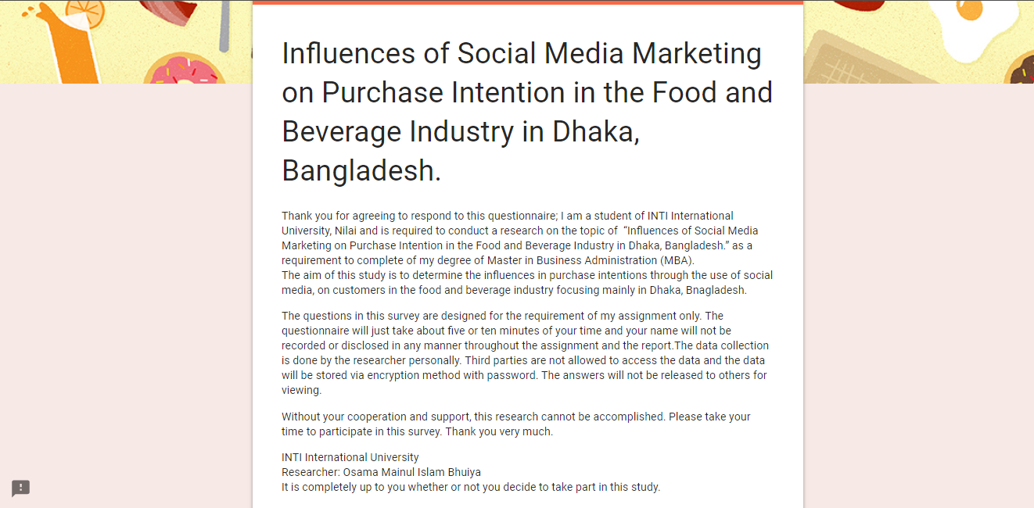

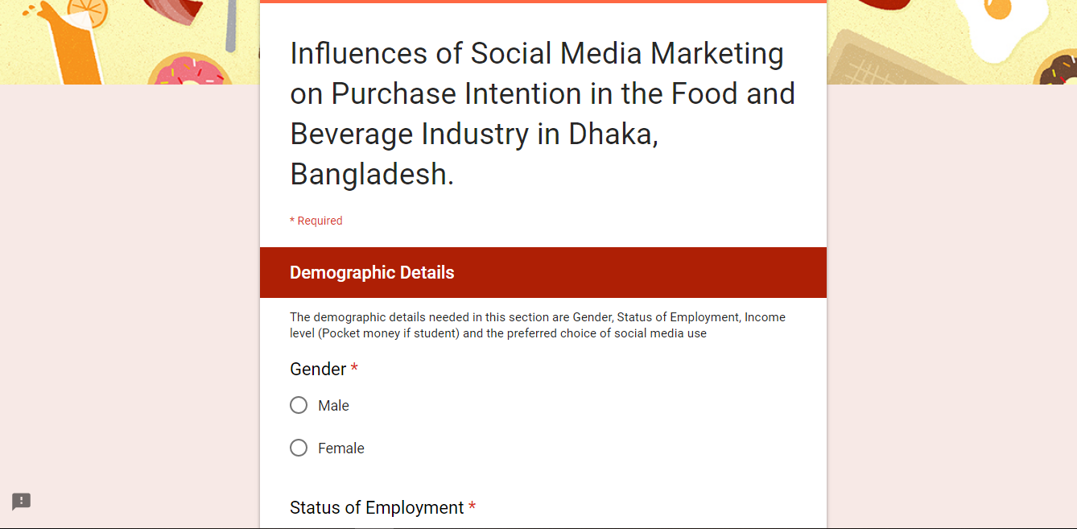

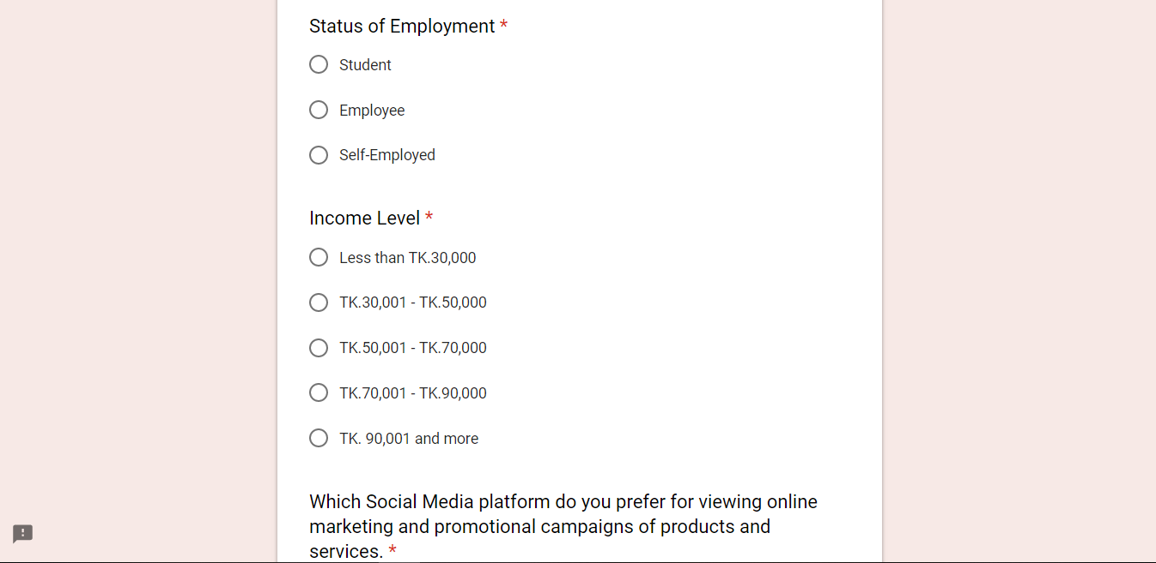
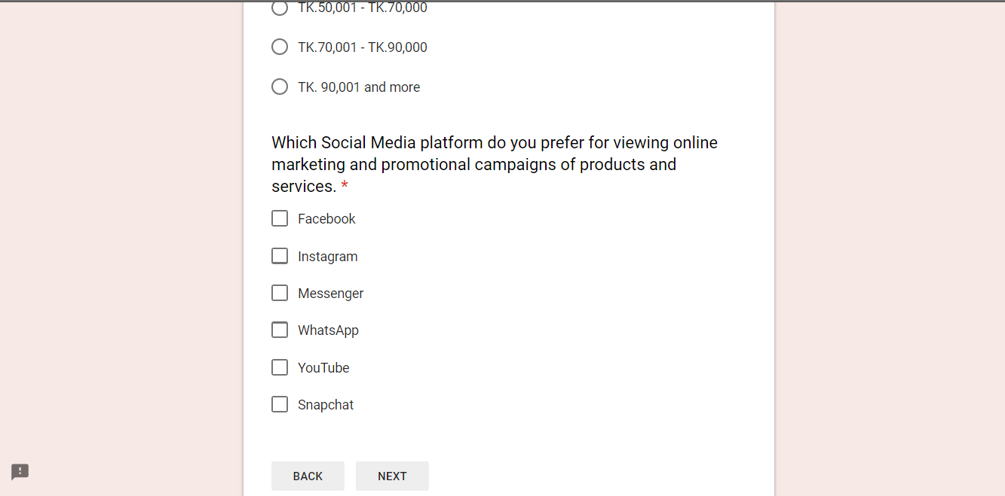

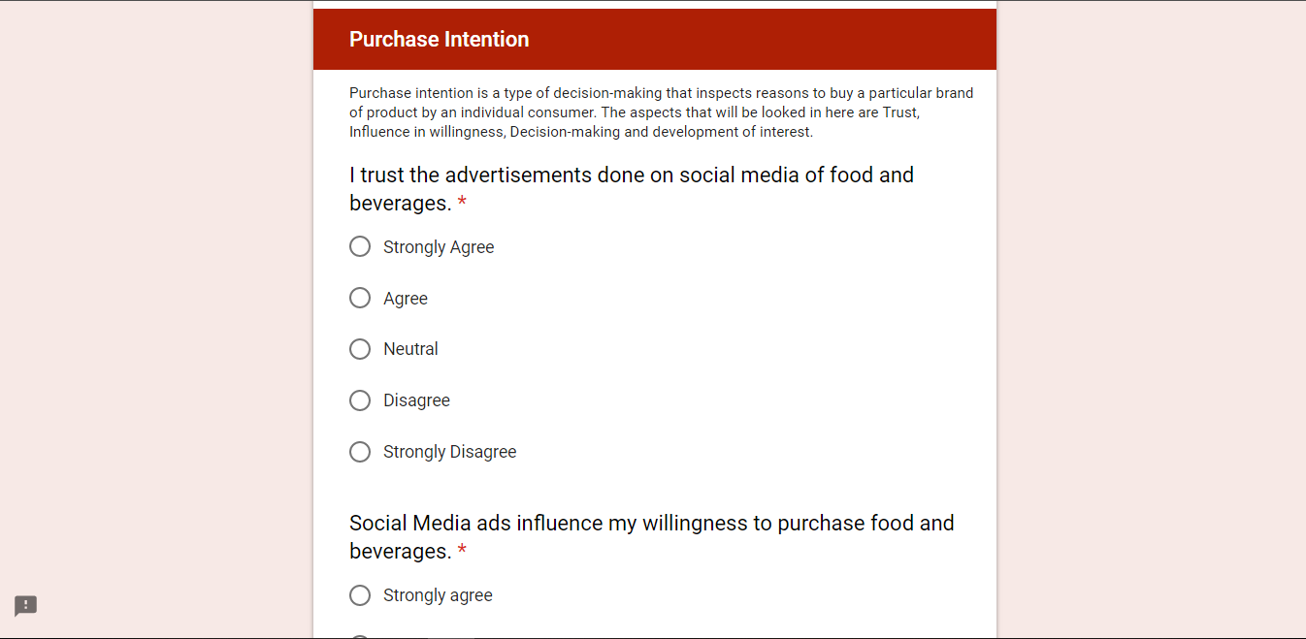
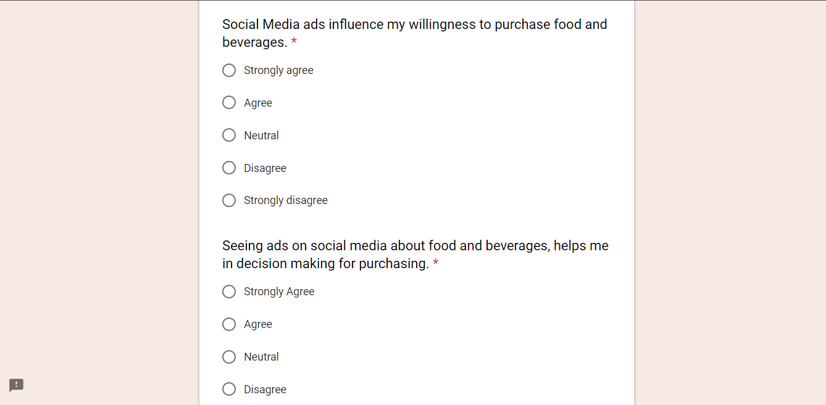

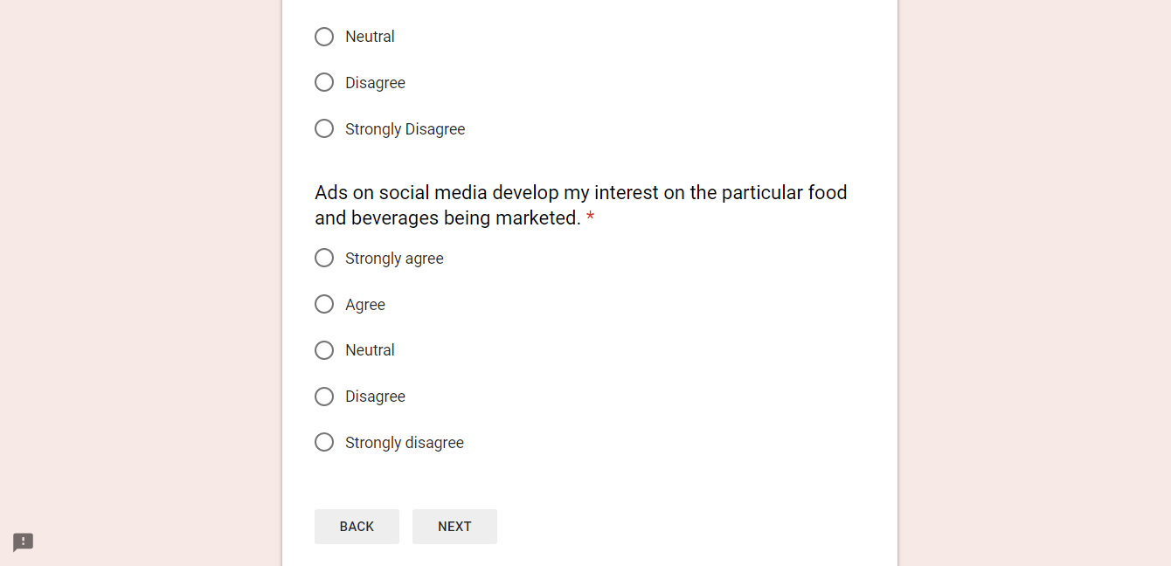
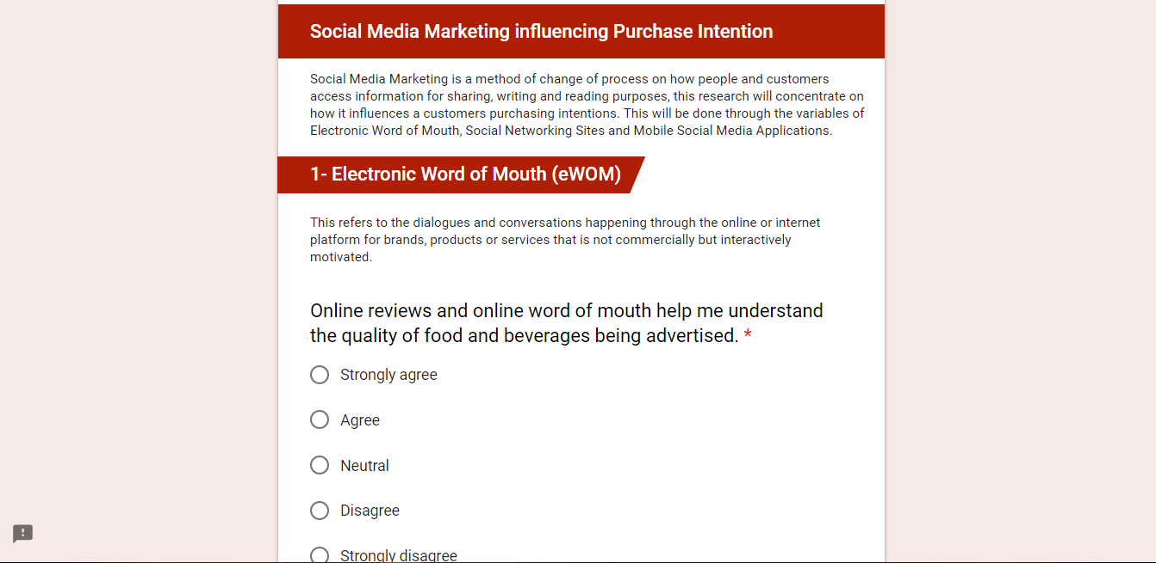

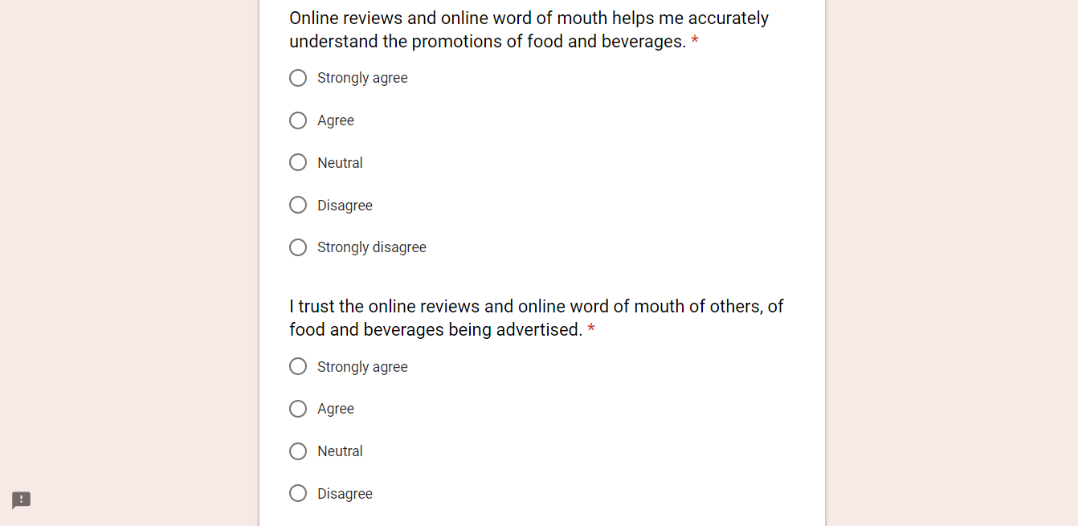
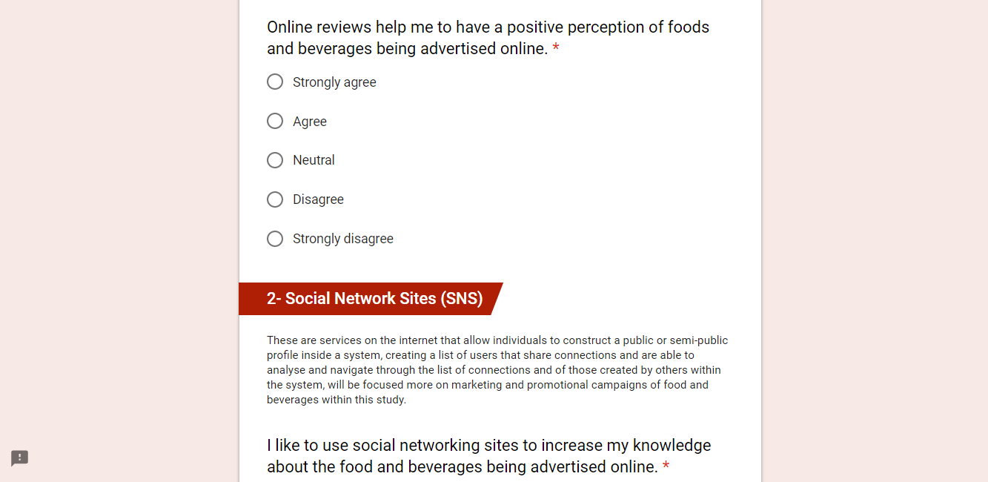

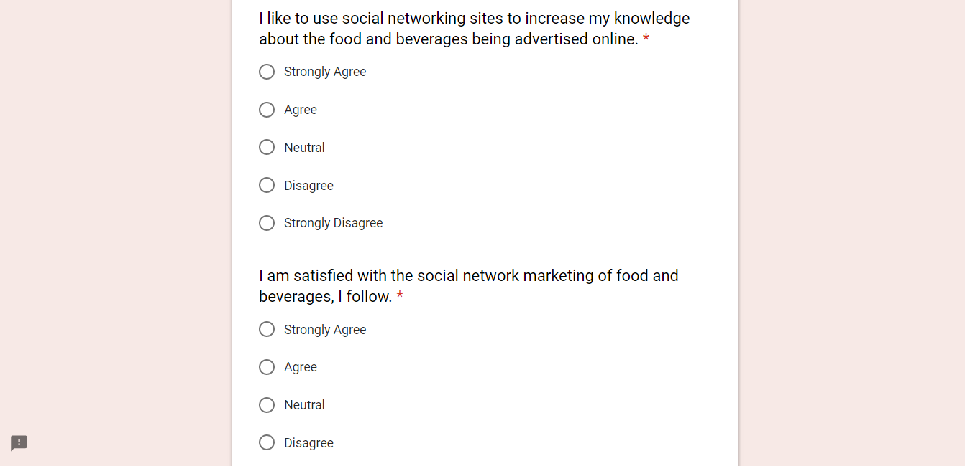
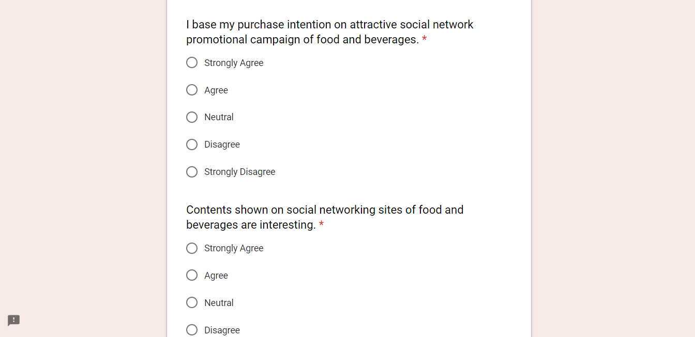

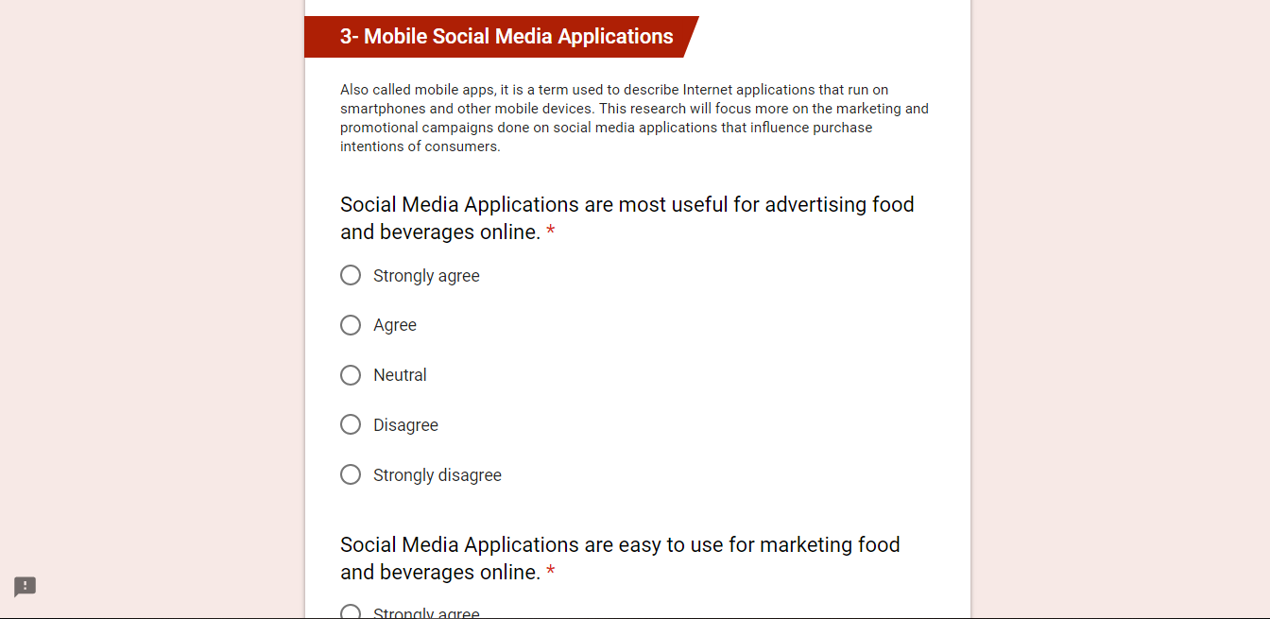
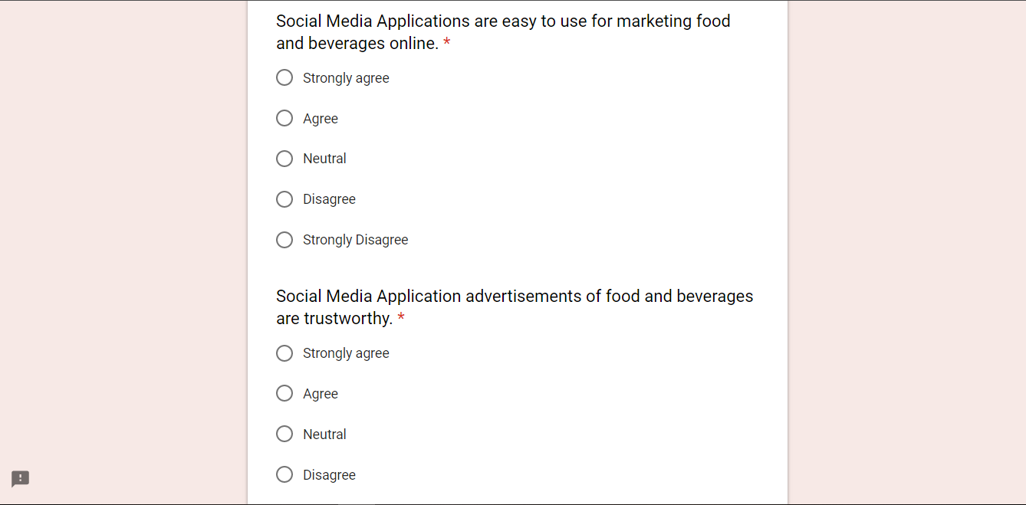

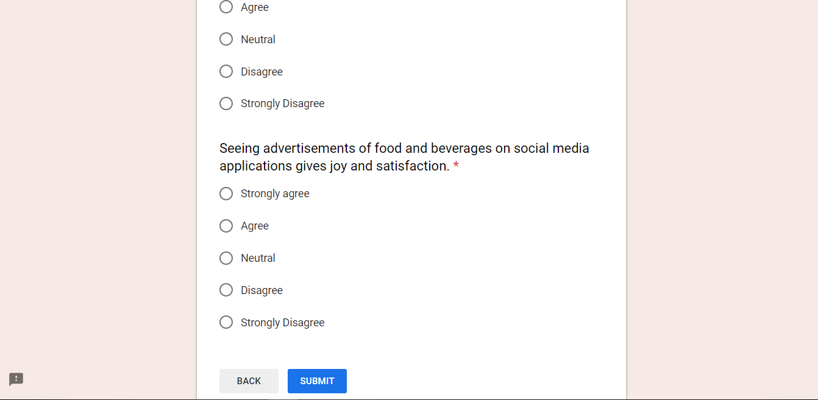
Project Log Book:
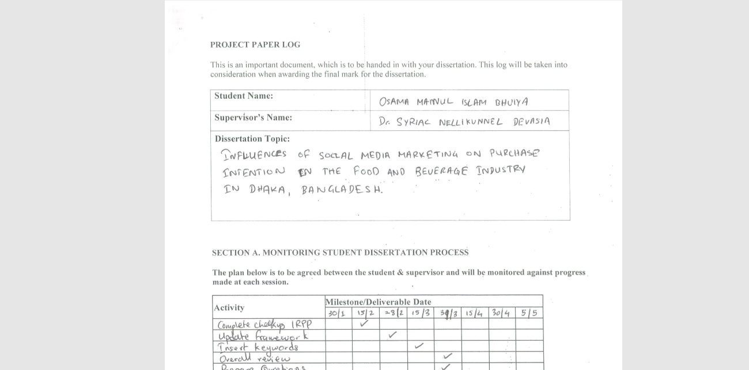

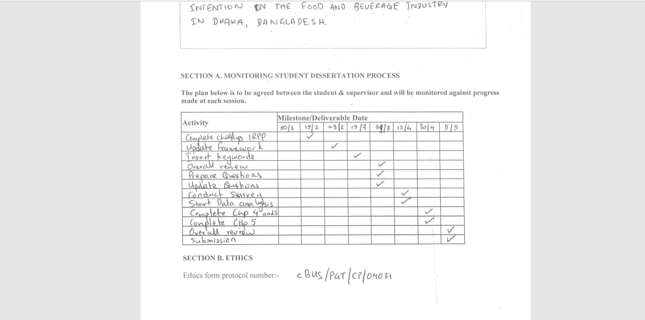
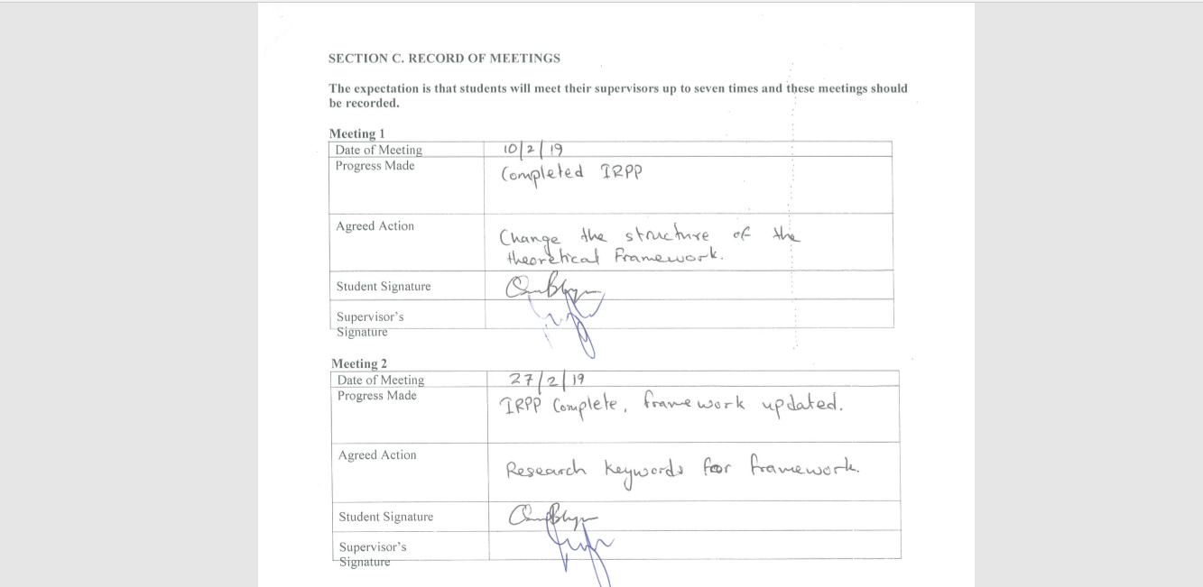

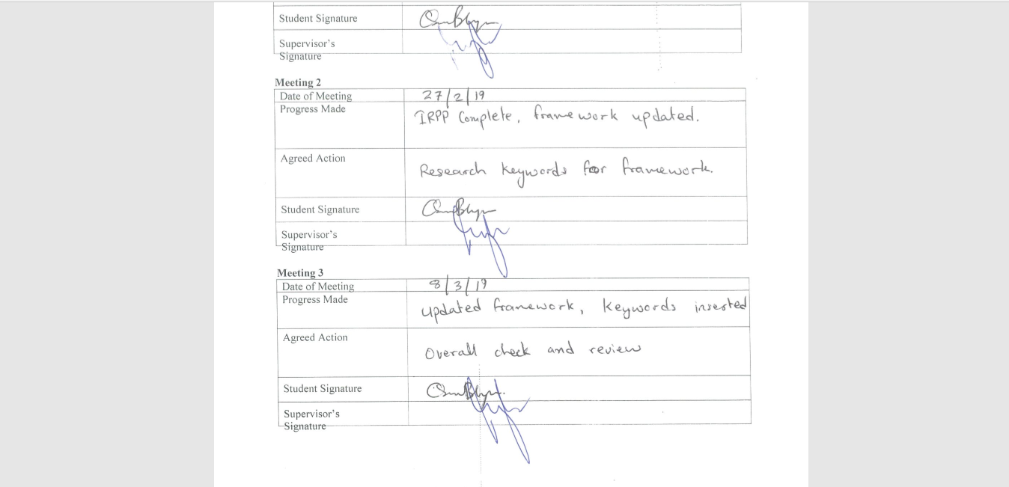
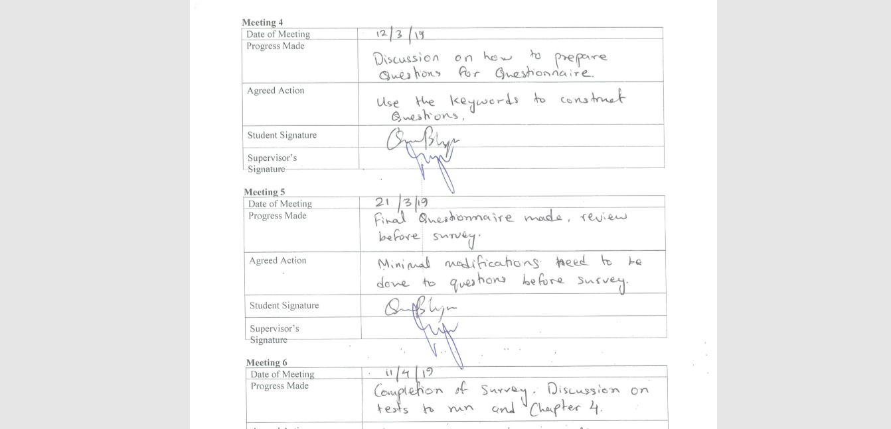

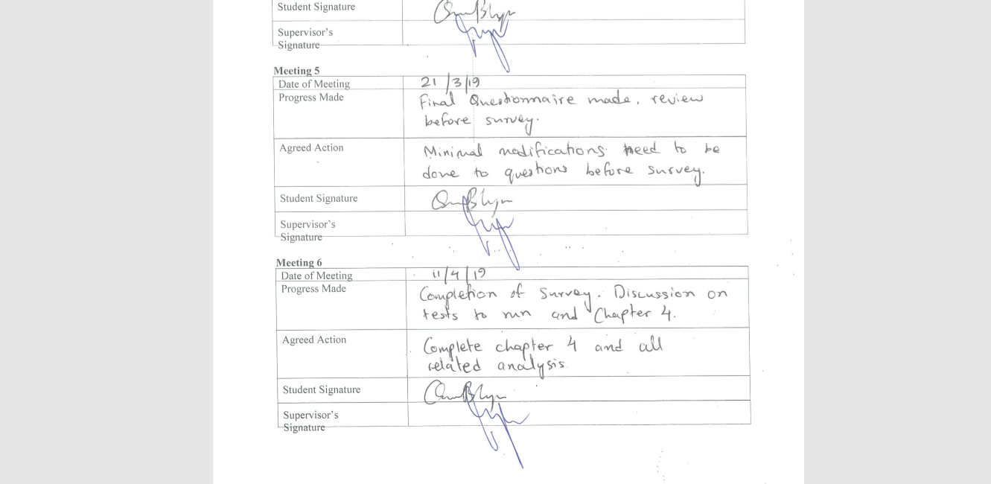
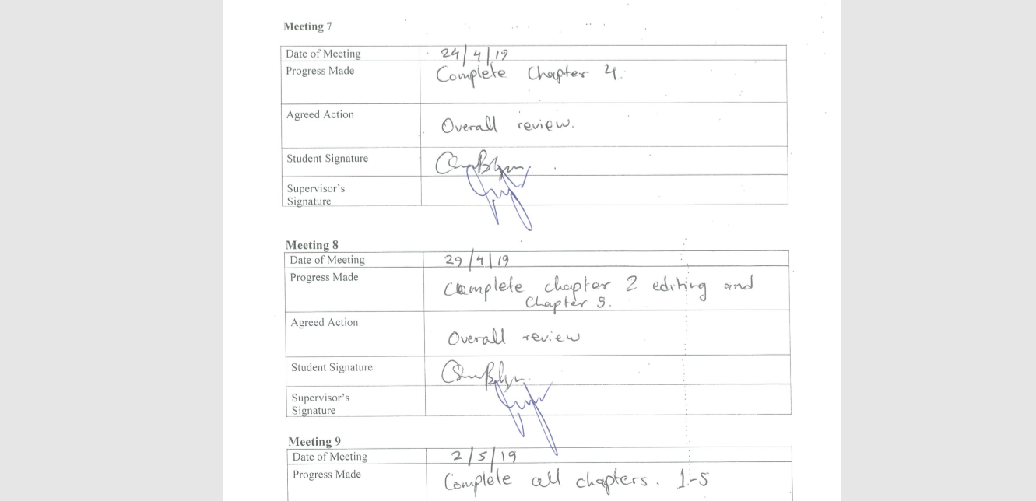

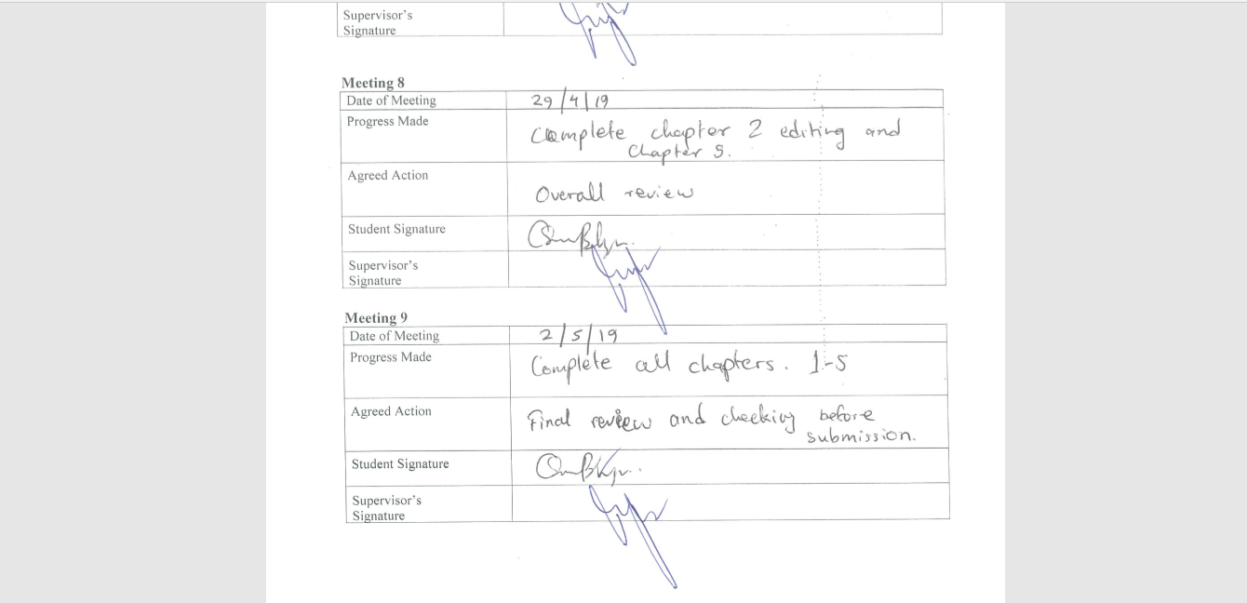


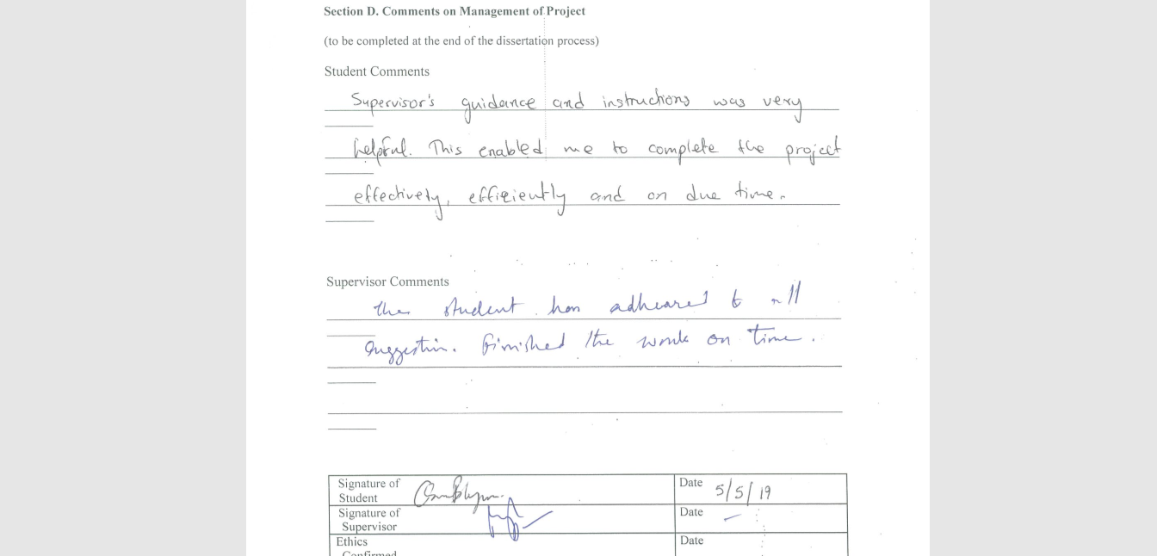
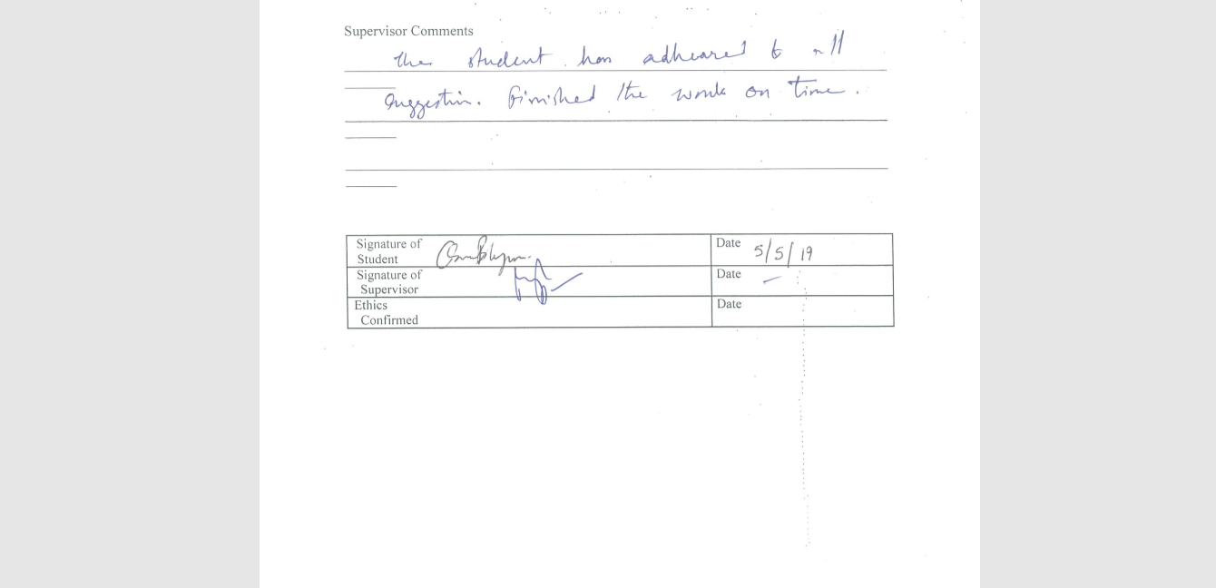

EC7 Protocol Monitoring Form:
UNIVERSITY OF HERTFORDSHIRE
FORM EC7 – PROTOCOL MONITORING FORM
Ethics Committee with Delegated Authority (ECDA) Social Sciences, Arts and Humanities
Name of Principal Investigator
(or name of class protocol holder) Osama Mainul Islam Bhuiya………..
Student/Staff ID I14005023……………………………..
Programme of Study or Module Name MGT7998 MBA Project………………..
Influences of Social Media Marketing on Purchase Intention in the Food and Beverage Industry in Dhaka, Bangladesh.
Title of study
(or name of class protocol)

UH Protocol Approval Number cBUS/PGT/CP/04031...………………..
Date 05/05/2019………………………………..

Has data collection for this project been completed? YES/NO
If NO, please explain why:
If an extension is required, a Form EC2 will need to be completed and submitted.
Have any of the participants within the study experienced or reported any of the following: (if you answer YES to any of these, you must provide the details)
Physical reaction/harm YES/NO
Mental/emotional harm YES/NO
Intrusion of privacy YES/NO
Breach of confidentiality YES/NO
If the UH Protocol Approval you were originally sent included any conditions (for example supervisor to approve interview schedule prior to data collection), were all conditions complied with? YES/NO.
If NO please include any documents and/or information with this form"

DECLARATION (overleaf)
DECLARATION

TICK THE APPROPRIATE BOXES IN EACH COLUMN

(i) Declaration by staff applicant |  | (ii) Declaration by student applicant
(tick) |  | (tick)
 | I confirm that I have followed the approved Protocol for this study and, where appropriate, the relevant code(s) and/or practice(s) that apply |  | I confirm that I have followed the approved Protocol for this study and, where appropriate, the relevant code(s) and/or practice(s) that apply
 | Signed ……………………………………….  (staff applicant)  Date ………………………………………… |  | Signed ……………………………………….  (student applicant)  Date …………………………………………
(iii) Declaration by student's supervisor
(tick)
 |  |  | As far as I can ascertain, the student has followed the approved Protocol for this study and, where appropriate, the relevant code(s) and/or practice(s) that apply
Signed ……………………………………….
(student's supervisor)

Date …………………………………………

This completed form, together with any relevant documents (where applicable) must be returned to the relevant ECDA (ssahecda@herts.ac.uk hsetecda@herts.ac.uk ) when you submit your project/dissertation. Failure to submit this Form may result in a breach of the University’s regulations (UPR RE01, ‘Studies Involving Human Participants’, refers)

Turnitin Similarity Index:
