Farouq Salisu Lawal  MASTER OF BUSINESS ADMINISTRATION  2019 | CONSUMER BEHAVIOR TOWARDS ONLINE BANKING SYSTEM IN NIGERIA  FAROUQ SALISU LAWAL  MASTER OF BUSINESS ADMINISTRATION  FACULTY OF BUSINESS, COMMUNICATION & LAW  INTI INTERNATIONAL UNIVERSITY  2019



MASTER OF BUSINESS ADMINISTRATION

Dissertation Title:
FACTORS INFLUENCING CONSUMER BEHAVIOR TOWARDS ONLINE BANKING SYSTEM IN NIGERIA

AUTHOR: FAROUQ SALISU LAWAL

STUDENT ID: I18014887

PROGRAM: MASTER OF BUSINESS ADMINISTRATION
SUBJECT: MGT7998 MBA PROJECT
SUPERVISOR: DR. ARASU RAMAN
SUBMITTION DATE: 30/04/2019
FINAL WORD COUNT:

STUDENT’S DECLARATION

I hereby declare that this thesis is my own work and effort and that it has not been submitted anywhere for any award. Where other sources of information have been used, they have been duly acknowledged.

Name : Farouq Salisu Lawal

Student ID : I18014887

Signature :

Date : 05/05/2019

ACKNOWLEDGEMENT

First of all, I would like to thank Dr Arasu for his supervision, valuable guidance and advice throughout this research. I would like to convey my appreciation for your patience as I have been asking many questions in many in several occasions whenever I face any problem or get stuck with my research over the semester. Your inspiration not only allowed me to implement and learn much about marketing research methods, but I started to be interested in research as it is even motivating me to enter the doctoral program for a further research in the future.
In addition, I appreciate your readiness to sacrifice your precious time, no matter how much busy you were during that time, which has taught me how to be professional when it comes to jobs. I am very thankful for your timely and prompt response to my several messages and emails during my research. Without promptly responding to my questions I could not imagine how much at loss and worried I could have been. Furthermore, I want to gladness for the consultations and meetings whenever I needed to make an appointment with you. Through inspiring discussions, I can clearly understand my logic about this research.
Finally, I would like to thank my family for helping me with the MBA research and all my friends who were great of a support morally and physically. I would also like to all show my appreciation to everyone who took part in the survey and the people who helped hand out the questionnaire in Nigeria. Thank you for everything you did for me.

Contents
Abstract 8
Table 1.0 Operation Definition 9
Chapter 1: Introduction 11
1.0 Overview 11
1.1 Research Background 12
1.2 Problem Statement 13
Figure 1 The number of internet users in Nigeria 2013-2019 13
1.3 Research Objectives 15
1.4 Research Question 15
Chapter 2: Literature review 16
2.0 Overview 16
2.1 Over view of Customer behavior 17
2.1.1 Global View on Consumer Behavior 17
2.1.2 Over View Of Consumer Behavior in Nigeria 21
2.2 Influencing factors 23
2.2.1 Perceived Convenience of online banking 24
2.2.2 Perceived security of online banking 25
2.2.3 Perceived Usefulness of online banking 26
2.3 Gaps in the literature 27
2.4 Fundamental theory (TAM) 28
2.5 Conceptual framework 29
2.6 Hypothesis 30
2.7 Conclusion 30
Chapter 3: Research Methodology 31
3.0 Overview 31
3.1 Research design 31
3.2 Sampling Design 32
3.2.1 The Target Population of Research 32
3.2.2 Sampling Plan and Sampling Size 32
3.3 Data Collection for correlation study 33
3.3.1 Questionnaire Design 34
3.4 Measurement 34
3.4.1 Pilot test 35
3.4.2 Descriptive statistics 35
3.4.3 Preliminary test 35
3.4.3.1 Factor Analysis 35
3.4.3.2 Reliability Tests 36
3.4.4 Hypothesis Testing 37
3.4.4.1Multiple Regression Analysis 37
3.4.4.1 One-Way ANOVA 37
3.5 Chapter Conclusion 38
Chapter 4 – Data analysis and findings 39
4.0 Overview 39
4.1 Pilot Testing 39
4.1.1 Factor Analysis (for Pilot Testing) 39
1) KMO Bartlett’s test of Sphericity 39
2) Factor Loading/ Extraction/ Communalities 40
3) Eigenvalue Table 41
4.1.2 Reliability Test – Cronbach Alpha 41
4.2 Demographic Profile of Respondents 42
4.3 Frequency Descriptive Analysis 43
4.4 Preliminary Analyses 43
4.4.0 Factor Analysis 43
4.4.0.1 KMO Test 44
4.4.0.2 Factor Loading 44
4.4.0.3 Eigenvalues 45
4.4.1 Reliability Test – Cronbach Alpha 46
4.5 Hypotheses Testing 46
4.5.0 Multiple Regression and One-way ANOVA Table 46
4.5.1 Beta Coefficient 47
4.5.2 Model Summary 48
4.5.3 ANOVA 48
4.6 Summary of Findings 49
Chapter 5: Conclusion and Recommendation 50
5.0 Summary 50
5.1 Recommendation 50
5.2 Limitations 51
5.3 Conclusion 52
5.5 Personal Reflection 52
6.0 Reference 53
7.0 Appendix 64
Appendix- 1 Literature Review 64
Appendix 2- Questionnaire 65
Appendix 3：MBA Project Log 71
Appendix 4: Turnitin Report 76
Appendix 5: SPSS Output 77
List of Tables
Table 1. Operational Definitions 8
Table 2 Questionnaire items summary 33
Table 3: The Rule of Cronbach Alpha Measurement 35
Table 4 Summary of Questionnaire Table 42
Table 5 Demographical Data of Respondent 43

Abstract
Nigeria was characterized to be the fastest growing telecommunications country in Africa. Currently, all banks in the industry engaged massively in the use of Information and Communication Technology (ICT) as a platform for effective and efficient means of conducting financial transactions. The scale of online users is increasing continuously in Nigeria. However, with the rise of other payment method in the banking system, the development speed of online banking users is decreasing. Therefore, competitive advantage is an essential factor which plays around the banks in the industry as customer satisfaction is an important condition that measures bank’s competitiveness. Base on this background, this study focuses on determining the factors that influence customer satisfaction of online banking in Nigeria. An extended Technology Acceptance Model (TAM) is used as a conceptual framework to investigate the factors that influence customer satisfaction. The model measured the impact of perceived convenience, perceived security and perceived usefulness on customer satisfaction in Nigeria. To test the model, data will be collected from commercial banks users in Nigeria. The tool used for the analyses and to identify the variable’s loadings and the relationships is SPSS. Before distributing the entire 334 questionnaires, a sample of only 40 questionnaires will be first taken to conduct the pilot test to ensure the feasibility of the questionnaire’s items or constructs, afterwards the final data collection and the proper tests was executed to evaluate the presence and level of relationships between the variables in the study. The results showed that all the independent variables which are perceived convenience, perceived security and perceived usefulness have significance relationship with consumer behavior towards online banking system in Nigeria.

Keywords: Customer satisfaction, perceived convenience, perceived security, perceived usefulness.

Table 1.0 Operation Definition
Operation | Definition
Online banking | Abba, El-Maude and Oyewole (2013) online banking and bank performance in Nigeria state that online banking has enable banks to deliver an efficient service and increase the performance of the bank in term of return on asset as well as equity.
Consumer behavior | According to Solomon (2012) defines consumer behavior as the physical action that are displayed by customer and their purchasing decision. Consumer behavior is an emotional process if individual through physical and emotional and mental process which are considered to be detectable (Mittal and Agarwal, 2012)
Perceived convenience | Pew (2003) state that convince has a direct influence on consumer behavior as it provides 24/7 access. The convenience of online banking is based upon its features such as; online payments, account enquiry, international transfer (Neli and Boshoffii, 2014).
Perceived security | Perceived security is the process ensuring the safety of customer information, account from cyber that can hack the account of any customer (Dixit and Datta, 2010). According to Omariba (2012) perceived security is often regard as a vital influencer of customer satisfaction. Bedman (2012) state that perceived security is an important factor in the field of online banking as financial institution has to gain customers trust.
Perceived usefulness | Abdalsalam (2013) state that the usefulness of modern online banking is based upon the service it provides contrary to the past banking that is done manually. Kumar (2013) discovered that there is immediate positive correlation between consumer satisfaction and internet banking.

Chapter 1: Introduction

1.0 Overview
This chapter provides an overall view of the study which describes the background of the study and the phenomenon of the article research. After the research goals and problems are proposed and then the scope of the study is illustrated. The aim of the research is to empirically determine the factors influencing consumer behavior towards online banking in Nigeria. However, this study also focuses on some of the limitations that are being experience which further provides direction of future research and explain the definitions associated with the independent variables.

1.1 Research Background
Nigeria has undergone different banking sector reform since 1986 (Ajayi, 2015). However, the banking reforms in Nigeria is an integral part of the country - wide reform program undertaken to reposition the country’s economy to attain the objective of becoming one of the 20 largest economy by the year 2020 (Ezeoha, 2013). This led to the adaption of different strategies by the banking institution such as merger and acquisition while some divert into capital market to obtain additional capital through initial public offering (Uchendu, 2012). The rapid advancement of technology has brought a great impact on the business environs which also forced Nigerian banks to adapt to the new era (Lemo, 213). The introduction of the online banking system makes it easy for the banks to operate more effectively and make high profits thereby providing customers with more convenient service with better prices and higher privacy (Ovia, 2012). Online banking has made it very convenient for consumers to make transfers, online payment within a short period of time without visiting any banking outlet (Hui, 2013). However, the study focuses and examines the current status of consumer behavior towards online banking in Nigeria which also defines the major factors that influence consumer behavior that leads to the adaptation of online banking in Nigeria and makes recommendations on how Nigeria banks can improve. Previous researches focus mainly on the practices and potentials of Internet Banking in Nigeria (Awogbemi and Taiwo, 2012), but specifically on customer satisfaction.
The central bank of Nigeria serves as the country’s central monetary authority which was established 1959. CBN controls the operations of financial institutions and banks in Nigeria, this help to ensures high banking standards and financial stability in the industry, as well as promoting an efficient payment system (Sarah, 2014). In 8th of June, 2018, the central bank has realized that there are 22 commercial banks that operate in Nigeria (Uchendu, 2012). However, the banking industry experience a reform in 2005 which reduce the number to 22 consolidated banks out of 89 which were in operation before the reform (Sarah, 2014). The Managing Director of Nigeria Inter-Bank Settlement System, Mr. Adesonubi Adebisi, has stated that Nigeria has recorded growth in online banking, He spoke at the Fintech Summit 2017, where he analyzed the data of the Fintech industry in the past few years and admitted that mobile users in Nigeria are now about 29 million. Online banking is growing and USSD is also growing while ATM usage remains stagnant as users engage more with the mobile world because it is fast and convenient, card transaction/POS is also growing while cheque transaction remains stagnant (Awogbemi and Taiwo, 2012).

1.2 Problem Statement
The banking industry is well known in terms of its adaption to technological changes as internet is the most vital factor in the online banking sector which protects the financial stability (Apak and Ataya, 2013). According to the National bureau of statistic report of 2019 report that Nigerian population is approximately around 198,000,000. Nigeria is estimated to have more than 148 million mobile telephone subscribers and at least 92 million of them access internet data services on their device. This made the country to be among the top ten in the world with highest number of internet users.

Figure 1 The number of internet users in Nigeria 2013-2019 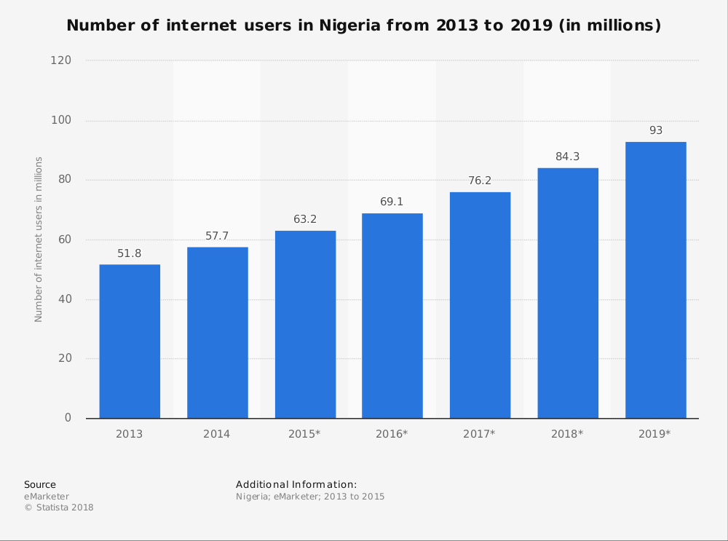

In 2011, the central bank of Nigeria introduced the cashless policy in other to reduce the amount of physical cash in circulation and encourage the use of electronic based transactions (CBN, 2011). This system forces the citizen to embrace online transaction as the banking institution introduced different transaction options which even enables non-smart phone users to perform transaction. According to Adeyemi (2012) state that awareness of online payment in Nigeria is increasing which was account to be N360 billion worth of transaction since 2008. According to KPMG survey also states that from 2013 to 2016 online banking has increase from 14% to 21% (Obinna Chima and Ugo Aliogo, 2017).
Figure 2 The number of online banking users in Nigeria 2016-2017
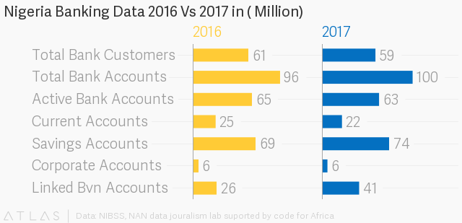
However, in the recent years between 2016 to 2017, it has been reported that the online banking transaction drops drastically. Figure to above shows the financial inclusion report of Nigerian bank accounts which serves as a proxy value as data regarding the online users in Nigeria was hard to obtain from the financial institution and hence the data was on the study as this project was conducted. However, from the year it can be seen that active bank accounts drop from 65 million to 63 million which shows that almost 2 million users had stop using their bank accounts within the range of that year. Similarly, the current accounts which are also known as business accounts drops from 25 million users in 2016 to 22 million users in 2017. This shows that almost 3 million users stop using their business account within 2016 to 2017.

1.3 Research Objectives
Research objectives are specific research actions that are plan to carry out in the research project (Pickton, 2013). The objectives describe the expected achievement of the study (Railean, 2015). However, this research focuses on the factors influencing customer satisfaction of online banking in Nigeria.

- RO1: To determine whether perceived convenience has a significant relationship with consumer behavior towards online banking in Nigeria.

- RO2: To determine whether perceived security has a significant relationship with consumer behavior towards online banking in Nigeria.

- RO3: To determine whether perceived usefulness has a significant relationship with consumer behavior towards online banking in Nigeria.

1.4 Research Question
This study focusses on the factors that influence customer satisfaction of online banking in Nigeria. The main research questions are;

- RQ1: Does perceived convenience have a significant relationship with consumer behavior toward online banking in Nigeria?

- RQ2: Does perceived security has a significant relationship with consumer behaviour toward online banking in Nigeria?

- RQ3: Does perceived usefulness has a significant relationship with consumer behaviour toward online banking in Nigeria?

Chapter 2: Literature review

2.0 Overview
In the advance world, online banking system is playing an important role in every industry through online payment which provide a sufficient platform for online transaction such as internet stock trading, online shopping as well as online auction (Guerrero, Egea and Gonzalez, 2007). However, online banking system provide customer with vast number of advantages through easy transfer of fund and low handling charges (Kalakota and Whinstone 1997). Therefore, competition among businesses has turned out to be progressively serious and organizations realize that they cannot compete with each other mainly on price, yet need to pay attention on their valued customers. This chapter contains a comprehensive literature review on factors influencing consumer behavior towards online banking transaction. This chapter will also compare and contrast the literature review of two different perspectives on the different factors that influences consumer behavior towards online transaction thereby showing how these factors influence users of the online banking system. However, this chapter will also propose a research framework based on the relevant theories of online banking on different factors that influence customer satisfaction there by making assumptions on this basis.

2.1 Over view of Customer behavior
According to Solomon (2012) state that consumer behavior is the study of the process by which an individual or group of individuals chose, buy, use or dispose of goods, service or experience with the view to get a desirable satisfaction. Consumer behavior can be seen as those actions that are exhibited by an individual directly through obtaining, disposing as well as using of goods and service that are of value which includes the decision process that precede and determine these act (Engel, 1986). However, Bhattacharya and Sen (2003) defines consumer behavior as an individual emotion or mental process as well as the noticed behavior of the customer while searching, purchase and after consumption of a particular good or service. Therefore, Zeithaml (2012) states that consumer can have a positive experience of a good or service through an increased level of perceived quality.
According to Kotler and Keller (2012) state that consumer behavior is process by which an individual, group or organization select, purchase as well as dispose the goods base on factors like price, quality and taste upon which the individual made the purchasing decision. Therefore, Lancaster (2012) state that understanding consumer behavior will serve as a central factor as a result of massive competition among business organization round the globe. According to (Papanastassiu and Rouhani, 2006) defines consumer behavior as the physical action that are displayed by customer and their purchasing decision. Consumer behavior can be defined as the series of activity physically or mentally that an individual involves in the process of searching a desirable product or services that will satisfy a need or want (Khalid, 2008).
However, Solomon (2013) affirms that consumer behavior is the process of various stages that a consumer undergoes such as post purchase, purchasing decision as well as pre purchase in making a decision to purchase a good or service. According to Mittal and Agarwal (2012) state that consumer behavior is an emotional process if individual through physical and emotional and mental process which are considered to be detectable. According to Deborah, Maclnnis and Hoyer (2012) state that consumer behavior consists of the following factors such as goods, service and experience which determines the purchasing decision of a customer. Similarly, Jansson-Boyd (2012) affirms that other factors such as quality, price also determines consumer purchasing decision so as to satisfy as desirable need or want by the consumer.

2.1.1 Global View on Consumer Behavior
According to Neol (2012) defines consumer behavior as a blue print which provide an explanation of an individual, group or organizational action which contains many pivotal factors in a business environment. However, a lot of research has been conducted in other to determine different factors that could influence consumer behavior and intention (Asongu, Nwachukwu and Malaquias, 2018). Online banking transaction serves as an intermediary through which financial activities are carried out online which have positive relationship that influenced the customers behavior (Ahanger, 2011). Rapid technological advancement has created many changes in the banking industry (Kirakosyan and Dănăiaţă, 2014).
According to a study by Awamleh (2015) in United Arab Emirates highlights some factors such as perceived security, independence, perceived convenience which influence customer behavior. Omar (2011) state that majority of the customers in Pakistan prefer online banking transaction service as it is more reliable, secured, efficient, fast as well as very easy to access. However, Zavareh (2012) in a research conducted in Iran found that efficient and reliable services, performance, perceived security, perceived trust, site aesthetics and perceived convenience have positive relationship with consumer behavior towards online banking transaction. Assurance, reliability, perceived security, accessibility as well as cost effective as the factors that influenced customer behavior in a study conducted in Nairobi County, Kenya (Njuguna, 2012). According Yin, H.S. and Susan, S. (2012) in a study of consumer behavior toward international and national attires, where the findings shows that consumers with high purchasing power are influenced by the international brand. However, Variawa (2010) conduct a research with the view to determine the influence of packaging on consumers action where the finding suggest that consumers with low income preferred premium packaging which could be reused after consumption.
Raza (2013) research was based on SERVEQUAL model which focus on the service quality. This was similarly conducted in Pakistan where Reliability, empathy, assurance, responsiveness as well as tangibility and so on five aspects to study the consumer behavior towards online banking (Raza and Hanif, 2012). According to Aljabir and Sohail (2012) state that perceived usefulness influenced consumer behavior towards online transaction through compatibility at which the experienced service caters for the value, belief, action, current experience as well as the post experience of the customers. Therefore, Khasawneh (2012) beleifs that customers that perceived online banking as useful and conform in usage exhibit high level of effectiveness in the usage of the online banking transaction. Santouridis and Kyritsi (2014) is of the view that online banking provides a 24-hour service which help in saving time as well as cost effective and remove anxiety of cash been carried which positively influenced customer behavior.
However, Tully (2015) state that consumer can be influenced by compatibility of online banking transaction as it is very easy to transfer fund irrespective of customers location or fund destination. Similarly, Jeong& Yoon (2013) also confirms that online banking users that perceived the banking system as very ease in usage tends to show more effectiveness in the usage of online banking transaction. On the contrary, according to a research conducted by Vladimirov (2012) found that navigability is a vital factor that affects consumer behavior, it contains the clear website card which is expected to be accessible and user friendly. According to a research conducted by Taasim (2015) found that perceived ease of use has a positive effect on consumer behavior toward the adoption of online banking transaction. Nor (2018) state that perceived security of the online banking transaction tends to influenced customer behavior positively.
Quality, price, service, consumer satisfaction, product features are some of the factors that influence the customer behavior (Gupta and Bansal 2012). According to a research conducted in India by Kumar and Georg (2013) used TAM model to show that the influenced of perceived risk, perceived ease of use and perceive usefulness on customer behavior towards the online banking transaction. Masrek (2012) state that perceived trust also influences customer behavior with regard to online banking transaction as a result of absence of physical interaction between customer and the banking institution. Tabari and pamsari (2016) conduct a research in Iran using different factors such as perceived security, customer support service, transaction speed, content of information and pattern in other to determine the level of influence on consumer behavior. According to Munusamy, Run ECD, Chelliah, Annamalah (2012) state that income level and occupational level have negative relationship with customer behavior towards adoption of online banking transaction.
Sharma and Malviya (2014) conduct a research in district of Madhya Pradesh which attempts to measure customer’s behavior and found that there is existence of significant relationship between service quality and consumer behavior. In contrary, according to Masrek (2012) state that the online banking system experienced great challenge as a result of lack of confidence in the banking system. Consumer behavior has turned to be the determinant and predictable aspects for success in the service-based industries, thus, service-based industries are not able of competing with their competitors if customers’ expectations are yet to be met (Forozia, 2013). According to a research conducted by Kumar (2013) state that the importance of online banking is based upon some factors such as easy access, time saving and provide 24-hour service. Jolly (2016) is of the view that that cost effectiveness, efficiency and effectiveness and easy access to information enhance customer satisfaction. DrigA and Isac (2014) affirm that accessibility, low cost as well as operating cost tends to influenced the customer behavior in positive manner toward the usage of online banking transaction.
Sharma (2016) states that online banking provide service that is accessible anywhere, anytime, anyhow within 365 days of the year which have great impact on customer behavior. According to Gera (2015) state that customer satisfaction is directly antecedent of positive recommendation as well as behavior intent. However, Gounaris and Dimitriadis (2003) state that customer who have positive experience from the usage of online banking will have a consistent usage of the online banking transaction thereby showing more loyal behavior. Therefore, consumer will react negatively if a product or service perform below expectation thereby switching to alternative product or service available (Karim and Chowdhury, 2014). Similarly, Amin (2013) state that consumer will find it difficult to develop positive reaction and loyalty if the banking institution fails to meet the expectation of the customer there by making it difficult for transaction. However, consumer that are satisfy with the banking service will show more loyalty as the service meet the customers expectation (Wirtz, 2007). Alshurideh (2017) state that banking institution should aimed at maintaining higher customer satisfaction so as to gain the loyalty of the customer as there is massive competition in the banking industry. Amin (2016) affirms that the online banking website is very easy in usage whereby it provides information immediately without freezing once requested by the customer.

2.1.2 Over View Of Consumer Behavior in Nigeria
Rapid advancement in technology have creates paradigm shift at how customers are been served (Kamakodi, 2012). According to Adewuyi (2013) state that introduction of online banking leads to reduction in consumers complains, dissatisfaction by provision of prompt effective and efficient service by the banks. Aliyu, Tasmin and Younus (2012) state six factors that lead to adoption of online banking in Nigeria which are namely awareness, ease of use, perceived security, cost, reluctance to change and accessibility which all are positively correlated to influence the behavior of the consumer. Adewuyi (2013) found that transaction in online banking is highly secured with user identity such as pin code as well as code identification which have positive impact consumers behavior. The advancement of technology leads to the introduction of online banking has brought many changes in the banking sector which enables the banks to provide efficient service to their respective consumers (Adewuyi, 2013). Abba, El-Maude and Oyewole (2013) in their research titled study of e-banking and bank performance in Nigeria state that online banking has enable banks to deliver an efficient service and increase the performance of the bank in term of return on asset as well as equity.
Abaenewe, Ndugbu and Ogbulu (2013) conduct a research on the impact of online banking performance in Nigeria, where the findings show that online banking has a positive relationship with the bank performance which also create service efficiency to consumers. Adesola, Moredeyo and Oyeniyi (2013) found that advancement in technology has made banks to embrace online banking which help them to render an adequate and reliable service the consumers. According to research conducted by Adeyemi, Ola and Oyewole (2014) between eight banks across Nigeria where the findings shows that Nigerian banks are not highly engage in training staffs about online banking which this have positive impact on the behavior of the consumers. Oluwatolani (2011) state that banks should provide a well qualitative and highly secured service to consumers, this will help them in attracting new users as well as retaining the existing once.
Online banking enables consumers to perform transaction as well as payment such as transferring funds, paying bills, viewing current and savings account balance, paying mortgages, and purchasing financial instruments and certificates of deposits conveniently which improves positive consumer behavior as well as loyalty which will influence the consumer behavior. Abaenewe (2013) state that online banking has a positive relationship with consumers behavior as it enables its consumer to make payment of good and service online without walking with cash to the bank or other business organizations. Agwu and Carter (2014) in their research which focus on mobile phone banking in Nigeria, where the finding shows that it is very convenient to make transaction and payment through online banking with the aid of mobile phone which has positive impact on consumers behavior. Adewoye (2013) is of the view that consumer behavior is an essential tool that every organization should focus on for sustainable growth of the organization. Aduda and Kingoo (2012) state that online banking has make transaction more convenient by bringing service close to customers, thereby increasing satisfaction and the performance of the banks which greatly influenced the behavior of the consumers. Banks are used primarily for daily transaction, business payment which the major aim to increase customer satisfaction there by attracts possible consumers (Chiemeke, 2006).
According to Chandio (2011) the acceptance and success of any banking institution depends on how the potential users are satisfied with the service that the bank provides which will influence the consumers choice. According to Madueme (2013) state that Nigerian banks have to adapt to technological changes in the banking system for them to stay competitive as it has strong relationship with consumers behavior which depends on the service quality that the bank provides. Timothy (2012) argues that online banking refers to as automatic way of delivering service to customers which aimed at making all banking operations easy for customers and influence the behavior of other consumers. Bashir and Mwinyi (2012) state that accomplishment of any service or product depends on the consumers behavior as well as acknowledgement and consumer behavior is set to be attain when there is positive acknowledgement of consumers on a particular product.
According Chinedum (2013) state that consumers are the key to every business as it is the determinant and predictable aspects for success, therefore the challenge that every business face is to stay competitive. The findings of the research state that the behavior of the consumers occurs when their expectation is attained or exceeds. Osuagwu and Onyeukwu (2016) state that consumers behavior is influenced when consumers start to patronize the product or service while on the other hand dissatisfied consumers tend to avoid the product or service. Moreover, According to Akpan (2013) state that there is significant correlation between consumer behavior and the availability of ATM machine, he further suggests high level of ATM quality will lead to influenced the behavior of the consumers. Oluwatolani (2012) state that banks should provide a well qualitative and highly secured service to consumers, this will help them in attracting new customers as well as retaining the existing once.

2.2 Influencing factors
In this study, the influencing factor of the dependent variable (consumer behavior towards online banking) are mainly; perceived security, perceived convenience and perceived usefulness. These factors have crucial influence on the dependent variable. As a result of rapid advancement of technology, it has created an extensive application of technological ideas in the financial industry, online banking has gained more patronage as a result of its convenient and cost effectiveness (Jolly, 2016). This brought about continuous growth and competition among the banking institutions in Nigeria (Forozia, 2013). Kazi (2016) state that the attributes and features of network provides a great opportunity for the development of online banking Consumers conception about usefulness, credibility and convenience of online banking have main effect on consumer behavior and intentions towards using online banking (Santouridis and Kyritsi 2013).
Firstly, customers are being influence with the features of online banking such as privacy as well as perceived security (Timothy, 2012). The secure part of the online banking aimed at ensuring that the account of users is secured and their information is highly protected (Moscato and Altschuller, 2012). Jolly (2016) said factors like perceived security, efficiency are the most crucial and vital aspect of the online banking which brings a cost effective service to the users. The introduction of online banking aimed at providing different service that ease banking procedure, users can make transactions as well as payment from their comfort, while in the contrary in brings efficiency in work thereby reducing productivity and operational cost (Clemes, 2012).

Influencers of Consumer Behavior

2.2.1 Perceived Convenience of online banking
Convenience is often regard as the major factor that attracts consumers behavior towards the online banking, this is in line with how all financial institutions are looking forward to provide the best service to their users (Neli and Boshoffii, 2014). Similarly, Zavareh (2012) state that convenience plays a vital role at influencing the behavior of any consumer. In a research that was conducted by Kassim and Abdullah (2010) however discovered that there is positive correlation between consumer behavior and convenience. However, in other to stay competitive as well as reach the requirement of users to improve positive behavior of the consumers, many financial institutions come up different varieties of online banking system operation which enable users to operate as well as make transaction at its own convenient time (Waithaka, 2015). In other to achieve a sustainable growth in the banking industry, each bank has adopted a convenient as well as most effective procedure through using information network in other to satisfy their users and to stay competitive in the industry (Liu, 2016). Online banking system always experienced constant technological changes by innovating and attachment of the existing banking system (Begum, 2012). Therefore, continuous technological changes are the main driving factors that support innovation in the operation of online banking (Khan, 2016). However, consumers always look forward for accurate and better service to be provided by the banking institutions due to the maximum technical efficiency (Isik, Peters and Ton 2016; Jahantan and Upadhyay 2016; Karjaluoto 2012) state that introduction of different online banking accessories in the industry brings about convenience to the customer with regard to access and use of banking services.
In the previous banking system, all activities are carried out manually which leads to loss of information where by the users have to bear the loss, contrary to the online banking where information are saved automatically into the server which is more reliable (Sin, 2012). However, in Nigeria customers prefer the online banking system due to its conveniences in terms of operation (Begum, 2012). The banks have come up with different online payment of bills which all makes it very convenient, whereas consumers ease of use has a positive relationship with customer satisfaction (kumar, 2013). Migdadi (2013) said financial institution can gain a competitive advantage through adoption of convenient banking procedure. Online banking also leads to a boost in online business where by transaction and payment are done online which has mutual benefit to the bank and users as well (Bhatt, 2016).
The convenience of online banking is based upon its features such as; online payments, account enquiry, international transfer (Neli and Boshoffii, 2014). Account enquiry is one of the most vital aspect of online banking now a days as it was carried out manually in the previous days which is inconvenient to the users, the current personalized technological procedure makes it more convenient to the consumers (Zhang, 2015). Pew (2003) state that convince has a direct influence on consumers behavior as it provides 24/7 access.

2.2.2 Perceived security of online banking
Security is the process ensuring the safety of user’s information, account from cyber that can hack the account of any consumer (Dixit and Datta, 2010). According to Omariba (2012) security is often regard as a vital influencer of customer satisfaction. There is positive relationship between consumer behavior and security (privacy). According to Bhatt (2016) state that security refers to prevention of any risky transaction as well as maintaining a secured data base for transaction. As a result of rapid development of the internet and some pitfalls accompanied with network technology, online banking is exposed to different sort of threats which needs a quick action of control (Jolly, 2016).
The banking institutions should adopt different form of identity certification before making any online transaction, the online service should request a user identity before confirming any transaction or payment (Omariba, 2012). The security procedure should be combined with other privacy-enhancing features such as password, mother’s maiden name, and automatic logging off (Chiou and Shen, 2012). Liao and Cheung (2002) maximum security should give to transaction that includes a huge amount of money. Similarly, Bedman (2012) state that security is an important factor in the field of online banking as financial institution has to gain customers trust. Online transaction should be extensively secured so that customers should not worry about the risk that is attached to leakage of personal information during online transaction (Frank, Phillip and Markos, 2012).
This was also affirmed by Miyazaki and Krishnamurthy (2012) which state that financial institutions should ensure a secure and safety access of users account, history, transfer, bill payment as well as other banking operation. When all this are achieved, the campaign and development of online banking will be adopted (Ching 2011, Frederic, 2012). Mahmadi (2016) states that confidential information should be encrypted in such a way that it does not reveal all the information when stolen. However, Odoh (2015) is of the view that all banking institutions should ensure information integrity, this is to ensure that all transactions made are completed without being obstructed or hacked. As Kumar (2013) stats that privacy as well as security are the major concern in online banking which influences consumer behavior. Every online transaction should be monitored such that all payments are control as well as free of threats, application errors, as well as operational errors (Begum, 2012).

2.2.3 Perceived Usefulness of online banking

Kumar (2013) discovered that there is immediate positive correlation between consumer behavior and internet banking. However, financial institutions should utilize smart capital in providing effective and efficient service to customer (Sharma, 2016). According to Ahmad and Alzubi (2011) state that online banking is very useful as customers are able to access information about service and product online. Bank website should be created in such a way that all useful information is easy to access (Harison, 2015). Abdalsalam (2013) state that the usefulness of modern online banking is based upon the service it provides contrary to the past banking that is done manually. This tends to make the operation more efficient as well as cost effective (Sharma, 2016). According to Jazani (2014) state that majority of the online banking operations are made through mobile phone which is known as mobile banking. Therefore, different types of operations are being carried out through smart phones such account enquiry, bills payment (Lin, 2013).
Lee, Ooi and Wei (2015) states that financial institution should provide mobile application that are very easy to use, whereas the perception of on the usefulness of mobile application has a direct influence on consumer behavior. However, it is further suggested by Harrison (2015) the usefulness of online banking also depends on the compatibility, performance as well as credibility that the financial institution provides. It was found that there is existence of positive correlation between usefulness and consumer behavior (Noz 2012; Aboelmaged and Gebba 2013; Khin and Teng, 2016). It is found that perceived convenience has a direct relationship with usefulness as users perform different sort of transaction online, online request of cheque, account enquiry without much effort (Singh, 2003). Miremad (2012) state consumers behavior tends to be positively influenced when expectations are attained or exceeds user’s expectation through perceived usefulness of a product or service. Therefore, for the purpose of this study focus on the factors that influence consumer behavior which are perceive usefulness, perceived convenience and perceived security (Waithaka, 2015)

2.3 Gaps in the literature

Having gone through the existing researches that are available within the phenomena under investigation, there are existing gaps within the literature of online banking system in Nigeria. Consequently, while many studies have been conducted on the online banking and the use of mobile banking but there are limited studies in respect to consumer behavior towards online banking system in Nigeria which makes data to be very rare (Tiwari and Buse, 2007). However, the advancement of technology has led to emergence of many researches about online banking focuses on how banks can increase productivity while the measure concern of the online banking is to influenced consumer behavior toward the usage of online banking as well (Dash, Dash and Sharma, 2012). Egwali (2014) online banking is not highly effective in Nigeria at alerting and protecting users’ information from hacker. Similarly, Ezeoha (2013) found that online banking is slowly embraced by Nigerians because it is very easy for hackers to manipulate users account through fake banking website.
Previous studies were mainly conducted in the cities thereby neglecting behavior of consumers that are living in the rural areas (Zinkhan, 2012). Therefore, there is need for current studies to be conducted about online banking in Nigeria. Majority of the previous studies were imaginative, failing to produce a general approach on how to overcome the challenges that are experienced by the banks so as to provide efficient service to the users, this renders the analysis defective (Nwabueze, 2001). However, the international researches focus on other factors thereby overlooking the issue of network which is a major concern in Nigeria.
Nigerian banking institution faced a lot of challenges in term of network issues as the network service is very costly as well as slow (Adesina and Ayo, 2013). Many studies fail to address the issue of network as the service providing companies are directly correlated with the banks (Aderson and Srinivasan, 2003). It is also noticed that there is shortage of ATM galleries in Nigeria and a times there is existence of ATM malfunction, shortage of fun available, stacking of card by the machine as well as long waiting days to return incomplete transaction which all needs immediate attention to address the problems (Tasmin et. al. 2012). Adewoye (2013) state that security as well as Network problem is the major pitfalls that are found in the online banking system in Nigeria. However, the introduction of online banking has seriously affected the bank staff which leads to loss of jobs as a result of automation of the work (Adesina and Ayo, 2013).

2.4 Fundamental theory (TAM)

The Technology Acceptance Model is used as the fundamental theory in this research which is use to forecast the adoption of online banking (Surendran, 2012). Many literatures (Bashir and Madhavaiah 2015; Sellitto 2015; Slade, Dwivedi, and Williams, 2015) state that the Technology acceptance model was used by few studies in other to study the factors that influence the acceptance of mobile application with regard to mobile banking. In the contrary, Alwan and Al-Zubi (2016) found that Davi’s TAM has been used widely in various studies that have to do with technological discipline. The Technology Acceptance Model is the model that analyzes how customers are willing and adopts technological changes.
The TAM was also used by Cheung and Vogel (2013) to identify the factors that influence acceptance of Google apps for joint learning while in the contrary; this study uses the TAM model is applied in order to study the influential factors base on consumer behavior. However, the main objective is to authenticate the TAM influential factors to the context of online banking. The perceived convenience that is being experience by a consumer has a direct relationship with usefulness of online banking (Alwan and Al-Zubi, 2016).
According to Money and Turners (2004) TAM is often used so as to study the relationship among the four main construct which are; convenience, ease of use as well as privacy to use a particular target system. Lai (2016) states that he TAM model has being used in many researches which the model is found as the most suitable model at explaining about information system acceptance and its influence. It is found that there is positive relationship between consumer behavior and the use of online banking operation (Walker and Johnson, 2006).
In Nigeria, online banking users tend to be influence by its convenience in use as well as the security which transaction performed by users are highly secured. However, this shows that users can easily make transaction or payments instantly with full access round the clock service (Kazi, 2016). Similarly, Fo and Ak (2015) found that security, privacy as well as performance has a positive relationship which influenced consumer behavior towards the usage of online banking. The TAM is specifically used in this research in order to determine the factors that influence consumer behavior towards the adoption of online banking. According to Davis model (TAM) state that customers intentions to use technology will predict determine whether consumers will use the technology or not. This research will however focus on three factors that influence consumer behavior towards online banking, where by the factors are chose in line with their share of the researchers’ attention, therefore different literature has been reviewed according to the factors.

2.5 Conceptual framework

The main objective of this research is to study the relationship between consumer behavior as well as the factors that influence it. The framework aimed at helping researchers in conducting an efficient analysis. In this study, there are three major influencing factors of customer satisfaction in online banking. However, convenience, security and usefulness play a very important role with regard to customer satisfaction of online banking (Zhang, 2015). Users often use online banking via smart phone to make payment, transfer because of its convenience and security purpose (Neli and Boshoffi, 2013). Therefore, the theoretical framework of this research is as follows;

Independent Variable (IVs) Dependent Variable (DVs)

Perceived convenience
H1
Factors influencing Consumer behavior towards online banking transaction in Nigeria
Perceived usefulness
H2
Perceived security
H3

2.6 Hypothesis

Base on the objective of the research as well as the reviewed literature, the research hypotheses are as follows;
H1: Perceived convenience has positive relationship on consumer behavior toward online banking system in Nigeria
H2: Perceived usefulness has positive relationship on consumer behavior towards online banking system in Nigeria
H3: Perceived security has positive relationship on consumer behavior towards online banking system in Nigeria.

2.7 Conclusion
This chapter reviewed different literature on consumer behavior based on global as well as Nigerian perspective. As a result of rapid advancement of technology, online banking brings about competition within the financial institution. The chapter began with theory of Technological Acceptance Model (TAM) model as the fundamental grounded theory, which was followed by different definitions of the dependent variable which is consumer behavior. The influencing factors include security, convenience as well as usefulness. All the reviews that support the influencing factor (independent variables) play a vital role towards the behavior of the consumer.

Chapter 3: Research Methodology

3.0 Overview
This chapter will explain the methodology that has been adopted in this study. Questionnaires will be used in this study to collect and analyzed the sample data, population sample, technical tools as well as the dependent and independent variables as mentioned above.

3.1 Research design
The main objective of this study is to determine those factors that influence consumer behavior towards online banking in Nigeria. However, the research design offers different critical choice points for each component that serves as a master plan that outline the methods and procedures to be adopted right from data collection, analysis as well as testing the hypothesis (Sekeran, 2016). This part basically discussed issues relating to decision based on the purpose of the study, type of the research, the extent to which it is manipulated and controlled by the researcher which all are adopted in this research design (Bougie, 2016).
Quantitative analysis is chosen to test the research model which is the appropriate tool in measuring how many and in what proportion according to the level of explanation (Bold, 2011). The type of research according to its use is Applied research while according to the dept level of data analysis is explanatory research. In this study,400 survey questionnaires were sent out to randomly to online banking users in Nigeria. The research design was divided into two sections. The first section consists of demographic profile which have 5 questions and the second part consist of 15 questions; 3 questions from the dependent variable which is consumer behavior toward online banking in Nigeria while 4 question from perceived convenience, 4 questions from perceived usefulness and 4 questions from perceived security. The participants were asked to indicate their experience and perception with response ranging from ‘‘strongly agree to strongly disagree’’. The collected data were analyzed based on correlation and regression analyses using the statistical package for social sciences (SPSS).
The extend of interference by the researcher with the normal flow of work at the workplace is directly bearing of the fact that whether the study undertaken is causal or correlation (Sekaran and Bougie, 2016). Correlation studies are invariably conducted in a non-contrive setting, the research setting for any study can be either natural or controlled (Sunders, 2015). In this study, the level of interference was minimal as the study was a naturally occurring event were by the researcher had no control over the variables and thus the research setting is non-contrive.

3.2 Sampling Design
According to Sekaran and Bougie (2016) state that there are two major type of sampling design which are probability and non-probability sampling. The sampling is basically done in other to obtain a random sample from the population of the study. Probability sampling is often associated with survey and experimental research strategies which is extremely important since the finding from the sample will be generalize towards the entire population (Lohr, 2016).

3.2.1 The Target Population of Research
Population refers to the total number of target group, items, element or events intended to be studied (Sekeran and Bougie, 2016). It determines the focus of investigation as hypothesis and methodology are designed in such a way of findings can be generalized (Lankton, 2014). Moreover, population of this research involves the period from which Nigeria started using the online system platform. Therefore, in other to study the influence of different factors in the consumer behavior towards the online banking in Nigeria, the target population expressed their experience or feelings through an online questionnaire (Chartzoudes, 2013).
Previous studies try to focus on white collar worker or to a specific organization meanwhile restricting to capture of other online banking users in Nigeria (Adeyemi, 2012). However, this study targets the population irrespective of our occupation, age or marital status or qualification. Thus, not only individuals with education qualification or white-collar jobs have used online banking, but also people with other social attributes have taken part in the usage of online banking system (Statista, 2017).

3.2.2 Sampling Plan and Sampling Size
The targeted population of this particular research is composed of users of online banking in Nigeria, as there many any online banking users, appropriate sampling technique is very important in the study (Mukhtar, 2015). However, this study has selected the sample users through convenient sampling which is seen to be very convenient to the researcher to obtain response from the sample (Chitungo and Munongo, 2013). In other to avoid any form of bias, this study has selected sample of respondents from different places and on different occasion in such a way that the is diverse and unbiased selection of sample (Mukhtar, 2015).
Selection of sample size is often very critical which requires careful consideration by the researcher as the statistical techniques are strongly influenced by it (Rahi, 2017). The sample size is usually determined when the study is been design. However, before determining the size of the sample that needed to be drawn from the population from the population there by taken some factors into consideration (Saunders, 2015).
According to Krejcei and Morgan (1970) state that if any population happen to be more than 1000000 then the required sample size would have to be 384. According to National Bureau of Statistics (NBS) state that that the value of online payment in Nigeria rose by 10% of N32.5 trillion in the first quarter of 2018 and the online banking report shows that there are about 4 million to 5 million online banking users which the number is increasing in the recent years. Therefore, the rule of Krejcei and Morgan is applicable to this study were the sample size order have to be 384 (Krejcei and Morgan, 1970).

3.3 Data Collection for correlation study
In this study the data has been collected with the aid of online questionnaire. A questionnaire is a systematic list of questions that is design to obtain information from people about specific event, attitudes, values or their beliefs (Needham and Dransfield, 2010). Dujsik and Zhu (2016) state that a questionnaire is an instrument that is used in obtaining data which contains a set of specific questions that are constructed by the researcher in obtaining information from a set of respondents. However, questionnaire is often regarded as the instrument that is used in distinguishing factor of survey research methods which is used in obtaining raw data that will be used for further analysis.
According to Asika Mukhtar (2015) state that the scale items used in a questionnaire are design to recognize the degree of intensity in the respondent’s experience about and perception of certain concept which cannot ordinarily be gathered from two-way or even multi choice questions. The experiences or feelings of the respondents are represented with the aid of a scale and the choice of a particular point on the scale is expected to be representing the experience or feelings that will be use for further analysis (Johns, 2010). However, the questionnaire in this study is divide into five dimensions which are; Strongly Agree, Agree, Neutral, Disagree and Strongly Disagree (Dujsik and Zhu, 2016).
There questionnaire is made being organized online using google form where by it will be sent to the participants requesting them to answer if they are interested (Kaur and Pathak, 2015). Therefore, this study combines the independent variables and the dependent variables which will be used in determining the factors that influence the consumer behavior towards the adoption of online banking system. The questionnaire is divided into three parts; Demographical information, information about dependent variable and the last part which ask information about the independent variables.

3.3.1 Questionnaire Design
The questionnaire of this study is divided into three parts. Part A ask about demographical Information which serves as a characteristic of the population such as; Gender, Age, level of income and Educational qualification which are used in this study (Al-Jabri&Sohail, 2012). The part B of the questionnaire ask information about the dependent variable which is consumer behavior towards the online banking system in Nigeria. The part C ask information about the independent variable which are the factors that influence thee dependent variable which includes; Perceived convenience, Perceived security and Perceive usefulness.
However, this study adopted all the questions from previous study and researches for innovation which the answers are based on a scale on a platform of five coding ranging from Strongly agree, Agree, Neutral, Disagree and Strongly disagree (Harry and Boone, 2012). The analysis will be according to the collected data through the data statistics, test the influence of the independent variables on the dependent variable (Kumar, 2011).

Table 1: Questionnaire items summary
Section | Area | No. of Items
A | Demographic | 5
B  (Dependable variable) | Consumer behavior towards online banking system in Nigeria | 3
C  (Independent Variable) | Perceived Convenience | 4
C  (Independent Variable) | Perceived Usefulness | 4
C  (Independent Variable) | Perceived Security | 4

3.4 Measurement
Rossi and Crenna (2018) defined measurements as outcomes gotten after evaluating something and are commonly conveyed in numbers, making values ​​more meaningful and useful in certain ways but acting as labels. Because this study is a quantitative research, a measurement of hypothesis testing, pilot test and descriptive information (demographic profile) will be performed to confirm that all data are statistically significant.

3.4.1 Pilot test
Pilot study is a mini version of a feasibility study using the result from pre-testing of a particular research instrument like the questionnaire (Khakid and Hilman, 2012). This study conducts the pilot test on those questionnaires to the target population. Barlett (2013) state that the pilot test is basically conducted in other to make sure that every respondent in the sample understand the questionnaire and the flow or sequential pattern of the questions. Therefore, a minimum percent of the respondent like 40 of the sample size is selected in other to conduct this test through factor analysis and reliability testing to detect any question that might make the respondent to feel otherwise and to measure the time frame that will take the respondent to fill the questions (Peersman, 2014). However, the factor loading value range from 0.0 to 1.0, and the item having factor loading below 0.6 should be deleted from the construct since its meaningless in measuring that particular construct.
In this study, 10% of 400 questionnaire were selected in order to make sure that the content in the questionnaire are understood fully, therefore, 40 questionnaires were distributed as a pilot test while the formal collection of data was continued after affirming that 40 participants could understood and answer the questionnaire correctly.
A sample of 40 online banking users in Nigeria was taken as participants were by the result shows that all the layout, problem as well as process are clear. Furthermore, reliability test was also conducted in other to check the consistency of each project within the overall questionnaire. The table below shows the Cronbach’s alpha value was 0.960, exceeding 0.7.

3.4.2 Descriptive statistics
Descriptive are usually used in describing variables which is performed by analyzing a single variable at a time which is often called as univariate analysis (Patel, 2009). The descriptive statistic is conducted prior to the analysis of data as it done by all researchers (Saunder, 2015). Sekaran and Bougie (2016) state that the descriptive statistic such as standard deviation, variance, means, maximum as well as minimum were obtained for the interval-scaled independent and dependent variables.

3.4.3 Preliminary test

3.4.3.1 Factor Analysis
Khalid and Hilman (2012) state that the factor analysis is one of the most important tools in analyzing data. The adequacy of the sample can be assessed by examining the Kaiser-Meyer-Olkin (KMO) (Kaiser, 1970). The rule of thumb of the KMO state that when the case of the variable ratio is less than 1:5. It ranges from 0 to 1 while according to Tabachnick and Fidell (2001) consider 0.50 suitable for the factor analysis. However, in the view of Netemeyer and Bearden (2003) state that any KMO correlation within the range of 0.60 – 0.70 can b considered acceptable and can proceed for further for EFA output. Hamed, Shamsul and Neda (2016) state that Bartlett’s test of sphericity must provide a significant chi-square output.
Therefore, it indicates the matrix that is not an identity matrix accordingly and accordingly it should be significant (p<.05) for the suitability of the factor analysis. Hence, the factor analysis can only be proceeded when the KMO shows sample adequacy as well as the Bartlett’s test of spherical shows the item correlation matrix is not an identity matrix (Sekaran and Bougie, 2016).

3.4.3.2 Reliability Tests
Neuman (2012) state that the reliability refers to the degree of consistency or the dependability of an instrument which includes; internal consistency, stability as well as equivalence. However, Bolarinwa (2015) state that the reliability test of a questionnaire is basically conducted using a pilot test. The reliability of the instrument is determined by computing the value of the Cronbach’s Alpha (Schierz, 2010). The Cronbach’s Alpha is an index reliability associated with the variation accounted by the true score of the underlying construct which expected to be greater than 0.7 for the instrument to be reliable (Mahdavi and AliDaryaei, 2017). The coefficient of the Alpha range in value of 0 to 1which might be used in describing the reliability of the factors extracted from dichotomous (question that have two possible answers) or questionnaire that is in a multi-point formatted manner. The reliability generated scale depends on the level of the score (Panayides, 2013). However, according to Nunnaly (1978) state that 0.7 can be considered as an acceptable reliability coefficient but lower thresholds are sometimes used in the literature. Thus, reseachers usually creates the scoring by reliability to reduce errors in the measurement (Mohajan, 2017). The rule of the Cronbach’s Alpha measurement is shown in the below char (Malley, 2003).
Table 2: The Rule of Cronbach’s Alpha Measurement
Cronbach’s Alpha Internal Consistency
a > 0.9 Excellent
  - <a <0.9 Good
0.7 <a < 0.8 Acceptable
0.6 <a < 0.7 Questionable
0.5 <a <0.6 Poor
a < 0.5 Unacceptable
Source: George and Mallery (2003)

3.4.4 Hypothesis Testing
According to Sekaran and Bougie (2016), hypotheses testing refers to the statistical tool that test whether the hypotheses at the proposed level is significant or not by comparing it with the null hypotheses. The hypothesis is rejected only when the outcome is lower than the pre-set significance level. Simply put, according to Zikmund et al. (2013) hypotheses testing is implemented by researchers to identify whether hypotheses can be accepted or not. Hypothesis testing is very vital because it allows investigators to get an idea of what outcomes to look for an accurate study and to keep the whole study procedure reliable and scientific (Park and He, 2017). According to Sekaran and Bougie (2016), hypothesis testings’ function is to asses two mutually excluded statements to identify which the best to describe and support the outcome from the data.

3.4.4.1Multiple Regression Analysis
Regression analysis is statistical technique that is used in estimating the relationship that exist within variables that have result relation (Uyanik and Guler, 2013). The regression analysis basically focusses on univariate regression which analyses the relationship between the dependent variable and a single independent variable (Peerson, 2014). Uyanik and Guler (2013) state that a regression that is conducted between one dependent variable and more than one independent variable is often regard to as multiple regression. The multiple regression analysis refers to as powerful technique used in predicting the hidden value of a variable from the known value of two or multiple variables which are referred to as predicators. However, this study makes use of the multiple regression analysis which is used in studying various factors as well as related data of online banking that influenced consumer behavior toward the online banking system (Perkins and Annan, 2013). The linear regression equation is shown as below;
CS=β0+𝛽1(𝑃C) +𝛽2(𝑃𝑈)+𝛽3(𝑃S)
The PC= Perceived Convenience, PU= Perceived Usefulness while PS= Perceived Security. The value of 𝛽 represented as B in an unstandardized coefficient.

3.4.4.1 One-Way ANOVA
Sedgwick (2012) defined One-Way ANOVA as a as a statistical tool to determine whether there is a variance that exist between the means of a number of independent variables (usually more than three). If the in the results the P-value is less than 0.05, there is significant variance between the means of the independent variables under study (Sekaran and Bougie, 2016). Moreover, for this current study One-Way ANOVA is required to be done since this study contains three independent variables which need to be examined whether a considerable level of variance exist between the mean of each other (Sedgwick, 2012).
According to Zikmund et. al (2013), If the factor is ordinal and F value is found to be significant, it can be said that the kind of variance present in the data would show the difference between groups. However, if the data is scale data, the recommend tool to be applied are Dunnett's post-hoc test or Kruskal-Wallis (Sekaran and Bougie, 2016). As for this study, for the ordinal data the likert scale is used therefore the post-hoc tests within one-way ANOVA using Kruskal-Wallis will be implemented to ensure the equality of variances or means among respondents

3.5 Chapter Conclusion
This chapter shows the research methodology that is been used in this study with relevant theoretical knowledge. Firstly, the design process investigation is presented as well as the method, research environment and the level of intervention of the research study. The sampling method used in the investigation process that was been adopted in this study is also explained in this chapter and the calculation of the appropriate sample size according to the previous researches there by designing the corresponding questionnaire. Lastly, different method was followed in verifying the data reliability as well as the correlation.

Chapter 4 – Data analysis and findings

4.0 Overview
The data analysis will be conducted based on the methodology as discussed in chapter 3. In this chapter the results or findings of the data from the questionnaires outcomes received would be discussed. In this research, SPSS software would be used for the preliminary analysis including reliability test, descriptive analysis, factor analysis as well as multiple linear regression analysis.

4.1 Pilot Testing
Pilot test will be done as a pre-trial of the questionnaire by itemizing statement and arrange them in a proper sequence in other to achieve the face validity of the questionnaire (Walliman, 2011). According to Bougie and Sekaran (2016), if the target population considered for the research is 384, the pilot testing conducted would be on 10% of 384, which is on 42 respondents.

4.1.1 Factor Analysis (for Pilot Testing)
Factor analysis is being conducted in order to validates the component of the idea that has been operationally characterized, as well as indicate the appropriateness of each dimension (Bougie and Sekaran, 2016). It aimed at reducing the immense number of factors to a progressively important and reasonable set of factors (Kumar, 2011).

1) KMO Bartlett’s test of Sphericity
Figure 4.1: KMO and Barlett’s Test
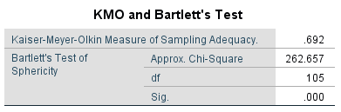
KMO Bartlett’s test of sphericity provides the Kaiser-Meyer-Olkin measure of sampling adequacy where if the data is adequate the KMO value should be greater than 0.6 (Zikmund et. al., 2013). As shown in table 4.1. The KMO value is 0.69 which indicates the sample is adequate and researcher can go ahead with further analysis.

2) Factor Loading/ Extraction/ Communalities
Figure 4.2 Communalities
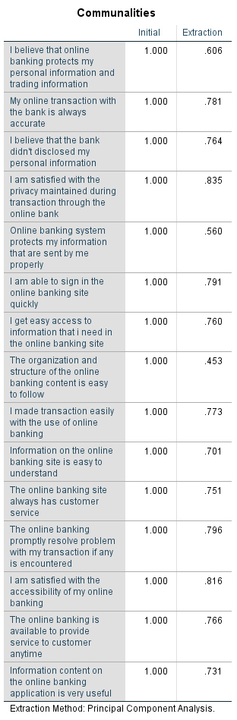
For factor loading testing, the dependent variables and independent variables are tested. The outcome from the independent variable showed that almost all item’s value are greater than 0.6 which considered acceptable (Kong and Liu, 2018). According to Hair et al (2014), for a factor to be deemed to be suitable for further analysis, the factor loading should be greater than 0.6. Therefore, in this analysis as shown in the results from the table 4.2 the factor loading is greater than 0.6.

3) Eigenvalue Table
Figure 4.3 Total Variance Explained
Component | Initial Eigenvalues |  |  | Extraction Sums of Squared Loadings
Component | Total | % of Variance | Cumulative % | Total | % of Variance | Cumulative %
1 | 5.598 | 37.320 | 37.320 | 5.598 | 37.320 | 37.320
2 | 1.536 | 10.243 | 47.563 | 1.536 | 10.243 | 47.563
3 | 1.336 | 8.907 | 56.470 | 1.336 | 8.907 | 56.470
4 | 1.271 | 8.470 | 64.941 | 1.271 | 8.470 | 64.941
5 | 1.141 | 7.607 | 72.548 | 1.141 | 7.607 | 72.548
6 | .948 | 6.323 | 78.870
7 | .600 | 4.002 | 82.873
8 | .593 | 3.952 | 86.824
9 | .505 | 3.368 | 90.193
10 | .470 | 3.131 | 93.323
11 | .335 | 2.236 | 95.559
12 | .242 | 1.615 | 97.174
13 | .186 | 1.237 | 98.411
14 | .127 | .847 | 99.259
15 | .111 | .741 | 100.000
Extraction Method: Principal Component Analysis.

The Eigenvalue ​​for certain factors indicates inconsistency within all variables. If the Eigenvalue is greater than one, it is regarded as significant. The construct and dimension should be more than 1 in other to be valid and proceed to the test (Cooper and Schinder 2013). Table 4.3 shows that the constructs are more than 1 which means that these constructs are valid for the study.

4.1.2 Reliability Test – Cronbach Alpha
Figure 4.4 Reliability Statistics
Cronbach's Alpha | Cronbach's Alpha Based on Standardized Items | N of Items
.768 | .817 | 15

The Reliability test is characterized as a statistical tool that is conducted in other to quantify the internal consistency of the variables under a factor, which can help ensure that the gathered information is reliable, and the instrument utilized in the study is valuable for analyzing (Baker, Ponton & Rovai, 2013). The reliability of the instrument is determined by computing the value of the Cronbach’s Alpha model. The reliability test for this research is done on 39 respondents’ data, collected for the pilot test. According to Hair et al. (2014), the value of Cronbach Alpha should be more than 0.7, if it is less than 0.7, item is not consistent and hence should be removed. However, from the above table 4.4 the Cronbach alpha’s value is above 0.7 which is 0.85 which means items in the questionnaire has good reliability.

4.2 Demographic Profile of Respondents
After the pilot testing was done, the questionnaires were distributed. Around 400 responses were expected, however received back on 334 responses. All data collected were usable as the study make used of online questionnaire (Google docs) in data collection process. The below table 4.5 shows the summary of questionnaire table.
Summary of questionnaire table
Table 4.5 Summary of Questionnaire Table
Items | Quantity
Questionnaires Distributed | 400
Questionnaires Collected | 334
Questionnaires Used for Analysis | 334

Therefore, descriptive analysis is required through which will help to provide the descriptive statistics on the data received from the respondents. Below table shows the demographic data of the respondents.

4.3 Frequency Descriptive Analysis
Table 3: Demographical Data of Respondents
Demographic | Item | Frequency | Percentage
Gender | Male | 271 | 81.1
Gender | Female | 63 | 18.9
Age | 21 – 30 | 258 | 77.2
Age | 31 – 40 | 76 | 22.8
Level of Education | High School | 93 | 27.8
Level of Education | Bachelor | 123 | 36.8
Level of Education | Master | 94 | 28.1
Level of Education | PHD | 24 | 7.3
Monthly Income | Below 2000 | 117 | 35.0
 | 2001 - 5000 | 109 | 32.3
 | 5000 - 8000 | 12 | 3.0
 | Above 8000 | 96 | 29.7

From the table 4.6 above shows that 81.1 percent of the respondent are Male. However, majority of the respondents in this research are between 21-30 years of age with a frequency of 77.2. 36.8% of the respondents has bachelor of degree as their level of education which account as the majority. The participants who earn below 2000 score the highest in this study with about 35.0%. However, the target population for this study was 400, however I could manage to get only 334 respondents till this moment.

4.4 Preliminary Analyses
Preliminary analysis is conducted after pilot test. The main objective or reason of preliminary data analysis is to prepare the data for future analysis, describe the factors of the data and summarize the findings or outcomes (Blischke et al., 2011).

4.4.0 Factor Analysis
Several tests were performed to confirm the validity of the constructs. Where Kaiser-Meyer-Olkin (KMO) followed by Bartlett’s tests were performed to measure the research data adequacy as well as to confirm the relationship of the constructs respectively (Pallant, 2011). The acceptable individual measure of sample adequacy (MSA) should be above 0.5, whereas the overall KMO should be greater than 0.6 (Kaiser, 1974 cited in Pallant, 2011). Where the significance value for Barlett’s test should be of p < 0.05. In Addition to this, communalities and component matrix were also examined that helped to confirm the validity of the research constructs. Hence, the communalities value should exceed 0.5 and 0.4 for component matrix correlation.

4.4.0.1 KMO Test
Figure 4.3.1 KMO and Barlett’s Test
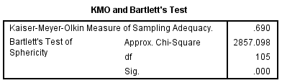
KMO Barlett`s test was conducted for the independent variables and the outcome of the significance value is greater than 0.6. The value of the dependent variable’s KMO is 0.754 which is greater than 0.6, indicating that the statistical significance is sufficient and further questions need not to be added. Therefore, since the KMO requirement is met by the dependent variables, the sample is adequate and investigator can continue with factor loading. Therefore, after considering all the 332 responses, as shown in table 4.3.1, the KMO value is 0.69 which indicates the sample is adequate.

4.4.0.2 Factor Loading
Table 4.3.2 Communalities Table
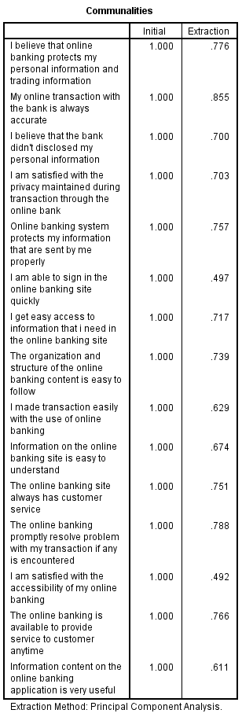
As shown in table 4.3.2, majority of the items have the factor loading value are above 0.5, which means these items are usable and acceptable for further analysis. The availability component matrix clearly shows that each load factor is above 0. 5, other common factors can be theoretically distributed and convergent, that is to say, the content of general factors can be well explained by general factors in the scale.

4.4.0.3 Eigenvalues
Figure 4.3.3 Eigenvalues
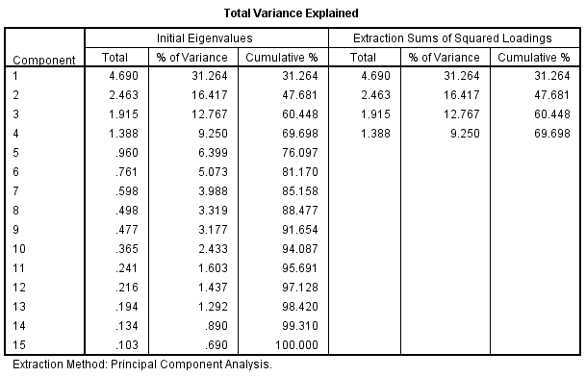
The Eigenvalue ​​is used identify if there is any inconsistency within all variables. If the Eigenvalue is greater than one, it is regarded as significant. As shown in the above table 4.3.3, In order to ascertain the most significant factors where all the factors with eigenvalues are greater than the cut-off criteria of 1 which means the constructs, or the dimensions are viable and appropriate for the study. Hence, it can be concluded that the scale taken for compensation are deemed to be adequate and appropriate for the conduct of further tests or analyses for this research as the KMO Bartlett’s test of Sphericity criteria have all been met (Pallant, 2011).

4.4.1 Reliability Test – Cronbach Alpha
Reliability analysis is one of the most important analysis used by researchers that helps to analyse the consistency of the variables, further by ensuring that they are consistent (Bryman and Bell, 2011). Where Cronbach’s Alpha is measured and values equal or greater than 0.7 is taken as having good internal consistency (Pallant, 2011). In addition, Gliem and Gliem (2003) emphasised that if the value ranged between 0.70 > 0.80 then it is considered as acceptable, if between 0.80 > 0.90 then the reliability is good and lastly any value above 0.90 has an excellent consistency.
Figure 4.3.4 Reliability Test
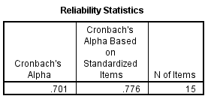
According to Hair et al. (2014), if the value of Cronbach alpha is more than 0.7, then the items designed in the questionnaire has excellent reliability but if the value is less than 0.7, the item is not consistent and hence should be removed. As shown in table 4.3.4, the value of Cronbach’s alpha is 0.70, which means the items in the questionnaire are reliable and indicates high internal consistency. However, the overall reliability analysis conducted shows good results indicating that the 21 items for independent as well as dependent variable are appropriate for further analyses.

4.5 Hypotheses Testing

4.5.0 Multiple Regression and One-way ANOVA Table
According to Schmidheiny (2016), multiple regressions refer to the statistical tool that is generally used to determine the relationship between one dependent variable and different independent variables by looking at the alpha value. If the alpha value is less than 0.05 the relationship is statistically significant, however if it greater than 0.05 it is not significant (Badgujar and Wani, 2018).

4.5.1 Beta Coefficient
Figure 4.4.1 Beta Coefficient Table
Coefficientsª
Model |  | Unstandardized Coefficients |  | Standardized Coefficients | t | Sig. | Collinearity Statistics
 |  | B | Std. Error | Beta | t | Sig. | Tolerance | VIF
1 | (Constant) | 2.610 | .324 |  | 8.065 | .000
1 | Securitytotal | .386 | .021 | .721 | 18.725 | .000 | .857 | 1.167
1 | Conveniencetotal | .067 | .029 | .089 | 2.308 | .000 | .847 | 1.181
1 | Usefulnesstotal | .030 | .026 | .042 | 1.169 | .000 | .987 | 1.014
a. Dependent Variable: DVtotal

The above table shows the coefficient for independent variables to dependent variables. The unstandardized beta represents the slope of line between the independent variable and dependent variable. Beta Coefficient is done to identify the factor with highest influence, which states that higher the value of beta coefficient, higher is the predictive value toward phenomenon, which means the standardized Beta will range from 0 to 1 or 0 to -1, depending on the direction of the relationship which means the closer to 1 or -1, the stronger the relationship. (Bougie & Sekaran, 2016). According to Hair et al. (2014), Multi-Collinearity is done to determine whether there are multiple overlaps and correlation between all variables which states that VIF has to be less than 10; if VIF is more than 10 means that factor is not strong predicter and will skew the results. From table 4.4.1, it is shown that the VIF is less than 10 which means the factors have strong predicter.

4.5.2 Model Summary
Figure 4.4.2 Model Summary table
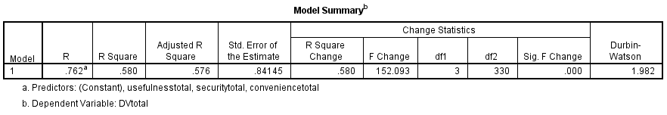
Multiple Regression is done to determine whether relationship exists between variables and whether the framework is able to explain/describe/predict the phenomenon (Bougie & Sekaran, 2013), which states two things; 1) if value is more than 0.5 it shows that it is at least 50% fit; anything less than 0.5, the model or construct is not fitting and doesn’t describe the relationship between variables, also 2) the nearer it is to 1 the stronger is the model fit (Zikmund et. al., 2013). As shown in table 4.4.2 the R square value is 0.580 which means the model is 50% fit and determines the relationship between the variables. Therefore, from the above table shows that all the independent variables have strong relationship with the dependent variable.

4.5.3 ANOVA
Figure 4.4.3 Anova table
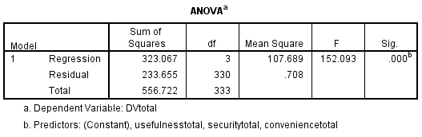
One-way ANOVA is done to determine the extent of variance within respondents or between respondents, through which it shows that the results or the p-value is less than 0.5 (Sedgwick, 2012). As shown in table 4.4.3 the p-value is less than 0.05, which shows the extent of variance within the respondents.

4.6 Summary of Findings
This chapter highlighted the research findings based on the data analysis. SPSS statistical software version 22.0 was mainly used to measure the hypotheses testing. Data are tested sequentially by factor analysis, reliability testing, and hypothesis testing to be sure that the adapted items are relevant and appropriate to this research. The investigator conducted preliminary tests multiple regressions separately to verify the hypothesis significance to the proposed dependable variable. The findings show that there is significance relationship between the independent variables and the dependent variable which is consumer behavior towards online banking system in Nigeria. Based on the p-value, the H1, H2 and H3 is accepted, which means the perceived convenience, perceived security and perceived usefulness has a significant influence on consumer behavior towards online banking system in Nigeria.

Chapter 5: Conclusion and Recommendation

5.0 Summary
This study analyzed the factors influencing consumer behavior towards online banking system in Nigeria. It assessed three factors that are expected to influence the consumer behavior with the aim of identifying the reason of why online banking has been decreasing in the past few years and come up with a recommendation to improve the banking system in Nigeria. However, the data was collect with the use of online questionnaire by which several tests were conducted including factor analysis, reliability test, descriptive analysis and multiple regression to analyze the data, whereby Descriptive analysis to identify variable characteristics in terms of relative proportions, standard deviation, standard deviation, frequency and distribution; reliability test was performed to assess the internal consistency of the items before factor analysis; factor analysis was implemented to decrease the number of variables to an appropriate level and group the elements that represent variables into items into independent dimensions; Multiple regression analyzes was executed to demonstrate statistical significance between dependent and independent variables and were used to statistically confirm whether the relationship between dependent and independent variables is affected by other factors.
However, in this study, a total number of 400 questionnaire was distributed which only 334 received back. The survey questions were structured in a way to determine the factors influencing consumer behavior towards online banking system in Nigeria with regard to perceived convenience, perceived security as well as perceived usefulness. The analysis was done based on the survey outcome (334 respondents) where the findings shows that perceived convenience, perceived security as well as perceived usefulness has significance influence on consumer behavior toward online banking in Nigeria.

5.1 Recommendation
Further studies are recommended to be continued in the future to assess and re-confirm more factors that can influence consumer behavior towards online banking in Nigeria to help both the academic world to obtain more detailed references for future studies and the banking institutions. However, majority of the respondents are still afraid of the security of the service due to the absence of physically present security personnel, it is necessary to provide information to the respondents how to maintain their personal security. Similarly, Nigerian Banks should take security of their Internet banking sites into serious consideration since fraud and websites hacking still haunt most of the users. However, it also recommended that banks in Nigeria should not attached unnecessary charges to their customer for the online banking services as users have to incur other costs.
The banks should make sure that the costs of transacting manually within the branch does not exceed the costs of online banking system. Small transaction costs are quite burdensome, it is recommended that transaction costs are adjusted for the transaction size. Features too many views that are often confusing for beginners, should be simplified for the front page. The Banks should make their customer more aware of their new services so as to encourage higher adoption rate. However, Nigerian banks can consider targeting their promotional activities towards those in the younger business personnel who are quite flourishing as they are more likely to use the online banking system. Equipment often damaged, presumably there is a system that can notify in real time that equipment is damaged so that the respondent did not already transact.

5.2 Limitations
Some of the major constraint in this study is the time frame which have only 10 weeks which is considered as very short period, because of the limited time the researcher could not distribute and collect an effective questionnaire for respondents from all over the country, so the basic information collected may not be as powerful and accurate as to support the outcomes. However, Nigeria is one of the biggest countries in Africa with people of different living standards, cultures and income levels, therefore to obtain more accurate baseline data, the researcher needs to collect information from each part of the country that uses online banking system. Factors influencing consumer behavior are many and changeable, except those three critical factors discussed in this research, therefore, other variables are encouraged to be explored in further study related to customer satisfaction with online banking.
Ineffective items were deleted before proceeding with the analysis on SPSS, however, there may still be inaccurate data for the remaining questionnaire from respondents to the proposed question, especially the items for the variables in this research. Meaning that the respondents might just fill the results with being fully honest or accurate and these data can still lead to inaccurate results. In the social demographic descriptive analysis, it illustrates that 77.2% of the participants are within the age range of 21 – 30 years old. It could result of the data gathered being centralized in this age range, which may also lead to results which are no accurate. In addition, future research should increase the sample size and gather more information regarding consumer behavior on the online banking. However, this study offers and recommends direction for future research is strengthening the findings and overcoming limitations. Future researches are recommended to expand a study range on the more different occupation people, which means that not just focus on several occupations, but also the people who do not have a job or retire people.

5.3 Conclusion
Online banking is likely to become more important in the growing global economy based on technology and information. Therefore, financial institutions must provide better quality in terms of products and services, thus increasing market competitiveness. Considering that many factors may affect consumers' attitude towards online banking, it is very important to investigate the consumers and understand the factors influencing consumer behavior.
Based on previous literature, SERVQUAL model was chose by many scholars in other to study service quality, while online banking should not only pay attention to service quality, but also to the systematic factors brought by science and technology. Therefore, this research proposed the framework and made a questionnaire based on the TAM model to study the relationship between perceived convenience and security, perceived usefulness to study the consumer behavior towards online banking system in Nigeria. The results show that consumer behavior towards online banking in Nigeria is positively correlated with perceived convenience, perceived security and perceived usefulness.

5.5 Personal Reflection
While conducting this research, I reviewed a lot of previous study in writing literature reviews and has identified numerous academic articles to obtain a deeper knowledge and understanding of consumer behavior towards online banking system in Nigeria. Moreover, once the research was completed, I have gain a better idea of the Technological Acceptance Model (TAM) and how it is used to identify consumer behavior. The main benefit that I gain from conducting this study is that the I have learned how to employ SPSS to execute results and analyze data in a study. This selected topic of the study is a topic in which I have very great interest in. however, under the guidance of Dr. Arasu Raman, I have erudite how to effectively complete studies in a limited period of time with high-quality.
Generally speaking, with Dr. Arasu’s professional guidance, the investigator have gained a lot of knowledge of the overall research and learning in an enjoyable and valuable way. It was a big relief for me to have obtained valid responses for the questionnaire in a very short period of time and to have finished the study in a successful way and on time.

6.0 Reference
  - Factors influencing the adoption of internet banking: An integration of TAM and TPB with perceived risk and perceived benefit. Electronic Commerce Research and Applications, 8(3), 130–141 | 10.1016/j.elerap.2008.11.006. 2019. Sci-Hub | Factors influencing the adoption of internet banking: An integration of TAM and TPB with perceived risk and perceived benefit. Electronic Commerce Research and Applications, 8(3), 130–141 | 10.1016/j.elerap.2008.11.006. [ONLINE] Available at: https://sci-hub.tw/https://doi.org/10.1016/j.elerap.2008.11.006. [Accessed 22 February 2019].

  - Abdalslam, S., 2013. The Adaptation of E- Commerce in Malaysia. International Journal of Engineering Research and Development, 7(2278-800X), pp. 36-42.

  - Abdulkadir, L. M. M. and Khadija, 2012. An overview of e-commerce implementation in developed and developing country; A case study of United State and Nigeria. International Journal of Modern Engineering Research (IJMER), 2(ISSN: 2249-6645), pp. 3068-3080.

  - Ahmad, S. Z. and Bakar, A. R. A., 2015. An Empirical Study of Factors Affecting e-commerce Adoption among Small- and Medium Sized Enterprises in a Developing Country:Evidence from Malaysia. Information Technology for Development, 21(ISSN: 0268-1102), pp. 555-572.

  - Alexopoulos, E. C., 2010. Introduction to Multivariate Regression Analysis. Hippokratia, Volume 14, pp. 23-28.

  - AliResearch, 2017. E-commerce and inclusive growth in China,.

  - AlHaliq, H. A. and AlMuhirat, A. A., 2016. Customer Satisfaction with Electronic Banking Services in the Saudi Banking Sector. Asian Social Science, 12(ISSN 1911-2017 ), pp. 139-146.

  - Alwan, H. A. and Al-Zubi, A. I., 2016. Determinants of Internet Banking Adoption among Customers of Commercial Banks: An Empirical Study in the Jordanian Banking Sector. International Journal of Business and Management, Volume 11, pp. 95-104.

  - Apak, S. and Ataya, E., 2013. An Overview of GDP and Internet Banking Relations in the European Union Versus China. In: Procedia - Social and Behavioral Sciences. s.l.:s.n., pp. 36-45.

  - Awan, M. A., 2016. Online Banking: A Comparative Study Of Chinese And Saudi Customers Perceptions Of Service Quality. Journal of Internet Banking and Commerce, Volume 21.

  - Azizan, N. B., 2013. The Adaptation of E- Commerce in Malaysia. International Journal of Engineering Research and Development, 7(2278-800X), pp. 36-42.

  - Baghdadi, Y., 2013. From E-commerce to Social Commerce: A Framework to Guide Enabling Cloud Computing. Journal of Theoretical and Applied Electronic Commerce Research, 8(ISSN 0718-1
  - BaharŞanlı, 2015. Development of Internet Banking as the Innovative Distribution Channel and Turkey Example. Social and Behavioral Sciences, Volume 195, pp. 343-352.
  - Barquin, S. and HV, V., 2015. Digital Banking in Asia: What do consumers really want?, s.l.: McKinsey & Company .

  - Bartlett, L., 2013. Pilot Test for Reliability and Validity of a New Assessment Tool Measuring Relationships between Individual Health and Environmental Sustainability. Health and Sustainability Assessment Tool, Volume 1-51.

  - Begum, N. J. a. N., 2012. The role of perceived usefulness, perceived ease of use, security and privacy, and customer attitude to engender customer adaptation in the context of electronic banking. African Journal of Business Management, Volume 2.

  - Bhatt, A., 2016. Factors Affecting Customer’s Adoption of Mobile Banking Services. Journal of Internet Banking and Commerce, Volume 21.

  - Bolarinwa, O. A., 2015. Principles and Methods of Validity and Reliability Testing of Questionnaires Used in Social and Health Science Researches. Nigerian Postgraduate Medical Journal, Volume 22, pp. 195-201.

  - Cecilia, 2015. E-banking Replacing Over 80% of China’s Banking Transactions,

  - Chatzoudes, D. M. S., 2013. An examination of the critical factors affecting consumer acceptance of online banking A focus on the dimensions of risk. Journal of Systems and Information, 15(1328-7265), pp. 97-116.

  - Chavan, J., 2013. Internet Banking- Benefits And Challenges In An Emerging Economy. International Journal of Research in Business, Volume 1, pp. 19-26.

  - Chen, Y. and Barnes, S. J., 2007. Initial trust and online buyer behaviour. Industrial Management and Data Systems, pp. 21-36.

  - Clemes, M. D., 2012. The factors impacting on customers' decisions to adopt Internet banking. Banks and Bank Systems, Volume 7.

  - Cronbach, L. J., 1951. Coefficient alpha and the internal structure of tests. Psychometrika, Volume 16, pp. 297-334.

  - Dan, C., 2014. Electronic Commerce: State-of-the-Art. American Journal of Intelligent Systems, pp. 135-141.

- Consumer Behaviour: a Literature Review. The Marketing Review, 2(3), 319–355 | 10.1362/1469347012569896. 2019. Sci-Hub | Consumer Behaviour: a Literature Review. The Marketing Review, 2(3), 319–355 | 10.1362/1469347012569896. [ONLINE] Available at: http://sci-hub.tw/10.1362/1469347012569896. [Accessed 23 February 2019].
- Research-Methodology. 2019. A Brief Literature Review on Consumer Buying Behaviour . [ONLINE] Available at: https://research-methodology.net/a-brief-literature-review-on-consumer-buying-behaviour/. [Accessed 24 February 2019].

- elvin Okafor. 2018. How many banks are in Nigeria today? ▷ Legit.ng. [ONLINE] Available at: https://www.legit.ng/1101269-how-banks-nigeria-today.html.

- THISDAYLIVE. 2018. Mobile Banking Grows as Phone Users Hit 29 Million - THISDAYLIVE. [ONLINE] Available at: https://www.thisdaylive.com/index.php/2017/08/24/mobile-banking-grows-as-phone-users-hit-29-million/.

- Impact of ICT and related problems on online banking in Nigerian Banks. 2018. Impact of ICT and related problems on online banking in Nigerian Banks. [ONLINE] Available at: https://www.slideshare.net/taufiqghilan/impact-of-ict-and-related-problems-on-online-banking-in-nigerian-banks.

- Employee's Perception of Change Effect as a Competitive Advantage on Nigeria Banking Industry: An Empirical Analysis - ScienceDirect. 2018. Employee's Perception of Change Effect as a Competitive
- Advantage on Nigeria Banking Industry: An Empirical Analysis - ScienceDirect. [ONLINE] Available at: https://ac.els-cdn.com/S1877042814051106/1-s2.0-S1877042814051106-main.pdf?_tid=8f7dfe98-301b-44e3-92df-0dbcf359b9ea&acdnat=1541740774_95bfb7ca32276a2ab7744b3cac25c830

- The Adoption of Internet Banking in Nigeria: An Empirical Investigation | Open Access Journals. 2018. The Adoption of Internet Banking in Nigeria: An Empirical Investigation | Open AccessJournals. [ONLINE] Available at: http://www.icommercecentral.com/open-access/the-adoption-of-internet-banking-in-nigeria-an-empirical-investigation-1-9.php?aid=38546.

- THISDAYLIVE. 2018. Mobile Banking Grows as Phone Users Hit 29 Million - THISDAYLIVE. [ONLINE] Available at: https://www.thisdaylive.com/index.php/2017/08/24/mobile-banking-grows-as-phone-users-hit-29-million/.

- Impact of ICT and related problems on online banking in Nigerian Banks. 2018. Impact of ICT and related problems on online banking in Nigerian Banks. [ONLINE] Available at: https://www.slideshare.net/taufiqghilan/impact-of-ict-and-related-problems-on-online-banking-in-nigerian-banks.

- Consumer behavior on Reliability and Responsiveness of Self Service Technology for Retail Banking Services - ScienceDirect. 2018. Customer Satisfaction on Reliability and Responsiveness of Self Service Technology for Retail Banking Services - ScienceDirect.
- [ONLINE] Available at: https://ac.els-cdn.com/S2212567116300867/1-s2.0-S2212567116300867-main.pdf?_tid=6a114a02-dd49-48aa-b007-df9a9f369848&acdnat=1538982180_a415359a18d9019ee5ff7cf3b43d60e9

- INT E-Resources. 2018. INTI E-Resources. [ONLINE] Available at: http://web.a.ebscohost.com.ezproxy.inti.edu.my:2048/ehost/pdfviewer/pdfviewer?vid=9&sid=a047f063-968a-487b-978e-a5fffb81bd46%40sdc-v-sessmgr01

- International Journal of Management and Commerce Innovations ISSN 2348-7585 (Online) Vol. 4, Issue 1, pp: (491-498), Month: April 2016 - September 2016, Available at: www.researchpublish.com

- Prioritizing Factors Affecting Customer Satisfaction in the Internet Banking System Based on Cause and Effect Relationships - ScienceDirect. 2018. Prioritizing Factors Affecting Customer Satisfaction in the Internet Banking System Based on Cause and Effect Relationships - ScienceDirect. [ONLINE] Available at: https://ac.els-cdn.com/S2212567116300326/1-s2.0-S2212567116300326-main.pdf?_tid=ec6c78b2-c43d-42e8-80ac-22e2e1dca7ff&acdnat=1539007506_fa487cfe6caad14d9c07e72abef41062

- (PDF) The Impact of Online Banking on the Performance of Nigerian Banking Sector. Available from: https://www.researchgate.net/publication/323830125_The_Impact_of_Online_Banking_on_the_Performance_of_Nigerian_Banking_Sector
- Musa et al ( 2015) The Impact of Online Banking on the Performance of Nigerian Banking Sector

- Ahmad, S. Z. and Bakar, A. R. A., 2015. An Empirical Study of Factors Affecting e-commerce Adoption among Small- and Medium Sized Enterprises in a Developing Country:Evidence from Malaysia. Information Technology for Development, 21(ISSN: 0268-1102), pp. 555-572.

- Asad et al Prioritizing Factors Affecting Customer Satisfaction in the Internet Banking System Based on Cause and Effect Relationships……1st International Conference on Applied Economics and Business, ICAEB 2015

- Tabari, N. A. Y. and Pamsari, M. M. P., 2016. . Investigating effective factors on customer satisfaction of Internet banking (The Case of Post Bank of Iran). International journal of humanities and cultural studies, pp. 1706-1718.

- Understanding Consumer behavior of Internet Banking: A Case Study In Malacca - ScienceDirect. 2018. Understanding consumer behavior of Internet Banking: A Case Study In Malacca - ScienceDirect. [ONLINE] Available at: https://ac.els-cdn.com/S221256711630096X/1-s2.0-S221256711630096X-main.pdf?_tid=b76dc749-3af0-4403-a4d8-e7821ba0d4e0&acdnat=1539072268_f1e8d77609d3e5ad3c4af6861cabeebb

- Munusamy J, Run ECD, Chelliah S, Annamalah S (2012) Adoption of Retail Internet Banking: A Study of Demographic Factors 17: 1-14.

- Jolly, V., 2016. The Influence Of Internet Banking On The Efficiency And Cost Savings For Banks’ Customers. International journal of social sciences and management, 3(DOI: 10.3126/ijssm.v3i3.15257), pp. 163-170.

- Kumar, G. G. and George, A., 2013. Antecedents of Customer Satisfaction In Internet Banking: Technology Acceptance Model (TAM) Redefined. Global Business Review, Volume 14, p. 627–638.

- Kumar, G. G. and George, A., 2013. Antecedents of Customer Satisfaction In Internet Banking: Technology Acceptance Model (TAM) Redefined. Global Business Review, Volume 14, p. 627–638.

- Consumer use of mobile banking (M-Banking) in Saudi Arabia: Towards an integrated model - ScienceDirect. 2018. Consumer use of mobile banking (M-Banking) in Saudi Arabia: Towards an integrated model - ScienceDirect. [ONLINE] Available at: https://www.sciencedirect.com/science/article/pii/S0268401218306935

- BaharŞanlı, 2015. Development of Internet Banking as the Innovative Distribution Channel and Turkey Example. Social and Behavioral Sciences, Volume 195, pp. 343-352.
- Barquin, S. and HV, V., 2015. Digital Banking in Asia: What do consumers really want?, s.l.: McKinsey & Company .

- Bartlett, L., 2013. Pilot Test for Reliability and Validity of a New Assessment Tool Measuring Relationships between Individual Health and Environmental Sustainability. Health and Sustainability Assessment Tool, Volume 1-51.

- Begum, N. J. a. N., 2012. The role of perceived usefulness, perceived ease of use, perceived security and privacy, and customer attitude to engender customer adaptation in the context of electronic banking. African Journal of Business Management, Volume 2.

- Bhatt, A., 2016. Factors Affecting Customer’s Adoption of Mobile Banking Services. Journal of Internet Banking and Commerce, Volume 21.

- Bolarinwa, O. A., 2015. Principles and Methods of Validity and Reliability Testing of Questionnaires Used in Social and Health Science Researches. Nigerian Postgraduate Medical Journal, Volume 22, pp. 195-201.

- Cecilia, 2015. E-banking Replacing Over 80% of China’s Banking Transactions,
- Chatzoudes, D. M. S., 2013. An examination of the critical factors affecting consumer acceptance of online banking A focus on the dimensions of risk. Journal of Systems and Information, 15(1328-7265), pp. 97-116.

- Chavan, J., 2013. Internet Banking- Benefits and Challenges In An Emerging Economy. International Journal of Research in Business, Volume 1, pp. 19-26.
- Chen, Y. and Barnes, S. J., 2007. Initial trust and online buyer behaviour. Industrial Management and Data Systems, pp. 21-36.

- Study of Young Non-Muslim Consumers in Thailand. IRA-International Journal of Management & Social Sciences (ISSN 2455-2267), 6(3), p.354.
- Medium. (2019). Customer Decision Making Criteria and the Importance of Price. [online] Available at: https://medium.com/stax-insights/consumer-decision-making-criteria-and-the-importance-of-price-1783d5589a8e [Accessed 6 Mar. 2019].
- Mei, O.J., Ling, K.C. and Piew, T.H., 2012. The antecedents of green purchase intention among Malaysian consumers. Asian Social Science, 8(13), p.246.
- Mirabi, V., Akbariyeh, H. & Tahmasebifard, H. (2015). A Study of Factors Influenceing on Customers Purchase Intention. Journal of Multidisciplinary Engineering Science and Technology (JMEST), 2(1), pp.267-273. (DV3)
- Merchandizing: A Study on Fashion Merchandizing in Thailand. SSRN Electronic Journal.
- Setia, M. (2016). Methodology series module 3: Cross-sectional studies. Indian Journal of Dermatology, 61(3), p.261.
- Sevanandee, B. and Damar-Ladkoo, A., 2018. Country-of-Origin Effects on Consumer Buying Behaviours. A Case of Mobile Phones. Studies in Business and Economics, 13(2), pp.179-201.
- Shah Alam, S. and Mohamed Sayuti, N., 2012. Applying the Theory of Planned Behavior (TPB) in halal food purchasing. International journal of Commerce and Management, 21(1), pp.8-20.
- Shah, S., Aziz, J., Jaffari, A., Waris, S., Ejaz, W., Fatima, M and Sherazi, S. (2012). The Impact of Brands on Consumer Purchase Intentions. Asian Journal of Business Management, 4(2), PP.105-110.
- Stan, S., 2018. An analysis of changing customer attitude towards smartphones, considering whether a technological plateau has been reached: research focusing on comparison of Romanian and British customers (Doctoral dissertation).
- Stoenescu, R.D., 2014. Country-of-Origin and its Influence on Consumers’ Buying Intention–A Conceptual Study. International Journal of Economic Practices and Theories, 4(5), pp.824-828.

- Chen, C.C., Chen, C.W. and Tung, Y.C., 2018. Exploring the Consumer Behavior of Intention to Purchase Green Products in Belt and Road Countries: An Empirical Analysis. Sustainability, 10(3), p.854.
- Chen, H., Tsai, B. and Hsieh, C. (2017). Determinants of Consumers’ Purchasing Intentions for the Hydrogen-Electric Motorcycle. Sustainability, 9(8), p.1447.
- Chen, X., Hu, Y., Zhu, D., Li, J. and Zhou, L. (2015). Chinese version of the Aging Perceptions Questionnaire (C-APQ): assessment of reliability and validity. Aging & Mental Health, 20(6), pp.567-574.
- Dachyar, M. & Banjarnahor, L. (2017). Factors influencing purchase intention towards consumer-to-consumer e-commerce. Intangible Capital, 13(5), p.948.
- Dachyar, M. & Banjarnahor, L. (2017). Factors influencing purchase intention towards consumer-to-consumer e-commerce. Intangible Capital, 13(5), p.948.
- Devanoorkar, A. (2016). Profile of Patients with Periodontal Disease: A Descriptive Study. Annals of International Medical and Dental Research, 2(5).
- Ehsani, Z. and Ehsani, M. (2014). Effect of Quality and Price on Customer Satisfaction and Commitment in Iran Auto Industry. International Journal of Service Science, Management and Engineering, 1(5), pp. 52-56.
- Etikan, I. (2017). Combination of Probability Random Sampling Method with Non Probability Random Sampling Method (Sampling Versus Sampling Methods). Biometrics & Biostatistics International Journal, 5(6).
- Garten, J. E. (2012). When everything is made in China. Bloomberg Business Week Magazine.
- Garten, J. E. (2012). When everything is made in China. Bloomberg Business Week Magazine.
- Giampietri, E., Verneau, F., Del Giudice, T., Carfora, V. and Finco, A., 2018. A Theory of Planned behaviour perspective for investigating the role of trust in consumer purchasing decision related to short food supply chains. Food Quality and Preference, 64, pp.160-166.
- Griffiths, D. and Mullock, A. (2017). Cosmetic Surgery: Regulatory Challenges in a Global Beauty Market. Health Care Analysis, 26(3), pp.220-234.
- Griffiths, D. and Mullock, A. (2017). Cosmetic Surgery: Regulatory Challenges in a Global Beauty Market. Health Care Analysis, 26(3), pp.220-234.
- Haque, A., Anwar, N., Yasmin, F., Sarwar, A., Ibrahim, Z. & Momen, A. (2015). Purchase Intention of Foreign Products. SAGE Open, 5(2), pp.1-12.
- Harsono, S., Perdana, S., Riyadi, D. and Normasita (2018). The Influence of Brand Image, Brand Trust, Perceived Quality and Perceived Value on Consumer Purchase Intention at Different Categories of Product. Advanced Science Letters, 24(5), pp.3198-3207.
- Hartmann, P. and Apaolaza-Ibáñez, V., 2012. Consumer attitude and purchase intention toward green energy brands: The roles of psychological benefits and environmental concern. Journal of business Research, 65(9), pp.1254-1263.
- Hittner, J. (2016). On Correctly Adjusting the Squared Multiple Correlation Coefficient in Linear Regression: Effect Size Estimation and Significance Testing with Application to Substance Abuse Research. Journal of Drug Abuse, 02(02).
- Hoque, K., Kamaluddin, M., Abdul Razak, A. and Abdul Wahid, A. (2016). Building healthy eating habits in childhood: a study of the attitudes, knowledge and dietary habits of schoolchildren in Malaysia. PeerJ, 4, p.e2651.
- Hussain, R. and Ali, M. (2015). Effect of Store Atmosphere on Consumer Purchase Intention. SSRN Electronic Journal.

7.0 Appendix

Appendix- 1 Literature Review
Author name and year | Journal | DV | IV
Hanafizadeh (2014) | Systematic review on internet adoption | x
Al-jabir and Sohail (2012) | Mobile banking adoption |  | X
Suki (2010) | Factors affecting online banking |  | X
Foon (2011) | Intenet banking adoption in Kuala lampur |  | X
Raman and Chien (2013) | Digital banking make transaction more trusted and secure | x
Ugwu and Onyearboy (2012) | Banking sector reform in Nigeria | x
Ola and Oyewole (2014) | Internet banking functionality in Nigeria | x
Oluwatolani (2011) | Technology in Nigerian banking industry |  | X

Appendix 2- Questionnaire

Dear Sir/Maam,
I am Farouq Salisu Lawal studying for Master of Business Administration at INTI International University. As part of my course I am undertaking a dissertation and am writing to request your help with my research. The title of my research is ‘Consumer behavior towards online banking system in Nigeria’. This project is under the supervision of Mr. Arasu Raman.
I would be very grateful if you will complete the enclosed questionnaire. You might take approximately 10 to 20 minutes to complete it. Please answer the questions based on your opinions by providing accurate information. Any data that you provide to me will be treated with total confidence which will be used for this research purpose only. You have the right to not take part and withdraw at any time. your cooperation is highly appreciated.
Yours faithfully
Farouq Salisu Lawal
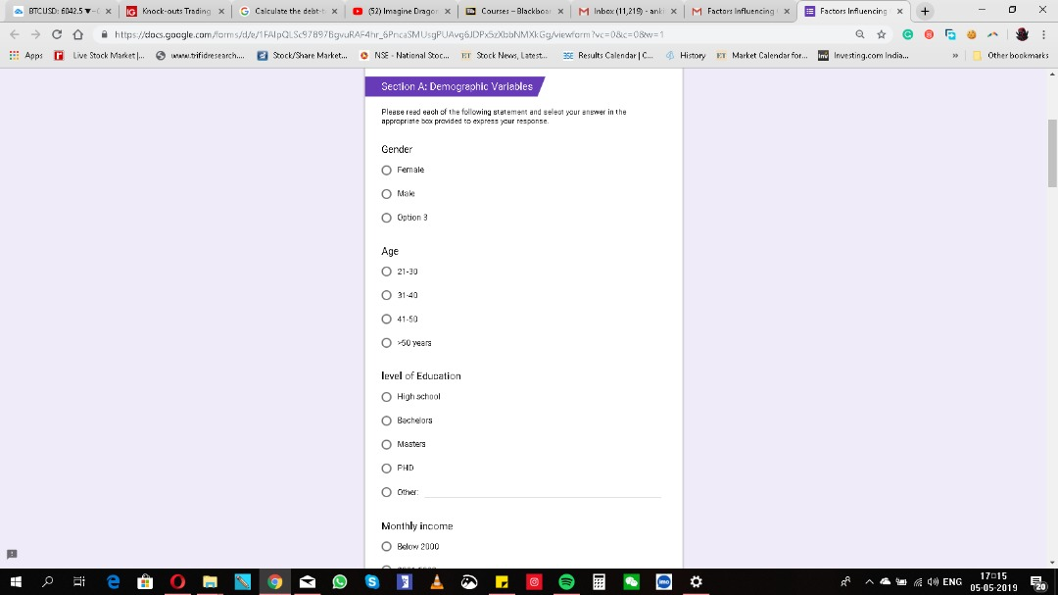

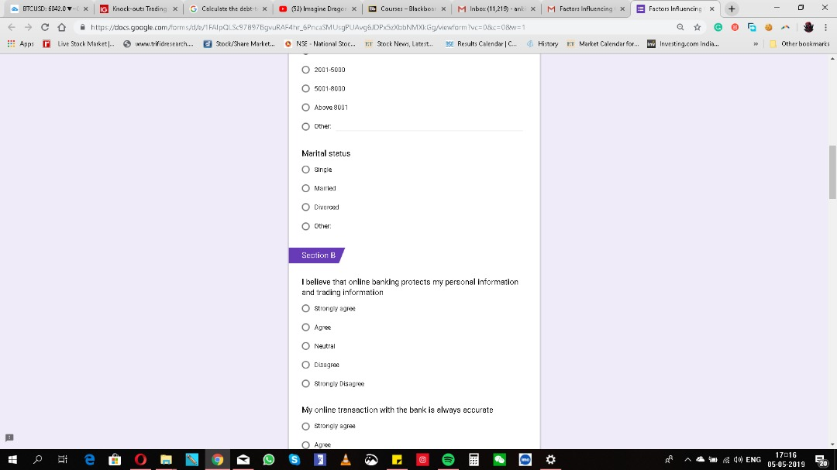

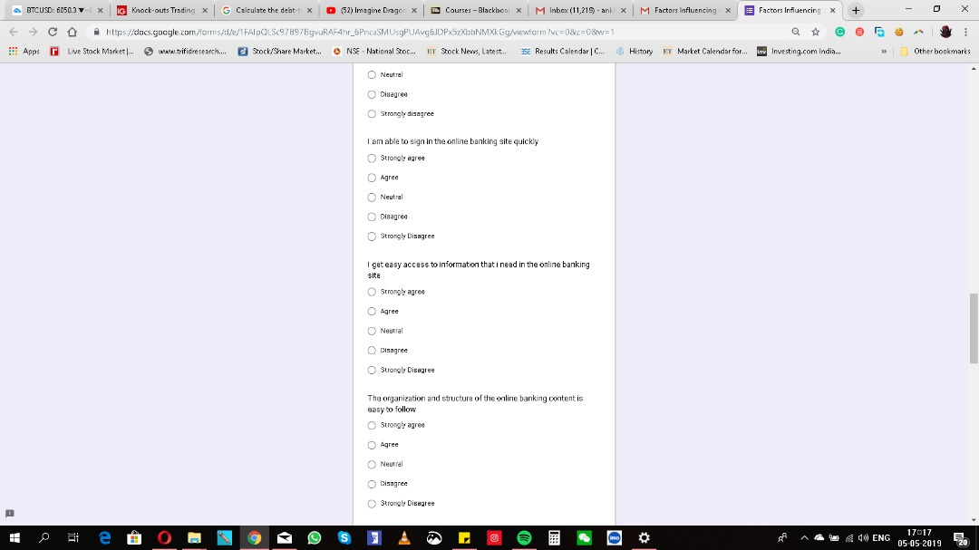

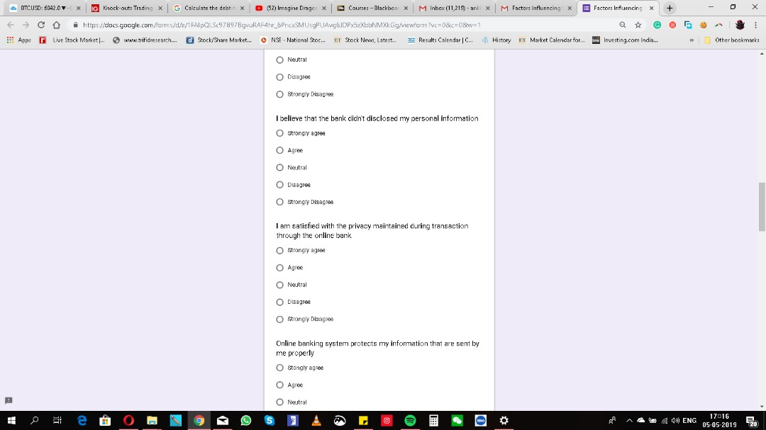

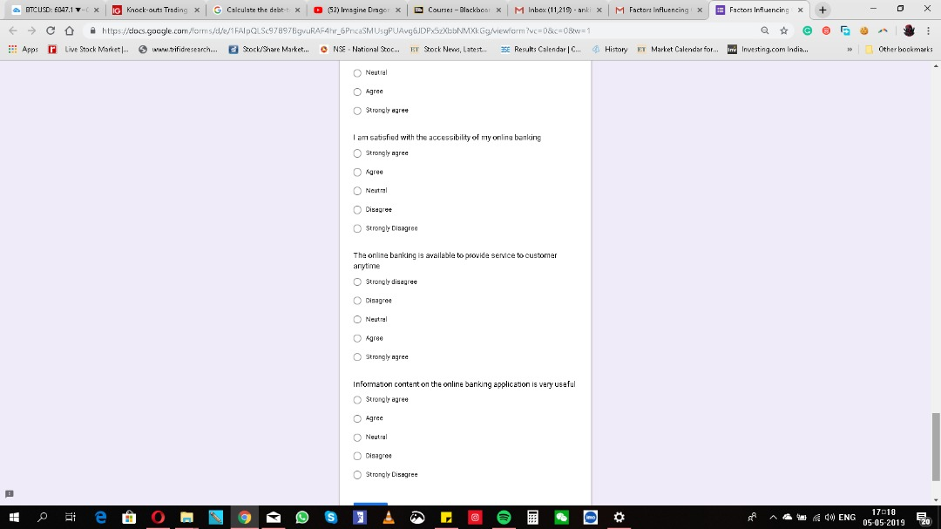

Appendix 3：MBA Project Log
Student Name: | Farouq Salisu Lawal
Supervisor’s Name: | Dr. Arasu
Dissertation Topic:
Factors Influencing Consumer Behavior Towards Online Banking in Nigeria

SECTION A. MONITORING STUDENT DISSERTATION PROCES
The plan below is to be agreed between the student & supervisor and will be
Activity | Milestone/Deliverable Date
Activity | 14/01 | 24/01 | 05/02 | 13/02 | 19/03 | 05/03 | 11/03 | 14/03 | 28/04 | 30/04
1st Meeting | √
2nd Meeting |  | √
3rd Meeting |  |  | √
4th Meeting |  |  |  | √
5th Meeting |  |  |  |  | √
6th Meeting |  |  |  |  |  | √
7th Meeting |  |  |  |  |  |  | √
8th Meeting |  |  |  |  |  |  |  | √
9th Meeting |  |  |  |  |  |  |  |  | √
10th Meeting |  |  |  |  |  |  |  |  |  | √
monitored against progress made at each session.

Section B: Record of Meetings
The expectation is that students will meet their supervisors up to seven times and these meetings should be recorded.
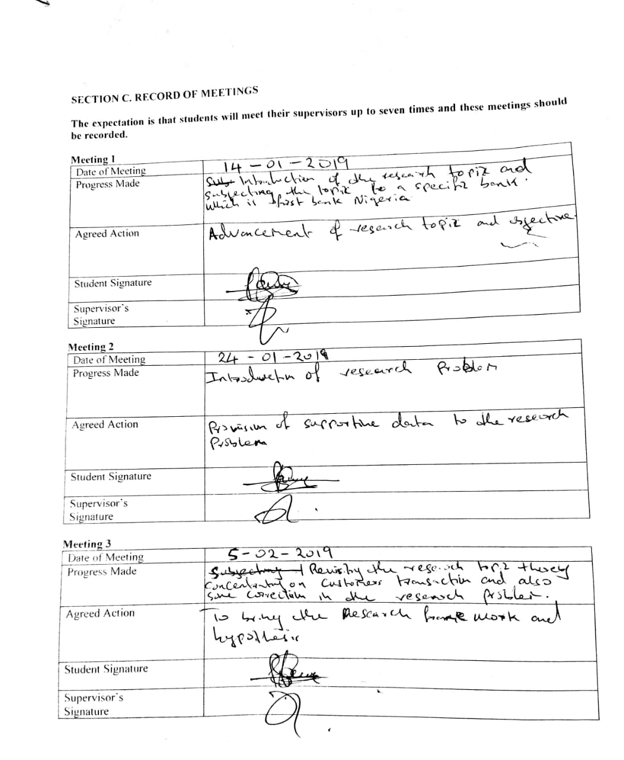

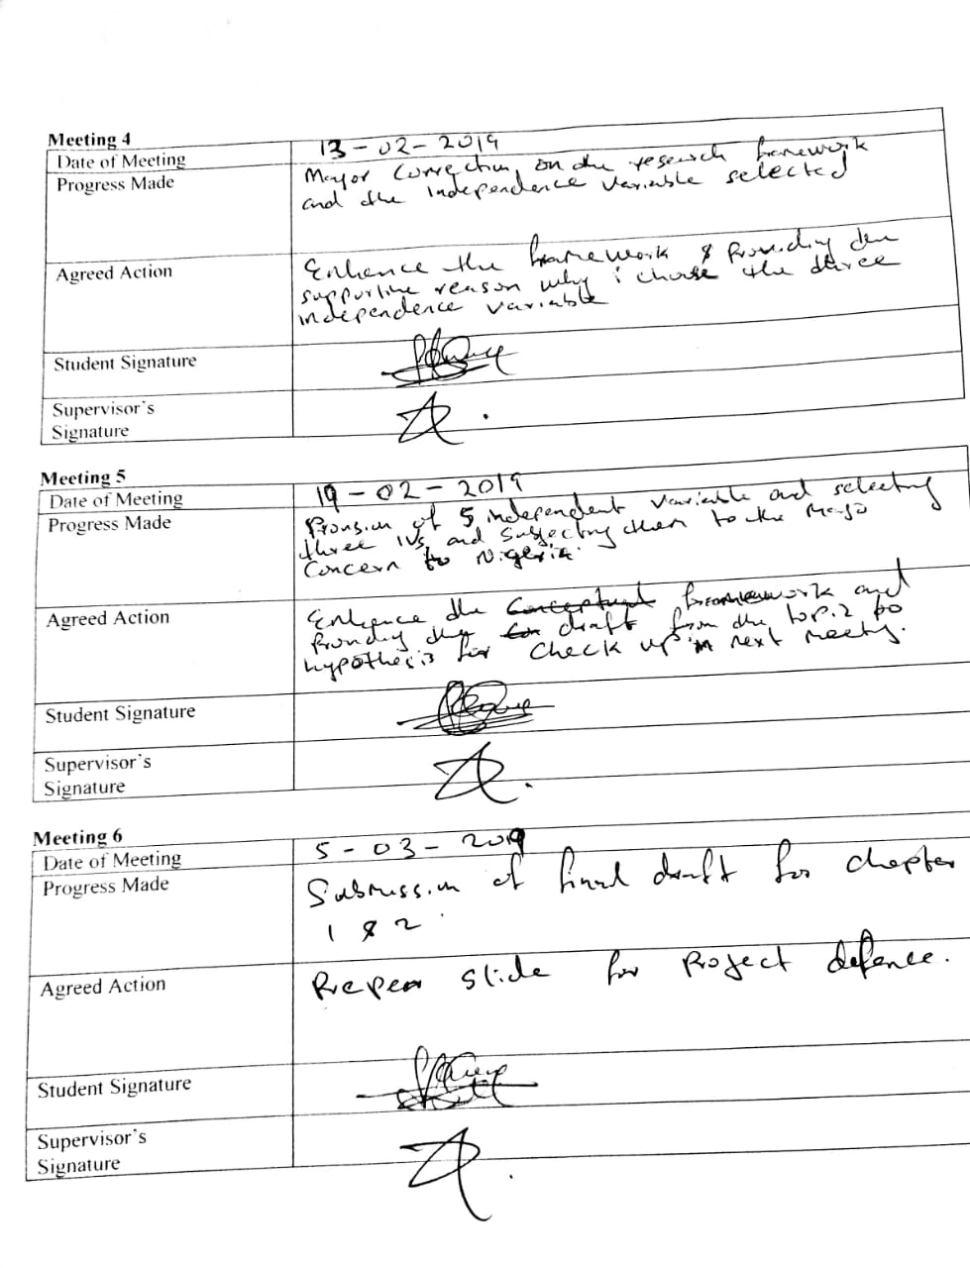

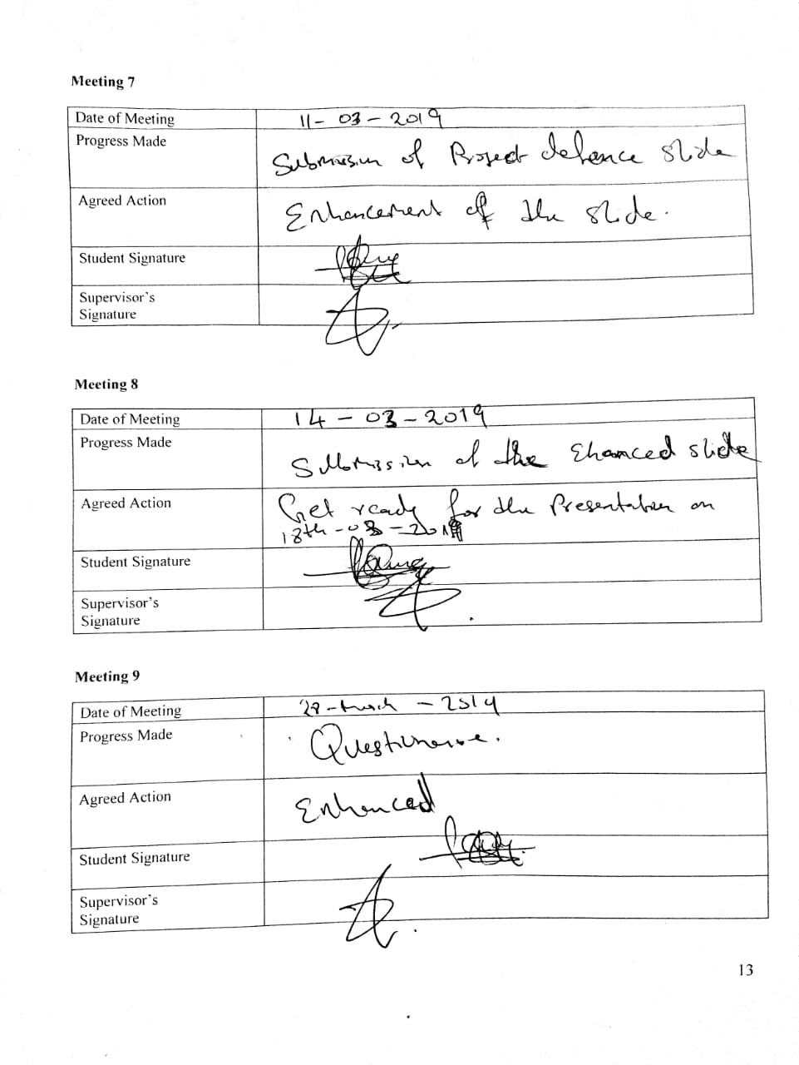


Appendix 4: Turnitin Report

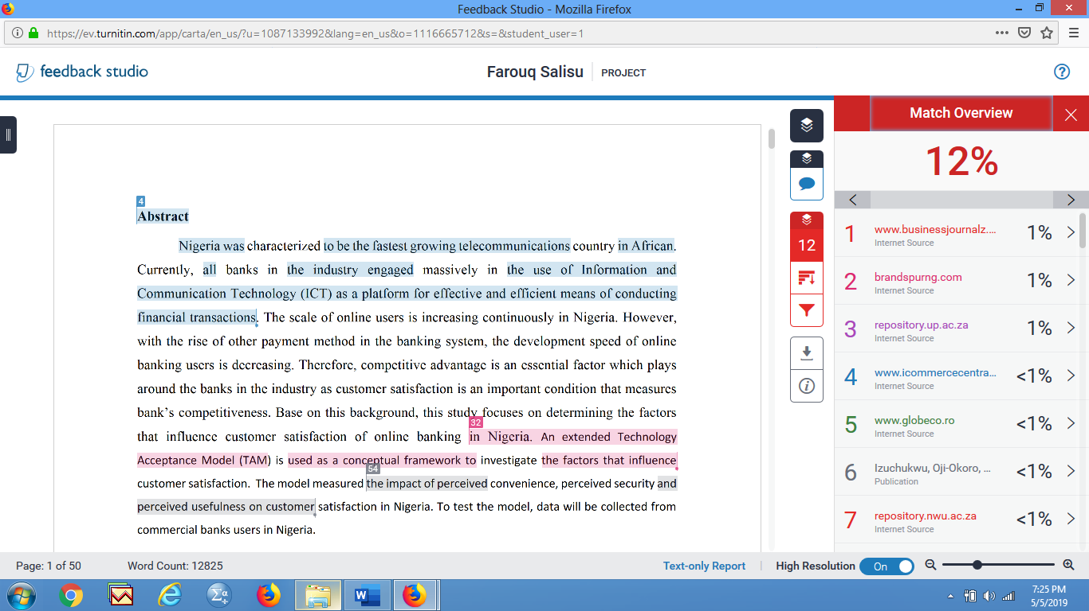

s

Appendix 5: SPSS Output
Pilot test

Total Variance Explained
Component | Initial Eigenvalues |  |  | Extraction Sums of Squared Loadings
Component | Total | % of Variance | Cumulative % | Total | % of Variance | Cumulative %
1 | 5.598 | 37.320 | 37.320 | 5.598 | 37.320 | 37.320
2 | 1.536 | 10.243 | 47.563 | 1.536 | 10.243 | 47.563
3 | 1.336 | 8.907 | 56.470 | 1.336 | 8.907 | 56.470
4 | 1.271 | 8.470 | 64.941 | 1.271 | 8.470 | 64.941
5 | 1.141 | 7.607 | 72.548 | 1.141 | 7.607 | 72.548
6 | .948 | 6.323 | 78.870
7 | .600 | 4.002 | 82.873
8 | .593 | 3.952 | 86.824
9 | .505 | 3.368 | 90.193
10 | .470 | 3.131 | 93.323
11 | .335 | 2.236 | 95.559
12 | .242 | 1.615 | 97.174
13 | .186 | 1.237 | 98.411
14 | .127 | .847 | 99.259
15 | .111 | .741 | 100.000
Extraction Method: Principal Component Analysis.

Reliability Statistics
Cronbach's Alpha | Cronbach's Alpha Based on Standardized Items | N of Items
.768 | .817 | 15

Preliminary Analyses

Component | Initial Eigenvalues |  |  | Extraction Sums of Squared Loadings
Component | Total | % of Variance | Cumulative % | Total | % of Variance | Cumulative %
1 | 5.598 | 37.320 | 37.320 | 5.598 | 37.320 | 37.320
2 | 1.536 | 10.243 | 47.563 | 1.536 | 10.243 | 47.563
3 | 1.336 | 8.907 | 56.470 | 1.336 | 8.907 | 56.470
4 | 1.271 | 8.470 | 64.941 | 1.271 | 8.470 | 64.941
5 | 1.141 | 7.607 | 72.548 | 1.141 | 7.607 | 72.548
6 | .948 | 6.323 | 78.870
7 | .600 | 4.002 | 82.873
8 | .593 | 3.952 | 86.824
9 | .505 | 3.368 | 90.193
10 | .470 | 3.131 | 93.323
11 | .335 | 2.236 | 95.559
12 | .242 | 1.615 | 97.174
13 | .186 | 1.237 | 98.411
14 | .127 | .847 | 99.259
15 | .111 | .741 | 100.000
Extraction Method: Principal Component Analysis.

Multiple Regression and One-way ANOVA

Coefficientsª
Model |  | Unstandardized Coefficients |  | Standardized Coefficients | t | Sig. | Collinearity Statistics
 |  | B | Std. Error | Beta | t | Sig. | Tolerance | VIF
1 | (Constant) | 2.610 | .324 |  | 8.065 | .000
1 | Securitytotal | .386 | .021 | .721 | 18.725 | .000 | .857 | 1.167
1 | Conveniencetotal | .067 | .029 | .089 | 2.308 | .000 | .847 | 1.181
1 | Usefulnesstotal | .030 | .026 | .042 | 1.169 | .000 | .987 | 1.014
a. Dependent Variable: DVtotal

