

MASTER OF BUSINESS ADMINISTRATION

FACTORS INFLUENCING CUSTOMER SATISFACTION TOWARDS ONLINE BANKING IN SAUDI ARABIA

AUTHOR: HESHAM MOHAMED HASAN
STUDENT ID: i18015028
DUAL AWARD
SUBJECT: MGT7998 MBA PROJECT
SUPERVISOR: Dr. SAM TOONG HAI
SUBMITTION DATE: 03 MAY 2019

UH ETHIC APPROVAL NUMBER: cBUS/UG/CP/04065

STUDENT’S DECLARATION

I hereby declare that this thesis is my own work and effort and that it has not been submitted anywhere for any award. Where other sources of information have been used, they have been duly acknowledged.

Name : HESHAM MOHAMED HASAN

Student ID : i18015028

Signature : HESHAM M. HASAN

Date : 03/05/2019

ACKNOWLEDGEMENT
I would like to take this opportunity to thank my supervisor Dr. Sam who had helped me from beginning until the end of this project. I am grateful for his effort in helping me to finish my project. I would like also to thank my second supervisor Dr. Alex in helping me to update my work accordingly. Also, I would like to thank all people who participated and helped me completing my research.

Name: Hesham Mohamed Hasan
Student ID: i18015028

ABSTRACT
Online banking has become more popular because of the flexibility and convenience it offers to customers. Financial institutes and banks started promoting online banking to reap the associated benefits, lowering operating costs and enhance their competitive advantages. In Saudi Arabia, many studies were done on customer satisfaction toward online banking; however, most of the studies have been done on basis of service quality perspective. This study investigates factors influencing customer satisfaction toward online banking in Saudi Arabia using technology acceptance model (TAM). The dependent variable is customer satisfaction towards online banking in Saudi Arabia. The independent variables are perceived security and privacy, perceived usefulness; and perceived ease of use. Data were collected using questionnaires. Data analysis and findings were discussed in chapter four. Finally, it concludes that the customer satisfaction towards online banking in Saudi Arabia is influenced by perceived security and privacy, perceived ease of use and perceived usefulness.

Key words: Online Banking, Customer Satisfaction, Perceived security and privacy, Perceived ease of use, Perceived usefulness.

Table of Contents
CHAPTER 1: INTRODUCTION 8
1.0 Overview 8
1.1 Research background 8
1.2 Problem statement 9
1.3 Research objectives (RO’s) 10
1.4 Research questions (RQ’s) 10
1.5 Significance of the study 11
1.6 Scope of the study 11
1.7 Operational definitions 12
1.8 Organization of chapters 12
CHAPTER 2: LITERATURE REVIEW 14
2.0 Overview 14
2.1 Customer satisfaction 14
2.1.1 Global perspective on customer satisfaction 15
2.1.2 Customer satisfaction in Saudi Arabia 18
2.2 Factors influencing customer satisfaction 19
2.2.1 Perceived security and privacy 20
2.2.2 Perceived Usefulness 21
2.2.3 Perceived ease of use 23
2.3 Gap in the literature 25
2.4 Grounded Theory: Technology Acceptance Model (TAM) 26
2.5 Conceptual framework 27
2.6 Hypotheses 28
2.7 Conclusion 28
CHAPTER 3: RESEARCH METHODOLOGY 29
3.0 Overview 29
3.1 Research design 29
3.2 Unit of analysis 31
3.3 Sampling design 31
3.3.1 Sample plan 31
3.3.2 Sample size 31
3.4 Questionnaire design 32
3.5 Pilot Test 33
3.5.1 Factor Analysis 33
3.5.2 Reliability Test 34
3.6 Measurements 35
3.6.1 Preliminary Test 35
3.6.2 Demographic Information 36
3.6.3 Hypotheses testing 36
3.7 Summary of measurements 38
3.8 Conclusion 39
CHAPTER 4: RESEARCH FINDINGS AND ANALYSIS 40
4.0 Overview 40
4.1 Pilot test 40
4.1.1 Factor analysis 40
4.1.2 Reliability Test 41
4.3 Frequency and descriptive analysis 42
4.4 Preliminary data analysis 44
4.4.1 Factor Analysis 44
4.4.2 Reliability Test 45
4.5 Hypothesis testing 46
4.6 Summary of findings 48
4.7 Conclusion 48
CHAPTER 5: CONCLUSION AND RECOMMENDATIONS 49
5.0 Overview 49
5.1 Discussion of findings and recommendation 49
5.2 Contributions 51
5.3 Limitations of the study 51
5.4 Future study recommendation 51
5.5 Personal reflection 52
References 53
Appendices 58
Appendix 1: Questionnaire 58
Appendix 2: Statistical Analysis Results 62
Appendix 3: Project paper log 88
Appendix 4: UH ethic approval note 93
Appendix 5: Similarity report 94

List of Tables
Table 1.1: Key terms and definitions………………………………………………………………….12
Table 3.2: summary of questionnaire items…………………...……………………………………....33
Table 3.3: MSA values guidelines …………………………………………………………….…..….34
Table 3.4: Cronbach’s alpha value…………………………………………………………………….35
Table 3.5: Measurements summary………………………………………………………………..….38
Table 4.1: Factor Analysis Result for dependent variable (DV) - Pilot test……………….……….…40
Table 4.2: Factor Analysis Result for independent variables (IV) – Pilot test…………………….….41
Table 4.3: Reliability Test Result – Pilot test………………………………………………...……….42
Table 4.4: Factor Analysis Result for dependent variable (DV) – Preliminary test…………………..44
Table 4.5: Factor Analysis Result for independent variables (IV) – Preliminary test………………...45
Table 4.6: Reliability Test Result – Preliminary test………………………………………………….46
Table 4.7: Multiple regression – Model summary…………………………………………………….47
Table 4.8: ANOVA Table……………………………………………………………………………..47
Table 4.9: Multiple regression - Coefficients Table…………………………………………………..47
Table 4.10: key findings summary…………………………………………………………………….48

List of Figures
Figure 2.1: conceptual framework…………………………………………………………………….27
Figure 3.1: The research design diagram……………………………………………………………...30
Figure 4.1: Gender……………………………………...……………………………………………..43
Figure 4.2: Age groups distribution…………………………………………..……………………….43
Figure 4.3: education level distribution……………………………………….………………………44

CHAPTER 1: INTRODUCTION

1.0 Overview
This chapter provides an introduction to the research, presents the background and rationale for the study, and describes the importance of phenomenon under study. Furthermore, the chapter presents the research problem statement, describes the research objectives for the study and proposed research questions.

1.1 Research background
The increased use of internet and computers has forced businesses around the world to adopt new technologies to improve and modernize their services to grow and reach more customers; thus, banks introduced the service of online banking to their customers (Al-Haliq and Al-Muhirat, 2016). Online banking is a service provided by financial institutions and banks, allowing customers to conduct financial transactions such as bills payments and funds transfers through the internet, using the bank website (Al-Otaibi, Aljohani and Hoque et al., 2018). Financial institutions, banks, customers and businesses benefited from introducing online banking through many advantages it provide (Mukhtar, 2015). Online banking helped many businesses to grow rapidly and reach more customers in short time (Jolly, 2016). Online banking gives business the way to reduce operational cost and hence increase profit margin (Mukhtar, 2015). Online banking saves time and provides convenience, allows instant transactions and business and saves the environment as it leads to huge reduction in paper uses and wastes, thus; compared to the traditional banking method of doing business, online banking is considered more sustainable (Jolly, 2016).
Saudi Arabia is a financially rich developing country. With the popularity of use and the high penetration of internet, Saudi banks started to shift their strategies to adopt new services based on new internet technologies (Al-Haliq and Al-Muhirat, 2016). According to Ministry of Communications and Information Technology of Saudi Arabia, the internet users number reached 24.5 million and is rising rapidly, reaching a population penetration of 77% by the end of year 2017 (MCIT.gov, 2017). According to Al-Haliq and Al-Muhirat (2016), online services in Saudi Arabia have evolved to become a cornerstone in Saudi banking business due to the benefits of enhanced productivity, performance and speed, and completely adopted to obtain cost advantages and customer satisfaction.
Thus, the study will examine customer satisfaction toward online banking in Saudi Arabia, and study the influence of factors, such as level of security and privacy, perceived usefulness and perceived ease of use.

1.2 Problem statement
With increased competition in the banking sector, Saudi banks started to shift their strategies to adopt new services and technologies to attract customers (Al-Haliq and Al-Muhirat, 2016). Online banking service became popular around the world with the flexibility and convenience it offers (Mukhtar, 2015). Saudi Banks had invested in internet technology, and introduced online banking service to attract customers and enhance their competitive advantage (Al-Haliq and Al-Muhirat, 2016). However, despite the high penetration of internet usage in Saudi Arabia, a study done by ATKearney company in 2014 found that online banking still not reached highest level of maturity, as only 33.3% of banks customers have subscribed in online banking service, and only 50% of them are actively using the service (ATkearney, 2014).
Furthermore, researches were done to study customer satisfaction toward the banking industry; however, most of the studies have been done by using SERVQUAL model (Lone, Aldawood and Bhat, 2017). According to Al-Otaibi et al. (2018), researchers investigated online banking in Saudi Arabia did not focus much on technology acceptance. Therefore, this study will investigate the factors influencing customer satisfaction toward online banking in Saudi Arabia using technology acceptance model (TAM). Thus, the study may help to enhance banks competitive advantage by understanding factors influencing customer satisfaction from technology acceptance perspective, and identifying most important factors to increase customer satisfaction effectively.

1.3 Research objectives (RO’s)
Generally, research objectives specify the planned actions for the project under study (Pickton, 2013). The following Research objectives describe what to be achieved from the study:
- RO1: To enhance banks competitive advantage by increasing customer satisfaction through studying the influence of perceived security and privacy on customer satisfaction toward online banking in Saudi Arabia.

- RO2: To enhance banks competitive advantage by increasing customer satisfaction through studying the influence of perceived usefulness on customer satisfaction toward online banking in Saudi Arabia.

- RO3: To enhance banks competitive advantage by increasing customer satisfaction through studying the influence of perceived ease of use on customer satisfaction toward online banking in Saudi Arabia.

1.4 Research questions (RQ’s)
The following questions are proposed to study the factors influencing customer satisfaction toward online banking in Saudi Arabia:
- RQ1: Does perceived security and privacy have a significant relationship with customer satisfaction toward online banking in Saudi Arabia?

- RQ2: Does perceived usefulness has a significant relationship with customer satisfaction toward online banking in Saudi Arabia?

- RQ3: Does perceived ease of use has a significant relationship with customer satisfaction toward online banking in Saudi Arabia?

1.5 Significance of the study
The importance of this study stems from the recommendation based on findings that would help banks to increase customer satisfaction, loyalty and hence enhance competitiveness. Banking industry is adopting new technologies to gain a competitive advantage; hence this study could help banks in planning carefully for online banking service elements that contributes greatly to customer satisfaction. In addition, this study contributes to academia by further exploring TAM model in different context, as previous researches done to study customer satisfaction toward the banking industry employed SERVQUAL model (Lone, Aldawood and Bhat, 2017). According to Al-Otaibi et al. (2018), researchers investigated online banking in Saudi Arabia did not focus much on technology acceptance.

1.6 Scope of the study
The study submitted here is about customer satisfaction towards online banking in Saudi Arabia. The research studies factors influencing customers’ satisfaction in online banking context. Customers in this study are individuals from the general public who are currently users of online banking service in Saudi Arabia. There are many variables or factors influencing customer satisfaction towards online banking, however the scope of this study will consider only factors that are stated in the research questions and hypotheses.

1.7 Operational definitions
To ensure clear understanding of terms used throughout this study, this section presents operational definitions of terms related to this study as shown in (Table 1.1).

Table 2.1: Key terms and definitions.
Term | Operational Definition | Reference
Online banking | Also known as internet banking. It is a technology based service provided by banks, allows customers to conduct financial transactions and payments orders through the internet network, using the bank website and personal computers, mobile phones or any other platform that is connected to internet. | Ahmad and Al-Zu’bi (2011); Mukhtar (2015); Pikkarainen et al. (2004).
Customer satisfaction | The reflected customer judgment and evaluation for the bought product or service, given pre-purchase expectations and feelings. | Ahmad and Al-Zu’bi (2011); Kotler and Keller (2012); Sharma (2016).
Perceived security and privacy | The degree to which customer believes that online banking is safe in preventing intruders from attacking the customer’s privacy and protecting customer’s information and assets. | Ahmad and Al-Zu’bi (2011); Bhatt (2016); Dixit and Datta (2010); Mukhtar (2015).
Perceived ease of use | The degree to which customer believes that online banking requires less efforts and is easy to use. | Nel and Boshoff (2014); Waithaka and Nzeveka (2015).
Perceived usefulness | The degree to which customer believes that online banking is useful in many ways. | George and Kumar (2013); Mukhtar (2015).

1.8 Organization of chapters
The study presented here is organized into (5) chapters. Each chapter provides information and summarized as following:

Chapter 1: Introduction
This chapter provides an introduction to the research, presents the background and rationale for the study, and describes the importance of phenomenon under study. Furthermore, the chapter presents the research problem statement, describes the research objectives for the study and proposed research questions.
Chapter 2: Literature Review
This chapter introduces a comprehensive literature review of customer satisfaction in online banking and discusses the current situation of online banking service in Saudi Arabia. This chapter compares previous literature reviews for different perspectives on factors that influence customer satisfaction in online banking and shows how these factors relate to the satisfaction of online banking users. Finally, presents a framework based on the relevant theories and models in customer satisfaction of and various factors influencing customer satisfaction of online banking.

Chapter 3: Research Methodology
This chapter explains the research methodology employed in this study. Furthermore, the chapter presents research design details, sampling design plan and size, measurements, questionnaire design, analysis and methods used to test research hypotheses.
Chapter 4: Research findings and analysis
This chapter presents the findings of the study. After collecting the sample data, (SPSS) software was used to analyze and test data. Pilot test and preliminary test results are outlined to show the validity and reliability of collected data. Finally, hypotheses testing were conducted using multiple regression and one-way ANOVA to accept or reject the formulated research hypotheses.

Chapter 5: Conclusion and recommendations
The final chapter in this study provides recommendations and discusses the findings of the study. Moreover, future researches recommendation, limitations of this research study and the personal reflection are highlighted.

CHAPTER 2: LITERATURE REVIEW

2.0 Overview
The creation of satisfied customers is a key issue in marketing field nowadays and it will continue to be in the future. Understanding customer satisfaction and influencing factors is crucial to retain loyal customers and build a strong relationship with customers. This chapter introduces a comprehensive literature review of customer satisfaction in online banking and discusses the current situation of online banking service in Saudi Arabia. This chapter compares previous literature reviews for different perspectives on factors that influence customer satisfaction in online banking and shows how these factors relate to the satisfaction of online banking users. Finally, presents a framework based on the relevant theories and models in customer satisfaction of and various factors influencing customer satisfaction of online banking.

2.1 Customer satisfaction
Previous studies show that Customer satisfaction is considered one of the most influential factors in marketing activities, especially in service-oriented industry (Radojevic, Stanisic and Stanic, 2017). Customer satisfaction is generally defined as a customer post consumption evaluation and judgment regarding a specific service or product (Kotler and Keller, 2012). It is the result of the evaluation process that distinguishes between expectations of pre-purchase with the performance perceptions during and after the consuming experience (Sharma, 2016). Customer satisfaction can be explained as consumer post purchase evaluation of the overall service or product experience, it is an emotional state or feeling reaction in which the customer needs and expectations have been met or exceeded (Jones and Suh, 2000). Customer satisfaction refers to the feeling that the product or service provided to the customer has reached or exceeded expectations (Raza, Jawaid and Hassan, 2015). El-Said and Fathy (2015) stated that customer satisfaction is the essence of business. The ultimate goal of satisfying customers is to retain loyal customers, attract new customers, and in result get more market shares (Anderson, 2012). According to Manjunath and Reginald (2016), Customer satisfaction can directly influence customers demand, especially for slow moving products. Satisfied customers usually rebound, buy more and work as a network to reach other potential customers by sharing experiences (Hague and Hague 2016). Customer satisfaction is a barometer that predicts the future customer behaviour (Hill, Roche and Allen, 2007). Satisfaction can be determined by objective factors, like product and service features, and subjective factors, like emotions and customer needs (Sharma, 2016).

2.1.1 Global perspective on customer satisfaction
Numerous studies have been conducted on customer satisfaction around the world, as the popularity of customer satisfaction topic has been rising in marketing practice and academic research since Cardozo's first study of customer effort, expectations and satisfaction in 1965 (Sharma, 2016). The studies on service quality and customer satisfaction had the interest of many literatures recently (Ismail and Yunan, 2016). Customer satisfaction now is widely used as a marketing tool and an ultimate goal for companies (Kotler and Keller, 2012).

Consumers centered businesses and service providers gradually realized the importance of service quality and customer satisfaction determinants and gradually started to use market research and market research methods to gather information about services and products (Sharma, 2016). Customer satisfaction surveys are used as methods to evaluate customer service quality and customer satisfaction (Raza, Jawaid and Hassan, 2015). Different theoretical and conceptual frameworks have been applied by scholars to study customer satisfaction (Sharma, 2016). TAM model and SERVQUAL model are used to study customer satisfaction, however, the difference between TAM model and SERVQUAL model is that SERVQUAL model focuses on the service quality researches, while TAM model is based on people acceptance of technology, and the dimension of the two models is different (Fang, Zhang and Bao et al., 2013).

According to Sharma (2016), the expectancy disconfirmation theory is the most widely accepted conceptualization of the customer satisfaction concept, which proposes that satisfaction level, is a result of the difference between perceived and expected performance.

Using TAM model to study the influence of perceived risk, perceived ease of use and perceived usefulness on customer satisfaction of online banking in India, George and Kumar (2013) proved that TAM model can predict customer satisfaction.

In another study, were SERVQUAL model was used to focus on the service quality dimensions, assurance, empathy, reliability, responsiveness and tangibility to study customer satisfaction of the online banking in Pakistan, Raza, Jawaid and Hassan (2015) concluded that tangibility; reliability, responsiveness and assurance have a significant positive effect on customer satisfaction.

In a different way, Tabari and Pamsari (2016) used factors of ease of use, security, customer support service, transaction speed, information content and design to study the influence on customer satisfaction of the Post Bank in Iran.

Moreover, in a study to explore the relationship of dimensions of online service quality with the general online banking service quality, and its influence on satisfaction of customer in the American banking industry, Nathan (2014) suggested eight dimensions to measure overall service quality of online banking and the influence on customer satisfaction. The dimensions that were used are (responsiveness, site aesthetics, fulfillment, efficiency, system availability, assurance privacy and contact).

Furthermore, in a study to analyze the influence of online banking service quality dimensions on the overall customer satisfaction in India, Gupta and Bansal (2012) used a scale of 22 items to measure online banking service quality, using exploratory factor analysis which resulted into five dimensions: security and privacy, Reliability, Efficiency, Responsiveness, and Site Aesthetics.

In addition, in a study on online banking customers of Puducherry in India, Elangovan and Sabitha (2011) found that there is no significant difference in the level of satisfaction of the respondents belonging to different age, education and occupation except income.

Gupta and Bansal (2012) concluded that security and privacy dimension hold the maximum influence on the overall online banking service quality whereas customer satisfaction is mostly influenced by the efficiency dimension compared to other dimensions. Nathan (2014) found that between perceptions of overall online banking service quality and customer satisfaction, there is a positive relationship.

In a study to investigate the influence of dimensions of service quality on customer satisfaction in the banking sector in India, Kant and Jaiswal (2017) found that the service quality dimensions: assurance, empathy, responsiveness, tangibility and image have a significant positive relationship with customer satisfaction in the banking sector in India, moreover, responsiveness was found to be the most important factor of customer satisfaction. According to Nathan (2014), the eight dimensions of e- service quality directly influence customers’ perceptions of service quality of online banking, which influences the whole customer satisfaction.

In a study on customer satisfaction and service quality and in Nigerian bank sector, using discrete choice analysis, Dauda and Lee (2016) found that the four attributes, which are waiting time, reducing of transaction errors, transaction cost, and time of online learning have strong influence on satisfaction of customer.

Using factor analysis for internet banking service quality and regression method to analyze the influence on customer satisfaction, Sharma and Malviya (2014) found that there is a positive relationship with customer satisfaction and internet banking service quality dimensions, where ease of use, comfort, accessibility, are influential factors, whereas, confidence and responsiveness have significant influence on satisfaction of the online customers.

According to Nathan (2014), the strong relationship between customer satisfaction and the service quality of online banking means that when the perception of service quality of online banking is high, customers will be inclined to be satisfied with the online banking services.

2.1.2 Customer satisfaction in Saudi Arabia
According to Al-Haliq and Al-Muhirat (2016), the banks in Saudi Arabia have successfully improved the online banking services, performance of processing electronic transactions, facilitated and enhanced the specifications of electronic services, which provided customer satisfaction by.

Previous researchers noted that the differences in cultural and social context between developed countries and Saudi Arabia had significant influence on satisfaction and acceptance of using technology such as mobile banking (Al-Otaibi, Aljohani and Hoque et al., 2018).

Al-Tit (2015) concluded that there is a positive influence on customer satisfaction from quality of service, which leads to customer attraction and retention. According to Eid (2011), the quality of information on e-commerce sites and quality of the user interface have a positive influence on customer satisfaction. Al-Otaibi et al. (2018) noted that, unlike in United Kingdom, quality of system doesn’t have a significant influence on customer satisfaction in Saudi Arabia, while both interface design quality and information quality and have significant effects on customer satisfaction in both Saudi Arabia and the UK.

Al-Haliq and Al-Muhirat (2016) found that Saudi banks had broadly provided customer satisfaction, customers are subjected to different offers supplied in Saudi Arabia, to attain satisfaction of customers, attract and retain customers, but in order to achieve greater success in customer satisfaction, banks must pay attention to user guides and instructions on how customers can deal with the bank website.

In the banking sector of Saudi Arabia, many researches were done on customer satisfaction, however; most of the studies have been done by using SERVQUAL model (Lone, Aldawood and Bhat, 2017). According to Sanjuq (2014), the SERVQUAL model is the most effective model in measuring satisfaction of customers in banking sector. In the recent past, some of the researchers conducted their studies by employing some other models to investigate the different aspects of customer satisfaction of banks industry in Saudi Arabia (Lone, Aldawood and Bhat, 2017).

Sanjuq (2014) concluded that there is a positive relationship between responsiveness assurance, and empathy, and, but that this relationship has no significant influence on customer satisfaction, whereas reliability was found to have a negative relationship to customer satisfaction, but no significant influence on the same, and only tangibles were found to have a positive relationship and a significant influence.

According to Amin (2016), the efficiency of online banking site is the important aspect of online banking service quality, and the relationship between service quality of online banking, customer loyalty and online customer satisfaction are significant.

Furthermore, in the study for perceptions differences and satisfaction of customers of banks in Saudi Arabia depending on gender, Aljasser and Sasidhar (2015) found that male category in lower age group have high level satisfaction with online banking while female customers have lesser satisfaction.

2.2 Factors influencing customer satisfaction
In this research, the dependent variable is customer satisfaction toward online banking in Saudi Arabia. The independent variables are level of security and privacy, perceived usefulness and perceived ease of use. According to Ling, Fern and Boon et al. (2016), content and design of website, speed and convenience and are related to customer satisfaction toward Internet banking. Raza and Hanif, (2013) found that ease of use and usefulness were the main influencing factors for costumer satisfaction of people using online banking. Based on the TAM theoretical model, the study intend to investigate the factors influencing customer satisfaction of online banking, such as the perceived usefulness, usability and security of online banking.
In this study, TAM theoretical model is used to investigate the influence of privacy and security, perceived usefulness and perceived ease of use on customer satisfaction toward online banking in Saudi Arabia.

2.2.1 Perceived security and privacy
Security and privacy is a crucial element of online banking industry. According to Dixit and Datta (2010), security could be explained as a provided guarding to make sure that customers are safe and to prevent intruders from attacking the customer’s privacy. According to Moscato and Altschuller (2012), online banking security means protecting customer’s information and privacy. The security of online banking is regarded as the most important factor affecting online banking. According to Omariba and Masese (2012), the privacy and safety of online form of banking is the biggest factor affecting customers and banks, thus level of security and privacy have become the focus of everyone's attention in the survey of online banking.

Online banking has attracted a large number of users with its convenience and advantages. However, the first reason for Internet users to avoid using online banking is because of security and privacy concerns (Clemes, Gan and Du, 2012). Online banking is operating in the open space of Internet, information and data are open to the outside world, which requires banks to guarantee the safety of customer information and data (Khrais, 2015). It is very difficult for banks to monitor and control with all ongoing updated threats and attacks. The convenience of online banking attracted more users, especially users of younger ages (Waithaka and Nzeveka, 2015).

On the other hand, the online banking industry has attracted criminals and hackers, the means and methods of cyber attacks are continuously updated, internet security experts are challenged many times and having difficulties tracing all issues, most systems used currently by banks are vulnerable, UNIX operating system is an open source system and has security vulnerabilities, NT server has security risks (Nwogu and Odoh, 2015). The security of the firewall and the settings are not yet clear enough, and there is no guarantee that it will block attacks, hacking technologies continue to improve, hackers can attack the banking system's firewall, embed malicious codes to destabilize the banking system, and carry out illegal activities (Omariba and Masese, 2012).

According to Bhatt (2016), online banking security and privacy means to prevent security risks in transaction, transmission and maintenance of transaction data based on the banking platform. According to George and Kumar (2013), services delivered through the medium of internet have more risk than other services due to the high uncertainty associated with internet security. In the online banking context, customers performing online banking transactions perceive some kind of risk (Sharma, 2016). Risk perception can influence customer satisfaction of online banking, with great perceived risks linked to internet banking; chances are few that customers will use online financial services (Nel and Boshoff, 2014). According to George and Kumar (2013), customer security and privacy concerns are a major cause for people to avoid the use of online banking, and proper security should be provided by the banks to the customers so that customers can easily use these internet services.

Security has a significant influence on customer satisfaction (Ahmad and Al-Zu’bi, 2011). Banks management must treat this to attract customers to the use online financial service, by creating awareness on security scams, educating online service users on security issues with using of internet banking and how to avoid scams (Nel and Boshoff, 2014).

2.2.2 Perceived Usefulness
The saved time by the automated banking services processing and the tools to manage people money are the main advantages of online banking (Al-Haliq and Al-Muhirat, 2016).

According to Ahmad and Al-Zu’bi (2011), online banking advantages are: costs reduction of access and use of banking services; saving time, convenience, customers are able to process transactions anytime during the day; access is rapid and to information; efficiency of banking business operations. Internet Banking is a bank provides clients with intelligent services at anytime, anywhere and anyhow (Sharma, 2016).

In addition, Jolly (2016) stated that usefulness of online banking is to provide product or service which suit customer needs, saving cost and saving time. According to George and Kumar (2013), the usefulness of online banking includes the following aspects: saving time, availability at anytime, and accessible from anywhere and less expensive. The main benefit to customers in using online banking is the relatively lower cost of delivering services compared to the traditional banking practices which possess large network of physical branches, the costs to build and maintain staff branches are relatively high (Jolly, 2016). With the emerging of online banking, more people gradually have subscribed and dealt with banks that have no physical branches (Sharma, 2016).

The online banking advantages are far beyond quick checking of balances and payments transactions (Ahmad and Al-Zu’bi, 2011). With the popularity of mobile phones applications, service providers can use WAP online banking services to further expand customer service model (Sharma, 2016). With an online banking adoption, operations cost savings can be passed to by banks clients in many forms and allow for more investments in technology. Online banking provides services 24 hours a day. Online banking has no time and space constraints, no physical contact with customers, all transactions and communications through the medium of Internet. This gives banks the advantage to control and lower their costs (Jolly, 2016).

Individuals and organizations can reach and access various financial services on the Internet, including investments, electronic payments and getting overview of financial information (Ahmad and Al-Zu’bi, 2011). Through utilizing the multiple features that online service provides, and it seems clear that information technologies can lead to profit increase. Customers can easily get information they need, Information sharing efficiency are enhanced with low costs and price advantage (Jolly, 2016).

Traditional banks mainly rely on material capital to provide services to customers through hard work of employees (Abdalslam, 2013). Online banking uses smart capital management to provide better services, faster and more convenient services than traditional banks by utilizing of a small number of workers (Sharma, 2016). The online banking intelligent features make the online banking free from space and time constraints (Jolly, 2016). Online banking provides interactive and diversified information, customers can enjoy online payment, schedule payment orders, check account balances, loan plans requests, financial information inquiries, investment and financial services (Mukhtar, 2015).

Moreover, online banking functions and benefits go far beyond conventional and telegraphic banking. Online banking enables customers to get a better overview of financial status and help manage banking transactions more efficiently and easily.

According to George and Kumar (2013), the perceived usefulness has a positive influence on customer satisfaction of online banking service, online banking enabled using mobile phones to perform banking activities, transfers and checking balances, these aspects of usefulness may increase the intention of customer to use online banking, and therefore influencing customer satisfaction. According to Pham and Anh (2014), perceived benefit was statistically significant in directly influencing intention to use online banking.

Internet banking increases customer satisfaction through providing excellent services to customers who increasingly in need for 24 hours banking service, and through the reduction of waiting time (Nathan, 2014). According to Dauda and Lee (2016), bank managers should focus on: reduction of transaction errors, transaction cost, waiting time and initial online learning time to attain customer satisfaction.

2.2.3 Perceived ease of use
In the online banking service, ease of use is an important factor influencing customer satisfaction. Ease of use is a term used to convey the meaning of convenience. Perceived ease of use can be defined as to what level an individual believes that the technology utilization to serve his need will be with limited use of effort (Nel and Boshoff, 2014).

According to Mukhtar (2015), the ease of use of online banking greatly enhances the frequency of using online banking by consumers. The ease of use means service interface is easy to be used by customers, understandable and there is no need to be skillful to deal with. With online banking, customers can easily access their own accounts which provide great convenience (Waithaka and Nzeveka, 2015).

According to George and Kumar (2013), the perceived ease of use has a positive influence on customer satisfaction of online banking. The ease of use of online banking service can be reflected in two aspects which are convenience and speed (Nel and Boshoff, 2014). The convenience of online banking relies mainly on business form, such as account inquiries, fees and online payment. Convenience is reflected in the ability of conducting instant online transactions without going to the network to do business (Waithaka and Nzeveka, 2015). With the rapid development of online banking, the electronic commerce has been further improved, provided the consumers with convenience to complete online payments on the Internet (Mukhtar, 2015).

Online banking provided great convenience to the banks and consumers (Bhatt, 2016). Features in online banking such as personal internet banking, provided customers with easy access to online shopping, services subscriptions, utilities bill payment, personal loans and other banking services (Sharma, 2016). The ease of use is one of the reasons for the growth of online banking popularity. Customer payment patterns and behavior had changed. Banks started to cooperate with third-party payment platforms. Commercial banks now focus on promoting mobile payment as a form fast online payment model to improve payment efficiency (Al-Otaibi et al., 2018).

Factors that influence customer satisfaction of Internet Banking on top are speed and convenience (Ling et al., 2016) According to the rational choice theory, online banking customers will use this service more frequently when perceive online banking to provide the saving of time, ease of use and convenience (Nel and Boshoff, 2014).

According to Ahmad and Al-Zu’bi (2011), customer satisfaction toward online service is positively related to convenience. Commercial institutions and banks are required need to develop user interfaces and software that are "consumer-friendly", to make it easy for customers to use (Al-Haliq and Al-Muhirat, 2016).

It is concluded that for the most effective use of internet services, banks should provide easy to use and attractive online interface, complexity is an important element in understanding and using online banking which is considered an indication of whether the customer will adopt and continue using online banking or not (Waithaka and Nzeveka, 2015). According to Akhlaq (2011), a user-friendly banking website is an important determinant influencing the adoption of internet banking.

2.3 Gap in the literature
In Saudi Arabia, many researches were done on customer satisfaction in the banking industry; however, most of the studies have been done by using SERVQUAL model (Lone, Aldawood and Bhat, 2017). Previous researchers noted that the differences in cultural and social between developed countries and Saudi Arabia had significant influence on satisfaction and acceptance of using technology such as mobile banking (Al-Otaibi et al., 2018).

In the recent past, some of the researchers conducted their studies by employing some other models to investigate the different aspects of in Saudi Arabian customer satisfaction in the area of financial services (Lone, Aldawood and Bhat, 2017). However, there are limited researches on the subject of online banking in Saudi Arabia in English language, as most of the studies were done in Arabic language, and researches found in English language are limited.

This study will investigate the factors influencing customer satisfaction of online banking in Saudi Arabia using TAM model. Al-Otaibi et al. (2018) noted that few researches investigated online banking in Saudi Arabia and did not focus much on user acceptance. Therefore, this study will focus on the subject from technology acceptance perspective and not from service quality perspective.

2.4 Grounded Theory: Technology Acceptance Model (TAM)
As an adaptation of Theory of Reasonable Action, Fred Davis introduced Technology Acceptance Model (TAM) in 1986, mainly proposed for modeling user acceptance of technologies (Lai, 2017). TAM model has been widely used to help in understanding and explaining user behavior in an information system context, and there are number of researches which have been used to test the model and results have been reliable (Surendran, 2012). TAM has been widely recognized and used to implement information technology in the information systems discipline (Alwan and Al-Zubi, 2016). TAM assumes that perceived usefulness and perceived ease of use are the two main factors that determine the individual acceptance and use of information systems (Davis, 1989).

Technology Acceptance Model is popular in explaining the usage of information systems and widely used with so many studies that have been conducted and led to the changes in the original model (Surendran, 2012). According to George and Kumar (2013), the TAM variables have influence on online banking customer satisfaction.

This study focuses on the influence of the three independent variables on the customer satisfaction toward online banking in Saudi Arabia. The dependent variable is customer satisfaction of online banking in Saudi Arabia. The independent variables are level of security and privacy, perceived usefulness and perceived ease of use. The first independent variable is level of security and privacy, this independent variable is related to the consumer experience with the use of online banking. The online banking level of security and privacy is considered crucial and a very important factor influencing customer satisfaction. The second independent variable is perceived usefulness, an independent variable that can influence customer intention of use of online banking. The third independent variable is perceived ease of use.

2.5 Conceptual framework
As shown below in (Figure 2.1), the framework, explores the process through the three independent variables: level of security and privacy, perceived usefulness and perceived ease of use; and the dependent variable, customer satisfaction of online banking in Saudi Arabia.

Independent Variables (IVs)
Dependent Variable (DV)

H3
H2
H1
Figure 2.1: conceptual framework.

2.6 Hypotheses
The following hypotheses are formulated to have a disciplined approach and guidance to the study:

- H1: Perceived security and privacy has a significant relationship with customer satisfaction toward online banking in Saudi Arabia.
- H2: Perceived usefulness has a significant relationship with customer satisfaction toward online banking in Saudi Arabia.
- H3: Perceived ease of use has a significant relationship with customer satisfaction toward online banking in Saudi Arabia.

2.7 Conclusion
Online banking made conducting banking transactions more easy and allowed customers to enjoy many advantages (Jolly, 2016). From a global perspective, usefulness, ease of use and security and privacy, have a positive relationship with customer satisfaction of online banking (George and Kumar, 2013). However, with increased popularity of online services and convenience, the threats of online banking have become a major concern and some time a reason to avoid using online services (Nel and Boshoff, 2014). Online services are more risky than other services due to the high uncertainty associated with internet security; therefore, risk perception can influence customer satisfaction of online banking (George and Kumar, 2013). Customer satisfaction and loyalty to the bank with online banking services depend on the security and protection against identity theft and financial fraud (Eid, 2011). Based on previous literatures, the online banking security and privacy is considered crucial and a very important factor influencing customer satisfaction (George and Kumar, 2013).
From a local perspective, differences in the social cultural settings between developed countries and Saudi Arabia had significant influence on technology acceptance and satisfaction of using online banking service (Al-Otaibi et al., 2018). Saudi banks have succeeded to provide customer satisfaction, but in order to achieve greater success in customer satisfaction of online banking, banks must enhance user guides and instructions on how customers can use the bank website (Al-Haliq and Al-Muhirat, 2016).

CHAPTER 3: RESEARCH METHODOLOGY

3.0 Overview
This chapter explains the research methodology employed in this study. Furthermore, the chapter presents research design details, sampling design plan and size, measurements, questionnaire design, analysis and methods used to test research hypotheses.

3.1 Research design
The research design for study is a quantitative, descriptive and correlation design. The quantitative research design approach utilizes data collection and data analysis methods to achieve the study objectives (Zikmund et al., 2013). The relationships between variables in the study are described to determine the influence on the phenomenon under study (dependent variable), whether it is positive or negative relationship. The study research design diagram is shown in (Figure 3.1) in accordance with Sekaran and Bougie (2016). The study is done in non-contrived setting. Data collected through questionnaires, which are distributed to individuals randomly without interference from the researcher.
The research design is appropriate for this study topic provided the reason is to study the influence of the independent variables: (1) Perceived security and privacy; (2) Perceived usefulness; and (3) Perceived ease of use; on customer satisfaction toward online banking in Saudi Arabia as the dependent variable.

Figure 3.1: The research design diagram

3.2 Unit of analysis
Unit of Analysis explains who and what is being under study and analysis (Case and Hunter, 2012). In this study, customer satisfaction toward online banking in Saudi Arabia is the phenomenon under study; therefore, individual users of online banking in Saudi Arabia are the unit of analysis. Time horizon for this study is cross-sectional; data are collected from individuals only once over a limited period of time and (Collis and Hussey, 2014).

3.3 Sampling design
Sampling design determines the target group of population, sampling size and method of sampling (Malhotra and Peterson, 2006; Saunders, Lewis and Thornhill, 2009). The population in this study is the online banking customers in Saudi Arabia. The population is approximately estimated to be above one million according to MCIT (2017). Therefore the target population for this research study is approximately above one million.

3.3.1 Sample plan
The sampling plan determines the method of selecting the sample from population (Saunders and Lewis, 2009). There are two methods for selecting samples: probability sampling and non-probability sampling. In this study, the method used is non-probability convenience sampling. Through this method, the sample is selected because it is easy to recruit and accessible to the researcher. This method is suitable for the study due to time and workforce constraints, and to ensure high response rate (Sekaran and Bougie, 2016).

3.3.2 Sample size
Sample size is the number of participants being analyzed in the study (Malhotra and Peterson, 2006). According to Krejcie and Morgan (1970), sample size can be determined by identifying the population size ‘N’, then determine the required sample size ‘S’.
In this study, the population size is estimated to be above one million according to MCIT (2017), accordingly, using Krejcie & Morgan (1970) to determine the sample size, we find that the minimum required sample size ‘S’ to be 384.

3.4 Questionnaire design
Using questionnaire is one of the methods to collect data from the research study participants, in which such data enable the researcher to conduct analysis and generate findings (Saunders et al., 2009). The design of questionnaire with close ended type questions provides simple way for participants to understand and complete the questionnaire in short time (Zikmund et al., 2013).

In this research study, the questionnaire is categorized into three parts, shown in (Table 3.2).

Part A
In this Part, participants will be asked to give demographic information to define the characteristics of the selected sample. The demographic questions in this study questionnaire are the age range, gender and education level.

Part B
In this Part, using Likert rating scale from (1) one to (5) five participants will be given questions related to the dependent variable in this study, which are about satisfaction towards online banking in Saudi Arabia.

Part C
In this Part C, using Likert rating scale from (1) one to (5) five, respondents will be asked questions related to the independent variables in this research about the factors customer satisfaction towards online banking in Saudi Arabia.

Table 3.2: summary of questionnaire items.
Section | Variable | Items | Source (Adapted)
A | Demographic profile | 3 | George and Kumar (2013); Sekaran and Bougie (2016).
B (Dependent Variable) | Customer satisfaction toward online banking in Saudi Arabia | 5 | Ahmad and Al-Zu’bi (2011); Al-Haliq and Al-Muhirat (2016); George and Kumar (2013).
C (Independent variables) | Perceived security and privacy | 4 | Ahmad and Al-Zu’bi (2011); George and Kumar (2013); Mukhtar (2015).
C (Independent variables) | Perceived usefulness | 4 | Ahmad and Al-Zu’bi (2011); George and Kumar (2013); Mukhtar (2015).
C (Independent variables) | Perceived ease of use | 4 | Ahmad and Al-Zu’bi (2011); George and Kumar (2013); Mukhtar (2015).

3.5 Pilot Test
A pilot test is to be performed by the researcher on a small scale of data before going on with the full scale data collection for the analysis, to spot any mistakes and check suitability for further tests (Leon, Davis and Kraemer, 2011). Considering the questionnaire is adapted from previous studies, respondents’ feedback during pilot test gives an indication of the quality and suitability of questions. About 10% of the designated sample size is recommended for pilot test (Creswell, 2013). Therefore, the number of participants for the pilot test must be 40, based on the sample size of 384. Subsequently, factor analysis and reliability test would be run on the collected data from participants in this pilot test, to determine the suitability for larger scale.

3.5.1 Factor Analysis
Factor Analysis must be done before reliability test (Zikmund et al, 2013). The collected data must be checked for Kaiser-Meyer-Olkin (KMO) Bartlett’s test of Sphericity to determine the relevancy of data, in which inappropriate factors are to be discarded before conducting the subsequent analysis (Kumar, 2010). The KMO Bartlett’s test of Sphericity measures sampling adequacy (MSA), whereby the range of value is between 0 and 1 (Table 3.3). Higher value of MSA gives indication of higher relevancy in the research study (Hair et al., 2014). Additionally, Principal Component Analysis (PCA) is used for extraction to be performed on each independent variable (IV), and also on dependent variable (DV) separately. The factor loading values from the extraction result, which is called Communality value, must be more than 0.5 (Babin and Zikmund, 2015). Accordingly, when the Communality value is more than 0.5 for each item, it is considered relevant and appropriate to proceed with the measurements for further analysis. Conversely, when communality value is less than 0.5, items must be removed from subsequent tests and analysis. In addition, only Eigenvalue that is more than 1 can be included for further analysis (Cooper and Schindler, 2013), other items with Eigenvalues less than 1 should be removed.

Table 3.3 : MSA values guidelines. Source: Hair et al. (2014)

3.5.2 Reliability Test
After running factor Analysis, reliability test is to be conducted. This test checks the internal consistency of construct items, and that it gives same results under the same situation (Sekaran and Bougie, 2016). For reliability test, as shown in (Table 3.4), the measurement is determined by Cronbach’s alpha value, whereas the acceptable range is between 0.7 to 0.9 (Hair et al., 2014). When the items measured gives more than 0.7, the model then is considered reliable and appropriate for subsequent and further analysis. Reliability test has to be conducted on the dependent variable (DV) and independent variables (IV) separately.

Table 3.4: Cronbach’s alpha value. Source: Hair et al. (2014)

3.6 Measurements
There are many tools to conduct analysis and tests on collected data. In this study, the Statistical Package Social Sciences (IBM-SPSS) was used to carry out all analysis. After transferring all data to IBM-SPSS software, the researcher performs Factor Analysis, Reliability test, Descriptive analysis, multiple regression and One Way (ANOVA). The analysis and tests are divided into three (3) elements: Preliminary test, Descriptive statistic analysis and Hypotheses testing

3.6.1 Preliminary Test
During preliminary test, the Factor Analysis and Reliability test are conducted on the full data after pilot test completion. Factor Analysis is required before proceeding to Reliability test (Zikmund et al, 2013). The full collected data must be checked for Kaiser-Meyer-Olkin (KMO) Bartlett’s test of Sphericity to determine the relevancy of data, in which inappropriate factors are to be discarded before conducting the subsequent analysis (Kumar, 2010). The KMO Bartlett’s test of Sphericity measures sampling adequacy (MSA), whereby the range of value is between 0 and 1. Higher value of MSA gives indication of higher relevancy in the research study (Hair et al., 2014).

Furthermore, Principal Component Analysis (PCA) is to be used for extraction. The extraction method is to be performed on each independent variable (IV), and also on dependent variable (DV) separately. The factor loading values from the extraction result, which is called Communality value, must be more than 0.5 (Babin and Zikmund, 2015). Accordingly, when the Communality value is more than 0.5 for each item, it is considered relevant and appropriate to proceed with the measurements for further analysis. Conversely, when communality value is less than 0.5, items must be removed from subsequent tests and analysis. In addition, only Eigenvalue that is more than 1 can be included for further analysis (Cooper and Schindler, 2013), other items with Eigenvalues less than 1 should be removed.

After completing factor Analysis, reliability test is to be run. This test examines the internal consistency of construct items, and that it gives same results under the same situation (Sekaran and Bougie, 2016). For reliability test, as shown in Table 3.4, the measurement is determined by Cronbach’s alpha value, whereas the acceptable range is between 0.7 to 0.9 (Hair et al., 2014). When the items measured gives more than 0.7, the model then is considered reliable and appropriate for subsequent and further analysis. Reliability test must be conducted on the dependent variable (DV) and independent variables (IV) separately.

3.6.2 Demographic Information
Respondents’ demographic information is to be collected and analyzed using descriptive analysis. Information will be collected for this study as demographic information are gender, age and highest educational level.

3.6.3 Hypotheses testing
Multiple Regression analysis and One Way ANOVA will be used in this study for testing hypotheses. The goal of hypotheses testing is to examine the relationship between two or more variables and test the statements, using logical approach for accepting or rejecting hypotheses (Yockey, 2011). Multiple Regression analysis is used here to test the relationship between the dependent variable (DV) and independent variables (IV). In this test analysis, R squared is the value that determines the fitness of the model, accordingly R squared must be more than 0.5 to be considered fit. Conversely, the model is considered not fit when R squared is below 0.5 (Sekaran and Bougie, 2016).

Moreover, One Way ANOVA determines the significance of the model and the difference between the mean values of two or more independent groups. The correlation and significance of variables is determined through p-value, which should be less than 0.05 (Sekaran and Bougie, 2016).
Furthermore, the strength of influence of each independent variable (IV) on the dependent variable (DV) is determined by the beta coefficient value. Higher values of beta coefficient indicate higher influence of the independent variable on the dependent variable (Sekaran and Bougie, 2016).

3.7 Summary of measurements
The summary of measurement for this research is tabulated in (Table 3.5) for easy reference.

Table 3.5: Measurements summary.

3.8 Conclusion
The research methodology has been identified in this chapter to suit this research topic using quantitative, descriptive and correlation design. A systematic research can proceed to the next stage based on the requirement set in this chapter covering several areas on chosen population, sample sizes, questionnaire design, pilot test, preliminary test and measurement tools.

CHAPTER 4: RESEARCH FINDINGS AND ANALYSIS

4.0 Overview
Based on the research methodology and processes outlined before, this chapter presents the findings of the study. After collecting the sample data, (SPSS) software was used to analyze and test data. Pilot test and preliminary test results are outlined to show the validity and reliability of collected data. Finally, hypotheses testing were conducted using multiple regression and one-way ANOVA to accept or reject the formulated research hypotheses.

4.1 Pilot test
For the pilot test, a 10% of sample size is to be collected and tested before proceeding with the full data collection for the full analysis of study. A sample of 40 respondents was collected to do the pilot test, and determined based on the full study sample size of 384. The Factor Analysis and Reliability test will be used in this pilot study before proceeding to the preliminary test with the full set of data.

4.1.1 Factor analysis
Exploratory factor analysis was done on the dependent variable and each independent variables separately as shown in (Table 4.1) and (Table 4.2).

Table 4.1 : Factor Analysis Result for dependent variable (DV) - Pilot test
Variable | Item | Factor loading
Dependent variable | CS1 | 0.936
Customer satisfaction | CS2 | 0.962
 | CS3 | 0.916
 | CS4 | 0.929
 | CS5 | 0.846
KMO: 0.762
Barlett’s Test of Sphericity : Approx. Chi-Square 353.044, df : 10, Sig.: 0.000

According to Table 4.1, the result for dependent variable is showing that KMO value of 0.762, which is more than the rule of thumb 0.6 in accordance with the MSA value explained before in chapter 3, this value is acceptable and indicating that there is relevancy for the dependent variable in this research study, therefore, reliability test can be proceeded with the dependent variable.

According to Table 4.2, the result for independent variables is showing that the KMO for all independent variables is 0.773 which is above 0.6 and the acceptance level is ‘Middling’, hence, reliability test can be carried with independent variables.

Table 4.2: Factor Analysis Result for independent variables (IV) – Pilot test
Variable - Independent Variables | Item | Factor loading
Perceived security and privacy | S1 | 0.944
 | S2 | 0.895
 | S3 | 0.923
 | S4 | 0.933
Perceived usefulness | U1 | 0.774
 | U2 | 0.866
 | U3 | 0.907
 | U4 | 0.561
Perceived ease of use | E1 | 0.876
 | E2 | 0.894
 | E3 | 0.859
 | E4 | 0.545
KMO: 0.773
Barlett’s Test of Sphericity : Approx. Chi-Square 579.295, df : 66, Sig.: 0.000

4.1.2 Reliability Test
After the factor analysis is done, reliability test is to be conducted on dependent variable and independent variables separately to test the internal consistency of measurements (Sekaran and Bougie, 2016). According to (Table 4.3), the result of the reliability test showing that for the dependent variable, Cronbach’s co-efficient alpha (α) value is above 0.9 which indicates excellent internal consistency. For and independent variables, Cronbach’s co-efficient alpha (α) values are above 0.8, which indicates good to excellent internal consistency. All construct reliabilities surpassed the required minimum reliability score of 0.60, hence the model is reliable for further analysis.

Table 4.3: Reliability Test Result – Pilot test
Variable | Item | Cronbach’s Alpha
Dependent Variable
Customer satisfaction | 5 items | 0.978
Independent Variables
Perceived security and privacy | 4 items | 0.976
Perceived usefulness | 4 items | 0.853
Perceived ease of use | 4 items | 0.897

4.3 Frequency and descriptive analysis
The characteristics of the collected sample are extracted from the demographic information (Dierckx, 2013). A total of 385 responses have been collected through questionnaires, which meets the minimum required sample size of 384 in accordance with the Krejcie and Morgan (1970). The collected demographic data are gender, age and education level. According to the collected data, majority of the respondents were males and represent 292 (75.84%) of the sample (Figure 4.1). Moreover, majority of the respondents were of age below 31 years and represent 69.09% of the collected sample (Figure 4.2). The education level data show that the majority of respondents are well educated with 241 (62.60%) respondents with bachelor degree, followed by 53 (13.77%) respondents with a diploma, 48 (12.47%) with high school or below, and 43 (11.20%) respondent with master degree or above (Figure 4.3).

Figure 4.1: Gender
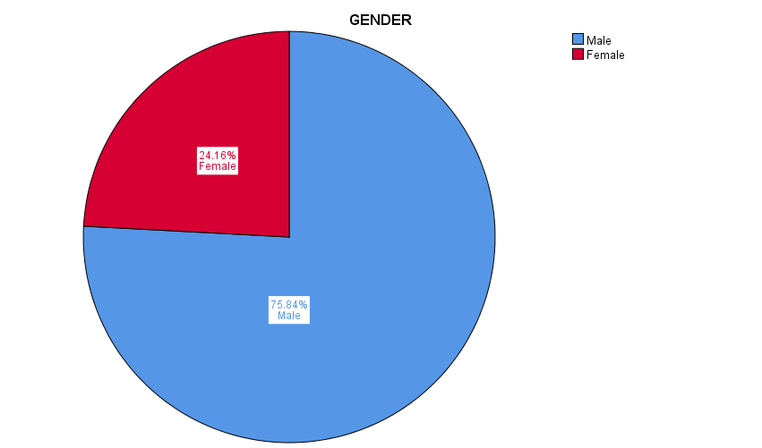

Figure 4.2: Age groups distribution
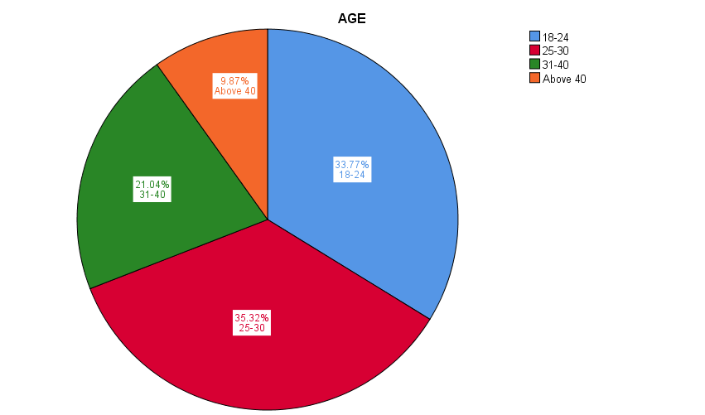

Figure 4.3: education level distribution
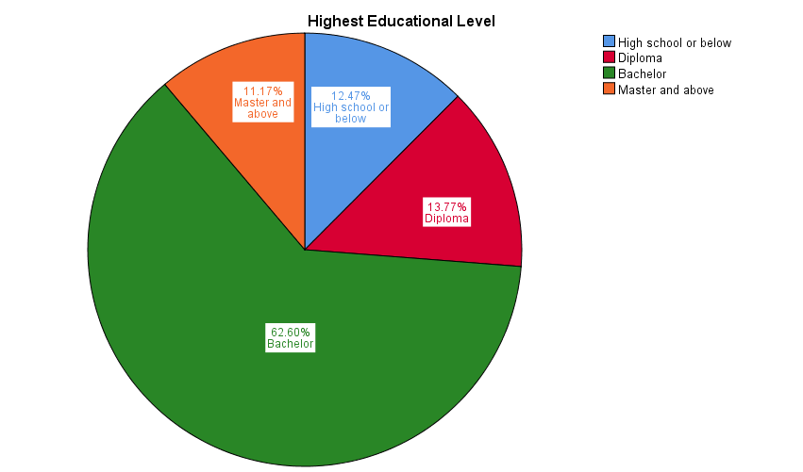

4.4 Preliminary data analysis

4.4.1 Factor Analysis
Exploratory Factor Analysis (EFA) was conducted on the full data to validate the independent variables and customer satisfaction constructs.

Table 4.4: Factor Analysis Result for dependent variable (DV) – Preliminary test
Variable | Item | Factor loading
Dependent variable | CS1 | 0.938
Customer satisfaction | CS2 | 0.964
 | CS3 | 0.931
 | CS4 | 0.957
 | CS5 | 0.885
KMO: 0.884
Barlett’s Test of Sphericity : Approx. Chi-Square 3557.894, df : 10, Sig.: 0.000

According to Table 4.4, the result for exploratory factor analysis on the dependent variable is showing that Kaiser-Meyer-Olkin Measure of Sampling Adequacy (KMO = 0.884), which is more than the rule of thumb 0.6, and Bartlett’s test of sphericity is significant, this value is acceptable and indicating that there is relevancy for the dependent variable in this research study, therefore, reliability test can be proceeded with the dependent variable.

Table 4.5: Factor Analysis Result for independent variables (IV) – Preliminary test
Variable - Independent Variables | Item | Factor loading
Perceived security and privacy | S1 | 0.971
 | S2 | 0.959
 | S3 | 0.963
 | S4 | 0.966
Perceived usefulness | U1 | 0.825
 | U2 | 0.872
 | U3 | 0.882
 | U4 | 0.860
Perceived ease of use | E1 | 0.823
 | E2 | 0.813
 | E3 | 0.794
 | E4 | 0.549
KMO: 0.927
Barlett’s Test of Sphericity : Approx. Chi-Square 8680.229, df : 66, Sig.: 0.000

According to Table 4.5, the result for exploratory factor analysis on the independent variables is showing that Kaiser-Meyer-Olkin Measure of Sampling Adequacy (KMO = 0.927), which is more than the rule of thumb 0.6, and Bartlett’s test of sphericity is significant, this value is acceptable and indicating that there is relevancy for the independent variables in this research study, therefore, reliability test can be proceeded with the independent variables.

4.4.2 Reliability Test
After the factor analysis is done, reliability test is to be conducted on dependent variable and independent variables separately to test the internal consistency of measurements (Sekaran and Bougie, 2016). According to Table 4.6, the result of the reliability test showing that for the dependent variable and independent variables, Cronbach’s co-efficient alpha (α) is above 0.9 which indicates excellent internal consistency. All construct reliabilities surpassed the required minimum reliability score of 0.60; hence the model is reliable for further analysis.

Table 4.6: Reliability Test Result – Preliminary test
Variable | Item | Cronbach’s Alpha
Dependent Variable
Customer satisfaction | 5 items | 0.982
Independent Variables
Perceived security and privacy | 4 items | 0.989
Perceived usefulness | 4 items | 0.977
Perceived ease of use | 4 items | 0.948

4.5 Hypothesis testing
Multiple Regression analysis and One-Way ANOVA are used to determine the relationship between two or more variables and to test a statement using a logical approach (Yockey, 2011). Multiple regression analysis was done to examine the influence of perceived security and privacy, perceived usefulness and perceived ease of use on customer satisfaction. Multi-co linearity was checked by tolerance and Variance Inflation Factor (VIF). Tolerance value ranges from 0.354 to 0.4044, and Variance Inflation Factor (VIF) values were ranged from 2.474 to 2.827, therefore, there is no multi-co linearity problem between the predictor variables (Table 4.9). The Durbin-Watson statistic is 1.477, which indicates independence of observations (Table 4.7).

The regression model is statistically significant at 0.000 level (F = 747.616) (table 4.8). The derived R square value is 0.855, which indicates that 85.5% of variations in customer satisfaction were explained by the predictors; hence the fitness of the model (Table 4.7). Perceived ease of use has the highest beta coefficient (0.569) followed by perceived security and privacy (0.274) and perceived usefulness (0.161). The β coefficients of predictor variables were found to be statistically significant, as the 3 variables showed their p-value = 0.000 which means a significant relationship, therefore, hypotheses H1, H2, and H3 were supported.

Table 4.7: Multiple regression – Model summary
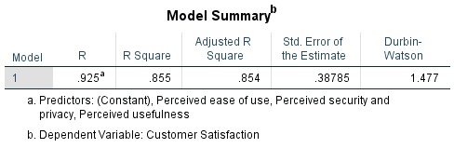

Table 4.8: ANOVA Table
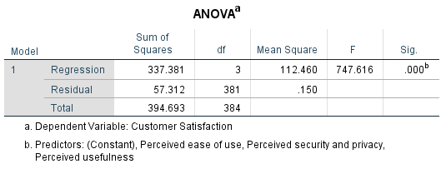

Table 4.9: Multiple regression - Coefficients Table

4.6 Summary of findings
Based on the pilot and preliminary test results, all questionnaire items related to the dependent and independent variables had met the minimum requirements for factor analysis and reliability test. Moreover, the hypotheses test results show regression model is statistically significance and hypotheses H1, H2, and H3 were supported.

The key findings summary for this research is shown in (Table 4.10).

Table 4.10: key findings summary
Hypothesis |  | Result
H1: Perceived security and privacy has a significant relationship with customer satisfaction towards online banking in Saudi Arabia. |  | Accepted
H2: Perceived usefulness has a significant relationship with customer satisfaction towards online banking in Saudi Arabia. |  | Accepted
H3: Perceived ease of use has a significant relationship with customer satisfaction towards online banking in Saudi Arabia. |  | Accepted

4.7 Conclusion
In accordance with the research methodology, pilot test and preliminary test were done including factor analysis and reliability test. All questionnaire items related to the dependent variable (DV) and independent variables (IV) passed the minimum requirements for factor analysis and reliability test. Finally, the hypotheses test done using multiple regression and one-way ANOVA, showing that model is statistically significance and hypotheses H1, H2, and H3 were supported.

CHAPTER 5: CONCLUSION AND RECOMMENDATIONS

5.0 Overview
The final chapter in this study provides recommendations and discusses the findings of the study. Moreover, future researches recommendation, limitations of this research study and the personal reflection are highlighted.

5.1 Discussion of findings and recommendation
The goal of this research is to study the factors influencing customer satisfaction towards online banking in Saudi Arabia. The influencing factors determined in this study are perceived security and privacy, perceived usefulness and perceived ease of use. Three (3) research questions and research objectives were formulated to test the hypotheses according to the collected data.

Hypothesis (H1):
Perceived security and privacy has a significant relationship with customer satisfaction towards online banking in Saudi Arabia.

In consistence with similar studies on online banking, and supported by George and Kumar (2013), the hypotheses test result shows significant influence of (Perceived security and privacy) on customer satisfaction toward online banking in Saudi Arabia. Among predictor variables, (Perceived security and privacy) showed up as the second predictor variable, which means that for banks to enhance customer satisfaction, retain customers, and ultimately get a competitive advantage, banks must made customers to feel safe to provide sensitive and private information over online banking platforms. This could be achieved by enhancing awareness within customers that banks are employing best security and technology standards. Furthermore, banks should also inform and create customer awareness that banks uses security features. The banks also should advise customers on a regular basis to keep their passwords, user ID and other classified and critical information safe and not to expose to others. Banks also should promptly warn customers about emerging security issues and threats such as cyber attacks, false e-mails which ask for password and user ID, phishing and others cyber threats.

Hypothesis (H2):
Perceived usefulness has a significant relationship with customer satisfaction towards online banking in Saudi Arabia.

Supported by George and Kumar (2013) research and in consistent with previous studies on online banking, (Perceived usefulness) emerged as a third prediction variable. The hypotheses test result shows significant influence of (Perceived usefulness) on customer satisfaction toward online banking in Saudi Arabia, which means that there is room for banks to enhance customer satisfaction and competitive position by enhancing customer awareness of the advantages of using online banking, and showing the benefits of this service compared to traditional branch service banks, especially cost savings associated with the use of online banking service. Furthermore, banks should enhance speed of online banking service. Convenient and fast online banking service saves customer time, so customers can see online banking service as time saving tool. According to this research results, banks should emphasize and inform customers about the whole benefits and advantages of using online banking service in terms of speed, time saving and cost savings.

Hypothesis (H3):
Perceived ease of use has a significant relationship with customer satisfaction towards online banking in Saudi Arabia.

In consistence with previous studies on online banking, and supported by George and Kumar (2013), the hypotheses test result shows significant influence of (Perceived ease of use) on customer satisfaction toward online banking in Saudi Arabia. (Perceived ease of use) appeared as the first predictor variable with the highest beta coefficient. Consequently, banks can increase customer satisfaction and enhance competitiveness greatly by providing more user friendly interfaces, websites with clear contents and instructions, thus customers may perceive that online banking service is easy to use. According to study analysis and results, customers paid the most attention to the ease of use, which means that for banks to enhance customer satisfaction and retain current customers, they must bring simplicity to the online banking processes, provide user guides and tools to help customers to navigate and complete transactions easily and with the minimum effort.

5.2 Contributions
To academia, this study confirms previous research results done on customer satisfaction towards online banking, and proves that (TAM) variables can influence and predict customer satisfaction in online banking context. Additionally, future studies can benefit from this study by exploring more factors based on these study findings, which could influence customer satisfaction towards online banking in Saudi Arabia. Furthermore, the study contributes to banking industry by providing recommendations and insights on how to enhance competitiveness through increasing customer satisfaction for online banking service. The online banking service contributes greatly to banks competitive position by lowering operation cost, hence identifying the most important factors affecting the customer satisfaction would enhance banks competitive position effectively.

5.3 Limitations of the study
Limitations in this research study are related to time, sampling method and questionnaire design. Due to limited time available to finish this study, non probability convenient sampling was employed to collect the data. Therefore, the questionnaires were distributed to accessible participants and may not statistically represent the whole population. Furthermore, researcher limited experience in designing and adapting questionnaires could be the cause behind low factor analysis results for some questions.

5.4 Future study recommendation

Despite the (3) factors that have been discussed in this research study, other factors could be exist and to be searched in future studies. The future studies on customer satisfaction toward online banking in Saudi Arabia could explores more factors, as there must be many more influencing factors other than (TAM) factors and security and privacy. Therefore, future studies could be directed to incorporate additional constructs, adding additional measures to the constructs such as familiarity using technology and computers. In addition, sample size should be increased in future research to cover more geographical areas, and to gather more information about customer satisfaction towards online banking.

5.5 Personal reflection
By completing this study, a better understanding on how to conduct a research is gained by the researcher. The researcher was exposed different academic procedures and methods preparing study background, formulating problem statement, research objectives and study significance. The researcher reviewed related literatures, examined the findings of previous research studies. The researcher studied methodologies, measurements, statistical analysis and findings to better understand the phenomenon under study. Personally, I find it is important for banks today to concentrate on key elements that influencing customer satisfaction of online banking, to increase customer satisfaction in online banking service, to keep loyal customers and attract new customers; which ultimately would enhance competitive position. Finally, conducting this research was a valuable and excellent learning experience.

References

Abdalslam, S. (2013). The Adaptation of E- Commerce in Malaysia. International Journal of Engineering Research and Development, 7(10), pp. 36-42.

Ahmad, A., and Al-Zu’bi, H. (2011). E-banking Functionality and Outcomes of Customer Satisfaction: An Empirical Investigation. International Journal of Marketing Studies, 3(1), pp.50-65.

Akhlaq, M. A. (2011). Internet banking in Pakistan: finding complexities. Journal of Internet Banking and Commerce, 16 (1), pp. 1-14.

Al-Haliq, H. and Al-Muhirat, A. (2016). Customer Satisfaction with Electronic Banking Services in the Saudi Banking Sector. Asian Social Science, 12(5), pp.139-146.
Aljasser, I. and Sasidhar, B. (2015). Satisfaction Perceptions Differences of Customers of Banks in Saudi Arabia Based on Gender. British Journal of Economics, Management and Trade, 7(4), pp.279-287.
Al-Otaibi, S., Aljohani, N., Hoque, M. and Alotaibi, F. (2018). The Satisfaction of Saudi Customers Toward Mobile Banking in Saudi Arabia and the United Kingdom. Journal of Global Information Management, 26(1), pp.85-103.
Al-Tit, A. A. (2015). The Effect of Service and Food Quality on Customer Satisfaction and Hence Customer Retention. Asian Social Science, 11(23), pp.129-139.

Alwan, H. A. and Al-Zubi, A. I. (2016). Determinants of Internet Banking Adoption among Customers of Commercial Banks: An Empirical Study in the Jordanian Banking Sector. International Journal of Business and Management, 11(3), pp. 95-104.

Amin, M. (2016). Internet banking service quality and its implication on e-customer satisfaction and e-customer loyalty. International Journal of Bank Marketing, 34(3), pp.280-306.
Anderson, C.K. (2012). The impact of social media on lodging performance. Cornell Hospitality Report, 12(15), pp.4-11.

ATkearney. (2014). [online] Available at: http://www.middle-east.atkearney.com/documents/10192/707238/Online+Banking+in+the+GCC.pdf/bc3dadf2-25f4-4127-bde7-c2bad974abde [Accessed 1 Nov. 2018].
Babin, B & Zikmund, W. (2015). Exploring Marketing Research. 11th ed. s.l:South-Western College Pub.rnal of Consumer Psychology. 9(2) pp.97-106.

Bhatt, A. (2016). Factors Affecting Customer’s Adoption of Mobile Banking Services. Journal of Internet Banking and Commerce, 21(1), pp.1-23.

Case, A.D. & Hunter, C.D. (2012) ‘Counterspaces: A unit of analysis for understanding the role of settings in marginalized individuals’ adaptive responses to oppression’. American Journal of Community Psychology. 50(1-2) pp.257-270.

Clemes, M., Gan, C. and Du, J. (2012). The factors impacting on customers' decisions to adopt Internet banking. Banks and Bank Systems, 7(3), pp.33-50.

Collis, J. & Hussey, R. (2014) Business Research. 4th edn. Hampshire: Palgrave Macmillan.

Creswell, J.W. (2013) ‘Research design: Qualitative, quantitative, and mixed methods approaches’. London, UK: SAGE.

Dauda, S. and Lee, J. (2016). Quality of service and customer satisfaction: a conjoint analysis for the Nigerian bank customers. International Journal of Bank Marketing, 34(6), pp.841-867.
Davis, F. D. (1989). Perceived Usefulness, Perceived Ease of Use, and User Acceptance of Information Technology. MIS Quarterly, 13(3), pp. 319-340.

Dierckx D. (2013). The importance of socio-demographics in online surveys. [Online} Available at: https://www.checkmarket.com/2013/08/the-importanceof sociodemographics-
in-online-surveys.
Dixit, N. and Datta, S. K. (2010). Acceptance of E-banking among Adult Customers: An Empirical Investigation in India. Journal of Internet Banking and Commerce, 15(2), pp. 4-14.

Eid, M. I. (2011). Determinants of E-Commerce Customer Satisfaction, Trust, and Loyalty in Saudi Arabia. Journal of Electronic Commerce Research, 12(1), pp. 78-93.

Elangovan, R. and Sabitha, K. (2011). Customers perception towards internet banking services-A Study with reference to Pondicherry Territory Sankhya. International Journal of Management and Technology, 2(2), pp.60-63.
El-Said, O. and Fathy, E. (2015). Assessing university students' satisfaction with on-campus cafeteria services. Tourism Management Perspectives, 16, pp.318-324.
Fang, H., Zhang, J., Bao, Y. and Zhu, Q. (2013). Towards effective online review systems in the Chinese context: A cross-cultural empirical study. Electronic Commerce Research and Applications, 12(3), pp.208-220.

George, A. and Kumar, G. (2013). Antecedents of Customer Satisfaction In Internet Banking: Technology Acceptance Model (TAM) Redefined. Global Business Review, 14(4), pp.627-638.
George, D. and Mallery, P. (2003). SPSS for Windows Step by Step: A Simple Guide and Reference. 4th ed. Boston: Allyn & Bacon.
Gupta, K. K., and Bansal, D. I. (2012). Development Of An Instrument To Measure Internet Banking Service Quality In India. International Refereed Research Journal,3(2), pp.11-25.
Hague, P. and Hague, N. (2016). Customer Satisfaction Survey: The customer experience through the customer’s eyes. London: Cogent Publication.
Hair, J.F., Black, W.C., Babin, B.J. & Anderson, R.R. (2014) ‘Multivariate Data Analysis, 7th edn. New Jersey: Prentice Hall.

Hill, N., Roche, G. and Allen, R. (2007). Customer satisfaction: The customer experience through the customer’s eyes. London: Cogent.
Igbaria, M., Ivari, J. and Maragahh, H. (1995). Why do individuals use computer technology? A Finnish case study. Information and Management, 29(5), pp.227-238.

Ismail, A. and Yunan, Y. (2016). SERVICE QUALITY AS A PREDICTOR OF CUSTOMER SATISFACTION AND CUSTOMER LOYALTY. Scientific Journal of Logistics, 12(4), pp.269-283.

Jolly, V. (2016). The Influence of Internet Banking on the Efficiency and Cost Savings for Banks’ Customers. International Journal of Social Sciences and Management, 3(3), pp.163-170.

Jones, M. and Suh, J. (2000). Transaction‐specific satisfaction and overall satisfaction: an empirical analysis. Journal of Services Marketing, 14(2), pp.147-159.
Kaiser, H. (1974). An index of factorial simplicity. Psychometrika, 39(1), pp.31-36.
Kant, R. and Jaiswal, D. (2017). The impact of perceived service quality dimensions on customer satisfaction. International Journal of Bank Marketing, 35(3), pp.411-430.
Khrais, L. (2015). Highlighting the Vulnerabilities of Online Banking System. The Journal of Internet Banking and Commerce, 20(3), pp.1-10.

Kotler, P. and Keller, K. (2012). Marketing management. 14th ed. Upper Saddle River, New Jersey: Pearson/Prentice Hall.
Krejcie, R. and Morgan, D. (1970). Determining Sample Size for Research Activities. Educational and Psychological Measurement, 30(3), pp.607-610.
Kumar, R. (2010). Research methodology: A Step-by-Step Guide for Beginners. London: SAGE.

Lai, P. (2017). THE LITERATURE REVIEW OF TECHNOLOGY ADOPTION MODELS AND THEORIES FOR THE NOVELTY TECHNOLOGY. Journal of Information Systems and Technology Management, 14(1), pp.21-38.
Lakhi, M., and Gul, R. (2012). Factors Distressing Internet Banking Adoption among Adult Students: Evidence from Kingdom of Saudi Arabia. Business and Management Review, 2(1), pp. 76-82.

Leon, A.C., Davis, L.L. & Kraemer, H.C. (2011) ‘The role and interpretation of pilot studies in clinical research’. Journal of Psychiatric Research. 45(5), pp.626-629.

Ling, G., Fern, Y., Boon, L. and Huat, T. (2016). Understanding Customer Satisfaction of Internet Banking: A Case Study In Malacca. Procedia Economics and Finance, 37, pp.80-85.
Lone, F., Aldawood, E. and Bhat, U. (2017). Customer satisfaction towards Islamic banking in Saudi Arabia: an application of CARTER model. International Review of Management and Marketing,, 7(1), pp.273-280.
Malhotra, N.K., & Peterson, M. (2006). ‘Basic Marketing Research: A decision making approach’ (2nd ed.). New Jersey: Prentice Hall.

Manjunath, S. and Reginald, S. (2016). Customer Satisfaction in Fast Food Industry: A Case Study of Mysore. International Journal of Research in Finance and Marketing, 6(5), pp.72-78.

MCIT.gov. (2017). Telecommunication Indicators in the Kingdom of Saudi Arabia by the end of Q3-2017. [online] Available at: https://www.mcit.gov.sa/en/standard-indicators/99050 [Accessed 1 Nov. 2018].
Mian, T. S. (2014). The Role of Service Quality in Developing Customer Loyalty in the Banking Sector: A Case study of the Kingdom of Saudi Arabia. International Journal of Accounting and Financial Reporting, 4(2), pp.339-360.
Moscato, D. R. and Altschuller, S., (2012). International Perceptions of Online Banking Security Concerns. Communications of the IIMA, 12(3), pp. 51-64.

Mukhtar, M. (2015). Perceptions of UK Based Customers toward Internet Banking in the United Kingdom. Journal of Internet Banking and Commerce, 20(1), pp.1-38.

Nathan, D. (2014). The relationship among e-service quality dimensions, overall internet banking service quality, and customer satisfaction in the USA. Journal of Modern Accounting and Auditing, 10(4), pp.479-493.
Nel, J. and Boshoff, C. (2014). Enhancing the use of internet banking in an emerging market. South African Journal of Economic and Management Sciences, 17(5), pp.624-638.
Nwogu, E. and Odoh, M. (2015). Security Issues Analysis on Online Banking Implementations in Nigeria. International Journal of Computer Science and Telecommunications, 6(1), pp.20-27.

Omariba, Z. and Masese, N. (2012). security and privacy of Electronic Banking. International Journal of Computer Science Issues, 9(4), pp.432-446.
Pham, L. and Anh, D. (2014). Intention to Use E-Banking in a Newly Emerging Country. International Journal of Enterprise Information Systems, 10(2), pp.103-120.
Pickton, M. (2013) Writing your research plan. In: Grant, M. J., Sen, B. and Spring, H. (eds.) Grant, Maria J, Sen, Barbaraand Spring, Hannah Research, Evaluation and Audit: Key Steps in Demonstrating Your Value. London: Facet Publishing. pp. 45-63.
Pikkarainen, T., Pikkarainen, K., Karjaluoto, H. and Pahnila, S. (2004). Consumer acceptance of online banking: An extension of the Technology Acceptance Model. Internet research, 14(3), pp.224-235.

Radojevic, T., Stanisic, N. and Stanic, N. (2017). Inside the Rating Scores: A Multilevel Analysis of the Factors Influencing Customer Satisfaction in the Hotel Industry. Cornell Hospitality Quarterly, 58(2), pp.134-164.

Raza, S. and Hanif, N. (2013). Factors affecting internet banking adoption among internal and external customers: a case of Pakistan. International Journal of Electronic Finance, 7(1), pp.82-96.

Raza, S., Jawaid, S. and Hassan, A. (2015). Internet banking and customer satisfaction in Pakistan. Qualitative Research in Financial Markets, 7(1), pp.24-36.
Sanjuq, G. (2014). The Impact of Service Quality Delivery on Customer Satisfaction in the Banking Sector in Riyadh, Saudi Arabia. International Journal of Business Administration, 5(4), pp.77-84.
Saunders, M. Lewis, P. & Thornhill, A. (2009) Research Methods for Business Students. New York: Pearson Education Limited.

Sekaran, U. and Bougie, R. (2016). RESEARCH METHODS FOR BUSINESS. 7th ed. New York: Wiley.
Sharma, G. and Malviya, S. (2014). Internet Banking Service Quality and Its Impact On Customer Satisfaction In Indore District Of Madhya Pradesh. International Journal of Business and Management Invention, 3(3), pp.1-6.
Sharma, S., 2016. A detail comparative study on e- banking VS traditional banking. International Journal of Applied Research, 2(7),pp. 302-307.
Surendran, P. (2012). Technology Acceptance Model: A Survey of Literature. International Journal of Business and Social Research, 2(4), pp. 175-178.

Tabari, N. and Pamsari, M. (2016). Investigating effective factors on customer satisfaction of Internet banking (The Case of Post Bank of Iran). INTERNATIONAL JOURNAL OF HUMANITIES AND CULTURAL STUDIES, [online] pp.1706-1718. Available at: https://www.ijhcs.com [Accessed 01 Oct. 2018].

Waithaka, S. and Nzeveka, K. (2015). Customers Perception on Ease of Use of Internet Banking in Commercial Banks in Kenya. International Journal of Novel Research in Marketing Management and Economics, 2(2), pp.66-74.

Zikmund, W.G., Babin, B.J., Carr, J.C. & Griffin, M. (2013) ‘Business Research
Methods’. 8th ed. Ohio: South-Western.

Appendices

Appendix 1: Questionnaire

Appendix 2: Statistical Analysis Results

(1) PILOT TEST

(2) PRELIMINARY TEST

(3) Multiple regression results

Appendix 3: Project paper log

Student Name: | Hesham Mohamed Hasan
Supervisor’s Name: | Dr. Sam Toong Hai
Dissertation Topic: | FACTORS INFLUENCING CUSTOMER SATISFACTION TOWARDS ONLINE BANKING IN SAUDI ARABIA

SECTION A. MONITORING STUDENT DISSERTATION PROCESS

SECTION B. ETHICS
Ethics form protocol number:- cBUS/UG/CP/04065

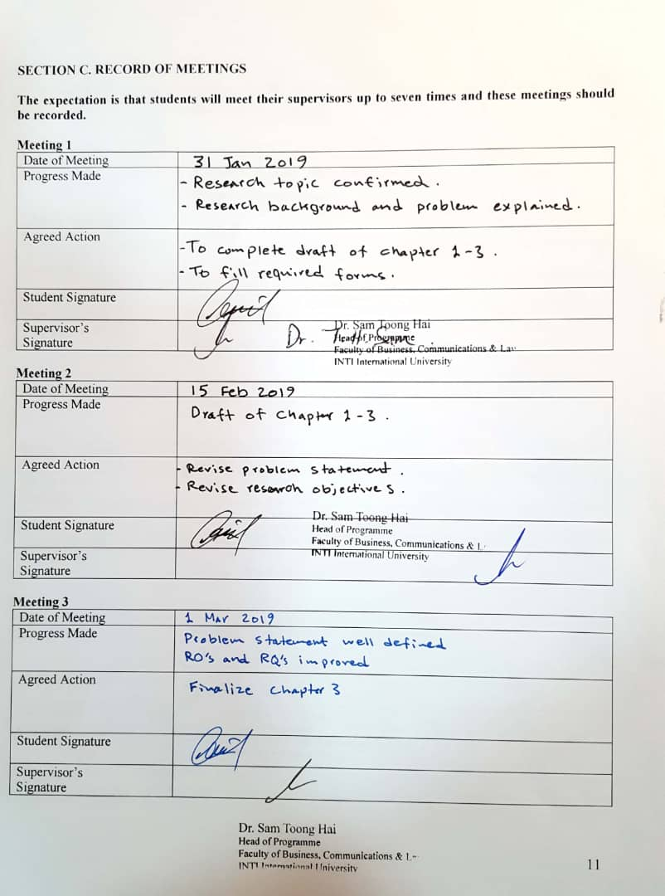

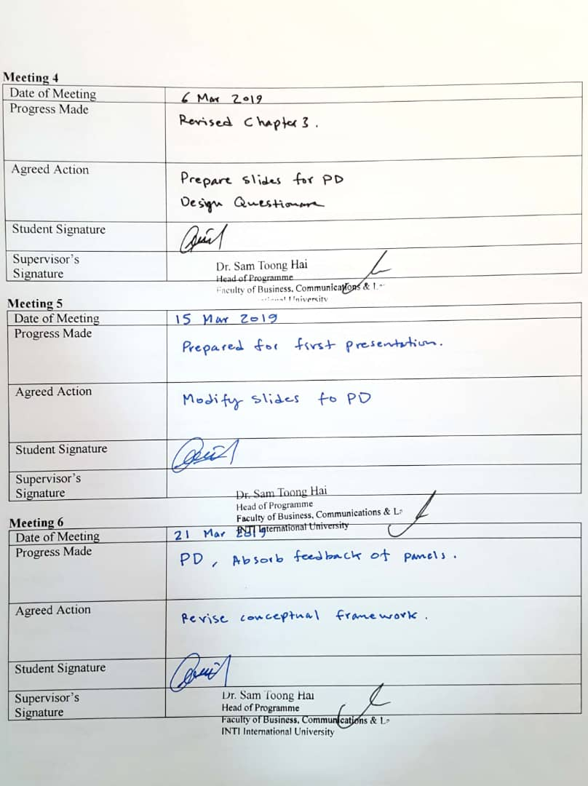





Appendix 4: UH ethic approval note

Appendix 5: Similarity report

