
MASTER OF BUSINESS ADMINISTRATION

Module Name | MBA Project | Module Code |  | MGT7998
Module Leader | Assoc. Prof. Dr. Lee Kar Ling |  | Individual Assignment  Title – Personal Characteristics and Work Performance in the Food and Beverage Industry in Nigeria
Student Name | Priti Sundrani | Student ID |  | I18014431  (Dual Award)
Student’s Declaration | I certify that this assignment is my own work and where materials have been used from published sources, they have been properly acknowledged. I understand I will receive a mark of 0% for this assignment and may receive further penalties if the content is found to be plagiarised.  Signed: ____________________________________________  Date: ______________________________________

Contents
Abstract 5
Keywords: Work Performance, Personal Characteristics, OCEAN, Nigeria 5
Chapter One 6
INTRODUCTION 6
1.0 Overview 6
1.1 Background of Research 6
1.2 Problem Statement 7
1.3 Research Objective 8
1.4 Research Questions 8
1.5 Significance of study 9
1.5.1 Academics 9
1.5.2 Industry 9
1.6 Scope of Study 10
1.7 Limitations 10
1.7.1 Time Constraints 10
1.7.2 Geographical Constraints 10
1.8 Operations Definitions 11
1.9 Organization of Chapters 12
Chapter Two 13
LITERATURE REVIEW 13
2.0 Overview 13
2.1 Work Performance 13
2.1.1 Global View on Work Performance 15
2.1.2 Nigeria’s Perspective on Work Performance 17
2.2 Factor influencing Work Performance 18
2.2.1 Personal Characteristics 19
2.3 Gaps in the Literature 22
2.4 Fundamental Theory 23
2.5 Theoretical Framework 25
2.6 Hypotheses 26
2.7 Conclusion 27
Chapter Three 28
RESEARCH METHODOLOGY 28
3.1 Research Design 28
3.2 Unit of Analysis and Time Horizon 29
3.3 Sampling Design 29
3.3.1 Population 29
3.3.2 Sampling Method 30
3.3.3 Sample Size 30
3.1 Summary of Research Design 32
3.2 Questionnaire Design 33
3.3 Measurement Table 34
3.5.1 Pilot Testing 36
3.5.2 Factor Analysis 36
3.5.3 Reliability Test 37
3.5.4 Correlation Matrix 37
3.5.5 Hypotheses Testing 38
3.6 Conclusion 38
Chapter Four 39
DATA ANALYSIS AND FINDINGS 39
4.0 Overview 39
4.1 Pilot Testing 39
4.1.1 Factor Analysis 39
4.1.2 Reliability Test – Cronbach Alpha 45
4.3 Demographic Profile of Respondents 46
4.3 Preliminary Analyses 47
4.3.1 Factor Analysis 48
4.3.2 Reliability Test – Cronbach Alpha 52
4.4 Hypotheses Testing 52
4.5 Summary of Findings 54
4.6 Conclusion 55
Chapter Five 56
CONCLUSION AND RECOMMENDATIONS 56
5.0 Overview 56
5.1 Summary of Findings 56
5.2 Contribution 57
5.2.1 Contribution to industry 57
5.2.2 Contribution to literature 57
5.3 Recommendation 58
5.4 Limitation of Research 58
5.5 Future Research Direction 59
5.6 Conclusion 59
5.7 Personal Reflection 60
6. 0 References 61
7.0 Appendix 67

Abstract

The purpose of this study is describing the work performance, verifying the personal characteristics in the Food and Beverage industry in Nigeria and to use the social interaction theory to further study the influencers. The study was therefore conducted using questionnaire to collect data on the factors which are influencing work performance. Additionally, OCEAN personal characteristics of the employees are reviewed to determine the influence on work performance. From one viewpoint, look into incorporates potential research restrictions.

The researches do have two information sources (managers and employees), however, the information gathered might be constrained; therefore, information accumulation may influence some propositional impacts. The factor influencing work performance in the Food and Beverage industry in Nigeria also thought to be very much reliant in the nature and varies from different industry. Hence this research focuses on ascertaining the possible factor influencing the work performance in Food and Beverage industry in Nigeria.

Keywords: Work Performance, Personal Characteristics, OCEAN, Nigeria

Chapter One

INTRODUCTION

1.0 Overview

This quantitative study examines whether an employee's OCEAN personal characteristics influences the work performance of the Food and Beverage industry in Nigeria. However, this study will describe inevitable connections between employees and work performance. The following will describe the purpose and issues of the study. Finally, the end of this chapter will summarize the chapters of the complete study.

1.1 Background of Research
In the current rapid development of society, many companies focus on recruitment of high-quality personnel to ensure the company's sound and rapid development (Adair and Jaeger, 2012). Also, due to economic problems, organizational resources are decreasing every year (Harter and Mann, 2016). In other words, organizations tend to use small amounts of resources to complete annual business goals, including financial, physical, and human resources (Nguyen, 2013). As a result, the OCEAN personal characteristics are influenced by a variety of factors, focusing on each leader's attention (Adair and Jaeger, 2012).

In the case of employees, each of the employees will not be in the same state, so the company will assess the individual’s ability to drive the company’s development (McQuerrey, 2009). Likewise, good attitudes and abilities are important to businesses and individuals (Mason, 2011). Hence, this study is mainly focusing on exploring the effect of OCEAN Personal Characteristics on employee’s work performance (McQuerrey, 2009).

One of the tools used in this study, the personal traits of employee’s in the work performance is OCEAN personal characteristics (Adair and Jaeger, 2012). Personal traits mean people in all sorts of social life, which have both external and internal forms of expressions (Nguyen, 2013). Personal traits are important as prophets of action and which is why personal characteristics play a very important role which helps to ensure the performance of individuals (Maslow, 2014).

1.2 Problem Statement

Many researches (Iitzhak and Liat, 2015) have been done on factors that influence work performance that are more focused on common types of factors such as compensation and benefits, work environment, nature of the work and so on. The Food and Beverage industry in Nigeria is facing a lot of problems like not able to get the right people for this industry, so this study is done to verify whether personal characteristics matches with the jobs responsibilities in this particular industry (Maslow, 2014). However, there are limited researches in Nigeria that has focused on the characteristics of individuals and the influence on the employee’s work performance (Denham, 2010). Therefore, this research is worth helping and supporting Food and Beverage industry to recruit the right people for the jobs to ensure that the hired person can meet the company's expectations (Darren, 2003).

From the statistics shown, there are around 270 restaurants in Lagos, which is the capital city of Nigeria (Finelib, 2018). Approximately each restaurant has around 36 - 40 employees which is a floating figure (Statista.com, 2018). Therefore, the target population and the industry is of sufficient importance to conduct a study regarding the influence of personal characteristics on the performance of employees within the food and beverage industry of Nigeria.

It is important to study the personal characteristics of employees because employees are all people and when people or employee come to work the personality and characteristics are brought along (Adair and Jaeger, 2012). By understanding the personal nature of an employee, the organization can understand better whether that individual is the person the organization wants to develop and retain (Maslow, 2014). The reason for the study is that different industries, culture and individuals, may have different character influence on work performance (Adair and Jaeger, 2012), hence, the need to verify whether personal characteristics will have an influence on the work performance of employees in Nigeria’s food and beverage industry.

1.3 Research Objective

The purpose of this study is to analyze factors that influence work performance based on the OCEAN Personal Characteristics and to examine the association between the employee and the organizational work to explore the performance (Maslow, 2014). Therefore, it is important for a researcher to understand and know the set of research objectives to carry out the entire research work more effectively (Bougie and Sekaran, 2013). The following are the research objectives for this study:

RO1: To determine whether OCEAN personal characteristics has a significant relationship with work performance in Food and Beverage industry in Nigeria.
RO1a: To determine whether openness as a dimension of OCEAN personal characteristics has a significant relationship with work performance in Food and Beverage industry in Nigeria.
RO1b: To determine whether conscientiousness as a dimension of OCEAN personal characteristics has a significant relationship with work performance in Food and Beverage industry in Nigeria.
RO1c: To determine whether extraversion as a dimension of OCEAN personal characteristics has a significant relationship with work performance in Food and Beverage industry in Nigeria.
RO1d: To determine whether agreeableness as a dimension of OCEAN personal characteristics has a significant relationship with work performance in Food and Beverage industry in Nigeria.
RO1e: To determine whether neuroticism as a dimension of OCEAN personal characteristics has a significant relationship with work performance in Food and Beverage industry in Nigeria.

1.4 Research Questions

Research objectives and questions will guide the study to arrive at appropriate findings (Alvesson and Sandberg, 2013). However, research questions are very crucial than the objectives hence should be mentioned after the research objectives (Bougie and Sekaran, 2013). The research questions based on the research objectives above are thus identified below:

RQ1: Does OCEAN personal characteristics have a significant relationship with work performance in Food and Beverage industry in Nigeria?
RQ1a: Does openness as a dimension of OCEAN personal characteristics have a significant relationship with work performance in Food and Beverage industry in Nigeria?
RQ1b: Does conscientiousness as a dimension of OCEAN personal characteristics have a significant relationship with work performance in Food and Beverage industry in Nigeria?
RQ1c: Does extraversion as a dimension of OCEAN personal characteristics have a significant relationship with work performance in Food and Beverage industry in Nigeria?
RQ1d: Does agreeableness as a dimension of OCEAN personal characteristics have a significant relationship with work performance in Food and Beverage industry in Nigeria?
RQ1e: Does neuroticism as a dimension of OCEAN personal characteristics have a significant relationship with work performance in Food and Beverage industry in Nigeria?

1.5 Significance of Study

1.5.1 Academics

This section focuses on the significance of the studying OCEAN Personal Characteristics and Work Performance in Nigeria when it comes to the food and beverage industry. This research will help in contributing and of those conducting this similar kind of study in future and to understand which type of personality is suitable for the food and beverage industry which will enhance the work performance of the employees and therefore will promote the company’s economic growth and development (Lawrie, 2015).

1.5.2 Industry

Employee characteristics and their applications are ending up progressively significant in the organization, choosing the right individuals in the correct spot, empowering every worker to perform and decrease their turnover (Gebre, 2007). Dynamic employees, to appreciate more work understanding, to make more commitments to society (Gill, 2010). Outward, adjusted, genuine, open experience can frame a positive feeling, and at last with the authority to set up a high-quality relationship (Keene, 2004). Then again, the contrary feelings of individuals, their pioneers' commitments and relational connections are less, so it is hard to set up a top-notch association with the leadership (Braun, 2016). In this manner, in the association, the administrators need to utilize by picking the correct personality as indicated by the right job (Keene, 2004). This won't just influence their own qualities and performance, yet additionally can bring the organization a decent advancement and improve the viability of the organization (Gill, 2010).

1.6 Scope of Study

This research mainly focuses on verifying whether the Personal Characteristics have a significant relationship with Work Performance in Food and Beverage Industry in Nigeria. However, it will be conducted using the OCEAN theory (Big 5 Traits) which has dimensions as Openness, Conscientiousness, Extraversion, Agreeableness and Neuroticism. The target of this study is the employees working in the food and beverage industry in Nigeria to have a fair data. Moreover, the analysis will be done basis on the data collected from the respondents which will be used as evidence in future to support the results of this study.

1.7 Limitations

Although this study has contribution to industry and academia, there are also potential limitations.

1.7.1 Time Constraints

This study refers to the impact of Personal Characteristics and Work Performance. Therefore, a lot of time should be spent in reading the previous or earlier articles to find more new and detailed information or data.

1.7.2 Geographical Constraints
This study is only limited to Nigeria, so the outcomes of this study are only applicable to Nigeria.
Moreover, by going through these limitations the researcher is encouraged to provide more research space for further research

1.8 Operations Definitions
Sr. No | Keywords | Definitions
1 | Work Performance | Work performance is characterized as the aggregate anticipated that esteem would the organization of the discrete behavioral scenes that an individual completes over a standard timeframe (Motowidlo and Kell, 2012).
2 | Personal Characteristics | Personal characteristics are close to home qualities of a person. It is what make up one's identity. It enables an individual to get along in another situation (Gray and Irons, 2016).
3 | Openness | The openness of ‘experience is defined as the breadth, depth, originality and complexity of an individual's mental and experiential life (Jain, 2014).
4 | Conscientiousness | Conscientiousness is characteristic to reflect those who are thoroughly diligent, careful, organized, accountable and conservative (Barrick and Mount, 2012).
5 | Extraversion | Extraversion is characterized as a conduct where an individual appreciates being around everyone more than being distant (Smillie and Wacker, 2015).
6 | Agreeableness | Agreeableness is composed of polite, flexible, innocent, helpful, supportive, compassionate, friendly and unbiased temperament while maintaining a generous, calm, trustworthy, sincere, and sincere attitude (Inceoglu and Warr, 2012).
7 | Neuroticism | Neuroticism indicates a tendency to experience negative influences such as anger, anxiety, depression, embarrassment, fear, guilt, hostility, impulse, sadness, self-consciousness and vulnerability (Barrick and Mount, 2012).
8 | Food and Beverage Industry | The Food and Beverage industry is all organizations engaged with preparing raw food materials, packaging, and circulating them around. This also includes all kinds of beverages as well (Maras, 2015). However, in this study, Food and Beverage industry is mainly about restaurants.

1.9 Organization of Chapters

The Chapter 1 briefly discusses the introduction of this study, which consists of definitions of questions, research objectives, research questions, research significance, scope of study and limitations. Therefore, the first chapter can provide the reader with an overview of this study.
Chapter 2 focuses on the review of the relevant literature that is related to this study whereby the main focus will be on work performance as the main study emphasis and the OCEAN Personal Characteristics as the factor with its dimensions along with the research framework which will be mentioned as well.
However, for Chapter 3, the focus is on the research methodology. For the study, the methodology used is quantitative by using SPSS Software to obtain the data for the study. It starts from data collection and the tests used in this study.
In the Chapter 4 the research results are described and analyzed, and the outcomes or results are summarized in order to back up this study.
Finally, the last Chapter 5 includes the study of the contribution to the industry and literature, recommendations, limitations and future research direction of the overall study. Additionally, personal reflection of this research is also mentioned in this chapter.

Chapter Two

LITERATURE REVIEW

2.0 Overview

This chapter provides the literature review for the study to have deep understanding on all the theories involved and all the theories are relevant to the study and the development of the hypotheses.

This chapter will cover the background and overview of the literature on the importance of the study includes keys concepts such as Big 5 traits OCEAN and work performance. Moreover, this chapter will describe about the relationship between the key words that form the focus of this study. A theoretical framework will be established to guide the direction of the study and this chapter will then end with a conclusion after the provision of the hypotheses for the study.

2.1 Work Performance

Work performance is a specific description of the expectations for employees and the ongoing goal-oriented program to motivate employees to improve performance (Bliese, 2014). Goal setting is an effective strategy to improve work performance (Remus, 2012). Work can be made clearer and employees can direct the efforts (Frink, 2013). Managers must comply with the stated principles to measure the achievement of goals (Bliese, 2014).
Similarly, these factors can extend work performance to task performance, contextual and counterproductive (adaptive) performance where task performance is defined as: professional skills in which individuals perform core business or technical tasks related to the jobs whereas contextual performance is defined as actions that enhance the organization's work in the social and psychological environment, technology core functions and obviously semi-productive work are behaviours that harm the well-being of the organization (Koopmans, 2014). Additionally, adaptive performance is defined as the individual's ability to alter the employee’s behaviour when responding to the demands of a new task, event, circumstance or environmental constraint (Huang, Palmer, and Ryan et. al., 2014). In this study the performance is measured based on both behavioural and outcome elements (Huang, 2014).

Thus, a model is derived by adding these elements together which is called the Triarchy Model of Employee Performance (Jena and Pradhan, 2017).

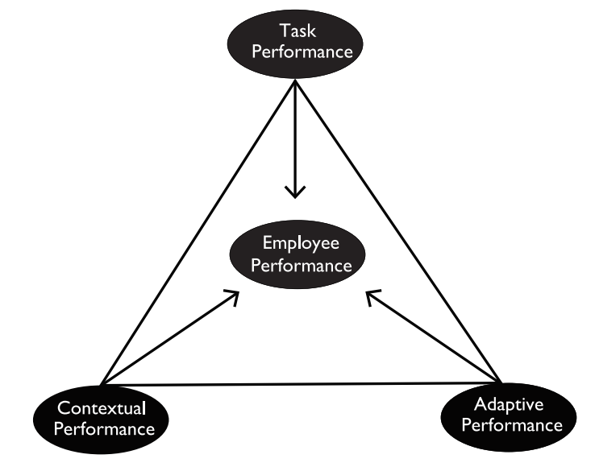
Figure 1: The Triarchy Model of Employee Performance Source: Jena and Pradhan, (2017)
1) Task performance is a clear list of jobs responsibilities and duties defined in the job description of an employee and requires specific job knowledge, job skills, technical skills, and job habits (Jena and Pradhan, 2017). There are two factors that are set to measure job performance levels that is service focus and results (Koopmans, 2014).

2) Contextual performance is defined as behaviour that indirectly contributes to the organization and that supports the social environment of the organization in which the technical core function is must (Jena and Pradhan, 2017). The four elements that represent this dimension are known as collaboration, communication, diversity and coaching and mentoring (Koopmans, 2014).

3) Adaptive performance is one of the main measures of job performance which means applying job profile performance in dynamic situations, including changes in assigned work and changes in interpersonal behaviour with peers and subordinates (Jena and Pradhan, 2017). Being adaptive also refers to the flexibility and acceptance of changes that an employee can cope with in a variety of work environments and this factor measures the effectiveness of an employee's performance when an employee is away from the comfort zone (Baard, Kozlowski and Rench, 2014). The three elements will be used to determine the adaptive performance: Adaptability, Creativity and Initiative (Koopmans, 2014).

The goal of "driving the company to success" is too vague to use (Carlson, 2014). Through a systematic assessment of progress toward achieving goals, employees can work to improve performance (Martin, 2011). If managers spend a lot of time recognizing measurable goals and fail to evaluate it later and are asking for trouble (Halim, 2013). Unless the performance of the goal is assessed, these goals cannot improve employee performance and can only motivate employees who are interested in meeting the goals and managing the commitments of the members that will have a negative effect (Frink, 2013).

2.1.1 Global View on Work Performance

Work performance provides a unique perspective on employee which is beyond the motivation characteristics (Humphrey, Morgeson and Nahrgang, 2011). There are the structural features of the profession that influences in promoting interpersonal interaction and social environment as pervasive and it as an important determining factor for work performance (Humphrey, 2011). Work performance has become especially important because of the wider spread in recent years and there are few relevant attitudes like social support, interaction within the organization, 360 feedback process (Bliese, 2014).

The current study attempts to focus on work performance of employees in the F&B industry serving in Lahore region (Masood and Rafique, 2017). The results of previous studies have shown a significant positive association between extroversion, equivalence, openness, and work performance (Rafique, 2017). There are a few factors that can influence employees training and development opportunities, working conditions, worker performance, job security and rewards for employees (Amponsah-Tawiah and Boye Kuranchie-Mensah, 2016). Among the factors influencing work performance rewards and motivation are most important (Rafique, 2017).

According to Inceoglu and Warr (2012) and Ziapour (2015), who revealed that extroversion, agreeableness, openness and work performance were significantly associated with work engagement and work performance patterns of employees in the Food and Beverage industry. The overall work performance in the Chinese context indicates the effect of several dimensions on work performance that has cultural differences between Western and Eastern countries (Zhang, Zhou, and Zhang et al., 2012).

According to the findings by Munisamy (2013), is believed to be helpful in providing information for Food and Beverage industry to understand and motivate employees' needs which in turn improves the work performance and can achieve the organization's vision and goals. This would help in planning, evaluating and resolving issues related to job performance which will indirectly strive to improve performance (Bliese, 2014).
Management can take the appropriate steps to improve the employee’s work performance where future career performances lead to job satisfaction at the same time (Munisamy, 2013). This research can also provide new ideas and knowledge on how to cope with a job and performance issues for the management which will therefore help the strategic action plans that can be planned to achieve high productivity (Bliese, 2014).

From an employee's point of view, work performance is essentially a result of the series of behaviours and a variety of actions performed each day of the action helps in the work performance of an employee (Munisamy, 2013).On the other hand, from the perspective of the supervisor, as a result of the day, the results is the key factor for the performance evaluation and is more important to employers than to subsequent activities (Bliese, 2014).

Work performance is also referred from two aspects which consists of employees' natural and acquired skills (Mofoluwake and Oluremi, 2013). Employee self-efficacy, competitiveness and effort has a significant positive effect on the performance of the duties of the employees performing the duties in the front liner (Munisamy, 2013).

A number of factors have been identified that may influence the work performance of an employee ranging from individual-related factors, organizational-level factors, as well as organized environmental factors, for example, an employee's commitment influences the performance of the work (Mofoluwake and Oluremi, 2013)

2.1.2 Nigeria’s Perspective on Work Performance

This study presents the initial comprehensive’ analysis of the effectiveness of work performance in Nigeria (Allik, 2010). The ‘results of this study are’ generally similar to ‘those found in other international contexts’, conscientiousness and technical competence and emotional stabilities, which are emerging as the most powerful predictors of training, are low enough (Barrick and Mount, 2012). Extraversion was a major predictor of this standard, as evidenced by ‘the interpersonal nature of most occupations and high cultural collectivism in’’ Nigeria (DeYoung, 2015).

Extraversion’ may promote socializing and other procrastination’ behaviours ‘over studying’ (Irefin and Mechanic, 2014). When measuring performance using specially-collected manager ratings for research purposes and were more effective than those ‘measured using objective indicators or ratings’ created for management ‘decision-making’ and the ‘results support the’ intercultural universality ‘of personality’ and ‘performance’ (Allik, 2010).

Since almost ‘all included studies used imported personality’ tools, ‘the strength of operational’ validity ‘observed in this study’ indicates that the readability and interpretability problems hardly support the hypothesis that it weakens the validity of income measures (DeYoung, 2015). ‘Overall, this study provides’ additional ‘evidence that personality traits’, particularly ‘conscientiousness, are’ strong ‘predictors of work performance’ in an international context (Chang, Connelly and Geeza, 2012). The personality structure and development, the difference between self-evaluation and other evaluations, and the contribution of personality to romantic success - work performance validity ‘appears to be a cultural universal observed in all countries’ of the world (DeYoung, 2015).

Most personality’ evaluations ‘used by psychologists and organizations in’ Nigeria ‘have been imported’ and adopted for use in Nigeria (Allik, 2010). ‘Previous research indicates that these measures may not be completely free’ of prejudice and language misunderstandings ‘when used with’ modern Nigerian samples (Chang et al., 2012). Ideally, current research ‘would have compared the relative’ feasibility ‘of imported versus locally developed personality measures’ (Irefin and Mechanic, 2014). However, because ‘only one sample used locally developed’ measurements, this coordinator could not be checked (Barrick and Mount, 2012). Continued efforts are needed to evaluate the measurement characteristics of ‘imported instruments and to develop personality measures specifically for use in’ Nigeria (Campbell and Wiernik, 2015).

In addition, personality research and practice in Nigeria is desirable to move to ipsative measures and non-ipsive personality measures that dominate personality assessment (Brown and Maydeu-Olivares, 2013). The ‘forced choice ipsative personality’ measure is ‘typically adopted as a countermeasure’ against the perceived risk of fake and exposure management by the applicant (Brown, 2013). However, it has been ‘consistently demonstrated that impression management’ behaviours do not influence ‘predictive validity of personality measures and that homosexual ‘personality measures have weaker validity than normative’ measures (Anderson, Salgado and Tauriz, 2014).
The meta-analytical ‘evidence provided’ in the present ‘study confirms that the Big Five personality’ trait plays ‘an important role’ in ‘predicting work performance’ in Nigeria (Campbell et al., 2015). ‘Human resource practitioners, industrial psychologists, and managers’ must ‘adopt personality’ assessment to ‘incorporate’ employee ‘selection as well as’ decision-making systems ‘for other applications such as career guidance, coaching, succession planning, and development’ mediation (Salgado et al. 2014). Evidence from Nigeria and ‘abroad supports the universal validity of’ conscience ‘and emotional stability for’ various work performance standards (Brown, 2014).

2.2 Factor influencing Work Performance
According to Kavitha and Pandey (2015), who have identified the big five factors of personality traits which would influence the work performance. Personality comes from the Latin word persona, which is the cover or mask that a person uses to describe the personality (Chang, Wang, and Yao et al., 2015). It is defined by the dynamic organization of its characteristics and by its distinctive behavioural patterns that are unique to each person (Saucier, 2009). According to Helmreich (2014), also commented that that personality has long lasting characteristics that are not easily influenced by external interference. Personality traits have certain components in the organizational structure and dynamic characteristics that react differently to changes in the environment (Wang et al, 2015).

2.2.1 Personal Characteristics

a) Openness
Art, emotions, adventures, unusual thoughts, curiosity of imagination, and general appreciation for various experiences (Jain, 2014). It also features characteristics such as imagination and insight, and people with high traits in this trait tend to have broader interests and those with low openness are classified as "preservers", tend to be conservative, and tend to be proficient, efficient and professional in the specific knowledge (Didericksen, Li, and Yao et al., 2018)
The openness of ‘experience is defined as "the breadth, depth, originality and complexity of an individual's mental and experiential life’ (Jain, 2014). It depicts ‘people who are not’ strict in the ‘own views’ or ‘expectations’ towards others and ‘are curious about new experiences and products and will adopt new products’ sooner ‘than people’ with ‘less experience’ and display more environmentally friendly behaviour (De Fruyt, Feys and Wille, 2012).
Openness to experience includes aesthetics, attention to inner emotions, fantasy, thought, independence of judgment, intellectual curiosity and value (Didericksen et al., 2018).
A person who gets a high score in openness is very curious about the inner and are willing to accept novel and non-traditional ideas and values ​​that promote new ethical, social, and political trends (De Fruyt et al., 2012).

Openness is compatible with self-initiative (‘autonomy of’ thinking ‘and action, openness to new ideas and experiences) and’ motivational goals of universalism (understanding of all people and ideas, recognition of tolerance, ‘beauty and nature’) and ‘also compatible with motivational goals of’ stimulus ‘values’(motivation ‘and excitement’) (Wile et al., 2012).

b) Conscientiousness

It is characteristic to reflect those who are thoroughly diligent, careful, organized, accountable and conservative (Barrick and Mount, 2012). High conscience is logical, reliable and risk averse and conscientiousness individuals are the best people who can lead to important work performance because of the ability to get involved and get the opportunity to get formal and informal rewards (Wille et al., 2012).

A conscientious person is governed by conscience which includes ability, order, loyalty, self-control, achievement efforts, accountability and deliberation (Barrick and Mount, 2012). High scorers in this dimension are meticulous, punctual, and reliable which does not mean that it lacks a low conscientious personality, but it means that it lacks the correct personality and because of this nature, conscientious individuals will intentionally plan coping strategies in advance to reduce possible conflicts of work and non-professional life (Didericksen et al., 2018).

The active aspects of conscientiousness are compatible ‘with the motivational’ goals ‘of achievement’ value, while ‘the inhibitive’ aspects are ‘compatible with the motivational’ goals of fitness value (Barrick and Mount, 2012). Achievement and fitness values ​​are relatively far from motivational values (Wille et al., 2012). Therefore, it is surprising that both hypotheses are correlated with conscientiousness factors (Didericksen et al., 2018).

c) Extraversion

This includes social, outgoing, aggressive and energetic traits (Barrick and Mount, 2012). Extroverts can get energy from interaction with others, but introverts get energy from within (Wille et al., 2012). Attributes such as warmth, sociability, assertiveness, excitement, and optimism are usually seen by people who are very extrovert. Extroverts also likes large groups and gatherings and has good temperament (Didericksen et al., 2018).

Extraversion is compatible with pursuing excitement, novelty and challenge’, in addition, the active and assertive aspect of extroversion promotes accomplishment values ​​and success goals by demonstrating competence based on social standards (Barrick and Mount, 2012). Extroverted behaviour ‘is also likely to’ promote ‘the pursuit of pleasurable experience, the goal of’ hedonistic value (Didericksen et al., 2018).

Extraverts have an energetic approach to the social and material world and the traits or attitudes such as sociability, activity, assertiveness, and positive emotionality (Quintelier, 2014).

d) Agreeableness

There is a tendency to be sympathetic, cooperative and antagonistic to others, rather than doubtful (Blanz, 2017). It is composed of polite, flexible, innocent, helpful, supportive, compassionate, friendly and unbiased temperament while maintaining a generous, calm, trustworthy, sincere, and sincere attitude (Inceoglu and Warr, 2012).

Those who report a high level of equivalence exhibit characteristics such as trust, sympathy for others, altruism, compliance, humility, and soft mind (Blanz, 2017).
Agreeable people are very supportive and eager to help others and believe others will do the same for themselves (Jain, 2014). Low consensus can be identified through hostility, egocentrism, competition, and scepticism about the intentions of others (Inceoglu and Warr, 2012). Agreeable people are likely to have a vast social network that helps to discuss workplace issues with others and find solutions (Blanz, 2017).
Agreeableness is compatible with the motivational goal of’ the value of compassion, that of interest in the welfare of those with personal contact (Jain, 2014). It ‘is also compatible with the motivational goals of conformity values ​​(not violating norms or’ offending ‘others) and’ traditional ‘values ​​(accepting and’ adhering to ‘cultural and religious norms’) whereas ‘in contrast’, when seeking validity and conflict with validity in seeking ‘control over others, the goal of power values’ (Blanz, 2017).

e) Neuroticism
This means a variety of personal tendencies to experience suffering and is defined as a tendency to easily experience unpleasant emotions such as anger, anxiety, and depression (Barrick and Mount, 2012). The nervous system does not have the social expertise to handle situations that claim control (Wille et al., 2012).
Neurosis indicates a tendency to experience negative influences such as anger, anxiety, depression, embarrassment, fear, guilt, hostility, impulse, sadness, self-consciousness and vulnerability (Inceoglu and Warr, 2012). A person with a high score on this dimension will show maladjustment and will have low ability to control impulse and vice versa (Wille et al., 2012). Such people are also less likely to cope with stressful demands in life so thus, when one life area collides with another life area, it tends to get more burden and withdrawal motivation (Inceoglu and Warr, 2012).
People with strong neurotic tendencies ‘tend to be anxious, depressed, angry, and’ anxious and people with low attitudes toward neurosis ‘tend to be calm’, well-prepared, ‘and emotionally stable’ (Wille et al., 2012). Neuroticism does not ‘facilitate the’ achievement ‘of motivational’ goals of ‘any type of value’ (Inceoglu and Warr, 2012).

2.3 Gaps in the Literature

Many researchers had carried out the research about the topic related to work performance, but the information is still very limited (Blanz, 2017). The factor influencing work performance in the Food and Beverage industry in Nigeria also thought to be very much reliant in the nature and varies from different industry (Allik, 2010). Therefore, for work performance in the Food and Beverage industry in Nigeria, the factor influencing may differ which is why, this research focuses on ascertaining the possible factor influencing the work performance in Food and Beverage industry in Nigeria (DeYoung, 2015). This is because such documents and studies written in English in Nigeria are very limited and the ones translated to English might not be accurate when re-writing from the original theme in the past literature is referred (Chang et al., 2012).

A broad study of different dimension aspects of the OCEAN (Openness, Conscientiousness, Extraversion, Agreeableness, Neuroticism) personal characteristics influencing the studies conducted in Nigeria; researches on this study have made every effort to analyse the work performance in the Food and Beverage industry in Lagos, Nigeria (Allik, 2010). Going through researches done in this topic, almost all of the studies that were conducted focussed on big cities in the country like Abuja and Lagos and few only included rural areas (Brown, 2013).

From the information above, it is clear that this study needs to be conducted to reaffirm whether factor like personal characteristics influences Nigerian’s work performance in the country (Allik, 2010). The selected topic in research is also aiming to cover this research gap in rural and urban areas of this country (Blanz, 2017). Reviews are reasonably cooperative to detecting the gaps and provide ideas for conducting a paper in a precise way (Brown, 2013).

2.4 Fundamental Theory

Group activities and social processes are based on social behaviours with mutual conditions and consequences (Turner, 2013). Both sides take social action to form social interaction (Jones, 2012).

Social interaction is an individual who accepts others who respond to the process of social action as a social action, and others continue to be aware of the actions, and as a result, the expectations of others influence the behaviour (Turner, 2013). The main forms of social interaction are exchange, cooperation, conflict, competition and coercion (Granen, 2012).

It is in this series of linguistic and non-verbal interactions that people continue to learn from social construction and, through symbolic meanings, understand the thoughts of others through the role of borrowing, complete exchanges in symbolic interactions, understanding the ideas of others, build meaning system (Jones, 2012).

a) Exchange
Individuals or organizations take the form of interacting with each other, and this kind of communication aims at reward or profit, and the relationship is the exchange of relations (Morsella, 2015). The return is not necessarily a type, has no clear purpose, and is often the unconscious expectation of others (Blake, 2010).

b)Cooperation
Co-operation is an interactive form in which people or groups work together because it is difficult or impossible to achieve a common interest or goal for an individual or group of individuals (Blake, 2010). Functional theory argues that in a broad sense all social life is based on cooperation, without cooperation, society cannot exist (Morsella, 2015).

c) Conflict
Conflict has a positive effect and can be a kind of force that promotes unity of one another. Conflict can also lead to social change (Jones, 2012). A society without conflict will be a life-dwelling and boring society (Jonathan, 2013). Conflicting opposition is a struggle against rare items or values, and it is necessary to defeat the opponent in order to achieve the desired goal (Bailey, 2014).

d) Competition

Competition means contest between actors to achieve a common goal, it is a common way of social interaction (Blake, 2010). Like Economic competition, political competition, position competition and reputation competition (Morsella, 2015). This is a cooperative conflict that follows certain rules (Blake, 2010). In this type of interaction, it is more important to achieve the goal than to completely defeat the other (Morsella, 2015).

e) Forced

This type of interaction is forced when a person or group imposes a will on the other party (Walter, 2013). Essentially all forms of coercion are the ultimate basis for the use of material force or the threat of violence (Sheldon, 2015). However, in general, the performance of coercion is subtler (Walter, 2013). As with conflict, coercion is often viewed as a form of negative social interaction, as well as positive social functioning (Sheldon, 2015).
According to the theory of social interaction, social interaction is involved in the task behaviour related to the interactive work dimension, loyalty and loyalty to the mutual trust and commitment of a high level of relationship between the leaders and the members can support each other in the social environment (Biddle, 2011). On the other hand, the exchange may be negatively related to the relationship with the leader because it is based on trade i.e, economic exchange which would influence the work performance (Granen, 2012).

2.5 Theoretical Framework

Based on the literature reviewed, the factor shown in the below figure 2, in which independent variable is Personal Characteristics, having 5 dimensions also known as OCEAN Personal Characteristics i.e. Openness, Conscientiousness, Extraversion, Agreeableness, Neuroticism. There is also one dependent variable which is Work Performance in Food and Beverage industry in Nigeria.
IV
Personal Characteristics (OCEAN Characteristics)
DV
Employee Work Performance in Food and Beverage Industry in Nigeria
Dimensions
- Openness
- Conscientiousness
- Extraversion
- Agreeableness
- Neuroticism

Figure 2 Theoretical Framework

2.6 Hypotheses

The purpose of this study is to understand the possible factor which might influence the work performance in Food and Beverage industry in Nigeria. Since there is only on independent variable, so the focus will be more on the OCEAN Personal Characteristics, which is the independent variable, having a significant relationship with the work performance which is the dependent variable. However, RO’s and RQ’s are properly aligned with the Hypotheses.

Hypotheses –
H1: OCEAN personal characteristics has a significant relationship with work performance in Food and Beverage industry in Nigeria.
H1a: Openness as a dimension of OCEAN personal characteristics has a significant relationship with work performance in Food and Beverage industry in Nigeria.
H1b: Conscientiousness as a dimension of OCEAN personal characteristics has a significant relationship with work performance in Food and Beverage industry in Nigeria.
H1c: Extraversion as a dimension of OCEAN personal characteristics has a significant relationship with work performance in Food and Beverage industry in Nigeria.
H1d: Agreeableness as a dimension of OCEAN personal characteristics has a significant relationship with work performance in Food and Beverage industry in Nigeria.
H1e: Neuroticism as a dimension of OCEAN personal characteristics has a significant relationship with work performance in Food and Beverage industry in Nigeria.

2.7 Conclusion

In the review of the literature, the authors describe in detail the latest existing literature on personal attitudes, self-motivation, and ability to influence work performance. In addition, the basic theories of social interaction theory which is associated with work performance, as well as the effect of social interaction theory on employee and work performance, theoretical frameworks and research are presented to better understand the whole study.

Chapter Three

RESEARCH METHODOLOGY
3.0 Overview

This part is a detailed image of the different ways to deal with this study and a study of research procedure that presents factual research strategies for information accumulation and analysis method. These endeavours will at last focus on the research topic that is Personal Characteristics and Work Performance in the Food and Beverage industry in Nigeria. The structure of this chapter will depict three designs, first design would show the research design, followed by the questionnaire design and lastly showing the measurement table. Thus, this chapter will also show the measurement of this study, data analysis and the statistical tools used in data collection. However, in the end a summary would be given based on the findings (if any) in this chapter followed by preliminary explanation for the next chapter.

3.1 Research Design

This research aims to analyze the factors that influence work performance based on the OCEAN Personal Characteristics and to examine the association between the employee and the organizational work to explore the performance of the employees in the Food and Beverage industry in Nigeria (Maslow, 2014).
This is a quantitative based research as it creates numerical information to study the targeted population. This kind of research is regularly deductive in nature that gives assumptions and forecasts about the attributes of the population (Lewis, Saunders, and Thornhill, 2012).
The purpose of this study is to describe the Work Performance and to verify Personal Characteristics based on OCEAN context. This is a correlation type of investigation as it is to determine whether relationship exist between variables and the strength and direction of the relationships (Babin, Carr, and Zikmund et al., 2013).
According to Bougie and Sekaran (2016), if the data in a research are collected from secondary data, then, there is no interference; while if the data that are collected through questionnaire without influencing the respondents` work, then, the extent of interference is minimum. The research environment can be considered as non-contrived because it is not going to manipulate the environment in which the research is conducted (Arezzini, Bosco and Retico et. al. 2017).

3.2 Unit of Analysis and Time Horizon

The unit of analysis is characterized as the main item that will be considered during research, which can be an individual or organization (Bougie and Sekaran, 2016). In this study, the unit of analysis is Individual since the questionnaire would be distributed to employees and employees are individuals which means the cross-sectional time horizon implies that study is led by gathering information from the respondents within only one time; the proposed respondents can be comparative on similar qualities however different on the characters like wages, ages or geographic areas however in terms of time horizon, since the questionnaire of this study is given to the respondents and gathering the information from the respondents is just once, the time horizon of this study is cross-sectional (Zikmund et. al., 2013).

3.3 Sampling Design

Sampling Design is characterized as the system or guide which indicates how the examples of a study will be chosen, and which likewise influence numerous different parts of the study (Bougie and Sekaran, 2016). It is critical, provided that the sampling design isn't proper, a vast example size won't enable the findings to be summed up (Berardi, Laucelli and Simone et. al., 2017). According to Bougie and Sekaran (2016), the steps in sampling design, for the most part, cover inquiries which are related to target population, parameters of interest, sampling frame, sampling method, and sample size.

3.3.1 Population

According to Statista (2018), it is stated that there are around 36-40 employees approximately working in one restaurant which comes under the F&B industry in Nigeria. However, there are many restaurants which have more than standard number of employees working there as well.

3.3.2 Sampling Method

As for the sampling methods, comprehensively, there are two kinds of techniques for sampling dependent on the nature of the research study, which is Probability and Non-probability (Zikmund et. al., 2013). The sampling method of this study is Non-probability convenient sampling because the questionnaires can be given to friends and can pass it on to other friends, also since there is time constraint and the time given to complete the project is only 10 weeks (Rahi, 2017).

3.3.3 Sample Size

Sample Size is characterized as a count of the number of sample units that are to be estimated or the observations that are to be utilized in an investigation or overview under any of the statistical setting, the reason for which is to ensure there are adequate examples to enable the study to get enough power for statistical significance (Krejcie and Morgan, 1970). Birks and Malhotra (2007) have clarified that decision of sample size is essential for study because the results will be not dependable if the sample size is little; while an expansive sample size takes quite a while and needs many resources. Hence, according to Krejcie and Morgan, (1970), the sample size used in this study would be 384.

3.1 Summary of Research Design
Figure 1: The Research Design - Source: Bougie and Sekaran (2016)
Measurement and Measures
Study Setting
Types of investigation
Purpose of the Study
Extent of researcher interference

Minimum because distributing questionnaire to respondents to answer and not disturbing in the work
This study is describing the phenomenon which is Work Performance and verifying the constructs which is Personal Characteristics in different context
It is a correlation design as it is to determine whether or not relationship exist between variables and the strength and direction of the relationships.
Non-Contrived (because not manipulating environment in which research is conducted)
Please refer to the Measurement Table

Data Analysis
PROBL E M

S T A T EM E N T

Not running Data Analysis until Chapter 4. Data Analysis would be based on measurement table

Time Horizon
Unit of Analysis
Data Collection Method
Sampling Design

Please refer to Questionnaire Design table
1) Types -Non-probability convenient sampling – because can give to friends and project to be completed in 10weeks which means less time constraint. 2) Population – It is estimated approx. 36-40 employees in F&B industry according to Statista (2018). 3) Sample Size -according to (Krejcie and Morgan,1970) is 384. 4) Sampling Data – Questionnaires
Cross Sectional because data collection is from respondents only one time.
Individuals is Unit of Analysis, since distributing questionnaire to employees and employees are individuals.

3.2 Questionnaire Design

Questionnaire design is characterized as the way toward designing the format and applicable questions that are to be utilized for gathering information from the proposed respondents, which covers a few phases like defining key concepts, choosing survey models, generating hypotheses and assumed relationship, sampling, planning questions, managing surveys, gathering and analysing information (Lavrakas, 2013). It is vital for the study in light of the fact that a very much structured survey can enable the researcher to gather information from the respondents all the more effectively and extract the required data for study all the more conveniently (Rahi, 2017).

Section | Questions/Items | No. | Adopt/Adapt (Sources)
Part A | Demographic Information | 3 | (Munisamy, 2013) - adapted
Part B (Work Performance – Dependent Variable) | Work Performance | 5 | (Palvalin, 2017), (Chiang, Hsu,and Hsu, 2012) - adapted
Part C (OCEAN Personal Characteristics – Independent Variable) | Openness | 3 | (Ahn, Mortara and Minshall, 2013), (Solodovnikova and Tsoy, 2015) - adapted
 | Conscientiousness | 3 | (Holmberg, McWilliams and Patterson, 2012) - adapted
 | Extraversion | 3 | (Li and Tsai, 2013). (DeYoung, Hall, and Smillie, 2014) -
 | Extraversion | 3 | adapted
 | Agreeableness | 3 | (Nai and Lee, Tov, 2014) - adapted
 | Neuroticism | 3 | (Psychology Today, 2018) - adapted

This table explains whether the questions have been adopted or adapted from the previous researchers. Firstly, the demographic questions which have 3 items, is adapted from Muniswamy (2018). Secondly for the independent variable which is Work Performance, there are 5 items and have been adapted from Palvalin (2017) and Chiang, Hsu, and Hsu (2012). In addition, as for the dependent variable which is Personal Characteristics which is based on OCEAN as dimensions, there are 3 items for each dimension and to mention a few have been adapted from Solodovnikova and Tsoy (2015), DeYoung, Hall, and Smillie (2014) etc.

3.3 Measurement Table

Sr. No. | Measurement | Purpose | Rule of Thumb
1. | Pilot Testing | To examine the feasibility of an approach that is intended to be used in a larger scale study. | 10% - 20% of total sample size
1a. | Factor Analysis | To determine whether there is a need to reduce the number of constructs (Hair et al, 2014).
1ai. | KMO – Test of sphericity | To test sampling adequacy. | Results should be more than 0.6, If less then sample size of pilot is not enough (Zikmund et. al., 2013)
1aii. | Factor Loading | To check if items is usable and acceptable for further analysis. | Loadings>0.7 (Hair et al, 2014).
1aiii. | Eigenvalues | To ensure that construct is viable and appropriate for the study. | For constructs and dimensions must be more than 1, in order to be valid (Cooper and Schinder, 2013).
2. | Reliability Test | To test internal consistency of data and reliability of data obtained (Bougie and Sekaran, 2016). | Cronbach alpha should be more than 0.7. If it’s less than 0.7, item is not consistent and hence should be removed (Hair et al, 2014).
3. | Correlation Matrix | To determine extent of inter-relatedness between items and constructs. Inter construct correlation not allowed; lack of robustness in the validity. | If result is skewed – internal validity is challenged
4.  4a. | Hypotheses Testing  Multiple Regression R² (Model Fit) | To determine whether relationship exists between variables and whether the framework is able to explain/describe/predict the phenomenon (Bougie and Sekaran, 2016). | 1) More than 0.5 to show that it is at least 50% fit. Anything less than 0.5, the model or construct is not fitting and doesn’t describe the relationship between variables.  2) the nearer it is to 1 the stronger is the model fit.
4b. | One-way ANOVA (Analysis of Variance) | To determine the extent of variance within respondents or between respondents. | Significance: p<0.05
4c. | Beta Coefficient | To identify the factor with highest influence. | Nearer to 1, it shows higher predictive value toward phenomenon.
4d. | Multi-Collinearity | To determine whether there are multiple overlaps and correlation between all variables (Hair et al, 2014). | VIF has to be less than 10 (Bougie and Sekaran, 2016). If VIF is more than 10 means that factor is not strong predicter and will skew the results.

3.5.1 Pilot Testing

Pilot test is characterized as a little extent preliminary study that is utilized to assess time, adverse event, cost, practicality, and influence of the sample size to judge on whether the execution of the entire study will be proper and sufficiently applicable before the real execution of the entire study (Bougie and Sekaran, 2016). The purpose of Pilot Testing is to examine the feasibility of an approach that is intended to be used in a larger scale study. According to Bolarinwa (2015), if the survey is utilized as the information collection way, the study will forward the pilot test to improve the questionnaire for the reason that respondents can completely comprehend it and give exact answers. According to Bougie and Sekaran (2016), the sample size of pilot test will be 10% of the entire study sample size to fortify the legitimacy of the questionnaire.

3.5.2 Factor Analysis

Factor analysis is characterized as a statistical device that is utilized to explore the variable connections of the observed and associated factors so that it very well may be comprehended by respondents (Pearce and Yong, 2013). The purpose of this analysis is to determine whether there is a need to reduce the number of constructs (Hair et al, 2014). Factor analysis can help remove the similar factors to leave the key factors only so that it will be less demanding for the researcher to lead the study all the more adequately and effectively (Pearce and Yong, 2013). However, under factor analysis - KMO Barlett`s test of sphericity, Factor Loading and Eigenvalues will also be tested. KMO Barlett`s test of sphericity is to test the sampling adequacy, which states that the results of each variable (IV and DV) should be more than 0.6, if the value is less than 0.6 then sample size of pilot test is not enough and need to add more sample size (Zikmund et. al., 2013). Factor loading is to check if items is usable and acceptable for further analysis, which states that the result of each question should be greater than 0.7, if it is less then question should be removed or changed (Hair et al, 2014). Eigenvalues is to ensure that construct is viable and appropriate for the study, which states that the constructs and dimensions must be more than 1, in order to be valid, if less than 1 then the construct or dimension should be removed or rewritten (Cooper and Schinder, 2013).

3.5.3 Reliability Test

Reliability test is characterized as a statistical tool that is utilized to quantify the internal consistency of the variables under a factor, which can help ensure that the gathered information is reliable, and the instrument utilized in the study is valuable for analyzing (Baker, Ponton and Rovai, 2013). The purpose of this test is to test internal consistency of data and reliability of data obtained (Bougie and Sekaran, 2016). It states that Cronbach alpha should be more than 0.7, if it is less than 0.7, item is not consistent and hence should be removed, which would be applied in this study as well (Hair et al, 2014).

3.5.4 Correlation Matrix

A correlation matrix is characterized as a table of correlations which shows the relationship coefficients between various set of variables and which is utilized for computing the correlation coefficients of the matrix's segments (Bougie and Sekaran, 2016). It is important for the study since it enables the researcher to remove the correlated factors and non-correlated factors in the study (Bommarito and Duran, 2018). The purpose is to determine extent of inter-relatedness between items and constructs; inter construct correlation not allowed; lack of robustness in the validity, which states that if result is skewed – internal validity is challenged (Zohrabi, 2013).

3.5.5 Hypotheses Testing

Hypotheses testing is characterized as a statistical instrument to test whether the hypotheses is significant at the proposed level or not by contrasting it with the null hypotheses which is dismissed just when its probability is below the predetermined level of significance (Bougie and Sekaran, 2016). Hypotheses testing is to be utilized by researchers to test whether hypotheses can be accepted or not (Zikmund et. al., 2013). However, under hypotheses testing – Multiple Regression, One-way ANOVA, Beta Coefficient and Multi-Collinearity are also tested. Multiple Regression is done to determine whether relationship exists between variables and whether the framework is able to explain/describe/predict the phenomenon (Bougie and Sekaran, 2013), which states two things; 1) if value is more than 0.5 it shows that it is at least 50% fit; anything less than 0.5, the model or construct is not fitting and doesn’t describe the relationship between variables, also 2) the nearer it is to 1 the stronger is the model fit (Zikmund et. al., 2013). One-way ANOVA is done to determine the extent of variance within respondents or between respondents, through which it shows that the results or the p-value is less than 0.5 (Sedgwick, 2012). Beta Coefficient is done to identify the factor with highest influence, which states that higher the value of beta coefficient, higher is the predictive value toward phenomenon (Bougie and Sekaran, 2016). Multi-Collinearity is done to determine whether there are multiple overlaps and correlation between all variables (Hair et al, 2014), which states that VIF has to be less than 10; if VIF is more than 10 means that factor is not strong predicter and will skew the results (Bougie and Sekaran, 2016).

3.6 Conclusion

This chapter sums up research methodology in three tables (Research Design, Questionnaire Table and Measurement Table). Under Research Design a summary is given mostly about the unit of analysis and time horizon, followed by the Questionnaire Table which states whether the items have been adopted or adapted from the previous researchers. Subsequently under the Measurement Table, it is introduced about the pilot tests by specifying factor analysis, reliability testing, and correlation matrix analysis. Measurements give top to bottom measurable data that gives inferential outcomes on the wonder under examination to more likely clarify the phenomenon. This section records all methodologies used in this research are recorded and hypothetical establishment for future chapters are spread out.

Chapter Four

DATA ANALYSIS AND FINDINGS

4.0 Overview

Based on the methodology as discussed in chapter 3, data analysis would be conducted. In this chapter the results or findings of the data from the questionnaires outcomes received will be discussed. In this research, SPSS software would be used as this is a project, and not a full academic dissertation.

4.1 Pilot Testing

Pilot test will be done as a pre-trial of the questionnaire to get a feel of the adequacy and appropriateness of the questionnaire as well the quality of reactions regarding the survey (Walliman, 2011). According to Bougie and Sekaran (2016), if the target population considered for the research is 384, the pilot testing conducted would be on 10% of 384, which is on 38 respondents, however, for the current study, 42 respondents were selected for the pilot test.

4.1.1 Factor Analysis

Factor analysis is to verify whether the construct or dimension is appropriate for further analysis (Bougie and Sekaran, 2016). It likewise reduces an immense number of factors to a progressively important and reasonable set of factors (Kumar, 2011).
1) KMO Bartlett’s test of Sphericity
a) KMO Test for Dependent Variable (DV) (Work Performance) –
Table 4.1. KMO and Bartlett’s Test of Sphericity
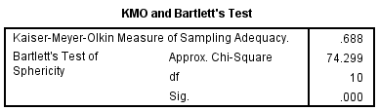
b) KMO Test for Independent Variable (IV) (OCEAN Personal Characteristics) –
Table 4.2 KMO and Bartlett’s Test of Sphericity
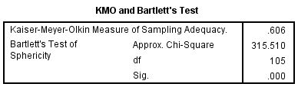
KMO Bartlett’s test of sphericity provides the Kaiser-Meyer-Olkin measure of sampling adequacy where if the data is adequate the KMO value should be greater than 0.6 (Zikmund et. al., 2013). As shown in table 4.1 (KMO test for Dependent Variable), the KMO value is 0.68 and as shown in table 4.2 (KMO test for Independent Variable), the KMO value is 0.60 which indicates the sample is adequate and researcher can go ahead with further analysis.
2) Factor Communalities
a) Factor Communalities for Independent Variable (IV) (OCEAN Personal Characteristics) –

Table 4.3 Factor Communalities Table
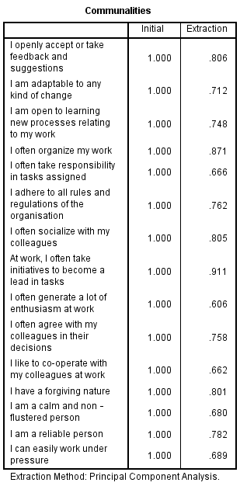
b) Factor Communalities for Dependent Variable (DV) (Work Performance) -

Table 4.4 Factor Communalities Table
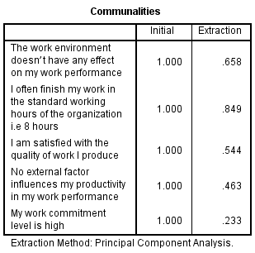
According to Hair et al (2014), for a factor to be deemed to be suitable for further analysis, the factor loading should be greater than 0.6. However, as shown in the results from the table 4.3 (factor communalities for Independent Variable) of communalities, the majority extraction values are more than 0.6 but however, as shown in table 4.4 (factor loading for Dependent Variable) of communalities, the last two extraction values are less than 0.6, however according to Fornell and Larcker (1981), the average cut off for factor communalities is 0.4, which means the second last extraction value is still acceptable but will change the question for clarity and improved results. However, the last item would be modified as well from the questionnaire as values below 0.4 is not acceptable (Hair et al, 2014). After the last item is modified, factor communalities test has been run again, as shown in the below table 4.5. When factor loading is applied, the rule of thumb is higher at 0.6 to be valid. However, when the extraction is not based on principal component analysis (PCA) or factor loading, but on communalities, then a lower value is acceptable as per Fornell and Larcker (1981). This is especially so when the factor analysis test is based on EFA (exploratory factor analysis) and not CFA (confirmatory factor analysis). This study is using EFA and thus, the focus is on the extraction of communalities and not PCA.

Table 4.5 Factor Communalities Table Dependent Variable (DV) after modification of items
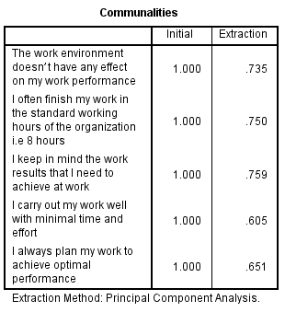
Thus, after the modification of the items or question for the Dependent Variable factor, the principal component analysis now aligns with the academic requirements for pilot test, whereby a value of >0.4 is acceptable especially when EFA (exploratory factor analysis) method is adopted (Fornell and Larcker, 1981).
3) Eigenvalue -

Table 4.6 Eigenvalue Table
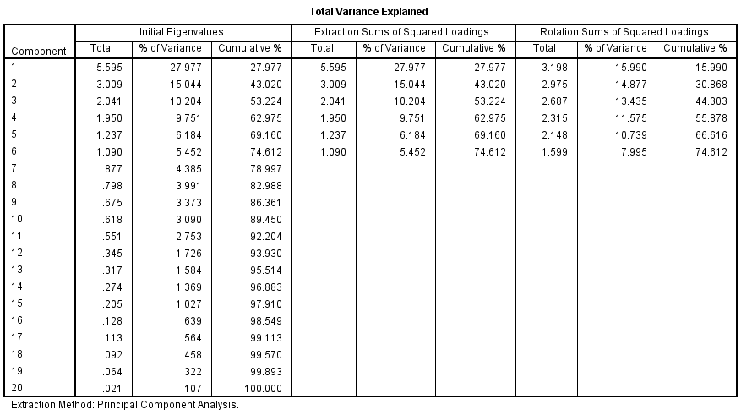
According to Cooper and Schinder (2013), the constructs and dimensions must be more than 1, in order to be valid for the study. As shown from table 4.6, the constructs are more than 1 which means that these constructs are valid for the study. However, as this study has 5 dimensions (under 1 independent variable) and 1 dependent variable, hence, the above table has 6 eigenvalues more than 1. This indicates that the data is relevant and appropriate for further analyses and thus, the full data collection will now be carried out.

4.1.2 Reliability Test – Cronbach Alpha
Item by item Cronbach Alpha Pilot testing –
Table 4.7 Summary of Results of Reliability Analysis
Item | Cronbach Alpha | Cronbach’s alpha based on standardized items | N of items
Openness | 0.778 | 0.776 | 3
Consciencetiouness | 0.718 | 0.726 | 3
Extraversion | 0.756 | 0.763 | 3
Agreeableness | 0.738 | 0.746 | 3
Neuroticism | 0.711 | 0.737 | 3

Reliability test is characterized as a statistical tool that is utilized to quantify the internal consistency of the variables under a factor, which can help ensure that the gathered information is reliable, and the instrument utilized in the study is valuable for analyzing (Baker, Ponton and Rovai, 2013). The reliability test for this research is done on 42 respondents’ data, collected for the pilot test. According to Hair et al. (2014), the value of Cronbach Alpha should be more than 0.7, if it is less than 0.7, item is not consistent and hence should be removed. However, from the above table 4.7, the Cronbach alpha’s value of all the items is above 0.7 which means items in the questionnaire has good reliability.
Given the above pilot test results, except for the DV where two (2) questions needed to be modified, the full data collection can now be executed.

4.3 Demographic Profile of Respondents

After the pilot testing was done, the questionnaires were distributed. Around 384 responses were expected, however received back on 332 responses. All data collected were usable as the researcher was using online questionnaire (Google docs). The below table 4.8 shows the summary of questionnaire table.
Summary of questionnaire table
Table 4.8
Items | Quantity
Questionnaires Distributed | 400
Questionnaires Collected | 332
Questionnaires Used for Analysis | 332

There is no spoilt questionnaire as the survey was conducted via online questionnaire, where respondents were required to answer all the items in the questionnaire. However, skewness was not ascertained. However, there is a need to run descriptive analysis which helps to provide the descriptive statistics on the data received from the respondents. Below table shows the profile of the respondents.

Table 4.9 Profile of Respondents
 |  | Frequency | Percentage
Gender | Male | 124 | 37.3
Gender | Female | 208 | 62.7
Age | Below 21 Years | 15 | 4.5
Age | 21-30 | 68 | 20.5
Age | 31-40 | 122 | 36.7
Age | 41-50 | 60 | 18.1
Age | >50 Years | 67 | 20.2
Employment of Duration | <12 Months | 56 | 16.9
Employment of Duration | 1-3 Years | 58 | 17.5
Employment of Duration | 3-5 Years | 100 | 30.1
Employment of Duration | >5 Years | 118 | 35.5

From the above table 4.9, around 62.7% of the respondents were female. Majority of the respondents in this research were between 31-40 Years of age. However, around 35.5% of the respondents has a work experience of more than 5 years. The sample size for this study was 384, however only 332 responses were received via the online questionnaire platform. According to Bougie and Sekaran (2016), as long as the number of data points collected exceed 250, the statistical significance can be ascertained. Hence, with 332 respondents, subsequent tests could not be carried out.

4.3 Preliminary Analyses

The main objective or reason of preliminary data analyses is to prepare the data for future analysis, describe the factors of the data and summarize the findings or outcomes (Blischke et al., 2011).

4.3.1 Factor Analysis

1) KMO Test
a) KMO test for Dependent Variable (DV) (Work Performance)
Table 4.10 KMO and Bartlett’s Test of Sphericity
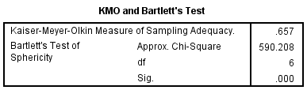

b) KMO test for Independent Variable (IV) (OCEAN Personal Characteristics)
Table 4.11 KMO and Bartlett’s Test of Sphericity
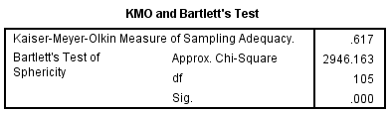
After considering all the 332 responses, as shown in table 4.10 and 4.11, the KMO value of Dependent Variable and Independent Variable is 0.65 and 0.61 respectively which indicates the sample is adequate.
2) Factor Communalities
a) Factor Communalities for Dependent Variable
Table 4.12 Factor Communalities
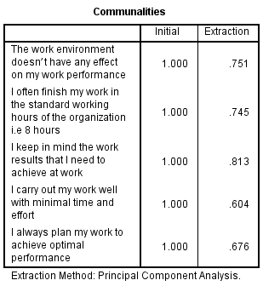
b) Factor Loading for Independent Variable
Table 4.13 Factor Communalities
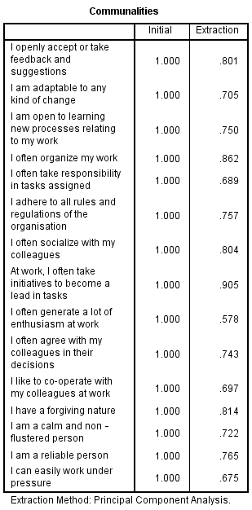
As shown in table 4.12 and 4.13, majority of the items have the factor loading value which is above 0.6, which means these items are usable and acceptable for further analysis (Hair et al., 2014)
3) Eigenvalues –
Table 4.14 Eigenvalue Table
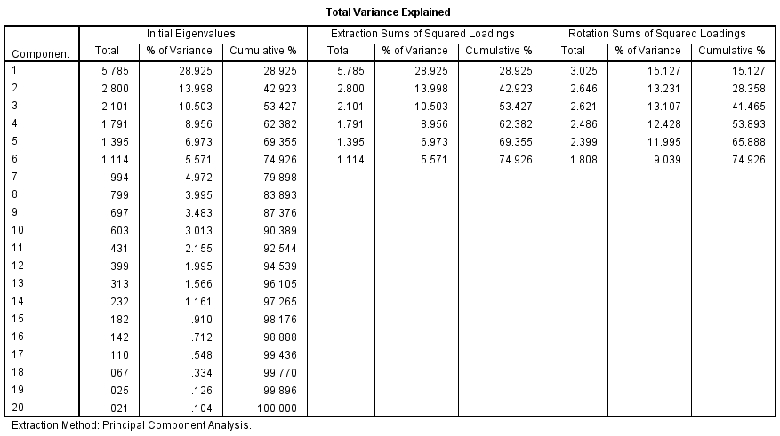
The above table 4.14 shows 6 (1 dependent variable and 6 dimensions of 1 independent variable) eigenvalues above 1. However, the dependent variable questions were modified and shown in the below table 4.15. 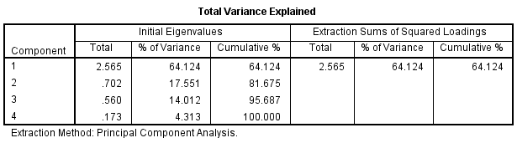
As shown in the above table 4.15, the eigenvalues of the items are more than 1 which means the constructs, or the dimensions are viable and appropriate for the study.

4.3.2 Reliability Test – Cronbach Alpha
Item by item Cronbach Alpha–
Table 4.16 Summary of Results of Reliability Analysis
Item | Cronbach Alpha | Cronbach’s alpha based on standardized items | N of items
Openness | 0.768 | 0.766 | 3
Consciencetiouness | 0.703 | 0.711 | 3
Extraversion | 0.735 | 0.740 | 3
Agreeableness | 0.727 | 0.732 | 3
Neuroticism | 0.748 | 0.755 | 3

According to Hair et al. (2014), if the value of Cronbach alpha is more than 0.7, then the items designed in the questionnaire has excellent reliability but if the value is less than 0.7, the item is not consistent and hence should be removed. As shown in table 4.16, the Cronbach alpha’s value of all the items is above 0.7 which means items in the questionnaire are reliable and indicates high internal consistency.

4.4 Hypotheses Testing

Multiple Regression and One-way ANOVA Table
Table 4.17 Coefficients Table
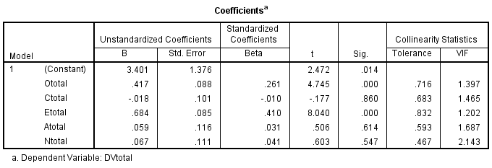
The above table shows the coefficient for independent variables to dependent variables. According to Bougie and Sekaran (2016), Beta Coefficient is done to identify the factor with highest influence, which means that higher the value of beta coefficient, higher is the predictive value toward phenomenon, the standardized Beta will range from 0 to 1 or 0 to -1, depending on the direction of the relationship which means the closer to 1 or -1, the stronger the relationship. As shown from the above table 4.17, openness and extraversion have the highest influencing power on work performance however conscientiousness have a negative beta coefficient which means there is an increase in one standard deviation in the predictor variable which results in a decrement of some portion of a standard deviation in the dependent variable, which means there is an inverse relation and is symptomatic of multi collinearity (Fisher, 2015) According to Hair et al. (2014), Multi-Collinearity is done to determine whether there are multiple overlaps and correlation between all variables which states that VIF has to be less than 10; if VIF is more than 10 means that factor is not strong predicter and will skew the results. From table 4.17, it is shown that the VIF is less than 10 which means the factors have strong predicter. According to Bougie and Sekaran (2016), Hypotheses testing is a statistical instrument to test whether the hypotheses is significant at the proposed level or not by contrasting it with the null hypotheses which is dismissed just when its probability is below the predetermined level of significance. According to Hair et al., if the p value is less than 0.05, hypothesis is accepted, if the p value is more than 0.05, hypothesis is rejected. However, from table 4.17 Hypothesis - Openness and Extraversion as a dimension of OCEAN personal characteristics has a significant relationship with work performance in Food and Beverage industry in Nigeria is accepted but Hypothesis - Conscientiousness, Agreeableness and Neuroticism as a dimension of OCEAN personal characteristics does not have a significant relationship with work performance in Food and Beverage industry in Nigeria and hence, is rejected.
Table 4.18 Multiple Regression Table
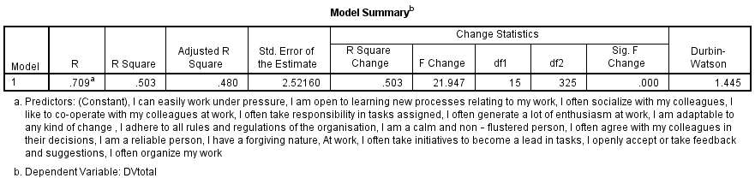
Multiple Regression is done to determine whether relationship exists between variables and whether the framework is able to explain/describe/predict the phenomenon (Bougie and Sekaran, 2013), which states two things; 1) if value is more than 0.5 it shows that it is at least 50% fit; anything less than 0.5, the model or construct is not fitting and doesn’t describe the relationship between variables, also 2) the nearer it is to 1 the stronger is the model fit (Zikmund et. al., 2013). As shown in table 4.19 the R square value is 0.503 which means the model is 50% fit and determines the relationship between the variables. However, the other 50% determines that there could be some other external factors influencing the model. Durbin Watson provides the auto correlation among the variables (Field, 2009). From above table 4.18 there is minimal autocorrelation since the value is between 0-4 which is 1.445.
Table 4.20 ANOVA Table
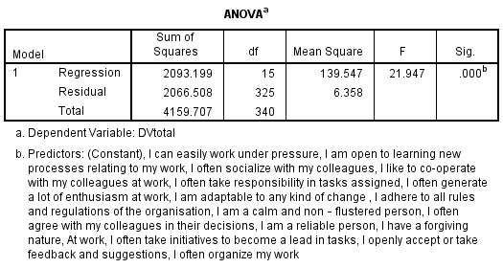
One-way ANOVA is done to determine the extent of variance within respondents or between respondents, through which it shows that the results or the p-value is less than 0.5 (Sedgwick, 2012). As shown in table 4.20 the p-value is less than 0.05, which shows the extent of variance within the respondents.

4.5 Summary of Findings

Based on the research findings, the hypothesis results is illustrated in table 4.17, which shows that Openness and Extraversion as a dimension of OCEAN personal characteristics has a significant relationship with work performance in Food and Beverage industry in Nigeria however, Conscientiousness, Agreeableness and Neuroticism as a dimension of OCEAN personal characteristics does not have a significant relationship with work performance in Food and Beverage industry in Nigeria and hence, is rejected. Thus, please find the summary of the hypothesis results in the below table 4.21.

Table 4.21 Summary of Hypothesis Results
Hypothesis | Results
H1: | OCEAN personal characteristics has a significant relationship with work performance in Food &Beverage industry in Nigeria. P-value (0.00<0.05), hence it is accepted
H1a: | Openness as a dimension of OCEAN personal characteristics has a significant relationship with work performance in F&B industry in Nigeria. P-value (0.00<0.05), hence it is accepted
H1b: | Conscientiousness as a dimension of OCEAN personal characteristics does not have a significant relationship with work performance in F&B industry in Nigeria. P-value (0.860>0.05), hence it is rejected
H1c: | Extraversion as a dimension of OCEAN personal characteristics has a significant relationship with work performance in F&B industry in Nigeria. P-value (0.00<0.05), hence it is accepted
H1d: | Agreeableness as a dimension of OCEAN personal characteristics does not have a significant relationship with work performance in F&B industry in Nigeria. P-value (0.614>0.05), hence it is rejected
H1e: | Neuroticism as a dimension of OCEAN personal characteristics does not have a significant relationship with work performance in F&B industry in Nigeria. P-value (0.547>0.05), hence it is rejected

4.6 Conclusion
In this chapter, the research finding based on the data analysis is highlighted, using SPSS statistical software version 22. The aim of this study was to verify whether OCEAN Personal characteristics has a significant relationship with work performance in the Food and Beverage Industry in Nigeria. However, from the findings, it was gathered that Openness and Extraversion as a dimension of OCEAN personal characteristics has a significant relationship with work performance in F&B industry in Nigeria and Conscientiousness, Agreeableness and Neuroticism as a dimension of OCEAN personal characteristics does not have a significant relationship with work performance in Food and Beverage industry in Nigeria. The next chapter will include the key findings, contributions and recommendations of this research.

Chapter Five

CONCLUSION AND RECOMMENDATIONS

5.0 Overview

In this chapter, a summary of Chapter 1 – 4 would be provided along with the conclusion of the entire research. It will include a summary, contribution to industry and literature, recommendation, limitation of research, future research direction and finally a conclusion of what has been discussed. From this study, the entire research would be summarized as below.

5.1 Summary of Findings

According to the research, employees play an important role in today’s company, in most cases, each employee have their own personality which not only influences their work performance but also directly influences the effectiveness of business and company development (Barney, 2010). Due to the role of employees in their work, most employees are affected by many factors that need to be distracted and take care of their families (Sheldon, 2015). Improving work performance, promoting business development is important for managers and employees that not only to make them feel happy, value and motivated at work, but also can represent the company's image (Lawrie, 2015). From the perspective of the employees, as employees, they need to work carefully for the enterprise (Bruce, 2010). However, human nature's instinct makes most employees can not completely abandon external factors such as family, marriage and social relations (Sheldon, 2015). From the finding it was gathered that Openness and Extraversion as a dimension of OCEAN personal characteristics has a significant relationship with work performance in Food and Beverage industry in Nigeria however, Conscientiousness, Agreeableness and Neuroticism as a dimension of OCEAN personal characteristics does not have a significant relationship with work performance in Food and Beverage industry in Nigeria. Extraversion have the highest influencing power but Openness is also influencing however, they are correlating because when an individual is an very extrovert, there are chances are that the individual might be more open, which means work performance in the food and beverage industry can be influenced by these two characteristics and also since food and beverage is a service industry, so the individual is required to be an extrovert. Conscientiousness has an inverse relationship with work performance, because the more conscientious the individual, the more rules and regulations are followed, therefore in food and beverage industry, the individual is required to be flexible, hence the work performance goes down specially in Nigeria, the individual is not required to be highly conscientious. In food and beverage industry, an individual with high agreeableness and neuroticism would influence the work performance majorly, a highly neurotic individual would scare all the customers and also, if the individual agrees with all the customers, the work performance would drop as it won’t be good for the business.

5.2 Contribution

5.2.1 Contribution to industry

This research will help the managers to understand which type of personality is suitable for the food and beverage industry which will enhance the work performance of the employees and therefore will promote the company’s economic growth and development (Lawrie, 2015). From the findings from the current study, it is clear that the personal characteristics of Openness and Extroversion will lead to better work performance as these two (2) characteristics are required for a service industry like the food and beverage industry of Nigeria.
In the future, managers from the food and beverage industry of Nigeria can use appropriate tools during the interview to ensure that only employees with Openness and Extroversion are employed, thereby helping to ensure improved work performance for the hiring organization within the industry. By doing so, it will help to bring up the quality of performance as a whole for the entire food and beverage industry of Nigeria which is increasingly gaining importance as the country continues to develop and move toward greater level of prosperity.

5.2.2 Contribution to literature

Extensive academic research would be conducted on personal characteristics and work performance of the employees working in food and beverage industry in Nigeria (Barrick and Mount, 2012). However, the existing literature has been conducted in different context. Therefore, with this study effective data will be added to the existing database regarding OCEAN personal characteristics and work performance (Inceoglu and Warr, 2012).

5.3 Recommendation

In order to enhance the work performance of the employees from moderate to high level, the hiring managers in the food and beverage industry should have enough understanding knowledge on different personalities and which personality traits is suitable for this industry (Masood et al., 2017). OCEAN Personal Characteristics helps to identify how flexible the individual is in adjusting to the company’s environment (Ackerman, 2019). However, in food and beverage industry, individuals who have Openness and Extraversion in the first three level as their personality traits are surely to perform better since this a service industry and the employee is required to be an extrovert and open (Venkatesh et al., 2017). If the employee is an extrovert and open he can deal with his team and clients properly and as trends keep changing he can openly adapt and accept any changes to keep the position in the service industry (Schaap and Visser, 2017). Therefore, individuals who have personality traits like EOCAN, or OECAN under their OCEAN personality traits will be excellent in their work performance and are suitable for the food and beverage industry.

5.4 Limitation of Research

Although researchers try their best to improve research, there are also have limitations (Jenny, 2011). Firstly, the geographical locations are a limitation as the location of this study is in Nigeria (DeYoung, 2015). The existing data and information are all researched under the cultural background of Nigeria and cannot be used as extensive reference materials (Irefin and Mechanic, 2014). Secondly, because of time constraints, there is not enough time for more careful research and more literature and data collection (Jenny, 2011). Given the overall population was large, the sample size had to be much larger than the one that was conducted in this study (Anderson, Salgado and Tauriz, 2014). More than 500 respondents would have been ideal for population of this size however due to time constraints that could not be achieved (Brown, 2014). This will have some impact on the overall efficacy of the results, as a larger data set implies that there are less mistakes and there are less edge cases which are having an impact on the overall outcome (DeYoung, 2015). Finally, the sample of the current study only consists of participants from Nigeria region; thus, the generalizing of these current findings throughout the globe may be problematic. There are many other geographical regions which are socially, economically and culturally different from Nigeria (Alwis and Leka, 2017)

5.5 Future Research Direction

This study is done to expand the scope of the study and to increase the number of research samples, which will help future research to obtain more accurate information (DeYoung, 2015). It is suggested that qualitative research method should be used to conduct a thorough discussion and find more information about OCEAN personal characteristics having a significant relationship with work performance in Food and Beverage industry in Nigeria (Irefin and Mechanic, 2014). The proposed research method consists of conducting interviews and focus groups method which will help the future researchers to obtain more valuable data (Campbell and Wiernik, 2015). However, this study can be done to verify the relationship between OCEAN Personal Characteristics and Work Performance of the employees in the Food and Beverage Industry in different countries to see the results as there are different personalities at different locations and culture.

5.6 Conclusion

In conclusion, this study gives an extraordinary contribution to the area of work performance research through exploring how work meddles with more extensive personalities types. Based on findings of the present study, personality is an important factor which contributes to the work performance of a person. Extraversion was the most related personality factor to work performance, followed by Openness. Personality dimensions such as neuroticism and agreeableness did not show any substantial relationship with the work performance. However, Conscientiousness showed an inverse relation. Further, it was evident that these personalities may differ from one geographic location to another. Future research in this topic area should focus on verify the relationship between OCEAN Personal Characteristics and Work Performance of the employees in the Food and Beverage Industry in different countries (Alwis and Leka, 2017).

5.7 Personal Reflection

Through this research, the researcher is aware of the importance of understanding how personality traits or characteristics influences work performance in this service industry and which would help the companies in future while hiring the employees. Secondly, during this study, the researcher learned how to conduct a quantitative research using SPSS Software which helps in understanding the outcome and analysis the results. Thirdly, while conducting this research, very less literatures were found with regards to Personal Characteristics and Work Performance in the food and beverage industry, but many literatures were found in different context but with the same location. After completing the study, the researcher has a better understanding of the social interaction theory. After this study, researcher has a deeper understanding on Human Resource Management so that the whole research process has value and significance.

A big thanks to Assoc. Prof. Dr. Lee Kar Ling for giving the researcher a lot of insight and constant guidance at every step so the researcher knows which area needs enhancement and improvement and which area was not reliable. Under her supervision the researcher learnt how to work effectively to complete high-quality project in a short period of time. Hence the researcher believed that the entire research and learning process is a valuable and enjoyable experience.

6. 0 References

Ahn, J., Mortara, L. and Minshall, T. (2013). Linkages between Openness and CEO Characteristics in Innovative SMEs. SSRN Electronic Journal.
Allik, J. (2010). How people see others is different from how people see themselves: A replicable pattern across cultures. Journal of Personality and Social Psychology, 99(5), pp.870-882.
Baard, S., Rench, T. & Kozlowski, S., 2014. Performance Adaptation A Theoretical Integration and Review. A Theoretical Integration and Review, 40(2), p. 48–99.
Babin, B., Carr, J., Griffin, M. and Zikmund, W. (2013). Business Research Methods. CENGAGE Learning Custom Publishing.
Bailey, F. (2014). The four elementary forms of sociality: Framework for a unified theory of social relations.
Barrick, M. And Mount, M. (2012). The Big Five Personality Dimensions and Job Performance: A Meta-Analysis. Personnel Psychology, 44(1), Pp.1-26.
Biddle, J. (2011). Recent developments in role theory. Journal of Center for Research in Social Behavior, 12(3), pp 67-92.
Blake, E. (2010). Social identity theory and organization. Journal of Academy of Management Review, 24(7), pp 257-273.
Bland, W. (2003). How to develop a business growth strategy.
Blanz, M. (2017). Employees’ Job Satisfaction: A Test of the Job Characteristics Model Among Social Work Practitioners. Journal of Evidence-Informed Social Work, 14(1), pp.35-50.
Bliese, D. (2014). Journal of Applied Psychology. The big five personality traits and individual job performance growth trajectories in maintenance and transitional job stages. 89(5), pp 835-853.
Bolarinwa, O. (2015). Principles and Methods of Validity and Reliability Testing of Questionnaires Used in Social and Health Science Researchers. Nigerian Postgraduate Medical Journal, 22 (4), pp. 195.
Boye Kuranchie-Mensah, E. and Amponsah-Tawiah, K. (2016). Employee motivation and work performance: A comparative study of mining companies in Ghana. Journal of Industrial Engineering and Management, 9(2), p.255.
Brown, A. and Maydeu-Olivares, A. (2013). How IRT can solve problems of ipsative data in forced-choice questionnaires. Psychological Methods, 18(1), pp.36-52.
Campbell, J. and Wiernik, B. (2015). The Modeling and Assessment of Work Performance. Annual Review of Organizational Psychology and Organizational Behavior, 2(1), pp.47-74.
Carlson, R. E. (2014). Degree of job fit as a moderator of the relationship between job performance and job satisfaction. Journal of Personnel Psychology, 22(4), pp 159-170.
Chang, L., Connelly, B. and Geeza, A. (2012). Separating method factors and higher order traits of the Big Five: A meta-analytic multitrait–multimethod approach. Journal of Personality and Social Psychology, 102(2), pp.408-426.
Cooper, R., and Schinder, S. (2013). Business Research Methods. New York: McGraw Hill.
Darren, D. (2003). The production development strategy of the company.
Denham, T. (2010). The 10 most important personality traits for career success.
DeYoung, C. (2015). Cybernetic Big Five Theory. Journal of Research in Personality, 56, pp.33-58.
finelib. (2018). [online] Available at: https://www.finelib.com/cities/abuja/business/foods/restaurants. [Accessed 15 Nov. 2018].
Frink, D. (2013). The big five personality dimensions and job performance. Journal of Industrial Psychology, 29(1), pp 68-74.
Gray, D. and Irons, P. (2016). Managers’ Opinions of Management Accountants’ Competency Skills and Personal Qualities. World Journal of Business and Management, 2(1), p.33.
Hair, J.F., Black, W.C., Babin, B.J., Anderson, R.E. and Tatham, R.L., 2014. Multivariate data analysis (Vol. 6).
Harter, J. & Mann, A., 2016. The Worldwide Employee Engagement Crisis, s.l.: Gallup Business Journal.
Holmberg, D., McWilliams, L. and Patterson, A. (2012). Conscientiousness and attachment avoidance as moderators of the association between attachment anxiety and neuroticism. Journal of Social and Personal Relationships, 30(4), pp.515-525.
Hsu, C., Chiang, Y. and Hsu, W. (2012). The Congruence of High Performance Work Performance Perception and Work Team Performance. Academy of Management Proceedings, 2012(1), p.12877.
Humphrey, S., Nahrgang, J. and Morgeson, F. (2011). Integrating motivational, social, and contextual work design features: A meta-analytic summary and theoretical extension of the work design literature. Journal of Applied Psychology, 92(5), pp.1332-1356.
Iitzhak, H. & Liat, E., 2015. A process model of employee engagement: The learning climate and its relationship with extra-role performance behaviors. Journal of Organizational Behavior, Volume 37, p. 213–235.
Inceoglu, I. and Warr, P. (2012). Personality and Job Engagement. Journal of Personnel Psychology, 10(4), pp.177-181.
Irefin, P. and Mechanic, M. (2014). Effect of Employee Commitment on Organizational Performance in Coca Cola Nigeria Limited Maiduguri, Borno State. IOSR Journal of Humanities and Social Science, 19(3), pp.33-41.
Jaeger, M. and Adair, D. (2005). The development of the company.
Jain, K. (2014). Big Five Personality Types & Knowledge Hiding Behaviour: A Theoretical Framework. Archives of Business Research, 2(5), pp.47-56.
Jena, L. K. & Pradhan, R. K., 2017. Employee Performance at Workplace: Conceptual Model and Empirical Validation. Business Perspectives and Research, I(5), p. 69–85.
Jones, W. H. (2012). Loneliness and social behavior. Journal of Human Behavior, 23(8), pp 432-458.
Journal of Psychological Review, 112(4), pp 100-121.
Koopmans, L. et al., 2014. Construct Validity of the Individual Work Performance Questionnaire. Journal of Occupational and Environmental Medicine, 56(3), pp. 331-337.
Krejcie, R. and Morgan, D. (1970). Determining Sample Size for Research Activities. Educational and Psychological Measurement, 30(3), pp.607-610.
Lavrakas, P. (2013). Encyclopedia of Survey Research Methods. Thousand Oaks, Calif [u.a.]: Sage.
Leka, S. and Alwis, S. (2017). Work, Life and Personality: The Relationship Between the Big Five Personality Traits and Work-life Conflict. Young Consumers, 15(4), pp.342-352.
Lewis, Saunders & Thornhill, 2012. Research Methods for Business Student. 6 ed. s.l.:Financial Times Prentice Hall.
Li, C. and Tsai, B. (2013). Impact of Extraversion and Sensation Seeking on International Tourism Choices. Social Behavior and Personality: an international journal, 41(2), pp.327-333.
Li, X., Yao, P., Didericksen, K., Jang, J. and Olson, D. (2018). Five Personality Types Based on Big Five: A Latent Class Analysis. Family Science Review, 22(2).
Malhotra, N. K. and Birks, D. F. (2007). Marketing Research: An Applied Approach.
Maras, E. (2015) ‘F&B Industry Supports Food Safety Improvement, But Calls For Changes To FSMA’, Food Logistics, (165), pp. 16–25.
Martin, J. (2011). Job satisfaction and organizational commitment in relation to work performance and turnover intentions. Journal of Human Relations, 42(7), pp 625-638.
Maslow, A. H. (2014). New work attitude measures of trust, organizational commitment and personal need non-fulfilment. Journal of Occupational Psychology, 23(7), 24-33.
Mason, C. (2011). Personality, Attitudes and Work behaviors. Journal of Personnel Psychology, 109(1), pp 45-48
Masood, A. and Rafique, R. (2017). Personality Traits as Predictor of Job Performance in Police Officers. Bahria Journal of Professional Psychology, 16(2), pp.31-53.
McQuerrey, L. (2009). Importance of employee behavior in an organization. Journal of Nutrition Society, 56(1), p.17-25
Mofoluwake, A. and Oluremi, A. (2013). Job Satisfaction, Organizational Stress and Employee Performance. Journal of Ife Center for Psychological Studies and Services, 21(2), pp.75- 82.
Morsella, E. (2015). The Function of phenomenal states: Supramodular interaction theory.
Motowidlo, S. and Kell, H. (2012). Handbook of psychology. 2nd ed. Wiley, pp.82-103.
Munisamy, S. (2013). Identifying Factors That Influences Job Performance Amongst Employees In Oil Palm Plantation. Degree of Bachelor in Psychology. Open University Malaysia.
Nguyen, H. (2013). 10 Important Personal Characteristics of Entrepreneurs.
Palvalin, M. (2017). How to measure impacts of work environment changes on knowledge work productivity – validation and improvement of the Smart WoW tool. Measuring Business Excellence, 21(2), pp.175-190.
Palvalin, M. (2017). How to measure impacts of work environment changes on knowledge work productivity – validation and improvement of the Smart WoW tool. Measuring Business Excellence, 21(2), pp.175-190.
Patton, E. (2010). The job satisfaction – Job performance lationship: A qualitative and quantitative review. Journal of Psychological Bulletin, 127(3), pp 376-407.
Psychology Today. (2018). Neuroticism | Psychology Today.
Quintelier, E. (2014). The influence of the Big 5 personality traits on young people’s political consumer behavior. Young Consumers, 15(4), pp.342-352.
Rahi, S. (2017). Research Design and Methods: A Systematic Review of Research Paradigms, Sampling Issues and Instruments Development. International Journal of Economics and Management Services, 6(2), pp. 1-5.
Remus, A. (2012). Relationship of personality to performance motivation: A Meta-Analytic review. Journal of Applied, 87(4), pp 797-807
Retico, A., Arezzini, S., Bosco, P., Calderoni, S., Ciampa, A., Coscetti, S., Cuomo, S., Santis, L. D., Fabiani, D., Fantacci, M. E., Giuliano, A., Mazzoni, E., Mercatali, P., Miscali, G., Pardini, M., Prosperi, M., Romano, F., Tamburini, E., Tosetti, M. and Muratori, F. (2017). ARIANNA: A research environment for neuroimaging studies in autism spectrum disorders. Computers in Biology and Medicine, 87, pp. 1–7.
Rovai, A., Baker, J. and Ponton, M. (2013). Social Science Research Design and Statistics: A Practioner`s Guide to Research Methods and SPSS Analysis. 1st edition. Watertree Press LLC.
Salgado, J., Anderson, N. and Tauriz, G. (2014). The validity of ipsative and quasi-ipsative forced-choice personality inventories for different occupational groups: A comprehensive meta-analysis. Journal of Occupational and Organizational Psychology, 88(4), pp.797-834.
Saucier, G. (2009). What Are the Most Important Dimensions of Personality? Evidence from Studies of Descriptors in Diverse Languages. Social and Personality Psychology Compass, 3(4), pp.620-637.
Sedgwick, P. (2012). One-Way Analysis of Variance. BMJ, 344 (apr04 1), pp. 2427-2427.
Sekaran, U. & Bougie, R., 2013. Research Methods for Business: A Skill-Building. 6th ed. New York: John Wiley & Sons, Inc.
Sekaran, U. and Bougie, R. (2016). Research Methods for Business. Chichester: Wiley.
Sekaran, U. and Bougie, R. (2016). Research Methods for Business: A Skill Building Approach.
Sheldon, C. (2015). Stress, social support and the buffering hypothesis. Journal of Psychology Bulletin, 8(2), pp 310-327.
Simone, A., Berardi, L., Laucelli, D. and Giustolisi, O. (2017). A Proposal of Optimal Sampling Design Using Infrastructure Modularity. Procedia Engineering, 186, pp. 559 – 566.
Smillie, L., DeYoung, C. and Hall, P. (2014). Clarifying the Relation Between Extraversion and Positive Affect. Journal of Personality, 83(5), pp.564-574.
Solodovnikova, O. and Tsoy, G. (2015). The Top Questions of the Higher Education: Openness, Availability, Elitism. Procedia - Social and Behavioral Sciences, 166, pp.472-474.
Statista.com. (2018). [online] Available at: https://www.statista.com/Overview/Working-at-Flour-Mills-of-Nigeria-EI_IE435102.11,33.htm [Accessed 15 Nov. 2018].
Tov, W., Nai, Z. and Lee, H. (2014). Extraversion and Agreeableness: Divergent Routes to Daily Satisfaction with Social Relationships. Journal of Personality, 84(1), pp.121-134.
Turner, H. T. (2013). A theory of social interaction. Journal of A Theory of problematic internet use and psychology well-being, 44(5), pp 112-134.
Wacker, J. and Smillie, L. (2015). Trait Extraversion. Social and Personality Psychology Compass, 9(6), pp.225-238.
Walliman, N., 2011. Research Methods: The Basics. 1st ed. New York: Routledge.
Walter, M. (2013). Toward a cognitive social learning reconceptualization of personality. Journal of Psychology Review, 8(4), pp 252-283.
Wang, J., Chang, C., Yao, S. and Liang, C. (2015). The contribution of self-efficacy to the relationship between personality traits and entrepreneurial intention. Higher Education, 72(2), pp.209-224.
Wille, B., De Fruyt, F. and Feys, M. (2012). Big Five Traits and Intrinsic Success in the New Career Era: A 15-Year Longitudinal Study on Employability and Work-Family Conflict. Applied Psychology, 62(1), pp.124-156.
Yong, A. and Pearce, S. (2013). A Beginner`s Guide to Factor Analysis: Focusing on Exploratory Factor Analysis. Tutorials in Quantitative Methods for Psychology, 9(2), pp. 79-94.
Zhang, S., Zhou, M., Zhang, J. and Chen, S. (2012). The nonlinear effects of conscientiousness on overall job performance and performance dimensions in the Chinese context. Asian Journal of Social Psychology, 15(4), pp.231-237.
Zikmund, W., Babin, B., Carr, J. and Griffin, M. (2013). Business Research Methods. CENGAGE Learning Custom Publishing.
Zikmund, W., Babin, B., Carr, J. and Griffin, M. (2013). Business Research Methods. CENGAGE Learning Custom Publishing.
Zohrabi, M. (2013). Mixed Method Research: Instruments, Validity, Reliability and Reporting Findings. Theory and Practice in Language Studies, 3 (2), pp. 1-9.

7.0 Appendix

Questionnaire 1 - …………………………………………………...............…………...........................................................................
PERSONAL CHARACTERISTICS AND WORK PERFORMANCE IN THE FOOD AND BEVERAGE INDUSTRY IN NIGERIA
……………………….................………………………
Dear Sir or Madam,

Thank you for agreeing to respond to this questionnaire; I am a student of INTI International University, Nilai and is required to conduct a research on the topic of “Personal Characteristics and Work Performance in the Food and Beverage Industry in Nigeria” as a requirement to complete of my degree of Master in Business Administration (MBA).
The aim of this study is to determine the personal characteristics influence the work performance on the food and beverage industry mainly focusing on restaurants in Nigeria.

The questions in this survey are designed for the requirement of my assignment only. The questionnaire will just take about five or ten minutes of your time and your name will not be recorded or disclosed in any manner throughout the assignment and the report.The data collection is done by the researcher personally. Third parties are not allowed to access the data and the data will be stored via encryption method with password. The answers will not be released to others for viewing.

Without your cooperation and support, this research cannot be accomplished. Please take your time to participate in this survey. Thank you very much.

INTI International University
Researcher: Priti Sundrani
It is completely up to you whether or not you decide to take part in this study.
If you agree to participate to this survey, please select “agree”
Agree

Part A. Respondents profiles
Instruction: please tick () at the appropriate box.
1. Gender
Male Female

- Age
Below 21 years 21 – 30 31– 40
41-50 More than 50

3. What is the duration of your employment?
Less than 12 months 1 – 3 years 3 – 5 years
5 years and above

Part B. Work Performance

The scale is given below:
1 | 2 | 3 | 4 | 5
Strongly Disagree | Disagree | Neutral | Agree | Strongly Agree

Listed below are the series of statements that represents feelings that you may have about the factors that may influence your work performance. There are no right or wrong answers. Your responses will be treated as strictly confidential.
Instruction: Please tick (√) in the box with relevant information.
Statement | 1 | 2 | 3 | 4 | 5
B1. The work environment doesn’t have any effect on my work performance
B2. I often finish my work in the standard working hours of the organization i.e 8 hours
B3. I am satisfied with the quality of work I produce
B4. No external factor influences my productivity in my work performance
B5. My work commitment level is high

Part C. Personal Characteristics Influencing Work Performance
Instruction: Please tick (√) in the box with relevant information.
NO | Questions | 1 | 2 | 3 | 4 | 5
A | Openness to Change
1 | I openly accept or take feedback and suggestions
2 | I am adaptable to any kind of change
3 | I am open to learning new processes relating to my work
B | Conscientiousness
1 | I often organize my work
2 | I often take responsibility in tasks assigned
3 | I adhere to all rules and regulations of the organisation
C | Extraversion
1 | I often socialize with my colleagues
2 | At work, I often take initiatives to become a lead in tasks
3 | I often generate a lot of enthusiasm at work
D | Agreeableness
1 | I often agree with my colleagues in their decisions
2 | I like to co-operate with my colleagues at work
3 | I have a forgiving nature
E | Neuroticism
1 | I am a calm and non – flustered person
2 | I am a reliable person
3 | I can easily work under pressure

Thank you very much for reading this information and giving consideration to taking
part in this study.

Revised Questionnaire 2 –
…………………………………………………...............…………...........................................................................
PERSONAL CHARACTERISTICS AND WORK PERFORMANCE IN THE FOOD AND BEVERAGE INDUSTRY IN NIGERIA
……………………….................………………………
Dear Sir or Madam,

Thank you for agreeing to respond to this questionnaire; I am a student of INTI International University, Nilai and is required to conduct a research on the topic of “Personal Characteristics and Work Performance in the Food and Beverage Industry in Nigeria” as a requirement to complete of my degree of Master in Business Administration (MBA).
The aim of this study is to determine the personal characteristics influence the work performance on the food and beverage industry mainly focusing on restaurants in Nigeria.

The questions in this survey are designed for the requirement of my assignment only. The questionnaire will just take about five or ten minutes of your time and your name will not be recorded or disclosed in any manner throughout the assignment and the report.The data collection is done by the researcher personally. Third parties are not allowed to access the data and the data will be stored via encryption method with password. The answers will not be released to others for viewing.

Without your cooperation and support, this research cannot be accomplished. Please take your time to participate in this survey. Thank you very much.

INTI International University
Researcher: Priti Sundrani
It is completely up to you whether or not you decide to take part in this study.
If you agree to participate to this survey, please select “agree”
Agree

Part A. Respondents profiles
Instruction: please tick () at the appropriate box.
1. Gender
Male Female

- Age
Below 21 years 21 – 30 31– 40
41-50 More than 50

3. What is the duration of your employment?
Less than 12 months 1 – 3 years 3 – 5 years
5 years and above

Part B. Work Performance

The scale is given below:
1 | 2 | 3 | 4 | 5
Strongly Disagree | Disagree | Neutral | Agree | Strongly Agree

Listed below are the series of statements that represents feelings that you may have about the factors that may influence your work performance. There are no right or wrong answers. Your responses will be treated as strictly confidential.
Instruction: Please tick (√) in the box with relevant information.
Statement | 1 | 2 | 3 | 4 | 5
B1. The work environment doesn’t have any effect on my work performance
B2. I often finish my work in the standard working hours of the organization i.e. 8 hours
B3. I keep in mind the work results that I need to achieve at work
B4. I carry out my work well with minimal time and effort
B5. I always plan my work to achieve optimal performance

Part C. Personal Characteristics Influencing Work Performance
Instruction: Please tick (√) in the box with relevant information.
NO | Questions | 1 | 2 | 3 | 4 | 5
A | Openness to Change
1 | I openly accept or take feedback and suggestions
2 | I am adaptable to any kind of change
3 | I am open to learning new processes relating to my work
B | Conscientiousness
1 | I often organize my work
2 | I often take responsibility in tasks assigned
3 | I adhere to all rules and regulations of the organisation
C | Extraversion
1 | I often socialize with my colleagues
2 | At work, I often take initiatives to become a lead in tasks
3 | I often generate a lot of enthusiasm at work
D | Agreeableness
1 | I often agree with my colleagues in their decisions
2 | I like to co-operate with my colleagues at work
3 | I have a forgiving nature
E | Neuroticism
1 | I am a calm and non – flustered person
2 | I am a reliable person
3 | I can easily work under pressure

Thank you very much for reading this information and giving consideration to taking
part in this study.

Turnitin
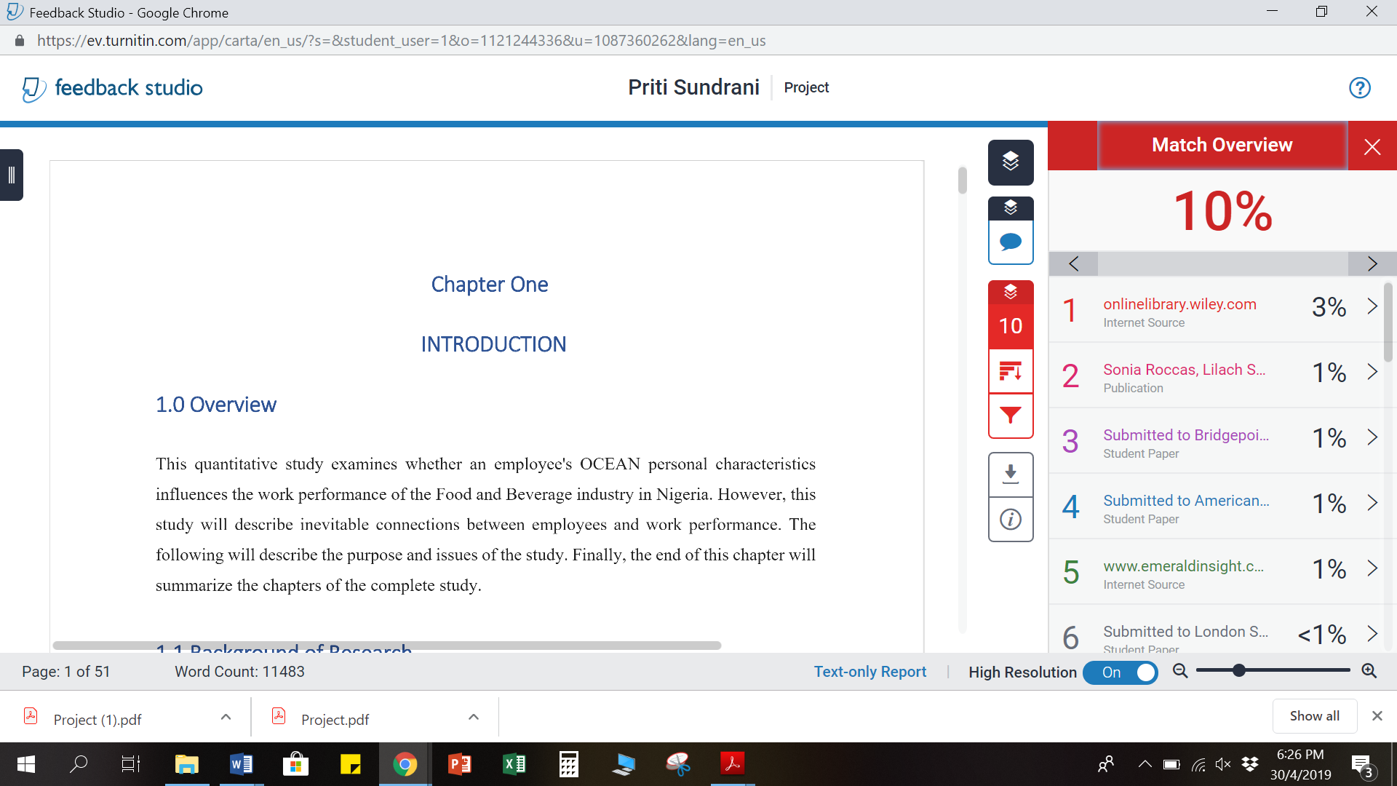

Project Log Paper –

