

**SOCIAL MEDIA FACTORS AND PURCHASE INTENTION OF BEAUTY PRODUCTS IN MAURITIUS**

|  |  |
| --- | --- |
| Name: | Hanaa Maysoon Mohamodhossen |
| Student No: | I14004669 |
| Course code: | MGT7998 |
| Supervisor: | Dr. Lim Kim Yew |
| Submission Date: | May 2019 |

**FACULTY OF BUSINESS COMMUNICATION AND LAWS (FOBCAL)**

**MBADI-MASTER OF BUSINESS ADMINISTRATION**

**DECLARATION**

I hereby declare that this thesis is my own work and effort and that it has not been submitted anywhere for any award. Where other sources of information have been used, they have been duly acknowledged.

Name : Hanaa Maysoon Mohamodhossen

Student ID : I14004669



Signature :

Date : 5th May 2019

# ACKNOWLEDGEMENTS

First and foremost, I would like to thank the Al-mighty for giving me a well-functioning body and mind that allow me to live life, learn and mainly work on my final year project for my master’s in business administration.

Secondly, my respectful gratitude goes to my lead supervisor, Dr Lim Kim Yew, for his guidance, expertise, patience and facilitation of the project. Without his guidance, this project would not have been possible. His insights and expertise knowledge in marketing has indeed helped me in further understanding the project.

I would like to also thank Dr. Syriac Nellikunnel for his useful insights regarding the thesis as well as his perseverance and diligence in excellently managing the MBA program.

A special thanks to my husband, Hashim Sayyid, for his constant support and motivation. I would like to extend my gratitude to my friends Priti and Osama who have supported me likewise throughout this project.

Lastly but not the least, I would like to thank my parents, Youssouf and Yasmin, for their emotional and financial support and my sister, Mushira, whose involvement in the beauty industry helped me in constructing this research.

# ABSTRACT

Social Media Marketing has become increasingly popular in Mauritius as businesses have found a mean to advertise their products or services and achieve their marketing objectives. Social media marketing has shown its impact when it comes to boosting e-commerce. However, there are very limited academic research which focuses on the relationship between social media marketing and purchase intention of beauty products. The purpose of this research is to investigate how social media marketing increase purchase intension through platforms such as Electronic Word of Mouth, Social Networking Sites and Mobile Applications. The geographic focus of the study is in Mauritius where descriptive research designed is employed in this research. The study population involves 267 questionnaires filled by the female population of different age groups, using convenience sampling method. Pilot test (N=30) was firstly conducted to ensure reliability is supported to proceed for further analysis. Multiple regression analysis was then conducted using SPSS. The research findings do not support the third hypothesis which is the relationship between Mobile Applications and purchase intention. The research finds significant positive relationship between Electronic Word of Mouth and Social Networking Sites and purchase intention. Social networking sites has a stronger effect on purchase intention as the beta coefficient value was highest. In this respect, beauty product seller could benefit from this research by obtaining better understanding on social media marketing strategies. Finally, this research also has contributions to the academia with statistical evidence that this research could provide on the context of beauty industry.

**Keywords:** Purchase Intention, Social Media Marketing, Electronic word-of-mouth, Social Networking Sites, Mobile Applications, Mauritius.

Contents

ACKNOWLEDGEMENTS 3

ABSTRACT 4

LIST OF TABLES 8

LIST OF FIGURES 8

INTRODUCTION 9

1.0 Overview 9

1.1 Background of Research 9

1.2 Problem Statement 10

1.3 Research Questions 11

1.4 Research Objective 11

1.5 Significance of study 12

1.5.1 Significance to Academy 12

1.5.2 Significance to the beauty industry in Mauritius 12

1.6 Scope of study 12

1.7 Limitations of the Research 13

1.8 Operations Definitions 14

1.9 Organization of Chapters 15

LITERATURE REVIEW 16

2.0 Overview 16

2.1 Purchase Intention 16

2.1.1 Global perspective in Purchase intention 17

2.1.2 Mauritius’ perspective in purchase intention 19

2.2 Factors influencing Purchase Intention 21

2.2.1 Electronic Word of Mouth (eWOM) Communication 21

2.2.2 Social Networking Sites (SNS) 23

2.2.3 Mobile Applications 26

2.3 Gaps in the Literature 27

2.4 Theory of Reasoned Action (TRA) 28

2.5 Conceptual framework of Purchase Intention 29

2.6 Hypotheses 30

2.7 Summary 30

RESEARCH METHODOLOGY 31

3.0 Overview 31

3.1 Research Design 31

3.2 Preliminary Tests 32

3.3 Reliability Test in SPSS 32

3.4 Validity Tests 32

3.4.1 Internal validity: Content Validity and Face Validity Tests 32

3.4.2 External Validity 33

3.5 Study Population, Unit of Analysis, Sample Selection and Sampling 33

3.6 Measuring Instruments 34

3.7 Data Collection Method 36

3.7.1 Operationalisation of Variables 36

3.8 Data Analysis 38

3.8.1 Multiple Regression Analysis in SPSS 38

3.9 Ethical Consideration 39

3.10 Summary 39

RESEARCH FINDINGS 40

4.0 Overview 40

4.1 Pilot Test 40

4.1.1 Reliability Test 40

4.1.2 Correlation Matrix 41

4.2 Demographics Characteristics 42

4.2.1 Response Rate 42

4.2.2 Demographic Profile of Respondents 43

4.3 Preliminary Data Analysis 46

4.3.1 Reliability Analysis 46

4.3.2 Correlation Analysis 47

4.4 Hypothesis Analysis 47

4.4.1 Model Fit Multiple Regression 48

4.5 Summary 50

CONCLUSION AND RECOMMENDATIONS 51

5.0 Overview 51

5.1 Findings: Answering the research questions 51

5.2 Recommendations 54

5.3 Contributions 55

5.3.1 Contribution to Academy 55

5.3.2 Contribution to Industry 55

5.4 Limitations of Study 55

5.6 Future Directions of Research or Future Research Focus 56

5.7 Conclusion 57

5.8 Personal Reflection 57

REFERENCES 59

APPENDICES 71

Appendix 1: Questionnaire 71

Appendix 2: Project Paper Log 77  
Appendix 3: Turnitin Report………………………………………………………………85

# LIST OF TABLES

|  |  |  |
| --- | --- | --- |
| **Table No.** | **Title** | **Page Number** |
| 1.0 | Operations Definitions | 14 |
| 3.1 | Measuring instruments | 35 |
| 3.2 | Questionnaire items and constructs | 37 |
| 4.1 | Cronbach Alpha values for the reliability test | 40 |
| 4.2 | Correlation matric values for the pilot test | 41 |
| 4.3 | Summary of research response rate | 43 |
| 4.4 | Demographic profile of respondents | 43 |
| 4.5 | Frequency of age | 44 |
| 4.6 | Frequency of income | 44 |
| 4.7 | Summary of dependent and independent variables | 46 |
| 4.8 | Reliability test results | 46 |
| 4.9 | Results from correlation analysis | 47 |
| 4.10 | Research hypotheses | 47 |
| 4.11 | Model Summary | 48 |
| 4.12 | Results from Multiple Regression | 48 |
| 4.13 | Summary of the hypothesis results | 50 |

# LIST OF FIGURES

|  |  |  |
| --- | --- | --- |
| **Figure No.** | **Title** | **Page Number** |
| 2.0 | Conceptual framework of purchase intention | 29 |
| 4.1 | Bar chart display of preferred social media platform | 45 |

CHAPTER 1

# INTRODUCTION

## 1.0 Overview

This study provides a literature view of the purchase intention, social media marketing and the factors affecting purchase intention. The aim of this study is to provide empirical evidence regarding factors influencing purchase intention of beauty through social media marketing in Mauritius. This study focuses on the female customers wherein the first-hand information is collected out of self-administered questionnaire which will be discussed in depth in later chapters.

## 1.1 Background of Research

Over the last 20 years, the global beauty industry has grown by 4.5% with annual growth rates from 3% to 5.5% (Łopaciuk and Łoboda, 2013). The global cosmetics products market garnered a value of USD 532.43 billion in 2017 only (Costello, 2018). Moreover, the growth of cosmetics sales over the internet is increasing as there were than 11 billion USD worth of online sales in 2010 (Łopaciuk and Łoboda, 2013) .In Mauritius, the cosmetic industry has grown by 22% from 2011 to 2015 with a revenue of MUR 1.8 billion (Mauritius Chamber of Commerce and Industry, 2018). Beauty consciousness is a flagrant trait among female (Kim & Seock, 2009). It has also been shown that beauty consciousness is increasing amongst the younger generation whereby a considerate amount of emphasis are laid on complexion, figure and self-image (Ganesan and Saravanaraj, 2014). With increase in literacy and purchasing power, more money is being spent in consumption of beauty product (Łopaciuk and Łoboda, 2013). Therefore, with growth in the beauty industry, the survival of competitors relies on technical expertise and digital marketing skills (SBDC, 2014).

Social media is an online tool that facilitates connections, collaborations, competitions and provide another platform whereby consumers can easily access information from other users across the globe (Kaplan, Andreas and Haenlein, 2010). Social media platforms is also becoming a new market place as more than 14.8 billion USD was spent on social media advertisements in 2016 in The United States (Baptista et al, 2017). Digital marketers attract social media users by sending targeted ads related to the products or services in order to obtain likes, followers and eventually purchases (Miller et al. 2010). Social media such as E-WOM, online communities and ads have shown to be effective in promoting brand loyalty and consumer purchase decision making via social media platforms (Balakrishnan, Dahnil, and Yi, 2014). Cosmetic companies are expanding their businesses to e-commerce platforms and the sales are being driven by social medial (Łopaciuk and Łoboda, 2013). Results have also shown that each generation have different beauty shopping characteristics and should be targeted differently such as Facebook can be used to attract older generations and YouTube is more apt for generation X (Radtke, 2017).

With social media gaining in popularity in UK, more beauty companies are engaging with online customers (Stokinger and Ozuem, 2018). Therefore, the purpose of this study is to determine whether similar phenomenon is evident in beauty product purchases in Mauritius.

## 1.2 Problem Statement

With the rise of digital age, majority of the Mauritian population are social media users (Khedo et al, 2013). When it comes to online purchases, Mauritian online banking has facilitated online purchases and this has led to burgeoning of e-commerce platforms such as marideal.mu (Pudaruth and Busviah, 2018). In terms of beauty product purchases, the current conglomerates in the Mauritian cosmetic industry with the highest purchases are Yves Rocher followed by Adopt Ile Mauritius, Maybelline NY Mauritius and L’Oreal Paris (Zare, Ashtiani and Arak, 2017).

Social media is still a relatively new concept and platform in the beauty industry because it has not gone through a long period of development in Mauritius and therefore has relatively fewer success stories (Kassean, 2017). It has been shown that ease of shopping, security and product risk, lesser waiting line and enjoyment are the factors influencing online purchase intention in Mauritius (Ramtohul, Khan and Hosenally, 2014). However, there are limited research conducted in terms of the influence of social media marketing on purchase intention of beauty products in Mauritius. Therefore, this study aims at reducing the gap by studying the causable social media marketing factors that influence the purchase intention of consumers with regards to beauty products in Mauritius. Since there are mixed findings as well, as explained later on in gaps of this research, the study also aims at verifying which findings are more accurate.

## 1.3 Research Questions

Research questions help to guide the study to reach the appropriate findings (Alvesson & Sandberg, 2013). The research questions based on the research objectives above are thus identified below:

RQ1:What is the relationship between electronic word of mouth and purchase intention of beauty products in Mauritius?

RQ2: What is the relationship between Social Networking Sites and purchase intention of beauty products in Mauritius?

RQ3: What is the relationship between Mobile Application (WhatsApp) and purchase intention of beauty products in Mauritius?

## 1.4 Research Objective

The research objective of a study describes the end goal of the study and what the expected outcome of the research (Tabachnick and Fidell, 2013). This descriptive research aims to achieve the following research objectives which are to identify social media marketing factors that influence purchase intension in beauty product industry in Mauritius and to examine which factor has a higher influence on the purchase intension in beauty product industry in Mauritius.

**Research Objectives**

RO1:To examine the relationship between electronic word of mouth and purchase intention of beauty products in Mauritius.

RO2: To assess the relationship between Social Networking Sites and purchase intention of beauty products in Mauritius.

RO3: To investigate the relationship between Mobile Application (WhatsApp) and purchase intention of beauty products in Mauritius.

## 1.5 Significance of study

This research aims to contribute to the following parties:

### 1.5.1 Significance to Academy

This study provides an overview on social media marketing influence on purchase intention in the beauty industry in Mauritius where fewer research have been conducted within this research context in said geographical area. In this regard, this paper aims to ascertain a relationship between purchase intention and factors influencing social media marketing. The research model will also aim at contributing to further research in this context and the results aim at bridging the gap in regard to literatures in beauty industry in Mauritius.

### 1.5.2 Significance to the beauty industry in Mauritius

As discussed above, marketing plays a vital role in the beauty industry. This research aims at giving further insights in digital marketing for beauty product sellers in Mauritius by providing significant findings about the importance of coverings social media platforms, increasing visibility and converting awareness into purchase intention. The significance of this research is that, through the findings, SMEs, the marketers, management and businesses in the beauty industry, will know the key factors and aspects that influence the purchase intentions of customers towards their products. Since the Generation Y and Z are becoming the prime target market, this research could help beauty product businesses adapt to digital marketing and attracting the target customers, through the increasing use of technology and social media sites and apps.

## 1.6 Scope of study

With the rise of industry 4.0, the marketing industry is constantly evolving and plays a significant role in attracting new customers and keeping loyal customers excited (Kagermann, 2015). The beauty industry is getting more competitive and marketing tactics need to be evolving alongside the beauty industry (Ganesan and Saravanaraj, 2014). The main focus of this project is to ascertain a relationship between social media marketing and purchase intention of beauty products in Mauritius. The researcher has limited the geographical location to only Mauritius as social media marketing has not reached its peak in Mauritius. The population of this study will be female aged 18 to 55 and above as the female population is considered to make more beauty purchases (Mastin et al, 2004).

## 1.7 Limitations of the Research

In consideration of time limitation, this study uses non-probability, convenience sampling where the major respondents are easily accessible which are Facebook groups consisting of college students. Therefore, the inherent limitation of convenience sampling could only represent the purchase intension of young adults and cannot be generalized to the purchase intension of all age groups. Therefore, stratified sampling and responses or even a meta-analysis are suggested in further studies to generalize the research result.

## 1.8 Operations Definitions

|  |  |  |
| --- | --- | --- |
| **Sr. No** | **Keywords** | **Definitions** |
| 1 | Purchase Intention | Purchase Intention is described as a habit of consumers with a known aim where it is usually measured in terms of real buying (Kim and Kim, 2004). |
| 2 | Social Media Marketing | Social Media Marketing is a marketing tool used on digital platforms which leads to more unified and instant customer relationship model at a global level (Kim, Martinez, McClure and Kim, 2016). |
| 3 | Electronic word-of-mouth | Electronic Word of mouth (WOM) is defined as a form of social influence which occurs in the form of person to person contact on the internet and it is considered to be the most reliable approach in regards to providing product information in terms of feedback or recommendation (Lis and Neßler, 2014). |
| 4 | Social Networking Sites | Social Networking Site is described as any website that allows users to create profile within the website and form relationships with other users from the same website (Hampton, Goulet, Rainie, and Purcell, 2011). |
| 5 | Mobile Applications | A mobile application is a type of application software made to run on mobile devices such as a smartphone or a tablet (Wozniak, 2013), |
| 6 | Beauty Products | Beauty Products are made and sold for the purpose of beautifying the physical attractiveness of users (Cosgrove, 2017). |

*Table 1.0 Operations Definitions*

## 1.9 Organization of Chapters

This research consists of five chapters and the aim of each chapter is set as such so as to provide a clear understand of this thesis. Chapter 1 (Introduction) introduced the research background and current development. It offers a general view of the development of social media marketing and beauty industry globally. The problem statement is defined, followed by research questions and objectives. Also, this chapter address the scope and significance of this research as well as the limitation that exists.

Chapter 2 (Literature review) aims to review relevant existing literatures on the research phenomenon globally and in Mauritius as well as the variables used in this research. The chapter starts with a literature review on the dependent variable which in purchase intention, followed by the factors that influence social media marketing. Lastly the chapter addresses the research gaps that link to the purpose of this research.

Chapter 3 (Research Methodology) demonstrates the research design and methodology that are applied in this research. The research design is presented and linked with the research framework. The research design, measurement design and preliminary test are conducted to ensure that the research is relevant and valid. Lastly, data collection and measurement part address how data collection is performed, and the relevant analysis method needed to analyse the data collected.

Chapter 4 (Research finding and discussion) highlights several of key research findings of the data collected. Hypotheses are tested, discussed and presented accordingly. This chapter addresses the research objectives and answer research questions in Chapter 1.

Chapter 5 (Conclusion) summarizes and concludes research findings and discussions with comments on implications for academic research, significance for the industry and the academy as well as limitations of the research and ends with a personal reflection.

**CHAPTER 2**

# LITERATURE REVIEW

## 2.0 Overview

This chapter aims to review significant existing literature on the variables of this research along with an analysis on the context and location of this research. The dependent variable chosen for this study is purchase intention which is also known as the willingness of a customer to buy a certain product. The independent variable is Social Media Marketing (SMM) which will be centralize on electronic Word-of-Mouth (eWOM), Social Media Sites (SNS) and mobile applications. The social media sites will focus on Facebook, Instagram and YouTube while mobile applications will focus on WhatsApp and Snapchat. The context of this study is beauty products in Mauritius. Therefore, a global perspective covers this literature review as well as Mauritius’s perspective in purchase intention in order to understand the phenomenon in depth. The theory of reasoned action represents the fundamental grounded theory of this research while the framework is based on the conceptual framework of purchase intention. Lastly, the review also fixates on literature gaps, especially in the context of Mauritius.

## 2.1 Purchase Intention

Purchase intention is the process of decision-making whereby one can study the factors influencing the purchase decision of the consumer (Shah et al, 2012). Constructs like considering something before purchasing a brand and anticipating purchasing a brand helps to scope the intentions of purchasing (Chu, Kamal and Kim, 2013). Consumer purchase decision is known to be a complex process. Purchase intention centralizes around behavior, perceptions and attitudes of consumers (Hartmann and Apaolaza-Ibáñez, 2012). Kim and Kim (2004) described purchase intention as a habit of consumers with a known aim where it is usually measured in terms of real buying. Purchase intention may vary depending on the price, perceived quality and value (Shah et al, 2012). Furthermore, Gogoi (2013) mentions that consumers can be changed by internal and external factors during purchasing. Researchers have proposed six stages before real purchase, which are: awareness, knowledge, interest, preference, persuasion and purchase (Kawa, Rahmadiani and Kumar 2013). By recognizing those stages, purchase intention can be analysed based on how the consumers decide the preferences. Marketing is an important tool when it comes to purchase intention (Gogoi, 2013). A study on factors influencing cosmetic buying behaviour of consumers demonstrated the positive and strong effect of marketing and advertising on buying behaviours of consumers (Anjana, 2018).

### 2.1.1 Global perspective in Purchase intention

Malaysia is considered to be a rising gem in the east as the country is raising its purchasing power (Kana, 2018). The article further adds, “more spending will boost retail businesses only if the households are confident, a trend witnessing.” According to a research conducted among 297 undergraduate students in 2012 in Malaysia, social media highly influenced the online purchase intention of these young consumers (Sin, Nor and Al-Agaga, 2012). Yet another study in Malaysia shows that ‘perceived value’ influences the purchasing intention towards private label brand food product, followed by other factors which are price, packaging, advertisement, store image, quality, risk and consumers’ attitudes (Jaafar, Lalp and Naba, 2012). In contradiction to the previous study, another study shows that trust and attitude has a stronger effect on online purchase intention whereas consumers’ choice, convenience, prices, product variety, and income had stronger indirect effect on online shopping intention (Delafrooz, Paim and Khatibi, 2011).

Indonesia’s GDP has been raising at a rate of 7.16% over the last 5 years (Tradingeconomics.com, 2018). With a raising economy comes a raising purchasing power. A study conducted with 350 respondents residing in Jakarta, Bogor, Depok, Tangerang, and Bekasi concluded that the factors which have positive relationship with consumer decision-making on imported cosmetics are only brand name, packaging, location and store environment. (Kawa et al, 2013). A recent study shows that influence and trust are the main factors influencing purchase intention in a customer-to-customer (C2C) e-commerce among Indonesians (Mariani, Muhamad and Lamarauna, 2018). The study also shows that based on gender, social influence contributes highly towards purchase intention. Therefore, in an Indonesian perspective, one can conclude that in order to influence purchasing intention, stores or e-commerce platforms should enhance social influence and develop more trust between sellers and buyers.

Looking over at the perspective on purchase intention across other countries in the southeast region, one can see a variety of factors influencing the phenomenon. According to a study conducted in Thailand regarding online food purchase, the results demonstrated that perceived usefulness was the strongest determinant of behavioural intention while customer experience and perceived risk followed consecutively in order of determinant (Leelayouthayotin, 2004). The study also shows that perceived ease of use and product and company attributes had less effect on purchase intention. When considering the effect country image and product image on purchase intention, a study was conducted in China whereby the result provides evidence that cognitive and affective country image have a different effect on the intention to purchase, with the former influencing purchase through product image, and the latter having a direct influence of product image. However, the factors influencing the phenomenon may differ in fashion industry in China. According to Wang (2004), people of China who have can afford expensive imported branded items of clothing are welcoming fashion styles internationally and the demand for imported brand products are increasing due to the change in the attitudes of consumer as well as growing purchasing power.

In today’s competitive and fluctuating business world, the power of sellers and the demand of buyers are constantly growing (Amadeo, 2018). The same case can be seen in Tehran, the capital of Iran, whereby the economy boosted by 7% in GDP compared to 2017 (Tehran Times, 2018). A recent study in Tehran aimed to investigate the factors influencing purchase intention of Bano brand tile customers (Mirabi, Akbariyeh and Tahmasebifard, 2015). Based on the results, product quality, brand advertising and brand name had the strongest effect on consumer’s purchase intention. Further, the research also concluded that packaging and pricing have very minimal effect on purchase intention. Perspective on purchase intention in Pakistan holds similar factors. A study conducted on smokers situated in Rawalpindi (Pakistan) shows that brand image and consumer attitude in terms of economy have a high effect on the purchase intentions (Shah et al, 2012).

Amadeo from thebalance.com states the following: “The European Union is the second largest economy in the world in nominal terms and according to purchasing power parity” (Amadeo, 2018). A cross country study between Germany and Sweden, the two largest economy in the European Union, shows that electronic word of mouth has a strong effect on brand attitude and purchase intention (Baur and Nyström, 2017). While another study conducted in Ireland and Germany shows that attitudes towards fictional brands (Central Perk from TV show Friends) have an effect on purchase intention. Hence product placement can be considered as an emerging area in the determinants of purchase decision (Muzellec, Kanitz and Lynn, 2013).

Considering the African perspective on purchase intention, a study in Kenya examined the relationship between brand quality, brand prestige and brand purchase intention of mobile phone brands in Kenya. The results show that brand quality and brand prestige were the strongest factor in influencing consumer purchase intention (Chepchirchir and Leting, 2015). Additionally, result from 151 retailers in Gauteng Province of South Africa indicates that the relationship between customer satisfaction and the trust, customer satisfaction and the loyalty, customer trust and the loyalty, customer loyalty and the repurchase intention and customer trust and the repurchase intention are positive in a significant way (Chinomona and Dubihlela, 2014). In conclusion, purchase intention varies from country to country and from industry to industry.

### 2.1.2 Mauritius’ perspective in purchase intention

Mauritius is an island country in the Mascarene archipelago of the Indian Ocean. Despite having a population of 1.26 million, Mauritius has a good record of growth (Statistics Mauritius, 2018). The country’s isolation from major world markets did not stop it from becoming the most successful of small developing countries in Africa. The economy of the country depends highly on agriculture (sugar), manufacturing, tourism and lately finance and technology (Thecommonwealth.org, 2018). Over the past 10 years, Mauritius has grown its economy by 195% (in US$ terms), which made it one of the faster growing economy in Africa (BusinessReport, 2018). The facts and figures above give an indication of the purchase power of Mauritians.

According to a study conducted in 2016 in Mauritius, social media in Mauritius is mostly used by the youth. Telecom Regulatory Authority of Mauritius reported a rapid rise in the number of internet users with 700,000 users as of 2012 (Jha, 2016). Another study shows that Customer Based Brand Equity has a strong influence on purchase intention on Mauritian consumers (Kassean, 2017). The study found that brand loyalty and brand awareness with integrated word of mouth has a stronger influence in the clothing industry of Mauritius.

Other factors that have found to influence purchase intention in Mauritius is religion. According to Esoo (2001)’s research on the religious influences on purchasing behavior in Mauritius concludes there are significant differences among the purchasing behavior of Muslims, Hindus, and Catholics. While another study conducted with 224 respondents in Mauritius indicates that online shopping conveniences, security and product risk, complexity and waiting time and enjoyment and pleasure were the main factors influencing purchase intention towards online shopping (Ramtohul, Khan and Hosenally, 2014). In light of the findings, it can be concluded that marketers in Mauritius can online shopping convenience and brand awareness in order to influence purchase behavior (Kassean, 2017).

Green advertising has been taking over the world of marketing recently (Nyilasy, Gangadharbatla and Paladino, 2014). A study was performed to analyse the effect of green marketing strategies on consumer purchasing patterns in Mauritius (Juwaheer, Pudaruth and Noyaux, 2012). The results from the study show that consumers have shown a growing concern towards environmental protection. Therefore, there was a positive relationship between green marketing strategies and consumer’s purchasing pattern. Hence, it can be concluded that marketers can adopt green branding, eco-labelling and green packaging to enhance the consumers purchase behaviour (Pudaruth, Juwaheer, and Seewoo, 2015).

Demographic data of Mauritian has also been studied in regard to purchase intention. A paper was written to study the factors influencing the purchasing patterns of eco-friendly cosmetics and beauty care products among female customers in Mauritius (Pudaruth, Juwaheer and Seewoo, 2015). From the eight factors that were studied (female lifestyle, ethical consumerism, pharmacological essence, store, price, promotion, brand awareness and social influence), female lifestyle was the most powerful factor. Other demographic factors such as marital status also contribute towards online shopping behavior (Jha, 2016).

It can be concluded that with rising economy and internet users, Mauritian purchasing power will be increasing. Hence it is imperative to look into social media marketing and its effect on the purchase intention of the population as of 2018.

## 2.2 Factors influencing Purchase Intention

For this research, Social Media Marketing have been chosen to determine the influence on purchase intention. Ward (2018) explains social media marketing as a way for businesses to interact with the target audience over several platforms. Social media marketing aims at brand awareness, increasing sales, building word of mouth, improving brand credibility and generally a platform to keep the audience informed (Gautam and Sharma, 2017). Singh (2017) mentions that, “Social media marketing involves the use of social networks, consumers’ online brand-related activities and electronic word of mouth to successfully advertise online.” A study conducted in regard to the role of Customer Relationship on the Social Media Marketing and Purchase Intention Relationship in regard to Luxury Fashion Brands conclude that social media marketing and customer relationships have strong effects on consumers' purchase intentions (Gautam and Sharma, 2017). The factors have been broken down into electronic word of mouth, social networking or social media sites and mobile applications.

### 2.2.1 Electronic Word of Mouth (eWOM) Communication

Word of mouth (WOM) is defined as a form of social influence in consumer behavior and is considered to be the most reliable approach in regard to providing product information in terms of feedback or recommendation (Lis and Neßler, 2014). In the lexicon of product information, recommendations are considered as feedback given from customers to customers. eWOM forms part of the same context but on a digital platform (Reza and Samiei, 2012). In a paper written about “what drives consumers to spread electronic word of mouth in online consumer-opinion platforms”, the writers identified various aims of consumer’s eWOM intention namely reputation, sense of belonging and enjoyment in helping other consumers (Cheung and Lee, 2012).

WOM has been identified as one of the most dominant resources of information transmission (Sotiriadis snd Van Zyl, 2013). Another study concluded that eWOM has been most influential in brand image and purchase intention of brands in consumer markets (Reza and Samiei, 2012). In the tourism industry, eWOM and online recommendations are influencing tourist’s decision making (Sotiriadis snd Van Zyl, 2013). In the hotel industry, the researcher laid emphasis on the negative reviews resulting in negative attitude of consumer. However, positive reviews have helped improve consumer’s attitudes towards hotel (Kudeshia and Kumar, 2017).

The use of eWOM in a social media marketing setting has often been associated with Social networking sites (SNS) (Alhidari, Iyer and Paswan, 2015). A study was conducted on establish relationship between involvement, self-reliance and risk taking and eWOM, and the relationship between eWOM and purchase intention on or influenced by SNS. Results shows that eWOM strongly correlated with both involvement and risk-taking but not with self-reliance. Results of this study indicate that eWOM is positively associated with both involvement and risk-taking, but not with self-reliance. Self-reliance was also not associated with purchase intention (Alhidari, Iyer and Paswan, 2015).

According to Zhang, Craciun and Shin (2010), word of mouth is a form of interpersonal communication which can take place with online or offline. Marketers should recognize risk-takers and involve to spread eWOM to improve purchase intentions (Alhidari, Iyer and Paswan, 2015). Zhang et al (2010) also found that eWOM increases consumption and improves businesses. Another study ascertained that eWOM not only improve relationship between consumers trust and purchase intention but also increases consumer’s perceived integrity and attitude (Cheung et al., 2009).

In the beauty industry, a study has shown evidence that there is a positive effect of eWOM in terms of blog trustworthiness, product attitude and blog involvement towards purchase intention (Wu and Lee, 2012). A study in Kuwait has shown that eWOM in terms of online beauty forum has a mediating effect on the female population with women being more likely to trust and purchase based on WOM (Alhaidari and Coughlan, 2014). A Vietnamese study also concluded that Vietnamese beauty bloggers have a positive influence on the followers which in turn becomes consumers with purchase intention (Tran, 2016). Another study found that while eWOM influences online shopping strongly, the females in general population were more likely to be followers Facebook pages (Hu and Ha, 2015).

### 2.2.2 Social Networking Sites (SNS)

Social media has brought forward new platforms for businesses to engage with the consumers (Wijaya and Kusumawati, 2018). Businesses are using social media to generate content as well as networking with other users (Hajli, 2014). Culture has been known to influence usage of social media sites (Fuchs, 2017). A study shows evidence that familiarity in Latin America was one of the strong determinant in purchase intention via social media sites (Ng, 2013). The study also showed that East Asia population was more focused on closeness. Celebrity engagement has taken a new shape in social media (Fuchs, 2017). A study indicates that celebrity-created social media communication has a stronger effect on brand awareness and purchase intention, when compared to firm-created social media communication (Wijaya and Kusumawati, 2018).

A study reveals that social media has enabled social interaction of consumers leading to developing more trust and increasing intention to purchase (Hajli, 2014). In a previous study, four websites have been studied using the gratifications theory: Facebook, Twitter, Instagram and Snapchat. The results show that those four social media sites allow users to follow brands and hence leading to brand trust (Phua, Jin nd Kim, 2017). Therefore, for this study, Facebook, Instagram and YouTube have been chosen as the social media sites as factors influencing purchase intention.

Facebook, as one of the chosen sites, have 770,000 subscribers from Mauritius as of December 2017 (Internetworldstats.com, 2018). This number represent 60% of the population (Worldometers.info, 2018). Facebook has become the new face of online shopping in the 21st century as it represents a platform that gives value to services to internet users (Sin et al, 2012). With applications such as page management and group networking, Facebook has enabled businesses to improve the branding. Further, with boosting to target audience, which is also known as promoted post, several businesses have claimed to achieve most of the sales through boosting (Young et al, 2014).

A study shows that celebrity endorsement has been proven to influence purchase intention of 234 Facebook users (Fink et al, 2018). Another study reveals that Facebook advertising has a great effect on brand image and brand equity, both factors which contribute highly in purchase intention (Rusdan, Satria and Yuliati, 2018). A research conducted in Indonesia shows that perception of product fanpage increased the purchase intention to the product of the fanpage (Puspitasari and Ishii, 2016).

Instagram is continuously growing with the majority of users being young women (Djafarova and Rushworth, 2017). A study conducted among 400 Instagram users shows that content of a post, involvement in the post (also known as comments), promoted posts and affiliation to the group of interests have shown to influence purchase intentions of users (Amornpashara, Rompho and Phadoongsitthi, 2015). While another study shows that there is a strong effect of Instagram on trustworthiness, consumer purchase intention and brand identification with celebrity engagement. The study also shows that non-traditional celebrities, also known as influencers, such as bloggers, Youtubers and ‘Instafamous’ profiles have a stronger effect on users (Djafarova and Rushworth, 2017).

Instagram businesses are basically utilizing the platform to sell the merchandise or to create awareness of the services (Latiff and Safiee, 2015). A study shows that out of 317 Instagram users, 82.6% use Instagram to follow branda, 40% have purchased on Instagram and 13% have spent over $100 on Instagram shopping (Pookulangara et al, 2018). Another study shows that knowledge and perceived ease of use are important factors when it comes to purchase intention on Instagram (Järvinen, Ohtonen and Karjaluoto, 2016).

YouTube is another primary type of social media site that highly influences purchase intention (Sin et al, 2012). YouTube provides a free platform to watch and share videos as well as subscribing to the channel to demonstrate fan following. Moreover, the number of views can be seen at the videos which indicate the popularity or the reach of the video (Dehghani et al, 2016). Furthermore, companies use YouTube to post the advertisement using Google’s AdSense and this is another way of augmenting commerce (Sin et al, 2012). With the comments acting as reviews and eWOM, YouTube represents an influential factor of purchase intention (Ananda and Wandebori, 2016).

A research conducted by Dehghani et al (2016) in Rome shows that entertainment, information sharing, and adaptation have positive effect on YouTube advertising. Therefore, advertising value through YouTube have a strong effect on awareness and purchase intention (Dehghani et al, 2016). Another study shows that trustworthiness, expertise and attractiveness of beauty products presented on YouTube by beauty vloggers have a strong effect towards purchase intention (Ananda and Wandebori, 2016). A study was conducted to analyse the relationship between user generated content, the perceived credibility of the contents and the factors that influences purchase intention of the products being reviewed. The study shows that user generated content has the most power in influencing purchase behaviour (Wang, 2015). Hence it can be concluded that with the evolution of digital age and development of new platforms, consumers are highly influence in the purchase behaviour by the shared content on social network (Ponte and Afonso, 2017).

### 2.2.3 Mobile Applications

Mobile Application, also abbreviated as “app”, is a rising phenomenon where the mobility platform draws attention of companies to promote products and services for users (Xu et al, 2015). Wozniak (2013) defines mobile app as “a piece of software that can run with the presence of Internet on any mobile devices.” For this research, WhatsApp and Snapchat will be used to study the purchase behavior of Mauritians. Snapchat is a both messaging platform and a social network app (Fuchs, 2017). Users often communicate by sending other users photos or short videos that can be viewed for 10 seconds only and while the app does provide text chats and video calls, Snapchat’s ephemeral components still remain the short span of viewing which make users post less perfect photos (Bayer et al, 2016). This component has made users feel more grounded and connected to other users, especially celebrities (Moreau, 2018).

Snapchat geofilters allow users to demonstrate the location by adding a filter (element) in the photos or videos that is unique to that place or location (Bayer et al, 2016). Researchers have shown that the geofilter component has an influence on self-brand congruity, self-reference and perceived humor which in turn influence customer’s brand attitude and purchase intention (Phua and Kim, 2018). Another research shows that social media apps allow users to prolong the visit duration and this in turn leads to increase repeat traffic and more purchase (Briliana, 2016).

WhatsApp is yet another social media application which revolves most around text messaging and calling (Montag et al, 2015). Whatsapp also has features such as short video viewing known as Whatsapp status. Whatsapp is considered to be the most effective when it comes to creating a sense of community and immediacy (Church and De Oliveira, 2013). In terms of Whatsapp demographic usage, a study conducted 2418 respondents show that users spend an average of 161.95 minutes daily on WhatsApp. The study also demonstrated that females tend to use WhatsApp for longer periods of time compared to males and the younger age is more associated with WhatsApp (Montag et al, 2015).

Another research shows that the beauty industry is highly influenced by social media applications (Ertekin, Muller and Pryor, 2016). The study reveal that what consumers think, feel and how the behaviour is towards the brands is imperative in the strong competitive beauty industry. Brands are showing more apt and impatience on joining the social media bandwagon. Some are looking for Snapchat strategy without considering the objectives of using the social media app (Thurston, 2014).  Female consumers are the most frequent users of social media app when looking for beauty products and the research shows most females tend to purchase beauty products based on social media advice (Ertekin, Muller and Pryor, 2016). In summary, the research above bring valuable insights on how social media application can have a positive influence on purchase intention.

## 2.3 Gaps in the Literature

While the factors above have been proven to influence purchase decision in various studies, some studies have proven otherwise. In regards of YouTube, a study found no direct influence of beauty vlog on consumers’ purchase intention (Sekarasih, Rahmi and Sjabadhyni, 2017). This shows that video reviews do not significantly predict consumer’s purchase intention. The same study shows that trustworthiness and expertise have no significant effect on purchase intention. Another study was conducted to investigate the link between word-of-mouth and its attribution in purchase. The findings show that users attributing negative reviews have influenced purchase intention of other users negatively (Jacobsen, 2018). This shows that word of mouth can have a negative effect on online reviews, therefore retailers should be cautious and implement new ways of utilizing online reviews. While other researchers have proven that positive influence social media marketing on purchase intention, Mauritius only holds 60% of internet users as mentioned above (Worldometers.info, 2018). Therefore, Mauritius has a long way to go for the population to be influenced by social media marketing (Khedo et al, 2013).

Mauritius is a booming economy and there has been a development in digital economy recently. Digital tablets have been given to students of grades 1 and 2 and the transaction cost of e-commerce has been reduced by the Bank of Mauritius. With 600 free WiFi Hotspots across the island, social media access will be definitely increase from 60% (Rate, 2016). A study shows that out of 4545 respondents in Mauritius, 85.9% are members of social media sites. The results further show that majority use social media for communication (Khedo et al, 2013). Despite the study showing no relation to social media marketing, it can be assumed that eWOM will penetrate social media and hence influence purchase intention.

Since much of literatures are limited related to customer’s purchase intention towards beauty products in Mauritius, with the mentioned objectives of this research, this paper will contribute highly to alleviate the research gap in this regard. With limited empirical evidence on the relationship between social media marketing and purchase intention, data found is currently limited on the literature searches conducted thus far. Therefore, this aims to enhance and augment the knowledge in social media marketing as factors influencing purchase intention.

## 2.4 Theory of Reasoned Action (TRA)

One of the main components in marketing literature is which has various applications in researches and the topic is mostly used regarding product and services (Hair et al, 2015). Further, purchase intention has been described as the possibility of purchasing a special brand in a product category during real time buying (Crosno, Freling and Skinner, 2009). However, the classification in terms of theory for purchase intention depends on many factors such as customer willingness and interest to the product, perceived social pressure on the customer and a sense of what is being received. These factors can be categorized under the theory of reasoned action. TRA is widely used in the consumer behaviour literature purchase intention settings (Alsughayir and Albarq, 2013). The theory explains an individual’s intention to act in a certain way as a function of the following factors which are the attitude towards that behaviour in a specific situation and the norms assumed in the behaviour regarding such situation and the dedication to follow these norms (subjective norms).

TRA is very influential and practical because the individual is held responsible for the purchase intention (Hakkak, Vahdati, and Mousavi Nejad, 2015). Therefore, it is only advisable to use TRA in this situation as it is a suitable framework to study the consumer’s purchase intention towards beauty products.

## 2.5 Conceptual framework of Purchase Intention

The antecedents of social media marketing can be divided into three major categories which are electronic word of mouth, social networking sites and mobile applications. The factors can be placed under Independent Variable (IV). The three factors will be tested on their relationship with customer purchase intention towards beauty products. On the other hand, the Dependent Variable (DV) is purchase intention which is also the phenomenon under study. Lastly, the study will be based in Mauritius.

**IV DV**

Electronic word of mouth

Purchase Intention of beauty Products in Mauritius.

Social networking sites

Mobile Applications

**Figure 2.0 shows Conceptual framework of purchase intention**

## 2.6 Hypotheses

This research study was conducted to find out the relationship of independent variables, which are electronic word of mouth, social networking sites and mobile application with the dependent variable, which is purchase intension of beauty products in Mauritius. In this research, the hypotheses were defined as below:

H1: There is a significant relationship between electronic Word of Mouth (eWOM) and purchase intention of beauty products in Mauritius.

H2: There is a significant relationship between Social Network Sites (SNS) and purchase intention of beauty products in Mauritius.

H3: There is a significant relationship between mobile applications and purchase intention of beauty products in Mauritius.

## 2.7 Summary

This chapter represents a review of the literatures on previous researches conducted on purchase intention and factors influencing the phenomenon. The research was conducted from both global and local perspectives. Additionally, the relationship between independent and dependent variables were studied, a conceptual framework was found and the literature gaps in terms of social media marketing media in Mauritius were highlighted. Overall, the literature research has augmented the understanding of the topic and can enhance further studies in the same context.

CHAPTER 3

# RESEARCH METHODOLOGY

## 3.0 Overview

This section contains a detailed image of the different ways of approaching this study and a research procedure that presents factual research strategies for information accumulation and analysis method. These endeavours will at last focus on the research topic which is influence of social media marketing on purchase intention of beauty products in Mauritius. The structure of this chapter will depict three designs whereby the first design demonstrates the research design, followed by the questionnaire design and lastly the measurement table. Thus, this chapter will also show the measurement of this study, data analysis and the statistical tools used in data collection.

## 3.1 Research Design

This descriptive research aims to identify the factors of social media marketing that influence the purchase intention of beauty products whereby quantitative research method will be adopted to obtain the required data via the employ of a questionnaire-based survey. Quantitative research is adopted to develop and employ mathematical models, theories and hypothesis and connects with the empirical observation (Cooper and Schindler, 2008). In addition, Correlation Design is commonly applied to identify the relationship between the independent and dependent variables in this research under non-contrived conditions to ensure minimum interference by the researchers in all occurrence of the events to maintain accuracy and independency of the research (Kumar et al., 2010). Simple multiple regression is applied to test the relationship between social media marketing and the purchase intention on beauty products.

## 3.2 Preliminary Tests

To measure consistent of scale, a pilot test as suggested by Lavrakas (2008) will be conducted at Mauritius island with a smaller focus group of 30 participants. The sample size of 30 participants is suggested by Hill (1998) as the best sample size for pilot test is usually ranging between 10 to 30 participants, which is approximately 10% of the total sample size.

## 3.3 Reliability Test in SPSS

The reliability of a measure is defined as an extend it is without bias and therefore required consistent measurement across time (Sekaran and Bougie, 2012). Bryman and Bell (2011) on the other hand define reliability as a measure of consistency in measuring a concept based on data collected. Reliability is an essential pre-requisite for validity, even though it is possible to have a reliable measure that is not valid (Sekaran and Bougie, 2012). Gidengil (2010) recommended that it is required to run the reliability on the data collected to ascertain its consistency of data for measuring the proposed research model.

Cronbach’s Alpha is calculated and checked against the data where, according to Tavakol and Dennick (2011), the recommended range is between 0.70 to 0.95, where the higher the value, the more reliable the data is.

## 3.4 Validity Tests

Validity can be defined as the ability to measure what is intended to measure (Zikmund et al., 2012). Sekaran and Bougie (2012) states that the purpose of validity test is to measure whether the research has constructed and measured with the right conceptual model.

### 3.4.1 Internal validity: Content Validity and Face Validity Tests

Face validity as defined by Zikmund et al. (2012) refers to the agreement where a scale logically appears to reflect accurately what it proposes to measure. Content validity as defined by Cooper and Schindler (2006) is the degree to which measure adopted adequately represent all facets of the given constructs. Therefore, in this study face validity and content validity is to be verified and reviewed by experts in the social media marketing and beauty products industry.

For content validity, the questionnaire developed in this research is adapted from existed literature and researches which provide assurance on content validity to this research. Authors of the researches will be emailed to obtain permission prior to full scale distribution of questionnaires on the adaptation of the research items.

Face validity, on the other hand will be tested before data collection as the questionnaire is not fully adopted from existing researches. As suggested by Lavrakas (2008), a pilot survey will be conducted with a smaller focus group of 30 young adults to ascertain whether the questionnaire is well designed, easily understood and well explained. Zikmund et al. (2012) added that a pilot survey is useful to aid respondents to be clear with the items of the questionnaires.

### 3.4.2 External Validity

Cook and Campbell (1979) defines external validity as the ability to generalize the contribution of the study to other situations, circumstances and people. However, there is a trade-off between internal and external validity, whereby the increase of external validity will cause decrease of internal validity, and vice versa (Zikmund et al., 2012). The external validity of this research will be higher as the research is not adopted from previous studies and researches, hence resulting in a lower internal validity.

## 3.5 Study Population, Unit of Analysis, Sample Selection and Sampling

This research is interested in the factors of social media marketing that influence the purchase intension of beauty products which motivated the research to focus on the target population mainly on female adults in Mauritius. Non-probability sampling, convenience sampling technique is adopted in this study. Adopting Krejcie and Morgan (1970) rule of thumb, a sample size of 384 questionnaires is suggested, assuming with 75% response rate. Thus, the number of questionnaires that would be distributed will be around 390 questionnaires. The reason why female adult respondents are selected is that such populations are deemed to be the greatest proportion of beauty products consumer and obtain information regarding beauty products through the internet or social media. College students and working female adults consists of people from different regions of Mauritius hence data collected will be able to reach beyond geographical region constraint and higher confidentiality level. In addition, the location was accessible and enabled more organized data collection.

## 3.6 Measuring Instruments

Measurement instruments are tools used commonly in research to study the evaluation of subjects or phenomena in a research setting (Gidengil et. al., 2010). Data collected from the questionnaires will undergo data analysis methods including preliminary tests, hypothesis testing and other supporting and confirmatory tests (Sekaran and Bougie, 2011). Krejcie and Morgan (1970) offered the table of determining sample size as an indication of what the size of sample ought to be therefore the researcher decided to set the sample size of about 384 individuals and assuming with 75% response rate. Thus, the number of questionnaires that would be distribute will be around 550 questionnaires via convenient sampling technique.

|  |  |  |  |
| --- | --- | --- | --- |
| **Sr. No.** | **Measurement** | **Purpose** | **Rule of Thumb** |
| 1. | Pilot Testing | To determine what resources are needed for the full study. | 10% - 20% of total sample size |
| 2. | Reliability Test | To test internal consistency of data and the reliability of data obtained (Sekaran and Bougie, 2011). | Cronbach alpha should be >0.7. If it’s <0.7, item is not consistent and thus should be removed (Hair *et al*, 2014). |
| 3. | Correlation Matrix | To determine the extent of inter-relatedness between items and constructs. Inter-construct correlation not allowed; lack of robustness in the validity. | If results are skewed – internal validity is challenged |
| 4. | Hypotheses Testing | | |
| 4a. | Multiple Regression R2 (Model Fit) | Implemented to determine whether relationship exists between variables and whether the framework can explain/describe/predict the phenomenon. | 1) >0.5 to show that it is at least 50% fit. Anything less than 0.5, the model or construct is not fitting and doesn’t describe the relationship within the variables.  2) The closer it is to 1 the stronger model fit. |
| 4b. | Beta Coefficient | To identify the factor with highest influence. | Nearer to 1, higher the predictive value towards phenomenon. |

*Table 3.1 demonstrated the measuring instruments*

## 3.7 Data Collection Method

### 3.7.1 Operationalisation of Variables

Table 3.2 demonstrates the items and constructs adapted from the previous researchers. The independent variables elaborate responses on the primary constructs for the conceptual frameworks adopted from Shah et al (2018) and Toor et al (2017). Three items measuring Electronic word of mouth were adapted from Shah et al (2008). Social networking sites was measured through a scale from Toor et al (2017) and three items measuring Mobile Applications were adapted from Shah et al (2018). Finally, five items measuring Purchase Intention were extracted from Toor et al (2018). All items used a five-point Likert scale which follows the format of 1= Strongly Disagree, 2 = Disagree, 3 = Neutral, 4 = Agree, and 5 = Strongly Agree. This format can be used to detect and analyze the attitudes of respondents. Likert scale is implemented to measure how strongly subjects either agree or disagree with statements provided (Ewe et.al, 2012).

|  |  |  |
| --- | --- | --- |
| **Items** | **Constructs Questions** | **Adapted/Adopted** |
| **Source Credibility Mobile eWOM** | SC1: I would trust Online reviews. | **(Shah et al, 2018)** |
| SC2: I trust on the reviews written by people who are young. |
| SC3: I trust the reviews written by people having same gender |
| **Social Networking Sites (SNS)** | SNS1: I like to use social networking sites to increase my knowledge about the products, services and brands. | **(Toor et al, 2017)** |
| SNS2: I am satisfied with the social network marketing of brands, I follow. |
| SNS3: The social network marketing of brands is very attractive. |
| SNS 4: Contents shown on social networking sites of brands are interesting. |
| SNS5: Social networking sites of brands enable information sharing with others. |
| **Ease of Use of Mobile Social Media Apps** | EOU1: I would find it easy to get mobile instant messenger to do what I want it to do. | **(Shah et al, 2018)** |
| EOU2: My interaction with mobile instant messenger would be clear and understandable. |
| EOU3: I would find mobile instant messenger easy to use |
| **Purchase Intention** | Using social networking sites of brands help me make decisions better before purchasing goods and services. | **(Toor et al, 2017)** |
| Using social networking sites of brands increase my interest in buying products and services. |
| I am very likely to buy products or services recommended by my friends on social networking sites. |
| I will definitely buy products as marketed on brands’ social networking sites, I follow. |
| I intend to purchase products as marketed on brand’s social networking sites, I follow. |

*Table 3.2 shows the questionnaire items and constructs*

## 3.8 Data Analysis

This research adapted validated points used by Eze et. al (2012) and many other more researchers to measure various variables. Once data has been collected from questionnaires, Statistical Packages for Social Sciences (SPSS) tool is used to test multiple regression of the proposed hypotheses.

### 3.8.1 Multiple Regression Analysis in SPSS

Multiple regression involves forming a self-weighting estimating equation that derive predicted variable of a dependent variable out of multiple independent variables (Goldstein, 1986). Multiple regression aid in determining the overall fit of the relative contribution of each of the independent variables to the dependent variable (Krugman et.al, 2012).

The multiple correlation is presented in the form of "R", where it represents the measure of the quality of the prediction of the dependent variable; whereas, the R2 value is the coefficient of determination, which is the proportion of variance in the dependent variable that can be explained by the independent variables (Sekaran and Bougie, 2012).

On the other hand, statistical significance of each of the independent variables is measured by p-value, where any p-value less than 0.05 will be significant as the general acceptance conventional level (Cooper and Schindler, 2008). Sekaran and Bougie (2012) states that the path coefficient, represented by the symbol β, measures the strength and direction of the linear association, usually ranging between -1 to +1 where the higher the Path Coefficient value the stronger the relationship.

## 3.9 Ethical Consideration

Eathough (2007) states the importance to gather data in an ethical manner to maintain integrity and quality of the research. This research collects data ethically where participants of survey are allowed to share opinions freely and voluntarily without any confusion. Participants of the survey are given a briefing sheet to understand the research topic and reason of conducting the research before questionnaire were distributed. Questionnaires were prepared in simple English language based on the research framework. Questionnaires distributed are reviewed to ensure no information other than the research topic is asked. The researcher also assured the privacy and confidentiality of data collected that it will not be shared publicly and exploited in the future without any consent. Confidence was provided to the participants based on the assurance procedure mentioned. Since the questionnaires were adopted from past researches, it helped to enhance internal validity and the external validity is also catered for ethically (Eze et. al, 2012). Besides that, secondary data obtained in the literature review are from authentic sources and appropriately referenced based on the Harvard Referencing Method.

## 3.10 Summary

This chapter summarises the research methodology in three tables (Research Design, Questionnaire Table and Measurement Table). Under Research Design a summary is given in regard to the unit of analysis and time horizon, followed by the Questionnaire Table which states whether the items have been adopted or adapted from previous researchers. Under the Measurement Table, a brief introduction is given in regard to the pilot tests by specifying factor analysis, reliability testing, and correlation matrix analysis. This section records all methodologies that will be used in this research and hypothesis are established that will be explained in later chapters.

CHAPTER 4

# RESEARCH FINDINGS

## 4.0 Overview

As mentioned in Chapter 3, the data collection and analysis has been conducted according to the proposed methodology. This chapter presents appropriate analysis and discussion on the findings which were obtained from the tests mentioned in Chapter 3. SPSS will be used to check the variable’s loadings and the relationships. First, the pilot test is carried out to verify the feasibility of the questionnaire’s constructs or items before the final data collection, and after the data collection, appropriate tests will be conducted to assess the existence and level of relationships between the variables in the study.

## 4.1 Pilot Test

The main purpose of pilot test is to check the feasibility of the approach which will be used in a larger scale research (Leon et al., 2011). The researcher firstly selected 30 participants’ data to perform the pilot test which included reliability test only. The items were adapted from previous researches; therefore, factor analysis was not conducted.

### 4.1.1 Reliability Test

|  |  |  |  |
| --- | --- | --- | --- |
| **Variables** | | **Cronbach’s Alpha** | **Number of items** |
| **Independent**  **Variables** | Electronic word of  mouth | 0.816 | 3 |
| Social networking sites | 0.833 | 5 |
| Mobile applications | 0.945 | 3 |
| **Dependent Variable** | Purchase Intention | 0.734 | 5 |
| **All variables** | | 0.832 | 16 |

*Table 4.1 shows the Cronbach Alpha values for the reliability test*

Cronbach’s Alpha is calculated and checked against the data where, according to Tavakol and Dennick (2011), the recommended range is between 0.70 to 0.95, where the higher the value, the more reliable the data is. In the current study the Cronbach alpha coefficient of all variables are more than 0.7 indicating a high level of internal consistency for the scale.

In summary, the internal consistency is high based on the pilot test, therefore this can infer that the questions or items in the survey questionnaire is able to be effectively understood by the respondents and can be used for the final data collection. The final data collection is expected to have the same level of internal consistency with a larger sample size.

### 4.1.2 Correlation Matrix

Correlation analysis is used to describe the strength and direction of the linear relationship between two variables (Brown and Martin, 1997; Pyrczak, 2006). Pearson product-moment coefficient is designed for interval level (continuous) variables. Pearson correlation coefficients (r) can take on only values from –1 to +1 (Bland and Altman, 1997). The sign out the front indicates whether there is a positive correlation (as one variable increases, so too does the other) or a negative correlation (as one variable increases, the other decreases) (Pallant, 2011). The size of the absolute value (ignoring the sign) provides an indication of the strength of the relationship. A perfect correlation of 1 or –1 indicates that the value of one variable can be determined exactly by knowing the value on the other variable. On the other hand, a correlation of 0 indicates no relationship between the two variables (Mukaka, 2012).

|  |  |  |
| --- | --- | --- |
| **Correlations** | | |
| **Variables** | | Purchase Intention |
| Electronic word of mouth | Pearson Correlation | 0.346 |
| Sig. (2-tailed) | 0.066 |
| Social networking sites | Pearson Correlation | 0.663** |
| Sig. (2-tailed) | 0.000 |
| Mobile Applications | Pearson Correlation | 0.274 |
| Sig. (2-tailed) | 0.150 |
| **. Correlation is significant at the 0.01 level (2-tailed). | | |

*Table 4.2 shows the correlation matrix values for the pilot test*

In this study, it can be concluded that there is a strong and positive correlation between the variables as the Pearson Correlation values are positive and nearer to 1. However, the significance level is more than 0.05. In a small sample (N=30), there can be moderate correlations that do not reach statistical significance at the traditional p<0.05 level. In large samples (N=100+), however, very small correlations may be statistically significant (Cohen, 1988). Therefore, correlation testing will be conducted again in preliminary analysis.

## 4.2 Demographics Characteristics

### 4.2.1 Response Rate

Dierckx (2013) stated that the findings of demographic test can provide general information on the population and distribution of one study. In this section, the results of demographic characteristics of the respondents are presented. Table 4.3 highlights the demographic information of 267 respondents in this research. A total of 267 surveys were received and collected back. All 267 were used as the questionnaires were fully completed.

In this pool of respondents, nearly half of participants are young people representing total of 43.4% and over half of the respondents are female with 56.6% representing total respondents. The respondents whom have the lowest salary in this survey group account for 51.7% of the respondent pool resulting in a lightly skewed result. For the other demographic information, 84.3% of the total population uses Facebook, 42.3% of the total population uses Instagram and the remaining applications are used amongst less than 40% of the total population.

The following table provides the information with regards to response rate and the number of surveys or questionnaires distributed and the returned surveys. The total number of questionnaires distributed were 450, but, only 267 were received and it was challenging to encourage more online purchasers of beauty products to complete the survey. Consequently, the response rate was only 59.3% which is relatively low, but acceptable. According to Baruch and Holtom (2008), an average level of response rate is 52.7%.

|  |  |  |
| --- | --- | --- |
| **Total Questionnaire Sent** | **Total Questionnaire Received** | **Response Rate** |
| 450 | 267 | 59.3% |

*Table 4.3 shows the summary of research response rate*

### 4.2.2 Demographic Profile of Respondents

|  |  |  |  |
| --- | --- | --- | --- |
| **Demographic Categories** | | Frequency | N= 267 Percentage (%) |
| **Age** | 18-24 | 116 | 43.3 |
| 25-34 | 104 | 39.0 |
| 34-44 | 38 | 14.2 |
| 45-54 | 7 | 2.6 |
| Above 55 | 2 | 0.7 |
| **Income level (MUR per month)** | Less than 10,000 | 138 | 51.7 |
| 10,000-20,000 | 52 | 19.5 |
| 20,000-30,000 | 53 | 19.9 |
| 30,000-40,000 | 12 | 4.5 |
| 40,000-50,000 | 1 | 0.4 |
| More than 50,000 | 11 | 4.1 |

*Table 4.4 shows the demographic profile of respondents*

|  |  |  |  |  |  |
| --- | --- | --- | --- | --- | --- |
| **Age** | | | | | |
|  | | Frequency | Percent | Valid Percent | Cumulative Percent |
| Valid | 18-24 | 116 | 43.4 | 43.4 | 43.4 |
| 25-34 | 104 | 39.0 | 39.0 | 82.4 |
| 35-44 | 38 | 14.2 | 14.2 | 96.6 |
| 45-54 | 7 | 2.6 | 2.6 | 99.3 |
| above 55 | 2 | .7 | .7 | 100.0 |
| Total | 267 | 100.0 | 100.0 |  |

*Table 4.5 shows the frequency of age*

|  |  |  |  |  |  |
| --- | --- | --- | --- | --- | --- |
| **Income** | | | | | |
|  | | Frequency | Percent | Valid Percent | Cumulative Percent |
| Valid | less than MUR 10,000 | 138 | 51.7 | 51.7 | 51.7 |
| 10000-20000 | 52 | 19.5 | 19.5 | 71.2 |
| 20000-30000 | 53 | 19.9 | 19.9 | 91.0 |
| 30000-40000 | 12 | 4.5 | 4.5 | 95.5 |
| 40000-50000 | 1 | .4 | .4 | 95.9 |
| above 50000 | 11 | 4.1 | 4.1 | 100.0 |
| Total | 267 | 100.0 | 100.0 |  |

*Table 4.6 shows the frequency of income*

*Figure 4.1 shows the bar chart display of preferred social media platform*

Table 4.4 provides the summary of all the relevant demographic information collected as explained above, whereas table 4.5 and 4.6 show the detailed analyses for each of the demographic variables. Sekaran & Bougie (2013) mentioned that the demographic test provides a profile of the respondents to ascertain whether the respondents are sufficiently representative for the study. Based on the tables above, it demonstrates that the younger generations are more like to use social media as the younger age group compose of half of the population. The lowest income frequency also matches with that of the age group as the youngest age groups will most likely be college students. Figure 4.1 shows the preferred social media platform amongst the population studied. Facebook is the most common social media used in Mauritius with 84.2% of the population opting for this platform whereas Whatsapp, Instagram and Youtube are preferred by almost 40% of the population. Messenger was the least preferred application (14.6%).

## 4.3 Preliminary Data Analysis

Having collected a set of multivariate data, the first step is to process the data and carry out a preliminary data analysis to obtain a general understanding on the data. SPSS is used to analyse the data. As mentioned in chapter 3, the Preliminary Data Analysis of this research compose of Reliability Test and correlation results generated by SPSS.

|  |  |
| --- | --- |
| **Dependent Variable** | **Independent Variable** |
| Purchase Intention | Electronic Word of Mouth |
| Social Networking Sites |
| Mobile Applications |

*Table 4.7 shows the summary of dependent and independent variables*

### 4.3.1 Reliability Analysis

|  |  |  |  |
| --- | --- | --- | --- |
| **Variables** | | **Cronbach’s Alpha** | **Number of items** |
| **Independent**  **Variables** | Electronic word of  mouth | 0.773 | 3 |
| Social networking sites | 0.753 | 5 |
| Mobile applications | 0.882 | 3 |
| **Dependent Variable** | Purchase Intention | 0.820 | 5 |
| **All variables** | | 0.807 | 16 |

*Table 4.8 shows the reliability test results*

As mentioned in the prior sections, reliability test aim to check if the respondents can understand the questionnaire’s questions or items and the results of the reliability test also provides a support for the feasibility of the research (Pallant, 2011).

Based on the above table, the values of Cronbach’s alpha are all more than 0.7, which means a high level of internal consistency for the scale. The research Bland and Altman (1997) also showed that Cronbach’s Alpha of 0.70 and above would show high internal consistency, the items are now considered to be relevant. The findings from this study from the final data collection was reflective of the pilot test reliability test.

### 4.3.2 Correlation Analysis

|  |  |  |
| --- | --- | --- |
| **Variables** | **Correlation, r** | **Sig.** |
| Electronic word of mouth and Purchase Intention | 0.432 | p < 0.005 |
| Social network sites and Purchase Intention | 0.555 | p < 0.005 |
| Mobile Applications and Purchase Intention | 0.306 | p < 0.005 |

*Table 4.9 shows the results from correlation analysis*

As mentioned above, correlation describes the relationship between two continuous variables, in terms of both the strength of the relationship and the direction. In this study, the complete set of data (N=267) shows that there is a positive relationship between the variables as the correlation value is positive. In the table presented above there is a large correlation between social networking sites and purchase intention (r=0.555) and a medium correlation between electronic word of mouth, mobile applications and purchase intention (r=0.432 and 0.306). This suggests quite a strong relationship between the variables.

## 4.4 Hypothesis Analysis

In this section, the researcher used the multiple-regression analysis to check the relationships between independent variables and dependent variable for this model. The table 4.10 shows the hypotheses in this study as follows:

|  |  |
| --- | --- |
| **Hypothesis Number** | **Hypothesis** |
| H1 | There is a significant relationship between electronic Word of Mouth (eWOM) and purchase intention of beauty products in Mauritius |
| H2 | There is a significant relationship between Social Network Sites (SNS) and purchase intention of beauty products in Mauritius. |
| H3 | There is a significant relationship between mobile application (WhatsApp) and purchase intention of beauty products in Mauritius. |

*Table 4.10 shows the research hypotheses*

### 4.4.1 Model Fit Multiple Regression

|  |  |  |  |  |  |
| --- | --- | --- | --- | --- | --- |
| **Model Summaryb** | | | | | |
| Model | R | R Square | Adjusted R Square | Std. Error of the Estimate | Durbin-Watson |
| 1 | .606a | .367 | .360 | 2.49665 | 2.286 |
| a. Predictors: (Constant), Total Mobile Apps, Total EWOM, Total SNS | | | | | |
| b. Dependent Variable: Total Purchase Intention | | | | | |

*Table 4.11 shows the Model Summary*

|  |  |  |  |  |  |  |
| --- | --- | --- | --- | --- | --- | --- |
| **Coefficientsa** | | | | | | |
| Model | | Unstandardized Coefficients | | Standardized Coefficients | t | Sig. |
| B | Std. Error | Beta |
| 1 | (Constant) | 2.627 | .755 |  | 3.477 | .001 |
| Total EWOM | .399 | .083 | .255 | 4.793 | .000 |
| Total SNS | .518 | .072 | .424 | 7.192 | .000 |
| Total Mobile Apps | .102 | .079 | .071 | 1.289 | .198 |

*Table 4.12 shows the results from Multiple Regression*

According to the table 4.11, the model summary gives the information of how much of the variance in the dependent variable (purchase intention) is explained by the model (which includes the variables of electronic word of mouth, social networking sites and mobile applications). In this case the value is 0.367. Expressed as a percentage, this means that this model (which includes the independent variables) explains 36.7% of the variance in purchase intention. This is quite a respectable result of R2 as Cohen (2008) shows that a value greater than 0.25 is considered medium. The Durbin Watson value is at 2.286 which is between 1.5 and 2.5, therefore there are very minimal autocorrelation among the variables (Field, 2009).

Table 4.12 indicates the main results of the structural relationships among the dependent and the independent variables. T-value can be used to evaluate the relationship (Hair et al., 2014). Based on the Table 4.12, it shows that two hypotheses (H1, H2) can be accepted based on the results and H3 is rejected.

The detailed test finding can be shown as following:

***Hypothesis 1: There is a significant relationship between electronic Word of-Mouth and purchase intention of beauty products in Mauritius.***

The relationship between electronic Word-of-Mouth and purchase intention of beauty products was evaluated. The table 4.12 shows that it has a positive significant relationship for the variable (T=4.793, sig. = 0.000). The beta coefficient of this variable is closer to 1 at 0.255 and therefore have a stronger effect on the dependent variable (Aiken & West, 1991). Therefore, Hypothesis 1 is supported.

***Hypothesis 2: There is a significant relationship between social network sites and purchase intention of beauty products in Mauritius.***

The relationship between social network sites and purchase intention of beauty products was evaluated. Table 4.12 shows that it has a positive significant relationship (T=7.192, sig. = 0.00). The beta coefficient of this variable is closer to 1 at 0.424 and therefore have the strongest effect on the dependent variable (Aiken & West, 1991). Hence, Hypothesis 2 is supported**.**

***Hypothesis 3: There is a significant relationship between mobile application and purchase intention of beauty products in Mauritius.***

The relationship between mobile application and purchase intention of beauty products was evaluated. Table 4.12 shows that the variable has not reached statistical significance and therefore does not make significance contribution to Purchase Intention. (T=1.289, sig. = 0.198). The beta coefficient of this variable is far from 1 at 0.071 and therefore have a weak effect on the dependent variable (Aiken & West, 1991). Thus, Hypothesis 3 is not supported.

Finally, the output table can be shown in the table as:

|  |  |  |
| --- | --- | --- |
| **Hypothesis Number** | **Hypothesis** | **Result** |
| H1 | There is a significant relationship between electronic Word of Mouth (eWOM) and purchase intention of beauty products in Mauritius | Supported |
| H2 | There is a significant relationship between Social Network Sites (SNS) and purchase intention of beauty products in Mauritius. | Supported |
| H3 | There is a significant relationship between mobile application (WhatsApp) and purchase intention of beauty products in Mauritius. | Not supported |

*Table 4.13 shows a summary of the hypothesis results*

## 4.5 Summary

To conclude the chapter, the data analyses were concluded with the findings obtained as provided above. In this chapter, the researcher demonstrated the pilot test results followed by a full-scale distribution to check the data reliability and validity. The full set of data was then checked again by reliability and correlation testing. The data was the sequentially used to test the hypotheses and the required findings were obtained. The next chapter will explore the discussion of the findings in this chapter and a general managerial recommendation will be presented.

CHAPTER 5

# CONCLUSION AND RECOMMENDATIONS

## 5.0 Overview

This chapter will discuss the results obtained from the study, contributions to both industry and academic world. The limitations of this study will also be discussed where further research focus are identified to address the limitations of this study. Lastly, a personal reflection is explained from the researcher’s point of view in relation to the personal research experience of this study.

## 5.1 Findings: Answering the research questions

This research focuses on investigating the relationship between social media marketing and purchase of beauty products, whereby three types of social media platforms were used as independent constructs for analysing the respondents’ purchase intention of beauty products in Mauritius. The three platforms include electronic word of mouth, social networking sites and mobile applications. Hypotheses were developed to answer the research questions and attain the research objectives as shown in Chapter 2. The results of the hypotheses were demonstrated in Chapter 4 using the data analysis methods discussed in Chapter 3. This section will therefore present detailed and critical discussion towards each of the research questions in regards with the views and results from existing literature and researches.

**Research Question 1: What is the relationship between electronic word of mouth and purchase intention of beauty products in Mauritius?**

Research question 1 is used to investigate whether electronic word of mouth can positively influence the purchase intention of beauty products in Mauritius. According to the statistical results presented in Table 4.12, the hypothesis was accepted.

In the beauty industry, a study conducted by Wu and Lee (2012) has shown evidence that there is a positive effect of electronic word of mouth in terms of blog trustworthiness, product attitude and blog involvement towards purchase intention. The researchers further clarify that electronic word of mouth is influenced by the fact that the consumer believe in the beauty products and is willing to share the messages with others, hence influencing the decision of others via social media. A study in Kuwait further shows electronic word of mouth in terms of online beauty forum has a mediating effect on the female population with women being more likely to trust and purchase based on WOM (Alhaidari and Coughlan, 2014).

Another study conducted by Al Mana and Mirza (2013) with most participants were females at 64% also shows that 60% of the total participants are influenced by the reviews available online and this affect their purchasing decisions. However, Buono (2015) shows that often social media interactions stop at the interaction phase such as liking, sharing and commenting on a social media post, but may not necessarily direct the consumer to purchase a certain product or service.

**Research Question 2: What is the relationship between Social Networking Sites and purchase intention of beauty products in Mauritius?**

Research question 2 helps to ascertain the relationship between social networking sites and the purchase intention of beauty products in Mauritius. According to the statistical results presented in Table 4.12, the hypothesis was accepted. This hypothesis can be considered as the one having more significance on purchase intention as the beta coefficient of social networking sites is at 0.424 and therefore have the strongest effect on the dependent variable (Aiken & West, 1991).

This study finds that social networking sites is significantly related to purchase intention. As shown by Telecom Regulatory Authority of Mauritius that a rapid rise in the number of internet users with 700,000 users as of 2012 will lead to an increasing number of people interacting online via networking sites such as Facebook, Instagram and Youtube (Jha, 2016). Individuals who become emotionally attached to social media platforms can be expected to become more engaged with companies (VanMeter & Grisaffe, 2013). Thus, social network marketing activities, can lead consumers to become more engaged with the sites.

Additionally, Facebook advertising has been shown to have a great effect on brand image and brand equity, both factors which contribute highly in purchase intention (Rusdan, Satria and Yuliati, 2018). A study conducted among 400 Instagram users shows that content of a post, involvement in the post (also known as comments), promoted posts and affiliation to the group of interests have shown to influence purchase intentions of users (Amornpashara, Rompho and Phadoongsitthi, 2015).

**Research question 3: What is the relationship between Mobile Application and purchase intention of beauty products in Mauritius?**

Finally, the only hypothesis which could not demonstrate the relationship between mobile applications and purchase intention of beauty products in Mauritius. According to the statistical results presented in Table 4.12, this research question could not be answered with positive findings.

While Mobile applications in this study explored the usability of the social media applications to influence purchase intentions, other researchers looked at how the applications influence the beauty product purchases. A study reveals that what consumers think, feel and how the behaviour is towards the brands online is imperative in the strong competitive beauty industry. Female consumers are the most frequent users of social media app when looking for beauty products and the research shows most females tend to purchase beauty products based on social media advice (Ertekin, Muller and Pryor, 2016). Yet another study on perceptions of app usage and purchase intention shows that perceived value and satisfaction highly influence purchase intention via mobile applications (hsu and Lin, 2015).

## 5.2 Recommendations

The findings of this study show that there is a strong relationship between social media marketing and purchase intention and therefore this address a greater for beauty product sellers to engage in digital marketing tools. In order to stay afloat in a competitive industry and to match the requirement of Generation Z beauty products sellers will have to invest in encouraging reviews from customers as well as improving their brand visibility and reach on all social media platforms. Given that Facebook has been the most preferred application, small medium enterprises can begin focusing more on Facebook to limit their expenses.

As discussed in Chapter 4, the majority respondents were young adults aging less than 25 years old which resonates with the use and influence of social media. Marketers can make sure of such data and therefore use social media platforms to retain the attention of the young generation as they are the next generation with a higher purchasing power. When target audience is segmented, the marketing strategies can be more effective.

According to Ern (2016), WeChat had become the first mobile marketing app widely used to realize competitive intelligence beyond its traditional instant messaging functions to facilitate co-creation of contents, hence facilitating two ways communication between business and consumers. Kim et al. (2016) also clarified that businesses can clarify and shape consumer opinions over the WeChat platform to minimize any possible damage of viral marketing. In this research, however, WeChat was not studied as WeChat is not a common application used in Mauritius. This study investigated the ease of use of mobile applications in leading to purchase but does not address the actual applications that can be used to instigate purchase intention. Given that WhatsApp is the most common used application in messaging when compared to instant messenger and WeChat (table 4.1) in Mauritius, organizations should investigate their current usage of WhatsApp and Instant messenger. The study findings show that ease of mobile applications does not influence purchase intention and hence, marketeers should focus more on social networking sites and online reviews (electronic word of mouth) instead on WhatsApp and Instant messenger until further research is conducted.

## 5.3 Contributions

### 5.3.1 Contribution to Academy

The findings of the study attempted to provide the theoretical and practical implication in understanding the relationship between social media marketing and purchase intention. Model adopted in this study shows a strong approach (R2= 36.7%) for researcher to conduct further testing and analysis using the model. This study contributes to future research by empirically testing further dimension of each social media platform individually. The model can also be used to investigate the factors affecting purchase intention in more industries such as the gaming industry and fashion industry. Given the geographical location of this research, the findings can be used for further study in Mauritius in the same context or for any purchase intention phenomenon.

### 5.3.2 Contribution to Industry

This study provides a better analysis of the impact of social media marketing on the purchase intention of beauty products in Mauritius. Based on the findings, electronic word of mouth and social network sites show a positive significant relationship on purchase intention. Therefore, marketeers should make heavy use of online reviews and social networking sites to attain more reach and awareness. The result will help beauty products sellers choose the marketing platforms more effectively to reach out to the target audience at a greater impact as discussed in recommendations.

## 5.4 Limitations of Study

Demographic focus is identified as a flaw in the study as the age group is not balanced. With majority of the age group being young adults aged less than 25 years with an income of less than MUR 10,000, the study cannot be used to generalized over the female population of Mauritius. As important as it is to investigate future trend and Generation Z, it is also imperative to address the needs of the current generation who has the current higher purchasing power.

The honesty of respondents in completing the survey questions are also deemed challenging. Since some of the respondents might be reluctant to discuss honest answers and feedbacks, this will limit the research in understanding deeper about the real purchase intention of consumer towards beauty products purchase. The language also presented as a barrier as the official language of Mauritius is French and the common tongue is Creole.

Besides that, this study only focuses on one single independent variable, which is social media marketing. There are many other factors that could influence the purchase intention of beauty products. This study does not fully represent all the factors and therefore does not show the factor the affects purchase intention the most. Moreover, the inherent limitation of smaller sample size, in which only 267 questionnaires are received out of 450 questionnaires distributed, limits the study to analyse the purchase intention of beauty products.

## 5.6 Future Directions of Research or Future Research Focus

Future research shall be conducted at a larger target population by expanding the coverage of more age groups. Also, additional variables can be inserted and remodelled to complement areas which are not covered in this research.

Mobile Applications (hypothesis 3) as a primary factor influencing purchase intention of beauty products was not supported in this research. However, as one of the most powerful marketing tools in social media marketing, Mobile applications had proven to be one of the most effective marketing tools in promoting purchase intention (Kim et al., 2016). Therefore, Mobile Applications could be another potential research topic that other researcher could bridge the gaps and reaffirm the relationships.

This research only looked at purchase intention of consumers and the factors affecting their purchase, however, at the other side of the coin, organizations and marketeers also need to know what platforms on their ends work the best. Further research can be conducted which can analyse the platforms used by marketeers currently and the effectiveness of these platforms. The research can then be combined with this research findings to bridge the gap and find constructive solution in the industry.

## 5.7 Conclusion

The purpose of this research is to investigate how social media marketing increase purchase intention through platforms such as electronic word of mouth, social network sites and mobile application. Social media marketing is very crucial in today’s world as one of the necessary marketing tools in attracting, reminding and communicating to eventually boost purchase intention.

Based on previous studies, there are many literatures that have examined beauty products purchase in the context of beauty industry. However, the beauty product industry was addressed with the independent variable which is social media marketing. The key sub-constructs of the independent variables addressed include electronic word of mouth, social network sites and mobile applications. Extensive literature review was conducted to explain in-depth on both the dependent variable and sub-constructs of the independent variables. The geographic focus of the study is Mauritius where descriptive research designed is employed in this research. The study population involves the female population. The data collection method used was 450 online questionnaires, using convenience sampling method. Only 267 questionnaires were filled which were used in the data analysis.

Pilot test was firstly conducted to ensure reliability and correlation are supported in order to proceed for further analysis. The research findings rejected the third hypothesis and accepted both hypothesis 1 and 2. The findings revealed that social media marketing in social networking sites and electronic word of mouth had significant relationship with purchase intension of beauty products, whereas mobile applications does not. In this respect, beauty product seller could benefit from this research by obtaining better understanding on social media marketing strategies. Finally, this research also has contributions to the literature academy with statistical evidence that this research could provide in the context of beauty industry.

## 5.8 Personal Reflection

As the research approach the final section, this chapter discusses personal experience and feelings of the researcher in the journey of completing this final project. The research was given high expectations and requirement along its journey to be completed within a short timeframe of three months. A lot of time was consumed to go through various discipline and emerging topics before ascertaining the right topic that is emerging, practical yet very much connected to the passion the researcher is striving to achieve. The researcher used her own insights in the beauty industry and her personal experiences to connect with the topic. Multiple coaching sessions and mentoring discussions by an experienced supervisor are crucial be able to guide the researcher yet stretch her beyond the limits to explore more possibilities.

Guidance was essential, not only in the initial stage, but along all chapters to address different technical challenges. Research methodology has been one of the most challenging yet crucial sections to contribute to the success of the entire MBA project. The researcher is fortunate to have guidance on the numerous strict rules and regulations of research methodology to ensure statistical knowledge required for the research to be mastered within an intense project timeframe.

As said, the research would not have been concluded without proper guidance. The MBA project has been an intense exploration to the academic research world where the researcher has limited knowledge prior to this study. The researcher is much grateful for the coaching, transparent feedbacks and constructive feedbacks provided along the journey by the supervisors and other lecturers. The knowledge gained during this project will definitely be used for more research and contributions to the academic world and industry.

# REFERENCES

Al Mana, A.M. and Mirza, A.A., 2013. The impact of electronic word of mouth on consumers' purchasing decisions. International Journal of Computer Applications, 82(9).

Albarq, A. and Alsughayir, A., 2013. Examining theory of reasoned action in internet banking using SEM among Saudi consumers.

Alhaidari, N. and Coughlan, J., 2014. The influence of electronic-word-of-mouth on consumer decision-making for beauty products in a Kuwaiti Women's online community.

Alhidari, A., Iyer, P. and Paswan, A., 2015. Personal level antecedents of eWOM and purchase intention, on social networking sites. Journal of Customer Behaviour, 14(2), pp.107-125.

Alvesson, M. and Sandberg, J., 2013. Constructing research questions: Doing interesting research. Sage.

Amornpashara, N., Rompho, N. and Phadoongsitthi, M., 2015. A study of the relationship between using Instagram and purchase intention. Journal for Global Business Advancement, 8(3), pp.354-370.

Ananda, A.F. and Wandebori, H., 2016. The impact of drugstore makeup product reviews by beauty vlogger on youtube towards purchase intention by undergraduate students in Indonesia. In International Conference on Ethics of Business, Economics, and Social Science (pp. 255-263).

Anjana, S.S., 2018. A study on factors influencing cosmetic buying behavior of consumers.

Balakrishnan, B.K., Dahnil, M.I. and Yi, W.J., 2014. The impact of social media marketing medium toward purchase intention and brand loyalty among generation Y. Procedia-Social and Behavioral Sciences, 148, pp.177-185.

Baptista, J., Wilson, A.D., Galliers, R.D. and Bynghall, S., 2017. Social media and the emergence of reflexiveness as a new capability for open strategy. Long Range Planning, 50(3), pp.322-336.

Baruch, Y. and Holtom, B.C., 2008. Survey response rate levels and trends in organizational research. Human relations, 61(8), pp.1139-1160.

Baur, T. and Nyström, B., 2017. The effect of eWOM components on brand attitude and purchase intention: A cross country study between Germany and Sweden.

Bayer, J.B., Ellison, N.B., Schoenebeck, S.Y. and Falk, E.B., 2016. Sharing the small moments: ephemeral social interaction on Snapchat. Information, Communication & Society, 19(7), pp.956-977.

Briliana, V., 2016. Business-Oriented Social Networking Sites (B-Sns) Stickiness: Its Antecedents And Outcome On Intention To Purchase Apparel. South East Asia Journal of Contemporary Business, Economics and Law, 10(2), pp.2289-1560.

BusinessReport. (2018). Mauritius is the richest country in Africa - Report | IOL Business Report. [online] Available at: https://www.iol.co.za/business-report/economy/mauritius-is-the-richest-country-in-africa-report-16051961 [Accessed 13 Oct. 2018].

Chepchirchir, J. and Leting, M., 2015. Effects of brand quality, brand prestige on brand purchase intention of mobile phone brands: Empirical assessment from Kenya. International Journal of Management Science and Business Administration, 1(11), pp.7-14.

Cheung, C.M. and Lee, M.K., 2012. What drives consumers to spread electronic word of mouth in online consumer-opinion platforms. Decision support systems, 53(1), pp.218-225

Cheung, Christy MK, Matthew KO Lee, and Dimple R. Thadani. "The impact of positive electronic word-of-mouth on consumer online purchasing decision." In World Summit on Knowledge Society, pp. 501-510. Springer, Berlin, Heidelberg, 2009.

Chinomona, R. and Dubihlela, D., 2014. Does customer satisfaction lead to customer trust, loyalty and repurchase intention of local store brands? The case of Gauteng Province of South Africa. Mediterranean Journal of Social Sciences, 5(9), p.23.

Chu, S.C., Kamal, S. and Kim, Y., 2013. Understanding consumers' responses toward social media advertising and purchase intention toward luxury products. Journal of Global Fashion Marketing, 4(3), pp.158-174.

Church, K. and De Oliveira, R., 2013, August. What's up with whatsapp?: comparing mobile instant messaging behaviors with traditional SMS. In Proceedings of the 15th international conference on Human-computer interaction with mobile devices and services (pp. 352-361). ACM.

Cohen, J., 1988. Statistical power analysis for the behavioural sciences, 2nd edn.(Hillsdale, NJ: L. Erlbaum Associates).

COSGROVE, J. (2017) ‘Sophisticated Samples Turn Trials into Sales: There Are Plenty of Practical Reasons Why Beauty Brands Invest in Product Sampling Initiatives. Bottom Line: Putting Product into the Hands of Consumers Increases the Odds of a Good Roi’, Beauty Packaging, 22(6), pp. 22–30.

Costello, H. (2018). Global Cosmetics Products Market expected to reach USD 805.61 billion by 2023 - Reuters. [online] Reuters.com. Available at: https://www.reuters.com/brandfeatures/venture-capital/article?id=30351 [Accessed 22 Nov. 2018].

Crosno, J.L., Freling, T.H. and Skinner, S.J., 2009. Does brand social power mean market might? Exploring the influence of brand social power on brand evaluations. Psychology & marketing, 26(2), pp.91-121.

Dehghani, M., Niaki, M.K., Ramezani, I. and Sali, R., 2016. Evaluating the influence of YouTube advertising for attraction of young customers. Computers in human behavior, 59, pp.165-172.

Delafrooz, N., Paim, L.H. and Khatibi, A., 2011. Understanding consumers internet purchase intention in Malaysia. African Journal of Business Management, 5(7), pp.2837-2846.

Djafarova, E. and Rushworth, C., 2017. Exploring the credibility of online celebrities' Instagram profiles in influencing the purchase decisions of young female users. Computers in Human Behavior, 68, pp.1-7.

Ertekin, S., Muller, R. and Pryor, S., 2016. You are Beautiful! Promoting Beauty Products through Social Media in the United States, Germany and Brazil. 2016 SMA Proceedings, p.209.

Essoo, N., 2001. A study of cultural influences on consumer behaviour in a small island economy: religious influences on purchasing behaviour in Mauritius (Doctoral dissertation, University of Warwick).

Fink, M., Koller, M., Gartner, J., Floh, A. and Harms, R., 2018. Effective entrepreneurial marketing on Facebook–A longitudinal study. Journal of Business Research.

Fuchs, C., 2017. Social media: A critical introduction. Sage.

Ganesan, D & Saravanaraj, M. G (2014) “A Study on Service Preference Towards Beauty Care Centers in Salem”, Sona Global Management Review, Vol. 9 Issue 1

Gautam, V. and Sharma, V., 2017. The mediating role of customer relationship on the social media marketing and purchase intention relationship with special reference to luxury fashion brands. Journal of Promotion Management, 23(6), pp.872-888.

Gogoi, B.J., 2013. Study of antecedents of purchase intention and its effect on brand loyalty of private label brand of apparel. International Journal of Sales & Marketing, 3(2), pp.73-86.

Hair Jr, J.F., Wolfinbarger, M., Money, A.H., Samouel, P. and Page, M.J., 2015. Essentials of business research methods. Routledge.

Hajli, M.N., 2014. A study of the impact of social media on consumers. International Journal of Market Research, 56(3), pp.387-404.

Hakkak, M., Vahdati, H. and Nejad, S.H.M., 2015. Study the role of customer-based brand equity in the brand personality effect on purchase intention. International Journal of Asian Social Science, 5(7), pp.369-381.

Hampton, K., Goulet, L.S., Rainie, L. and Purcell, K., 2011. Social networking sites and our lives. Pew Internet & American Life Project, 16, pp.1-85.

Hartmann, P. and Apaolaza-Ibáñez, V., 2012. Consumer attitude and purchase intention toward green energy brands: The roles of psychological benefits and environmental concern. Journal of business Research, 65(9), pp.1254-1263.

Hsu, C.L. and Lin, J.C.C., 2015. What drives purchase intention for paid mobile apps?–An expectation confirmation model with perceived value. Electronic Commerce Research and Applications, 14(1), pp.46-57.

Hu, X.I.A.O. and Ha, L.O.U.I.S.A., 2015. Which form of word-of-mouth is more important to online shoppers? A comparative study of WOM use between general population and college students. Journal of Communication and Media Research, 7(2), pp.15-35.

Husnain, M. and Toor, A., 2017. The impact of social Network marketing on consumer purchase intention in Pakistan: Consumer engagement as a mediator. Asian Journal of Business and Accounting, 10(1), pp.167-199.

Internetworldstats.com. (2018). Africa Internet Users, 2018 Population and Facebook Statistics. [online] Available at: https://www.internetworldstats.com/stats1.htm [Accessed 14 Oct. 2018].

Jaafar, S.N., Lalp, P.E. and Naba, M.M., 2012. Consumers’ perceptions, attitudes and purchase intention towards private label food products in Malaysia. Asian Journal of Business and Management Sciences, 2(8), pp.73-90.

Jacobsen, S., 2018. Why did I buy this? The effect of WOM and online reviews on post purchase attribution for product outcomes. Journal of Research in Interactive Marketing.

Järvinen, J., Ohtonen, R. and Karjaluoto, H., 2016, January. Consumer acceptance and use of Instagram. In System Sciences (HICSS), 2016 49th Hawaii International Conference on (pp. 2227-2236). IEEE.

Jha, K.K., 2016. Impact of Social Networking Sites on the Mauritian Youth: A Study of their Life Styles and its Effectiveness in Nation Building.

Juwaheer, T., Pudaruth, S. and Noyaux, M. (2012). Analysing the impact of green marketing strategies on consumer purchasing patterns in Mauritius. World Journal of Entrepreneurship, Management and Sustainable Development,, [online] 8(1), pp.36-59. Available at: https://doi.org/10.1108/20425961211221615 [Accessed 13 Oct. 2018].

Kagermann, H., 2015. Change through digitization—Value creation in the age of Industry 4.0. In Management of permanent change (pp. 23-45). Springer Gabler, Wiesbaden.

Kana, G. (2018). Raising purchasing power. The Star online. [online] Available at: https://www.thestar.com.my/business/business-news/2018/06/02/raising-purchasing-power/ [Accessed 13 Oct. 2018].

Kaplan, Andreas M., and Michael Haenlein. "Users of the world, unite! The challenges and opportunities of Social Media." Business horizons 53, no. 1 (2010): 59-68.

Kassean, H. (2017). Assessing the impact of CBBE and WOM on purchase intention of consumers in the clothing sector of Mauritius.

Kawa, L.W., Rahmadiani, S.F. and Kumar, S., 2013. Factors affecting consumer decision-making: a survey of young-adults on imported cosmetics in Jabodetabek, Indonesia. The SIJ Transactions on Industrial, Financial & Business Management (IFBM), 1(5).

Khedo, K.K., Suntoo, R., Elaheebocus, S.M.R.A. and Mocktoolah, A., 2013. Impact of online social networking on youth: Case study of Mauritius. The Electronic Journal of Information Systems in Developing Countries, 56(1), pp.1-7.

Kim, S., & Seock, Y. K. (2009). Impacts of health and environmental consciousness on young female consumers' attitude towards and purchase of natural beauty products. International Journal of Consumer Studies, 33(6), 627-638.

Kim, S., Martinez, B., McClure, C.S. and Kim, S.H., 2016. E-WOM Intentions towards Social Media Messages. Atlantic Marketing Journal, 5(1), p.8.

Kudeshia, C. and Kumar, A., 2017. Social eWOM: does it affect the brand attitude and purchase intention of brands?. Management Research Review, 40(3), pp.310-330.

Latiff, Z.A. and Safiee, N.A.S., 2015. New business set up for branding strategies on social media–Instagram. Procedia Computer Science, 72, pp.13-23.

Lis, B. and Neßler, C., 2014. Electronic word of mouth. Business & Information Systems Engineering, 6(1), pp.63-65.

Łopaciuk, A. and Łoboda, M., 2013, June. Global beauty industry trends in the 21st century. In Management, knowledge and learning international conference (pp. 19-21).

Mariani, M., Muhamad, A. and Lamarauna, I., 2018. The impact of social influence and trust on customer-to-customer online shoppers’ purchase intention: An empirical study in indonesia. GSTF Journal on Computing (JoC), 5(3).

Mastin, T., Coe, A., Hamilton, S. and Tarr, S., 2004. Product purchase decision-making behavior and gender role stereotypes: A content analysis of advertisements in Essence and Ladies’ Home Journal, 1990–1999. Howard Journal of Communications, 15(4), pp.229-243.

Mauritius Chamber of Commerce and Industry (2018). Trade Statistics - Mauritius Chamber of Commerce and Industry – MCCI. [online] Available at: https://www.mcci.org/en/our-services/trade-tools/trade-statistics/ [Accessed 22 Nov. 2018].

Miller, C. C., & Vega, T. 2010. After building an audience, twitter turns to ads. The New York Times.

Mirabi, V., Akbariyeh, H. and Tahmasebifard, H., 2015. A study of factors affecting on customers purchase intention. Journal of Multidisciplinary Engineering Science and Technology (JMEST), 2(1).

Montag, C., Błaszkiewicz, K., Sariyska, R., Lachmann, B., Andone, I., Trendafilov, B., Eibes, M. and Markowetz, A., 2015. Smartphone usage in the 21st century: who is active on WhatsApp?. BMC research notes, 8(1), p.331.

Moreau, E. (2018). What Exactly Is Snapchat, Anyway?. [online] Lifewire. Available at: https://www.lifewire.com/what-is-snapchat-3485908 [Accessed 14 Oct. 2018].

Mukaka, M.M., 2012. A guide to appropriate use of correlation coefficient in medical research. Malawi Medical Journal, 24(3), pp.69-71.

Muzellec, L., Kanitz, C. and Lynn, T., 2013. Fancy a coffee with Friends in ‘Central Perk’? Reverse product placement, fictional brands and purchase intention. International Journal of Advertising, 32(3), pp.399-417.

Ng, C.S.P., 2013. Intention to purchase on social commerce websites across cultures: A cross-regional study. Information & Management, 50(8), pp.609-620.

Nyilasy, G., Gangadharbatla, H. and Paladino, A., 2014. Perceived greenwashing: The interactive effects of green advertising and corporate environmental performance on consumer reactions. Journal of Business Ethics, 125(4), pp.693-707.

Phua, J. and Kim, J.J., 2018. Starring in your own Snapchat advertisement: Influence of self-brand congruity, self-referencing and perceived humor on brand attitude and purchase intention of advertised brands. Telematics and Informatics.

Phua, J., Jin, S.V. and Kim, J.J., 2017. Gratifications of using Facebook, Twitter, Instagram, or Snapchat to follow brands: The moderating effect of social comparison, trust, tie strength, and network homophily on brand identification, brand engagement, brand commitment, and membership intention. Telematics and Informatics, 34(1), pp.412-424.

Ponte, M. and Afonso, C., 2017. How consumers perceive vloggers? Exploring consumer’s perceptions and purchase intention applied to beauty and fashion industry. In XXIX Congreso de Marketing AEMARK (2017), p 229-235. ESIC.

Pookulangara, S., Parr, J., Tanoff, L. and Nix, K., 2018, July. The Instagram effect: exploring consumers’shopping behavior and its impact on purchase intention. In 2018 Global Marketing Conference at Tokyo (pp. 906-906).

Pudaruth, S. and Busviah, D., 2018. Developing and Testing a Pioneer Model for Online Shopping Behavior for Natural Flowers: Evidence from Mauritius. Studies in Business and Economics, 13(1), pp.128-147.

Pudaruth, S., Juwaheer, T.D. and Seewoo, Y.D., 2015. Gender-based differences in understanding the purchasing patterns of eco-friendly cosmetics and beauty care products in Mauritius: a study of female customers. Social Responsibility Journal, 11(1), pp.179-198.

Pudaruth, S., Juwaheer, T.D. and Seewoo, Y.D., 2015. Gender-based differences in understanding the purchasing patterns of eco-friendly cosmetics and beauty care products in Mauritius: a study of female customers. Social Responsibility Journal, 11(1), pp.179-198.

Puspitasari, L. and Ishii, K., 2016. Digital divides and mobile Internet in Indonesia: Impact of smartphones. Telematics and Informatics, 33(2), pp.472-483.

Radtke, A., 2017. A generational comparison of the effectiveness of social media advertisement on the likelihood of purchase in the cosmetics industry (Doctoral dissertation).

Ramtohul, P., Khan, N.M. and Hosenally, M., 2014. Factors Influencing Online Shopping in Mauritius: An Application of Principal Component Analysis and Binary Logistic Regression.

Rate, R.G., 2016. Financial sector.

Reza Jalilvand, M. and Samiei, N., 2012. The effect of electronic word of mouth on brand image and purchase intention: An empirical study in the automobile industry in Iran. Marketing Intelligence & Planning, 30(4), pp.460-476.

Rusdan, A.T., Satria, A. and Yuliati, L.N., 2018. The effect of owned and earned social media activities towards purchase intention on Facebook. Independent Journal of Management & Production, 9(2), pp.493-506.

SBDC (2014) Beauty Salon Business Overview & Trends, 2014 [Online] Available at: http://www.sbdcnet.org/small-business-research-reports/beauty-salon-2014 [Accessed at: 25 November 2018]

Sekarasih, L., Rahmi, Y. and Sjabadhyni, B., 2017. The Influence of Beauty Vlog on Perceived Source Credibility and Purchase Intention. Makara Hubs-Asia, 21(1), pp.13-23.

Shah, S. S. H., Aziz, J., Jaffari, A. R., Waris, S., Ejaz, W., Fatima, M., & Sherazi, S. K. (2012). The impact of brands on consumer purchase intentions. Asian Journal of Business Management, 4(2), 105-110

Sin, S.S., Nor, K.M. and Al-Agaga, A.M., 2012. Factors Affecting Malaysian young consumers’ online purchase intention in social media websites. Procedia-Social and Behavioral Sciences, 40, pp.326-333.

Singh, D.K., 2017. Social media marketing. From The Desk of HOD, 8(1), p.35.

Sotiriadis, M.D. and Van Zyl, C., 2013. Electronic word-of-mouth and online reviews in tourism services: the use of twitter by tourists. Electronic Commerce Research, 13(1), pp.103-124.

Statistics Mauritius (2018). Population and Vital Statistics. Port Louis.

Stokinger, E. and Ozuem, W., 2018. The intersection of social media and customer retention in the luxury beauty industry. In Digital Marketing and Consumer Engagement: Concepts, Methodologies, Tools, and Applications (pp. 1305-1328). IGI Global.

Tabachick, B. G & Fidelli, L.S (2013) Using Multivariate Statistics. Pearson.

Tavakol, M. and Dennick, R., 2011. Making sense of Cronbach's alpha. International journal of medical education, 2, p.53.

Tehran Times. (2018). Iran’s economy grows 4.4% in 9 months. [online] Available at: https://www.tehrantimes.com/news/422079/Iran-s-economy-grows-4-4-in-9-months [Accessed 13 Oct. 2018].

Thecommonwealth.org. (2018). Mauritius: Economy | The Commonwealth. [online] Available at: http://thecommonwealth.org/our-member-countries/mauritius/economy [Accessed 13 Oct. 2018].

Thurston, B. (2014). A New Social Contract. [online] Fast Company. Available at: https://www.fastcompany.com/3028133/a-new-social-contract [Accessed 14 Oct. 2018].

Tradingeconomics.com. (2018). Indonesia GDP From Construction | 2010-2018 | Data | Chart | Calendar. [online] Available at: https://tradingeconomics.com/indonesia/gdp-from-construction [Accessed 13 Oct. 2018].

Tran, D., 2016. Beauty bloggers' influence on Vietnamese young consumers.

Wang, C., 2015. Do people purchase what they viewed from YouTube? The influence of attitude and perceived credibility of user-generated content on purchase intention (Doctoral dissertation, The Florida State University).

Wang, C.L., Siu, N.Y. and Hui, A.S., 2004. Consumer decision-making styles on domestic and imported brand clothing. European Journal of Marketing, 38(1/2), pp.239-252.

Ward, S. (2018). Social Media Marketing Cheat Sheet: What, How and Why. [online] The Balance Small Business. Available at: https://www.thebalancesmb.com/social-media-marketing-definition-2948527 [Accessed 13 Oct. 2018].

Wijaya, K.R. and Kusumawati, A., 2018. The power of Instagram communication between firm and endorsed celebrities towards brand awareness and purchase intention amongst millenials (Study of VIVO Smartphone Instagram Communication in Indonesia). Journal Administrasi Bisnis, 62(1).

Worldometers.info. (2018). Mauritius Population (2018) - Worldometers. [online] Available at: http://www.worldometers.info/world-population/mauritius-population/ [Accessed 24 Nov. 2018].

Wozniak, T., 2013. Firm Use and Consumer Acceptance of Mobile Apps for Mobile Marketing Purposes (Doctoral dissertation, Difo-Druck).

Wu, W.L. and Lee, Y.C., 2012. The effect of blog trustworthiness, product attitude, and blog involvement on purchase intention. International Journal of Management & Information Systems (Online), 16(3), p.265.

Xu, J., Kang, Q., Song, Z. & Clarke, C., 2015. “Applications of Mobile Social Media: WeChat Among Academic Libraries in China”, Journal of Academic Librarianship, Vol. 41 Issue 1, p21-30.

Yan, X., Shah, A.M., Zhai, L., Khan, S. and Shah, S.A.A., 2018, January. Impact of Mobile Electronic Word of Mouth (EWOM) on Consumers Purchase Intentions in the Fast-Causal Restaurant Industry in Indonesia. In Proceedings of the 51st Hawaii International Conference on System Sciences.

Young Kim, E. and Kim, Y.K., 2004. Predicting online purchase intentions for clothing products. European journal of Marketing, 38(7), pp.883-897.

Young, S.W., Tate, A., Rossmann, D. and Mary Anne, H., 2014. The social media toll road: The promise and peril of Facebook advertising. College & Research Libraries News, 75(8), pp.427-434.

Zare, S., Ashtiani, P.G. and Arak, I., 2017. An investigation of the effect of green marketing on consumer purchase behavior. Current trends in organizational performance and future perspectives, (1), p.17.

Zhang, J.Q., Craciun, G. and Shin, D., 2010. When does electronic word-of-mouth matter? A study of consumer product reviews. Journal of Business Research, 63(12), pp.1336-1341.

# APPENDICES

## Appendix 1: Questionnaire











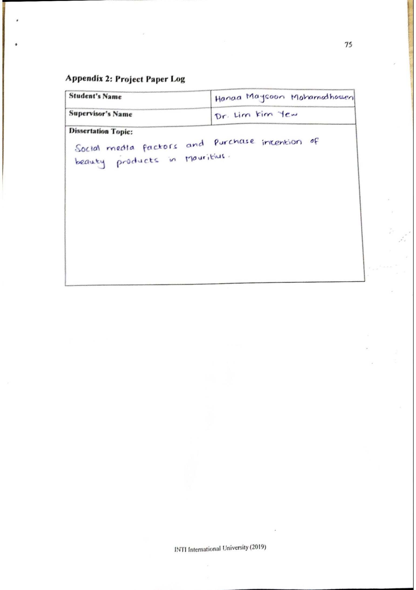

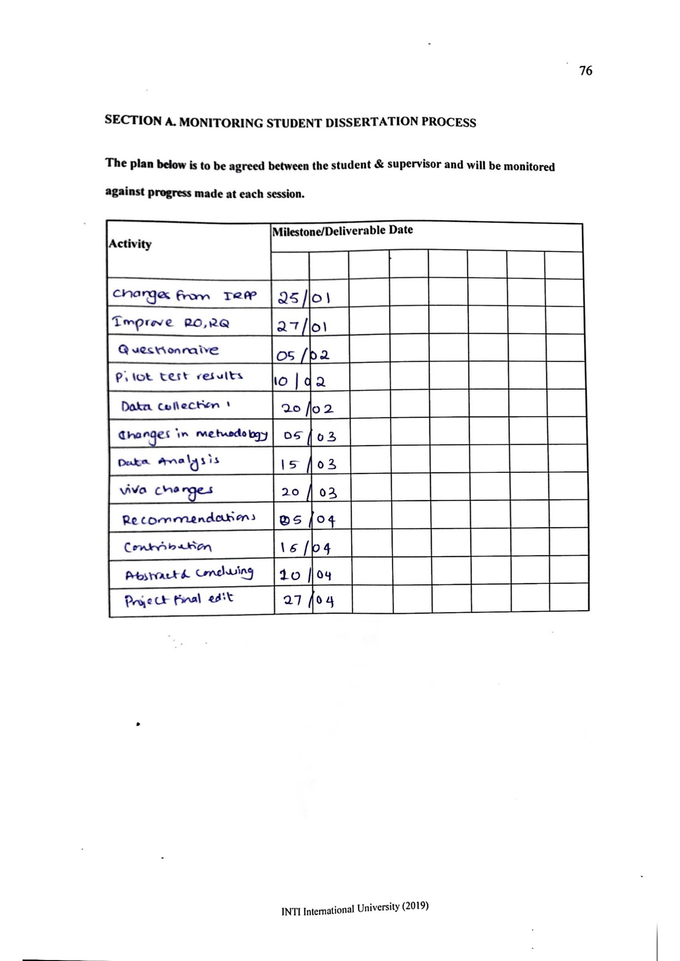



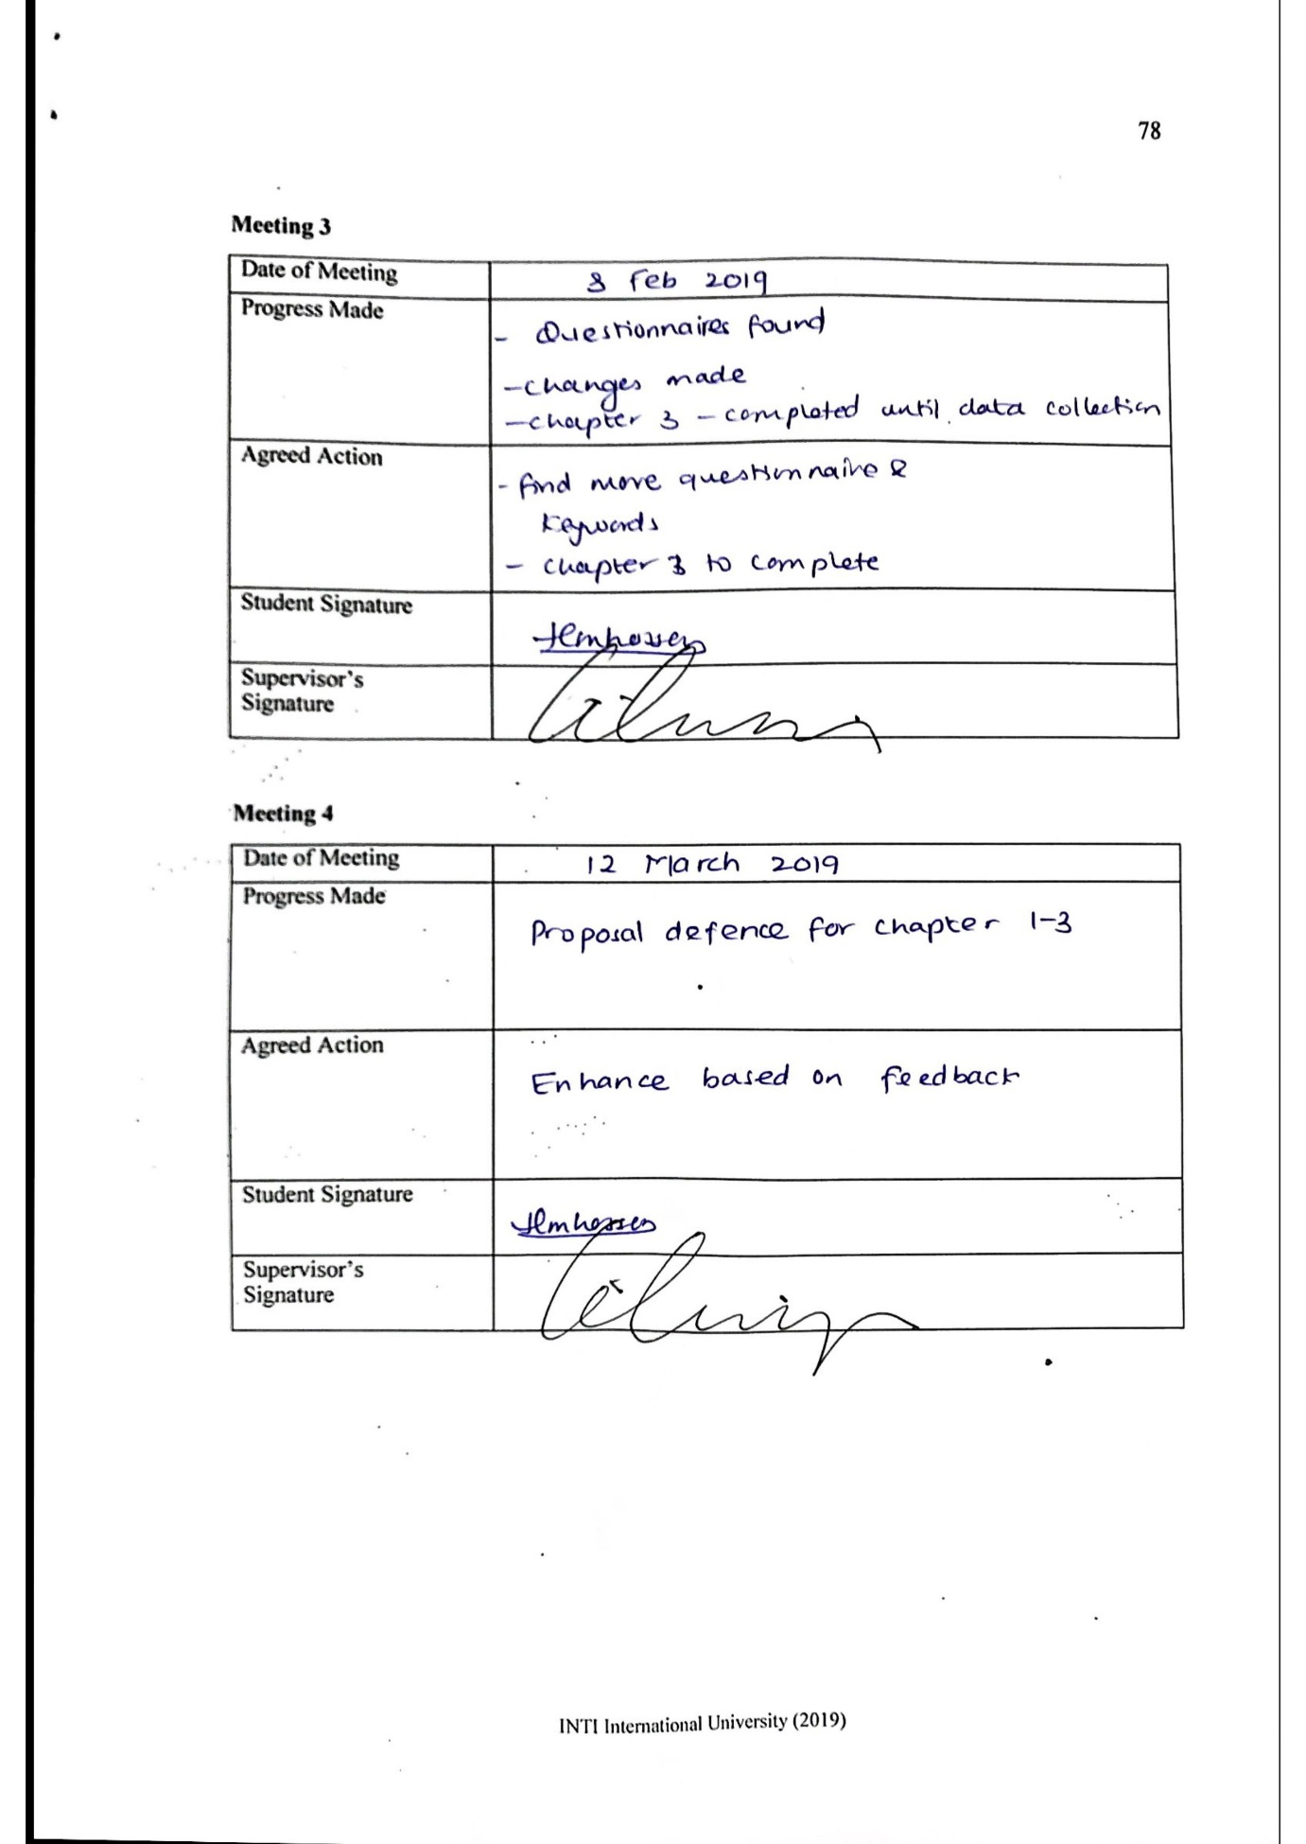

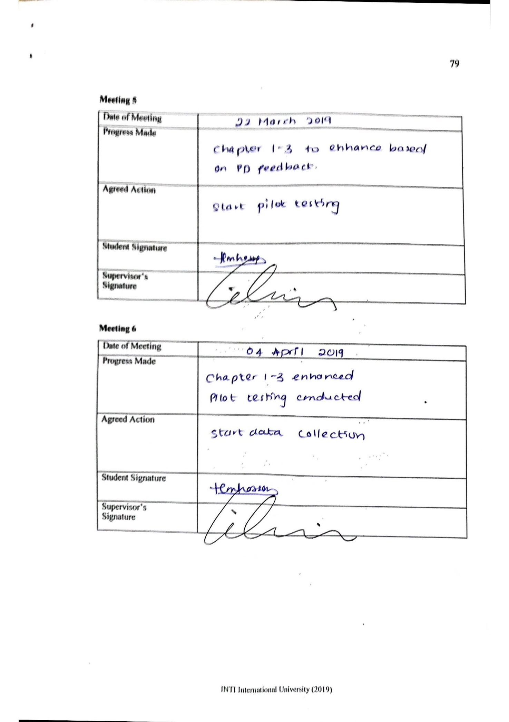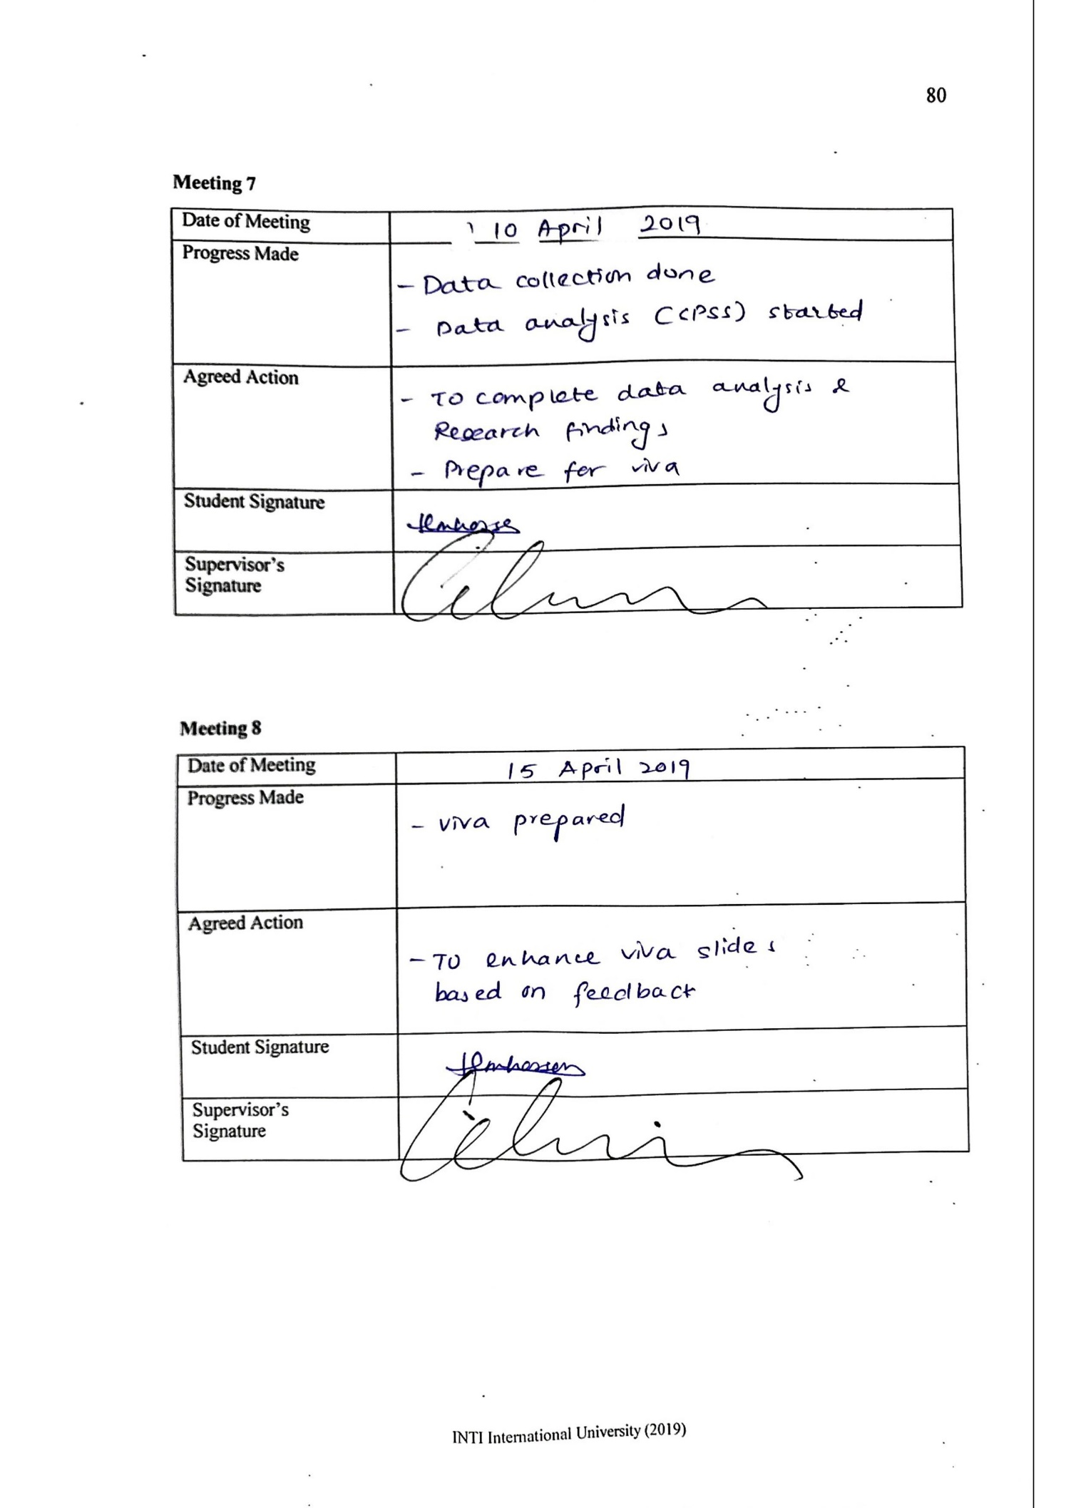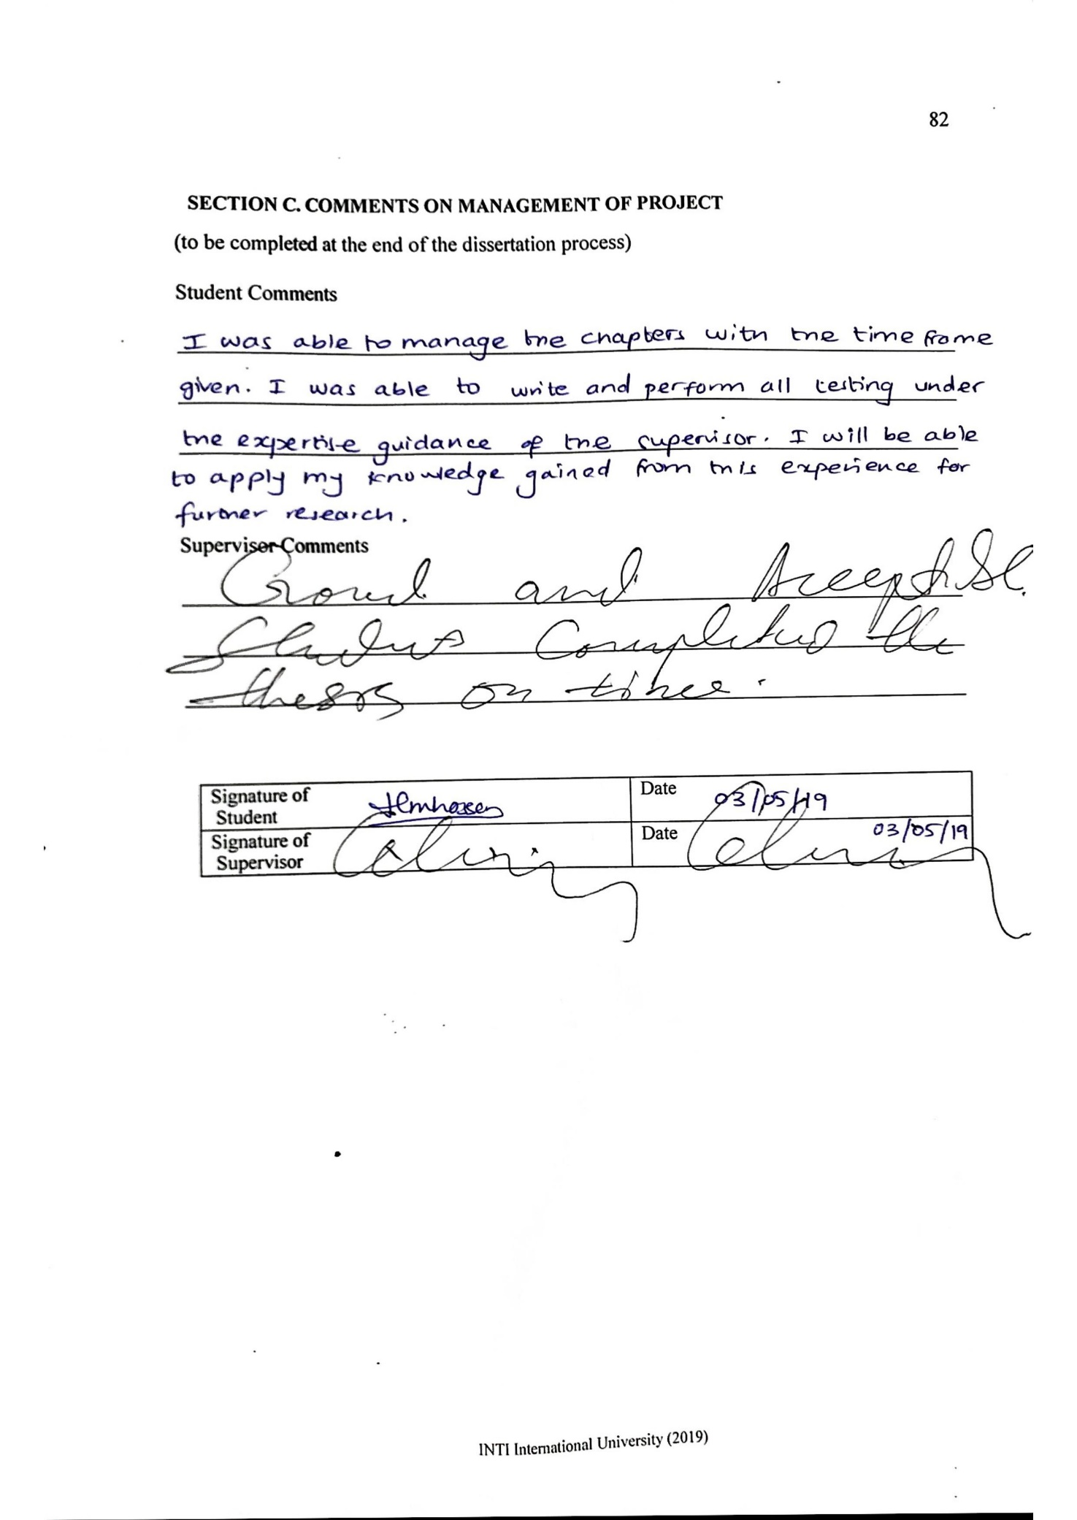

**Appendix 3: Turnitin Report**

