

**MASTER OF BUSINESS ADMINISTRATION**

**Dissertation Title:**

**CUSTOMER SATISFACTION OF PUBLIC HOSPITAL**

**TUANKU JA’AFAR IN SEREMBAN**

**AUTHOR: DOMINGO NTUTUMU AKENG**

**STUDENT ID: I12000237**

**PROGRAM: MASTER OF BUSINESS ADMINISTRATION**

**SUBJECT: MGT7998 MBA PROJECT**

**SUPERVISOR: DR. ALEX NG**

**SUBMITTION DATE: 7/05/2019**

**STUDENT’S DECLARATION**

I hereby declare that this thesis is my own work and effort and that it has not been submitted anywhere for any award. Where other sources of information have been used, they have been duly acknowledged.

Name : Domingo Ntutumu Akeng

Student ID : I12000237

Signature :

Date : 07/05/2019

**ACKNOWLEDGEMENTS**

I would like to thank each and everyone who have helped inspired and supported me in the process of completing this project. first of all, I would like to thanks my supervisor Dr Alex Ng for the supervision the advices and motivation in finishing the project. Secondly, I would like to thanks my second supervisor Dr Arasu for guiding me and helping me for the proposal defend and the final defend. word of thanks to Dr Kar ling for the knowledge transmitted and guidance during the beginning of the project.

Finally, I would also like to thanks my classmates, family and friends for the constant support given to me daily. I really appreciate it and I am very excited for finishing this project and most important, learn and gain experience. THANK YOU.

Contents

ABSTRACT 6

Chapter 1 7

Introduction 7

1.0 Overview 7

1.1 Background of the study 7

1.2 Problem statement 8

1.3 Research objectives (RO’s) 9

1.4 Research question (RQ’s) 10

Chapter 2: Literature review 10

2.0 Overview 10

2.1 Customer satisfaction 10

2.1.1 Global view 11

2.1.2 Local view 13

2.2 Influence factors 14

2.2.1 Service quality 14

**2.2.2 Technology** 15

**2.2.3 Waiting time** 16

2.3 Gaps in literature 18

2.4 fundamental theory 19

2.5 Conceptual Framework 20

2.6 hypothesis 21

2.7 conclusion 21

Chapter 3 22

3 22

3.2 Questionnaire table 23

3.3 Measurement Table 24

Chapter 4 26

4.0 Overview 26

4.1 Pilot Testing 26

4.1.1 Factor Analysis (for Pilot Testing) 26

Factor Loading/ Extraction/ Communalities 27

Eigenvalue Table 28

4.1.2 Reliability Test – Cronbach Alpha 29

4.2 Summary of questionnaire 29

4.2.1 Demographic of the respondents 29

4.2.2 Descriptive Analysis 30

4.3 Preliminary 31

4.3.1Factor Analysis 31

Kmo test 31

Factor Loading 32

Reliability test– Cronbach Alpha 34

4.3 Hypothesis testing Multiple Regression and One-way ANOVA Table 34

4.4 Summary of Findings 36

Chapter 5: Summary and Conclusion 37

5.0 Summary 37

5.2 Recommendation 37

5.3 Limitations 38

6.0 REFERENCES 39

7.0 Appendix 1 Questionnaire 42

7.1 Appendix 2 46

Turnitin report 46

# ABSTRACT

The research is a case study that shows and reveal the factors that have influence in the customer satisfaction of public Hospital, in the particular case of Tuanku Ja'afarin hospital in Seremban, and find out whether these factors have really influence in the satisfaction of the customers and patients toward that public hospital. This study positively improves the service quality the author tries to investigates the patient satisfaction Through adopted SERVQUAL Model and questionnaire survey, data of respondents will be collected from the surroundings of the hospital, and parking since to get access to the data collection inside the hospital is taking a very long procedure and time, another form of collecting the data will be through an online survey on social media , friends and relatives. Then, these data is analyzed by using SPSS statistical software. Finally, if the result of this research is tangible, assurance and responsiveness for the public hospital have the significant relationship with patient and customer satisfaction of public hospital.

Key Words: patient Satisfaction, Customers’ Satisfaction, Service Quality, SERVQUAL Model.

# Chapter 1

# Introduction

# 1.0 Overview

This research study will determine the customer satisfaction of public Hospital in Malaysia focusing on Tuanku Ja'afar hospital in Seremban. The chapter offers a brief overview of what is the research study by introducing the related background of the the chapter is structured into five sections. Firstly discuss and analyze the research background and the importance, impact and seriousness of the phenomenon as well. Following by confirming the problem statement that analyze the gaps of the research. Third, designing the research questions and research objectives.

# 1.1 Background of the study

Reaching quality needs of the society is a very important priority of any growing organization. Normally, the organizations in this case public hospitals place high priority on delighting their patients. They are regularly working and trying to improve the performance by introducing a brilliant quality to consumers once meeting the customer’s expectations in a manner that the observation and perception of the patient of experience surpasses the expectation then the service quality is considered achieved (Zeithaml, 2012). Thus, satisfied patient perceived the quality of service that they experience is superior. Hence satisfied patient is the result of patient having good experiences (Kim, 2008).

In services organizations like hospitals the service quality is a vital gage and it means to achieve patient satisfaction (Kim, and Lee, 2018). Great service quality can link to customer satisfaction.

Hospital is an organization that provides a service. It is a multifaceted service organization it can be seen as “a true people-based service industry” (Abdul, and Ng, 2018) and the level of intangibility should be high, inseparability of production and consumption, the interaction between patients and doctors must be high and all at the same time (Grönroos, 2012). Health care service provided by the public hospital is the service most patients required but may not want. However, to receive the services, patients need to be present during the service process and full and successfully delivery of health.

In many cases and situations patients cannot demand the exactly medical care required and most especially in public hospitals. The patients have to trust and also depend in the doctor’s judgment. Thus, the public hospital can lastly influence the life and death of a patient. Therefore, attention on public hospital service quality has been seen as very important (Sweeney and Johnson, 2011). In Malaysia, public hospitals are structured in different hospitals which are national hospitals following by state hospitals and lastly the district hospitals. Malaysia is counting with approximately 155 public hospitals (Statista, 2016). The main national and public hospital is Kuala Lumpur hospital situated in the country’s capital which is the capital of the country’s 13 states (Noor Hazilah, 2014).

Service quality is a priority for any public hospital. Public Hospital management have to get in mind that there is a need for keep the quality improvement. Thus, calculating health care quality is serious in order to accomplish continuous improvements in the public hospitals. It is through this proactive approach to improvement they will be able to provide the highest level of quality healthcare. Hence, today with the strong competitive business and informed and higher expectation stakeholder environment require a health care provider to build strong service quality to satisfy their customers (Lei and Jolibert, 2015). An improved effort on quality in health service delivery and a shift toward more patient needs has instituted the practice of patient satisfaction measurement.

# 1.2 Problem statement

The public Hospital Tuanku Ja'afar is one of the facilities which provides and offer health care for the patients and people in the country. Therefore, the service quality of the public hospitals plays an important role for the patients. However, the service quality of many public hospitals are not satisfactory and don’t reach the expected level and some of the issues are for instant the technology the waiting time and the service quality (Carnage, Martha, and Conklin et al., 2016). ).

Most of these patients that are going to government hospitals are patients with low income (Manaf, 2016). The reason is because the cost and prices for private hospital are very high and expensive and a large percentage of Malaysians are unable to afford it., a lot of patients feel grateful to have medical treatment from public hospitals (Manaf, 2015).

Since the prices and expenditure in the private hospitals increase time to time compare to the public hospitals (Rasiah, 2016). moreover, all the work ad effort made by the government to improve and make better the service quality in the government or public hospital has made many customers and people to tryst and depend more on public hospitals. (Sohail, 2013). However, some changes and improvements to the public hospital still needed and required (Abdullah, 2011).

Naidu (2008) states clearly that SERVQUAL model is used in many customers and patient’s satisfaction studies and it consider suitable however some changes and improvements need to be done.Mohsin (2010) used the servqual model as an important tool for organizations for continuous improvements. The study shows that the model is a great instrument for measuring the Malaysian healthcare service quality.

The public hospitals services marketplace is very complex and also vital Industries nowadays in this modern world. From routine checkups to heart transplants, doctors worldwide work very hard to improve the quality and longevity of countless lives daily. But unfortunately there are often problems and issues that need virtual help to overcome them (Glover, 2008).

Gratefully, the digital technology comity is willing to give its services and abilities to the health care professionals and doctors for good use to support the digital technology community is ready and willing to put its services and abilities to good apps, cloud-based services, and other digital technologies can help solve these issues to promote a healthier and happier world (Machanda, 2015).

# 1.3 Research objectives (RO’s)

**RO1:** To determine whether Service quality has significant relationship with customer satisfaction of Tuanku Ja'afar public hospital.

**RO2:** To determine whether the waiting time has significant relationship with customer satisfaction of Tuanku Ja'afar public hospital.

**RO3:** To determine whether technology has significant relationship with customer satisfaction of significant relationship with customer satisfaction of Tuanku Ja'afar public hospital.

# 1.4 Research question (RQ’s)

**RQ1:** Does Service quality has significant relationship with customer satisfaction of public hospital Tuanku Ja'afar?

**RQ2:** Does the waiting time has significant relationship with customer satisfaction of public Hospital Tuanku Ja'afar?

**RQ3:** Does technology has significant relationship with customer satisfaction of public Hospital Tuanku Ja'afar?

# Chapter 2: Literature review

# 2.0 Overview

The research study is determining the customer satisfaction on public Hospital in Malaysia focusing on Tuanku Ja'afar hospital in Seremban. This chapter offers the summary of the research study by introducing the phenomenon under study, the global perspective on the customer satisfaction and the local perspective as well. Next is the factors influencing the satisfaction of the customers, following by the gaps in the literature another aspect followed by the research is the grounded or fundamental theory using the SERVQUAL Theory. The research also includes the conceptual, research and theoretical framework. Finally the research includes the hypothesis propositions and assumptions following by the conclusion.

# 2.1 Customer satisfaction

Customer satisfaction indicates the fulfillment that consumers and customers get from the services of a company or from working together or doing business with that company. Customer satisfaction is about meeting the needs of the customers and attitudes about the products services and the brand, and it is also important necessary and clever to maintain the clients (Armstrong, 2013). In different phrases it define how joyful the customers are with the provider and experience with the firm, accurate size of patron pride via reliable client feedback is essential for creating high quality administration strategies coupled with allowing managers to enforce delight improvement programs The customer satisfaction on public hospitals Tuanku Ja'afar in Malaysia is the phenomenon that will be discussing in the research, as all nations Malaysia have public and privet hospitals and the customers have the freedom to choose where to go when they are in need of medical assistance and many aspect can be taken in consideration when measuring the customer satisfaction on public Hospital Tuanku Ja'afar such as service quality, technology, price, insurance and more.

# 2.1.1 Global view

Service quality is seen by the customer’s satisfaction as the alter and diverse between what the clients is anticipating and the recognition they have. The seen quality of benefit is palatable in case the execution meets desires (Holder and Berndt, 2011). The quality of the benefit might be analyzed and measured based on the user's discernment and assessment. (Ravaldo, 2011). The clients would assess the quality of benefit given based on the clients ' capacity in needs and wants of the clients. The match of quality of benefit was the fulfillment of the patient, the fulfillment of the persistent is the basic necessity of health care suppliers (Desai V, 2011). The quality of the administrations they get within the healthcare setting has been positive, fulfilling and satisfying their desires. Numerous patient’s satisfaction investigate depends on the patient's discernment of fulfillment with what is watched, such as Capacity environment or bedside way of a doctor. Low patient satisfaction may additionally end result in less compliance with the doable for resource waste and suboptimal clinical consequence (Abd Manaf, 2015.). Patient pleasure has come to be an vital issue in analyzing the first-class of scientific care. In the ultimate ten years, sufferers have emerged as the main and central focal point on fitness care. Delivery this new emphasis on fantastic of care and consequence measuremen has led to an expanded appreciation of the magnitude of patients’ understanding of care

(Amid, 2016). Traditionally, purchaser and patient pride research has been carried out primarily focusing on improving carrier effort by massive public and non-public hospitals. Important and massive hospitals often behavior patient satisfaction surveys to meet accreditation necessities and also to hyperlink the patient pleasure rating to economic incentives such as scientific bonuses and non-clinical employees ( Dortyol, 2014).

Patient pleasure with medical care have many dimensional concepts, those dimensions correspond to the foremost traits of vendors such as infrastructure, technical, functional, surroundings and offerings (Elleuch, 2011).

Patient and consumer pride are critical and important therefore influences at once and positively the patient’s satisfaction and enhances medical institution image, which in flip translates into accelerated carrier use and market shar (Alrubaiee and Alkaa and Moliner, 2011). To achieve a aggressive advantage, service companies that include hospitals have to center of attention on attaining patron pride and loyalty by turning in top-quality fee (Akdogan and Dortyol 2014).

Satisfied customers are likely to showcase favorable behavioral intentions that benefit the long-term success of the fitness care provider. There have been investigations into Turkish hospitals,

indicated that Tangibility, reliability, courtesy and empathy have been integral requirements for patron satisfaction, whereas responsiveness and assurance had been no longer recognized as vital predictors of satisfaction. In Japan, outpatient pleasure was once unaffected through bodily look or tangible attribute, then again affected person pride was as soon as affected (Alimana and Mohamad, 2015).

Process characteristics service speed, best of workforce interplay and putting appearance (Elluech, 2017). South Africa research in Johannesburg indicated that there have been tremendous and top relationships between perceptions of provider exceptional at all dimensional degrees and sufferers ' ordinary pleasure with medical practices (Mpinganjira, 2017).

The study stated that empathy dimension is the dimension with higher power accompanied via assurance, tangibles, and responsiveness and ultimately reliability research conducted in Amman, Jordon indicated that the five dimension of healthcare excellent were important and definitely widespread in explaining the satisfaction of the affected person and customers (Alrubaiee and Alkaa’ida, 2011).A lookup conducted in japan concluded that overall, a positive satisfactioncon can impact behavioral intentions (Elluech, 2011). According to (Naidu, 2009) healthcare excellent influences patient satisfaction which will then influence the conduct of the affected person such as loyalty.

# 

# 2.1.2 Local view

Patient satisfaction of public Hospital Tuanku Ja'afar is in the list of the Most important healthcare performance measures (Zabada 2011). All findings should assist the policy market in analyzing and e

valuating public hospital performance. Because Malaysian public healthcare is at a crossroads, ultimately with the government's intention to privatize services. The public healthcare zone is plagued many instances by using the influx of the patient’s admissions that is growing surplus demand of uneven population healthcare company ratio and also issuer of a bad carrier quality. (Ministry of Health Malaysia, 2011). Mentioning also the lengthy time waiting hours. Emotional burnout, service orientation of doctors, precise professionalism of doctors, there is additionally lack of empathy, terrible stage of competencies, pursuit of monetary gains and push aside for patients suffering throughout clinical practices, all these aspects had precipitated a tremendous dissatisfaction towards public healthcare and hospitals service providers. (Ganasegeran ,2014). In the healthcare industry the same type of service is provided to all the hospitals but all the hospital don’t provide the same quality service (Aliman and Mohamed, 2016)). According to (Scalera, 2016) they are having responsibility and moral for been accountable for the efficient use of the resources that a public while at the same time focusing on customer’s satisfaction. The customer or the patient has the right to get complete services even though the provider is private or public. In Malaysia, public hospital is the first option for the citizens compare to the private hospital. This is because of the cost. Besides that, the priority of public hospital is people who live in the rural area 'Public hospital ‘or 'hospital kerajaan' is very synonym to almost all Malaysian and also a chosen one no matter how the quality delivers. Service quality is totally different compare to product quality. In this case hospital service quality is an elusive and distinctive construct. It can be defined from several perspectives (sarji, 2012). According to Bergman and (Klefsjo,2017). The ability to fulfil and satisfy the needs and the expectation of the patient depend on the total characteristic of the product that bear on the ability to fulfil those needs (Evans and Lindsay, 2011). Public hospital is trying to win over many competitions in order to increase image and highlight high level of qualities services. In order to retain customers and attract new ones, a company must focus on providing value to the customer and also in a way that is more effective than its competitors. This was compounded by increasing patient expectations as consumers are becoming increasingly critical of Lyall, S (2011). service experiences patient satisfaction is one of the most important healthcare service delivery performance measures. The findings should therefore also assist policymakers in evaluating public hospital performance. Given that Malaysian public health care is at a crossroads with the ultimate intention of the government to privatize services, the findings should assist policymakers in drawing up (scalera, 2016).

The majority of patients in Malaysia public hospitals are patients with low income and low earners, as the service as well is almost free at the point of use (Manaf, 2016).

2.2 Influence factors**.**

# 2.2.1 Service quality

In Malaysia the standard of health care is controlled by Malaysia Ministry of Health (MOH). several attention organizations area unit starting to acknowledge that quality is needed for survival (Mohanty and Lakhe, 2011). it's tough for the general public to satisfy the medical necessities made public by the globe Health Organization (WHO). Quality management has emerged not solely because the most important and semipermanent strategy for making certain the survival of organizations however conjointly leads services to business excellence (Rose , 2014). that's why quality cannot he compete simply or overrated.

When service supplier affords to produce prime quality services to customers, they ought to always putting your all into to keep up and continually notice new strategy to be higher. Public hospital is trying to convert several competitions so as to extend image and highlight high level of qualities services. To retain customers and tempt new ones a corporation must focus on providing price to the client which too during a manner that's more practical thanthat of its competitors. This has been combined by increasing patient expectation as consumers become progressively essential regarding service experiences (Lewis and Mitchell, 2012). Healthcare industries understand that, the wants of health care services ought to go along with the standard of hospital services. in the meantime (Radhika 2013) expressed that, having a powerful attention system in situ can change attention suppliers to deliver better quality and worth to patients (Gronroos and Ravald, 2011).

# **2.2.2 Technology**

According to (Jalulah, 2011). pointed out that public hospital on the net web design, customer service, security, information and others latitude to influence customer satisfaction of the public hospital, but uses the research method is the description of the statistical method of comparing the difference between the customer satisfaction between private and public hospitals (Eze ,2011) studied the factors influencing young people's public hospital customer satisfaction, and the results showed that simplicity and usefulness were the key influencing factors. Based on the TAM theoretical model, this study investigated the customer satisfaction of Hospitals through factors such as the perceived usefulness, usability and security of customer on public hospitals According to (Hua, 2016). With the rapid development of science and technology, the competition among hospitals has become increasingly fierce. The products or services provided by the hospitals are rich in variety and features, providing customers with a variety of choices. No matter customers are satisfied with their consumption or not, they do not need to be loyal to any production enterprise. Therefore, customers are free to choose. However, how enterprises win the loyal consumption of customers with full freedom of choice is the most important thing for enterprise managers to pay attention to. Loyal customers can bring more profits, because they don't need to enterprise management cost more, but it can buy more products and services, and they keep trying new products, and recommend others to use or purchase. Customers are constantly aware of the satisfactory products and services provided by the enterprise, thus generating the loyalty of emotional consumption. It shows that loyal customers are driven by the constant customer satisfaction. HIS is defined as a built-in electronic system that collects, stores, retrieves and displays average affected person statistics and statistics such as affected person history, laboratory take a look at results, diagnoses, billing and different related hospital approaches used in multiple health center departments (Aniza, 2010). HIS consequently has several components, such Clinical Information System (CIS), Financial Information System (FIS), Laboratory Information System (LIS), Nursing Information Systems (NIS), Picture Archiving Communication System (PACS) and Radiology Information System (RIS) (Biomedical Informatics, 2012).

By connecting these aspects to every other. Each issue has one of a kind element based totally on their usage, branch and users. The implementation of the Hospital Information System (HIS) in Malaysian Public Hospitals is divided into three categories: Total Hospital Information System (THIS), Intermediate Hospital Information System (IHIS) and Basic Hospital Information System (BHIS).n which eleven public hospitals represented as THIS, two public hospitals represented as IHIS and eight hospitals represented as BHIS in Malaysia ( Syed Mohd., 2018)

# **2.2.3 Waiting time**

In Malaysia the public hospitals services shows good relationship between satisfaction with patient satisfaction and waiting time (Manaf,2016) researches recognized that there is a connection between customer satisfaction and dimension of time waiting (Littig, 2012) opposes that when the patient are outpatients the time they are waiting has an effect that is similar to the time of a price.

The matter of overcrowding at public hospitals is not new and Tuanku Jaafar Hospital Seremban (TJHS) here is not excluded.

The Negri Sembilan committee of health, environment, cooperatives and consumerism chairman S. Veerapan said, even though the overcrowding situation at Tuanku Jaafar Hospital is not as bad as Hospital Kajang, which was stated recently, but problem has been a major issue for the past five years (Azizi,2018)

Berita lately stated on the overcrowding problem in Kajang Hospital with regular bed usage rates getting up to 150% contributing to the congestion at the ward, expert clinics and emergency departments at the hospital.

There is a need on supporting the hospital to accommodate the current needs particularly in Seremban 2, Labu and Nilai areas because the population is increasing. Tuanku Jaafar Hospital overcrowding is also due to its nearness to the North-South Expressway (Azizi,2018)

findings specify that on an average, some patients wait more than two hours after the registration to get the prescription whilst the time the spend with the clinical personnel is solely about 15 minutes. Surveys on elements influencing in the waiting time indicate the stage of employee mindset and work process, big job capability management, supervision issues and insufficient services are covered in the elements that make a contribution to the ready time problems in the public hospital

(M.S. Pillay,2011).

In Malaysia the public healthcare is at the stage the place may want to be considered of provider the Public healthcare in Malaysia is in a period the place can be viewed of surplus demand where the demand for healthcare exceeds the supply. And this state of affairs is due to the massive charge gap between public and non-public medical institution services. The hospital managers want to minimize the boredom faces of the sufferers while ready and find approaches to tackle this problem in different manners, and it may want to be through imposing modeling and simulation techniques. (Manaf, 2016).

The lengthy time ready of the sufferers in the public hospitals has been diagnosed to be a in public hospitals has been identified to be a cause of an essential dissatisfaction among patients. ( Kay, 2019)

(Hart ,2016) states that it is a regular state of affairs of discomfort and dissatisfaction that many sufferers have expressed. There are numerous scopes in the Efficacy and efficiency of patient services, however an giant characteristic is the intense and useless time waited by way of the patients, which is a principal complaint of sufferers (Clague, 2017). Additional waiting time is also a time without a value because in that period, the resources ans contraptions are no longer used to make the prerequisites of the patients higher and improve (Kujala , 2016).extreme time of waiting Is regarded as a lose strategy the place the patients lose precious time, hospitals lose many patients and reputation and the staff experience stress and anxiety (Barlow, 2012).

(Demoulin, 2017) Moreover, it is stated that ready time no longer solely influences the service satisfaction relationship, however additionally moderates the satisfaction-loyalty relationship, while increasing waiting time is a hassle in Malaysia, the scenario is in all places in the world. A five-country medical institution survey determined that an average wait of two hours or greater was stated via Canada, Britain, and the US. (Blendom,2014). Public hospitals in Hong Kong located that the longest time sufferers have spent in the hospital is waiting for consultation the place eighty-two percentage of the total go to time is spent in the ready room. (The Daniel, 2016). In Britain, in accordance to the Patient's Charter, the authentic and marketed ready times are 30 minutes, although the reality may also be quite different. The stress of waiting in many cases, for a long time, sufferers have even been verbally aggressive closer to nurses or scientific receptionists (Bolton, 2002). A survey carried out in Malaysian public hospitals confirmed that there is a positive correlation between ready time pride and affected person satisfaction. (Manaf,2016) While research has identified the relationship between affected person delight and waiting time. Contends that when customers are external, the end result of ready time is comparable to that of a price. This capacity that customers come to be aware of the rate required in time and cash and modify their behavior and conduct accordingly. (Garber, in 2014)

# 2.3 Gaps in literature

Quality service and patient satisfaction had been strongly studied and also a huge effort had been done to create survey tools to measure it However, many reviews have critical view of its use since there is rarely any theoretical or conceptual development of the patient satisfaction concept .(Jackson,2011) The health industry is growing fast in Malaysia with an annual rate of 13% and is expected to continue growing in the future as a result of the increasing in increased urbanization and population. (Eze, Tan and Yeo, 2012) in a moment and era where the heath attention, and treatments are seen as necessity, public hospitals in Malaysia , However, the government provide approximately USD 6.75 billion or 10.4 % of the national budget per year for public healthcare and public hospitals Out of this allocation, about 7 percent is assigned for development purposes. (export.gov,2018).

(eze,2012). Findings shows that factors influencing patient and customer satisfaction on public hospitals in Nilai are traditional marketing factors such as quality service waiting time and technology.

However, there are fewer researchers and lack of investigation conducted in Malaysia on technology, waiting time and service quality on public hospitals Tuanku Ja'afar in Seremban.

# 2.4 fundamental theory

SERVQUAL model, determine how customers and how patients perceive service quality and whether they are satisfied with the offered services by Tuanku Ja'afar public hospital in Seremban.

(Efan, 2014) define service quality as a comparison between the expectations of customer service quality and the services actually received. Some researchers have broadly divided the literature on service quality into technical and functional perspectives. From a technical point of view, the nature of the service provided and from a functional point of view, the mode of service provided. Typically, market researchers use a functional perspective when measuring the quality of service in an industry. The main reason is that consumers often view service quality differently than technologists. Therefore, it is not appropriate to use technical methods to measure consumers' satisfaction with service quality. Experts and scientists have provided different research models for measuring service quality. The most famous and most widely used of these is Parasuraman, (Zeithaml and Berry,2012). SERVQUAL Model. Parasuraman et. al. mentioned that The SERVQUAL tool is designed specifically to measure service quality, using both the gap concept and the service quality dimension, and is designed to be the organization of any service department. In the original research form, SERVQUAL included 22 project statements in 5 service quality dimensions are presented in seven-point Likert scale. The first is the tangible related to the establishment of physical facilities, equipment and the appearance of personnel. Second, reliability refers to the ability of an organization to reliably and accurately deliver promised services. Third, responsiveness means that service providers are willing to help customers and provide timely services. Fourth, the assurance of employees' knowledge and politeness, and their ability to inspire trust and confidence (Mohanty and Lakhe, 2011).

Finally, empathy is the caring and personalized attention the company provides to its customers. The basic idea of the SERVQUAL Model is to assess the different between customer’s expectations of the service and their perception of the actual service. This difference is called “gap” that follow figure 7 gap 5. This gap 5 is the “perceived service quality”. Due to external factor may influence the customers’ expectation which is not controlled by service provider. SERVQUAL model is widely used in the service industry to understand the service needs and perceptions of target customers, and to provide enterprises with a set of methods to manage and measure service quality(Lewis and Mitchell, 2012).

.TAM theoretical model, this study investigated the customer satisfaction of Hospitals through factors such as the perceived usefulness, usability and security of customer on public hospitals According to (Hua, 2016), with the rapid development of science and technology, the competition among hospitals has become increasingly fierce. The products or services provided by the hospitals are rich in variety and features, providing customers with a variety of choices. No matter customers are satisfied with their consumption or not, they do not need to be loyal to any production enterprise. Therefore, customers are free to choose.

# 2.5 Conceptual Framework

The research framework is a conceptual framework that can help researchers to conduct better subject analysis. This paper mainly studies the factors that lead a customer satisfaction in the public hospital Tuanku ja’ afar in Seremban, Malaysia. Factors and the customer satisfaction. This research focus on the influence of three independent variables on the customer satisfaction of public Hospital Tuanku Ja'afar in Seremban.

IV DV

SERVICE QUALITY

CUSTOMER SATISFACTION OF PUBLIC HOSPITAL TUANKU JA'AFAR IN

SEREMBAN

TECHNOLOGY

WAITING TIME

# 2.6 hypothesis

**H1:** There is significant relationship between service quality and customer satisfaction of public hospital Tuanku Ja'afar.

**H2:** There is significant relationship between technology and customer satisfaction of public hospital Tuanku Ja'afar.

**H3:** There is significant relationship between waiting time and customer satisfaction of public hospital Tuanku Ja'afar.

# 2.7 conclusion

The key objective and main purpose for the research is to analyze the customer and patient satisfaction of Tuanku J;afar public hospital in Seremban, after analyzed and understood the factors leading to the customer satisfaction the conclusion is clearly stated in the hypothesis where SERQUAL has a positive relationship with customer satisfaction towards public hospital Tuanku Ja’ afar in Seremban.

# 

# Chapter 3

Extent of researcher interference

Purposeof the Study

Measure-ment and Measures

Study Setting

Types of investigation

Please refer to the measurement table

Is Non-Contrived (because we are not manipulating environment in which research is conducted)

Minimum because distributing questionnaire to respondents to answer and not disturbing in their work

It is a correlation design as it is to determine whether relationship exist between variables

This study is describing the phenomenon and verifying the constructs in different context

PROBL E M

S T A T EM E N T

Data Analysis

Data Collection Method

Sampling Design

Unit of Analysis

Time Horizon

Please refer to questionnaire design table

Individuals is Unit of Analysis, since distributing questionnaire to employees and employees are individuals.

Types -Non-probability convenient sampling – because can give to friends and relatives. Because of time constrain and the questionnaire is distributed to known people and the responses will be higher rate

Cross Sectional because data collection is from respondents only one time.

3

3.2 Questionnaire table**.**

|  |  |  |  |
| --- | --- | --- | --- |
|  | **Questions/Items** | **No.** | **Adopt/Adapt (Sources)** |
| Part A | Demographic Information | 3 | (Noor Hazilah, 2009).) -adopted |
| Part B Dependent Variable (DV) | Customer satisfaction of public Hospital Tuanku Ja'afar,Seremban. | 5 | Noor Hazilah Abd Manaf,2016)-adopted |
| Part C  Independent variable  (IV) | Quality service | 5 | Noor Hazilah Abd Manaf,2016)-adopted |
| Waiting time | 5 | (Littig, 2012) -adopted |
|  | Technology | 5 | (Mohamad and Syed Mohd., 2018)) - adopted |

# 

# 3.3 Measurement Table

|  |  |  |  |
| --- | --- | --- | --- |
| **Sr. No.** | **Measurement** | **Purpose** | **Rule of Thumb** |
| 1. | Pilot Testing | To determine what resources are necessary for the full study | 10% - 20% of total sample size |
| 1a. | Factor Analysis | To determine whether there is a need to reduce the number of constructs and used to simply data (Hair *et al*, 2014) |  |
| 1ai. | KMO – Test of sphericity | To test sampling adequacy | Results should be more than 0.6, If less then sample size of pilot is not enough (Zikmund *et. al*., 2013) |
| 1aii. | Factor Loading | To check if items is usable and acceptable for further analysis | Loadings>0.7 (Hair *et al*, 2014). |
| 1aiii. | Eigenvalues | To ensure that construct is viable and appropriate for the study | For constructs and dimensions must be more than 1, in order to be valid (Cooper & Schinder, 2013). |
| 2. | Reliability Test | To test internal consistency of data and reliability of data obtained (Sekaran and Bougie, 2011). | Cronbach alpha should be more than 0.7. If it’s less than 0.7, item is not consistent and hence should be removed (Hair *et al*, 2014). |
| 3. | Correlation Matrix | To determine extent of inter-relatedness between items and constructs. Inter construct correlation not allowed; lack of robustness in the validity. | If result is skewed – internal validity is challenged |

# Chapter 4

# 4.0 Overview

The data analysis will be conducted based on the methodology as discussed in chapter 3. In this chapter the results or findings of the data from the questionnaires results received would be discussed. In this research, SPSS software would be used for the preliminary analysis including reliability test, descriptive analysis, factor analysis as well as multiple linear regression analysis.

# 4.1 Pilot Testing

The Pilot test will be done as a pre-trial of the questionnaire by detailing statement and arrange them in an appropriate sequence in other to achieve the face validity of the questionnaire (Walliman, 2011). According to Sekaran (2016), if the target population considered for the research is 384, the pilot testing conducted would be on 10% of 384, which is on 42 respondents.

# 4.1.1 Factor Analysis (for Pilot Testing)

Factor analysis is being conducted in order to validates the component of the idea that has been operationally characterized, as well as indicate the appropriateness of each dimension (Bougie and Sekaran, 2016). It aimed at reducing the huge number of factors to a increasingly important and reasonable set of factors (Kumar, 2011).

**1**) KMO Bartlett’s test of Sphericity

**Table 4.1. KMO**

|  |  |  |
| --- | --- | --- |
| Kaiser-Meyer-Olkin Measure of Sampling Adequacy. | | .605 |
| Bartlett's Test of Sphericity | Approx. Chi-Square | 123.330 |
| df | 105 |
| Sig. | .107 |

KMO Bartlett’s test of sphericity offers the Kaiser-Meyer-Olkin measure of sampling suitability where if he data is adequate the KMO value should be greater than 0.6 (Zikmund et. al., 2013). As shown in table 4.1. The KMO value is 0.605 which indicates the sample is adequate and researcher can go ahead with further analysis.

Factor Loading/ Extraction/ Communalities

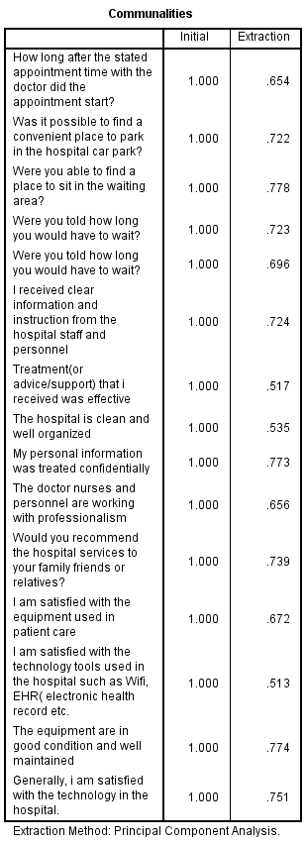

For factor loading testing, the dependent variables and independent variables are tested. The outcome from the independent variable showed that practically all element’s value are greater than 0.6 which is considered acceptable. According to Hair et al (2014), for a factor to be considered to be appropriate for further analysis, the factor loading should be greater than 0.6. Therefore, in this analysis as shown in the results from the table 4.3 the factor loading is greater than 0.6.

# Eigenvalue Table

**Table 4.5**

|  |  |  |  |  |  |  |
| --- | --- | --- | --- | --- | --- | --- |
| **Total Variance Explained** | | | | | | |
| Component | Initial Eigenvalues | | | Extraction Sums of Squared Loadings | | |
| Total | % of Variance | Cumulative % | Total | % of Variance | Cumulative % |
| 1 | 2.480 | 16.535 | 16.535 | 2.480 | 16.535 | 16.535 |
| 2 | 2.153 | 14.353 | 30.889 | 2.153 | 14.353 | 30.889 |
| 3 | 1.574 | 10.492 | 41.380 | 1.574 | 10.492 | 41.380 |
| 4 | 1.547 | 10.315 | 51.695 | 1.547 | 10.315 | 51.695 |
| 5 | 1.346 | 8.971 | 60.667 | 1.346 | 8.971 | 60.667 |
| 6 | 1.127 | 7.514 | 68.181 | 1.127 | 7.514 | 68.181 |
| 7 | .993 | 6.619 | 74.800 |  |  |  |
| 8 | .864 | 5.762 | 80.563 |  |  |  |
| 9 | .699 | 4.657 | 85.220 |  |  |  |
| 10 | .540 | 3.597 | 88.817 |  |  |  |
| 11 | .441 | 2.938 | 91.755 |  |  |  |
| 12 | .381 | 2.543 | 94.298 |  |  |  |
| 13 | .329 | 2.190 | 96.489 |  |  |  |
| 14 | .285 | 1.903 | 98.391 |  |  |  |
| 15 | .241 | 1.609 | 100.000 |  |  |  |
| Extraction Method: Principal Component Analysis.  The Eigenvalue ​​for certain factors shows discrepancy within all variables. If the Eigenvalue is greater than one, it is observed as significant. The construct and dimension should be more than 1 in other to be valid and proceed to the test (Cooper and Schinder 2013). Table 4.5 shows that the constructs are more than 1 which means that these constructs are valid for the study. | | | | | | |

# 4.1.2 Reliability Test – Cronbach Alpha

**Table 4.6**

|  |  |  |
| --- | --- | --- |
| **Reliability Statistics** | | |
| Cronbach's Alpha | Cronbach's Alpha Based on Standardized Items | N of Items |
| .758 | .239 | 15 |

The reliability of the instrument is determined by computing the value of the Cronbach’s Alpha model. The reliability test for this research is done on 39 respondents’ data, collected for the pilot test. According to Hair et al. (2014), the value of Cronbach Alpha should be more than 0.7, if it is less than 0.7, item is not consistent and hence should be removed. However, from the above table 4.6 the Cronbach alpha’s value is above 0.7 which is 0.758 which means items in the questionnaire has good reliability.

# 4.2 Summary of questionnaire

|  |  |
| --- | --- |
| Questionnaire distributed | 350 |
| Questionnaire collected | 322 |
| Questionnaire used for analysis | 322 |

# 4.2.1 Demographic of the respondents

After the pilot testing was done, the questionnaires were distributed. Around 350 responses were expected, however 322 responses were collected All data collected were useful as the study make used of online questionnaire and also physical questionnaire in data collection process. The below table 4.7 shows the summary of questionnaire table.

# 4.2.2 Descriptive Analysis

**Table 4.7**

|  |  |  |  |
| --- | --- | --- | --- |
|  |  | Frequency | Percentage |
| Gender | Male | 130 | 40.4 |
|  | Female | 192 | 59.6 |

|  |  |  |  |
| --- | --- | --- | --- |
|  |  | Frequency | Percentage |
| Age | 20 - 30 | 64 | 19.9 |
|  | 31 - 40 | 79 | 29.5 |
|  | 40 - 50 | 84 | 26.1 |
|  | 51 - above | 95 | 24.5 |

|  |  |  |  |
| --- | --- | --- | --- |
|  |  | Frequency | Percentage |
| Income Level | RM 500 -1000 | 7 | 25.0 |
|  | RM 1000 - 2000 | 10 | 35.0 |
|  | RM 2000 - 5000 | 14 | 17.5 |

|  |  |  |  |
| --- | --- | --- | --- |
|  |  | Frequency | Percentage |
| Marital status | Single | 10 | 25.0 |
|  | Married | 15 | 37.5 |
|  | Divorced | 10 | 25.0 |

|  |  |  |  |
| --- | --- | --- | --- |
|  |  | Frequency | Percentage |
| Education Level | High school | 6 | 15.0 |
|  | Degree | 2 | 5.0 |
|  | Master | 9 | 22.5 |
|  | PHD | 10 | 25.0 |
|  | Others | 13 | 32.5 |

From the table 4.7 above shows that 40.4 percent of the respondent are Male and 59.6 are female. However, majority of the respondents in this research are between 21-30 Years of age. Majority of the respondents with a 35.0% are having an income level of RM1000-2000. The majority of respondents with 37.5% of are married. Majority of the respondents with 32.2% are not having a considerable education level (others)

However, the target population for this study was 400, however I could manage to get only 322 respondents.

# 4.3 Preliminary

Preliminary analysis is conducted after pilot test. The main objective or reason of preliminary data analysis is to prepare the data for future analysis, describe the factors of the data and summarize the findings or outcomes (Blischke *et al*., 2011).

# 4.3.1Factor Analysis

Some tests were performed to confirm the validity of the constructs. Where Kaiser-Meyer-Olkin (KMO) followed by Bartlett’s tests were performed to measure the research data adequacy as well as to confirm the relationship of the constructs respectively (Pallant, 2011). The acceptable individual measure of sample adequacy (MSA) should be above 0.5, whereas the overall KMO should be greater than 0.6 (Kaiser, 1974 cited in Pallant, 2011). Where the significance value for Barlett’s test should be of p < 0.05. In Addition to this, communalities and component matrix were also examined that helped to confirm the validity of the research constructs. Hence, the communalities value should exceed 0.5 and 0.4 for component matrix correlation.

# Kmo test

**Table 4.8**

|  |  |  |
| --- | --- | --- |
| **KMO and Bartlett's Test** | | |
| Kaiser-Meyer-Olkin Measure of Sampling Adequacy. | | .624 |
| Bartlett's Test of Sphericity | Approx. Chi-Square | 1264.773 |
| df | 105 |
| Sig. | .000 |

Since the KMO requirement is met by the dependent variables, the sample is adequate and investigator can continue with factor loading. Therefore, after considering all the 322 responses, as shown in table 4.8, the KMO value is 0.624 which indicates the sample is acceptable.

# Factor Loading

**Table 4.9**

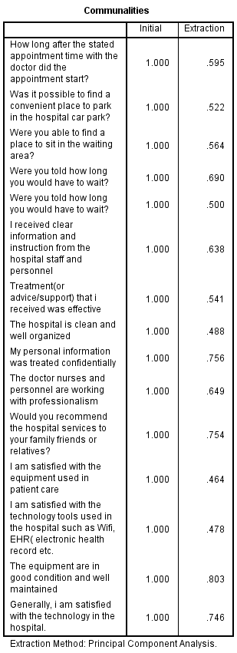

As shown in table 4.9 majority of the items have the factor loading value are above 0.5, which means these items are usable and acceptable for further analysis. The availability component matrix clearly shows that each load factor is above 0. 5, other common factors can be theoretically distributed and convergent, that is to say, the content of general factors can be well explained by general factors in the scale.

**Eigenvalues**

**Table 4.16**

|  |  |  |  |  |  |  |
| --- | --- | --- | --- | --- | --- | --- |
| **Total Variance Explained** | | | | | | |
| Component | Initial Eigenvalues | | | Extraction Sums of Squared Loadings | | |
| Total | % of Variance | Cumulative % | Total | % of Variance | Cumulative % |
| 1 | 2.221 | 14.804 | 14.804 | 2.221 | 14.804 | 14.804 |
| 2 | 2.157 | 14.377 | 29.181 | 2.157 | 14.377 | 29.181 |
| 3 | 1.831 | 12.206 | 41.387 | 1.831 | 12.206 | 41.387 |
| 4 | 1.579 | 10.523 | 51.910 | 1.579 | 10.523 | 51.910 |
| 5 | 1.401 | 9.341 | 61.252 | 1.401 | 9.341 | 61.252 |
| 6 | .990 | 6.598 | 67.850 |  |  |  |
| 7 | .980 | 6.534 | 74.384 |  |  |  |
| 8 | .971 | 6.471 | 80.855 |  |  |  |
| 9 | .717 | 4.779 | 85.634 |  |  |  |
| 10 | .585 | 3.902 | 89.536 |  |  |  |
| 11 | .449 | 2.993 | 92.530 |  |  |  |
| 12 | .377 | 2.512 | 95.042 |  |  |  |
| 13 | .336 | 2.243 | 97.284 |  |  |  |
| 14 | .209 | 1.394 | 98.678 |  |  |  |
| 15 | .198 | 1.322 | 100.000 |  |  |  |
| Extraction Method: Principal Component Analysis. | | | | | | |

The Eigenvalue is used identify if there is any inconsistency within all variables. If the Eigenvalue is greater than one, it is regarded as significant. As shown in the above table 4.16, In order to ascertain the most significant factors where all the factors with eigenvalues are greater than the cut-off criteria of 1 which means the constructs, or the dimensions are viable and appropriate for the study. Hence, it can be concluded that the scale taken for compensation are deemed to be adequate and appropriate for the conduct of further tests or analyses for this research as the KMO Bartlett’s test of Sphericity criteria have all been met (Pallant, 2011).

# Reliability test– Cronbach Alpha

Reliability analysis is one of the most important analysis used by researchers that helps to analyze the consistency of the variables, further by ensuring that they are consistent (Bryman and Bell, 2011). Where Cronbach’s Alpha is measured and values equal or greater than 0.7 is taken as having good internal consistency (Pallant, 2011).

|  |  |  |
| --- | --- | --- |
| **Reliability Statistics** | | |
| Cronbach's Alpha | Cronbach's Alpha Based on Standardized Items | N of Items |
| .753 | .184 | 15 |

According to Hair et al. (2014), if the value of Cronbach alpha is more than 0.7, then the items designed in the questionnaire has excellent reliability but if the value is less than 0.7, the item is not consistent and hence should be removed. As shown in the above table 4.17 the value of Cronbach’s alpha is 0.753 which means the items in the questionnaire are reliable and indicates high internal consistency

# 4.3 Hypothesis testing Multiple Regression and One-way ANOVA Table

According to Schmidheiny (2016), multiple regressions refer to the statistical tool that is generally used to determine the relationship between one dependent variable and different independent variables by looking at the alpha value. If the alpha value is less than 0.05 the relationship is statistically significant, however if it greater than 0.05 it is not significant (Badgujar and Wani, 2018).

**Table 4.10**

|  |  |  |  |  |  |  |  |  |  |  |
| --- | --- | --- | --- | --- | --- | --- | --- | --- | --- | --- |
| **Model Summaryb** | | | | | | | | | | |
| Model | R | R Square | Adjusted R Square | Std. Error of the Estimate | Change Statistics | | | | | Durbin-Watson |
| R Square Change | F Change | df1 | df2 | Sig. F Change |
| 1 | .262a | .769 | .060 | 1.83165 | .069 | 7.805 | 3 | 318 | .000 | 1.914 |
| a. Predictors: (Constant), timetotal, qualitytotal, technologytotal | | | | | | | | | | |
| b. Dependent Variable: DVtotal | | | | | | | | | | |

Multiple Regression is done to determine whether relationship exists between variables and whether the framework is able to explain/describe/predict the phenomenon (Bougie & Sekaran, 2013), which states two things; 1) if value is more than 0.5 it shows that it is at least 50% fit; anything less than 0.5, the model or construct is not fitting and doesn’t describe the relationship between variables, also 2) the nearer it is to 1 the stronger is the model fit (Zikmund et. al., 2013). As shown in table 4.19 the R square value is 0.769 which means the model is 50% fit and determines the relationship between the variables. Therefore, from the above table shows that all the independent variables have strong relationship with the dependent variable.

**Table4.11**

|  |  |  |  |  |  |  |
| --- | --- | --- | --- | --- | --- | --- |
| **ANOVAa** | | | | | | |
| Model | | Sum of Squares | df | Mean Square | F | Sig. |
| 1 | Regression | 78.553 | 3 | 26.184 | 160.215 | .000b |
| Residual | 1066.876 | 318 | 3.355 |  |  |
| Total | 1145.429 | 321 |  |  |  |
| a. Dependent Variable: DVtotal | | | | | | |
| b. Predictors: (Constant), timetotal, qualitytotal, technologytotal  One-way ANOVA is done to determine the extent of variance within respondents or between respondents, through which it shows that the results or the p-value is less than 0.5 (Sedgwick, 2012). As can be seen from the anova above table 4.11, F test of 160.215 (sig. = 0.000) illustrates that the whole regression is significant. The adequacy of regression is considered moderate to high, and thus the hypotheses and framework of this research indicate moderate to high predictive fitness when taken as a whole. | | | | | | |

**Table 4.12**

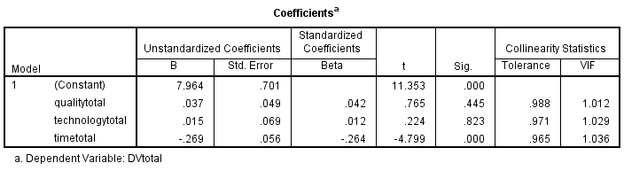

The above table shows the coefficient for independent variables to dependent variables. The unstandardized beta represents the slope of line between the independent variable and dependent variable. Beta Coefficient is done to identify the factor with highest influence, which states that higher the value of beta coefficient, higher is the predictive value toward phenomenon, which means the standardized Beta will range from 0 to 1 or 0 to -1, depending on the direction of the relationship which means the closer to 1 or -1, the stronger the relationship. (Bougie & Sekaran, 2016). According to Hair et al. (2014), Multi-Collinearity is done to determine whether there are multiple overlaps and correlation between all variables which states that VIF has to be less than 10; if VIF is more than 10 means that factor is not strong predicter and will skew the results. From table 4.12 it is shown that the VIF is less than 10 which means the factors have strong predicter.

# 4.4 Summary of Findings

This chapter emphasized on the research findings based on the data analysis. SPSS statistical software version 22.0 was mainly used to measure the hypotheses testing. Data are tested consecutively by factor analysis, reliability testing, and hypothesis testing to be sure that the adapted items are relevant and appropriate to this research. preliminary tests multiple regressions separately test was conducted to verify the hypothesis significance to the proposed dependable variable. The findings show that there is significance relationship between the independent variables and the dependent variable which customer satisfaction of public hospital Tuanku Ja'afar in Seremban Malaysia. Based on the p-value, the H1, H2 and H3 is accepted, which means the Service quality, waiting time and technology have a significant influence on customer satisfaction of public hospital Tuanku Ja'afar in Seremban Malaysia

# Chapter 5: Summary and Conclusion

# 5.0 Summary

This study analysed the customer satisfaction of public hospital Tuanku Ja'afar in Seremban Malaysia It measured three factors that are expected to influence the customer satisfaction of the hospital However, the data was collect with the use of online questionnaire and paper questionnaire in the surroundings of the hospital by which several tests were conducted including factor analysis , the reliability test, descriptive study and multiple regression to analyse the data, whereby Descriptive analysis to identify variable characteristics in terms of relative proportions, standard deviation, standard deviation, frequency and distribution; reliability test was performed to assess the internal consistency of the items before factor analysis; the factor analysis had been implemented to cut the quantity of variables to an appropriate level and group the elements that represent variables into items into independent dimensions; Multiple regression analysis was performed to prove statistical significance between dependent and independent variables and were used to statistically confirm whether the relationship between dependent and independent variables is affected by other factors.

Though, in this study, a total number of 350 questionnaire was distributed which only 322 received back. The survey questionnaire was organized in a way to determine the factors influencing customer satisfaction of public hospital Tuanku Ja'afar in Seremban Malaysia with regard to perceived convenience, perceived security as well as perceived usefulness. The analysis was done based on the survey result (322 respondents) where the findings shows that service quality, technology and waiting time have significance influence on customer satisfaction of public hospital Tuanku Ja'afar in Seremban Malaysia

# 5.2 Recommendation

Further studies are recommended to be continued in the future to evaluate and confirm more factors that can influence customer satisfaction of public hospital Tuanku Ja'afar in Seremban Malaysia to help both the academic world to obtain more detailed references for future studies. However, many respondents are highly complaining about the waiting time in the hospital so among the IV’s is the one that is highly demanded. However, it also recommended that the hospital could improve the staff training in terms of customer service and also improve and adapt the new tools and new hospital technologies out there that are emerging daily for the comfort of the patients, better service and fast treatment to compete with other important hospitals in the country.

The waiting time in the hospital is due to many factors and the hospital need to take action on that because there is n important factor to get into consideration which is the increasing of the population in the area therefore would recommend the hospital to implement and run a lean healthcare management system to reduce the waiting time for patients looking for treatment by providing extra treatment rooms to accommodate the increasing number of patients, another recommendation would be plan and analyze the idea of construct a new support hospital in the Area such as in Bandar Enstek Nilai or Seremban 2. To reduce the increasing number of patients that cause the waiting time.

# 5.3 Limitations

Some of the major constraint in this study is the time frame which have only 10 weeks which is considered as very short period, because of the limited time the researcher could not distribute and collect an effective questionnaire for respondents from, so the basic information collected may not be as powerful and accurate as to support the outcomes. However, the questionnaire could not be distributed inside the hospital because of the long-time procedures to get the permission to distribute the questionnaire inside the hospital and due to the time frame given for the study.

Ineffective items were deleted before proceeding with the analysis on SPSS, however, there may still be inaccurate data for the remaining questionnaire from respondents to the proposed question, especially the items for the variables in this research. Meaning that the respondents might just fill the results with being fully honest or accurate and these data can still lead to inaccurate results.

# 6.0 REFERENCES

Noor Hazilah Abd Manaf, 2016 ) PATIENT SATISFACTION IN OUTPATIENT CLINICS OF MALAYSIAN PUBLIC HOSPITALS:AN EMPIRICAL ANALYSIS[ONLINE] Available at: https://www.sciencedirect.com/search?

[Accessed 15 march 2019].

MIMS News. 2019. Patients foregoing treatment due to long waiting time in Malaysian hospital service, survey reveals. [ONLINE] Available at: https://today.mims.com/patients-foregoing-treatment-due-to-long-waiting-time-in-malaysian-hospital-service-survey-reveals. [Accessed 30 April 2019].

www.nst.com.my. 2019. No page title. [ONLINE] Available at: https://www.nst.com.my/news/nation/2018/08/400339/tuanku-jaafar-hospital-seremban-not-spared-overcrowding. [Accessed 30 April 2019]

RinggitPlus. 2018. Government and Private Hospitals in Malaysia: How Much Do They Really Cost? - RinggitPlus.com. [ONLINE] Available at: https://ringgitplus.com/en/blog/Insurance/Government-and-Private-Hospitals-in-Malaysia-How-Much-Do-They-Really-Cost.html. [Accessed 04 November 2018].

Evans, E., 2016. Managing for Quality and Performance Excellence:. Cengage Learning. ScienceDirect. [ONLINE] Available at: https://www.sciencedirect.com/search? . [Accessed 04 November 2018].

Kotler, P. and Armstrong, G. (2013) Principle of Marketing. 15th Edition, Prentice Hall. ScienceDirect. [ONLINE] Available at: https://www.sciencedirect.com/search?

[Accessed 04 November 2018].

Coyle, J. and Williams, B. (2011), “Seeing the woods for the trees: defining the forgotten concept of patient dissatisfaction in the light of patient satisfaction research. ScienceDirect. [ONLINE] Available at: https://www.sciencedirect.com/search? [Accessed 04 November 2018].

K. Narasimhan, (2011) "Quality: From Customer Needs to Customer Satisfaction, 3rd Edition", The TQM Journal, Vol. 23 IssueScienceDirect. [ONLINE] Available at: https://www.sciencedirect.com/search?. [Accessed 04 November 2018].

Peprah A and Atarah B, (2014, February). Assessing Patient’s Satisfaction Using SERVQUAL Model: A Case of Sunyani Regional Hospital. ScienceDirect. [ONLINE] Available at: https://www.sciencedirect.com/search?. [Accessed 04 November 2018].

Donabedian, A. (2012), “The quality of care: how can it be assessed?”, Journal of the American

Medical Association, Vol. 260 No. 12, pp. 1743-8. ScienceDirect. [ONLINE] Available at: https://www.sciencedirect.com/search? . [Accessed 04 November 2018].

Assurance, Vol. 21 No. 7, pp. 692-705. ScienceDirect. [ONLINE] Available at: https://www.sciencedirect.com/search? [Accessed 04 November 2018].

Evason, E. and Whittington, D. (2017), “Patients’ perception of quality in a Northern Ireland

hospital trust: a focus group study”, International Journal of Healthcare Quality Assurance,

Vol. 10 No. 1, pp. 7-19. ScienceDirect. [ONLINE] Available at: https://www.sciencedirect.com/search? [Accessed 04 November 2018].

Ghazali, R.J.M. (2002), Towards Patients’ Delight, Institute of Health Management, Ministry of Health Malaysia, Kuala Lumpur. ScienceDirect. [ONLINE] Available at: https://www.sciencedirect.com/search? [Accessed 04 November 2018].

Measuring Customer Satisfaction: 9 Steps to Success | State Public Health | ASTHO . 2018. Measuring Customer Satisfaction: 9 Steps to Success | State Public Health | ASTHO . [ONLINE] Available at: http://www.astho.org/Accreditation-and-Performance/Measuring-Customer-Satisfaction/Home/. [Accessed 04 november 2018].

Samuelsson, G. and A. Wister, 2000. Client expectations and satisfaction of quality in home care services: A consumer perspective. Home Care Provid., 5: 223-30. http://www.ncbi.nlm.nih.gov/pubmed/. [Accessed 04 november 2018].

Tomes, A.E. and Ng, S.C.P. (2011), “Service quality in hospital care: the development of an inpatient questionnaire”, International Journal of Healthcare Quality Assurance, Vol. 8 No. 3, pp. 25-33.

Torres, E.J. and Guo, K.L. (2004), “Quality improvement techniques to improve patient satisfaction”, International Journal of Healthcare Quality Assurance, Vol. 17 No. 6, pp. 334-8.

Tucker, J.L. (2009), “The moderators of patient satisfaction”, Journal of Management in Medicine, Vol. 16 No. 1, pp. 48-66. Yon, R. (2002), “Health care ﬁnancing in Malaysia: future trends”, in Aljunid, S.M. and Mohsein, N.A.A. (Eds), Health Economics Issues in Malaysia, University of Malaya Press, Kuala Lumpur.

Zabada, Z., Sanjay, S. and Munchus, G. (2009), “The role of information technology in enhancing patient satisfaction”, British Journal of Clinical Governance, Vol. 6 No. 1, pp. 9-16.

Wtvr.com. (2018). Student frustrations over ‘poor’ conditions at Hampton University go viral. [online] Available at: https://wtvr.com/2018/02/22/student-frustrations-overpoor-conditions-at-hampton-university-go-viral/ [Accessed 31 Jul. 2018].

Yarimoglu, E. (2014). A Review on Dimensions of Service Quality Models. Journal of Marketing Management, 2(2), pp.79-93.

Yildiz, E. (2017). Effect of Service Quality on Customer Satisfaction, Trust, Customer Loyalty and Word of Mouth: an Application on Cargo Companies in Gumushane. Global Journal of Economics and Business Studies, 6(12), pp.81-88.

Zikmund, W., Babin, B., Carr, J. and Griffin, M. (2013). Business research methods. 9th ed. Mason, OH: South-Western, p.Chapter 4.

Qin, H. and Prybutok, V. (2009). Service quality, customer satisfaction, and behavioral intentions in fast-food restaurants. International Journal of Quality and Service Sciences, 1(1), pp.78-95.

# 7.0 Appendix 1 Questionnaire

Customer satisfaction of Tuanku Ja'afar Public Hospital in Seremban Malaysia

Dear sir/madame,  
I am Domingo Ntutumu Akeng currently studying a Master degree in business administration at Inti International university. This survey is related to my final project which topic is, Customer satisfaction of Tunku Ja'afar public hospital in Seremban. The survey consists of 20 questions divided into 4 sections, demographic, waiting time, service quality and Technology. the questionnaire will take approximately 5 to 6 minutes and therefore your contribution and answers will be highly appreciated.   
  
Thanks & regards.

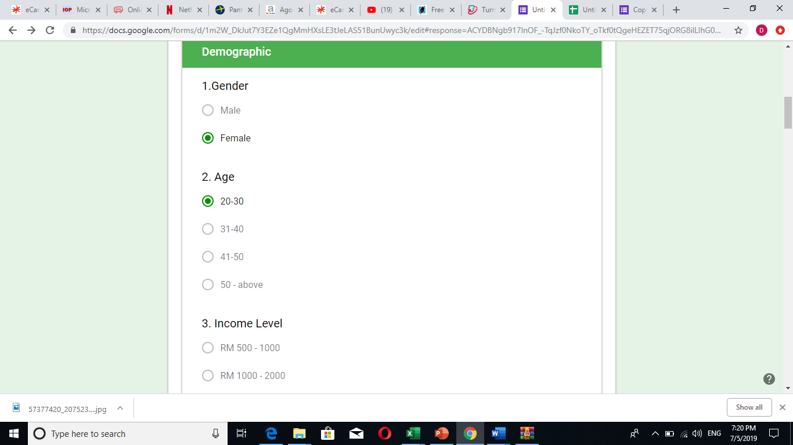

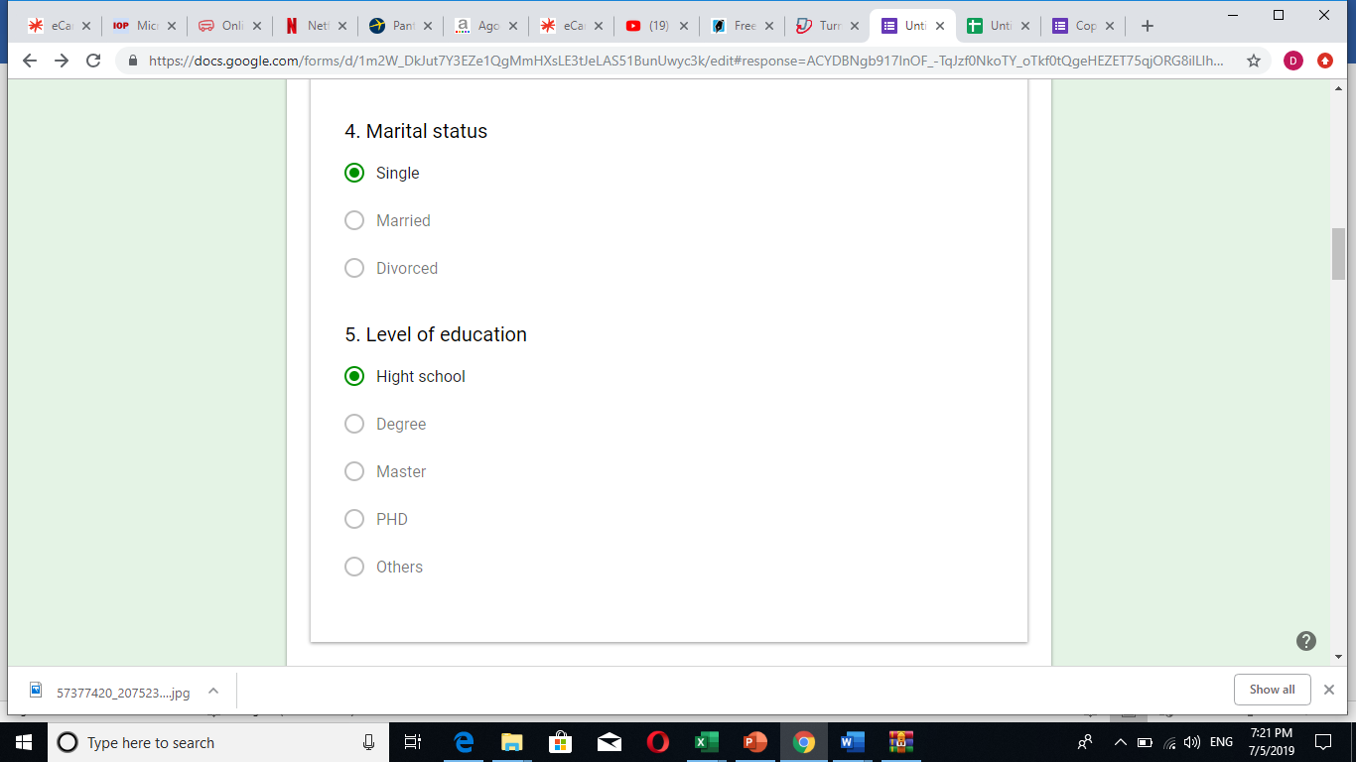

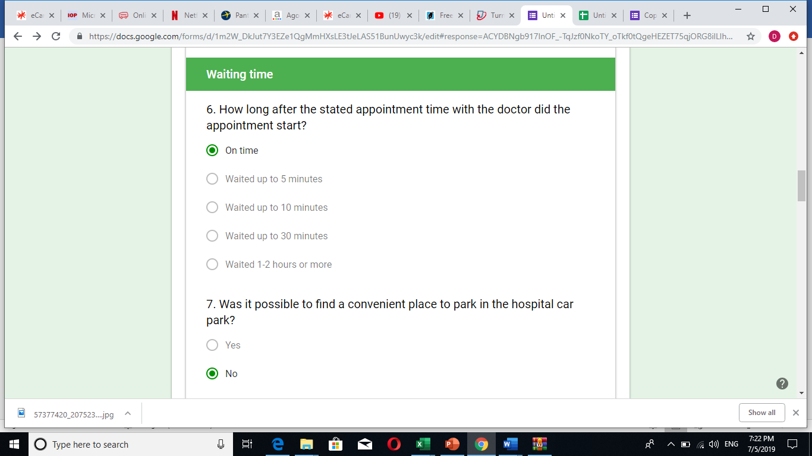

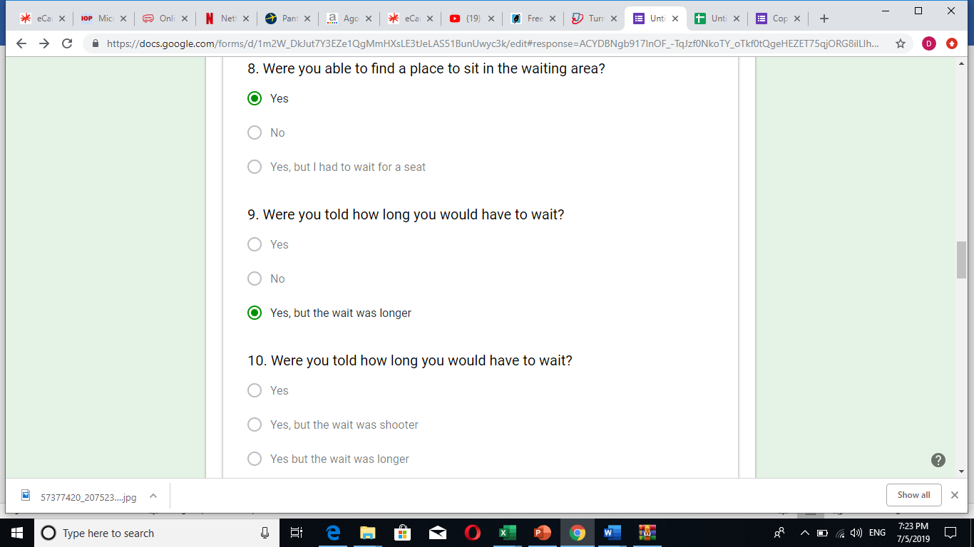

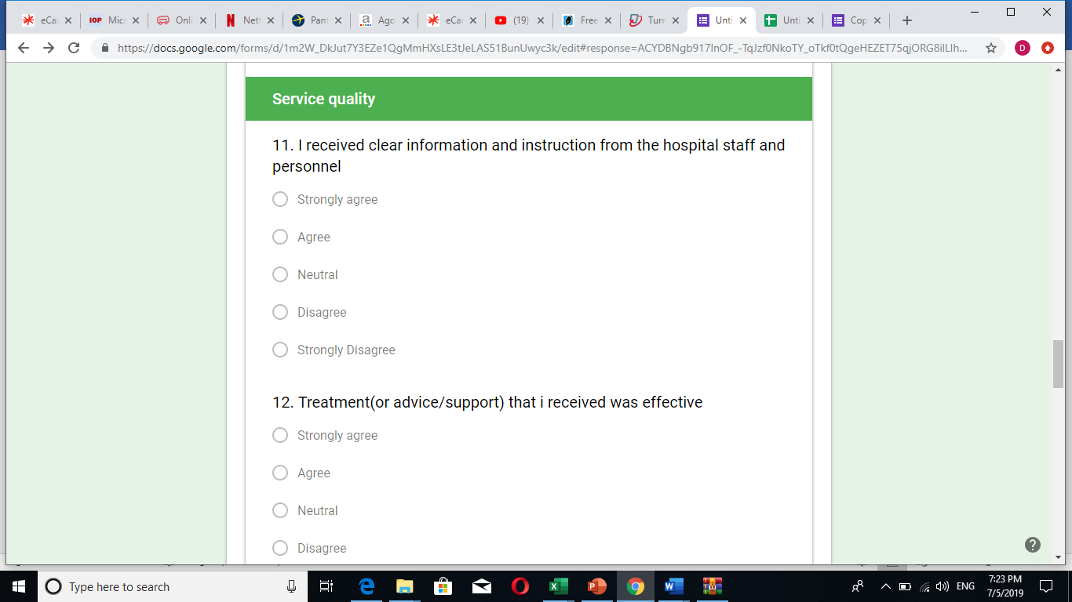

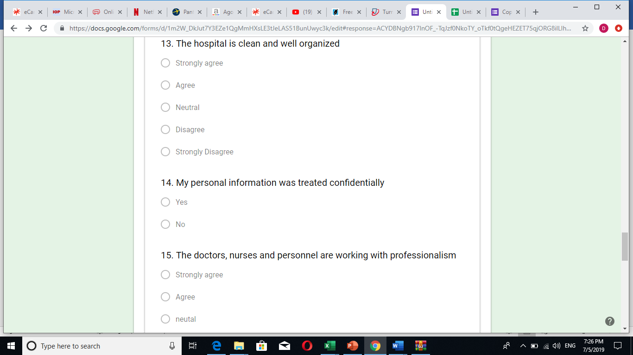

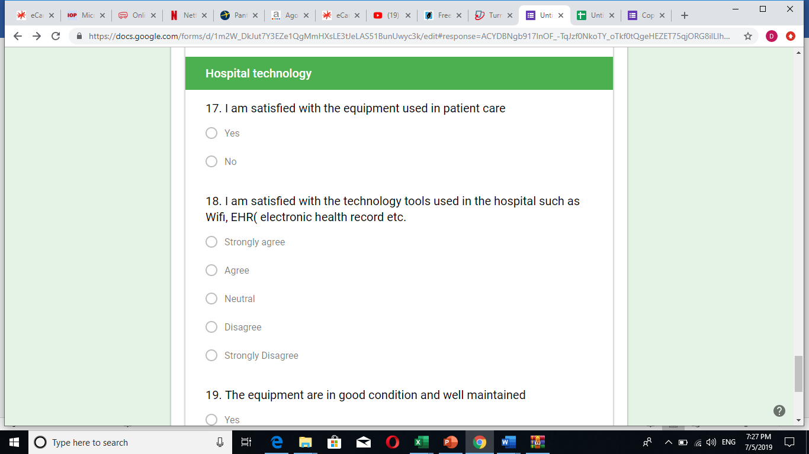

# 7.1 Appendix 2

# Turnitin report

