

MASTER OF BUSINESS ADMINISTRATION

FACTORS INFLUENCING CUSTOMER SATISFACTION TOWARDS ONLINE BANKING IN INDIA

AUTHOR: DANLAMI ZAHRADDEEN SULEIMAN
STUDENT ID: i18014310
SINGLE AWARD
SUBJECT: MGT7998 MBA PROJECT
SUPERVISOR: DR. SAM TOONG HAI
SUBMITTION DATE: 03 MAY 2019

STUDENT’S DECLARATION

I hereby declare that this thesis is my own work and effort and that it has not been submitted anywhere for any award. Where other sources of information have been used, they have been duly acknowledged.

STUDENT’S DECLARATION

I hereby declare that this thesis is my own work and effort and that it has not been submitted anywhere for any award. Where other sources of information have been used, they have been duly acknowledged.

Name : DANLAMI ZAHRADDEEN SULEIMAN

Student ID : i18014310

Signature :

Date : 03/05/2019

ACKNOWLEDGEMENT
I would like to take this opportunity to thank my supervisor Dr. Sam who had helped me from beginning until the end of this project. I am grateful for his effort in helping me to finish my project. I would like also to thank my second supervisor Dr. Wong in helping me to update my work accordingly. Also, I would like to thank all people who participated and helped me completing my research.

Name: Danlami Zahraddeen Suleiman
Student ID: i18014310

ABSTRACT
In recent years, with the continuous progress of technology and the Increasing competition in finance industry, the strength of e-banking marketing directly relates to the quantity and quality of a bank's individual customer base in the future. At present, the scale of online banking users in India is still expanding year by year. However, with the rise of other payment methods, the Development speed of online banking users is slowing down. Therefore, how to The guarantee competitive advantage is very important for banks, and customer’s satisfaction is an important condition that affects Banks' competitiveness. Based on the background, this paper investigates the customer satisfaction of Indian online banks, collects relevant data through the questionnaire, and analyzes the factors affecting customer satisfaction. Finally, it concludes that the customer satisfaction of India online banks is affected by the factors of safety and privacy, ease of use and usefulness, and puts forward some suggestions.

Key words: Online Banking, Customer Satisfaction, perceived security and privacy, perceived ease of use, Perceived usefulness.

Table of Contents
Chapter 1: Introduction 6
1.1 Research Background 7
1.2 Problem statement 9
1.3 Research objectives (RO’S) 10
1.4 Research question (RQ’S) 10
Chapter 2: Literature Review 11
2.1 Customer satisfaction 12
2.1.1 Global view on customer satisfaction 13
2.1.2 Customer satisfaction in India 15
2.2 Influencing factors 17
2.2.1 Security and privacy of online banking 18
2.2.2 Usefulness of online banking 20
2.2.3 Easiness of use of online banking 21
2.3 Gaps in literature 23
2.4 Fundamental theories: TAM 24
2.5 conceptual framework 25
2.6 Hypothesis 25
2.7 conclusion 27
3.0 Overview 28
3.1 Research design 28
3.2 Sampling design 29
3.2.1 The target population of research 29
3.2.2 Sampling plan and sampling size 30
3.3 Data Collection 30
3.3.1 Data collection for correlation study 30
Questionnaire design 31
3.4 Measurement 32
3.4.1 Pilot Test 32
3.4.2 Descriptive statistics 32
3.4.3 Preliminary test 33
3.4.3.1 Factor Analysis 33
3.4.3.2 Reliability Tests 33
3.4.4 Hypothesis Testing 34
3.5 Chapter Conclusion 36
Chapter 4: Findings and Discussion 37
4.0 Overview 37
4.1 Pilot Testing 37
4.1.1 Factor Analysis (for Pilot Testing) 37
4.1.2 Reliability Test – Cronbach Alpha 39
4.2 Demographic Profile of Respondents 40
4.3 Descriptive Analysis 41
4.4 Preliminary Analyses 42
4.5 Hypotheses Testing 46
4.6 Summary of Findings 48
Chapter 5: Summary and Conclusion 49
5.0 Summary 49
5.1 Recommendation 51
5.2 Limitations 51
5.3 Conclusion 53
References 54
Appendix 60
Appendices 1: Questionnaire 60
Appendix 2: statistics analysis result 67
Appendix 3: Project paper log 73
Appendix 4: Similarity report 74
Appendix 4: Similarity report 76

Factors influencing customer satisfaction towards online banking in India

Chapter 1: Introduction

- Overview
The chapter mainly describes the background of this study and the phenomenon of the article research. After the research problems and goals are proposed, the extent of the study is illustrated. The signification to study the customer satisfaction with online banking to the academic community and the industry as a whole is illustrated. In addition, this chapter also illustrates some of the limitations of this study as well as the direction of future research, and explains the definitions associated with the independent variables in the article.

1.1 Research Background
Over the last decade, India have rapidly improved their network environment, network security degree unceasing enhancement, the network coverage and number of Internet users increase rapidly (Kaur, 2015). According to a survey conducted by McKinsey and Company in (2014) the survey shows that customers in Asia are using the smartphones and internet banking almost three times more often than in 2011. Online banking has never left more and more customers, because it has the advantages of convenience, efficiency and low cost (Statista, 2018). Online banking transfer and other services anytime and anywhere without the limitation of time and space, which enables people's fast lifestyle paced (Hui, 2013). Therefore, consumers will more frequently choose to use online banking services, however India currently has 772 million internet users according to a report published by the India Internet Network Information Centre the Banking industry has seen an increase in the demand for online banking products due to lower reachability costs and increased bank competitiveness (Kaur, 2018). As of 2018, there are around 91 banks in India (Statista, 2018). In another research conducted by Financial Express, (2018) the number of online bank users in India and it’s expected to double up to 150 million from the actual 45 million users by 2020.

Level of online banking penetration in India
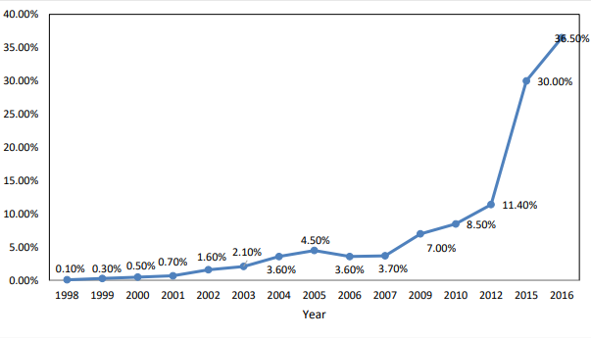
(Source: internetworldstats,2018)
This study intent of the research is to understand what factors influence customer satisfaction with online banking in India. This research will help Banks enhance the nature of online banking system, this is the reason why I selected this topic which is on the customer satisfaction with online banking in India.

1.2 Problem statement
After 1995, the Internet growth spread rapidly in the world economy, the web is regarded as the most critical factor in the internet banking system and safeguard the financial stability of the entire financial system, however the result of the technology and information revolution has prompted Banks to focus on technology to maximize profit and attract more customers (Apak and Ataya, 2013). Online banking includes all types of banking from home banking, rather than appreciation business in physical Banks (Kaur, 2015). Online banking focuses on ecommerce from Chinese customers and Banks. Internet banking is described as means of being able to deliver traditional and new technology banking services and products by using electronic and electronic means medium communications (Hosein, 2011). In internet banking, users may be able transactions of money from one account to another account and old past bills and transactions from credit card (Kaur, 2015).
India is the second largest Internet population in Asia / Pacific, India now has over 552 million online users, in a survey conducted by the India Internet Network commission Centre (India Network Commission, 2018). An add up of 40.47 m letters newly cyber surfers were created with a rate of growth of 5.2 % Internet growth rates has increased 55.7% in India, greater than the universal average (51.2%) and the normal rates for Asia (46.3%) and also Indian organizations are moreover showing that they are capable of being the best Internet (Kim, 2016).
Therefore, there is a need carry out the study to discover factors that are influencing customer satisfaction with on-line banking within India.

1.3 Research objectives (RO’S)
Research objectives are precise research acts that are plan to carry out in the research project (Pickton, 2013). The objectives describe the expected achievement of the study (Railean, 2015). However, this research concentrates on the factors that influence customer satisfaction with online banking in India.
- RO1: To determine whether perceived convenience has a significant relationship with customer satisfaction with online banking in India.

- RO2: To determine perceived security has a significant relationship with customer satisfaction with online banking in India.

- RO3: To determine whether perceived usefulness has a significant relationship with customer satisfaction with online banking in India.

1.4 Research question (RQ’S)
This study focus on the factors that are influencing customer satisfaction with online banking in India. The main research questions are;
- RQ1: Does perceived convenience have a significant relationship with customer satisfaction toward online banking in India?

- RQ2: Does perceived security has a significant relationship with customer satisfaction toward online banking in India?

- RQ3: Does perceived usefulness has a significant relationship with customer satisfaction toward online banking in India?

Chapter 2: Literature Review

2.0 Overview
This part will present a comprehensive literature review on the customer satisfaction with online banking and explain the present rapid growth of online banking in India. This chapter will also compare literature review of two different perspectives on the different influencing factors of online banking customer satisfaction as well as show in what way these factors are influencing the satisfaction of online banking users. Finally, this chapter will suggest a research framework based on the relevant theories of online banking on various factors influencing customer satisfaction and, on this basis make assumptions.

2.1 Customer satisfaction
As stated by Raza (2013), customer satisfaction reflecting to the feeling that the product or service provided by an organization or service has reached or exceeded its expectations, however Customer satisfaction refers to the ratio of perceived satisfaction of target customer groups and the satisfaction of individual customers(Hans, 2011).There are varieties of definitions related to customer satisfaction, as hotels customer satisfaction is a complicated evaluation process within a hospitality industry (Xiang, Schwartz & Gerdes, 2015). Past studies in regard to the SERVQUAL model that focus on service quality, assurance, empathy, reliability, responsiveness and tangibility and so on five aspects to examine the Pakistan customer satisfaction of the internet banking, finally it is concluded that tangibility, reliability, responsiveness and assurance does have a major positive outcome on customer satisfaction (Raza, 2013).

2.1.1 Global view on customer satisfaction
Past literatures shows that satisfaction of customer is placed at one of the most essential influential factors in aspect of all marketing activities, especially in service-oriented industry (Ara, 2016; Kandampully and Suhartanto,2000; Radojevic, Stanisic and Stanic, 2017), that is to say the purpose of satisfying customers is to retain loyal customers and attract new customers, consequently gain more market shares and get sustainable financial performance (Anderson, and Browning, 2011).
Felix (2017) carried his study and found out the linkage that exist within consumer satisfaction and service quality and in Banque Populaire capital of Rwanda offices, in regard on each descriptive and inter-sectoral survey styles, however conclusion drawn findings indicates a big as well as positive linkage betwixt quality service and consumer satisfaction however examination magnitude such as customers allegiance with responsibility, sensitivity and assuredness, this research suggests organizations ought to sustain a fault free service, manage consumer issues with persistent nature, be prepared to resolve consumer issues immediately as well as perceive individual wants of particular consumer (Hans, 2011).
Li (2013) the world of project management Customer satisfaction is commonly analysed during the last part of a project, when the customer is convinced with majority of customers money, the research argues that analysing satisfaction during the early stages of project management is bad for a project, significant data might be missed or overlooked in the process, customer satisfaction must be analysed at the beginning stages in project management as also must be analysed when the project is coming to an end (Xiang, 2016). A research in Nigeria conducted shows that customers complain, grievances and unhappiness can be lessening by banks through adequate service delivery and review structure, efficient service delivery has been described to be one in every of key performance indicators of company organizations together with banks, however The extent to which customers of banks are happy with the service rendered has impact on the performance and should be seriously taken by players of the trade (Adewuyi, 2013).
In a study conducted by Juma (2013), examined connection within prospect, operation as well as rendering of service, the research uncovered once the consumer evaluate the performance of service and product, customers compare collection of performance outcomes(Adewuyi, 2013).In another research conducted by Oluouch (2012), analyse the element’s influencing the selection of online banking based on consumers in which the research examined the linkage within the perceivable usefulness, perceivable ease of use, perceivable risk toward the usage of internet banking technology and discovered that consumers do like idea of using mobile banking technology however some customers are scared due to the perceivable risk component which is a major concern in security in using the technology (Kumar, 2012).
Previous research argued the problem in more comprehensive manner, claims that the analysing of customers' assessments of the success of a project should only be calculated when the project is complete, and furthermore that measures regarding customer acceptance and customer negotiation are the key solution factors in terms of customer satisfaction in a project management (Havaerila, 2013).
As the importance of customer satisfaction mentioned above, the concept of customer satisfaction is closely related to business opportunities, majority of studies had provided that customer satisfaction plays direct and indirect functions in affecting business outcomes (Bilim, and Yuksel , 2010; Kim, Lee and Ryu, 2012; Kandampully and Suhartanto, 2000), which research is supported by Radojevic, Stanisich & Stanic et al. (2014), claiming that the concept willingness of customer satisfaction definitely benefits on keeping customer loyalty, rising of customer repurchase rate, then leads positive financial performance(Kumar, 2012).

2.1.2 Customer satisfaction in India
Gupta and Bansal (2012) invented a machine to measure online banking service quality with five elements namely, security and privacy, reliability, efficiency site aesthetics, and responsiveness. in another research presented a nine dimensional service quality construct purposely for online banking consisting of system technical, availability, ease of use, performance, site security, trust, reliability customization, and responsiveness (kundu and Data, 2014).
However, in the past There has been significant study conducted to verify interconnection between perceivable satisfactory customer satisfaction, and consumer allegiance (Abdullah, Bagchi, and Kirs, 2010; Kassim and Udo, 2010). The satisfaction of the consumer particularly within the service industry had a good significance due to the contentment status of the consumer straightaway linkage with the customer loyalty as well as the victimisation of using the services the new generation of banking has given (Ravichandran, 2010). Most of the online organizations are bound to detach and concentrate on consumers need for their contentment (Rahman, Masina and Kadir, 2011).
According to Malhotra (2013) argued that estimation of customer satisfaction can create a huge challenge to researchers in such a situation, however analysis has shown that quality of service really has a detrimental or good influence on customer satisfaction (Nuk, 2013). Nupur (2010) found out that satisfaction level of online banking users has a close relation with tangibility, assurance, empathy, responsiveness and reliability, tangibles. In another book written by Rao, Aja, Chan and Dra (2013) found out that the is differences between MacDonald’s in united states and the MacDonald’s in India, but however parent do take kids to eat at MacDonald’s because kids love at the last instance the survey is being carried out by the parents.
Gupta (2012), planned to create a valid and reliable and equipment for gauging online banking level of service in India, as well gauge the influence of online banking service quality dimensions on the entire web consumer satisfaction and Banking Quality of service and, results shows that all dimensions carries remarkable impact on the total internet Banking System customer satisfaction Quality perceptions, nevertheless, privacy/security and Efficiency dimensions carries the utmost effect is on the entire online Banking operations satisfaction and value respectively (Bansal, 2012).
Jalal (2011), research explores the growth and the influence of pick out factors that has influences on the consumer’ intention to make usage of internet banking in, finding proves that every one of the factors of the three recognized factors are important as well as regard to the customer’s assumption of online banking system, (protection and safety) reliable factors are key causes of discontentment, that has remarkably influence customer satisfaction however For the time being, and discern usefulness perceived user friendliness and are the key to consumer satisfaction. Chang, Chiu, Hu and Cheng (2011), research shows the examine and the influence of relationship indolence as a medium for consumer satisfaction loyalty linkage and observed that relationship indolence have a powerful moderate result on the linkage.
Pandikumar (2011) in his research proclaimed that success of life insurance companies does not only depend on the successful attribute of its products, but also on the astonishing role of agents who take immense efforts towards solicitation of insurance.in another research carried out by Liu, Lin and Lai (2011) finding shows the passivity as well as switch costs that enfeeble influence on customer contentment towards customer retention.

2.2 Influencing factors
In this paper the influencing factors of the dependent variables are online banking customer satisfaction are: the benefit of internet banking security and privacy of internet banking, and easy interface of use of internet banking (kazi, 2016).
The factors influence on dependent variables is key. With the extensive demand of information technology in the financial industry, online banking has secured a lot and more favour with its advantages of convenient service and low cost (Jolly, 2016). The limitless feature of the network provides a bigger market space in favour of growth of internet banking (Kazi, 2016).
Growth of online banks has transform into an important medium for increasing the competition in the India online banking market, first of all, customer concentrate on the safety and privacy in online system, Security is to shield customer’s information and private data in online banking from leaking (Altschuller and Moscato, 2012). Security is one of the most important talked about issues regarding online banking, secondly usefulness is one of the means online banking can issue product or services that can surpass customer's needs, and will can help customer to save the cost of transport to come to the and time (Jolly, 2016). lastly, the ease of use of online banking is another important element influencing its growth (kazi ,2016).
The launch of different online banking service system will significantly upgrade the work efficiency of banks and customers, so that the funds will create the highest efficiency and reduce the production and operation costs (Clemes, 2012).
2.2.1 Security and privacy of online banking
As reported by Omariba (2012) online banking safety and privacy of is among one of the biggest factor of online banking, has troubled customers as well as banks, particularly when the incidence of online bank hacking theft and tort liability, the recognition of bank and client's liability has become the focus of legal disputes, At the same time there is no perfect law Regulatory system is not conducive to the overall development of online banking, and thus have an impact on the customer satisfaction with internet banking (Mukhtar, 2015).
Online banking is a product of the new generation of development, its comfort to make it a lot of and a lot of customers, particularly young users of all ages (Waithaka, 2015). At the same time, the online banking system has caught the attention of cyber criminals and has increasable become the target of cyber hackers (Clemes, 2012). The ways and means that of attack are endlessly updated (waithaka, 2015). Even cybersecurity specialists are helpless and lots of user’s area unit discouraged. within the survey of on-line banking users, privacy and security has another time become the main talking focus of everyone's attention (Begum, 2012).
Internet banking has captivated a huge number of consumers with its special advantages. moreover, the utmost reason for the survey shows that 71.7% of online consumers are scared to using online banking due to security and privacy issues (Clemes, 2012). for the reason that online banking is established on the open Internet, its data and information are widely easily open to the outside world however banks must fully assure the security of customer information and data (Khrais, 2015).
Although, banks find it very hard to monitor user’s data and information. On the one side, most of online banking operating systems currently uses by banks have network security leakages, example, the source code of UNIX operating system has been made open source and in jeopardy to cyber-attacks however There are safety risks on the NT server (Odoh, 2015). On the other hand, the safety of the firewall itself and the logic of the settings are how far yet clear enough, and there is no assurance that it will 100% influence block the cyber hackers (Du, 2014).At the same time, a spread of viruses for on-line banking, hacking Trojans are rising, once the user login authentication check system it's going to have invaded the system and access to the user's account and Arcanum (Driga and Isaac, 2014) for instance, there was a malicious program called "Internet Bank Thief" that would simply bypass the web banking account and Arcanum By circumventing bank security measures (Nor, 2017), additionally, hacker’s technology continues to boost, in order that hackers will break through the banking system's firewall, embedded malicious code to paralyze the banking system, and so do illegitimate activities (Omariba, 2012). As mentioned above, these exhibit a severe check on the operation of on-line banking moreover with the development and popularization of the web, on-line banking as a new variety of customer service has quickly become the main focus of the international banking community (Aizza, 2013). transnational banks have released the strategy of developing on-line banking, defrayment large sums to improve their on-line industry and creating on-line banking profitable Opportunities, for market share suggests that on-line banking to a specific extent on behalf of the banking sector's development (Hui, 2013).
In 2017, numerous number of online banking branches in India that have homepages and websites covering almost majority of cities in India, some of them have conducted substantial online banking of a reasonable size and major vital banks have created online banking services (Bank daily, 2015). According to the India Online Banking Survey Report 2016 released by India Financial Certification Authority, the total momentum of online banking growth in India is not so powerful, and the number of online users and the number of transactions have not risen significantly (Central bank India, 2016).
India is one of the world largest populated country, due to that the countries online banking is growing so fast in the world, there are still some safety problems in India online banking system (Ali Research, 2017). As a virtual working environment of real bank, India’s online banking only not has the same threat like the traditional banking business, but also has the growing features of high-technology, paperless tech and instant animosity, which determines its business risk is far Which is far greater than the risk of traditional banks (Ayar, 2010).

2.2.2 Usefulness of online banking
As stated by Kumar (2013) the use of online banking is mainly including the following aspects: available at any time, accessible from anywhere and less costly and save time. Online banking breakthrough time and area constraints, not face-to-face contact with customers, all transactions and communications through the Internet meaning on-line banks are simple to manage their costs however the value that customer must obtain the web bank is less than those of standard commercial banks, data sharing and potency are increased with low costs and worth benefits (Jolly, 2016). Previous research suggests that customers are simple to induce information that they have, however This advantage is embodied in many aspects, such as low establishment prices, low business prices and low in operation prices (Driga and Isaac, 2014). Additionally, web Banking will offer services anytime, anywhere, anyhow one year a year, twenty-four hours every day, twenty-four hours every day although with the recognition of WAP applications users will offer WAP on-line banking services to any expand client service model (Sharma, 2016) however, now India on-line banking has opened a water fee, electricity, gas fee payment system, that greatly saves the customer time needed for payment (kazi, 2016).
however, Since the beginning of online banking in India, more and more people have registered up accounts with banks that has no physical building branches. The advantages of online banking can go far beyond free checking accounts (Sharma, 2016) moreover The biggest benefit to customers in dealing with an online bank is the relatively lesser cost of giving services compared to a traditional bank or credit union that possesses a large branch network, the costs to create, maintain and staff branches are extremely high (kazi, 2016). With an online bank, these cost savings can be passed along to customers in the form of bigger deposit rates and more investments in technology (Clancy, 2017).

2.2.3 Easiness of use of online banking
Easiness to use is one key reason for the fast growth of the web, as a financial institution giving serving to the people, the idea pursued by banks is to do their utmost to bring the best service to their customers (Neli and Boshoffii, 2014). Therefore, so as to fulfil the wants of the moment, many large banks have decided to create their own online banking platform, With the online banking, users can easily use and manipulate their own private accounts and provide great convenience (Waithaka, 2015). In the face of the full liberalization of the financial industry and the highly competitive financial market, each bank has the convenience and advantage of using the information network in every possible way (Liu, 2016). Online banking is one of the most important representatives, and only by integrating the out-growth in online banking in the tide of innovation as well as reforming the financial industry, banks can lead the way lead for the future competitiveness and influence improve their competitiveness and adaptability (Begum, 2012). New appliance science is the vital motive power for the innovation of online banking (Kumar, 2012). However, in the traditional banking, the business is carried out by the staff to complete the input data, based on the busy bank, the information block bulk storage makes the data in the data processing business among branches know that a business or often takes some time to take impact, the customer for the bill, the details of the flow of funds and other inquiries often need to go through a series of cumbersome processes and long wait (Sharma, 2016). In online banking, when the customer completes the business transaction, the data is automatically sent to the server, and the information is uploaded and shared (Sin, 2012).
Eze (2011) study shows the factors influencing younger people's on-line banking customer satisfaction behaviour, and thus the results show that usefulness and simplicity were the key influencing factors. Supported by the tam theoretical model, this study investigated the customer’s satisfaction of on-line banking through factors like the perceived utility, usability and security of customer on on-line banking. However, in another study conducted by Hua (2016), shows the rapid growth of science and technology, the competition between Banks has become increasingly fierce.
Sin (2012) stated that the services or products provided by the bank are rich in variety and features, providing customers with a variety of choices, customers evaluate product or service and services with their consumption or not, customers do not have to be loyal to any production enterprise, Therefore, customers are absolving to opt for, how enterprises win the loyal consumption of consumers with full freedom of alternative is that the most important factor for enterprise managers to listen to customers, In this part, TAM theoretical model is applied to study the influence of usefulness perceived security, and usability of customers on customer satisfaction(Kumar and Gorge, 2013).

2.3 Gaps in literature
Having gone through the existing research by Kumar and George (2012) that are available within the phenomena under investigation, there are existing gaps within the literature of online banking system in India. Consequently, while many studies Beit, Daptarda and Marakardandy, (2011) have carried out a research on the internet banking and the usage of mobile banking but there are limited studies in respect to customer satisfaction of the online banking system in India which makes data to be very rare (Tiwari and Bus, 2007). However, the advancement of technology has led to emergence of many researches about online banking focuses on how banks can increase productivity while the measure concern of the online banking is to increase customer satisfaction as well (Dash, Dash and Sharma, 2012). Egwali (2014) stated that online banking is not highly effective in India at alerting and protecting users’ information from hacker. Similarly, Ezeoha (2013) found that online banking is being embraced at a slow pace by Indians because it is very easy for hackers to manipulate users account through fake banking website (Tyldum, 2017).
Previous study by Kumar and George (2012 were mainly conducted in the cities thereby neglecting customer’s satisfactions that are living in the rural areas (Zinkhan, 2012). Therefore, there is need for current studies to be conducted about online banking in India, regardless of cities or rural areas.

2.4 Fundamental theories: TAM
Technology acceptance model (TAM) created developed and introduce by Davis (1989) in other to explain the adoption of artificial intelligence, TAM could be applied to forecast online banking (Surendran, 2012). TAM is an ideal model that presents how customers use and accept artificial intelligence, Davis TAM and its extension have been widely accepted and applied to implement information technology in the information systems discipline (Alwen and Al-Zubi, 2016). TAM presupposes the perceivable usefulness and perceivable ease of use are the two key elements that determine users accepting and usage of information systems (Davis, 1989).
As stated by Kumar’s research 2015, the TAM variables will have influence on online negative or positive banking customer satisfaction. This research will focus on the three factors which are the independent variables of online banking influencing the, the factors are being in line with portion of researcher’s awareness, it is crucial to mention the number of different literatures which clearly review the factors, Furthermore Moutaz Abou-Robieh (2005) measured the linkage among respondent’s comfort degree, sense of security and customer’s view towards online banking. Research discovers that the is a connection linking these factors with considering the users age, user’s yearly salary, and user’s degree of education (Alwen and AlZubi, 2016). This linkage however was also observed by numerous researchers like Alda´s-Manzano (2009) who’s target was on the credibleness variables and came to a conclusion that.

2.5 conceptual framework
The research framework will help researchers to carry out better subject analysis, This paper mainly studies the relation that exist within online banking factors as well as the customer contentment however This study focus on the impact of three independent variables on the customer satisfaction of online banking, the first independent variable is the security and privacy of online banking however This independent variable is related to the consumer experience when using online banking, Therefore, the online banking security and privacy is a very important factor for customer satisfaction, the second independent variable is the service quality of online banking, an independent variable that can influence customer intention of use online banking, finally The third independent variable is the ease of use of online banking, The biggest reason that consumers use online banking to pay is its convenience, free from time and space constraints (Neli and Boshoffii, 2014)
Independent variables (IVs) Dependent variables(DV)
- Perceived security and privacy
Factors influencing customer satisfaction with online banking in India

2. perceived usefulness

3.perceived ease of use

2.6 Hypothesis

2.6 Hypothesis
According to the research objectives and all the literature materials, the research hypotheses are as follows:
H1: There is significant relationship between perceived security and privacy of online banking and customer satisfaction.
H2: There is significant relationship between perceived usefulness of online banking and customer satisfaction.
H3: There is significant relationship between perceived ease of use of online banking and customer satisfaction

2.7 conclusion
With the rapid growth of information technology in the world, Online Banks partake in an important role in the process of enhancing the competitiveness of commercial Banks. But the development of online banks depends on the satisfaction of customers to online banks. Based on world and India’s perspectives, this chapter provides a literature review of the independent variables influencing the customer satisfaction of online banking, including security and privacy, service quality of online banking and ease of use. All of the documents in this chapter support these three independent variables will play an important role in the customer satisfaction of online banking.

Chapter 3 Research Methodology

3.0 Overview
The methodology being used in this study will be explained in this chapter. This study will use questionnaire to collect and analyse sample data, including sample population, data collected, technical tools, and also the dependent variables and independent variables mentioned above.

3.1 Research design
The major objective of the study is to study the factors influencing customer satisfaction of banking in India. This research design gives different critical choice points for each component, in a study, the rigor of science is determined by how the researchers choose the right design, and given their specific purpose (Sekaran and Bougie, 2016). This part mainly discusses issues relating to compromise as regard to the purpose of the research, the type of the research, the extent to which it is controlled and manipulated by the researcher and all of these are integral to study design.
The research is a quantitative research, Bryman and Bell (2015) quantitative research quantitative research reviews a specific issue through certainty, systematically approach and quantitative research embroils numerical data and fact collected through interactive research which is tools know as survey. Because this study used questionnaire survey method, this study is quantitative research (Saunders, Lewis, and Thornhill, 2015). This quantitative research call for research designs in which the focus of the study describing, predict as well as explaining phenomena, using the probability sampling (Khalid and Hilman,2012). Therefore, in addition to this, the study will also carry out a descriptive research which is to analyse an accurate profile of persons, events or situations (Saunders, et al., 2015).
The researcher is interested in depicting the crucial variables linking with the problem, this study is termed a correlational study (Bougie and Sekaran, 2016). Bold (2011) noted that the purpose of a correlational study is to establish whether two or more variables are related. The study consists of three independent variables, which are the privacy and security, usefulness and ease of use of online banking. The study is to determine the relation between these three independent variables and the online banking customer satisfaction in India, so this study is considered to be a correlation type of study. The degree of intervention by the researcher with the typical flow of work at the workplace has a direct comportment on whether the study ventured is correlation or virtual (Sekaran and Bougie, 2016). Correlation studies are always carried out in non-contrived settings, the study setting for any research can be either natural or controlled, a non-contrived settings or uncontrolled setting are the natural environment in which situations happen normally (Saunders, et al., 2015).
In this research, the degree of intervention by the researcher was minimal, as the study was a naturally occurring event, researcher had no control over the variables and hence the research setting is non-contrived.

3.2 Sampling design
Furthermore, I will be using non probability as well as probability as my two types of samples design:(Bougie and Sekaran, 2016). Probability sampling is regularly related with experimental research strategies and survey. If a probability sampling design is achieved properly, an analyst can use almost little sample to make inferences about an arbitrarily big population (Lohr, 2016).

3.2.1 The target population of research
Population refers to the entire cluster of individuals, things, or events of importance that the researcher hope to review (Sekaran and Bougie, 2016). The population definition of this study is that of people who use online banking in India. So as to study the influence with different factors in the customer satisfaction of online banking in India, the target population expressed their opinions through an online questionnaire (Chatzoudes, 2013). Obviously, online banking users living in India represent the whole population of the research. In previous studies, the target populace is users of online banking are college students and white-collar workers in India. But the target population in this research is the person who has different occupation in India, because in the past decade, the amount of individuals who use of online banking is growing, and user’s acceptance of online banking is increasing (Cecilia, 2015). Not only college students and white-collar workers who have received higher education have used online banking, but also people with other social attributes have taken part in online banking users (statist, 2017). So it is necessary to survey people of different occupations.

3.2.2 Sampling plan and sampling size
The targeted population is composed of online customers from India with specific research, due to the fact that they are a lot of online banking users in India furthermore, it is crucial to pick a suitable sampling (Mukhtar, 2015). Through this specific study, sampling people have been chosen throughout convenience sample, the convenience sample approach pertains to choosing sample on the idea of convenience availability for the research (Sekaran and Bougie, 2016). In order to avoid generate bias factor, the researcher has selected sample of respondents from different places and on different occasions, and in this way, a diverse and unbiased sample has been selected for this study (Mukhtar, 2015). Selection of a correct sample size is still a big challenge for researchers, the sample size needs to be carefully considered as statistical techniques are strongly influenced by it (Rahim, 2017). Krejcie and Morgan (1970) have stated that if the given population was more than 1000000 than the required sample size would have to be 384.According to India’s financial certification centre (2017) released by the online Bank of India survey report shows that India’s online banking user has already more than 20 million in 2016, and the number of users is still growing fast in the recent years, so this rule is applied in this study, the sample size order has to be 384. According to the above research, set up the confidence level is 95%, the confidence interval is 5, and the population is 40 million in 2006, the sample size calculated is 384 (Krejcie and Morgan, 1970).

3.3 Data Collection

3.3.1 Data collection for correlation study
This study used questionnaires to collect data. A questionnaire is a systematic list of questions designed to obtain information from people about: specific events, their attitudes, their values, their beliefs (Needham and Grandfield, 2010). The questionnaire carries a particular question that are formulated and utilize by the analyst in gathering information through the respondents (Duisk and Zhu, 2016).
According to Asika (2004) scale questions used in questionnaires are designed to recognize the degrees of intensity in the respondent's feelings about and perceptions of certain phenomena which can not ordinarily be gathered from two-way or even multi choice questions. The respondent's anticipated feelings and perceptions are represented in scales and his choice of a particular point on the scale is assumed to represent this feeling or perception and it is, thus, this questionnaire based on Likert scales, which can measure broader attitudes and values ​​ (Johns, 2010). Therefore, this questionnaire is divided into five proportions: Strongly Agree, Agree, Neutral, Disagree, Strongly Disagree (Dujsik and Zhu, 2016).
In this method a questionnaire is sent to the person concerned with request to answer the questions and return the questionnaire (Kaur and Pathak, 2015). This survey combines the independent variables and dependent variables involved in the research, mainly to investigate the factors influencing the users ‘use of online banking. The questionnaire is divided into three parts: Demographic information, the customer satisfaction in China and online Banking factors that influence the results.

Questionnaire design
In this part I separated the questionnaire into three parts; part A is demographic information. Demographics information means characteristics of a population. Characteristics such as ethnicity, gender, age, education, are all typical examples of demographics that are used in surveys (Sekaran and Bougie, 2016). Part B is on the issue of the dependent variable that the customer satisfaction in India, and the C part is about the factors influencing the dependent variable changes, including the security and privacy of online banking, usefulness, and ease of use. All of these questions are adopted from the previous study, and combine with George and Kumar's research to innovation. The answers to these questions are based on the Likert scales, Settings five coding respectively Strongly agree, agree, Neutral, Disagree, Strongly Disagree (Harry and Boone, 2012). The final will be according to the collected data through the data statistics, test the impact that the in-dependent variable has towards dependent variable (Kumar, 2011).
Section | Area | No. of Items
A | Demographic | 3
B  (Dependable variable) | Consumer satisfaction towards online banking in India | 3
C  (Independent Variable) | Perceived Convenience | 4
C  (Independent Variable) | Perceived Usefulness | 4
C  (Independent Variable) | Perceived Security | 4
Figure 1: Table of questionnaire items summary

3.4 Measurement

3.4.1 Pilot Test
The term 'pilot studies' refers to mini versions of a feasibility study, as well as the specific pre-testing of a particular research instrument such as a questionnaire (Khalid and Hillman, 2012). Pilot testing means finding out the survey, key informant interview guide or observation form will work in the "real world "by trying it out first on a few people. The purpose is to make sure that everyone in the sample not only understands the questions, but understands them in the same way (Bartlett, 2013). This test selected a small percentage of the respondents, 40 sample size, through factor analysis and reliability testing to find out if any queries makes respondents feel discomfited, and it also be able to find out how even how long it takes to finish the survey in real time (Peersman, 2014).
Within this study, to ensure that the questionnaire content can be fully understood, 10% of 384 questionnaires were selected, 40 questionnaires were distributed as pilot tests, and formal data collection was continued after confirming that 40 participants could answer questions correctly. A sample of 40 online banking users in various regions of India was taken as participants. Test results show that the problem, process, layout is clear. In addition, reliability test was also carried out to check whether the results of each project were consistent with the overall questionnaire. The table below shows the Cronbach's alpha value is 0.960, exceeding 0.7 in the 34 projects, indicating good internal consistency.

3.4.2 Descriptive statistics
Descriptive are usually used in describing variables which is performed by analyzing a single variable one at a time which is often titled as outlier analysis (Patel, 2009). The descriptive statistic is conducted prior to the analysis of data as it done by all researchers (Saunder, 2015). Sekaran and Bougie (2016) state that the descriptive statistic such as standard deviation, variance, means, maximum as well as minimum were obtained for the interval-scaled independent and dependent variables.

3.4.3 Preliminary test

3.4.3.1 Factor Analysis
Khalid and Hilman (2012) state that the factor analysis is one of the most important tools in analysing data. The adequacy of the sample can be assessed by examining the Kaiser-Meyer-Olkin (KMO) (Kaiser, 1970). The rule of thumb of the KMO state that when the case of the variable ratio is less than 1:5. It ranges from 0 to 1 while according to Tabachnick and Fidel (2001) consider 0.50 suitable for the factor analysis. However, in the view of Niemeyer and Bearden (2003) state that any KMO correlation within the range of 0.60 – 0.70 can be considered acceptable and can proceed for further for EFA output. Hamed, Shamsul and Neda (2016) state that Bartlett’s test of sphericity must provide a significant chi-square output. Therefore, it indicates the matrix that is not an identity matrix accordingly and accordingly it should be significant (p<.05) for the suitability of the factor analysis. Hence, the factor analysis can only be proceeded when the KMO shows sample adequacy as well as the Bartlett’s test of spherical shows the item correlation matrix is not an identity matrix (Sekaran and Bougie, 2016).

3.4.3.2 Reliability Tests
Neumann (2012) state that the reliability refers to the degree of consistency or the dependability of an instrument which includes; internal consistency, stability as well as equivalence However, Bolarinwa (2015) state that the reliability test of a questionnaire is basically conducted using a pilot test. Cronbach’s Alpha is considered to be an indicator reliability responsible with the variation accrues by the correct score of final fundamental frame which expected to be greater than 0.7 for the instrument to be reliable (Mahdavi and Ali, 2017). The coefficient of the Alpha range in value of 0 to 1which might be used in describing the reliability of the factors extracted from dichotomous (question that have two possible answers) or questionnaire that is in a multi-point formatted manner. The reliability generated scale depends on the level of the score (Panayides, 2013). However, according to Nunnaly (1978) state that 0.7 can be considered as an adequate reliability coefficient nevertheless less brink could apply occasionally with the literature. Thus, researchers usually create the scoring by reliability to reduce errors in the measurement (Mohajan, 2017). The rule of the Cronbach’s Alpha measurement is shown in the below char (Malley, 2003).

Table 2: The Rule of Cronbach’s Alpha Measurement
Cronbach’s Alpha Internal Consistency
a > 0.9 Excellent
  - <a <0.9 Good
0.7 <a < 0.8 Acceptable
0.6 <a < 0.7 Questionable
0.5 <a <0.6 Poor
a < 0.5 Unacceptable
Source: George and Mallery (2003)

3.4.4 Hypothesis Testing
According to Sekaran and Bougie (2016), hypotheses testing refers to the statistical tool that test whether the hypotheses at the proposed level is significant or not by comparing it with the null hypotheses. The hypothesis is rejected only when the outcome is lower than the pre-set significance level. Simply put, according to Zikmund et al. (2013) hypotheses testing is implemented by researchers to identify whether hypotheses can be accepted or not. Hypothesis testing is very vital because it allows investigators to get an idea of what outcomes to look for an accurate study and to keep the whole study procedure reliable and scientific (Park and He, 2017). According to Sekaran and Bougie (2016), hypothesis testings’ function is to asses two mutually excluded statements to identify which the best to describe and support the outcome from the data.

Multiple Regression Analysis
Regression analysis is statistical technique that is used in estimating the relationship that exist within variables that have result relation (Uyanik and Guler, 2013). The regression analysis basically focusses on univariate regression which analyses the relationship between the dependent variable and a single independent variable (Pearson, 2014). Uyanik and Guler (2013) state that a regression that is conducted between one dependent variable and more than one independent variable is often regard to as multiple regression. The multiple regression analysis refers to as powerful technique used in predicting the hidden value of a variable from the known value of two or multiple variables which are referred to as predicators. However, this study will make usage of the multiple regression which is used in studying various factors as well as related data of online banking that influenced consumer satisfaction toward the online banking system (Perkins and Annan, 2013). The linear regression equation is shown as below;
CS=β0+𝛽1(𝑃C) +𝛽2(𝑃𝑈)+𝛽3(𝑃S)
The PC= Perceived Convenience, PU= Perceived Usefulness while PS= Perceived Security. The value of 𝛽 represented as B in an unstandardized coefficient.

One-Way ANOVA
Sedgwick (2012) defined One-Way ANOVA as a statistical tool to determine whether there is a variance that exist between the means of a number of independent variables (usually more than three). If the in the results the P-value is less than 0.05, there is significant variance between the means of the independent variables under study (Sekaran and Bougie, 2016). Moreover, for this current study One-Way ANOVA is required to be done since this study contains three independent variables which need to be examined whether a considerable level of variance exist between the mean of each other (Sedgwick, 2012). According to Zikmund (2013), If the factor is ordinal and F value is found to be significant, it can be said that the kind of variance present in the data would show the difference between groups. However, if the data is scale data, the recommend tool to be applied are Dennett’s post-hoc test or Kruskal-Wallis (Sekaran and Bougie, 2016). As for this study, for the ordinal data the likely scale is used therefore the post-hoc tests within one-way ANOVA using Kruskal-Wallis will be implemented to ensure the equality of variances or means among respondents

3.5 Chapter Conclusion
This part shows the type of methodology applied in the research with relevant theoretical knowledge. Firstly, the design process investigation is presented as well as the method, research environment and the level of intervention of the research study. The sampling method used in the investigation process that was been adopted in this study is also explained in this chapter and the calculation of the appropriate sample size according to the previous researches there by designing the corresponding questionnaire. Lastly, different method was followed in verifying the data reliability as well as the correlation

Chapter 4: Findings and Discussion

4.0 Overview
The data analysis will be conducted based on the methodology as discussed in chapter 3. In this chapter the results or findings of the data from the questionnaires outcomes received would be discussed. In this research, SPSS software would be used for the preliminary analysis including reliability test, factor analysis, multiple linear regression analysis as well as descriptive analysis.

4.1 Pilot Testing
Pilot test will be done as a pre-trial of the questionnaire by itemizing statement and arrange them in a proper sequence in other to achieve the face validity of the questionnaire (Walliman, 2011). According to Bougie and Sekaran (2016), if the target population considered for the research is 384, the pilot testing conducted would be on 10% of 384, which is on 42 respondents

4.1.1 Factor Analysis (for Pilot Testing)
Factor analysis is being conducted in order to validates the component of the idea that has been operationally characterized, as well as indicate the appropriateness of each dimension (Bougie and Sekaran, 2016). It aimed at reducing the immense number of factors to a progressively important and reasonable set of factors (Kumar, 2011).
1) KMO Bartlett’s test of Sphericity
Table 4.1 KMO
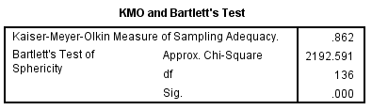
KMO Bartlett’s test of sphericity provides the Kaiser-Meyer-Olkin measure of sampling adequacy where if he data is adequate the KMO value should be greater than 0.6 (Zikmund et. al., 2013). As shown in table 4.1. The KMO value is 0.86 which indicates the sample is adequate and researcher can go ahead with further analysis
2) Factor Loading/ Extraction/ Communalities
Table 4.2
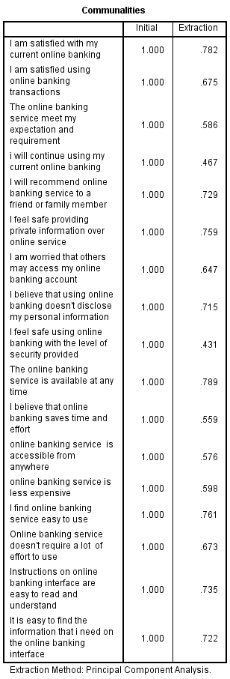
For factor loading testing, the dependent variables and independent variables are tested. The outcome from the independent variable showed that almost all item’s value is greater than 0.6 which considered acceptable (Kong and Liu, 2018). According to Hair et al (2014), for a factor to be deemed to be suitable for further analysis, factor load should exceed more than 0.6. Therefore, in this analysis as shown in the results from the table 4.2 the factor loading is greater than 0.6.

3) Eigenvalue Table
Table 4.3
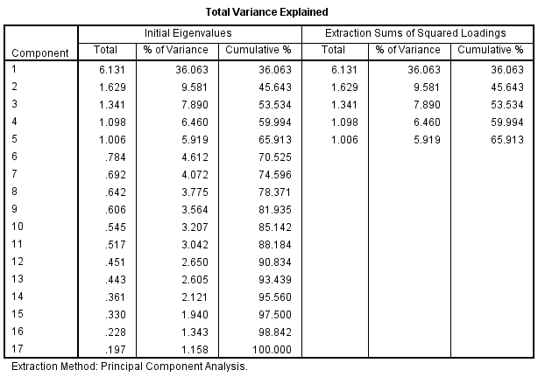
The Eigenvalue ​​for certain factors indicates inconsistency within all variables. If the Eigenvalue is greater than one, it is regarded as significant. The construct and dimension should be more than 1 in other to be valid and proceed to the test (Cooper and Schneider 2013). Table 4.3 shows that the constructs are more than 1 which means that these constructs are valid for the study.

4.1.2 Reliability Test – Cronbach Alpha
Table 4.4

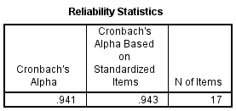

The Reliability test is characterized as a statistical tool that is conducted in other to quantify the internal consistency of the variables under a factor, which can help ensure that the gathered information is reliable, and the instrument utilized in the study is valuable for analysing (Baker, Ponton & Rovai, 2013). The reliability of the instrument is determined by computing the value of the Cronbach’s Alpha model. The reliability test for this research is done on 39 respondents’ data, collected for the pilot test. According to Hair et al. (2014), the value of Cronbach Alpha should be more than 0.7, if it is less than 0.7, item is not consistent and hence should be removed. However, from the above table 4.4 the Cronbach alpha’s value is above 0.7 which is 0.94 which means items in the questionnaire has good reliability.

4.2 Demographic Profile of Respondents
After the pilot testing was done, the questionnaires were distributed. Around 400 responses were expected, however received back on 328 responses. All data collected were usable as the study make used of online questionnaire (Google docs) in data collection process. The below table 4.5 shows the summary of questionnaire table.
Summary of questionnaire table
Table 4.5
Items | Quantity
Questionnaires Distributed | 400
Questionnaires Collected | 328
Questionnaires Used for Analysis | 328

Therefore, descriptive analysis is required through which will help to provide the descriptive statistics on the data received from the respondents. Below table shows the demographic data of the respondents.

4.3 Descriptive Analysis
Table 4.6
Gender composition
Gender | Percentage | Frequency
Male | 45.1 | 149
Female | 54.6 | 179

Table 4.7 Age
Age | Percentage | Frequency
18-24  25-30 | 6.9  29.4 | 25  98
31-40  AB 40 | 51.7  10.5 | 170  35

Table 4.8 Level of Education
Level of Education | Percentage | Frequency
High school | 15.6 | 52
Bachelor | 43.2 | 144
Masters | 32.2 | 106
PHD | 7.8 | 26

From the table 4.6 above shows that 45.1 percent of the respondent are Male. However, majority of the respondents in this research are between 31-40 years of age with a frequency of 51.7 as shown from table 4.7. Table 4.8 shows that 43.2 % of the respondents has bachelor of degree as their level of education which account as the majority.

4.4 Preliminary Analyses
Preliminary analysis is conducted after pilot test. The main objective or reason of preliminary data analysis is to prepare the data for future analysis, describe the factors of the data and summarize the findings or outcomes (Blischke et al., 2011).
- factor analysis
Several tests were performed to confirm the validity of the constructs. Where Kaiser-Meyer-Olkin (KMO) followed by Bartlett’s tests were performed to measure the research data adequacy as well as to confirm the relationship of the constructs respectively (Pallant, 2011). The acceptable individual measure of sample adequacy (MSA) should be above 0.5, whereas the overall KMO should be greater than 0.6 (Kaiser, 1974 cited in Pallant, 2011). Where the significance value for Bartlett’s test should be of p < 0.05. In Addition to this, communalities and component matrix were also examined that helped to confirm the validity of the research constructs. Hence, the communalities value should exceed 0.5 and 0.4 for component matrix correlation
- KMO Test
Table 4.3.1
KMO Bartlett’s test was conducted for the independent variables and the outcome of the significance value is greater than 0.6. The value of the dependent variable’s KMO is 0.86 which is greater than 0.6, indicating that the statistical significance is sufficient and further questions need not to be added. Therefore, since the KMO requirement is met by the dependent variables, the sample is adequate and investigator can continue with factor loading. Therefore, after considering all the 328 responses, as shown in table 4.3.1, the KMO value is 0.69 which indicates the sample is adequate.

2) Factor Loading
Table 4.3.2

As shown in table 4.3.2, majority of the items have the factor loading value are above 0.5, which means these items are usable and acceptable for further analysis. The availability component matrix clearly shows that each load factor is above 0. 5, other common factors can be theoretically distributed and convergent, that is to say, the content of general factors can be well explained by general factors in the scale.

3) Eigenvalues
Table 4.3.3
The Eigenvalue ​​is used identify if there is any inconsistency within all variables. If the Eigenvalue is greater than one, it is regarded as significant. As shown in the above table 4.3.3, In order to ascertain the most significant factors where all the factors with eigenvalues are greater than the cut-off criteria of 1 which means the constructs, or the dimensions are viable and appropriate for the study. Hence, it can be concluded that the scale taken for compensation are deemed to be adequate and appropriate for the conduct of further tests or analyses for this research as the KMO Bartlett’s test of Sphericity criteria have all been met (Pallant, 2011).

Reliability Test – Cronbach Alpha
Reliability analysis is one of the most important analysis used by researchers that helps to analyse the consistency of the variables, further by ensuring that they are consistent (Bryman and Bell, 2011). Where Cronbach’s Alpha is measured and values equal or greater than 0.7 is taken as having good internal consistency (Pallant, 2011). In addition, Glie (2003) emphasized that if the value ranged between 0.70 > 0.80 then it is considered as acceptable, if between 0.80 > 0.90 then the reliability is good and lastly any value above 0.90 has an excellent consistency.

Table 4.3.4
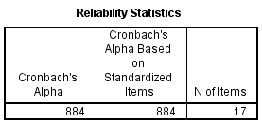
According to Hair et al. (2014), if the value of Cronbach alpha is more than 0.7, then the items designed in the questionnaire has excellent reliability but if the value is less than 0.7, the item is not consistent and hence should be removed. As shown in table 4.3.4, the value of Cronbach’s alpha is 0.88, which means the items in the questionnaire are reliable and indicates high internal consistency. However, the overall reliability analysis conducted shows good results indicating that the 17 items for independent as well as dependent variable are appropriate for further analyses.

4.5 Hypotheses Testing
Multiple Regression and One-way ANOVA Table
According to Schmidheiny (2016), multiple regressions refer to the statistical tool that is generally used to determine the relationship between one dependent variable and different independent variables by looking at the alpha value. If the alpha value is less than 0.05 the relationship is statistically significant, however if it greater than 0.05 it is not significant (Badgujar and Wani, 2018).

Table 4.4

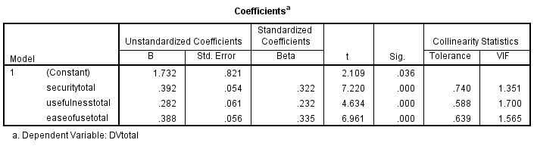
The above table shows the coefficient for independent variables to dependent variables. The unstandardized beta represents the slope of line between the independent variable and dependent variable. Beta Coefficient is done to identify the factor with highest influence, which states that higher the value of beta coefficient, higher is the predictive value toward phenomenon, which means the standardized Beta will range from 0 to 1 or 0 to -1, depending on the direction of the relationship which means the closer to 1 or -1, the stronger the relationship. (Bougie & Sekaran, 2016). According to Hair et al. (2014), Multi-Collinearity is done to determine whether there are multiple overlaps and correlation between all variables which states that VIF has to be less than 10; if VIF is more than 10 means that factor is not strong predicted and will skew the results. From table 4.4.1, it is shown that the VIF is less than 10 which means the factors have strong predictor.
Table 4.4.2
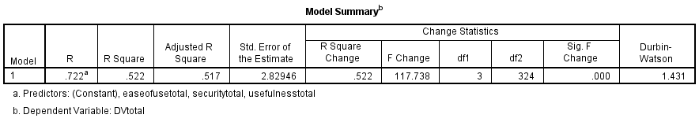
Using Multiple-Regression to determine whether relation exists within variables and weather framework is able to explain/describe/predict the phenomenon (Bougie & Sekaran, 2013), which states two things; 1) if value is more than 0.5 it shows that it is at least 50% fit; anything less than 0.5, the model or construct is not fitting and doesn’t describe the relationship between variables, also 2) the nearer it is to 1 the stronger is the model fit (Zikmund et. al., 2013). As shown in table 4.4.2 the R square value is 0.580 which means the model is 50% fit and determines the relationship between the variables. Therefore, from the above table shows that all the independent variables have strong relationship with the dependent variable

Table 4.4.3
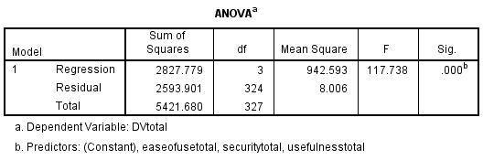

One-way ANOVA is used to determine the extent of variance within respondents or between respondents, through which it shows that the results or the p-value is less than 0.5 (Sedgwick, 2012). As shown in table 4.4.3 the p-value is less than 0.05, which shows the extent of variance within the respondents.

4.6 Summary of Findings
This chapter highlights the research findings based on the data analysis. SPSS statistical latest software version 25.0 was used to measure the hypotheses testing. Data are tested sequentially by factor analysis, reliability testing, and hypothesis testing to be sure that the adapted items are relevant and appropriate to this research. The investigator conducted preliminary tests multiple regressions separately to verify the hypothesis significance to the proposed dependable variable. The findings show that there is significance relationship between the independent variables and the dependent variable which is customer satisfaction towards online banking in India. Based on the p-value, the H1, H2 and H3 is accepted, which means the perceived convenience, perceived security and perceived usefulness has a significant influence on customer satisfaction towards online banking in India.

Chapter 5: Summary and Conclusion

5.0 Summary
This study analysed the factors influencing customer satisfaction towards online banking system in India. It addresses the three factors which are the IVs that are expected to influence the consumer satisfaction with the objective of identifying the reason of why online banking has been increasing but has been facing challenges in the past few years and come up with a recommendation to improve the banking industry in India. However, the data was collect with the use of online questionnaire by which several tests were conducted including factor analysis, reliability test, descriptive analysis and multiple regression to analyse the data, whereby Descriptive analysis to identify variable characteristics in terms of relative proportions, standard deviation, standard deviation, frequency and distribution; reliability test was performed to assess the internal consistency of the items before factor analysis; factor analysis was implemented to decrease the number of variables to an appropriate level and group the elements that represent variables into items into independent dimensions; Multiple regression analyses was executed to demonstrate statistical significance between dependent and independent variables and were used to statistically confirm whether the relationship between dependent and independent variables is affected by other factors.
Hypothesis (H1):
Perceivable privacy and security does create an important relation with customer satisfaction with on-line banking in India.
In relation with other research carried out concerning on-line banking and verified also by Kumar and George (2013), these hypotheses final result displays important influence of (Perceivable privacy as well as security) on consumer satisfaction toward on-line banking in India. Perceivable security among the predicted variables showed the highest issues which implies that enhance the safety level of their online platforms to boost customer satisfaction. This will also give the banks competitive advantage over their competitors in the banking industry, however banks can introduce artificial intelligence such as facial security or finger scanner to increase the safety of on-line banking from hackers and malicious attacks.

Hypothesis (H2):
Perceivable usefulness does create an important relation with customer satisfaction with on-line banking in India.
Verified through George and Kumar study (2013) with regards to other supporting literature review of other researchers towards on-line banking, (Perceived usefulness) surfaced as a 3rd predictable variables. These hypotheses outcome displays important impact with (Perceivable usefulness) with customer satisfaction toward on-line banking in India, the findings from the hypotheses shows that banks need to improve so as to meet the expectations of their customer, furthermore should make sure their sites or mobiles app speed is up to the standard of the current trend of technology. The faster the better in other to help customer carry out transaction smoothly without ease.
Hypothesis (H3):
Perceivable easiness of usage does have an important relation with customer satisfaction towards on-line banking in India.
In relation with other research carried out concerning on-line banking and verified also by Kumar and George (2013), these hypotheses final result displays important influence of (perceivable easiness of usage) on consumer satisfaction toward on-line banking in India. Online banking interface are very important because when the sites or application are not user friendly its gives complication to customer to use, banks need to create user friendly sites which helps in assisting the easiness of navigating from one page to another page without complication. Numerous research shows that customer do consider easiness of use very seriously because its gives the first impression to the users.

5.1 Recommendation
Further studies are recommended to be continued in the future to assess and re-confirm more factors that can influence customer satisfaction towards online banking in India to assist both the academic and the business world to obtain more detailed references for future studies and the banking industry. However, majority of the respondents are still afraid of the security of the service due to the absence of physically present security personnel, it is necessary to provide information to the respondents how to maintain their personal security. Similarly, Indian Banks should consider safety of customer online accounts as their number one priority due to increase in cybercrimes and hacking which may affect customer perception towards internet banking. more ever, it is advisable that Indian banks should avoid appending surplus fess on customer who use the online banking system which means additional charges to users.
The banks should make sure that the costs of transacting manually within the branch does not exceed the costs of online banking system. Small transaction costs are quite burdensome; it is recommended that transaction costs are adjusted for the transaction size. Features too many views that are often confusing for beginners, should be simplified for the front page. The Banks should make their customer more aware of their new services so as to encourage higher adoption rate. However, Indian banks can consider targeting their promotional activities towards those in the generation Z business personnel who are quite flourishing as they are more likely to use the online banking system. Equipment often damaged, presumably there is a system that can notify in real time that equipment is damaged so that the respondent did not already transact.

5.2 Limitations
Some of the major constraint in this study is the time frame which have only 10 weeks which is considered as very short period, because of the limited time the researcher could not distribute and collect an effective questionnaire for respondents from all over the country, so the basic information collected may not be as powerful and accurate as to support the outcomes. However, India is one of the biggest countries in terms of population in the world with people of different living standards, cultures and income levels, therefore to obtain more accurate baseline data, the researcher needs to collect information from each part of the country that uses online banking system. Factors influencing customer satisfaction are many and changeable, except those three critical factors discussed in this research, therefore, other variables are encouraged to be explored in further study related to customer satisfaction with online banking.
Ineffective items were deleted before proceeding with the analysis on SPSS, however, there may still be inaccurate data for the remaining questionnaire from respondents to the proposed question, especially the items for the variables in this research. Meaning that the respondents might just fill the results with being fully honest or accurate and these data can still lead to inaccurate results. In the social demographic descriptive analysis, it illustrates that 51.7% of the participants are within the age range of 31 – 40 years old. It could result of the data gathered being centralized in this age range, which may also lead to results the are more in working class range. In addition, future research should increase the sample size and gather more information regarding consumer behaviour on the online banking. However, this study offers and recommends direction for future research is strengthening the findings and overcoming limitations. Future researches are recommended to expand a study range on the more different occupation people, which means that not just focus on several occupations, but also the people who do not have a job or retire people.

5.3 Conclusion
Online banking is likely to become more important in the growing global economy based on technology and information. Therefore, financial institutions must provide better quality in terms of products and services, thus increasing market competitiveness. Considering that many factors may affect consumers' attitude towards online banking, it is very important to investigate the consumers and understand the factors influencing consumer satisfaction.
Based on previous literature, SERVQUAL model was chose by many scholars in other to study service quality, while online banking should not only pay attention to service quality, but also to the systematic factors brought by science and technology. Therefore, this research proposed the framework and made a questionnaire based on the TAM model to study the relation that exist within perceived convenience as well as security, perceived usefulness, in other to study the customer level of satisfaction towards on-line banking in India. Although results show that customer satisfaction level towards on-line banking in India is positively correlated with perceived convenience, perceived security and perceived usefulness.

References
- AliResearch, 2017. E-commerce and inclusive growth in China.

- Davis, F. D., 1989. Perceived Usefulness, Perceived Ease of Use, and User
Acceptance of Information Technology. MIS Quarterly, Volume 13, pp. 319-340

- Oluoch, R.A. Factors Affecting Adoption of Mobile Banking Technology in Kenya
Case Study of Nakuru Municipality. Unpublished Thesis

- Apak, S. and Ataya, E., 2013. An Overview of GDP and Internet Banking
Relations in the European Union Versus China. In: Procedia - Social and
Behavioural Sciences. s.l.:s.n., pp. 36-45.

- Gupta, K. K., & Bansal, I. (2012). Development of an instrument to measure internet banking service quality in India. Researchers World, 3(2), 11–25.
- Kassim, N., & Abdullah, N. A. (2010). The effect of perceived service quality dimensions on customer satisfaction, trust, and loyalty

- Fo., O. and Ak, A., 2015. Factors Influencing Intention to Adopt Internet Banking
by Postgraduate Students of the University of Ibadan, Nigeria. Journal of
Internet Banking and Commerce, Volume 20

- Kundu, S., &Datta, S. K. (2014). A scale for measuring internet banking service quality. Journal of Electronic Commerce in Organizations,

- Bartlett, L., 2013. Pilot Test for Reliability and Validity of a New Assessment
Tool Measuring Relationships between Individual Health and Environmental
- Sustainability. Health and Sustainability Assessment Tool, Volume 1-51

- Jahanshahi, A. A., Gashti, M. A. H., Mirdamadi, S. A., Nawaser, K., &Khaksar, S. M. S. (2011). Study the effects of customer service and product quality on customer satisfaction and loyalty. International Journal of Humanities and Social Science, 1(7), 253–260.

- Kundu S and DattaSaroj K (2015), “Impact of Trust on the Relationship of E-Service
Quality and Customer Satisfaction”, EuroMed Journal of Business, Vol. 10, pp. 21-46.

- DrigĂ, I. and Isac, C., 2014. E-banking Services – Features, Challenges And
Benefits. Annals of the University of Petroşani, Economics, pp. 49-58

- Jolly, V., 2016. The Influence of Internet Banking On The Efficiency And Cost
Savings for Banks’ Customers. International journal of social sciences and
management, 3(DOI: 10.3126/ijssm.v3i3.15257), pp. 163-170.

- Sharma, S., 2016. A detail comparative study on e- banking VS traditional
banking. International Journal of Applied Research, pp. 302-307.

- Kumar, G. G. and George, A., 2013. Antecedents of Customer Satisfaction In
Internet Banking: Technology Acceptance Model (TAM) Redefined. Global
Business Review, Volume 14, p. 627–638.

- Kazi, Q. Z. A. S., 2016. How Internet is Changing Retailers’ Business in China.
Business And Services · Topical.

- Neli, J. and Boshoffii, C., 2014. Enhancing the use of internet banking in an
emerging market. South African Journal of Economic and Management
Sciences, Volume 17.

- Begum, N. J. a. N., 2012. The role of perceived usefulness, perceived ease of
use, security and privacy, and customer attitude to engender customer
adaptation in the context of electronic banking. African Journal of Business
Management, Volume 2.

- Liu, K., 2016. The Influence of Electronic Commerce on the Traditional Trade
of Our Country. 6th International Conference on Electronic, Mechanical,
Information and Management.

- Waithaka, D. S. T., 2015. Customers Perception on Ease of Use of Internet
Banking in Commercial Banks in Kenya. International Journal of Novel
Research in Marketing Management and Economics, 2(ISSN 2394-7322), pp.
66-74.

- Alwan, H. A. and Al-Zubi, A. I., 2016. Determinants of Internet Banking Adoption
among Customers of Commercial Banks: An Empirical Study in the Jordanian
Banking Sector. International Journal of Business and Management, Volume
11, pp. 95-104

- Sin, L. G., 2012. China E-commerce Market Analysis: Forecasting and Profiling
Internet User. Journal of Arts, Science & Commerce, Volume 3.

- DrigĂ, I. and Isac, C., 2014. E-banking Services – Features, Challenges And

- Omariba, Z. B., 2012. Security And Privacy Of Electronic Banking. International
Journal of Computer Science Issues, 9(1694-0814).

- Nur, M. F. M. and Kamruddin, 2017. A New Approach to Enhance Internet
Banking Security. International Journal of Computer Applications, Volume 160.
Du, Y., 2014. Study on the Development of O2O E-commerce Platform of China
from the Perspective of Offline Service Quality. International Journal of
Business and Social Science , Volume 5

- Khrais, L. T., 2015. Highlighting the Vulnerabilities of Online Banking System.
Journal of Internet Banking and Commerce, Volume 20.

- Azizan, N. B., 2013. The Adaptation of E- Commerce in Malaysia. International
Journal of Engineering Research and Development, 7(2278-800X), pp. 36-42.

- Li, Zhijian; JialeHou, Lin Lu, ShenglanTang, Jin Ma, 2011, “On Residents’
Satisfaction with Community Health Services After Health Care System Reform in Shanghai, China, 2011”,BMC Public Health,Http://www.biomedcentral.com/147
1-2458/12/S1/S9

- Kotler, P., Keller, K.L., Sivaramakrushnan, S., Cunningham, P.H., 2013.Marketing Management 14th. Canadian ed. Pearson Education, Canada

- Internetworldstats.com. (2018). Online banking penetration in India and 2018 World Population Stats. [online] Available at: https://www.internetworldstats.com/stats.htm [Accessed 25 Nov. 2018].

- The Financial Express. (2018). Online banking users in India to reach 150 million by 2020 according to a Study. [online] Available at: https://www.financialexpress.com/industry/banking-finance/online-banking-users-in-india-to-reach-150-billion-by-2020-according-to-a-study/731048/ [Accessed 25 Nov. 2018].

- Sesameindia.com. (2018). Indian Mobile Banking, Digital Banking Trends. [online] Available at: https://www.sesameindia.com/images/mobile-banking-in-india-is-rising [Accessed 25 Nov. 2018].

- Kaur, N. and Pathak, A., 2015. Online Banking on E-Commerce in India. Journal of Engineering Research and Applications, 5 (ISSN: 2248-9622), pp.39-49.

- Statista. (2018). India - users of internet banks 2018 | Statistic. [online] Available at: https://www.statista.com/statistics/916875/india-users-of-internet-banks/ [Accessed 25 Nov. 2018].

- Hui, L., 2013. The Research of the Development of China's Commercial Banks'
Online Banking. Journal of Shandong Institute of Commerce and Technology,
Issue F832.2, pp. 38-41.

- Hosein, N. Z., 2011. Internet Banking: An Empirical Study Of Adoption Rates
Among Midwest Community Banks. Journal of Business & Economics
Research, Volume 7, pp. 51-72.

Appendix

Appendices 1: Questionnaire
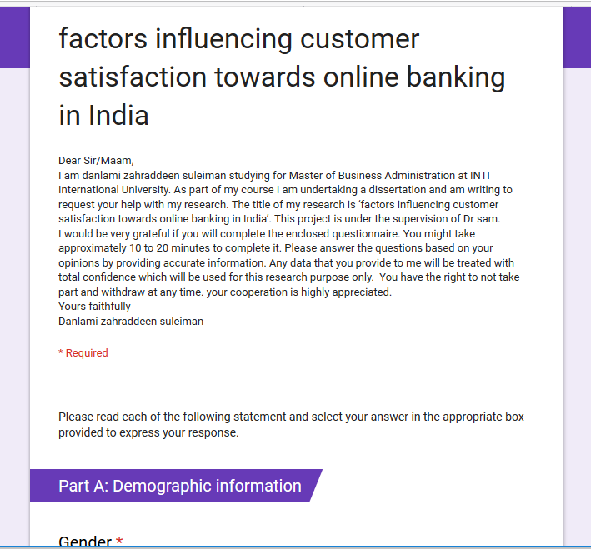

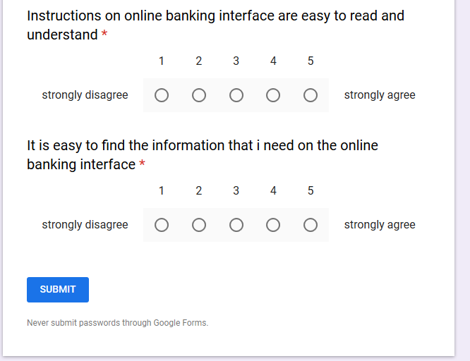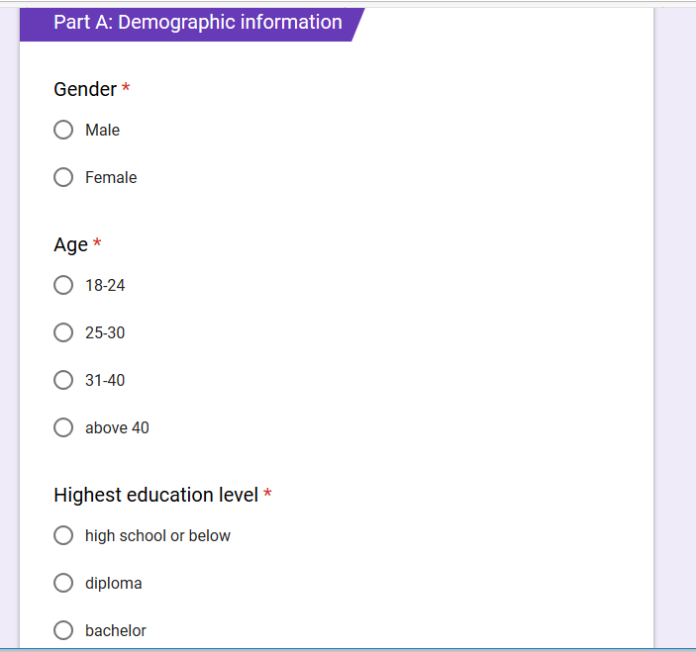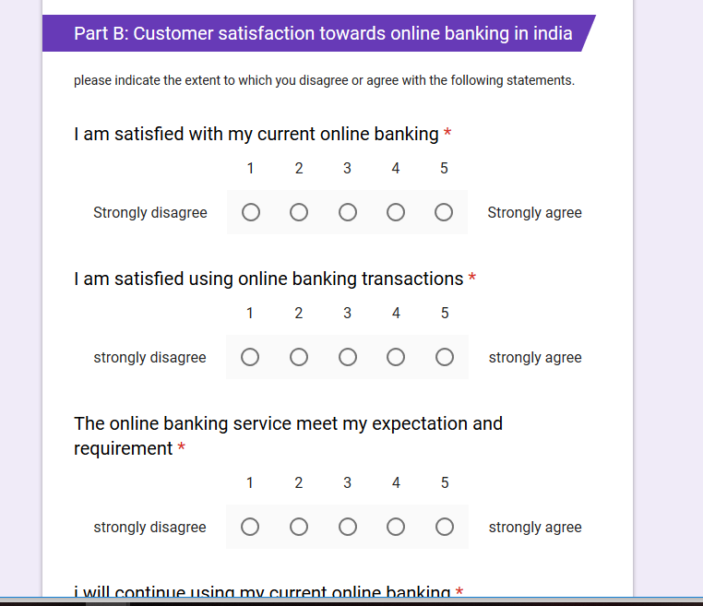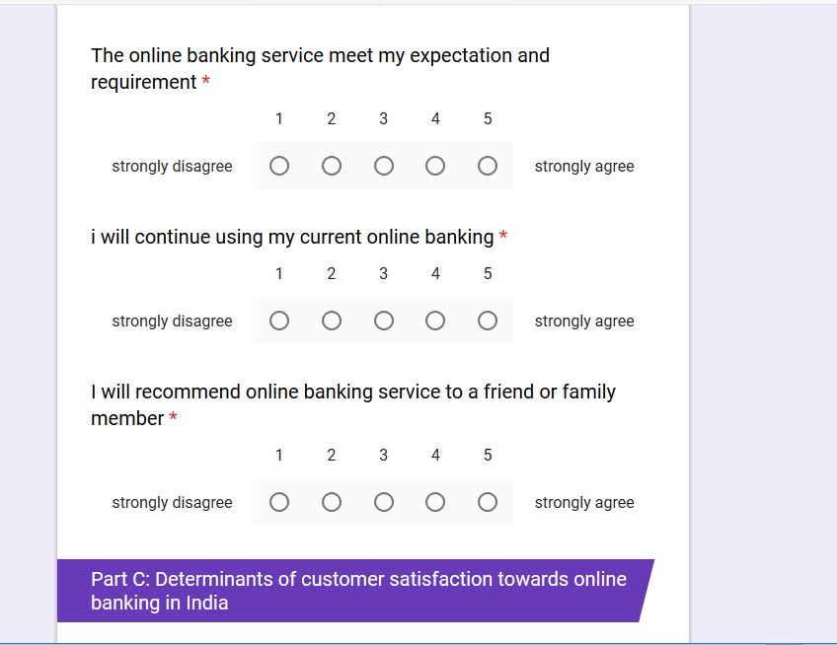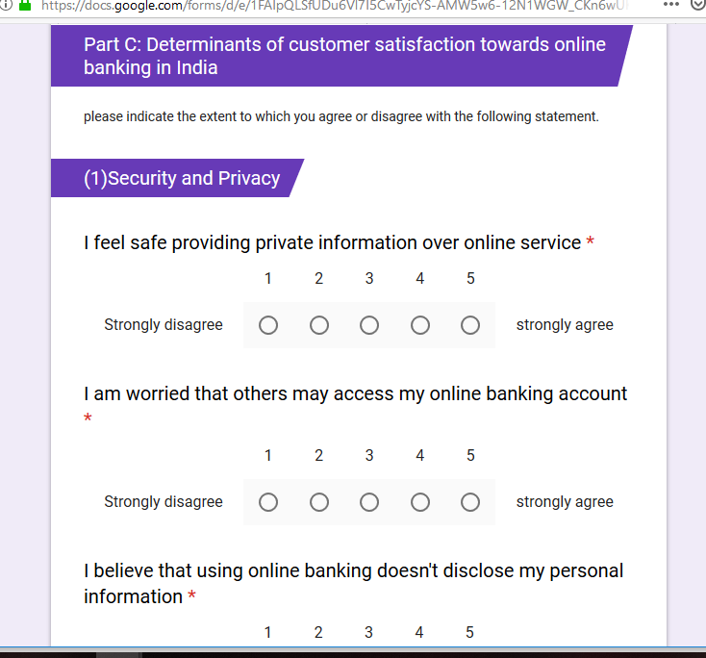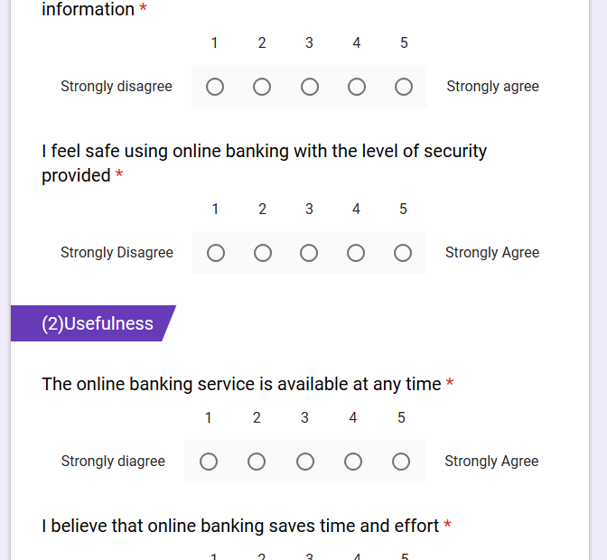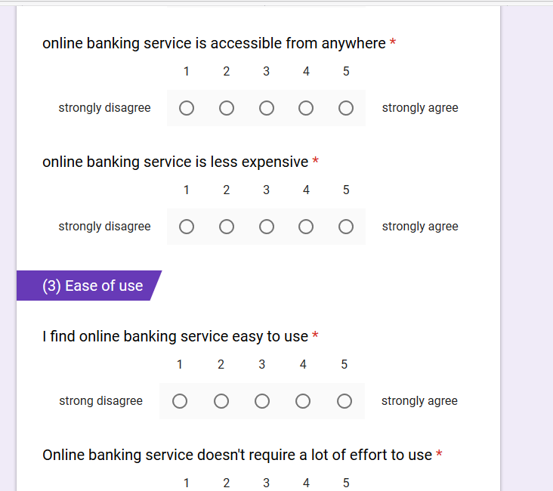

Appendix 2: statistics analysis result
Pilot testing
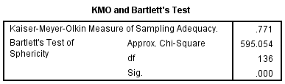
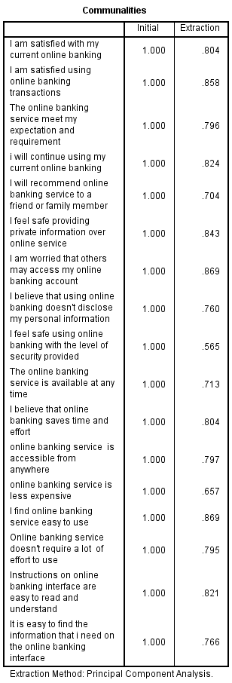

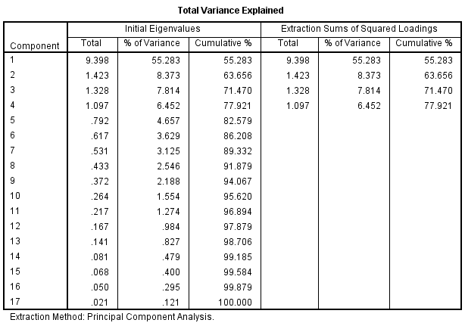

Preliminary analysis
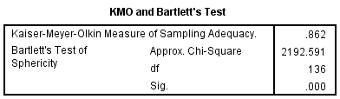

Multiple Regression and One-way ANOVA

Appendix 3: Project paper log

Student Name: | Danlami zahraddeen Suleiman
Supervisor’s Name: | Dr. Sam Toong Hai
Dissertation Topic: | FACTORS INFLUENCING CUSTOMER SATISFACTION TOWARDS ONLINE BANKING IN INDIA

SECTION A. MONITORING STUDENT DISSERTATION PROCESS

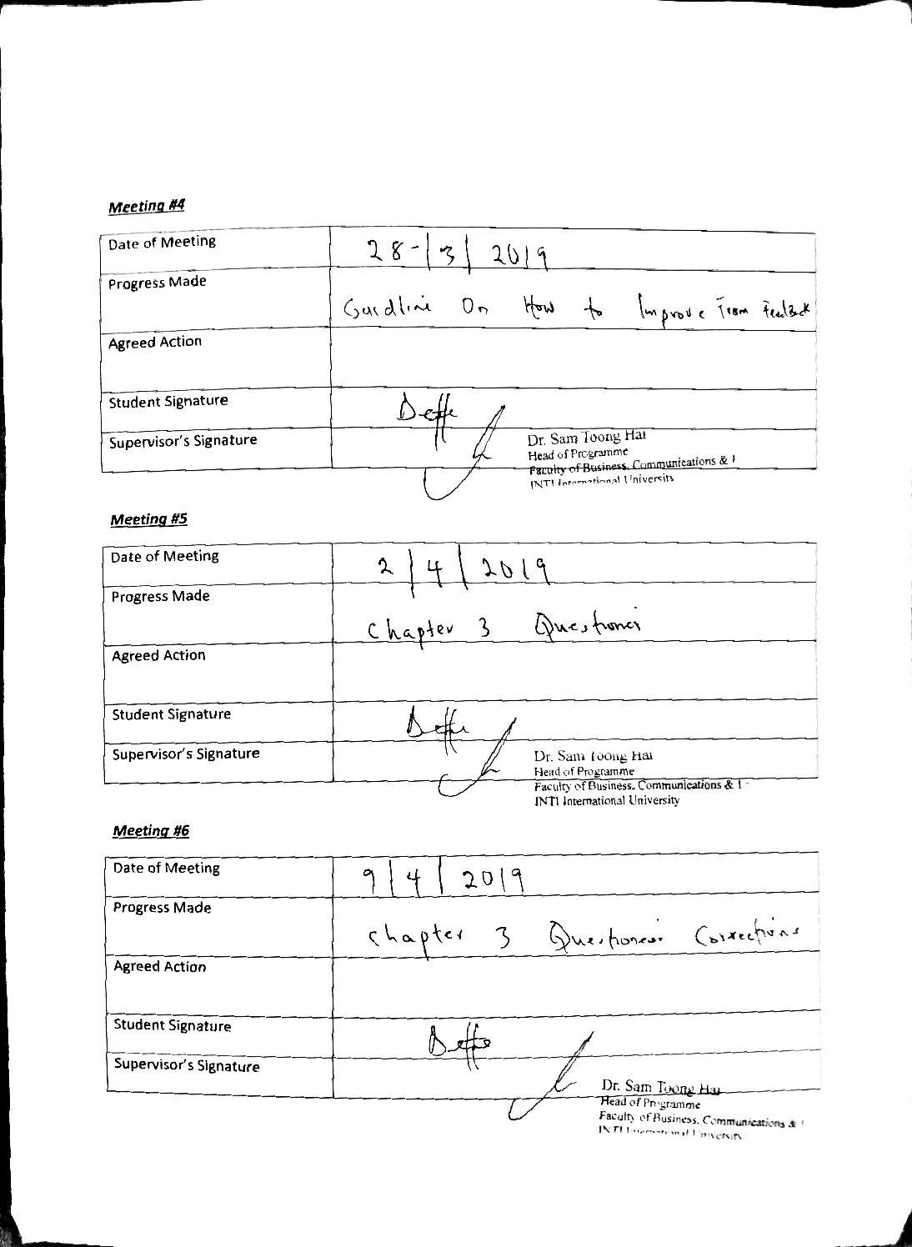

Appendix 4: Similarity report

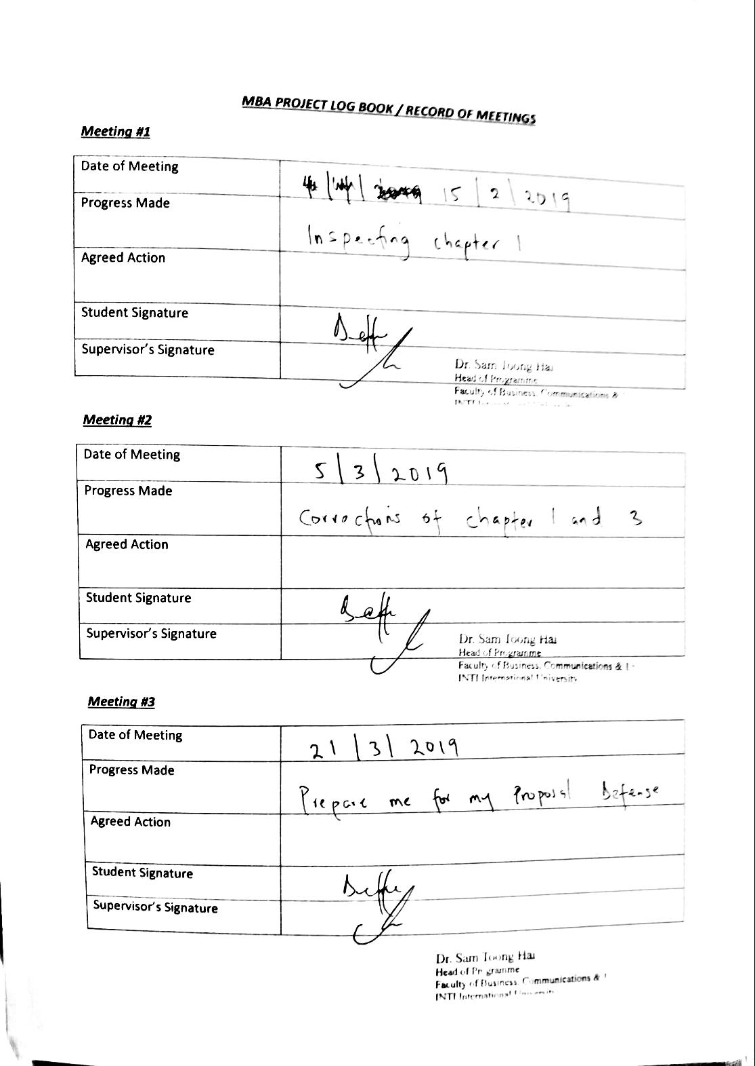

Appendix 4: Similarity report

